

***Mobile Services Platform***

***Home Location Register***

***User Manual***

**Confidentiality Notice**

*Use or disclosure of information contained in this document is subject to the restriction contained below.*

This document contains information proprietary & confidential to XIUS. It shall not be duplicated, used or disclosed in whole or in part for any purpose. Any disclosure, reproduction, duplication, transmittal or distribution of this document in whole or in part, using physical, electronic or any other media, requires written consent from an authorized XIUS signatory.

[www.xius.com](http://www.xius.com)

**Disclaimer**

XIUS Product Services and Features all those defined in this document are configurable and would be enabled based on the mutual agreement between XIUS and the Customer in accordance with the Product License availed by the customer.

**Revision History**

|  |  |  |  |  |  |
| --- | --- | --- | --- | --- | --- |
| Document ID | | **UG-HLR** | | | |
| Document Title | | Home Location Register - User Manual | | | |
| V. No | Start Date | Revision Details | Prepared by | Reviewed by | Approved by |
| 1.0 | 14th July 2017 | Initial Publication | Lakshmi Swati Patro | Haritha, KC |  |

**Table of Contents**

1 Introduction 7

1.1 Purpose 7

1.2 Scope 8

2 Overview 9

3 Architecture 10

4 Technical Description 11

4.1 Network Interface Gateway 11

4.2 Business Logic Applications 11

4.3 Subscriber / Application Data 11

4.4 Management Server 11

5 HLR (GUI) 12

5.1 Modules 12

6 User Management System Modules 15

6.1 Create User 16

6.2 Change User Password 19

6.3 Activate User 21

6.4 Deactivate User 22

6.5 View Info 23

6.6 Network Level Users 25

6.6.1 Associate 25

6.6.2 Activate 26

6.6.3 Deactivate 27

6.7 Role Management 28

6.7.1 Create Role 28

6.7.2 Show Role 32

6.7.3 View Role 33

6.7.4 Modify Role 34

6.7.5 Delete Role 36

7 System Configuration/HLR 39

7.1 PLMN Area Configuration 39

7.2 PLMN Configuration 45

7.3 HPLMN Configuration 54

7.4 System Parameters 59

7.5 Service Control Point 63

7.6 PLMN Specific SS Configuration 72

7.7 Allowed FTNs 74

7.8 PLMN Specific CUG 79

7.9 PLMN Specific Cell IDs 88

7.10 PLMN Specific LSA 96

7.11 PLMN Specific LAIs 105

7.12 PLMN Specific RSZI 113

8 Notifications 120

8.1 Roaming Partners 120

8.2 Notification Clients 127

9 GSM – CAMEL Subscriptions 136

9.1 Originating CSI 136

9.2 Terminating CSI 156

9.3 VMSC Terminating CSI 173

9.4 Supplementary Services CSI 187

9.5 Translation Information Flag CSI 198

9.6 Mobility Management GSM CSI 210

9.7 Mobile Originating SMS CSI 223

9.8 Mobile Terminating SMS CSI 235

9.9 Dialed Service CSI 248

9.10 USSD CSI 259

9.11 GPRS – CAMLE Subscriptions 269

9.11.1 GPRS CSI 270

9.11.2 Mobility Management GPRS CSI 281

9.12 Approve / Reject CSI Profile 293

10 Supplementary Services 299

10.1 CUG Profile 299

10.2 SS Profile Management 310

11 Location Services 325

11.1 GMLC Profile 325

11.2 LCS Services 336

11.3 External Clients 346

11.4 LCS Profiles 359

12 PDP Profile Management 373

13 Bearer Capability Profiles 392

14 Special Services 407

14.1 SoLSA 407

14.2 RSZI 415

15 Subscriber Profile Management 423

15.1 Home Profile 423

16 Subscriber Management 451

16.1 Manage KI Key Index 452

16.2 Manage OP Index 454

16.3 Authentication Center 456

16.4 Authentication View 458

16.5 Create Subscriber 459

16.6 Reference Subscriber 466

16.7 Bulk Subscriber Creation 467

16.8 Provision / Modify GPRS (Bulk) 472

16.9 Upload OCSI Number Criteria 474

16.10 Change Subscriber Profile 475

16.11 Change IMSI/MSISDN (Bulk) 479

16.12 Operator Determined Barring 482

16.13 Activate / Deactivate Subscribers 485

16.14 Attach / Detach SS Codes (Bulk) 487

16.15 Add / Remove Tele-Bearer (Bulk) 497

16.16 Subscriber Information 501

16.17 Remove Subscriber 566

16.18 Remove Subscriber (Bulk) 567

16.19 Cancel Location (Bulk) 568

17 Roaming Management 572

17.1 Subscriber Roaming 572

17.2 VPLMN Configuration 573

17.3 VPLMN Restriction 584

17.4 Restricted VLR(s) 597

17.5 Restricted SGSN(s) 606

17.6 Allowed VLR(s) 614

17.7 Allowed SGSN(s) 625

17.8 Allowed VPLMNIDs 636

17.9 Change Allowed VLR/SGSN (Bulk) 645

18 Reports 647

18.1 Peg Counts 647

19 Acronyms and Definitions 648

# Introduction

The Home Location Register or **HLR** is a database that resides in a local wireless network containing service profiles and checks the identity of a local subscriber.

**HLR** is a central database that contains details of each [mobile phone](http://en.wikipedia.org/wiki/Mobile_phone) subscriber that is authorized to use the GSM core network. In other words, the HLR stores details of every [Mobile](http://en.wikipedia.org/wiki/SIM_card) Subscriber who has availed Mobile services subscription issued by the [mobile phone operator](http://en.wikipedia.org/wiki/Mobile_phone_operator). Each mobile subscriber has a unique identifier called an [IMSI](http://en.wikipedia.org/wiki/IMSI) (International Mobile Subscriber Identifier) which is reckoned to be the [primary key](http://en.wikipedia.org/wiki/Primary_key) of each HLR record.

Subsequently, the next important component of data associated with the mobile subscriber is the [telephone number](http://en.wikipedia.org/wiki/Telephone_number), which is used to make and receive calls to / over the mobile phone, known as [MSISDN](http://en.wikipedia.org/wiki/MSISDN) (Mobile Subscriber ISDN Number). This HLR data is stored for as long as a subscriber remains with the [mobile phone operator](http://en.wikipedia.org/wiki/Mobile_phone_operator).

HLR is a system, which directly receives, processes and manages the GSM transactions. The main business processes expected of a **GSM-HLR** are the Subscriber Location Management, Call/Session Management, Service Registration & De-Registration, Service Activation & De-Activation, Authentication and Short Message Delivery management. In addition to the above basic functions, HLR also allows the operator to configure roaming restrictions to the subscribers.

The **prolific features of HLR** include the following:

* Facilitates hosting multiple operators on a single platform
* Supports multiple authentication algorithms (COMP128-1, COMP128-2, COMP128-3, GSM-Milenage)
* Supports multiple ‘Encryption Algorithmes’ (AES, DES)
* Quick provisioning of subscribers using pre-configured service templates

## Purpose

This document is for use by the internal organizations of XIUS and can be distributed to select customers and vendors. It communicates the technical architecture and GUI features of the XIUS HLR system. It will be used by the R&D organization to communicate a consistent technical understanding and navigational flow of HLR to other individuals and organizations.

## Scope

This document provides a technical and functional overview of the XIUS HLR. It contains information that is consistent with the current design and requirements for this system and is subject to change with respect to various customer/vendor specific implementations.

# Overview

**HLR** solution supports the following fundamental functional features and competencies.

* **Authentication –** Enables the subscribers to be authenticated with any of the 3GPP defined algorithms.
  + The HLR generates user authentication, integrity and ciphering data. In other words, the HLR supports the authentication procedures to access GSM services by storing the generated data for authentication, integrity and ciphering, and subsequently by providing this data to the appropriate entity.
* **Mobility Management**– Supports the user mobility through GSM network.
  + Access Authorisation - When requested by the serving MSC/VLR, the HLR authorises the user for mobile access after checking/confirming if the user is allowed to roam within that visited network.
  + Besides the user authorization, the HLR also apprises and updates the appropriate serving entities (i.e., MSC/VLR) with the relevant information related to various services to be provided to the user.
* **Call or session establishment**
  + HLR provides basic authorisation for MT call/session establishment and service invocation.
  + Enables the subscriber to have multi-numbering for discrete services.
* **Short Message Service**
* **Supplementary Service Management** 
  + It allows the subscriber or the operator to register, activate/deactivate or withdraw services at their discretion.

# Architecture

HLR structure is comprehensive utilizing a distributed architecture to achieve maximum scalability and resilience. The distributed architecture is based on decoupling transaction logic from subscriber/application data.

The following diagram depicts the high level overview of the HLR Architecture



# Technical Description

The HLR is decomposed into four basic components:

* Network Interface Gateway
* Business Logic Applications
* Subscriber / Application Data
* Management Server

## Network Interface Gateway

HLR Network Interface Gatewayis a sub-system that in turn comprises of two elements: SS7 Interface and the Event Handler & Dispatcher (EH&D). The SS7 Interface provides SS7 signalling termination for the GSM HLR, while the EH&D distributes the MAP events to the corresponding HLR Application. This uses the HP Universal Signalling Platform to interface with the SS7 Network.

## Business Logic Applications

The set of these applications is dedicated to realize the various functionalities of the HLR.

This layer comprises of Mobility Manager, Call/Session Manager, Supplementary service manager, SMS manager and Fault Recovery, each catering to the respective functionalities of the HLR.

## Subscriber / Application Data

This layer stores the entire subscriber data, service templates and application data in Oracle database. Based on the requirements of the Operator, this layer can be deployed in a RAC (Real Application Cluster) and/or SAN (Storage Area Network).

## Management Server

The HLR is managed through a web-based Graphical User Interface (GUI) or XML APIs. The Management Server can be used to check and update subscriber details and services. It can also be used to manage the service templates used for provisioning new subscribers.

# HLR (GUI)

HLR has an application interface (GUI) that helps the user registering information related to various subscriptions, supplementary services, subscribers data, and roaming details at (network) level.

However, Administrator (Network Operator) is authorized to create and manage the user accounts with in the independent network through the **User Management System** module (an integral part) of MSP. This enables the users carrying out various functional operations in their designated capacities based on the provisioning of access roles and permissions. These users may be categorized based on the responsibilities vested to carry out different functional operations through various modules of the MSP Application that includes HLR.

**NOTE:** Please refer user guide of the User Management System for HLR Users’ information.

## Modules

HLR user functionality has been broadly categorized into the following chapters having various modules and sub-modules:

1. User Management System
2. System Configuration
3. Notifications
4. Network Management
5. Profile Management
6. Subscriber Management
7. Roaming Management

The screen below shows the homepage of HLR.

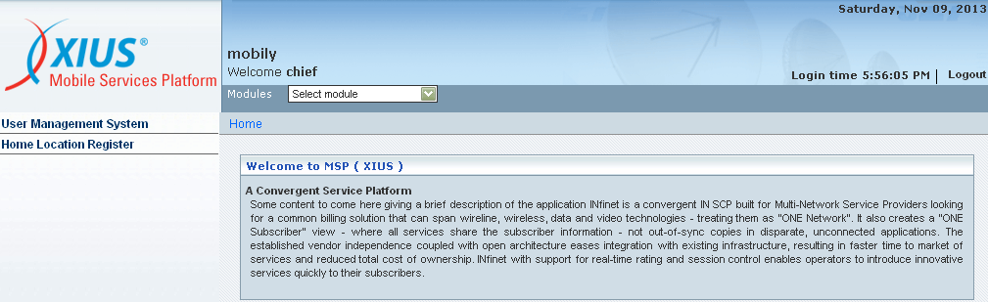

**User Management System**

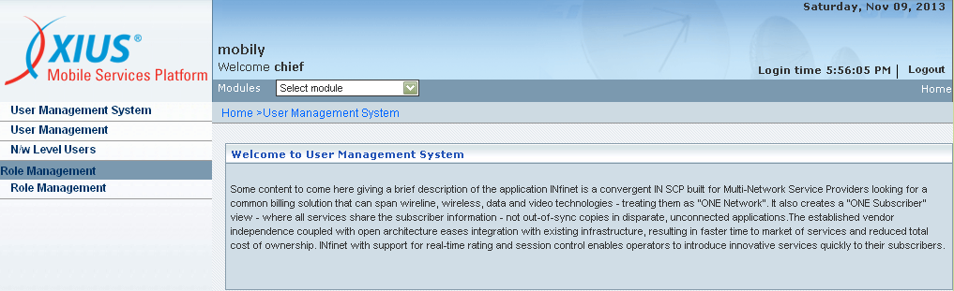

**Home Location Register**

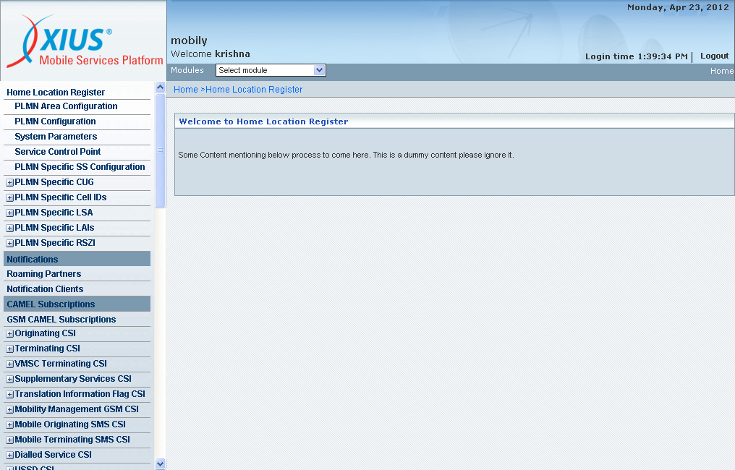

The screen below shows the Side Panel of HLR. The panel contains various links for HLR related operations.

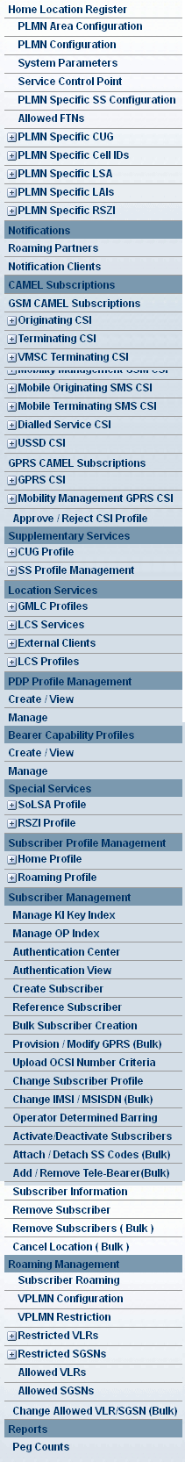

# User Management System Modules

* **User Management**
  + **Create User**
  + **Activate User**
  + **Deactivate User**
  + **View Info**
  + **Change User Password**
  + **Modify Roles**
  + **View Roles**
* **N/w Level Users**
  + **Associate**
* **Role management**
  + **Create Role**
  + **Delete**
  + **View**
  + **Modify**

| **STEP** | **ACTION** |
| --- | --- |
|  | On clicking the ‘User Management’ link in the left frame of the MSP Application it will direct the user to the home page of User Management System. Wherein, a list of users appears and the users can be managed by creating, activating, deactivating and changing the user’s password whenever needed. |

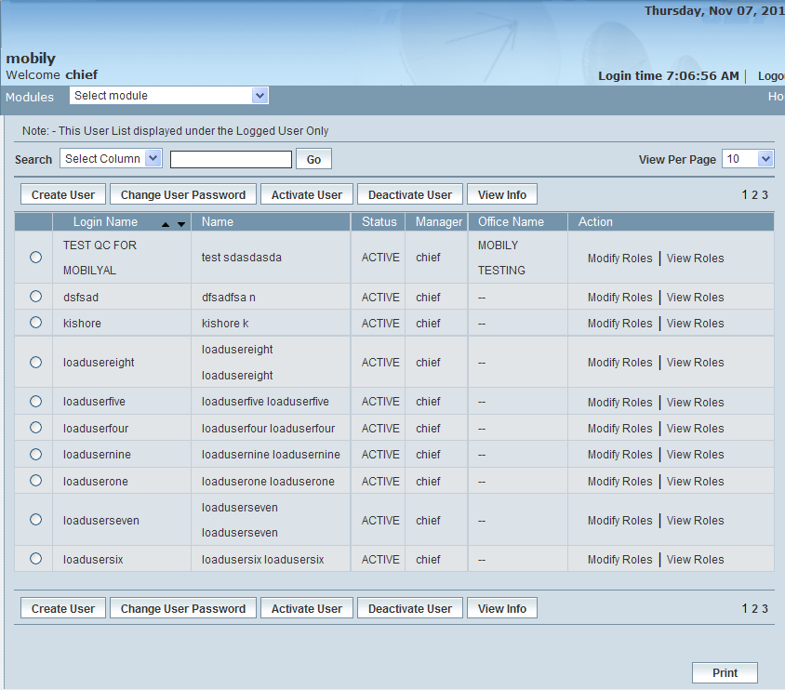

## Create User

‘Create User’ helps the User in creating a new user (User Account). A new User can be added along with his / her Roles.

NOTE**:** A Role can be defined as one element consisting of a set of modules or one module (as the case may be) to which accessibility can be attributed for provisioning the same (further) to the prospective users. Thus the privileges of new User depend on the Roles attributed to his / her User Account.

The screen below shows creating a new User (User Account).

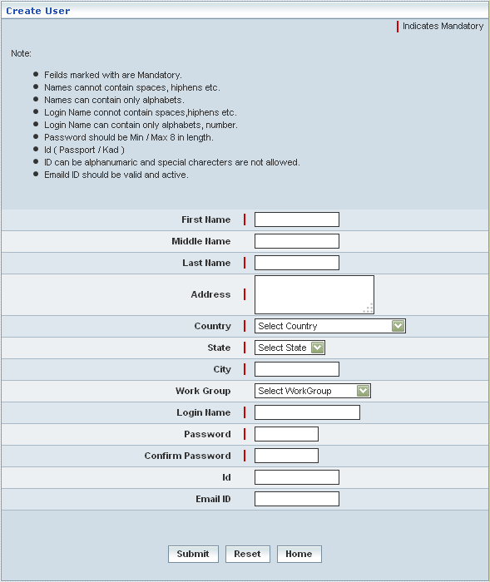

| **STEP** | **ACTION** |
| --- | --- |
|  | User must go through and follow the guidelines before entering the details of a new user. |
|  | User must essentially enter the details related to the user where it is a mandatory information |
|  | Enter the demographic details of the User (First Name, Last Name and Address etc.) in their respective fields |
|  | Select a ‘Work Group’ from the drop-down list of the <Work Group> field  **\*** By default, the list of pre-defined ‘Work Groups’ (defined / Created by the administrator through **Work Group Management** module) will be dynamically displayed as a drop-down list of the <Work Group> field |
|  | Enter details pertaining to Login Name, Password, Confirm Password, ID and Email ID in their respective fields |
|  | On clicking the  button, the new ‘User details’ will be registered and subsequently, it directs the user to the ‘**Change User Roles**’ screen. New User can be assigned to a set of predefined access roles through the ‘**Change User Roles**’ screen |
|  | On clicking the  button (before submitting the new User details), it clears the earlier entered details enabling the Authorized User to enter the details afresh |
|  | On clicking the  button (before submitting the new User details), it only redirects the Authorized User back to ‘UMS’ main page |

The screen below shows dispensing various (multiple) roles to the prospective User.

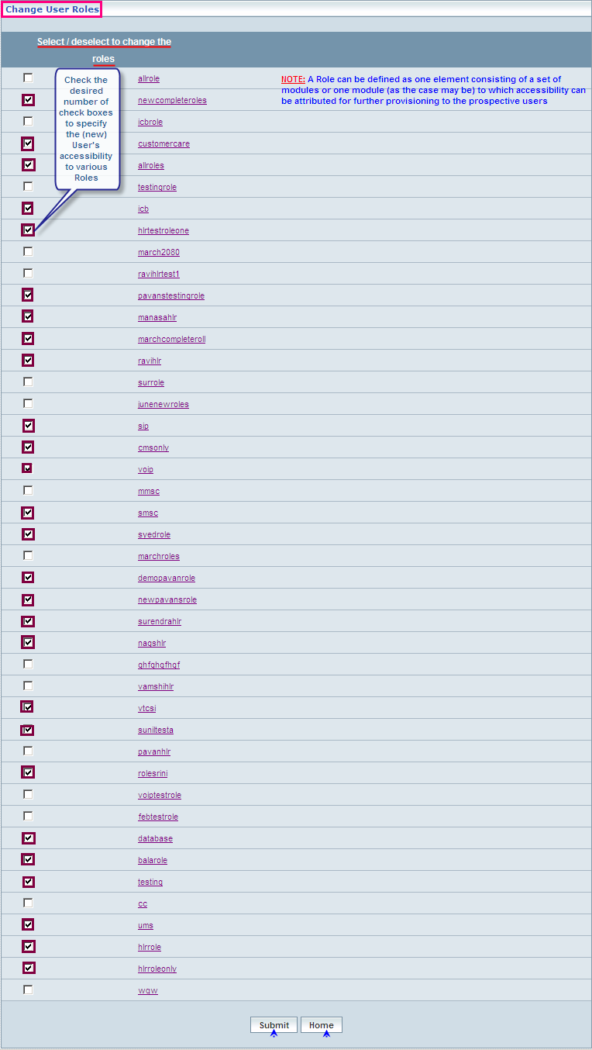

| **STEP** | **ACTION** |
| --- | --- |
|  | Check  the desired number of check boxes to specify the (new) User's accessibility to various Roles |
|  | On clicking the  button, ‘New User – User Account’ will be successfully created and saved. A Message Window will be displayed to that effect  Wor9EA  On clicking the  button of the Message Window, it redirects the Authorized User to the ‘UMS’ main page |
|  | On clicking the  button at the bottom of the screen (before assigning the roles), it directs the Authorized User to a separate screen ‘**Change User Roles**’. This screen displays the list of existing Users enabling the Authorized User to choose the Prospective (new) User to subsequently access corresponding the screen that allows assigning roles to the chosen (new) User |

## Change User Password

**Change User Password** enables the Authorized User to change Password of the User (User Account). However, it is not necessary to provide the Old Password to acquire a New Password for the chosen User Account. Authorized User can directly submit a New Password after confirming the same. Once the Password of a User Account is changed, it stands same till the next change.

A Chief Supervisor or Administrator can change the password of all the corresponding Users belonging to the Network. Other Users can change the password of the Users created by them.

The screen below enables changing Password of the chosen User by the Authorized User.

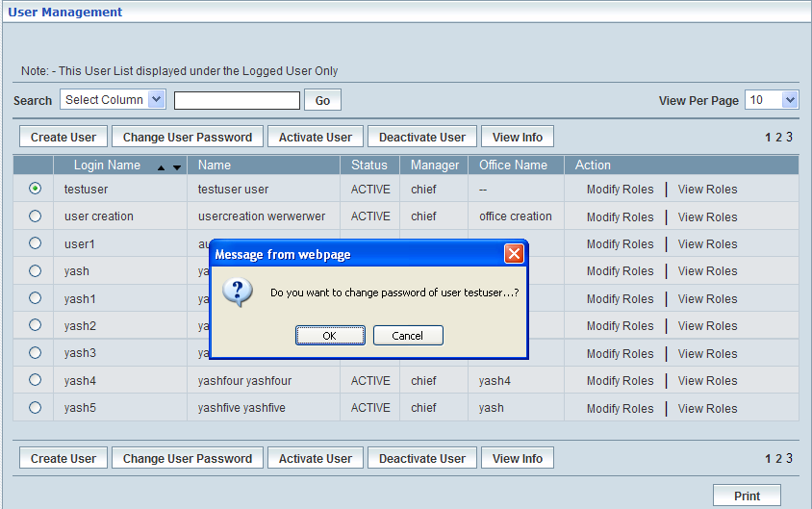

| **STEP** | **ACTION** |
| --- | --- |
|  | Select a User from the **Home** page whose password you want to change.  Note: An administrator can change the password of their User’s irrespective of the user’s status. |
|  | By clicking the **Change User Pas**sword button, a confirmation messages appears. |
|  | By clicking **OK** the Change Password dialog box appears. |
|  | Enter new Password in the <Password> field. |
|  | Re-enter the Password to confirm the new Password in the <Confirm Password> field. |
|  | On clicking the  button, the password will be changed / updated for the chosen User’s Account. A Message Window will be displayed to that effect.    On clicking the  button of the Message Window, it redirects the Authorized User to the ‘UMS’ main page. |
|  | On clicking the  button (before changing the Password), it only redirects the Authorized User back to ‘UMS’ main page. |

## Activate User

**Activate User** allows Authorized User to **activate** the **Inactive** Users.

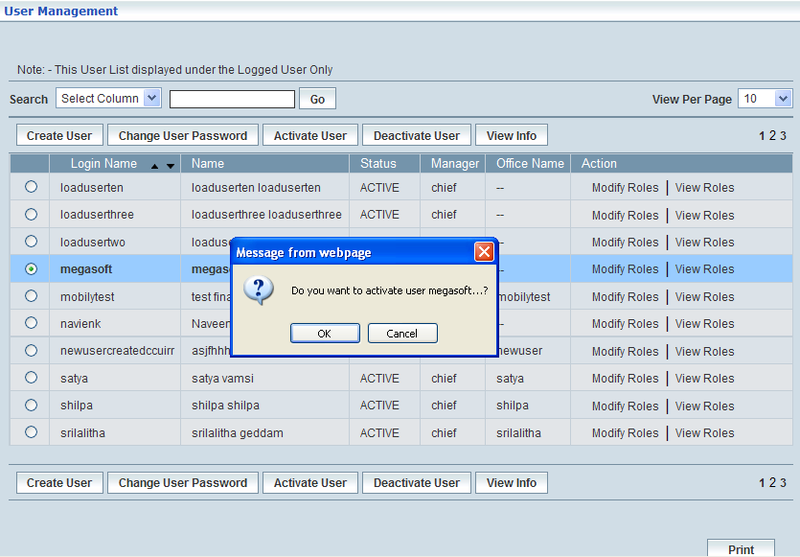

| **STEP** | **ACTION** |
| --- | --- |
|  | Select a deactivated User from the **Home** page whom you want to activate. |
|  | On clicking **Activate User** button, a confirmation message appears. |
|  | On clicking **OK** button, the **Activate User** window appears which confirms the successful activation of a deactivated user. |
|  | On clicking the  button, the chosen User’s Account will be activated and a Message Window will be displayed to that effect    On clicking the  button of the Message Window, it redirects the Authorized User to the ‘UMS’ main page. |
|  | On clicking the  button (before activating the User’s Account), it only redirects the Authorized User back to ‘UMS’ main page. |

## Deactivate User

**Deactivate User** allows Authorized User to **deactivate** the **Active** Users. Deactivation is disabling a User from using the privileges assigned to him/her. However, all the privileges and data stored about the User are preserved. Deactivated User can be activated any time later.

The screen below displays the list of **Active** Users enabling the Authorized User to choose a User to **deactivate** his / her User Account.

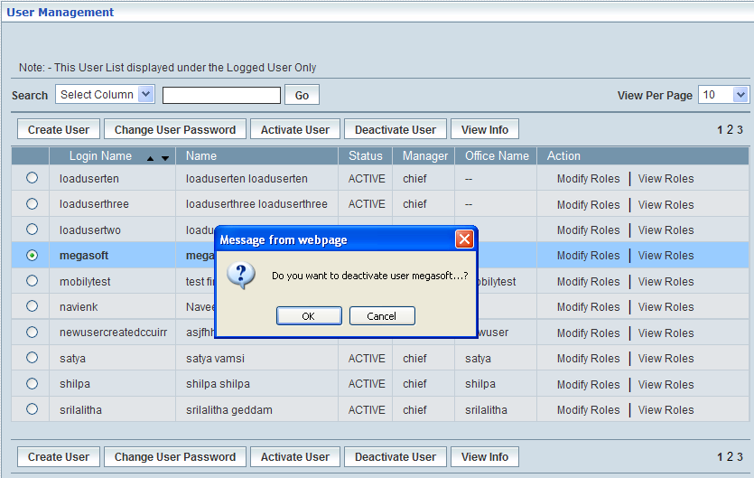

| **STEP** | **ACTION** |
| --- | --- |
|  | Select an Active User from the **Home** page whom you want to deactivate. |
|  | On clicking **Deactivate User** button, a confirmation message appears. |
| **3.** | On clicking **OK** button, the **Deactivate User** window appears which confirms the successful deactivation of an active user. |
| **4.** | On clicking the  button, the chosen User’s Account will be deactivated and a Message Window will be displayed to that effect    On clicking the  button of the Message Window, it redirects the Authorized User to the ‘UMS’ main page |
| **5.** | On clicking the  button (before deactivating the User’s Account), it only redirects the Authorized User back to ‘UMS’ main page |

## View Info

**View Info** displays the selected user’s (User Accounts) information regardless of the status (Active/Inactive/Roles required).

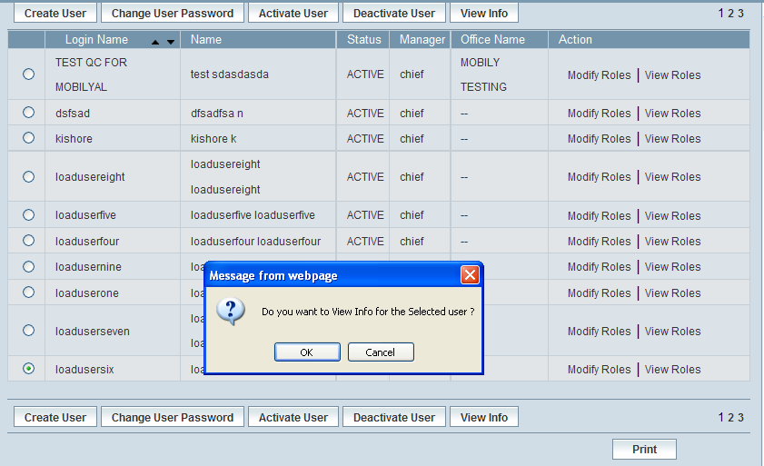

| **STEP** | **ACTION** |
| --- | --- |
|  | Select a User from the **Home** page whose information want to view. |
|  | On clicking **View Info** button, a confirmation message appears. |
|  | On clicking **OK** button of the message screen, the **View Info** screen appears as follows. |
|  | On clicking the  button of the Message Window, it redirects the Authorized User to the ‘UMS’ main page |

## Network Level Users

To access Network Level Users, go to User Management System > Network Level Users

The screen below shows ‘Network Level Users’ module

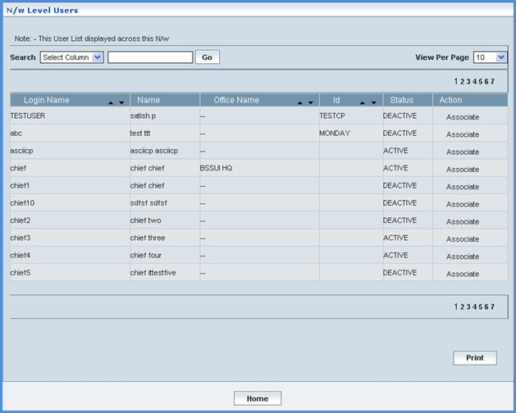

### Associate

Associate action helps the User to activate and deactivate the users across the network

| **STEP** | | **ACTION** |
| --- | --- | --- |
|  | | By default, the list of users list across the network will be displayed as records in a grid. The columns include ‘Login Name’, ‘Name, ‘Office Name’, ‘Id’, ‘Status’ and ‘Action’ |
|  |  | User can customize the view for the number of records to be displayed each time (per page) in a grid. |
| Select the number of records (For Ex: 10) from the drop-down list of the <View Per Page> field. |
| With the effect of choosing the desired number (10) for the display of records per page, the same (10 records) will be displayed in the grid. |
| However, based on the total number of records, page numbers will be dynamically displayed at the left bottom of the screen |
| User can navigate for subsequent records (10 each time) by clicking the desired ‘page number’ |
|  | | User can sort the records in ascending and descending orders with the help of up-arrowNW Details and down-arrows NW Details respectively |
|  | | On clicking the  button at the bottom of the screen, user can take printouts of the ‘Network Level Users’ records list |

### Activate

This section helps to activate the users across the network.

| **STEP** | **ACTION** |
| --- | --- |
|  | User can click  action link. The ‘Associate’ window displays. |
|  | On clicking **Activate** button, |

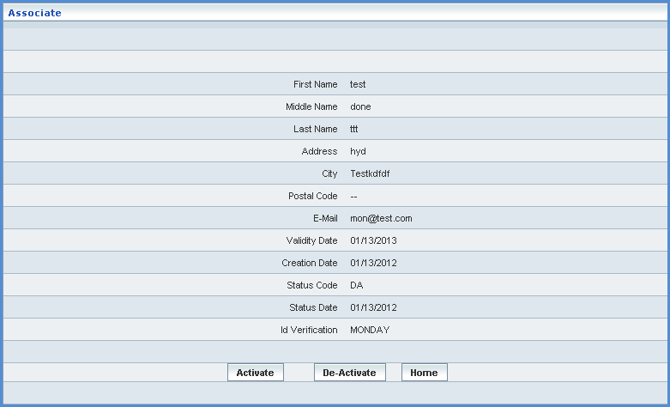

| **STEP** | **ACTION** |
| --- | --- |
|  | View the details of the selected user across the network |
|  | Click the  button. A message window gets displayed.    Notice that the **ACTIVE** appears in the ‘Status’ column  Click  button to go back to the ‘Network Level Users’ window |
|  | Click button before associating the selected user to activate, it directs the users to ‘User Management System’ main page |

### Deactivate

This section descries you how to deactivate the users across the network

| **STEP** | **ACTION** |
| --- | --- |
|  | User can click  action link. The ‘Associate’ window displays. |



| **STEP** | **ACTION** |
| --- | --- |
|  | View the details of the selected user across the network |
|  | Click the  button. The message window gets displayed.    Notice that the **DEACTIVE** status appears in the ‘Status’ column.  Click the  button to go back to the ‘Network Level Users’ window. |
|  | Click the  button before associating the selected user to activate, it directs the users to ‘User Management System’ main page. |

## Role Management

A Role can be defined as one element consisting of a set of modules or one module (as the case may be) to which accessibility can be attributed for further provisioning to the prospective users. In other words, a Role defines User rights and privileges.

### Create Role

User can create a new Role and specify privileges for that Role. Those Users who have been assigned to this Role shall have rights and privileges as per the configuration of the Role. User can configure Roles in such a manner that part privileges or full privileges of the features pertaining to one or more than one module could be considered while creating the Role.

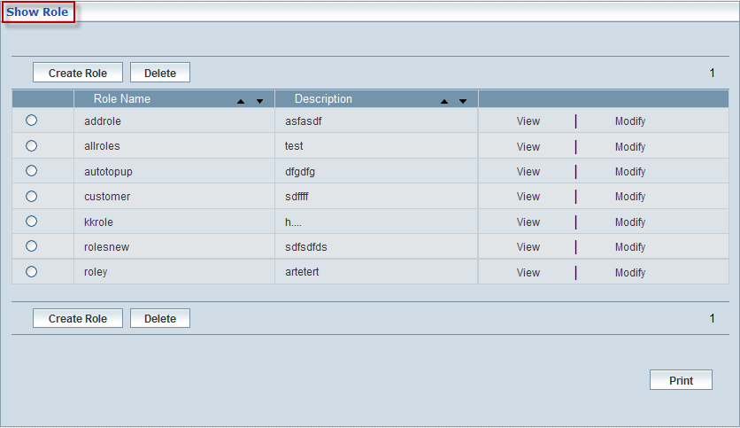

The screen below shows **creating** a Role.

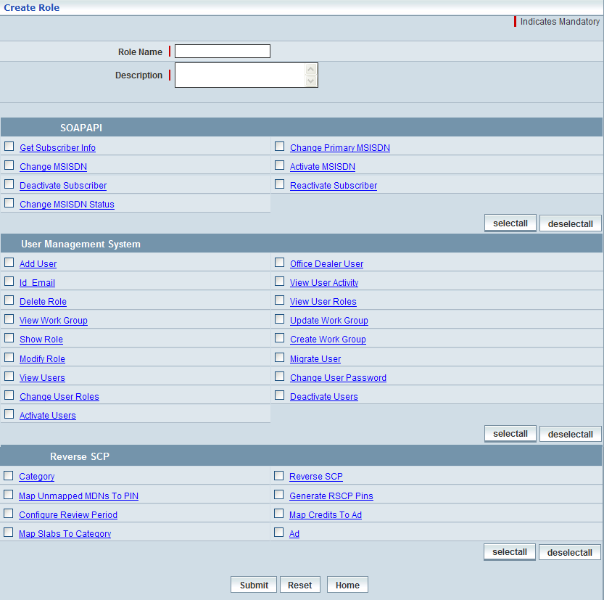

| **STEP** | **ACTION** |
| --- | --- |
|  | On clicking the **Create Role** button, the **Create Role** screen appears. |
|  | Enter name of the Role in the <Role Name> field. |
|  | Enter a description defining the proposed Role in the <Description> text field |
|  | Application Modules along with the corresponding functional features (sub modules) will be displayed as blocks. These blocks include – User Management, Configuration Management, Customer Management, Card Life Cycle Management, Migration, Telecommunication Services Gateway, Short Message Switching Center, Settlements, Service Offering and Rating Management, Home Location Register, Interconnect Billing Management, Customer Care, Voice Over Internet Protocol, Trouble Ticket Management, Reverse SCP and Multi-Media Message Switching Center |
|  | Check  the corresponding check boxes of the desired **Functional Features** related to **each of the modules** under the respective blocks. |
|  | On clicking the  button, it enables the User to select the entire features of the Module at one stretch. |
|  | To deselect all the checked features (of a Module) at one stretch, click the  button. |
|  | On clicking the  button, the new Role will be registered (added) and saved. A message window will be displayed to that effect.  WorA46  On clicking the  button of the Message Window, it directs the User to the ‘UMS’ main page. |
|  | On clicking the  button, it clears the screen (earlier enter details and check boxes) enabling the User to enter and select the details accordingly |
|  | On clicking the  button at the bottom of the screen (before the submission of new Role details), it directs the Authorized User back to ‘UMS’ main page |

### Show Role

**Show Role** enables the Authorized User to manage (view/modify/delete) the information related to a Role. User can peruse, modify / update and delete the details related to a chosen (specific) Role.

Initially, the entire Roles will be displayed as records in a grid.

The screen below shows **managing (view/modify/delete)** a Role.



| **STEP** | | **ACTION** |
| --- | --- | --- |
|  | | By default, the list of entire Roles will be displayed as records in a grid.  The columns include ‘Role Name’, ‘Description’ and ‘Action’ |
|  |  | User can customize the view for the number of records to be displayed each time (per page) in a grid. |
| Select the number of records (For Ex: 10) from the drop-down list of the <View Per Page> field. |
| With the effect of choosing the desired number (10) for the display of records per page, the same (10 records) will be displayed in the grid. |
| However, based on the total number of records, page numbers will be dynamically displayed at the left bottom of the screen |
| User can navigate for subsequent records (10 each time) by clicking the desired ‘page number’ |
|  | | On clicking the  link of a chosen Role, the corresponding details will be displayed in a separate screen enabling the Authorized User to peruse the details |
|  | | On clicking the  link of a chosen Role, the corresponding details will be displayed in a separate screen enabling the Authorized User to modify / update the details accordingly |
|  | | On selecting the corresponding radio option  of a chosen Role and by clicking the  button, the Role will be deleted |
|  | | On clicking the  button at the bottom of the ‘Roles List Grid’, Authorized User can take printouts of the Roles List |

### View Role

On clicking the  link of a chosen Role (from the Roles list), the corresponding details will be displayed in a separate screen enabling the Authorized User to peruse the details.

The screen below displays the details related to a chosen Role.

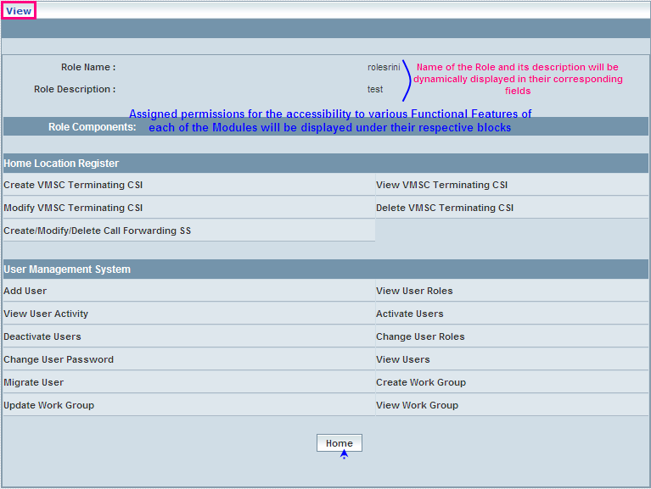

| **STEP** | **ACTION** |
| --- | --- |
|  | Name of the Role and its description will be dynamically displayed in their corresponding fields <Role Name> and <Role Description> |
|  | Assigned permissions for the accessibility to various Functional Features of each of the Modules will be displayed under their respective blocks under the **‘Roles Components’** heading |
|  | User can peruse the details |
|  | On clicking the  button at the bottom of the screen, it directs the Authorized User back to the ‘Roles List’ - (Show Role) grid |

### Modify Role

On clicking the  link of a chosen Role from the Roles list, the corresponding details will be displayed in a separate screen enabling the Authorized User to modify / update the details accordingly.

The screen below shows modifying the details related to a chosen Role.

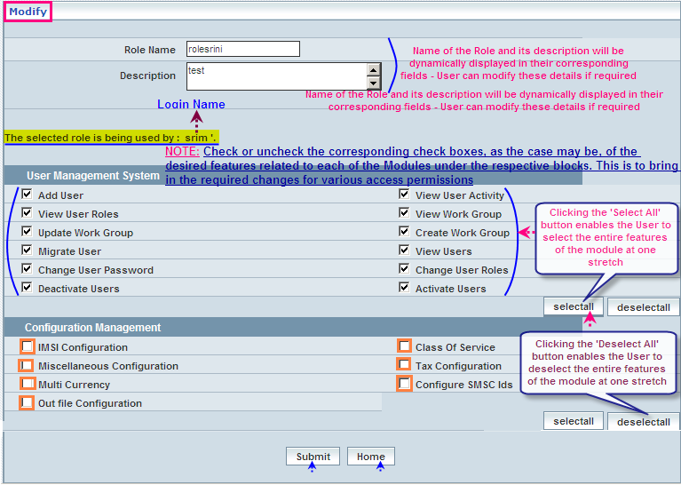

| **STEP** | **ACTION** |
| --- | --- |
|  | Name of the Role and its description will be dynamically displayed in their respective fields <Role Name> and <Description> - User can modify these details if required |
|  | Already assigned permissions for the accessibility to various Functional Features of each of the Modules will be displayed under their respective blocks |
|  | Select  or deselect  the corresponding check boxes, as the case may be, of the desired features related to each of the Modules under the respective blocks. This is to bring in the required changes for various access permissions |
|  | On clicking the  button, it enables the User to select the entire features of the Module at one stretch |
|  | To deselect all the checked features (of a Module) at one stretch, click the  button |
|  | On clicking the  button, changes related to the chosen Role will be updated and saved. A message window will be displayed to that effect  WorF1  On clicking the  button of the Message Window, it directs the Authorized User back to the ‘Roles List’ - (Show Role) grid |
|  | On clicking the  button at the bottom of the screen (before the submission of modifications), it directs the Authorized User back to the ‘Roles List’ - (Show Role) grid |

### Delete Role

On selecting the corresponding radio option of a chosen Role and by clicking the ‘Delete’ button, it enables the User to delete Role after confirming the deletion.

The screen below shows deleting a chosen Role.

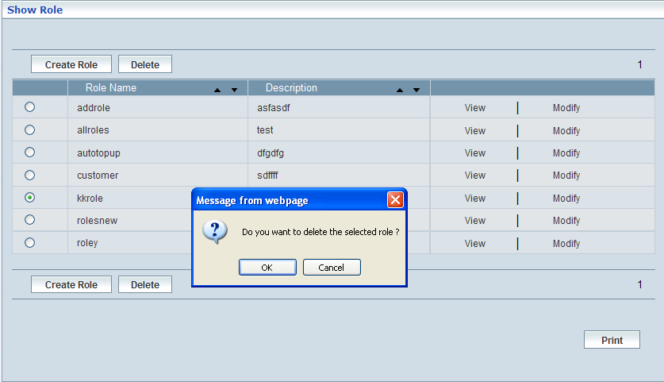

| **STEP** | **ACTION** |
| --- | --- |
|  | On selecting the corresponding radio option  of a chosen Role and by clicking the  button, an alert message window will be displayed enabling the user to confirm deletion |
|  | On clicking the  button of the alert window, it displays the information related to Role User and once again a confirmation alert in a separate ‘Delete Role’ screen |
|  | On clicking the  button of the alert window, it retains the ‘Roles List’ - (Show Role) grid |

The screen below shows information related to Role User and the confirmation alert.

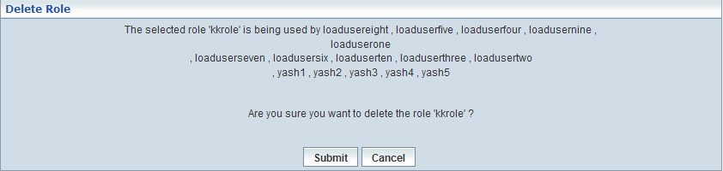

| **STEP** | **ACTION** |
| --- | --- |
|  | User can peruse the Role User details before confirming the deletion of the Role |
|  | On clicking the  button of the alert window, the corresponding Role will be deleted and a Message Window will be displayed to the effect  WorF6  On clicking the  button of the Message Window, it directs the User back to ‘Roles List’ - (Show Role) grid  NOTE**:** The corresponding ‘Role’ (record) will be automatically disappeared from the Roles List. |
|  | On clicking the  button of the ‘Delete Role’ screen, it retains the ‘Roles List’ - (Show Role) grid |

# System Configuration/HLR

This chapter describes about configuring PLMN Area before HLR is deployed.

## PLMN Area Configuration

Home Location Register 🡪 PLMN Area Configuration

PLMN Area Configuration module enables the user to manually configure PLMN Area Codes, each at a time. This area code shall be constituted in contemplation with corresponding parameters such as zip code and NXX values. The list of existing (already configured) area codes will be displayed in a grid. The columns of the grid includes Zip-Code, NPA (Actual Area Code) and NXX.

This module helps the user performing the following actions:

* Create
* Modify
* Delete
* Search

The screen below displays existing Area Codes:

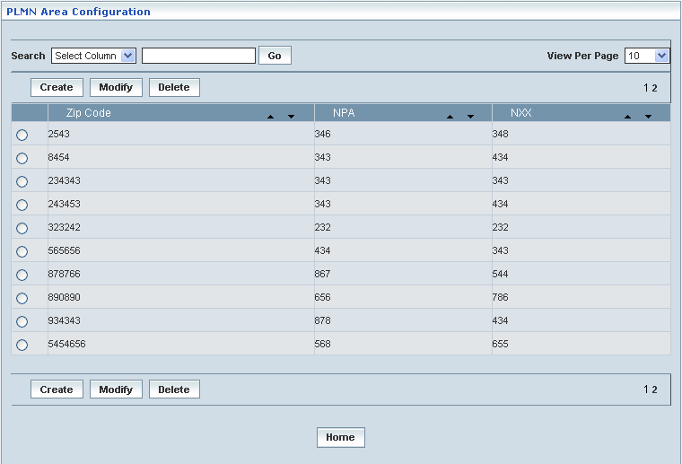

| **STEP** | | **ACTION** |
| --- | --- | --- |
|  | | By default, the list of Area Codes will be displayed as records in a grid. The columns include ‘Zip Code’, ‘NPA’ and ‘NXX’ |
|  |  | User can customize the view for the number of records to be displayed each time (per page) in a grid.  However, this option is applicable only if the total number of records exceeds 10. And also with the immediate effect of increase in the number of records more than 10, a ‘Search’ option would be dynamically displayed. |
| Select the number of records (For Ex: 10) from the drop-down list of the <View Per Page> field. |
| With the effect of choosing the desired number (10) for the display of records per page, the same (10 records) will be displayed in the grid. |
| User can sort the records in ascending and descending orders with the help of up-arrow and down-arrows respectively |
| However, based on the total number of records, page numbers will be dynamically displayed at the left bottom of the screen |
| User can navigate for subsequent records (10 each time) by clicking the desired ‘page number’ |
|  | | On clicking the **Create** button, ‘Create’ screen will be displayed enabling the user to create a new ‘Service Control Point’ |
|  | | On clicking the **Modify** button, ‘Modify’ screen will be displayed enabling the user to update / change corresponding values (as required) of a chosen Area Code. |
|  | | On clicking the **Delete** button, of a chosen ‘Area Code’, it enables the user to delete the same |
|  | | On clicking the **Home** button at the bottom of the grid, it redirects the user to the ‘HLR’ main page |

**Create**

Create enables the user to configure an area code along with the corresponding values related to Zip-Code and NXX.

The screen below shows creating a new area code.

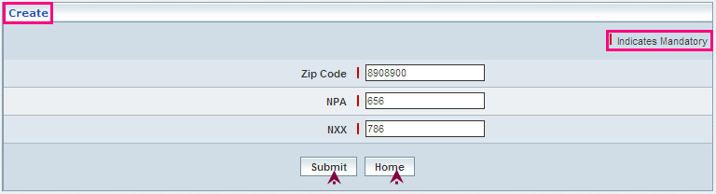

| **STEP** | **ACTION** |
| --- | --- |
|  | Enter values of Zip Code, NPA and NXX in their respective fields <Zip Code>, <NPA> and <NXX>  **NOTE:** The combined matrix (values) of an area code must be unique |
|  | User must enter the details of the Area Code where it is a mandatory information |
|  | On clicking the **Submit** button, the new Area Code will be created and added to the existing list. A message window will be displayed to that effect    On clicking the **Home** button of the message window, it redirects the user to the ‘PLMN Area Codes’ records grid |
|  | On clicking the **Home** button at the bottom of the ‘Create’ Screen (before creating a new Area Code), it redirects the user to the ‘PLMN Area Codes’ records grid |

**Modify**

Modify enables the user to update / change values related to an existing Area Code.

User can choose the corresponding radio option of the desired Area Code (from the records grid) that needs to be modified.

The screen below shows modifying / updating an existing area code.

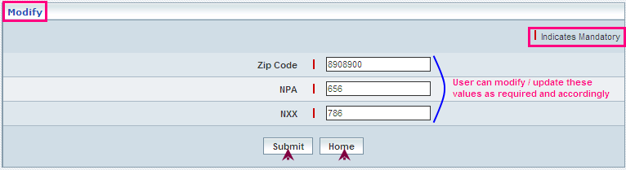

| **STEP** | **ACTION** |
| --- | --- |
|  | User can make necessary changes related to Area Code parameters (‘Zip Code’, ‘NPA’ and ‘NXX’) |
|  | On clicking the **Submit** button, the changes made will be updated accordingly in the database. A message window will be displayed to that effect  **NOTE:** If an Area Code has already been assigned to a HLR Address, the same cannot be modified    On clicking the **Home** button of the message window, it redirects the user to the ‘PLMN Area Configuration’ grid |
|  | On clicking the **Home** button at the bottom of the ‘Modify’ screen (before submission), it redirects to the ‘PLMN Area Configuration’ grid |

**Delete**

Delete enables the user to delete an existing Area Code.

User can choose the corresponding radio option of the desired Area Code (from the records grid) that needs to be deleted.

The screen below shows deleting an existing area code.

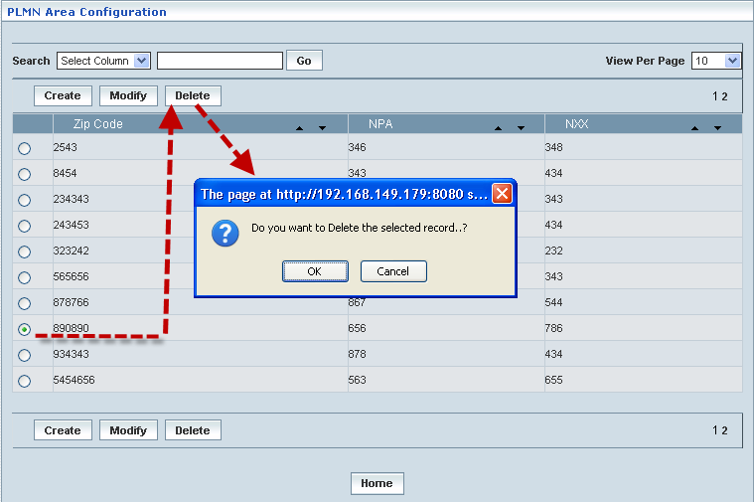

| **STEP** | **ACTION** |
| --- | --- |
|  | Select the radio button of the chose Area Code that needs deletion |
|  | On clicking the **Delete** button, an alert message window will be displayed enabling the user to confirm deletion of the chosen Area Code |
|  | On clicking the **OK** button of the alert message window, the chosen Area Code will be deleted and a message window will be displayed to that effect. It will be disappeared from the ‘Area Codes’ grid  **NOTE:** If an Area Code has already been assigned to a HLR Address, the same cannot be modified    On clicking the **Home** button of the message window, it directs the user to ‘PLMN Area Configuration’ grid  On clicking the **Cancel** button of the alert message window, it retains the grid without deleting the Area Code record |

**Searching for a specific Area Code (Record)**

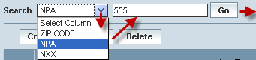

| **STEP** | **ACTION** |
| --- | --- |
|  | Select a search criterion (Zip Code/NPA/NXX) from the drop-down list of the search criteria of the <Search> field  **\*** By default the list of search criterion (Zip Code/NPA/NXX) will be dynamically displayed as drop-down list of the <Search> field |
|  | Enter the value (Zip Code/NPA/NXX) that corresponds with the given search criterion |
|  | On clicking the **Go** button, the corresponding Area Code (record) will be highlighted among the list of ‘Area Codes’ records |

The screen below depicts fetching and displaying the give Area Code record.

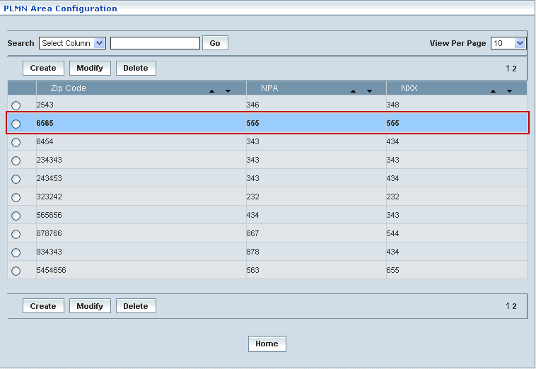

## PLMN Configuration

Home Location Register 🡪 PLMN Configuration

PLMN Configuration module enables the user to configure certain parameters related to HLR and VLR addresses. Again these configurations will be discretely carried out correspondingly and in contemplation with the following types of Numbering Plans:

* NANP: North American Numbering Plan (explicitly meant for North America)
* E164: This term covers any other Numbering Plans other than US & Canada Numbering Plans

The details related to HLR & VLR addresses of NANP include CC (Country Code), Area Code, NXX, SN (Subscriber Number) and PLMN Name.

The details related to HLR address of E164 include CC (Country Code), NDC (National Destination Code) and PLMN Name.

The screen below shows selecting the desired option for choosing NANP **North American Numbering Plan.**

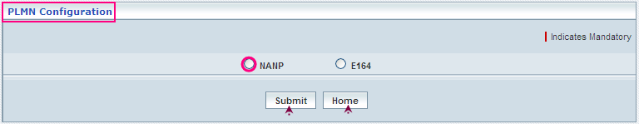

| **STEP** | **ACTION** |
| --- | --- |
|  | Select the desired radio option to choose a Numbering Plan, Ex: NANP |
|  | The corresponding details will be displayed below:  If the details have been already configured, the same shall be displayed  If the details have to be configured for the first time, user must enter the required details in their respective fields |

**Create**

The screen below shows entering details related to HLR and VLR Address parameters for NANP.

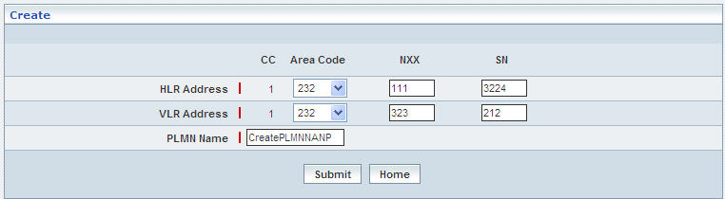

| **STEP** | **ACTION** |
| --- | --- |
|  | By default, the CC (Country Code) is **1 (one)** for the NANP |
|  | Select an area code from the <Area Code> drop-down list of HLR Address field  By default, the corresponding list of area codes will be dynamically displayed as drop-down list of the HLR Address field  **\*** Only one HLR Address has to be configured for one network |
|  | Enter NXX and SN values of the HLR Address in their respective fields |
|  | Select an area code from the <Area Code> drop-down list of VLR Address field  By default, the corresponding list of area codes will be dynamically displayed as drop-down list of the VLR Address field |
|  | Enter NXX and SN values of the VLR Address in their respective fields  **\*** However, SN value for VLR Address is not mandatory, it is an option for the Operator  **\*** NXX value of various VLR Addresses must be different from one another |
|  | Enter PLMN Name in <Name Name> field |
|  | On clicking the **Submit** button, the PLMN Configuration for the selected NANP will be created accordingly in the database. A message window will be displayed to that effect    On clicking the **Home** button of the message window, it redirects the user to the ‘PLMN Configuration’ Screen |
|  | On clicking the **Home** button at the bottom of the ‘Create’ screen (before creating a new PLMN configuration for NANP), it redirects the user to the ‘PLMN Configuration’ Screen |

The screen below shows PLMN Configuration grid details for NANP type

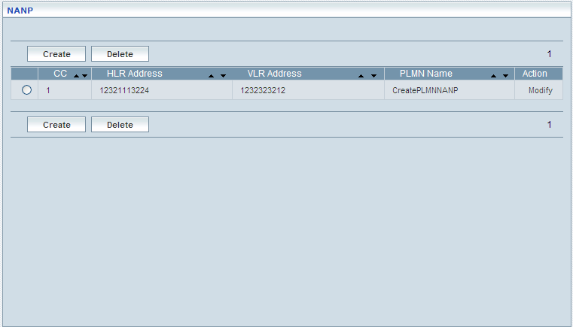

**Modify**

On clicking the **Modify** link, corresponding details will be displayed in their respective fields, which enables the user to modify / update HLR details as required and accordingly.

The screen below displays modifying / updating the details related to HLR address of the NANP.

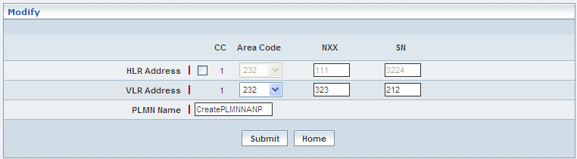

| **STEP** | **ACTION** |
| --- | --- |
|  | User can make necessary changes related to VLR address parameters |
|  | On clicking the **Modify** button, the HLR and VLR addresses matrix of NANP will be updated accordingly |
|  | On clicking the **Submit** button, the HLR and VLR addresses matrix of NANP will be updated accordingly in the database. A message window will be displayed to that effect    On clicking the **Home** button of the message window, it redirects the user to the ‘PLMN Configuration – Manage’ screen |
|  | On clicking the **Home** button at the bottom of the ‘PLMN Configuration – Manage’ screen (before submission), it redirects the user to the HLR main page |

**Delete**

On clicking the **‘Delete’** button, corresponding details will be deleted accordingly.

| **STEP** | **ACTION** |
| --- | --- |
|  | User must select any one of the NANP PLMN Configuration to delete from the NANP grid |
|  | On clicking the **Delete** button, an alert message window will be displayed enabling the user to confirm deletion of the chosen NANP PLMN Configuration |
|  | On clicking the **OK** button of the alert message window, the chosen NANP PLMN Configuration details will be deleted and a message window will be displayed to that effect. It will be disappeared from the ‘NANP’ grid.    On clicking the **Home** button of the message window, it directs the user to ‘PLMN Configuration’ Screen  However, if any HLR address (Country Code) has been attributed to a subscriber, the HLR address cannot be deleted.  On clicking the **Cancel** button of the alert message window, it retains the grid without deleting the ‘NANP’ grid |

The screen below shows selecting the desired option for choosing **E164** **Numbering Plan.**

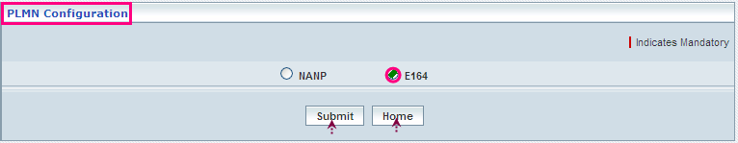

| **STEP** | **ACTION** |
| --- | --- |
|  | Select the desired radio option to choose a Numbering Plan, Ex: E164 |
|  | The corresponding details will be displayed below:  If the details have been already configured, the same shall be displayed  If the details have to be configured for the first time, user must enter the required details in their respective fields |

**Create**

The screen below shows entering details related to HLR Address parameters for E164.

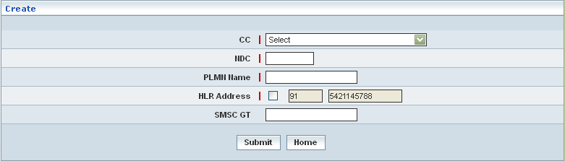

| **STEP** | **ACTION** |
| --- | --- |
|  | Select a country code from the drop-down list of CC field  By default, the corresponding list of various country codes will be dynamically displayed as drop-down list of the CC field  **\*** Only one HLR Address has to be configured for one network |
|  | Enter NDC in the <NDC> field |
|  | Enter PLMN Name in the <PLMN Name> field |
|  | Select the HLR Address check box, an alert message window will be displayed  C:\DOCUME~1\rajini.sn\LOCALS~1\Temp\SNAGHTML782b7d.PNG  On clicking the **OK** button of the alert message window, the HLR Address in the next field will be dynamically displayed. |
|  | Enter SMS GT value in the <SMSC GT> field |
|  | On clicking the **Submit** button, the PLMN Configuration for the selected NANP will be created accordingly in the database. A message window will be displayed to that effect    On clicking the **Home** button of the message window, it redirects the user to the ‘PLMN Configuration’ Screen |
|  | On clicking the **Home** button at the bottom of the ‘Create’ screen (before creating a new PLMN configuration for E164), it redirects the user to the ‘PLMN Configuration’ Screen |

The screen below shows PLMN Configuration grid details for E164 type

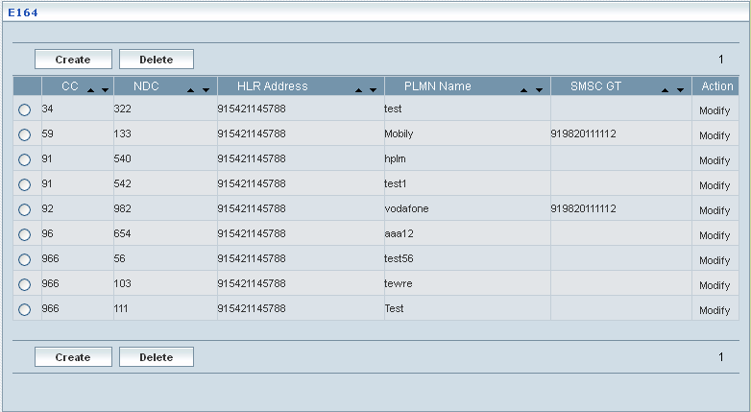

| **STEP** | **ACTION** |
| --- | --- |
|  | User can modify details related to HLR address with the help of the corresponding Modify link |
|  | User can delete the details related to HLR address with the help of the corresponding Delete link |
|  | On clicking the **Submit** button, the HLR address of E164 will be stored in the database. A message window will be displayed to that effect. *The configured HLR address will be dynamically applied even to other NDC values*    On clicking the **Home** button of the message window, it redirects the user to the HLR main page |
|  | On clicking the **Home** button at the bottom of the ‘PLMN Configuration – Manage’ screen (before submission), it redirects the user to the HLR main page |

**Modify**

On clicking the **‘Modify’** link, corresponding details will be displayed in their respective fields, which enables the user to modify / update HLR details as required and accordingly.

The screen below displays modifying / updating the details related to HLR address of the E164.

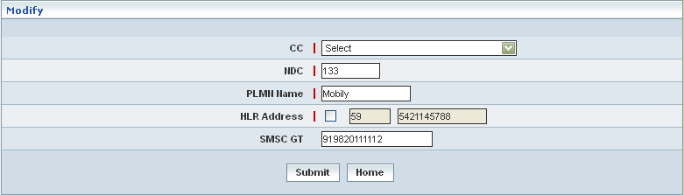

| **STEP** | **ACTION** |
| --- | --- |
|  | User can make necessary changes related to HLR address value |
|  | On clicking the **Submit** button, the HLR address of E164 will be updated accordingly in the database. A message window will be displayed to that effect    On clicking the **Home** button of the message window, it redirects the user to the ‘PLMN Configuration’ screen |
|  | On clicking the **Home** button at the bottom of the ‘Modify’ screen (before deletion), it redirects the user to the ‘PLMN Configuration’ screen |

**Delete**

On clicking the **‘Delete’** button, corresponding details will be deleted accordingly.

| **STEP** | **ACTION** |
| --- | --- |
|  | User must select any one of the E164 PLMN Configuration to delete from the NANP grid |
|  | On clicking the **Delete** button, an alert message window will be displayed enabling the user to confirm deletion of the chosen E164 PLMN Configuration  C:\DOCUME~1\rajini.sn\LOCALS~1\Temp\SNAGHTML78deb0.PNG |
|  | On clicking the **OK** button of the alert message window, the chosen E164 PLMN Configuration details will be deleted and a message window will be displayed to that effect. It will be disappeared from the ‘E164’ grid.    On clicking the **Home** button of the message window, it directs the user to ‘PLMN Configuration’ Screen  However, if any HLR address (Country Code) has been attributed to a subscriber, the HLR address cannot be deleted.  On clicking the **Cancel** button of the alert message window, it retains the grid without deleting the ‘E164’ grid |

## HPLMN Configuration

Home Location Register 🡪 HPLMN Configuration

HPLMN Configuration module enables the user to configure the MCC (Mobile country Code), and MNC (Mobile Network Code) specific to a HPLMN (Home Public Land Mobile Network) Name. By virtue of this configurations, HPLMN checks for the subscriber’s home network.

This module helps the user to perform the following actions:

* Create
* Modify
* Delete

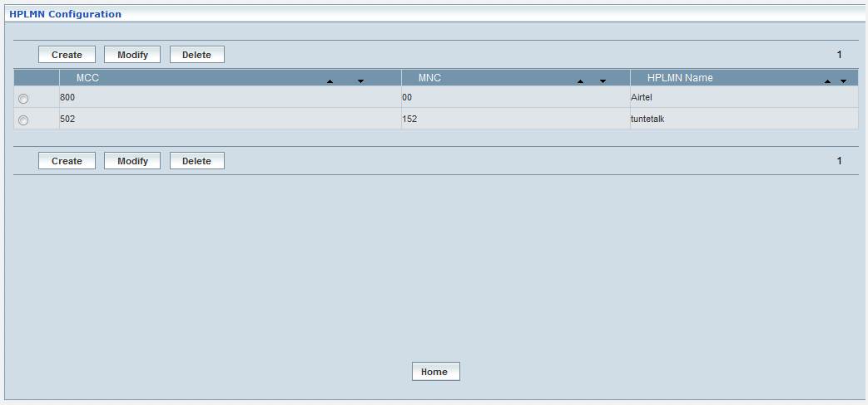

|  |  |  |
| --- | --- | --- |
| **STEP** | | **ACTION** |
|  | | By default, the list of HPLMN Configuration will be displayed as records in a grid. The columns include ‘MCC’ (Mobile Country Code), ‘MNC’ (Mobile Network Code) and ‘HPLMN Name’. |
|  |  | User can customize the view for the number of records to be displayed each time (per page) in a grid.  However, this option is applicable only if the total number of records exceeds 10. And also with the immediate effect of increase in the number of records more than 10, a ‘Search’ option would be dynamically displayed. |
| Select the number of records (For Ex: 10) from the drop-down list of the <View Per Page> field. |
| With the effect of choosing the desired number (10) for the display of records per page, the same (10 records) will be displayed in the grid. |
| User can sort the records in ascending and descending orders with the help of up-arrow and down-arrows respectively |
| However, based on the total number of records, page numbers will be dynamically displayed at the left bottom of the screen |
| User can navigate for subsequent records (10 each time) by clicking the desired ‘page number’ |
|  | | On clicking the **Create** button; ‘Create’ screen will be displayed enabling the user to configure MCC, MNC, and HPLMN Name of the subscriber, in order to validate home network. |
|  | | On clicking the **Modify** link, ‘Modify’ screen will be displayed enabling the user to update / change corresponding HPLMN configurations associated to subscribers profile |
|  | | On clicking the **Delete** link, ‘Delete’ screen will be displayed enables the user to delete the same |
|  | | On clicking the **Home** button at the bottom of the grid, it redirects the user to the ‘Roaming Management’ main page |

**Create**

The screen below shows entering details related to MCC, MNC and HPLMN name.

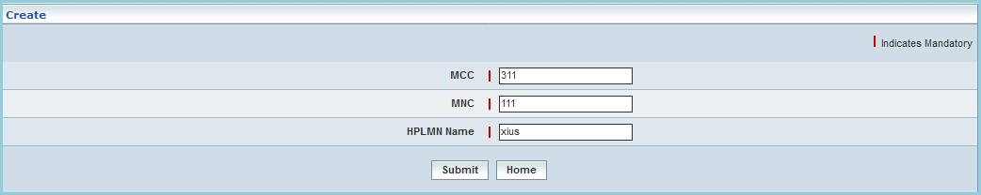

| **STEP** | **ACTION** |
| --- | --- |
|  | Specify the **MCC** (Mobile Country Code)Details |
|  | Specify the **MNC** (Mobile Network Code)Details |
|  | Enter the **HPLMN**(Home Public Land Network) Details |
|  | Click **Submit** the HPLMN is configured successfully. A Confirmation message is displayed as shown below |
|  | On clicking the **Home** button at the bottom of the ‘Create’ screen (before creating a new HPLMN configuration), it redirects the user to the ‘HPLMN Configuration’ Screen |

**Modify**

On clicking the **Modify** link, corresponding details will be displayed in their respective fields, which enables the user to modify / update HPLMN details as required and accordingly.

The screen below displays modifying / updating the details related to HPLMN address.

| **STEP** | **ACTION** |
| --- | --- |
|  | Select the desired HPLMN to modify. |
|  | Make the necessary changes to the MCC, MNC and HPLMN name. |
|  | Click **Submit** to save the changes. The Confirmation message is displayed as shown below |
|  | On clicking the **Home** button at the bottom of the ‘Modify’ screen, it redirects the user to the ‘HPLMN Configuration’ Screen |

**Delete**

On clicking the **Delete** link, corresponding details of the selected HPLMN configuration shall be deleted.



| **STEP** | **ACTION** |
| --- | --- |
|  | Select the desired HPLMN to delete. |
|  | Click **Delete** button to delete the selected HPLMN. A confirmation screen opens as shown below |
|  | Click **OK** to delete the selected HPLMN. The message is displayed as shown below |
|  | Click **Cancel** to go back to the HPLMN Configuration Screen |
|  | On clicking the **Home** button at the bottom of the ‘Modify’ screen, it redirects the user to the ‘HPLMN Configuration’ Screen |

## System Parameters

Home Location Register 🡪 System Parameters

This section enables users to set the system parameters.

The screen below shows the system parameters

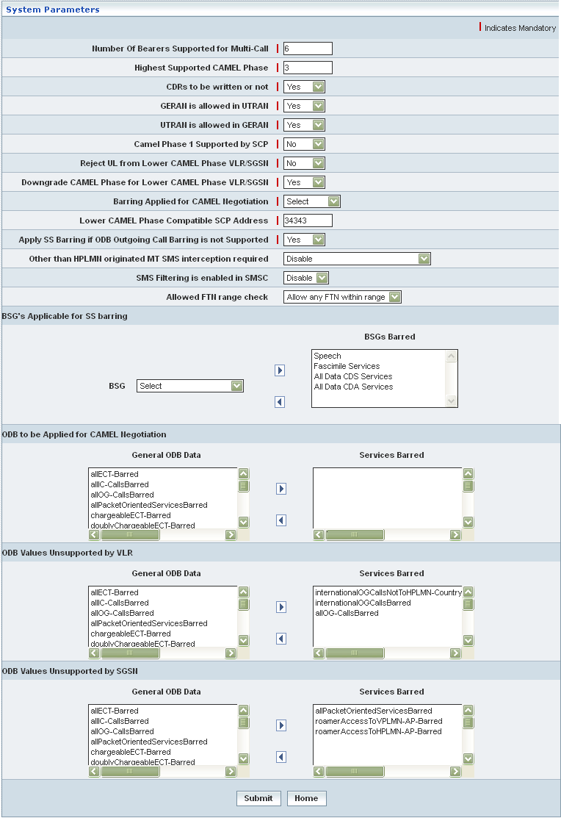

| **STEP** | **ACTION** |
| --- | --- |
|  | Enter Number of Bearers Supported for Multi-Call in <Number of Bearers Supported for Multi-Call> field. The entered number needs to be from 2 to 7.  **\*** If you want to enter the Number of Bearers Supported for Multi-Call next time, the number must be greater than or equal to the previous number. |
|  | Enter Highest Support CAMEL Phase number in <Highest Support CAMEL Phase> field. The entered number needs to be from 1 and 4. |
|  | Select CDRs to be written or Not in <CDRs to be written or Not> field. For example: Yes or No.  **\*** If you select Yes, the value store is 1. If you select No, the value stored is 0. |
|  | Select GERAN is allowed in UTRAN in <GERAN is allowed in UTRAN> field. For example: Yes or No. If you select Yes, the value store is 1.  **\*** If you select No, the value stored is 0. |
|  | Select UTRAN is allowed in GERAN in <UTRAN is allowed in GERAN> field. For example: Yes or No. If you select Yes, the value store is 1.  **\*** If you select No, the value stored is 0. |
|  | Select Camel Phase 1 Supported by SCP in <Camel Phase 1 Supported by SCP> field. For example: Yes or No. If you select Yes, the value store is 1.  **\*** If you select No, the value stored is 0. |
|  | Select Reject UL from Lower CAMEL Phase VLR/SGSN in <Reject UL from Lower CAMEL Phase VLR/SGSN> field. For example: Yes or No.  **\*** If you select Yes, the value store is 1. If you select No, the value stored is 0. |
|  | Select Downgrade CAMEL Phase for Lower CAMEL Phase VLR/SGSN in <Downgrade CAMEL Phase for Lower CAMEL Phase VLR/SGSN> field. For example: Yes or No.  **\*** If you select Yes, the value store is 1. If you select No, the value stored is 0. |
|  | Select Barring Applied for CAMEL Negotiation in <Barring Applied for CAMEL Negotiation> field |
|  | Enter Lower CAMEL Phase Compatible SCP Address in <Lower CAMEL Phase Compatible SCP Address> field |
|  | Select Apply SS Barring if ODB Outgoing Call Barring is not Supported in <Apply SS Barring if ODB Outgoing Call Barring is not Supported> field. For example: Yes or No.  **\*** If you select Yes, the value store is 1. If you select No, the value stored is 0. |
|  | Select option for <Other than HPLMN originated MT SMS interception required>   * Disable * Enable * Enable for roaming subscribers only |
|  | Select option for < SMS Filtering is enabled in SMSC>   * Disable * Enable |
|  | Select option for < Allowed FTN range check>   * Allow any FTN within range * Disable |
|  | **BSG's Applicable for SS barring:**  Select BSG from the drop-down list and click  button to map to BSGs Barred. To remove/un-map the selected BSG from the BSG Barred list box click  button. |
|  | **ODB to be Applied for CAMEL Negotiation**:  Select 1 or more than General ODB Data from the list box and click  button to map to Services Barred. To remove/un-map the selected General ODB Data from the Services Barred list box click  button. |
|  | **ODB Values Unsupported by VLR:**  Select 1 or more than General ODB Data from the list box and click  button to map to Services Barred. To remove/un-map the selected General ODB Data from the Services Barred list box click  button |
|  | **ODB Values Unsupported by SGSN**:  Select 1 or more than General ODB Data from the list box and click  button to map to Services Barred. To remove/un-map the selected General ODB Data from the Services Barred list box click  button |
|  | On clicking **Submit** button, the values are submitted. The successful response appears.    On clicking the **Home** button of the message window, it redirects the user to the ‘System Parameters’ screen. |
|  | On clicking the **Home** button at the bottom of the ‘System Parameters’ screen, t redirects the user to the HLR main page. |

## Service Control Point

Home Location Register 🡪 Service Control Point

Service Control Point enables the user to create a new service control point define SCF (Service Control Function) details and assign service keys. Subsequently, it allows the user to manage (View/Modify/Delete) the information related to a service control point.

Thus SCP helps the user performing the following functions:

* Create
* View
* Modify
* Delete
* Search

Initially, it displays a screen showing the list of existing service points as records in a grid.

The screen below shows the list of records for the existing service control points.

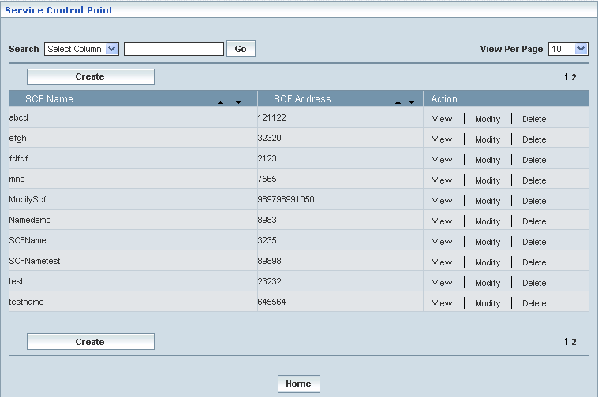

| **STEP** | | **ACTION** |
| --- | --- | --- |
|  | | By default, the list of service control points will be displayed as records in a grid. The columns include ‘SCF Name’, ‘SCF Address’ and ‘Action’ |
|  |  | User can customize the view for the number of records to be displayed each time (per page) in a grid.  However, this option is applicable only if the total number of records exceeds 10. And also with the immediate effect of increase in the number of records more than 10, a ‘Search’ option would be dynamically displayed. |
| Select the number of records (For Ex: 10) from the drop-down list of the <View Per Page> field. |
| With the effect of choosing the desired number (10) for the display of records per page, the same (10 records) will be displayed in the grid. |
| User can sort the records in ascending and descending orders with the help of up-arrow and down-arrows respectively |
| However, based on the total number of records, page numbers will be dynamically displayed at the left bottom of the screen |
| User can navigate for subsequent records (10 each time) by clicking the desired ‘page number’ |
| **2** | | On clicking the **Create** button, ‘Create’ screen will be displayed enabling the user to create a new ‘Service Control Point’ |
|  | | On clicking the **View** link of a chosen ‘SCF’, corresponding information related to the service control point will be displayed in a separate screen enabling the user to peruse details of the SCF |
|  | | On clicking the **Modify** link of a chosen ‘SCF’, the corresponding details will be displayed in a separate screen (Modify Screen) enabling the user to modify / update the ‘SCF’ details accordingly |
|  | | On clicking the **Delete** link of a chosen ‘SCF’, the corresponding details will be displayed in a separate screen (Delete Screen) enabling the user to delete the same |
|  | | On clicking the **Home** button at the bottom of the grid, it redirects the user to the ‘HLR’ main page |

**Create**

The screen below shows creating a new Service Control Point.

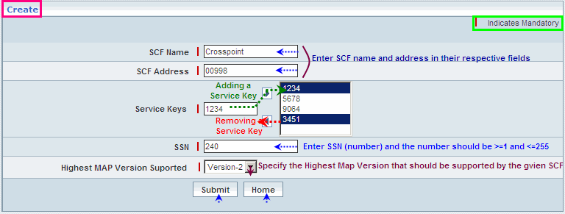

| **STEP** | **ACTION** |
| --- | --- |
|  | Enter SCF name and the address in their respective fields <SCF Name> and <SCF Address> |
|  | User must essentially enter the details of the SCF where it is a mandatory information |
|  | Enter a service key (number) in the <Service Keys> field |
|  | On clicking the right-arrow button, the service key (number) will be moved to the adjacent field  User can enter the desired number of service keys in a similar fashion |
|  | However, if the user wants to just remove certain service keys any time before creating or establishing the SCP, selecting the number (service key) from the list and subsequently clicking the left-arrow button removes the number |
|  | Enter SSN (number) in the <SSN> field  The number should be between 1 to 255, i.e. >=1 and <=255 |
|  | Select an option related to the relevant Map Version from the drop-down list of the <Highest Map Version Supported> field to specify the Highest Map Version that should be supported by the proposed SCF  * By default, the list of Map Versions will be dynamically displayed as the drop-down list of the <Highest Map Version Supported> field |
|  | On clicking the **Submit** button, the new Service Control Point will be created and added to the existing list. A message window will be displayed to that effect    On clicking the **Home** button of the message window, it redirects the user to the ‘Service Control Points’ records grid |
|  | On clicking the **Home** button at the bottom of the ‘Create’ Screen (before creating a new SCP), it redirects the user to the ‘Service Control Points’ records grid |

**View**

On clicking the **‘View’** link of a chosen ‘SCF’ (from the Service Control Points List); corresponding information related to the Service Control Point will be displayed in a separate screen enabling the user to peruse details of the same.

The screen below shows the view of a chosen Service Control Point.

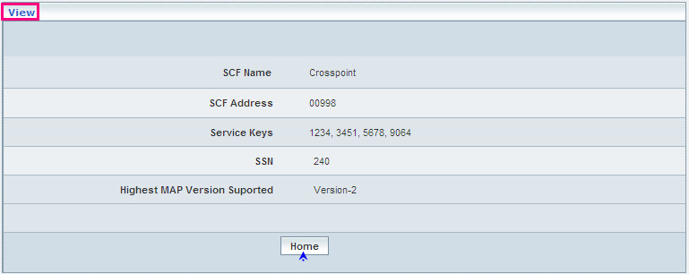

| **STEP** | **ACTION** |
| --- | --- |
|  | SCF Name, SCF Address, corresponding Service Keys (list), SSN Number and the Map Version will be dynamically displayed in their respective fields |
|  | On clicking the **Home** button at the bottom of the ‘View Screen’, it redirects the user to the ‘Service Control Points’ records grid |

**Modify**

On clicking the **‘Modify’** link of a chosen ‘SCF’ (from the Service Control Points List); the corresponding details will be displayed in a separate screen (Modify Screen) enabling the user to modify / update the ‘SCF’ details accordingly.

The screen below shows modifying details related to an existing service control point.

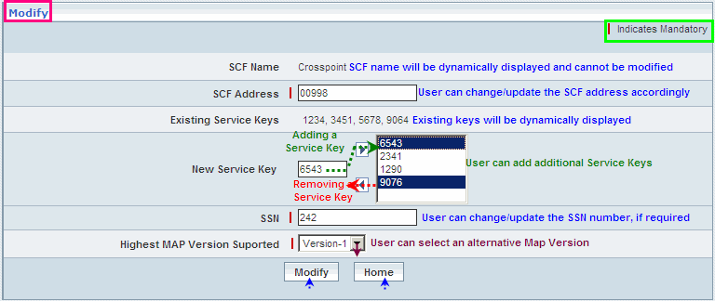

| **STEP** | **ACTION** |
| --- | --- |
|  | SCF Name, SCF Address, corresponding Service Keys (list), SSN Number and Map Version will be dynamically displayed in their respective fields |
|  | However, SCF Name once created cannot be changed later |
|  | SCF Address can be modified / updated |
|  | Existing Service Keys cannot be removed or changed |
|  | However, the desired list of additional service keys can be attributed to the SCP |
|  | SSN number can be modified / updated, if required |
|  | User can choose an alternative MAP Version to specify the Highest MAP Version |
|  | On clicking the **Modify** button, SCP details will be updated and a message window will be displayed to that effect    On clicking the **Home** button of the message window, it redirects the user to the ‘Service Control Points’ records grid |
|  | On clicking the **Home** button at the bottom of the ‘Modify’ Screen (before updating the details of SCP), it redirects the user to the ‘Service Control Points’ records grid |

**Delete**

On clicking the **‘Delete’** link of a chosen ‘SCF’ (from the Service Control Points List); the corresponding details will be displayed in a separate screen (Delete Screen) enabling the user to delete the same.

The screen below shows deleting an existing Service Control Point.

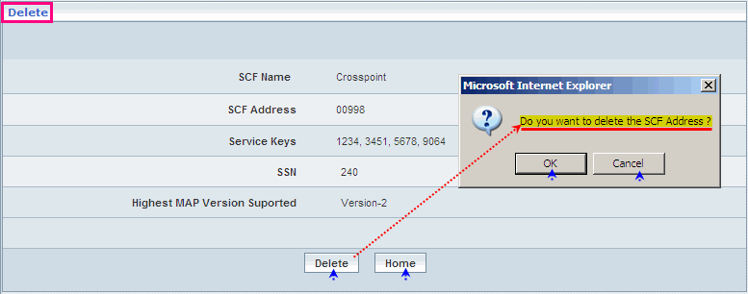

| **STEP** | **ACTION** |
| --- | --- |
|  | SCF Name, SCF Address, corresponding Service Keys (list), SSN Number, and Map Version will be dynamically displayed in their respective fields |
|  | On clicking the **Delete** button, an alert window will be displayed enabling the user to confirm deletion of the SCP  On clicking the **OK** button of the alert window, corresponding SCP will be deleted and a message window will be displayed to that effect    The SCP record will be deleted from the grid (Service Control Points list)  On clicking the **Home** button of the message window, it redirects the user to the ‘Service Control Points’ records grid  On clicking the **Cancel** button of the alert window, it closes the alert window (without any action being performed) |
|  | On clicking the **Home** button at the bottom of the ‘Delete’ Screen (before deleting SCP), it redirects the user to the ‘Service Control Points’ records grid |

However, if the SCP (SCF Address) is mapped to any subscriber or associated with a CSI Profile, it (SCP) cannot be deleted. If the User is trying to delete such SCP, an alert window will be displayed to the effect.

The screen below shows an alert message when trying to delete a Service Control Point where the SCF Address is either mapped to a subscriber or to a CSI Profile.

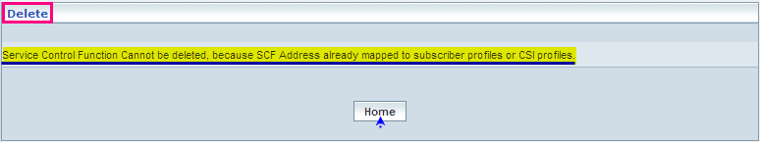

| **STEP** | **ACTION** |
| --- | --- |
|  | On clicking the **Home** button of the message window, it redirects the user to the ‘Service Control Points’ records grid |

**Searching for a specific Service Control Point (Record)**

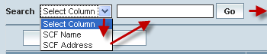

| **STEP** | **ACTION** |
| --- | --- |
|  | Select a search criterion (‘SCF Name’ or ‘SCF Address’) from the drop-down list of the search criteria of the <Search> field  **\*** By default the list of search criterion (‘SCF Name’ and ‘SCF Address’) will be dynamically displayed as drop-down list of the <Search> field |
|  | Enter the ‘SCF Name’ or ‘SCF Address’ that corresponds with the given search criterion |
|  | On clicking the **Go** button, the corresponding Service Control Point (record) will be highlighted among the list of Service Control Point records. |

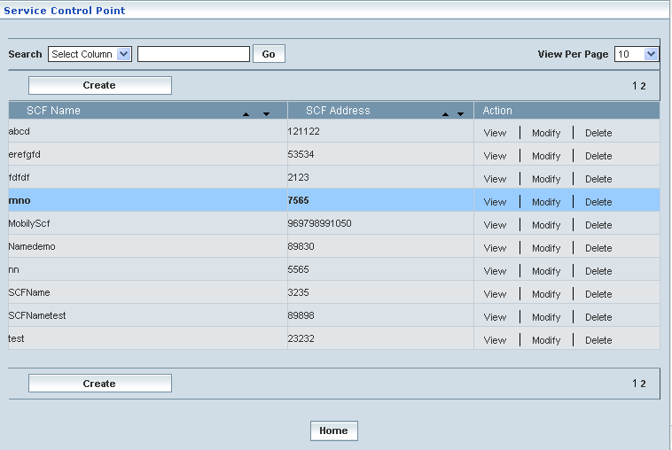

## PLMN Specific SS Configuration

PLMN Specific SS Configuration module enables the user to configure certain parameters related to MT, ISD, SS and IN Roaming details along with the specific PLMN SS codes.

The screen below shows the PLMN Specific SS Configuration

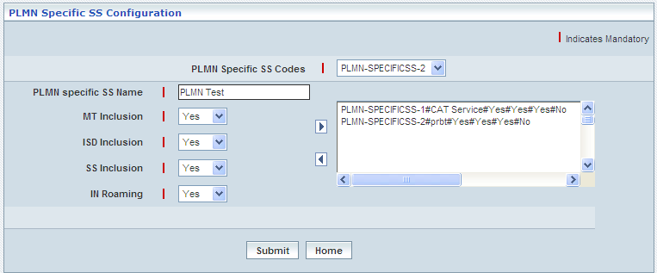

| **STEP** | **ACTION** |
| --- | --- |
|  | Select PLMN Specific SS codes from the dropdown list |
|  | Enter unique name in the <PLMN Specific SS Name> field |
|  | Select (YES / NO) for MT Inclusion, ISD Inclusion, SS Inclusion and IN Roaming from the drop down lists provided.  **\*** The above features are Mandatory. |
|  | On clicking the right-arrow button, the PLMN Specific SS codes along with the selected features will be moved to the adjacent field  **\*** There can be several PLMN Specific SS codes assigned and hence, user can enter the desired number of PLMN Specific SS codes in a similar fashion |
|  | However, if the user wants to remove a given PLMN Specific SS codes, selecting a string that needs to be removed from the list (of PLMN Specific SS codes) and subsequently clicking the left-arrow button removes the same |
|  | After adding the required number of PLMN Specific SS codes click **Submit** button |
|  | On clicking the **Submit** button, the PLMN Specific SS codes will be stored in the database. A message window will be displayed to that effect    On clicking the **Home** button of the message window, it redirects the user to the ‘PLMN Specific SS Configuration’ screen |
|  | On clicking the **Home** button at the bottom of the ‘PLMN Specific SS Configuration’ screen (before submission), it redirects the user to the ‘HLR’ main page |

## Allowed FTNs

Home Location Register 🡪 Allowed FTNS

Allowed FTNs module enables the user to configure CC (Country Code) and NDC (Network Destination Code) for a specific network. By virtue of this configurations, MSISDNs corresponding to the CC and NDC are allowed/eligible for the call forwarding.

This module helps the user to perform the following actions:

* Create
* Upload
* Modify
* Delete

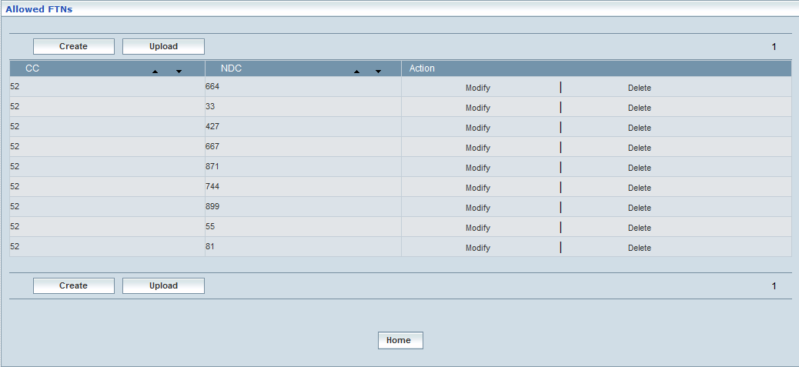

| **STEP** | | **ACTION** |
| --- | --- | --- |
|  | | By default, the list of Allowed FTNs Configuration will be displayed as records in a grid. The columns include ‘CC’(Country Code),‘NDC’ (Network Destination Code) and ‘Action’. |
|  |  | User can customize the view for the number of records to be displayed each time (per page) in a grid.  However, this option is applicable only if the total number of records exceeds 10. And also with the immediate effect of increase in the number of records more than 10, a ‘Search’ option would be dynamically displayed. |
| Select the number of records (For Ex: 10) from the drop-down list of the <View Per Page> field. |
| With the effect of choosing the desired number (10) for the display of records per page, the same (10 records) will be displayed in the grid. |
| User can sort the records in ascending and descending orders with the help of up-arrow and down-arrows respectively |
| However, based on the total number of records, page numbers will be dynamically displayed at the left bottom of the screen |
| User can navigate for subsequent records (10 each time) by clicking the desired ‘page number’ |
|  | | On clicking the **Create** button; ‘Create’ screen will be displayed enabling the user to configure ‘CC’(Country Code), and ‘NDC’ (Network Destination Code) |
|  | | On clicking the **Upload** button, ‘Upload’ screen will be displayed enabling the user to browse and locate the ‘.txt’ or ‘.csv’ file and upload |
|  | | On clicking the **Modify** link, ‘Modify’ screen will be displayed enabling the user to update / change configured CC and NDC details |
|  | | On clicking the **Delete** link, ‘Delete’ screen will be displayed and enables to delete the FTN details |
|  | | On clicking the **Home** button at the bottom of the grid, it redirects the user to the ‘Allowed FTNs’ main page |

**Create**

Home Location Register 🡪 Allowed FTNs 🡪 Create

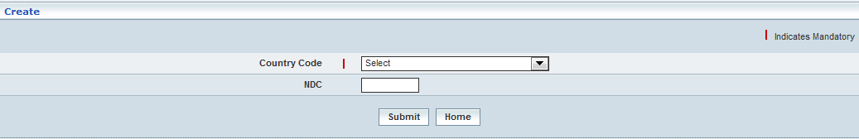

| **STEP** | **ACTION** |
| --- | --- |
|  | Select a **Country Code** fromthe drop down list |
|  | Specify **NDC** (Network Destination Code) details |
|  | Click **Submit** button to configure FTNs.The Confirmation message is displayed as shown below |
|  | On clicking the **Home** button at the bottom of the ‘Create’ screen, it redirects the user to the ‘Allowed FTNs’ Screen |

**Upload**

Home Location Register 🡪 Allowed FTNs 🡪 Create

Upload file enables the user to upload the CC and NDC files for configuring FTNs

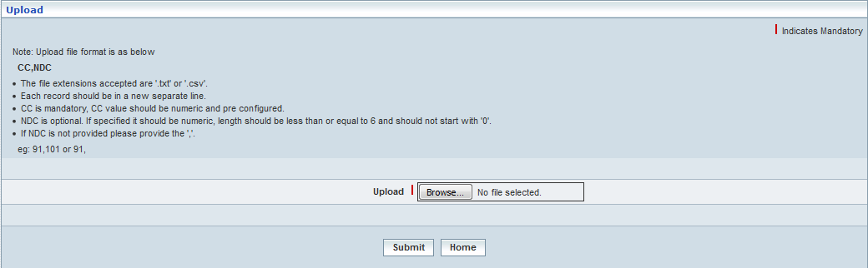

| **STEP** | **ACTION** |
| --- | --- |
|  | **Upload:** Click the **Browse** button, ‘Upload’ screen will be displayed enabling the user to browse and locate the ‘.txt’ or ‘.csv’ file and upload  **Note:**   * The file extensions accepted are '.txt' or '.csv'. * Each record should be in a new separate line. * CC is mandatory; CC value should be numeric and pre-configured. * NDC is optional. If specified it should be numeric, length should be less than or equal to 6 and should not start with '0'. * If NDC is not provided please provide the ','. * e.g.: 91,101 or 91. |
|  | Click **Submit** button the FTN will get configured successfully. The Confirmation message is displayed as shown below |
|  | On clicking the **Home** button at the bottom of the ‘Create’ screen, it redirects the user to the ‘Allowed FTNs’ Screen |

**Modify**

Home Location Register 🡪 Allowed FTNs 🡪 Modify

Modify enables the user to modify the existing configurations

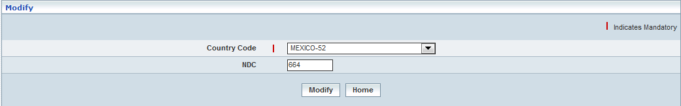

| **STEP** | **ACTION** |
| --- | --- |
|  | Specify the **Country Code** (CC) from the drop down list |
|  | Specify the **NDC** (Network Destination Code)of the MSISDN |
|  | Click **Modify** button to save the changes implemented. The Confirmation message is displayed as shown below |
|  | On clicking the **Home** button at the bottom of the ‘Create’ screen, it redirects the user to the ‘Allowed FTNs’ Screen |

**Delete**

Home Location Register 🡪 Allowed FTNs 🡪 Delete

Delete enables the user to delete the existing configurations

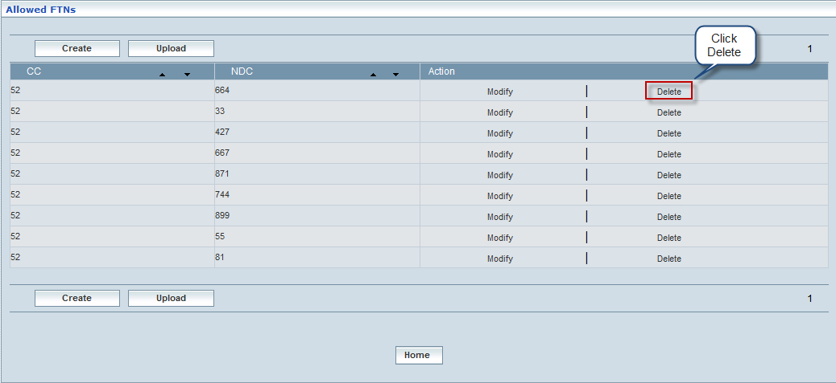

| **STEP** | **ACTION** |
| --- | --- |
|  | Click **Delete** to delete theFTNs configuration. |
|  | Click **Submit** button the HPLMN will be configured successfully. The Confirmation message is displayed as shown below |
|  | On clicking the **Home** button at the bottom of the ‘Create’ screen, it redirects the user to the ‘Allowed FTNs’ Screen |

## PLMN Specific CUG

Home Location Register 🡪 PLMN Specific CUG

This section enables users to perform the following tasks of the PLMN Specific Closed User Group.

This module helps the user performing the following actions:

* Create
* View
* Modify
* Delete
* Search

**Create**

Home Location Register 🡪 PLMN Specific CUG 🡪 Create

Create enables the user to create PLMN Specific CUG Interlock Code.

The screen below shows creating a new PLMN Specific CUG Interlock Code

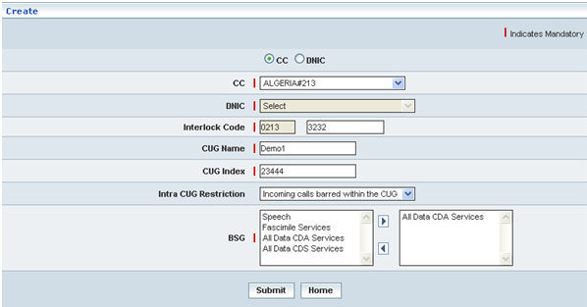

| **STEP** | **ACTION** |
| --- | --- |
|  | User must enter the details of the PLMN Specific CUG Interlock Code details where it is a mandatory information |
|  | Select CC (Country Code) or DNIC (Data Network Identification Code) and select the respectively CC or DNIC codes from <CC> or <DNIC> drop-down list.  **NOTE:** On selecting CC option, the CC drop-down list is enabled and on selecting DNIC option, the DNIC drop-down list is enabled. |
|  | Enter Interlock Code in <Interlock Code> field. It should be numeric value.  **NOTE:**  The Interlock Code cannot be more than 65,636 and its first 4 digits are displayed atomically on selecting ‘CC’ or ‘DNIC’ from the drop-down list. |
|  | Enter CUG Name in <CUG Name> field. |
|  | Enter CUG Index in <CUG Index> field. It should be numeric value.  **NOTE:**  The CUG Index cannot be more than 32,767 |
|  | Select Intra CUG Restriction from <Intra CUG Restriction> drop-down list |
|  | Select BSG from the <BSG> list box and map it by clicking  button it moves to the adjacent field |
|  | On clicking the **Submit** button, the new PLMN Specific CUG Interlock Code will be created successfully. A message window will be displayed to that effect    On clicking the **Home** button of the message window, it redirects the user to the ‘Create’ Screen |
|  | On clicking the **Home** button at the bottom of the ‘Create’ Screen (before creating a new PLMN Specific CUG Interlock Code), it redirects the user to the ‘PLMN Specific CUG’ Screen |

**Manage**

Home Location Register 🡪 PLMN Specific CUG 🡪 Manage

Manage enables the users to perform view, search, modify and delete PLMN Specific CUG Interlock Codes.

The screen below shows the ‘Manage’ Screen

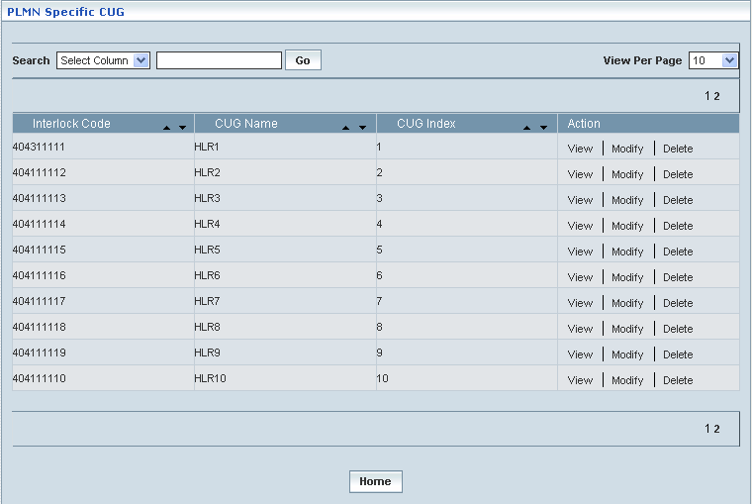

| **STEP** | | **ACTION** |
| --- | --- | --- |
|  | | By default, the list of CUGs will be displayed as records in a grid. The columns include ‘Interlock Code’, ‘CUG Name’, ‘CUG Index’ and ‘Action’ |
|  |  | User can customize the view for the number of records to be displayed each time (per page) in a grid.  However, this option is applicable only if the total number of records exceeds 10. And also with the immediate effect of increase in the number of records more than 10, a ‘Search’ option would be dynamically displayed. |
| Select the number of records (For Ex: 10) from the drop-down list of the <View Per Page> field. |
| With the effect of choosing the desired number (10) for the display of records per page, the same (10 records) will be displayed in the grid. |
| User can sort the records in ascending and descending orders with the help of up-arrow and down-arrows respectively |
| However, based on the total number of records, page numbers will be dynamically displayed at the left bottom of the screen |
| User can navigate for subsequent records (10 each time) by clicking the desired ‘page number’ |
| **2** | | On clicking the **View** link, ‘View’ screen will be displayed enabling the user to view the details of chosen ‘PLMN Specific CUG’ |
|  | | On clicking the **Modify** link, ‘Modify’ screen will be displayed enabling the user to update / change corresponding values (as required) of a chosen ‘PLMN Specific CUG’ |
|  | | On clicking the **Delete** link, of a chosen ‘LSA Specific CUG’, it enables the user to delete the same |
|  | | On clicking the **Home** button at the bottom of the grid, it redirects the user to the ‘HLR’ main page |

**View**

On clicking the **‘View’** link of a chosen ‘PLMN Specific CUG’ (from the PLMN Specific CUG List); corresponding information related to the PLMN Specific Code will be displayed in a separate screen enabling the user to peruse details of the same.

The screen below shows the view of a chosen PLMN Specific CUG

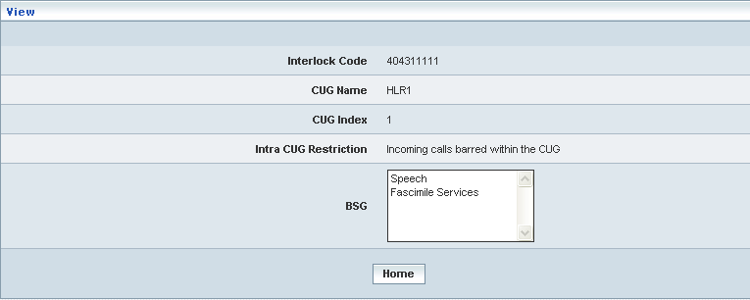

| **STEP** | **ACTION** |
| --- | --- |
|  | ‘Interlock Code’, ‘CUG Name’, ‘CUG Index’, Intra CUG Restriction’ and ‘BSG’ will be dynamically displayed in their respective fields |
|  | On clicking the **Home** button at the bottom of the ‘View’ Screen, it redirects the user to the ‘PLMN Specific CUG’ records grid |

**Modify**

On clicking the **‘Modify’** link of a chosen ‘PLMN Specific CUG’ (from the PLMN Specific CUG List); corresponding information related to the PLMN Specific CUG will be displayed in a separate screen enabling the user to modify details of the same.

The screen below shows modifying / updating an existing PLMN Specific CUG

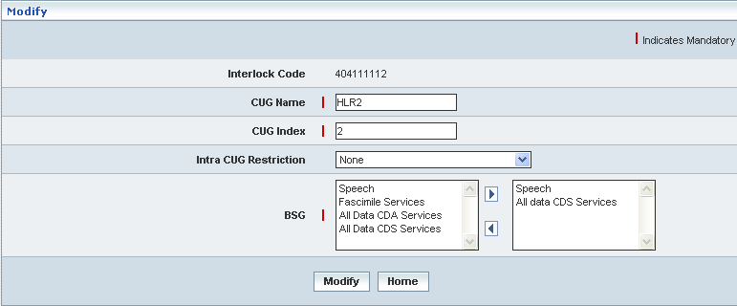

| **STEP** | **ACTION** |
| --- | --- |
|  | User can make necessary changes related to PLMN Specific CUG (‘CUG Name’, ‘CUG Index’ and ‘Intra CUG Restriction’) and finally configure at least one ‘BSG’ |
|  | On clicking the **Submit** button, the changes made will be updated accordingly in the database. A message window will be displayed to that effect  **NOTE:** If an CUG IC is assigned to a CUG Profile, the same cannot be modified    On clicking the **Home** button of the message window, it redirects the user to the ‘PLMN Specific CUG’ grid |
|  | On clicking the **Home** button at the bottom of the ‘Modify’ screen (before submission), it redirects to the ‘PLMN Specific CUG’ grid |

**Delete**

On clicking the **‘Delete’** link of a chosen ‘PLMN Specific CUG’ (from the PLMN Specific CUG List); corresponding information related to the PLMN Specific CUG will be displayed in a separate screen enabling the user to delete details of the same.

The screen below shows deleting an existing PLMN Specific CUG

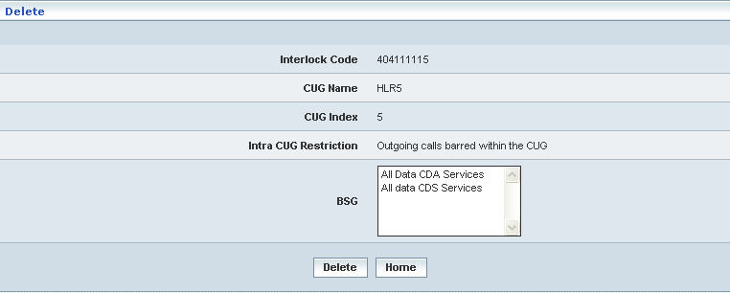

| **STEP** | **ACTION** |
| --- | --- |
|  | On clicking the **Delete** button, an alert message window will be displayed enabling the user to confirm deletion of the chosen PLMN Specific CUG Interlock Code  SNAGHTML52f221 |
|  | On clicking the **OK** button of the alert message window, the chosen PLMN Specific CUG Interlock Code will be deleted and a message window will be displayed to that effect. It will be disappeared from the ‘PLMN Specific CUG’ grid.  **NOTE:** If an CUG IC is assigned to a CUG Profile, the same cannot be modified    On clicking the **Home** button of the message window, it directs the user to ‘PLMN Specific CUG’ grid  On clicking the **Cancel** button of the alert message window, it retains the grid without deleting the ‘PLMN Specific CUG’ record |
|  | On clicking the **Home** button at the bottom of the ‘Delete’ screen (before submission), it redirects to the ‘LMN Specific CUG’ grid |

**7Searching for a specific PLMN Specific CUG (Record)**

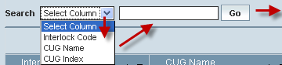

| **STEP** | **ACTION** |
| --- | --- |
|  | Select a search criterion (‘Interlock Code’, ‘CUG Name’ and ‘CUG Index’) from the drop-down list of the search criteria of the <Search> field  **\*** By default the list of search criterion (‘Interlock Code’, ‘CUG Name’ and ‘CUG Index’) will be dynamically displayed as drop-down list of the <Search> field |
|  | Enter the ‘Interlock Code’, ‘CUG Name’ and ‘CUG Index’ that corresponds with the given search criterion |
|  | On clicking the **Go** button, the corresponding PLMN Specific CUG (record) will be highlighted among the list of PLMN Specific CUG records. |

The screen below depicts fetching and displaying the give PLMN Specific CUG record.

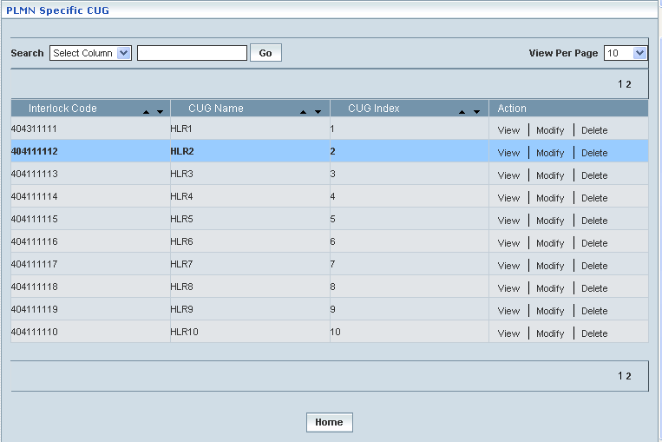

## PLMN Specific Cell IDs

Home Location Register 🡪 PLMN Specific Cell IDs

This section enables users to perform the following tasks of the PLMN Specific Cell IDs

This module helps the user performing the following actions:

* Create
* View
* Modify
* Delete
* Search

**Create**

Home Location Register 🡪 PLMN Specific Cell IDs 🡪 Create

Create enables the user to create PLMN Specific Cell IDs.

The screen below shows creating a new PLMN Specific Cell IDs

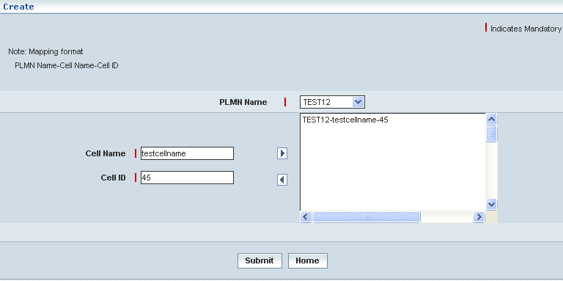

| **STEP** | **ACTION** |
| --- | --- |
|  | User must enter the details of the PLMN Specific Cell IDs details where it is a mandatory information |
|  | Select PLMN Name from <PLMN Name> drop-down list. |
|  | Enter Cell Name in <Cell Name> field. |
|  | Enter Cell ID in <Cell ID> field.  **NOTE:** Cell ID should be only numeric value. |
|  | On clicking  button allows the user to map at least one Cell configuration to the selected PLMN and it moves to the adjacent field. On clicking  the user can perform un-mapping at least one configuration and vice versa. |
|  | On clicking the **Submit** button, the new PLMN Specific Cell IDs will be created successfully. A message window will be displayed to that effect    On clicking the **Home** button of the message window, it redirects the user to the ‘Create’ Screen |
|  | On clicking the **Home** button at the bottom of the ‘Create’ Screen (before creating a new PLMN Specific Cell IDs), it redirects the user to the ‘PLMN Specific Cell IDs’ Screen |

**Manage**

Home Location Register 🡪 PLMN Specific Cell IDs 🡪 Manage

Manage enables the users to perform view, search, modify, print and delete PLMN Specific Cell IDs.

The screen below shows the ‘Manage’ Screen

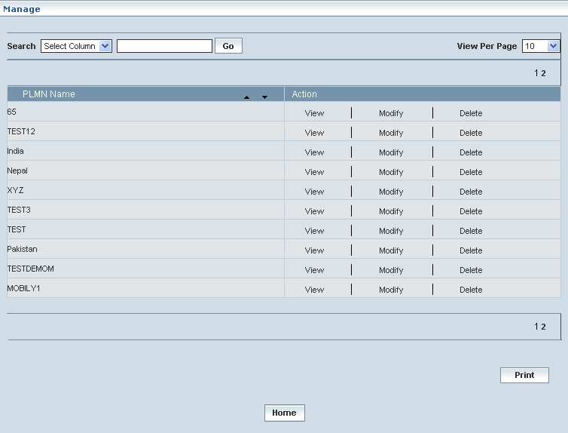

| **STEP** | | **ACTION** |
| --- | --- | --- |
|  | | By default, the list of Cell IDs will be displayed as records in a grid. The columns include ‘PLMN Name’ and ‘Action’ |
|  |  | User can customize the view for the number of records to be displayed each time (per page) in a grid.  However, this option is applicable only if the total number of records exceeds 10. And also with the immediate effect of increase in the number of records more than 10, a ‘Search’ option would be dynamically displayed. |
| Select the number of records (For Ex: 10) from the drop-down list of the <View Per Page> field. |
| With the effect of choosing the desired number (10) for the display of records per page, the same (10 records) will be displayed in the grid. |
| User can sort the records in ascending and descending orders with the help of up-arrow and down-arrows respectively |
| However, based on the total number of records, page numbers will be dynamically displayed at the left bottom of the screen |
| User can navigate for subsequent records (10 each time) by clicking the desired ‘page number’ |
|  | | On clicking the **View** link, ‘View’ screen will be displayed enabling the user to view the details of chosen ‘PLMN Specific Cell IDs’ |
|  | | On clicking the **Modify** link, ‘Modify’ screen will be displayed enabling the user to update / change corresponding values (as required) of a chosen ‘PLMN Specific Cell IDs’ |
|  | | On clicking the **Delete** link, of a chosen ‘LSA Specific Cell IDs’, it enables the user to delete the same |
|  | | On clicking the **Print** button at the bottom of the grid, user can take printouts of the PLMN Specific Cell ID(s) list |
|  | | On clicking the **Home** button at the bottom of the grid, it redirects the user to the ‘HLR’ main page |

**View**

On clicking the **‘View’** link of a chosen ‘PLMN Specific Cell IDs’ (from the PLMN Specific Cell IDs List); corresponding information related to the PLMN Specific Cell IDs will be displayed in a separate screen enabling the user to peruse details of the same.

The screen below shows the view of a chosen PLMN Specific Cell IDs.

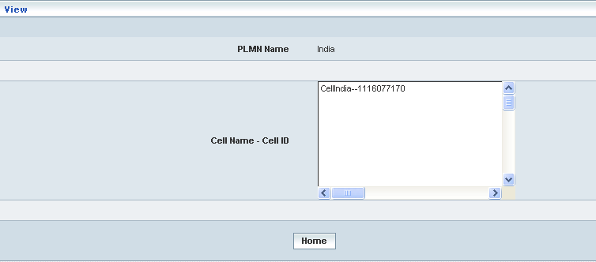

| **STEP** | **ACTION** |
| --- | --- |
|  | ‘PLMN Name’ and ‘Cell Name – Cell ID’ mapping will be dynamically displayed in their respective fields |
|  | On clicking the **Home** button at the bottom of the ‘View’ Screen, it redirects the user to the ‘Manage’ Screen |

**Modify**

On clicking the **‘Modify’** link of a chosen ‘PLMN Specific Cell IDs’ (from the PLMN Specific Cell IDs List); corresponding information related to the PLMN Specific Cell IDs will be displayed in a separate screen enabling the user to modify details of the same.

The screen below shows modifying / updating an existing PLMN Specific Cell IDs

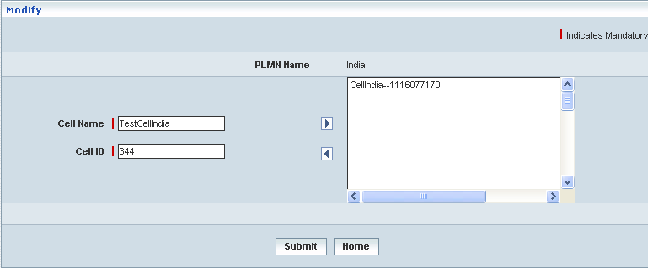

| **STEP** | **ACTION** |
| --- | --- |
|  | User can make necessary changes related to PLMN Specific Cell IDs (‘Cell Name’, ‘Cell ID’ and finally mapping at least one Cell Configuration to PLMN |
|  | On clicking the **Submit** button, the changes made will be updated accordingly in the database. A message window will be displayed to that effect  **NOTE:** If an Cell ID is assigned to LSA, the same cannot be modified    On clicking the **Home** button of the message window, it redirects the user to the ‘Manage’ Screen |
|  | On clicking the **Home** button at the bottom of the ‘Modify’ Screen (before submission), it redirects to the ‘Modify’ Screen |

**Delete**

On clicking the **‘Delete’** link of a chosen ‘PLMN Specific Cell IDs’ (from the PLMN Specific Cell IDs List); corresponding information related to the PLMN Specific Cell IDs will be displayed in a separate screen enabling the user to delete details of the same.

The screen below shows deleting an existing PLMN Specific Cell IDs

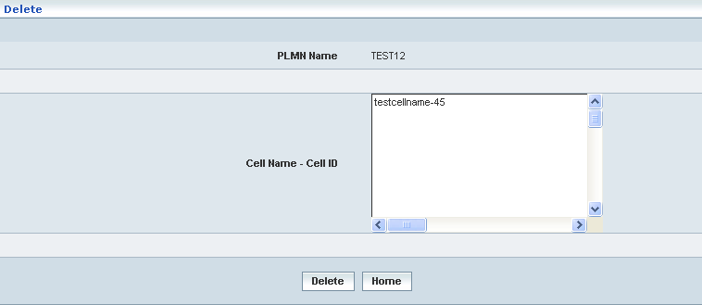

| **STEP** | **ACTION** |
| --- | --- |
|  | On clicking the **Delete** button, an alert message window will be displayed enabling the user to confirm deletion of the chosen PLMN Specific Cell IDs SNAGHTML82ace1 |
|  | On clicking the **OK** button of the alert message window, the chosen PLMN Specific Cell details will be deleted and a message window will be displayed to that effect. It will be disappeared from the ‘PLMN Specific Cell IDs’ grid.    On clicking the **Home** button of the message window, it directs the user to ‘Manage’ Screen  On clicking the **Cancel** button of the alert message window, it retains the grid without deleting the ‘PLMN Specific Cell IDs’ record |
|  | On clicking the **Home** button at the bottom of the ‘Delete’ screen (before submission), it redirects to the ‘Manage’ Screen |

**Searching for a specific PLMN Specific Cell IDs (Record)**

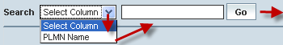

| **STEP** | **ACTION** |
| --- | --- |
|  | Select a search criterion (‘PLMN Name’) from the drop-down list of the search criteria of the <Search> field  **\*** By default the list of search criterion (‘PLMN Name’) will be dynamically displayed as drop-down list of the <Search> field |
|  | Enter the ‘PLMN Name’ that corresponds with the given search criterion |
|  | On clicking the **Go** button, the corresponding PLMN Specific Cell IDs (record) will be highlighted among the list of PLMN Specific Cell IDs records. |

The screen below depicts fetching and displaying the give PLMN Specific Cell IDs record.

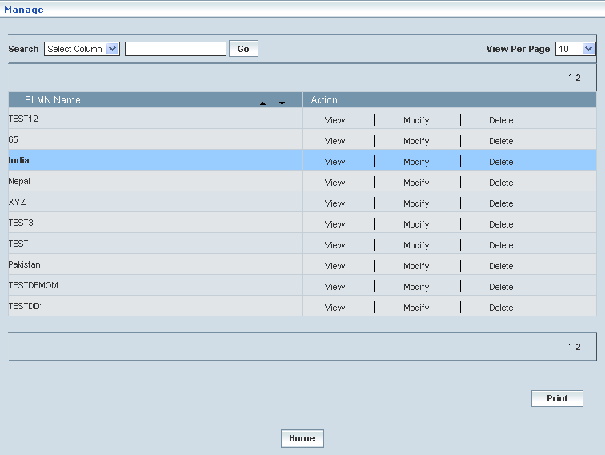

## PLMN Specific LSA

Home Location Register 🡪 PLMN Specific LSA

This section enables users to perform the following tasks of the PLMN Specific LSA (Localized Service Area).

This module helps the user performing the following actions:

* Create
* View
* Modify
* Delete
* Search

**Create**

Home Location Register 🡪 PLMN Specific LSA 🡪 Create

Create enables the user to create PLMN Specific LSA.

The screen below shows creating a new PLMN Specific LSA

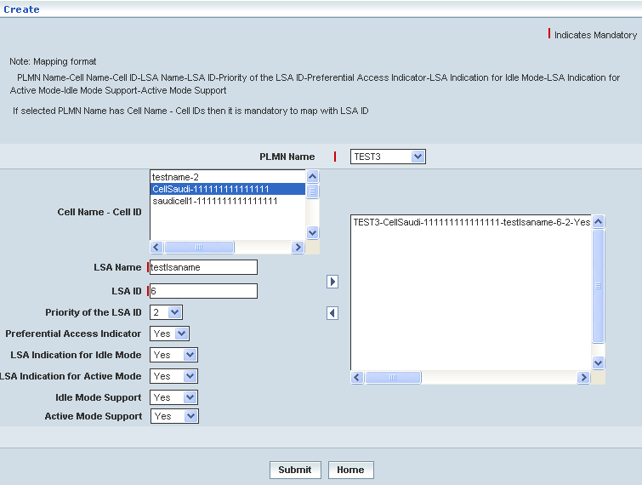

| **STEP** | **ACTION** |
| --- | --- |
|  | User must enter the details of the PLMN Specific Localized Service Area details where it is a mandatory information |
|  | Select PLMN Name from <PLMN Name> drop-down list.  **NOTE:** THE <PLMN Name> related Cell Name and Cell ID gets displayed in the <Cell Name – Cell ID> list box |
|  | Enter LSA Name in <LSA Name> field |
|  | Enter LSA ID in <LSA ID> field.  **NOTE:** LSA ID should be only numeric value. |
|  | Select the priority of the LSA ID number from <Priority of the LSA ID> drop-down list |
|  | Set the preferential access indicator to ‘Yes’ or ‘No’ from <Preferential Access Indicator> drop-down list |
|  | Set the LSA indication for idle mode to ‘Yes’ or ‘No’ from <LSA Indication for Idle Mode> drop-down list |
|  | Set the LSA indication for active mode to ‘Yes’ or ‘No’ from <LSA Indication for Active Mode> drop-down list |
|  | Set the idle mode support to ‘Yes’ or ‘No’ from <Idle Mode Support> drop-down list |
|  | Set the active mode support to ‘Yes’ or ‘No’ from <Active Mode Support> drop-down list |
|  | Select one or more than one Cell Name and Cell ID from <Cell Name – Cell ID> list box |
|  | On clicking  button allows the user to map at least one LSA configuration to the selected PLMN and it moves to the adjacent field. On clicking  the user can perform un-mapping at least one LSA configuration and vice versa. |
|  | On clicking the **Submit** button, the new PLMN Specific LSA will be created successfully. A message window will be displayed to that effect    On clicking the **Home** button of the message window, it redirects the user to the ‘Create’ Screen |
|  | On clicking the **Home** button at the bottom of the ‘Create’ Screen (before creating a new PLMN Specific LSA), it redirects the user to the ‘PLMN Specific LSA’ Screen |

**Manage**

Home Location Register 🡪 PLMN Specific LSA 🡪 Manage

Manage enables the users to perform view, search, modify, print and delete PLMN Specific LSA.

The screen below shows the ‘Manage’ Screen

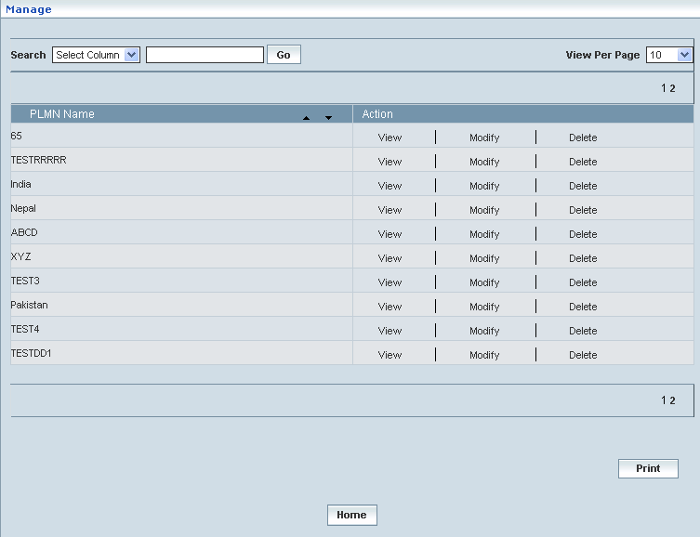

| **STEP** | | **ACTION** |
| --- | --- | --- |
|  | | By default, the list of LSAs will be displayed as records in a grid. The columns include ‘PLMN Name’ and ‘Action’ |
|  |  | User can customize the view for the number of records to be displayed each time (per page) in a grid.  However, this option is applicable only if the total number of records exceeds 10. And also with the immediate effect of increase in the number of records more than 10, a ‘Search’ option would be dynamically displayed. |
| Select the number of records (For Ex: 10) from the drop-down list of the <View Per Page> field. |
| With the effect of choosing the desired number (10) for the display of records per page, the same (10 records) will be displayed in the grid. |
| User can sort the records in ascending and descending orders with the help of up-arrow and down-arrows respectively |
| However, based on the total number of records, page numbers will be dynamically displayed at the left bottom of the screen |
| User can navigate for subsequent records (10 each time) by clicking the desired ‘page number’ |
|  | | On clicking the **View** link, ‘View’ screen will be displayed enabling the user to view the details of chosen ‘PLMN Specific LSA’ |
|  | | On clicking the **Modify** link, ‘Modify’ screen will be displayed enabling the user to update / change corresponding values (as required) of a chosen ‘PLMN Specific LSA’ |
|  | | On clicking the **Delete** link, of a chosen ‘PLMN Specific LSA’, it enables the user to delete the same |
|  | | On clicking the **Print** button at the bottom of the grid, user can take printouts of the PLMN Specific LSA(s) list |
|  | | On clicking the **Home** button at the bottom of the grid, it redirects the user to the ‘HLR’ main page |

**View**

On clicking the **‘View’** link of a chosen ‘PLMN Specific LSA’ (from the PLMN Specific LSA List); corresponding information related to the PLMN Specific LSA will be displayed in a separate screen enabling the user to peruse details of the same.

The screen below shows the view of a chosen PLMN Specific LSA.

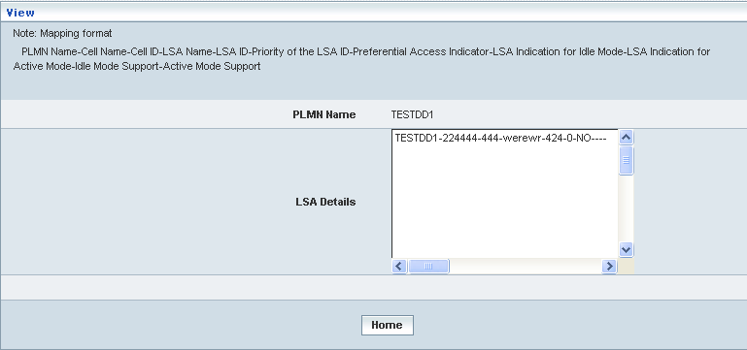

| **STEP** | **ACTION** |
| --- | --- |
|  | ‘PLMN Name’ and ‘LSA Details’ mapping will be dynamically displayed in their respective fields |
|  | On clicking the **Home** button at the bottom of the ‘View’ Screen, it redirects the user to the ‘Manage’ Screen |

**Modify**

On clicking the **‘Modify’** link of a chosen ‘PLMN Specific LSA’ (from the PLMN Specific LSA List); corresponding information related to the PLMN Specific LSA will be displayed in a separate screen enabling the user to modify details of the same.

The screen below shows modifying / updating an existing PLMN Specific LSA

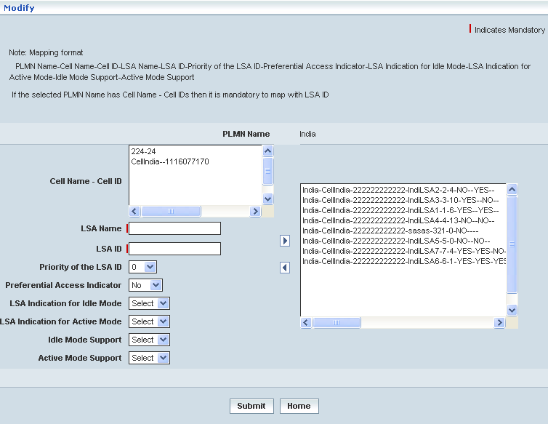

| **STEP** | **ACTION** |
| --- | --- |
|  | User can make necessary changes related to PLMN Specific LSA (‘LSA Name’, ‘LSA ID’, ‘Priority of the LSA ID’, ‘Preferential Access Indicator’, ‘LSA Indication for Idle Mode’, ‘LSA Indication for Active Mode’, ‘Idle Mode Support’, ‘Active Mode Support’ and then selecting at least one cell name – cell id from ‘Cell Name – Cell ID’ filed and finally mapping at least one LSA Configuration to PLMN |
|  | On clicking the **Submit** button, the changes made will be updated accordingly in the database. A message window will be displayed to that effect  **NOTE:** If LSA ID is assigned to LSA_PROFILE_ID, the same cannot be modified    On clicking the **Home** button of the message window, it redirects the user to the ‘Manage’ Screen |
|  | On clicking the **Home** button at the bottom of the ‘Modify’ Screen (before submission), it redirects to the ‘Modify’ Screen |

**Delete**

On clicking the **‘Delete’** link of a chosen ‘PLMN Specific LSA’ (from the PLMN Specific LSA List); corresponding information related to the PLMN Specific LSA will be displayed in a separate screen enabling the user to delete details of the same.

The screen below shows deleting an existing PLMN Specific LSA

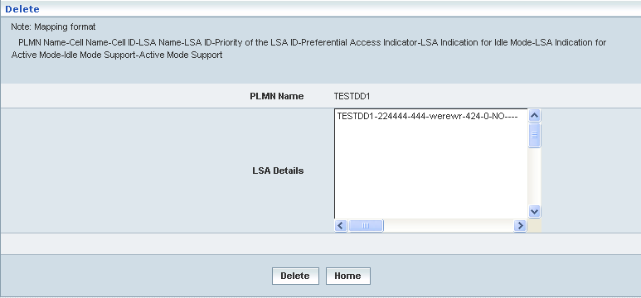

| **STEP** | **ACTION** |
| --- | --- |
|  | On clicking the **Delete** button, an alert message window will be displayed enabling the user to confirm deletion of the chosen PLMN Specific LSAs SNAGHTML1925233 |
|  | On clicking the **OK** button of the alert message window, the chosen PLMN Specific LSAs details will be deleted and a message window will be displayed to that effect. It will be disappeared from the ‘PLMN Specific LSAs’ grid.    On clicking the **Home** button of the message window, it directs the user to ‘Manage’ Screen  On clicking the **Cancel** button of the alert message window, it retains the grid without deleting the ‘PLMN Specific LSAs’ record |
|  | On clicking the **Home** button at the bottom of the ‘Delete’ screen (before submission), it redirects to the ‘Manage’ Screen |

**Searching for a specific PLMN Specific LSAs (Record)**



| **STEP** | **ACTION** |
| --- | --- |
|  | Select a search criterion (‘PLMN Name’) from the drop-down list of the search criteria of the <Search> field  **\*** By default the list of search criterion (‘PLMN Name’) will be dynamically displayed as drop-down list of the <Search> field |
|  | Enter the ‘PLMN Name’ that corresponds with the given search criterion |
|  | On clicking the **Go** button, the corresponding PLMN Specific Cell IDs (record) will be highlighted among the list of PLMN Specific Cell IDs records. |

The screen below depicts fetching and displaying the give PLMN Specific Cell IDs record.

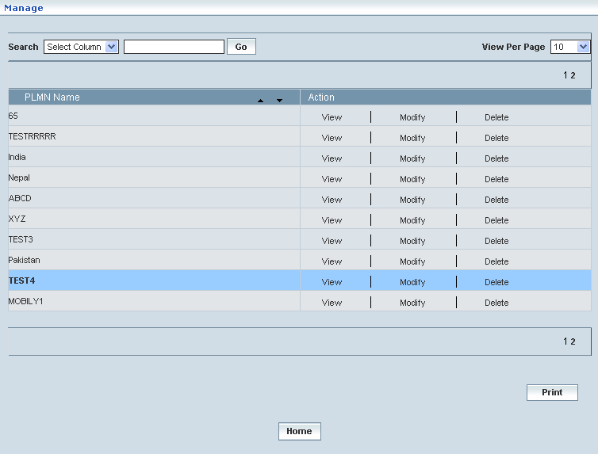

## PLMN Specific LAIs

Home Location Register 🡪 PLMN Specific LAIs

This section enables users to perform the following tasks of the PLMN Specific LAIs (GSM (Location Area Identity. Composed of MCC+MNC+LAC)

This module helps the user performing the following actions:

* Create
* View
* Modify
* Delete
* Search

**Create**

Home Location Register 🡪 PLMN Specific LAIs 🡪 Create

Create enables the user to create PLMN Specific LAIs.

The screen below shows creating a new PLMN Specific LAIs

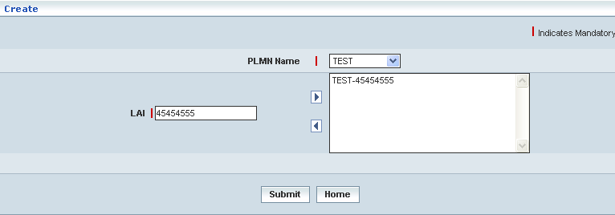

| **STEP** | **ACTION** |
| --- | --- |
|  | User must enter the details of the PLMN Specific LAIs details where it is a mandatory information |
|  | Select PLMN Name from <PLMN Name> drop-down list.  **NOTE:** <PLMN Name> related LAI gets displayed in the <LAI> field |
|  | On clicking  button allows the user to map LAIs configuration to the selected PLMN and it moves to the adjacent field. On clicking  the user can perform un-mapping LAIs configuration and vice versa. |
|  | On clicking the **Submit** button, the new PLMN Specific LAIs will be created successfully. A message window will be displayed to that effect    On clicking the **Home** button of the message window, it redirects the user to the ‘Create’ Screen |
|  | On clicking the **Home** button at the bottom of the ‘Create’ Screen (before creating a new PLMN Specific LAIs), it redirects the user to the ‘PLMN Specific LAIs’ Screen |

**Manage**

Home Location Register 🡪 PLMN Specific LAIs 🡪 Manage

Manage enables the users to perform view, search, modify, print and delete PLMN Specific LAIs.

The screen below shows the ‘Manage’ Screen

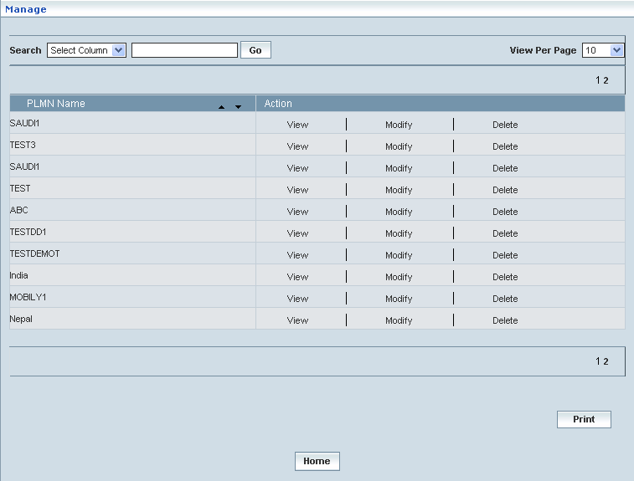

| **STEP** | | **ACTION** |
| --- | --- | --- |
|  | | By default, the list of LAIs will be displayed as records in a grid. The columns include ‘PLMN Name’ and ‘Action’ |
|  |  | User can customize the view for the number of records to be displayed each time (per page) in a grid.  However, this option is applicable only if the total number of records exceeds 10. And also with the immediate effect of increase in the number of records more than 10, a ‘Search’ option would be dynamically displayed. |
| Select the number of records (For Ex: 10) from the drop-down list of the <View Per Page> field. |
| With the effect of choosing the desired number (10) for the display of records per page, the same (10 records) will be displayed in the grid. |
| User can sort the records in ascending and descending orders with the help of up-arrow and down-arrows respectively |
| However, based on the total number of records, page numbers will be dynamically displayed at the left bottom of the screen |
| User can navigate for subsequent records (10 each time) by clicking the desired ‘page number’ |
|  | | On clicking the **View** link, ‘View’ screen will be displayed enabling the user to view the details of chosen ‘PLMN Specific LAI’ |
|  | | On clicking the **Modify** link, ‘Modify’ screen will be displayed enabling the user to update / change corresponding values (as required) of a chosen ‘PLMN Specific LAI’ |
|  | | On clicking the **Delete** link, of a chosen ‘LSA Specific LAI’, it enables the user to delete the same |
|  | | On clicking the **Print** button at the bottom of the grid, user can take printouts of the PLMN Specific LAI(s) list |
|  | | On clicking the **Home** button at the bottom of the grid, it redirects the user to the ‘HLR’ main page |

**View**

On clicking the **‘View’** link of a chosen ‘PLMN Specific LAI’ (from the PLMN Specific LAIs List); corresponding information related to the PLMN Specific LAI will be displayed in a separate screen enabling the user to peruse details of the same.

The screen below shows the view of a chosen PLMN Specific LAI.

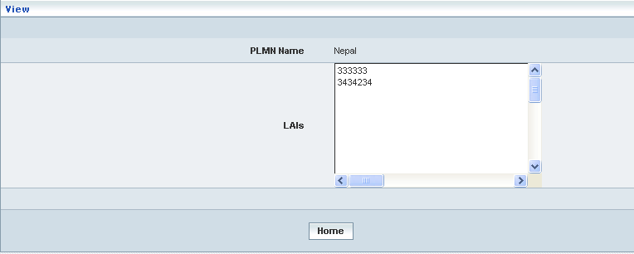

| **STEP** | **ACTION** |
| --- | --- |
|  | ‘PLMN Name’ and ‘LAIs’ details are viewed in their respective fields |
|  | On clicking the **Home** button at the bottom of the ‘View’ Screen, it redirects the user to the ‘Manage’ Screen |

**Modify**

On clicking the **‘Modify’** link of a chosen ‘PLMN Specific LAI’ (from the PLMN Specific LAIs List); corresponding information related to the PLMN Specific LAI will be displayed in a separate screen enabling the user to modify details of the same.

The screen below shows modifying / updating an existing PLMN Specific LAI

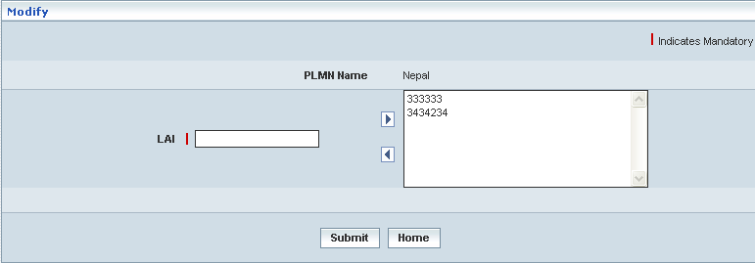

| **STEP** | **ACTION** |
| --- | --- |
|  | User can make necessary changes related to PLMN Specific LAI (‘LAI’) and map LAIs Configuration to PLMN |
|  | On clicking the **Submit** button, the changes made will be updated accordingly in the database. A message window will be displayed to that effect  **NOTE:** If LAI PLMN ID is assigned to Zone Codes, the same cannot be modified    On clicking the **Home** button of the message window, it redirects the user to the ‘Manage’ Screen |
|  | On clicking the **Home** button at the bottom of the ‘Modify’ Screen (before submission), it redirects to the ‘Modify’ Screen |

**Delete**

On clicking the **‘Delete’** link of a chosen ‘PLMN Specific LAI’ (from the PLMN Specific LAIs List); corresponding information related to the PLMN Specific LAI will be displayed in a separate screen enabling the user to delete details of the same.

The screen below shows deleting an existing PLMN Specific LAI

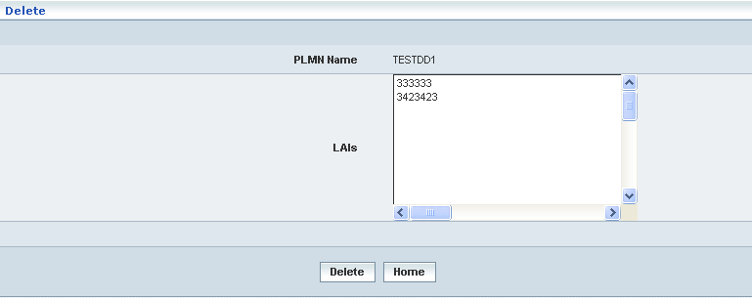

| **STEP** | **ACTION** |
| --- | --- |
|  | On clicking the **Delete** button, an alert message window will be displayed enabling the user to confirm deletion of the chosen PLMN Specific LAIs SNAGHTML1999fb5 |
|  | On clicking the **OK** button of the alert message window, the chosen PLMN Specific LAIs details will be deleted and a message window will be displayed to that effect. It will be disappeared from the ‘PLMN Specific LAIs’ grid.    On clicking the **Home** button of the message window, it directs the user to ‘Manage’ Screen  On clicking the **Cancel** button of the alert message window, it retains the grid without deleting the ‘PLMN Specific LAIs’ record |
|  | On clicking the **Home** button at the bottom of the ‘Delete’ screen (before submission), it redirects to the ‘Manage’ Screen |

**Searching for a specific PLMN Specific LAIs (Record)**

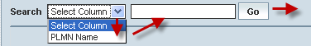

| **STEP** | **ACTION** |
| --- | --- |
|  | Select a search criterion (‘PLMN Name’) from the drop-down list of the search criteria of the <Search> field  **\*** By default the list of search criterion (‘PLMN Name’) will be dynamically displayed as drop-down list of the <Search> field |
|  | Enter the ‘PLMN Name’ that corresponds with the given search criterion |
|  | On clicking the **Go** button, the corresponding PLMN Specific LAIs (record) will be highlighted among the list of PLMN Specific LAIs records. |

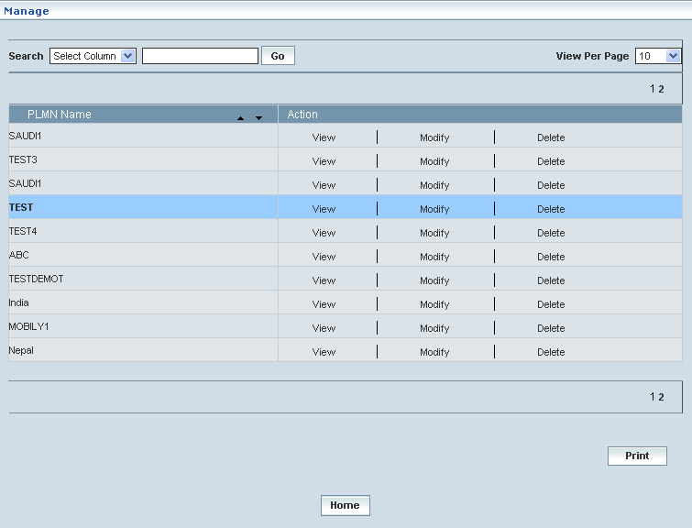

## PLMN Specific RSZI

Home Location Register 🡪 PLMN Specific RSZI

This section enables users to perform the following tasks of the PLMN Specific RSZI (Regional Subscription Zone Identity).

This module helps the user performing the following actions:

* Create
* View
* Modify
* Delete
* Search

**Create**

Home Location Register 🡪 PLMN Specific RSZI 🡪 Create

Create enables the user to create PLMN Specific RSZI.

The screen below shows creating a new PLMN Specific RSZI

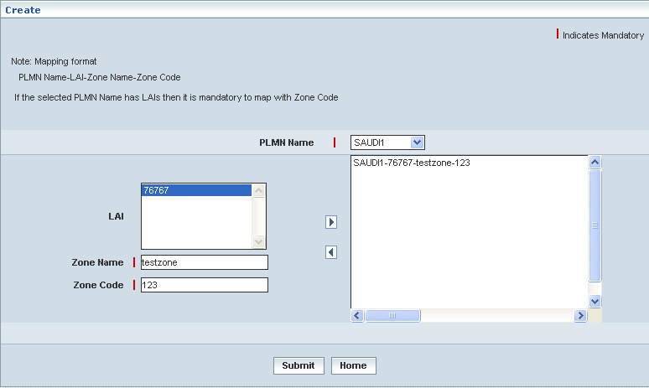

|  |  |
| --- | --- |
| **STEP** | **ACTION** |
|  | User must enter the details of the PLMN Specific RSZI details where it is a mandatory information |
|  | Select PLMN Name from <PLMN Name> drop-down list.  **NOTE:** <PLMN Name> related LAI gets displayed in the <LAI> list box |
|  | Enter Zone Name in <Zone Name> field |
|  | Enter Zone Code in <Zone Code> field.  **NOTE:** Zone Code should be only numeric value. |
|  | On clicking  button allows the user to map at least one RSZI Zone Code configuration to the selected PLMN and it moves to the adjacent field. On clicking  the user can perform un-mapping at least one RSZI Zone Code configuration and vice versa. |
|  | On clicking the **Submit** button, the new PLMN Specific RSZI will be created successfully. A message window will be displayed to that effect    On clicking the **Home** button of the message window, it redirects the user to the ‘Create’ Screen |
|  | On clicking the **Home** button at the bottom of the ‘Create’ Screen (before creating a new PLMN Specific RSZI), it redirects the user to the ‘PLMN Specific RSZI’ Screen |

**Manage**

Home Location Register 🡪 PLMN Specific RSZI 🡪 Manage

Manage enables the users to perform view, search, modify, print and delete PLMN Specific RSZI.

The screen below shows the ‘Manage’ Screen

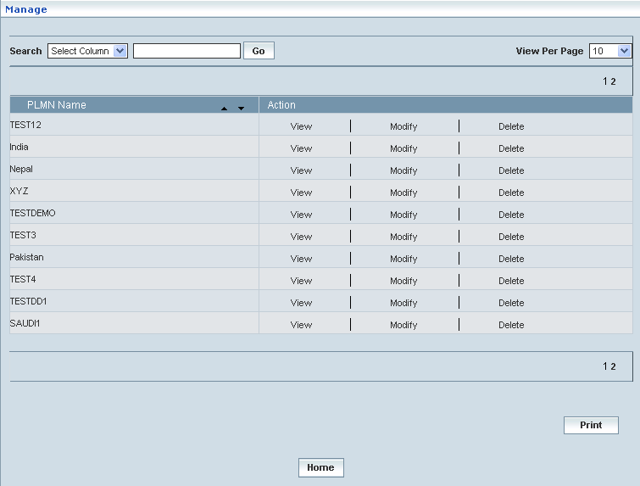

| **STEP** | | **ACTION** |
| --- | --- | --- |
|  | | By default, the list of RSZIs will be displayed as records in a grid. The columns include ‘PLMN Name’ and ‘Action’ |
|  |  | User can customize the view for the number of records to be displayed each time (per page) in a grid.  However, this option is applicable only if the total number of records exceeds 10. And also with the immediate effect of increase in the number of records more than 10, a ‘Search’ option would be dynamically displayed. |
| Select the number of records (For Ex: 10) from the drop-down list of the <View Per Page> field. |
| With the effect of choosing the desired number (10) for the display of records per page, the same (10 records) will be displayed in the grid. |
| User can sort the records in ascending and descending orders with the help of up-arrow and down-arrows respectively |
| However, based on the total number of records, page numbers will be dynamically displayed at the left bottom of the screen |
| User can navigate for subsequent records (10 each time) by clicking the desired ‘page number’ |
|  | | On clicking the **View** link, ‘View’ screen will be displayed enabling the user to view the details of chosen ‘PLMN Specific RSZI’ |
|  | | On clicking the **Modify** link, ‘Modify’ screen will be displayed enabling the user to update / change corresponding values (as required) of a chosen ‘PLMN Specific RSZI’ |
|  | | On clicking the **Delete** link, of a chosen ‘PLMN Specific RSZI’, it enables the user to delete the same |
|  | | On clicking the **Print** button at the bottom of the grid, user can take printouts of the PLMN Specific RSZI(s) list |
|  | | On clicking the **Home** button at the bottom of the grid, it redirects the user to the ‘HLR’ main page |

**View**

On clicking the **‘View’** link of a chosen ‘PLMN Specific RSZI’ (from the PLMN Specific RSZIs List); corresponding information related to the PLMN Specific RSZIs will be displayed in a separate screen enabling the user to peruse details of the same.

The screen below shows the view of a chosen PLMN Specific RSZIs.

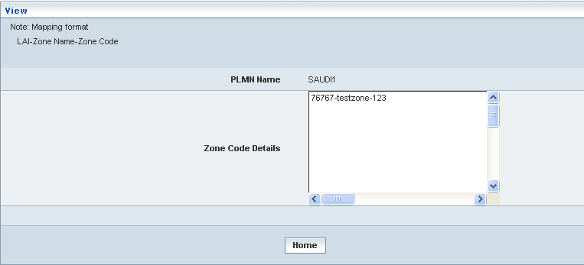

| **STEP** | **ACTION** |
| --- | --- |
|  | ‘PLMN Name’ and ‘Zone Code Details’ will be dynamically displayed in their respective fields |
|  | On clicking the **Home** button at the bottom of the ‘View’ Screen, it redirects the user to the ‘Manage’ Screen |

**Modify**

On clicking the **‘Modify’** link of a chosen ‘PLMN Specific RSZIs’ (from the PLMN Specific RSZIs List); corresponding information related to the PLMN Specific RSZIs will be displayed in a separate screen enabling the user to modify details of the same.

The screen below shows modifying / updating an existing PLMN Specific RSZIs

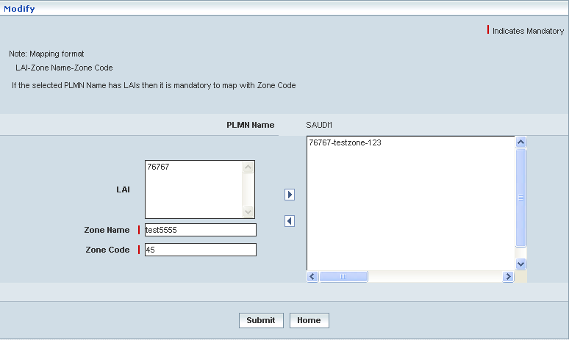

| **STEP** | **ACTION** |
| --- | --- |
|  | User can make necessary changes related to PLMN Specific RSZIs (‘LAI’, ‘Zone Name’, ‘Zone Code’ and finally mapping at least one RSZI Configuration to PLMN |
|  | On clicking the **Submit** button, the changes made will be updated accordingly in the database. A message window will be displayed to that effect  **NOTE:** If LAI PLMN ID is assigned to RSZI Profile, the same cannot be modified    On clicking the **Home** button of the message window, it redirects the user to the ‘Manage’ Screen |
|  | On clicking the **Home** button at the bottom of the ‘Modify’ Screen (before submission), it redirects to the ‘Modify’ Screen |

**Delete**

On clicking the **‘Delete’** link of a chosen ‘PLMN Specific RSZI’ (from the PLMN Specific RSZIs List); corresponding information related to the PLMN Specific RSZIs will be displayed in a separate screen enabling the user to delete details of the same.

The screen below shows deleting an existing PLMN Specific RSZIs

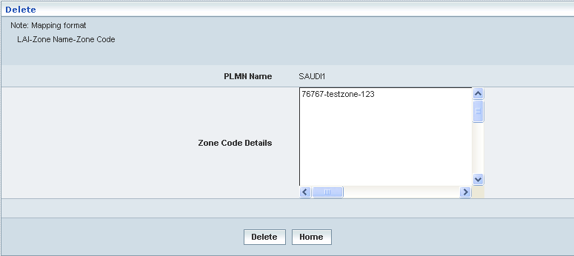

| **STEP** | **ACTION** |
| --- | --- |
|  | On clicking the **Delete** button, an alert message window will be displayed enabling the user to confirm deletion of the chosen PLMN Specific RSZIs SNAGHTML19fc6f7 |
|  | On clicking the **OK** button of the alert message window, the chosen PLMN Specific RSZI details will be deleted and a message window will be displayed to that effect. It will be disappeared from the ‘PLMN Specific RSZI’ grid.    On clicking the **Home** button of the message window, it directs the user to ‘Manage’ Screen  On clicking the **Cancel** button of the alert message window, it retains the grid without deleting the ‘PLMN Specific RSZI’ record |
|  | On clicking the **Home** button at the bottom of the ‘Delete’ screen (before submission), it redirects to the ‘Manage’ Screen |

**Searching for a specific PLMN Specific RSZIs (Record)**

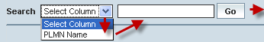

| **STEP** | **ACTION** |
| --- | --- |
|  | Select a search criterion (‘PLMN Name’) from the drop-down list of the search criteria of the <Search> field  **\*** By default the list of search criterion (‘PLMN Name’) will be dynamically displayed as drop-down list of the <Search> field |
|  | Enter the ‘PLMN Name’ that corresponds with the given search criterion |
|  | On clicking the **Go** button, the corresponding PLMN Specific RSZIs (record) will be highlighted among the list of PLMN Specific RSZIs records. |

The screen below depicts fetching and displaying the give PLMN Specific RSZIs record.

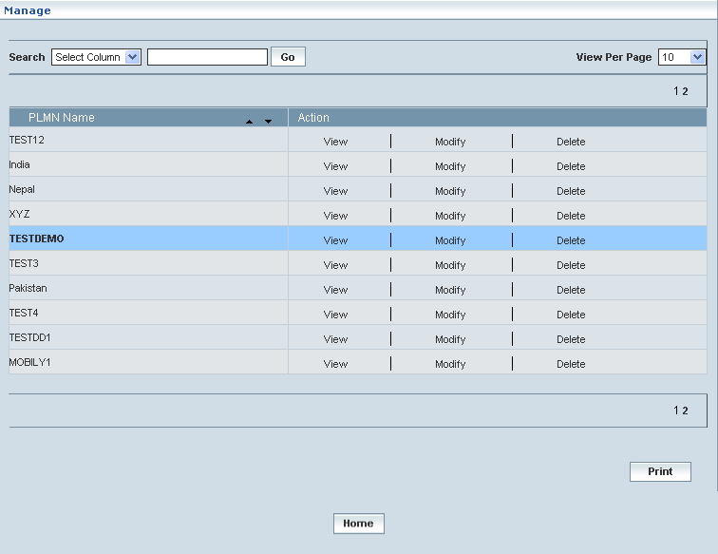

# Notifications

This chapter describes registering the information related to Roaming Partners and the Clients (external entities).

Roaming Partner refers to a network that has roaming alliance with the home network and the corresponding details are registered into HLR database.

Client refers to an external entity that would be privileged to receive notifications accordingly as and when the home network subscribers registering with other roaming networks while in roaming.

However, only those clients whose details are registered into HLR database are reckoned for receiving such notifications.

Home Location Register 🡪 Notifications

Notifications helps registering and managing the information related to Roaming Partners and Clients with the help of the following modules respectively:

* Roaming Partners
* Notification Clients

## Roaming Partners

Home Location Register 🡪 Notifications 🡪 Roaming Partners

This allows the user to create / register details related to a network that has roaming alliance with home network and further would be reckoned as Roaming Partner. A roaming partner would be typically identified with the attributes like CC, NDC, MNC, and MCC.

User can perform the following actions:

* Create a Roaming Partner
* View details related to a Roaming Partner
* Modify details related to a Roaming Partner
* Delete a Roaming Partner
* Search for a Roaming Partner

Initially, the list of existing Roaming Partner Networks is displayed as records in a grid.

The screen below shows the list of Roaming Partner Networks as records in a grid.

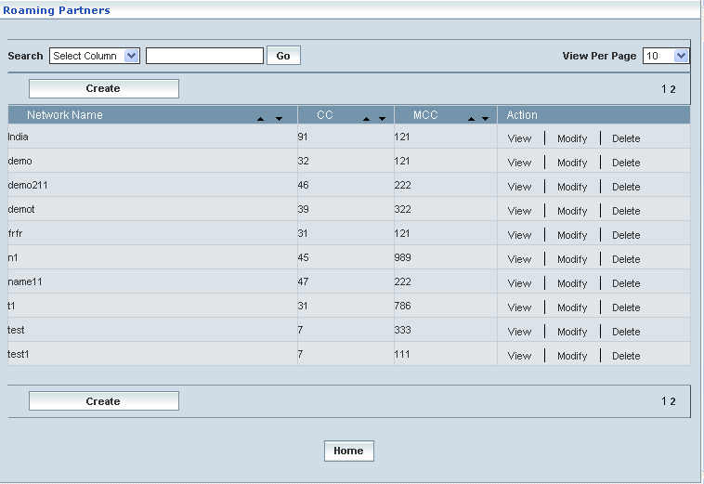

|  |  |  |
| --- | --- | --- |
| **STEP** | | **ACTION** |
|  | | By default, the list of networks (roaming partners) is displayed as records in a grid. The columns include ‘Network Name’, ‘CC’, ‘MCC’, and ‘Action’ |
|  |  | User can customize the view for the number of records to be displayed each time (per page) in a grid.  However, this option is applicable only if the total number of records exceeds 10. And also with the immediate effect of increase in the number of records more than 10, a ‘Search’ option would be dynamically displayed. |
| Select the number of records (For Ex: 10) from the drop-down list of the <View Per Page> field |
| With the effect of choosing the desired number (10) for the display of records per page, the same (10 records) will be displayed in the grid |
| User can sort the records in ascending and descending orders with the help of up-arrow and down-arrows respectively |
| However, based on the total number of records, page numbers will be dynamically displayed at the left bottom of the screen |
| User can navigate for subsequent records (10 each time) by clicking the desired ‘page number’ |
|  | | CC indicates the country code for which the network has been created |
|  | | Mobile Country Code (MCC) indicates the country code for which the network has been created |
|  | | On clicking the **Create** button, the ‘Create’ screen is displayed enabling the user to create a new ‘network’ (roaming partner) |
|  | | On clicking the **View** link of a chosen ‘Network’, corresponding information related to the network is displayed in a separate screen enabling the user to peruse details of the network |
|  | | On clicking the **Modify** link of a chosen ‘Network’, corresponding information related to the network can be modified including CC, MCC, NDC, and MNC. User cannot modify the network name |
|  | | On clicking the **Delete** link of a chosen ‘Network’, corresponding network can be deleted |
|  | | On clicking the **Home** button at the bottom of the grid, it redirects the user to the ‘HLR’ Home page |

**Create**

Home Location Register 🡪 Notifications 🡪 Roaming Partners 🡪 Create

Create enables the user to create a new network.

The screen below shows creating a new Roaming Partner network.

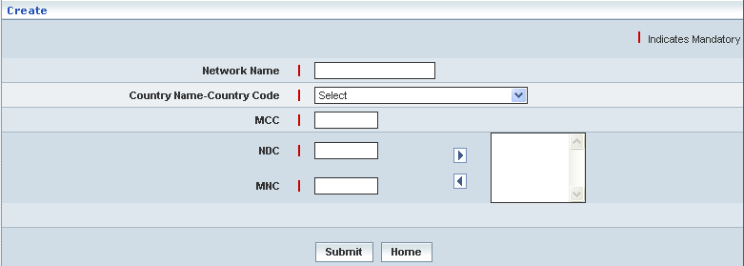

| **STEP** | **ACTION** |
| --- | --- |
|  | User must essentially enter the details related to a new profile where it is a mandatory information |
|  | Enter name of the network in <Network Name> field. The name can contain the numbers, characters, and space. It Cannot contain the special characters other than Hyphen and Underscore |
|  | Select the country name and code in the <Country Name-Country Code> field |
|  | Enter the Mobile Country Code (MCC). The length of the MCC must be 3 digits. The MCC should not start with zero |
|  | Enter Network Destination Code (NDC). The NDC can be from 1 to 4 digits. On clicking the right-arrow button, the NDC will be moved to the adjacent field. User can enter the desired number of NDCs in a similar fashion. |
|  | Enter the Mobile Network Code (MNC). The MNC can be from 2 to 3 digits. On clicking the right-arrow button, the MNC will be moved to the adjacent field. User can enter the desired number of MNCs in a similar fashion.  **\*** However if the user wants to just remove any MNC (any time before creating the network), selecting the MNC from the right text field and subsequently clicking the left-arrow button removes the MNC. Duplicates MNCs are not accepted. The MNC should not start with zero. The MNC cannot be duplicated for the same CC |
|  | On clicking the **Submit** button, new network will be created and a message window to that effect will be displayed    On clicking the **Home** button of the message window, it directs the user back to the ‘Roaming Partners’ grid |

**View**

Home Location Register 🡪 Notifications 🡪 Roaming Partners 🡪 View

View enables the user to peruse details related to chosen network.

On clicking the **‘View’** link of a chosen ‘Network’, corresponding information related to the network will be displayed in a separate screen enabling the user to peruse details of the network (Roaming partner).

The screen below displays the details related to chosen network (roaming partner).

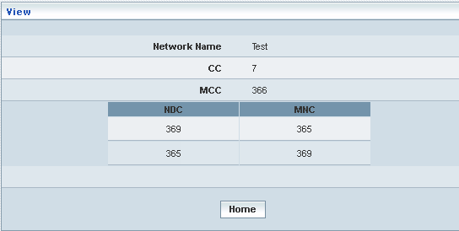

| **STEP** | **ACTION** |
| --- | --- |
|  | User can peruse details related to the chosen network |
|  | On clicking the **Home** button at the bottom of the ‘View’ Screen, it redirects the user to the ‘Roaming Partners’ grid |

**Modify**

Home Location Register 🡪 Notifications 🡪 Roaming Partners 🡪 Modify

Modify enables the user to modify / update the details related to an existing network (roaming partner).

On clicking the **‘Modify’** link of a chosen ‘Network’, corresponding information related to the network will be displayed in a separate screen enabling the user to modify / update details of the network – roaming partner.

The screen below shows modifying / updating the details related to a chosen network (roaming partner).

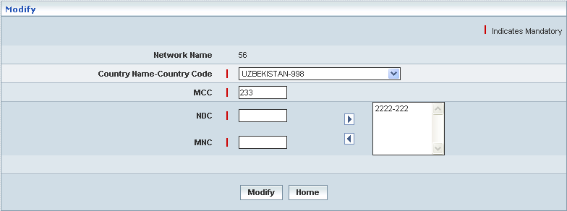

| **STEP** | **ACTION** |
| --- | --- |
|  | Name of the network (roaming partner) is dynamically displayed in the <Network Name> field and this cannot be modified |
|  | User can make necessary changes / updates to the existing values / configurations of the network (roaming partner) |
|  | On clicking the **Modify** button at the bottom of the ‘Modify’ screen, network details will be updated accordingly and a message window to that effect will be displayed    On clicking the **Home** button of the message window, it directs the user back to the ‘Roaming Partners’ grid |
|  | On clicking the **Home** button of the ‘Modify’ screen (before updating the details related to network), it directs the user to the ‘Roaming Partners’ grid |

**Delete**

Home Location Register 🡪 Notifications 🡪 Roaming Partners 🡪 Delete

Delete enables the user to delete existing networks (Roaming Partners).

On clicking the **‘Delete’** link of a chosen ‘Network’, corresponding information related to the network will be displayed in a separate screen enabling the user to delete the network.

The screen below shows the details related to an existing network, which enables the user to delete the same (Network) – Roaming Partner.

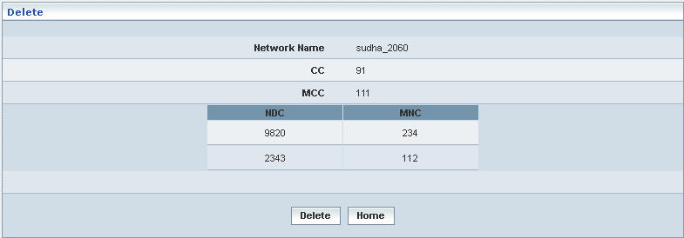

| **STEP** | **ACTION** |
| --- | --- |
|  | User can peruse the existing values / configurations of the network before deleting the network |
|  | On clicking the **Delete** at the bottom of the ‘Delete’ screen, it displays an alert window enabling the user to confirm deletion of the chosen network    On clicking the **OK** button of the alert window, the network will be deleted and a message window to that effect will be displayed    On clicking the **Cancel** button of the alert window, it retains the corresponding ‘Delete’ screen  On clicking the **Home** button of the message window, it directs the user back to the ‘Roaming Partners’ grid |
|  | On clicking the **Home** button of the ‘Delete’ screen (before deleting the network), it directs the user to the ‘Roaming Partners’ grid |

**Searching for a specific Roaming Partner (Record)**

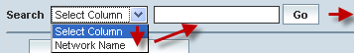

| **STEP** | **ACTION** |
| --- | --- |
|  | Select a search criterion (‘Network Name’) from the drop-down list of the search criteria of the <Search> field  **\*** By default the list of search criterion (‘Network Name’) will be dynamically displayed as drop-down list of the <Search> field |
|  | Enter the ‘Network Name’ that corresponds with the given search criterion |
|  | On clicking the **Go** button, the corresponding Roaming Partner (record) will be highlighted among the list of Roaming Partner records. |

The screen below depicts fetching and displaying the give Roaming Partner record.

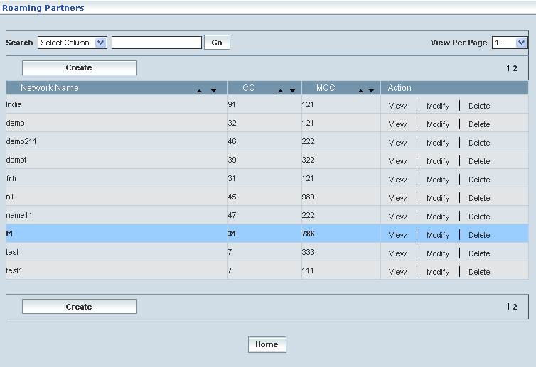

## Notification Clients

Home Location Register 🡪 Notifications 🡪 Notification Clients

This allows the user to create / register a client (an external entity) with home network (into HLR database). This entities or authorizes the client to receive notification in the event of a home subscriber registering with a roaming network (roaming partner) while in roaming.

User can perform the following actions:

* Create a Client
* View details related to a Client
* Modify details related to a Client
* Delete a Client
* Search for a Client

Initially, the list of existing Client is displayed as records in a grid.

The screen below shows the list of clients as records in a grid.

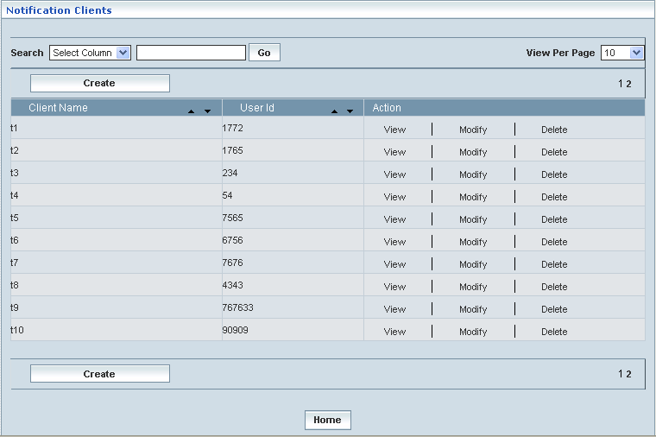

| **STEP** | | **ACTION** |
| --- | --- | --- |
|  | | By default, the list of clients (client names) will be displayed as records in a grid. The columns include ‘Client Name’, ‘User ID’, and ‘Action’ |
|  |  | User can customize the view for the number of records to be displayed each time (per page) in a grid.  However, this option is applicable only if the total number of records exceeds 10. And also with the immediate effect of increase in the number of records more than 10, a ‘Search’ option would be dynamically displayed. |
| Select the number of records (For Ex: 10) from the drop-down list of the <View Per Page> field |
| With the effect of choosing the desired number (10) for the display of records per page, the same (10 records) will be displayed in the grid |
| User can sort the records in ascending and descending orders with the help of up-arrow and down-arrows respectively |
| However, based on the total number of records, page numbers will be dynamically displayed at the left bottom of the screen |
| User can navigate for subsequent records (10 each time) by clicking the desired ‘page number’ |
|  | | User can search for the record by using the Client name or User ID |
|  | | Client Name indicates name of the client |
|  | | Client ID indicates the identification of the client. Each client can have only one user ID |
|  | | On clicking the **Create** button, ‘Create’ screen will be displayed enabling the user to create a new ‘client’ |
|  | | On clicking the **View** link of a chosen ‘Client’, corresponding information related to the client will be displayed in a separate screen enabling the user to peruse details of the client |
|  | | On clicking the **Modify** link of a chosen ‘Client’, corresponding information related to the client can be modified including user id, password, and events. User cannot modify the client name |
|  | | On clicking the **Delete** link of a chosen ‘Client’, corresponding client will be deleted |
|  | | On clicking the **Home** button at the bottom of the grid, it redirects the user to the ‘HLR’ Home page |

**Create**

Home Location Register 🡪 Notifications 🡪 Notification Clients 🡪 Create

Create enables the user to create a new client.

The screen below shows creating a new client.

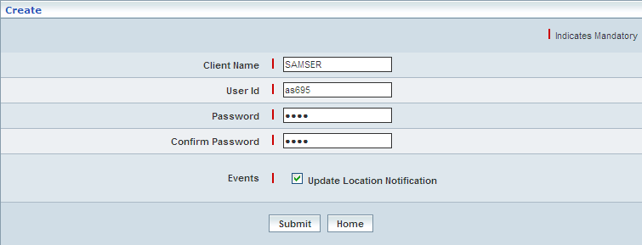

| **STEP** | **ACTION** |
| --- | --- |
|  | User must essentially enter the details related to a new client where it is a mandatory information |
|  | Enter name of the client in <Client Name> field. The name can contain numbers, characters, and space. It cannot contain the special characters other than Hyphen and Underscore. |
|  | Enter the User ID. The User ID can contain the numbers, characters but not the special characters the space the space is also not allowed. |
|  | Enter the password. The length of the password must be greater than or equal to 4 |
|  | Re-enter the password. The given password and the re-entered password must be same |
|  | Checking the <Events> check box entitles the registered client to receive notifications |
|  | On clicking the **Submit** button, new client will be created and a message window to that effect will be displayed    On clicking the **Home** button of the message window, it directs the user back to the Notification Clients grid |
|  | On clicking the **Home** button of the ‘Create’ screen, it directs the user back to the Notification Clients grid |

**View**

Home Location Register 🡪 Notifications 🡪 Notification Clients 🡪 View

View enables the user to peruse details related to chosen client.

On clicking the **‘View’** link of a chosen ‘Client’, corresponding information related to the client will be displayed in a separate screen enabling the user to peruse details of the client.

The screen below displays the details related to chosen client.

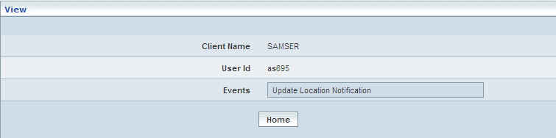

| **STEP** | **ACTION** |
| --- | --- |
|  | User can peruse details related to the chosen client |
|  | On clicking the **Home** button at the bottom of the ‘View’ Screen, it redirects the user to the ‘Notification Clients’ grid |

**Modify**

Home Location Register 🡪 Notifications 🡪 Notification Clients 🡪 Modify

Modify enables the user to modify / update the details related to an existing clients.

On clicking the **‘Modify’** link of a chosen ‘Clients’, corresponding information related to the client will be displayed in a separate screen enabling the user to modify / update details of the client.

The screen below shows modifying / updating the details related to the chosen client.

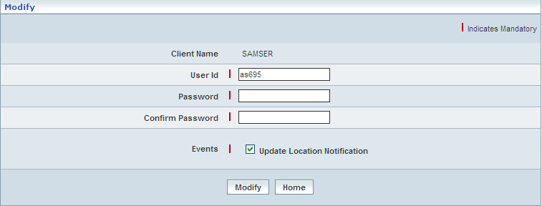

| **STEP** | **ACTION** |
| --- | --- |
|  | Name of the client will be dynamically displayed in the <Client Name> field and this cannot be modified |
|  | User can make necessary changes / updates to the user ID / password |
|  | On clicking the **Modify** button at the bottom of the ‘Modify’ screen, clients details will be updated accordingly and a message window to that effect will be displayed    On clicking the **Home** button of the message window, it directs the user back to the ‘Notification Clients’ grid |
|  | On clicking the **Home** button of the ‘Modify’ screen (before updating the details related to client), it directs the user to the ‘Notification Clients’ grid |

**Delete**

Home Location Register 🡪 Notifications 🡪 Notification Clients 🡪 Delete

Delete enables the user to delete existing clients.

On clicking the **‘Delete’** link of a chosen ‘Client’, corresponding information related to the client will be displayed in a separate screen enabling the user to delete the client.

The screen below shows the details related to an existing client, which enables the user to delete the same (Client).

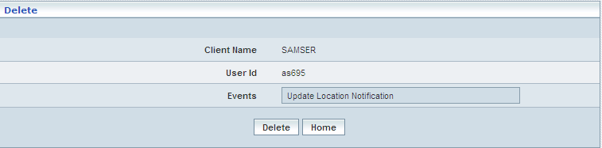

| **STEP** | **ACTION** |
| --- | --- |
|  | User can peruse the details of the client before deleting the client |
|  | On clicking the **Delete** at the bottom of the ‘Delete’ screen, it displays an alert window enabling the user to confirm deletion of the chosen client    On clicking the **OK** button of the alert window, the client will be deleted and a message window to that effect will be displayed    On clicking the **Cancel** button of the alert window, it retains the corresponding ‘Delete’ screen  On clicking the **Home** button of the message window, it directs the user back to the ‘Notification Clients’ grid |
|  | On clicking the **Home** button of the ‘Delete’ screen (before deleting the client), it directs the user to the Notification Clients grid |

**Searching for a specific Notification Clients (Record)**

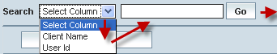

| **STEP** | **ACTION** |
| --- | --- |
|  | Select a search criterion (‘Client Name’ or ‘User Id’) from the drop-down list of the search criteria of the <Search> field  **\*** By default the list of search criterion (‘Client Name’ or ‘User Id’) will be dynamically displayed as drop-down list of the <Search> field |
|  | Enter the ‘Client Name’ or ‘User Id’ that corresponds with the given search criterion |
|  | On clicking the **Go** button, the corresponding Notification Clients (record) will be highlighted among the list of Notification Clients records. |

The screen below depicts fetching and displaying the give Notification Clients record.

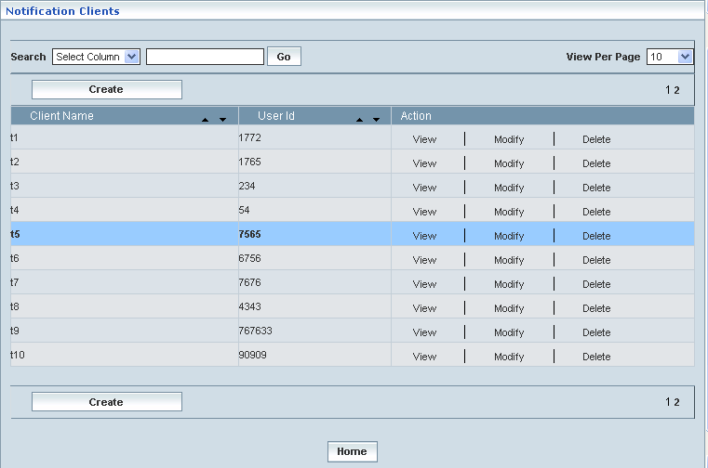

# GSM – CAMEL Subscriptions

Home Location Register 🡪 CAMEL Subscriptions 🡪 GSM CAMEL Subscriptions

Customized Application for the Mobile network Enhanced Logic (CAMEL) is an important standard for intelligent mobile communications networks. CAMEL enables mobile network operators to offer value-added services quickly and efficiently. This section deals with the CAMEL Subscriptions for GSM based subscriber data to be handled by HLR.

## Originating CSI

Originating CSI enables the user to configure parameters related to CAMEL Subscription Information (CSI) in terms of mobile origination (MO) perspective. This helps creating various Originating CSI profiles, which in turn provide a wider flexibility in attributing the same to different customer subscription types.

The Originating CSI data defines the contents of the dialled service CAMEL subscription information that is used to inter-work with the GSMSCF for MO and CF calls.

**Create / View**

Home Location Register 🡪 CAMEL Subscriptions 🡪 GSM CAMEL Subscriptions 🡪 Originating CSI 🡪 Create / View

Initially, ‘Originating CSI’ displays a grid showing the list of existing Originating CSI Profiles that are configured and created. This list may include those profiles that are created and approved, created and rejected and also those created but still to be approved or rejected.

The screen below shows the list of various Originating CSI configurations in a grid.

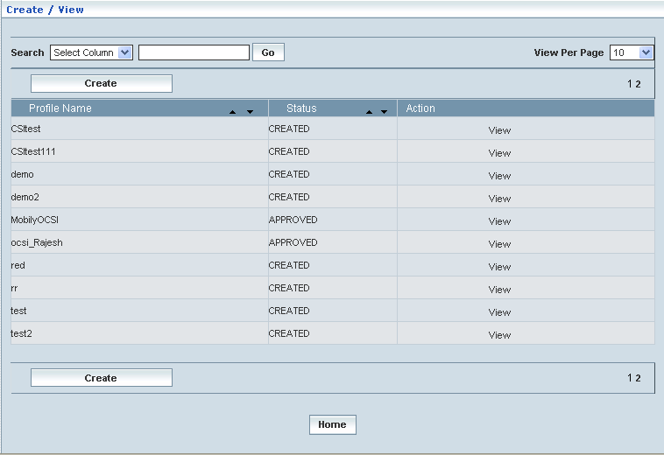

| **STEP** | | **ACTION** |
| --- | --- | --- |
|  | | By default, the list of profiles (Originating CSI) will be displayed as records in a grid. The columns include ‘Profile Name’, ‘Status’ and ‘Action’ |
|  |  | User can customize the view for the number of records to be displayed each time (per page) in a grid.  However, this option is applicable only if the total number of records exceeds 10. And also with the immediate effect of increase in the number of records more than 10, a ‘Search’ option would be dynamically displayed. |
| Select the number of records (For Ex: 10) from the drop-down list of the <View Per Page> field. |
| With the effect of choosing the desired number (10) for the display of records per page, the same (10 records) will be displayed in the grid. |
| User can sort the records in ascending and descending orders with the help of up-arrow and down-arrows respectively |
| However, based on the total number of records, page numbers will be dynamically displayed at the left bottom of the screen |
| User can navigate for subsequent records (10 each time) by clicking the desired ‘page number’ |
|  | | Status indicates the profile status whether just created (Created) or created and approved (Approved) or created but rejected (Rejected) |
|  | | On clicking the **Create** button, ‘Create’ screen will be displayed enabling the user to create a new ‘Profile’ (Originating CSI Profile) |
|  | | On clicking the **View** link of a chosen ‘Profile’, corresponding information related to the profile will be displayed in a separate screen enabling the user to peruse details of the profile |
|  | | On clicking the **Home** button at the bottom of the grid, it redirects the user to the ‘Originating CSI’ main page |

**Create**

Home Location Register 🡪 CAMEL Subscriptions 🡪 GSM CAMEL Subscriptions 🡪 Originating CSI 🡪 Create / View

Create enables the user to create a new profile (Originating CSI Profile) and attribute various values/parameters to constitute the same.

However, a new profile creation shall be based on the chosen phase (Phase1/Phase2/ Phase3/Phase4). Only the corresponding attributes/parameters will be displayed in accordance with the chosen phase for the proposed (new) **Originating CSI Profile** creation.

**First Level Screen Action:**

First level of the screen helps the user entering a name for the proposed (new) **Originating CSI Profile** and choosing a CAMEL Capability Handling attributes (Phase1, Phase2, Phase3 and Phase4) for the same.

| **STEP** | **ACTION** |
| --- | --- |
|  | User must essentially enter the details related to a new profile where it is a mandatory information |
|  | Enter name of the profile in <Profile Name> field |
|  | Select a CAMEL Capability Handling phase (Phase1, Phase2, Phase3 and Phase4) to specify the CAMEL capability handling from the drop-down list of the <CAMEL Capability Handling> field  **\*** By default, the list of phases will be dynamically displayed as drop-down list of the <CAMEL Capability Handling> field |

**New (Phase1) Originating CSI Profile**

| **STEP** | **ACTION** |
| --- | --- |
|  | With the effect of choosing CAMEL Capability Handling **Phase1**, only the corresponding attributes will be dynamically displayed, enabling the user to create new (Phase1) profile as Originating CSI  **\*** **Only the ‘Collected Info’ block will be displayed for the phase1 profile** |

The screen below shows creating a new profile as Originating CSI: the chosen CAMEL Capability Handling being the **PHASE1**.

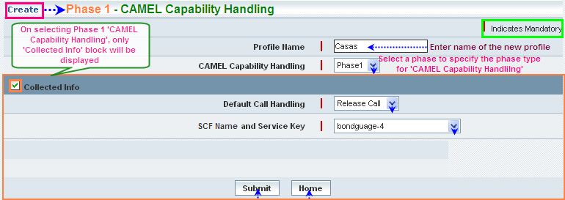

| **STEP** | **ACTION** |
| --- | --- |
|  | **Collected Info Block:**  Select the ‘Collected Info’ check box, which in turn would enable the user to enter details related to ‘Default Call Handling’ and ‘SCF Name and Service Key’ |
|  | Select a default call handling element (Continue Call or Release Call) to specify a default setting for the call handling, from the drop-down list of the <Default Call Handling> field  **\*** By default, the list of call handling elements (Continue Call / Release Call) will be dynamically displayed as drop-down list of the <Default Call Handling> field |
|  | Select a pair representing the combination of SCF Name and Service Key to specify the SCF Name & Service Key mix for the Collected Information element, from the drop-down list of the <SCF Name and Service Key> field  **\*** By default, the list of pairs representing SCF Name and Service Key will be dynamically displayed as drop-down list of the <SCF Name and Service Key> field |
|  | On clicking the **Submit** button, new **(Phase1)** profile (Originating CSI) will be created and a message window will be displayed to that effect  Wor7E  On clicking the **Home** button of the message window, it directs the user back to the Originating CSI profiles grid |
|  | On clicking the **Home** button of the ‘Create’ screen (before creating any new profile), it directs the user to the Originating CSI profiles grid |

**New (Phase2) Originating CSI Profile:**

| **STEP** | **ACTION** |
| --- | --- |
|  | With the effect of choosing CAMEL Capability Handling **Phase2**, only the corresponding attributes will be dynamically displayed, enabling the user to create new (Phase2) profile as Originating CSI  **\*** **Only the ‘Collected Info’ & ‘Basic Service Criteria’ blocks will be displayed for the phase2 profile** |

The screen below shows creating a new profile as Originating CSI: the chosen phase being the CAMEL Capability Handling **PHASE2**.

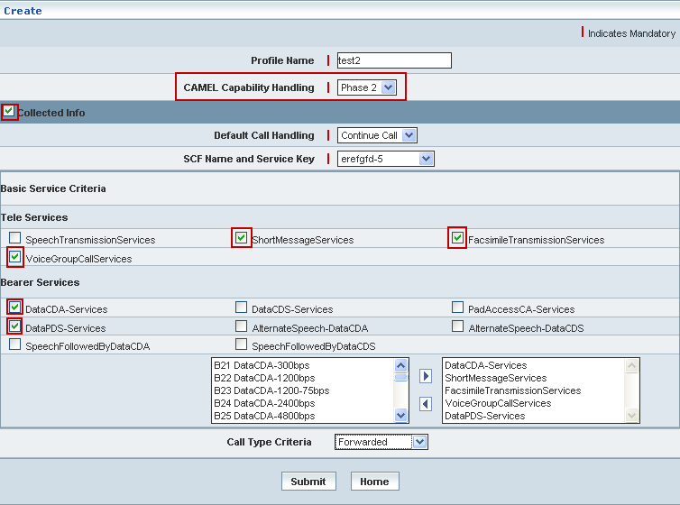

| **STEP** | **ACTION** |
| --- | --- |
|  | **Collected Info Block:**  Select the ‘Collected Info’ check box, which in turn would enable the user to enter details related to ‘Default Call Handling’ and ‘SCF Name and Service Key’ |
|  | Select a default call handling element (Continue Call or Release Call) to specify a default setting for the call handling, from the drop-down list of the <Default Call Handling> field  **\*** By default, the list of call handling elements (Continue Call / Release Call) will be dynamically displayed as drop-down list of the <Default Call Handling> field |
|  | Select a pair representing the combination of SCF Name and Service Key to specify the SCF Name & Service Key mix for the Collected Information element, from the drop-down list of the <SCF Name and Service Key> field  **\*** By default, the list of pairs representing SCF Name and Service Key will be dynamically displayed as drop-down list of the <SCF Name and Service Key> field |
|  | **Basic Service Criteria Block:**  Basic services comprise **Tele Services** and **Bearer Services**  **NOTE:** Only **5 (Five)** services (from both **Tele** and **Bearer** services) can be mapped as Basic Services criteria |
|  | **Tele Services**   * Selected Teleservices (as a string) will be dynamically moved to the text field below, which is on to the right side of the screen |
|  | **Bearer Services**   * Selected Bearer Services (as a string) will be dynamically moved to the text field below, which is on to the right side of the screen |
|  | **\*** Few services contain a list of sub-services  In this case, (on checking the specific service) the corresponding list of sub-services will be dynamically displayed in the text field, which is on to the left side of the screen  Select the desired service from the list (of the left text field) and on clicking the right-arrow button, the service (as a string) will be moved to the adjacent field  User can enter the desired number of services in a similar fashion but, subject to the maximum limitation of **5 (Five)** services  However if the user wants to just remove any service (any time before creating the profile), selecting the service from the right text field and subsequently clicking the left-arrow button removes the service |
|  | Select Call Type Criteria (Forwarded / Non-Forwarded) from the drop-down list of the <Call Type Criteria> field  **\*** By default, the list of call type criteria (Forwarded / Non- Forwarded) will be dynamically displayed as drop-down list of the <Call Forwarded> field |
|  | On clicking the **Submit** button, new profile (Originating CSI) will be created and a message window to that effect will be displayed    On clicking the **Home** button of the message window, it directs the user back to the Originating CSI profiles grid |
|  | On clicking the **Home** button of the ‘Create’ screen (before creating any new profile), it directs the user to the Originating CSI profiles grid |

**New (Phase3) Originating CSI Profile:**

| **STEP** | **ACTION** |
| --- | --- |
| **1** | With the effect of choosing CAMEL Capability Handling **Phase3**, only the corresponding attributes will be dynamically displayed, enabling the user to create new (Phase3) profile as Originating CSI  **\*** **All the attributes - ‘Collected Info’, ‘Basic Service Criteria’ & ‘Route Service Failure’ blocks will be displayed for the phase3 profile** |

The screen below shows creating a new profile as Originating CSI: the chosen phase being the CAMEL Capability Handling **PHASE3**.

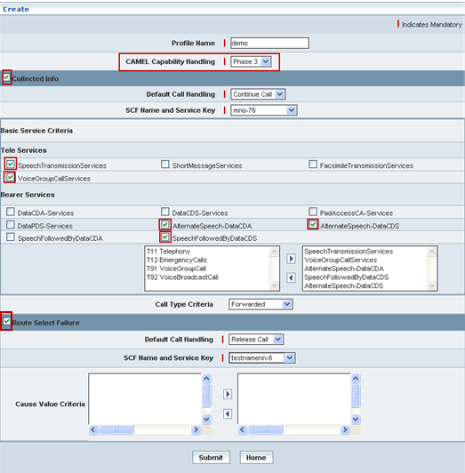

| **STEP** | **ACTION** |
| --- | --- |
|  | **Collected Info Block:**  Select the ‘Collected Info’ check box, which in turn would enable the user to enter details related to ‘Default Call Handling’ and ‘SCF Name and Service Key’ |
|  | Select a default call handling element (Continue Call or Release Call) to specify a default setting for the call handling, from the drop-down list of the <Default Call Handling> field  **\*** By default, the list of call handling elements (Continue Call / Release Call) will be dynamically displayed as drop-down list of the <Default Call Handling> field |
|  | Select a pair representing the combination of SCF Name and Service Key to specify the SCF Name & Service Key mix for the Collected Information element, from the drop-down list of the <SCF Name and Service Key> field  **\*** By default, the list of pairs representing SCF Name and Service Key will be dynamically displayed as drop-down list of the <SCF Name and Service Key> field |
|  | **Basic Service Criteria Block:**  Basic services comprise **Tele Services** and **Bearer Services**  **NOTE:** Only **5 (Five)** services (from both **Tele** and **Bearer** services) can be mapped as Basic Services criteria |
|  | **Tele Services**   * Selected Teleservices (as a string) will be dynamically moved to the text field below, which is on to the right side of the screen |
|  | **Bearer Services**   * Selected Bearer Services (as a string) will be dynamically moved to the text field below, which is on to the right side of the screen |
|  | **\*** Few services contain a list of sub-services  In this case, (on checking the specific service) the corresponding list of sub-services will be dynamically displayed in the text field, which is on to the left side of the screen  Select the desired service from the list (of the left text field) and on clicking the right-arrow button, the service (as a string) will be moved to the adjacent field  User can enter the desired number of services in a similar fashion but, subject to the maximum limitation of **5 (Five)** services  However if the user wants to just remove any service (any time before creating the profile), selecting the service from the right text field and subsequently clicking the left-arrow button removes the service |
|  | Select Call Type Criteria (Forwarded / Non-Forwarded) from the drop-down list of the <Call Type Criteria> field  **\*** By default, the list of call type criteria (Forwarded / Non- Forwarded) will be dynamically displayed as drop-down list of the <Call Forwarded> field |
|  | **Route Select Failure Block:**  Select the ‘Route Select Failure’ check box, which in turn would enable the user to configure parameters for ‘Default Call Handling’, ‘SCF Name and Service Key’ and the Cause Value Criteria |
|  | Select a default setting for Call Handling (Continue Call or Release Call) to specify the default call handling from the drop-down list of the <Default Call Handling> field  **\*** By default, the list of call handling types will be dynamically displayed as drop-down list of the < Default Call Handling> field |
|  | Select a pair representing the combination of SCF Name and Service Key to specify the SCF Name & Service Key mix for the Route Select Failure element, from the drop-down list of the <SCF Name and Service Key> field  * By default, the list of pairs representing SCF Name and Service Key will be dynamically displayed as drop-down list of the <SCF Name and Service Key> field |
|  | The default list of Cause Value Criteria will be dynamically displayed in the text field, which is on to the left side of the screen  Select the desired cause value from the list (of the left text field) and on clicking the right-arrow button, the cause value (as a string) will be moved to the adjacent field  User can enter the desired number of cause values in a similar fashion but, subject to the maximum limitation of **5 (Five)** cause values  However if the user wants to just remove any cause value (any time before creating the profile), selecting the cause value from the right text field and subsequently clicking the left-arrow button removes the service |
|  | On clicking the **Submit** button, new profile (Originating CSI) will be created and a message window to that effect will be displayed    On clicking the **Home** button of the message window, it directs the user back to the Originating CSI profiles grid |
|  | On clicking the **Home** button of the ‘Create’ screen (before creating any new profile), it directs the user to the Originating CSI profiles grid |

**New (Phase4) Originating CSI Profile:**

| **STEP** | **ACTION** |
| --- | --- |
|  | With the effect of choosing CAMEL Capability Handling **Phase4**, only the corresponding attributes will be dynamically displayed, enabling the user to create new (Phase4) profile as Originating CSI  **\*** **All the attributes - ‘Collected Info’, ‘Basic Service Criteria’ & ‘Route Service Failure’ blocks will be displayed for the phase4 profile**  **NOTE:** **The process of creating Phase4 Profile (Originating CSI) is similar to the process of creating Phase3 Profile (Originating CSI) as mentioned above.** |

**View**

Home Location Register 🡪 CAMEL Subscriptions 🡪 GSM CAMEL Subscriptions 🡪 Originating CSI 🡪 Create / View

View enables the user to peruse details related to chosen profile (Originating CSI).

On clicking the **‘View’** link of a chosen ‘Profile’ (from the Originating CSI Profiles List); corresponding information related to the profile will be displayed in a separate screen enabling the user to peruse details of the profile.

The screen below displays the details related to chosen profile (Originating CSI)

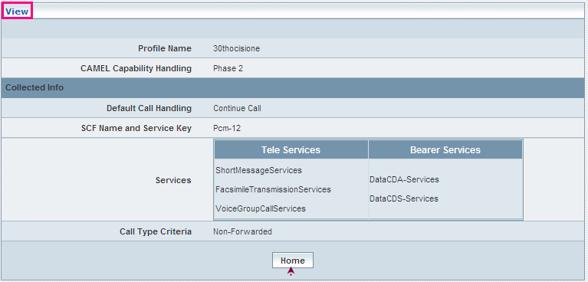

| **STEP** | **ACTION** |
| --- | --- |
|  | User can peruse details related to the chosen Originating CSI Profile |
|  | On clicking the **Home** button at the bottom of the ‘View’ Screen, it redirects the user to the ‘Originating CSI’ profiles grid |

**Searching for a specific Originating CSI Profile (Record)**

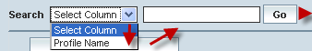

| **STEP** | **ACTION** |
| --- | --- |
|  | Select a search criterion (‘PLMN Name’) from the drop-down list of the search criteria of the <Search> field  **\*** By default the list of search criterion (‘PLMN Name’) will be dynamically displayed as drop-down list of the <Search> field |
|  | Enter the ‘PLMN Name’ that corresponds with the given search criterion |
|  | On clicking the **Go** button, the corresponding Originating CSI profiles (record) will be highlighted among the list of Originating CSI profiles records. |

The screen below depicts fetching and displaying the give Originating CSI profiles record.

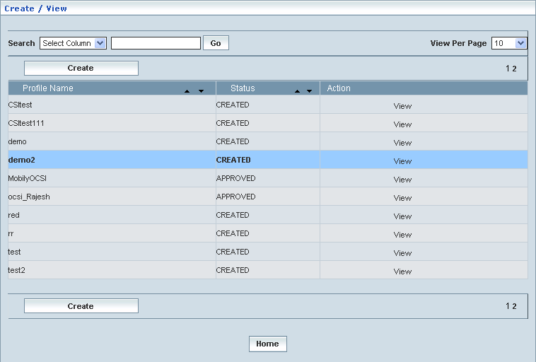

**Manage**

Home Location Register 🡪 CAMEL Subscriptions 🡪 GSM CAMEL Subscriptions 🡪 Originating CSI 🡪 Manage

‘Manage’ helps the user modifying and deleting (managing) a chosen Originating CSI profile that was created, but still to be approved. Initially, the screen displays the list of Originating CSI profiles that were configured and created.

The screen below shows the list of various Originating CSI (Profiles) configurations in a grid.

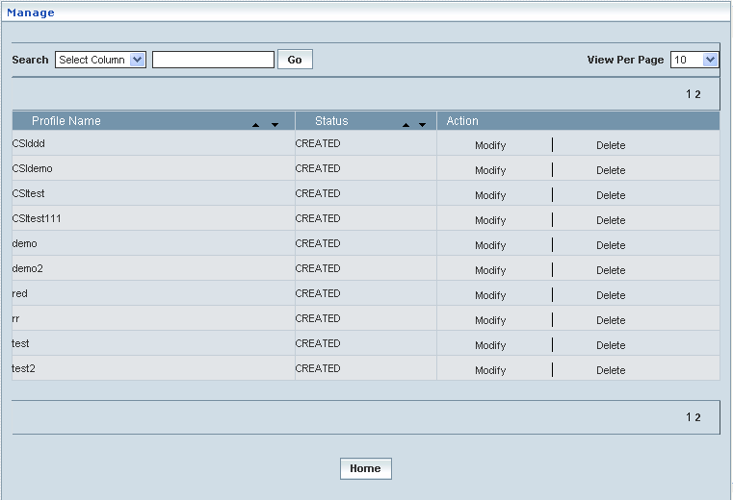

| **STEP** | | **ACTION** |
| --- | --- | --- |
|  | | By default, the list of profiles will be displayed as records in a grid. The columns include ‘Profile Name’, ‘Status’ and ‘Action’ |
|  |  | User can customize the view for the number of records to be displayed each time (per page) in a grid.  However, this option is applicable only if the total number of records exceeds 10. And also with the immediate effect of increase in the number of records more than 10, a ‘Search’ option would be dynamically displayed. |
| Select the number of records (For Ex: 10) from the drop-down list of the <View Per Page> field. |
| With the effect of choosing the desired number (10) for the display of records per page, the same (10 records) will be displayed in the grid. |
| User can sort the records in ascending and descending orders with the help of up-arrow and down-arrows respectively |
| However, based on the total number of records, page numbers will be dynamically displayed at the left bottom of the screen |
| User can navigate for subsequent records (10 each time) by clicking the desired ‘page number’ |
|  | | On clicking the **Modify** link of a chosen ‘Profile’, corresponding information related to the profile will be displayed in a separate screen enabling the user to modify / update details of the profile |
|  | | On clicking the **Delete** link of a chosen ‘Profile’, corresponding information related to the profile will be displayed in a separate screen enabling the user to delete the profile |
|  | | On clicking the **Home** button at the bottom of the grid, it redirects the user to the ‘Originating CSI’ main page |

**Modify**

Home Location Register 🡪 CAMEL Subscriptions 🡪 GSM CAMEL Subscriptions 🡪 Originating CSI 🡪 Manage 🡪 Modify

Modify enables the user to modify / update the details related to an existing Originating CSI profile that was just created, however, was still not approved.

On clicking the **‘Modify’** link of a chosen ‘Profile’ (from the Originating CSI Profiles List); corresponding information related to the profile will be displayed in a separate screen enabling the user to modify / update details of the profile.

The screen below shows modifying / updating the details related to an existing Originating CSI profile.

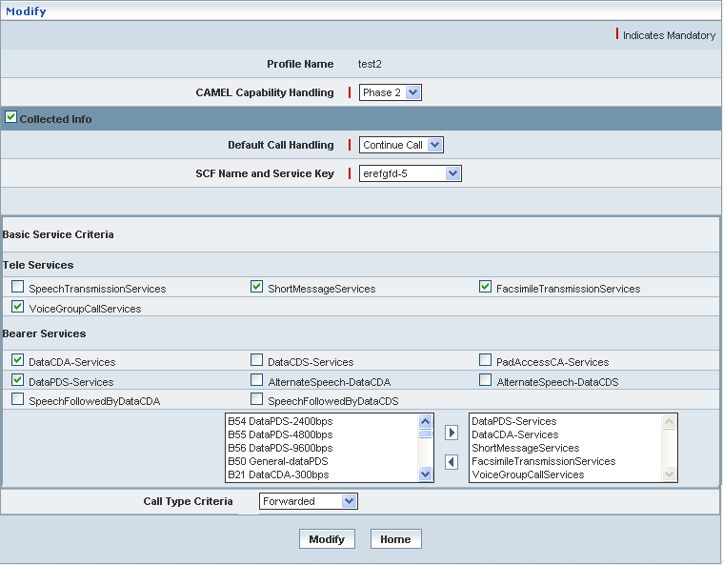

| **STEP** | **ACTION** |
| --- | --- |
|  | Name of the profile will be dynamically displayed in the <Profile Name> field and this cannot be modified |
|  | User can make necessary changes / updates to the existing values / configurations of the profile, yet subject to the stipulations related to mapping parameters |
|  | On clicking the **Modify** button at the bottom of the ‘Modify’ screen, profile (Originating CSI) details will be updated accordingly and a message window to that effect will be displayed    On clicking the **Home** button of the message window, it directs the user back to the ‘Originating CSI’ profiles grid |
|  | On clicking the **Home** button of the ‘Modify’ screen (before updating the details related to profile), it directs the user to the ‘Originating CSI profiles’ grid |

**Delete**

Home Location Register 🡪 CAMEL Subscriptions 🡪 GSM CAMEL Subscriptions 🡪 Originating CSI 🡪 Manage 🡪 Delete

Delete enables the user to delete an existing Originating CSI profile that was just created, however, was still not approved.

On clicking the **‘Delete’** link of a chosen ‘Profile’ (from the Originating CSI Profiles List); corresponding information related to the profile will be displayed in a separate screen enabling the user to delete the profile.

The screen below shows the details related to an existing Originating CSI profile, which enables the user to delete the same (Profile).

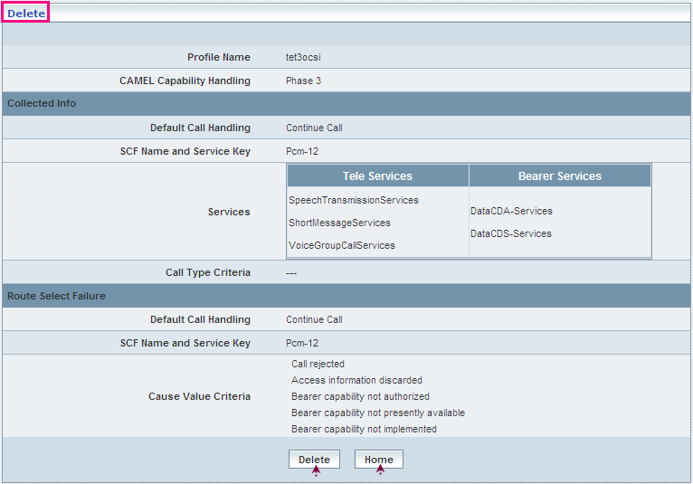

| **STEP** | **ACTION** |
| --- | --- |
|  | User can peruse the existing values / configurations of the profile before deleting the profile |
|  | On clicking the Delete at the bottom of the ‘Delete’ screen, it displays an alert window enabling the user to confirm deletion of the chosen profile (Originating CSI)  SNAGHTMLb8f185  On clicking the **OK** button of the alert window, the chosen Originating CSI profile will be deleted and a message window to that effect will be displayed    On clicking the **Cancel** button of the alert window, it retains the corresponding ‘Delete’ screen  On clicking the **Home** button of the message window, it directs the user back to the ‘Originating CSI’ profiles grid |
|  | On clicking the **Home** button of the ‘Delete’ screen (before deleting the profile), it directs the user to the ‘Originating CSI’ profiles grid |

**Searching for a specific Originating CSI profiles (Record)**

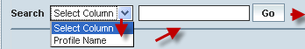

| **STEP** | **ACTION** |
| --- | --- |
|  | Select a search criterion (‘Profile Name’) from the drop-down list of the search criteria of the <Search> field  **\*** By default the list of search criterion (‘Profile Name’) will be dynamically displayed as drop-down list of the <Search> field |
|  | Enter the ‘Profile Name’ that corresponds with the given search criterion |
|  | On clicking the **Go** button, the corresponding Originating CSI Profiles (record) will be highlighted among the list of Originating CSI Profiles records. |

The screen below depicts fetching and displaying the give Originating CSI Profiles record.

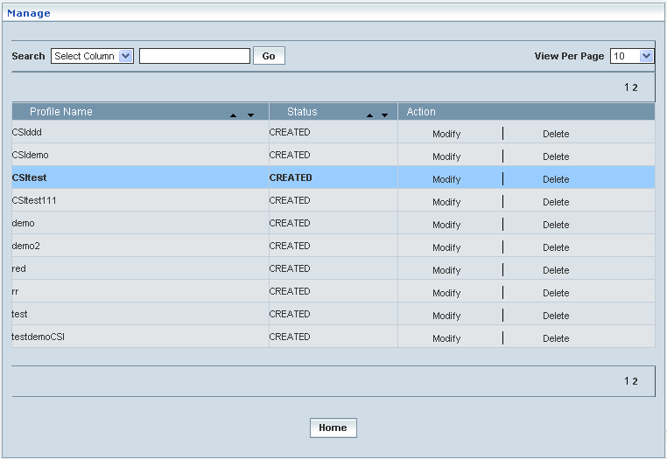

## Terminating CSI

Terminating CSI enables the user to configure parameters related to CAMEL Subscription Information (CSI) in terms of mobile termination (MT) perspective. This helps creating various Terminating CSI profiles, which in turn provide a wider flexibility in attributing the same to different customer subscription types.

The Terminating CSI data defines the contents of the dialled service CAMEL subscription information that is used to inter-work with the GSMSCF for MT calls.

**Create/View**

Home Location Register 🡪 CAMEL Subscriptions 🡪 GSM CAMEL Subscriptions 🡪 Terminating CSI 🡪 Create/View

Initially, ‘Terminating CSI’ displays a grid showing the list of existing Terminating CSI Profiles that are configured and created. This list may include those profiles that are created and approved, created and rejected and also those created but still to be approved or rejected.

The screen below shows the list of various Terminating CSI configurations in a grid.

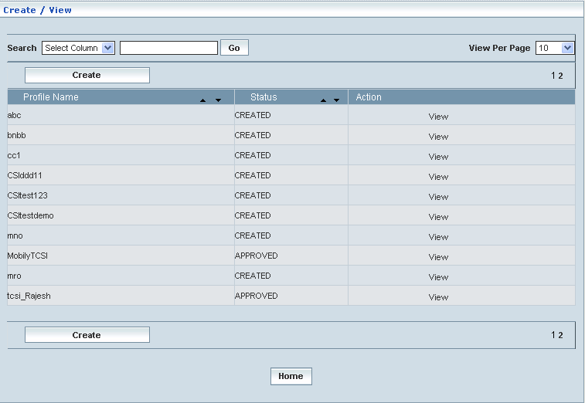

| **STEP** | | **ACTION** |
| --- | --- | --- |
|  | | By default, the list of profiles (Terminating CSI) will be displayed as records in a grid. The columns include ‘Profile Name’, ‘Status’ and ‘Action’ |
|  |  | User can customize the view for the number of records to be displayed each time (per page) in a grid.  However, this option is applicable only if the total number of records exceeds 10. And also with the immediate effect of increase in the number of records more than 10, a ‘Search’ option would be dynamically displayed. |
| Select the number of records (For Ex: 10) from the drop-down list of the <View Per Page> field. |
| With the effect of choosing the desired number (10) for the display of records per page, the same (10 records) will be displayed in the grid. |
| User can sort the records in ascending and descending orders with the help of up-arrow and down-arrows respectively |
| However, based on the total number of records, page numbers will be dynamically displayed at the left bottom of the screen |
| User can navigate for subsequent records (10 each time) by clicking the desired ‘page number’ |
|  | | Status indicates the profile status whether just created (Created) or created and approved (Approved) or created but rejected (Rejected) |
|  | | On clicking the **Create** button, ‘Create’ screen will be displayed enabling the user to create a new ‘Profile’ (Terminating CSI Profile) |
|  | | On clicking the **View** link of a chosen ‘Profile’, corresponding information related to the profile will be displayed in a separate screen enabling the user to peruse details of the profile |
|  | | On clicking the **Home** button at the bottom of the grid, it redirects the user to the ‘Terminating CSI’ main page |

**Create:**

Home Location Register 🡪 CAMEL Subscriptions 🡪 GSM CAMEL Subscriptions 🡪 Terminating CSI 🡪 Create / View

Create enables the user to create a new profile (Terminating CSI Profile) and attribute various values to constitute the same.

However, a new profile creation shall be based on the chosen CAMEL Capability Handling (Phase1/Phase2/ Phase3/Phase4). Only the corresponding attributes/parameters will be displayed in accordance with the chosen phase for the proposed (new) **Terminating CSI Profile** creation.

**First Level Screen Action:**

First level of the screen helps the user entering a name for the proposed (new) **Terminating CSI Profile** and choosing a phase (Phase1, Phase2, Phase3 and Phase4) for the same.

| **STEP** | **ACTION** |
| --- | --- |
|  | User must essentially enter the details related to a new profile where it is a mandatory information |
|  | Enter name of the profile in <Profile Name> field |
|  | Select a phase (Phase1, Phase2, Phase3 and Phase4) to specify the CAMEL capability handling from the drop-down list of the <CAMEL Capability Handling> field  **\*** By default, the list of phases will be dynamically displayed as drop-down list of the <CAMEL Capability Handling> field |

**New (Phase1) Terminating CSI Profile:**

| **STEP** | **ACTION** |
| --- | --- |
|  | With the effect of choosing CAMEL Capability Handling **Phase1**, only the corresponding attributes will be dynamically displayed, enabling the user to create new (Phase1) profile as Terminating CSI  **\*** **Only the ‘Term Attempt Authorized’ block will be displayed for the phase1 profile** |

The screen below shows creating a new profile as Terminating CSI: the chosen phase being the CAMEL Capability Handling **PHASE1**.

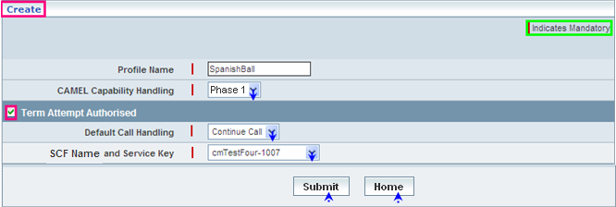

| **STEP** | **ACTION** |
| --- | --- |
|  | **Term Attempt Authorized Block:**  Select the ‘Term Attempt Authorized’ check box, which in turn would enable the user to   * enter details related to ‘Default Call Handling’ and ‘SCF Name and Service Key’ |
|  | Select a default Call Handling Element (Continue Call or Release Call) to specify a default setting for the call handling, from the drop-down list of the <Default Call Handling> field  **\*** By default, the list of call handling elements (Continue Call / Release Call) will be dynamically displayed as drop-down list of the <Default Call Handling> field |
|  | Select a pair representing the combination of SCF Name and Service Key to specify the SCF Name & Service Key mix for the ‘Term Attempt Authorized’ element, from the drop-down list of the <SCF Name and Service Key> field  * By default, the list of pairs representing SCF Name and Service Key will be dynamically displayed as drop-down list of the <SCF Name and Service Key> field |
|  | On clicking the **Submit** button, new profile Phase1 (Terminating CSI) will be created and a message window to that effect will be displayed  WorC  On clicking the **Home** button of the message window, it directs the user back to the ‘Terminating CSI’ profiles grid |
|  | On clicking the **Home** button of the ‘Create’ screen (before creating any new profile), it directs the user to the ‘Terminating CSI’ profiles grid |

**New (Phase2) Terminating CSI Profile:**

| **STEP** | **ACTION** |
| --- | --- |
|  | With the effect of choosing CAMEL Capability Handing **Phase2**, only the corresponding attributes will be dynamically displayed, enabling the user to create new (Phase2) profile as Terminating CSI  **\*** **Only the ‘Term Attempt Authorized’ block will be displayed for the phase2 profile**  **NOTE:** **The process of creating Phase2 Profile (Terminating CSI) is similar to the process of creating Phase1 Profile (Terminating CSI) as mentioned above.** |

**New (Phase3) Terminating CSI Profile:**

| **STEP** | **ACTION** |
| --- | --- |
|  | With the effect of choosing CAMEL Capability Handling **Phase3**, only the corresponding attributes will be dynamically displayed, enabling the user to create new (Phase3) profile as Terminating CSI  **\*** **All the attributes; ‘Term Attempt Authorized’, ‘Basic Service Criteria’, ‘TBusy’ and ‘TNo Answer’ blocks will be displayed for the phase3 profile** |

The screen below shows creating a new profile as Terminating CSI: the chosen phase being the CAMEL Capability Handing **PHASE3**.

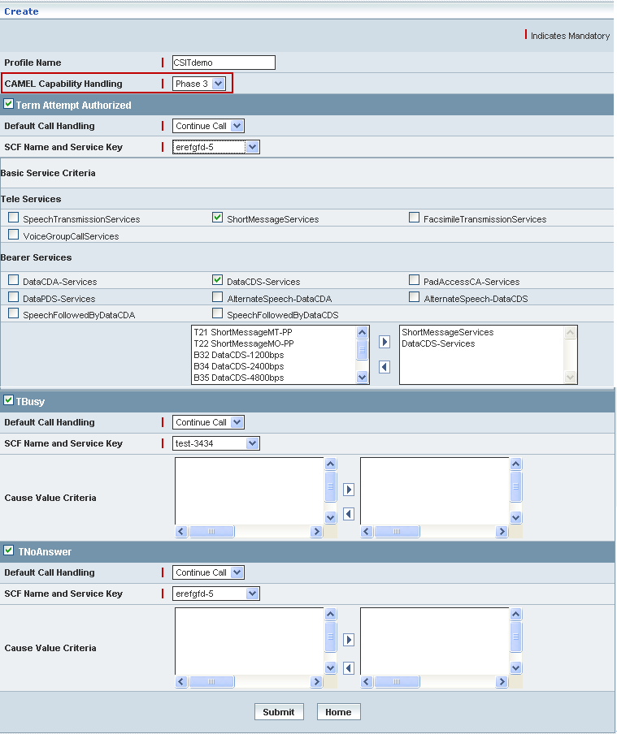

| **STEP** | **ACTION** |
| --- | --- |
|  | **Term Attempt Authorized Block:**  Select the ‘Term Attempt Authorized’ check box, which in turn would enable the user to   * enter details related to ‘Default Call Handling’ and ‘SCF Name and Service Key’ * configure Basic Service Criteria |
|  | Select a default call handling element (Continue Call or Release Call) to specify a default setting for the call handling, from the drop-down list of the <Default Call Handling> field  **\*** By default, the list of call handling elements (Continue Call / Release Call) will be dynamically displayed as drop-down list of the <Default Call Handling> field |
|  | Select a pair representing the combination of SCF Name and Service Key to specify the SCF Name & Service Key mix for the ‘Term Attempt Authorized’ element, from the drop-down list of the <SCF Name and Service Key> field  * By default, the list of pairs representing SCF Name and Service Key will be dynamically displayed as drop-down list of the <SCF Name and Service Key> field |
|  | **Basic Service Criteria:**  Basic services comprise **Tele Services** and **Bearer Services**  **NOTE:** Only **5 (Five)** services (from both Tele and Bearer services) can be mapped as Basic Services criteria |
|  | **Tele Services**   * Selected Teleservices (as a string) will be dynamically moved to the text field below, which is on to the right side of the screen |
|  | **Bearer Services**   * Selected Bearer Services (as a string) will be dynamically moved to the text field below, which is on to the right side of the screen |
|  | **\*** Few services contain a list of sub-services  In this case, (on checking the specific service) the corresponding list of sub-services will be dynamically displayed in the text field, which is on to the left side of the screen  Select the desired service from the list (of the left text field) and on clicking the right-arrow button, the service (as a string) will be moved to the adjacent field  User can enter the desired number of services in a similar fashion but, subject to the maximum limitation of **5 (Five)** services  However if the user wants to just remove any service (any time before creating the profile), selecting the service from the right text field and subsequently clicking the left-arrow button removes the service |
|  | **TBusy Block:**  Select the ‘TBusy’ check box, which in turn would enable the user to configure parameters for ‘Default Call Handling’, ‘SCF Name and Service Key’ and configure the Cause Value Criteria |
|  | Select a default setting for Call Handling (Continue Call or Release Call) to specify the default call handling from the drop-down list of the <Default Call Handling> field  **\*** By default, the list of call handling types will be dynamically displayed as drop-down list of the < Default Call Handling> field |
|  | Select a pair representing the combination of SCF Name and Service Key to specify the SCF Name & Service Key mix for the ‘TBusy’ element, from the drop-down list of the <SCF Name and Service Key> field  * By default, the list of pairs representing SCF Name and Service Key will be dynamically displayed as drop-down list of the <SCF Name and Service Key> field |
|  | The default list of Cause Value Criteria will be dynamically displayed in the text field, which is on to the left side of the screen  Select the desired cause value from the list (of the left text field) and on clicking the right-arrow button, the cause value (as a string) will be moved to the adjacent field  User can enter the desired number of cause values in a similar fashion but, subject to the maximum limitation of **5 (Five)** cause values  However if the user wants to just remove any cause value (any time before creating the profile), selecting the cause value from the right text field and subsequently clicking the left-arrow button removes the service |
|  | **TNoAnswer Block:**  Check the ‘TNoAnswer’ check box, which in turn would enable the user to configure parameters for ‘Default Call Handling’, ‘SCF Name and Service Key’ and configure the Cause Value Criteria |
|  | Select a default setting for Call Handling (Continue Call or Release Call) to specify the default call handling from the drop-down list of the <Default Call Handling> field  **\*** By default, the list of call handling types will be dynamically displayed as drop-down list of the < Default Call Handling> field |
|  | Select a pair representing the combination of SCF Name and Service Key to specify the SCF Name & Service Key mix for the ‘TNoAnswer’ element, from the drop-down list of the <SCF Name and Service Key> field  * By default, the list of pairs representing SCF Name and Service Key will be dynamically displayed as drop-down list of the <SCF Name and Service Key> field |
|  | The default list of Cause Value Criteria will be dynamically displayed in the text field, which is on to the left side of the screen  Select the desired cause value from the list (of the left text field) and on clicking the right-arrow button, the cause value (as a string) will be moved to the adjacent field  User can enter the desired number of cause values in a similar fashion but, subject to the maximum limitation of **5 (Five)** cause values  However if the user wants to just remove any cause value (any time before creating the profile), selecting the cause value from the right text field and subsequently clicking the left-arrow button removes the service |
|  | On clicking the **Submit** button, new profile (Terminating CSI) will be created and a message window to that effect will be displayed  WorC  On clicking the **Home** button of the message window, it directs the user back to the Terminating CSI profiles grid |
|  | On clicking the **Home** button of the ‘Create’ screen (before creating any new profile), it directs the user to the Terminating CSI profiles grid |

**New (Phase4) Terminating CSI Profile:**

| **STEP** | **ACTION** |
| --- | --- |
|  | With the effect of choosing CAMEL Capability Handling **Phase4**, only the corresponding attributes will be dynamically displayed, enabling the user to create new (Phase4) profile as Terminating CSI  **\*** **All the attributes; ‘Term Attempt Authorized’, ‘Basic Service Criteria’, ‘T-Busy’ and ‘T-No Answer’ blocks will be displayed for the phase4 profile**  **NOTE:** **The process of creating Phase4 Profile (Terminating CSI) is similar to the process of creating Phase3 Profile (Terminating CSI) as mentioned above.** |

**View**

Home Location Register 🡪 CAMEL Subscriptions 🡪 GSM CAMEL Subscriptions 🡪 Terminating CSI 🡪 Create / View

View enables the user to peruse details related to chosen profile (Terminating CSI).

On clicking the **‘View’** link of a chosen ‘Profile’ (from the Termination CSI Profiles List); corresponding information related to the profile will be displayed in a separate screen enabling the user to peruse details of the profile.

The screen below displays the details related to chosen profile (Terminating CSI)

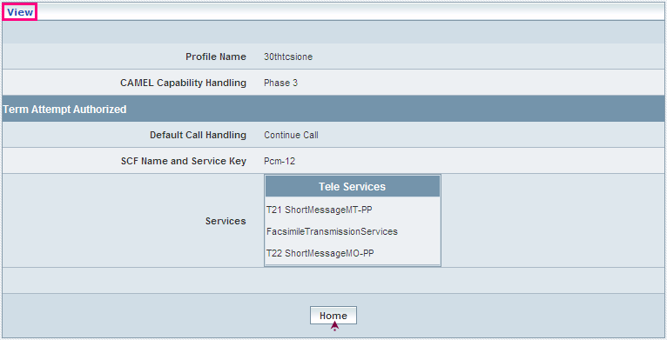

| **STEP** | **ACTION** |
| --- | --- |
|  | User can peruse details related to the chosen ‘Terminating CSI’ Profile |
|  | On clicking the **Home** button at the bottom of the ‘View’ Screen’’, it redirects the user to the ‘Terminating CSI’ profiles grid |

**Searching for a specific ‘Terminating CSI’ profiles (Record)**



| **STEP** | **ACTION** |
| --- | --- |
|  | Select a search criterion (‘Profile Name’) from the drop-down list of the search criteria of the <Search> field  **\*** By default the list of search criterion (‘Profile Name’) will be dynamically displayed as drop-down list of the <Search> field |
|  | Enter the ‘Profile Name’ that corresponds with the given search criterion |
|  | On clicking the **Go** button, the corresponding Terminating CSI profiles (record) will be highlighted among the list of Terminating CSI profiles records. |

The screen below depicts fetching and displaying the give Terminating CSI profiles record.

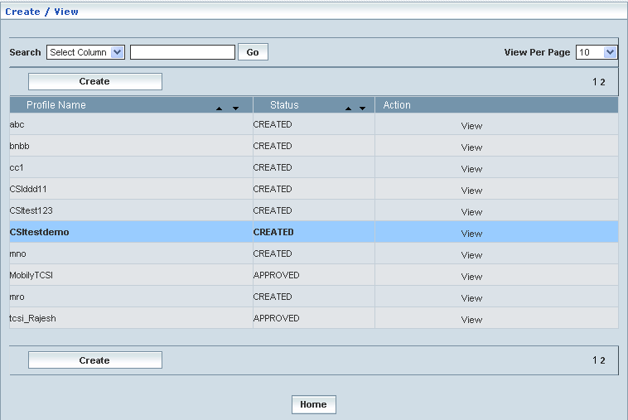

**Manage**

Home Location Register 🡪 CAMEL Subscriptions 🡪 GSM CAMEL Subscriptions 🡪 Terminating CSI 🡪 Manage

‘Manage’ helps the user modifying and deleting (managing) a chosen Terminating CSI profile that was created, but still to be approved

Initially, the screen displays the list of Terminating CSI profiles that were configured and created.

The screen below shows the list of various Terminating CSI (Profiles) configurations in a grid.

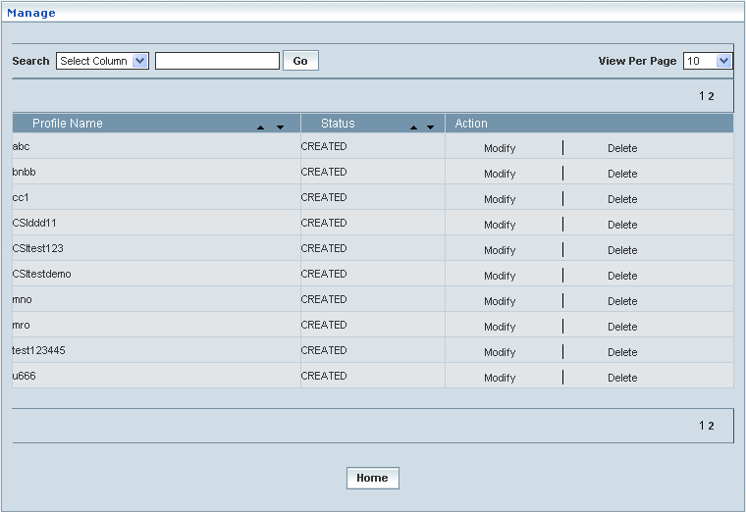

| **STEP** | | **ACTION** |
| --- | --- | --- |
|  | | By default, the list of profiles will be displayed as records in a grid. The columns include ‘Profile Name’, ‘Status’ and ‘Action’ |
|  |  | User can customize the view for the number of records to be displayed each time (per page) in a grid.  However, this option is applicable only if the total number of records exceeds 10. And also with the immediate effect of increase in the number of records more than 10, a ‘Search’ option would be dynamically displayed. |
| Select the number of records (For Ex: 10) from the drop-down list of the <View Per Page> field. |
| With the effect of choosing the desired number (10) for the display of records per page, the same (10 records) will be displayed in the grid. |
| User can sort the records in ascending and descending orders with the help of up-arrow and down-arrows respectively |
| However, based on the total number of records, page numbers will be dynamically displayed at the left bottom of the screen |
| User can navigate for subsequent records (10 each time) by clicking the desired ‘page number’ |
|  | | On clicking the **Modify** link of a chosen ‘Profile’, corresponding information related to the profile will be displayed in a separate screen enabling the user to modify / update details of the profile |
|  | | On clicking the **Delete** link of a chosen ‘Profile’, corresponding information related to the profile will be displayed in a separate screen enabling the user to delete the profile |
|  | | On clicking the **Home** button at the bottom of the grid, it redirects the user to the ‘Terminating CSI’ main page |

**Modify**

Home Location Register 🡪 CAMEL Subscriptions 🡪 GSM CAMEL Subscriptions 🡪 Terminating CSI 🡪 Manage 🡪 Modify

Modify enables the user to modify / update the details related to an existing Terminating CSI profile.

On clicking the **‘Modify’** link of a chosen ‘Profile’ (from the Termination CSI Profiles List); corresponding information related to the profile will be displayed in a separate screen enabling the user to modify / update details of the profile.

The screen below shows modifying / updating the details related to an existing Terminating CSI profile.

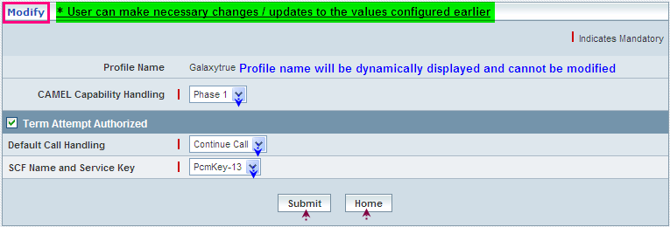

| **STEP** | **ACTION** |
| --- | --- |
|  | Name of the profile will be dynamically displayed in the <Profile Name> field and this cannot be modified |
|  | User can make necessary changes / updates to the existing values / configurations of the profile, yet subject to the stipulations related to mapping parameters |
|  | On clicking the **Modify** button at the bottom of the ‘Modify’ screen, profile (Terminating CSI) details will be updated accordingly and a message window to that effect will be displayed    On clicking the **Home** button of the message window, it directs the user back to the Terminating CSI profiles grid |
|  | On clicking the **Home** button of the ‘Modify’ screen (before updating the details related to profile), it directs the user to the Terminating CSI profiles grid |

**Delete**

Home Location Register 🡪 CAMEL Subscriptions 🡪 GSM CAMEL Subscriptions 🡪 Terminating CSI 🡪 Manage 🡪 Delete

Delete enables the user to delete an existing Terminating CSI profile.

On clicking the **‘Delete’** link of a chosen ‘Profile’ (from the Termination CSI Profiles List); corresponding information related to the profile will be displayed in a separate screen enabling the user to delete the profile.

The screen below shows the details related to an existing Terminating CSI profile, which enables the user to delete the same (Profile).

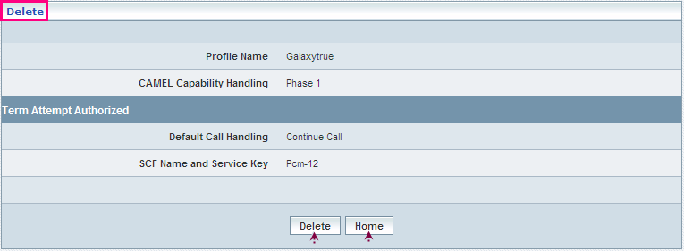

| **STEP** | **ACTION** |
| --- | --- |
|  | User can peruse the existing values / configurations of the profile before deleting the profile |
|  | On clicking the **Delete** at the bottom of the ‘Delete’ screen, it displays an alert window enabling the user to confirm deletion of the chosen profile (Terminating CSI)  Wor6  On clicking the **OK** button of the alert window, the chosen Terminating CSI profile will be deleted and a message window to that effect will be displayed    On clicking the **Cancel** button of the alert window, it retains the corresponding ‘Delete’ screen  On clicking the **Home** button of the message window, it directs the user back to the ‘Terminating CSI’ profiles grid |
|  | On clicking the **Home** button of the ‘Delete’ screen (before deleting the profile), it directs the user to the ‘Terminating CSI’ profiles grid |

**Searching for a specific ‘Terminating CSI’ Profiles (Record)**



| **STEP** | **ACTION** |
| --- | --- |
|  | Select a search criterion (‘Profile Name’) from the drop-down list of the search criteria of the <Search> field  **\*** By default the list of search criterion (‘Profile Name’) will be dynamically displayed as drop-down list of the <Search> field |
|  | Enter the ‘Profile Name’ that corresponds with the given search criterion |
|  | On clicking the **Go** button, the corresponding Terminating CSI Profiles (record) will be highlighted among the list of Terminating CSI Profiles records. |

The screen below depicts fetching and displaying the give Terminating CSI Profiles record.

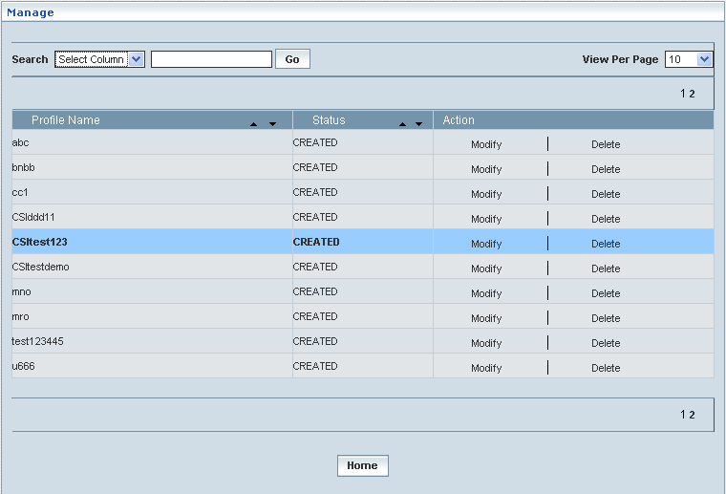

## VMSC Terminating CSI

VMSC Terminating CSI enables the user to configure parameters related to CAMEL Subscription Information (CSI) in terms of (Visiting Location - mobile termination) (V- MT) perspective. This helps creating various VMSC Terminating CSI profiles, which in turn provide a wider flexibility in attributing the same to different customer subscription types.

The VMSC Terminating CSI data defines the contents of the dialled service CAMEL subscription information that is used by the VMSC to inter-work with the GSMSCF for MT calls.

**Create/View**

Home Location Register 🡪 CAMEL Subscriptions 🡪 GSM CAMEL Subscriptions 🡪 VMSC Terminating CSI 🡪 Create / View

Initially, ‘VMSC Terminating CSI’ displays a grid showing the list of existing VMSC Terminating CSI Profiles that are configured and created. This list may include those profiles that are created and approved, created and rejected and also those created but still to be approved or rejected.

The screen below shows the list of various VMSC Terminating CSI configurations in a grid.

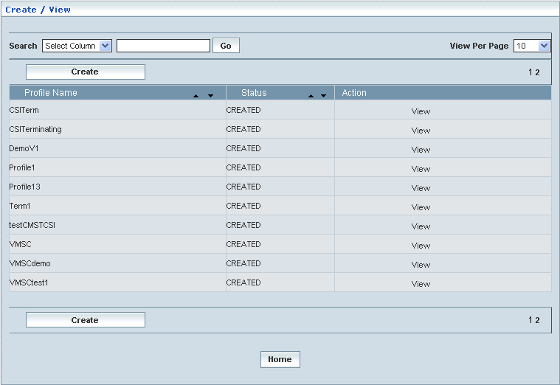

| **STEP** | | **ACTION** |
| --- | --- | --- |
|  | | By default, the list of profiles (VMSC Terminating CSI) will be displayed as records in a grid. The columns include ‘Profile Name’, ‘Status’ and ‘Action’ |
|  |  | User can customize the view for the number of records to be displayed each time (per page) in a grid.  However, this option is applicable only if the total number of records exceeds 10. And also with the immediate effect of increase in the number of records more than 10, a ‘Search’ option would be dynamically displayed. |
| Select the number of records (For Ex: 10) from the drop-down list of the <View Per Page> field. |
| With the effect of choosing the desired number (10) for the display of records per page, the same (10 records) will be displayed in the grid. |
| User can sort the records in ascending and descending orders with the help of up-arrow and down-arrows respectively |
| However, based on the total number of records, page numbers will be dynamically displayed at the left bottom of the screen |
| User can navigate for subsequent records (10 each time) by clicking the desired ‘page number’ |
|  | | Status indicates the profile status whether just created (Created) or created and approved (Approved) or created but rejected (Rejected) |
|  | | On clicking the **Create** button, ‘Create’ screen will be displayed enabling the user to create a new ‘Profile’ (VMSC Terminating CSI Profile) |
|  | | On clicking the **View** link of a chosen ‘Profile’, corresponding information related to the profile will be displayed in a separate screen enabling the user to peruse details of the profile |
|  | | On clicking the **Home** button at the bottom of the grid, it redirects the user to the ‘VMSC Terminating CSI’ main page |

**Create**

Home Location Register 🡪 CAMEL Subscriptions 🡪 GSM CAMEL Subscriptions 🡪 VMSC Terminating CSI 🡪 Create / View

Create enables the user to create a new profile (VMSC Terminating CSI Profile) and attribute various values to constitute the same.

**NOTE:** Only two CAMEL Capability Handling phases (Phase3 & Phase4) are relatable to **VMSC** **Terminating CSI Profile** creation. However, a new profile creation shall be based on the chosen phase (Phase3/Phase4).

**First Level Screen Action:**

First level of the screen helps the user entering a name for the proposed (new) **VMSC** **Terminating CSI Profile** and choosing a CAMEL Capability Handling phase (Phase3/Phase4) for the same.

| **STEP** | **ACTION** |
| --- | --- |
|  | User must essentially enter the details related to a new profile where it is a mandatory information |
|  | Enter name of the profile in <Profile Name> field |
|  | Select a phase (Phase3/Phase4) to specify the CAMEL capability handling from the drop-down list of the <CAMEL Capability Handling> field  **\*** By default, the list of phases (Only Phase3 & Phase4) will be dynamically displayed as drop-down list of the <CAMEL Capability Handling> field |

The screen below shows creating a new profile as VMSC Terminating CSI

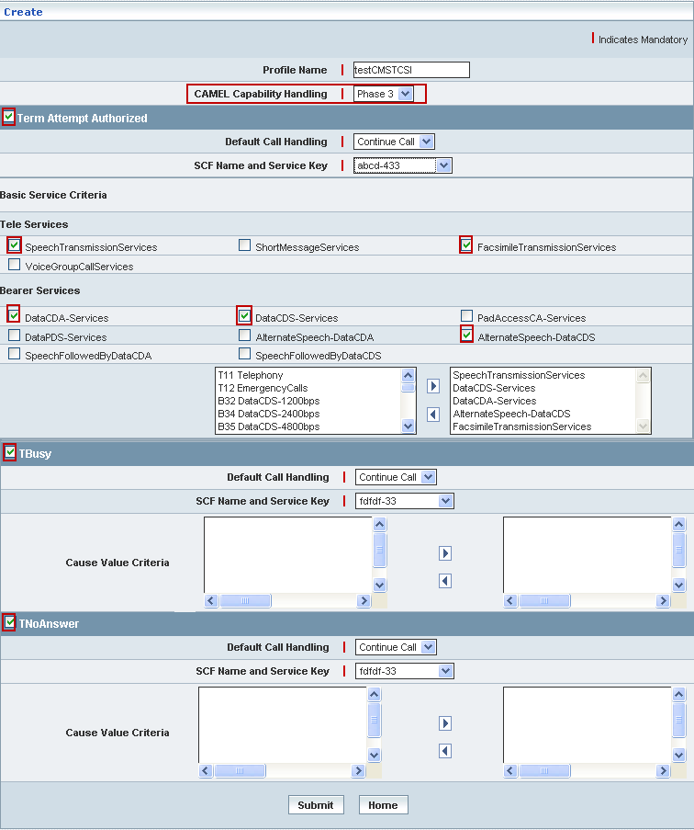

| **STEP** | **ACTION** |
| --- | --- |
|  | **Term Attempt Authorized Block:**  Select the ‘Term Attempt Authorized’ check box, which in turn would enable the user to   * enter details related to ‘Default Call Handling’ and ‘SCF Name and Service Key’ * configure Basic Service Criteria |
|  | Select a default call handling element (Continue Call or Release Call) to specify a default setting for the call handling, from the drop-down list of the <Default Call Handling> field  **\*** By default, the list of call handling elements (Continue Call / Release Call) will be dynamically displayed as drop-down list of the <Default Call Handling> field |
|  | Select a pair representing the combination of SCF Name and Service Key to specify the SCF Name & Service Key mix for the ‘Term Attempt Authorized’ element, from the drop-down list of the <SCF Name and Service Key> field  * By default, the list of pairs representing SCF Name and Service Key will be dynamically displayed as drop-down list of the <SCF Name and Service Key> field |
|  | **Basic Service Criteria:**  Basic services comprise **Tele Services** and **Bearer Services**  **NOTE:** Only **5 (Five)** services (from both Tele and Bearer services) can be mapped as Basic Services criteria |
|  | **Tele Services**   * Selected TeleServices (as a string) will be dynamically moved to the text field below, which is on to the right side of the screen |
|  | **Bearer Services**   * Selected BearerServices (as a string) will be dynamically moved to the text field below, which is on to the right side of the screen |
|  | **\*** Few services contain a list of sub-services  In this case, (on checking the specific service) the corresponding list of sub-services will be dynamically displayed in the text field, which is on to the left side of the screen  Select the desired service from the list (of the left text field) and on clicking the right-arrow button, the service (as a string) will be moved to the adjacent field  User can enter the desired number of services in a similar fashion but, subject to the maximum limitation of **5 (Five)** services  However if the user wants to just remove any service (any time before creating the profile), selecting the service from the right text field and subsequently clicking the left-arrow button removes the service |
|  | **TBusy Block:**  Select the ‘TBusy’ check box, which in turn would enable the user to configure parameters for ‘Default Call Handling’, ‘SCF Name and Service Key’ and configure the Cause Value Criteria |
|  | Select a default setting for Call Handling (Continue Call or Release Call) to specify the default call handling from the drop-down list of the <Default Call Handling> field  **\*** By default, the list of call handling types will be dynamically displayed as drop-down list of the < Default Call Handling> field |
|  | Select a pair representing the combination of SCF Name and Service Key to specify the SCF Name & Service Key mix for the ‘TBusy’ element, from the drop-down list of the <SCF Name and Service Key> field  * By default, the list of pairs representing SCF Name and Service Key will be dynamically displayed as drop-down list of the <SCF Name and Service Key> field |
|  | The default list of Cause Value Criteria will be dynamically displayed in the text field, which is on to the left side of the screen  Select the desired cause value from the list (of the left text field) and on clicking the right-arrow button, the cause value (as a string) will be moved to the adjacent field  User can enter the desired number of cause values in a similar fashion but, subject to the maximum limitation of **5 (Five)** cause values  However if the user wants to just remove any cause value (any time before creating the profile), selecting the cause value from the right text field and subsequently clicking the left-arrow button removes the service |
|  | **TNoAnswer Block:**  Select the ‘TNoAnswer’ check box, which in turn would enable the user to configure parameters for ‘Default Call Handling’, ‘SCF Name and Service Key’ and configure the Cause Value Criteria |
|  | Select a default setting for Call Handling (Continue Call or Release Call) to specify the default call handling from the drop-down list of the <Default Call Handling> field  **\*** By default, the list of call handling types will be dynamically displayed as drop-down list of the < Default Call Handling> field |
|  | Select a pair representing the combination of SCF Name and Service Key to specify the SCF Name & Service Key mix for the ‘TNoAnswer’ element, from the drop-down list of the <SCF Name and Service Key> field  **\*** By default, the list of pairs representing SCF Name and Service Key will be dynamically displayed as drop-down list of the <SCF Name and Service Key> field |
|  | The default list of Cause Value Criteria will be dynamically displayed in the text field, which is on to the left side of the screen  Select the desired cause value from the list (of the left text field) and on clicking the right-arrow button, the cause value (as a string) will be moved to the adjacent field  User can enter the desired number of cause values in a similar fashion but, subject to the maximum limitation of **5 (Five)** cause values  However if the user wants to just remove any cause value (any time before creating the profile), selecting the cause value from the right text field and subsequently clicking the left-arrow button removes the service |
|  | On clicking the **Submit** button, new profile (VMSC Terminating CSI) will be created and a message window to that effect will be displayed    On clicking the **Home** button of the message window, it directs the user back to the ‘VMSC Terminating CSI’ profiles grid |
|  | On clicking the **Home** button of the ‘Create’ screen (before creating any new profile), it directs the user to the ‘VMSC Terminating CSI’ profiles grid |

**View**

Home Location Register 🡪 CAMEL Subscriptions 🡪 GSM CAMEL Subscriptions 🡪 VMSC Terminating CSI 🡪 Create / View

View enables the user to peruse details related to chosen profile (VMSC Terminating CSI).

On clicking the **‘View’** link of a chosen ‘Profile’ (from the VMSC Terminating CSI Profiles List); corresponding information related to the profile will be displayed in a separate screen enabling the user to peruse details of the profile

The screen below displays the details related to chosen profile (VMSC Terminating CSI)

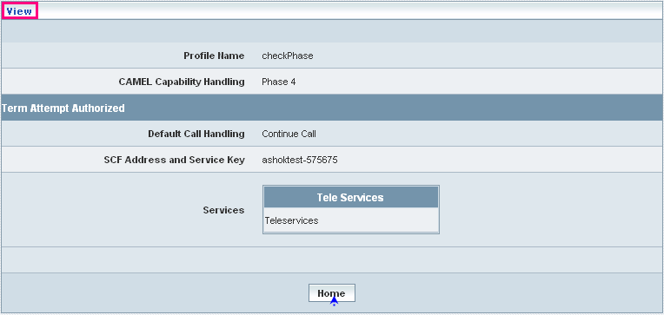

| **STEP** | **ACTION** |
| --- | --- |
|  | User can peruse details related to the chosen ‘VMSC Terminating CSI’ Profile |
|  | On clicking the **Home** button at the bottom of the ‘View’ Screen, it redirects the user to the ‘VMSC Terminating CSI’ profiles grid |

**Searching for a specific ‘VMSC Terminating CSI’ profiles (Record)**



| **STEP** | **ACTION** |
| --- | --- |
|  | Select a search criterion (‘Profile Name’) from the drop-down list of the search criteria of the <Search> field  **\*** By default the list of search criterion (‘Profile Name’) will be dynamically displayed as drop-down list of the <Search> field |
|  | Enter the ‘Profile Name’ that corresponds with the given search criterion |
|  | On clicking the **Go** button, the corresponding VMSC Terminating CSI Profiles (record) will be highlighted among the list of VMSC Terminating CSI Profiles records. |

The screen below depicts fetching and displaying the give VMSC Terminating CSI Profiles record.

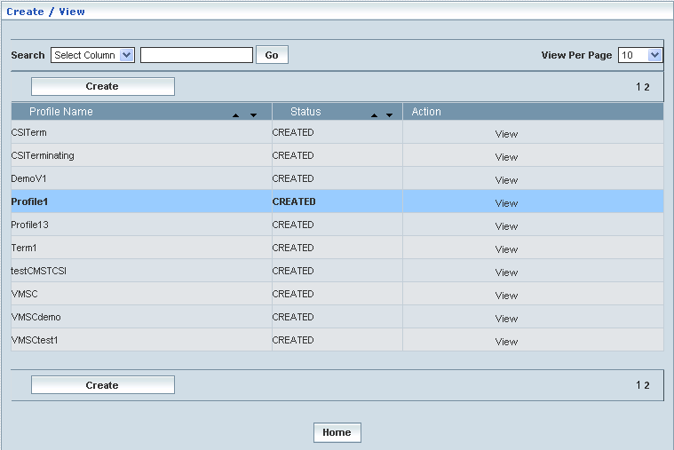

**Manage**

Home Location Register 🡪 CAMEL Subscriptions 🡪 GSM CAMEL Subscriptions 🡪 VMSC Terminating CSI 🡪 Manage

‘Manage’ helps the user modifying and deleting (managing) a chosen VMSC Terminating CSI profile that was created, but still to be approved. Initially, the screen displays the list of VMSC Terminating CSI profiles that were configured and created.

The screen below shows the list of various VMSC Terminating CSI (Profiles) configurations in a grid.

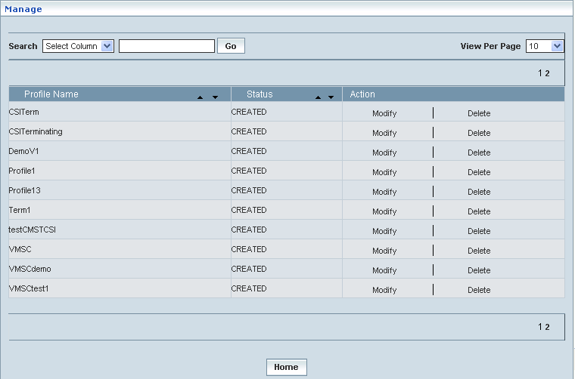

| **STEP** | | **ACTION** |
| --- | --- | --- |
|  | | By default, the list of profiles will be displayed as records in a grid. The columns include ‘Profile Name’, ‘Status’ and ‘Action’ |
|  |  | User can customize the view for the number of records to be displayed each time (per page) in a grid.  However, this option is applicable only if the total number of records exceeds 10. And also with the immediate effect of increase in the number of records more than 10, a ‘Search’ option would be dynamically displayed. |
| Select the number of records (For Ex: 10) from the drop-down list of the <View Per Page> field. |
| With the effect of choosing the desired number (10) for the display of records per page, the same (10 records) will be displayed in the grid. |
| User can sort the records in ascending and descending orders with the help of up-arrow and down-arrows respectively |
| However, based on the total number of records, page numbers will be dynamically displayed at the left bottom of the screen |
| User can navigate for subsequent records (10 each time) by clicking the desired ‘page number’ |
|  | | On clicking the **Modify** link of a chosen ‘Profile’, corresponding information related to the profile will be displayed in a separate screen enabling the user to modify / update details of the profile |
|  | | On clicking the **Delete** link of a chosen ‘Profile’, corresponding information related to the profile will be displayed in a separate screen enabling the user to delete the profile |
|  | | On clicking the **Home** button at the bottom of the grid, it redirects the user to the ‘VMSC Terminating CSI’ main page |

**Modify**

Home Location Register 🡪 CAMEL Subscriptions 🡪 GSM CAMEL Subscriptions 🡪 VMSC Terminating CSI 🡪 Manage 🡪 Modify

Modify enables the user to modify / update the details related to an existing VMSC Terminating CSI profile.

On clicking the **‘Modify’** link of a chosen ‘Profile’ (from the VMSC Terminating CSI Profiles List); corresponding information related to the profile will be displayed in a separate screen enabling the user to modify / update details of the profile

The screen below shows modifying / updating the details related to an existing VMSC Terminating CSI profile.

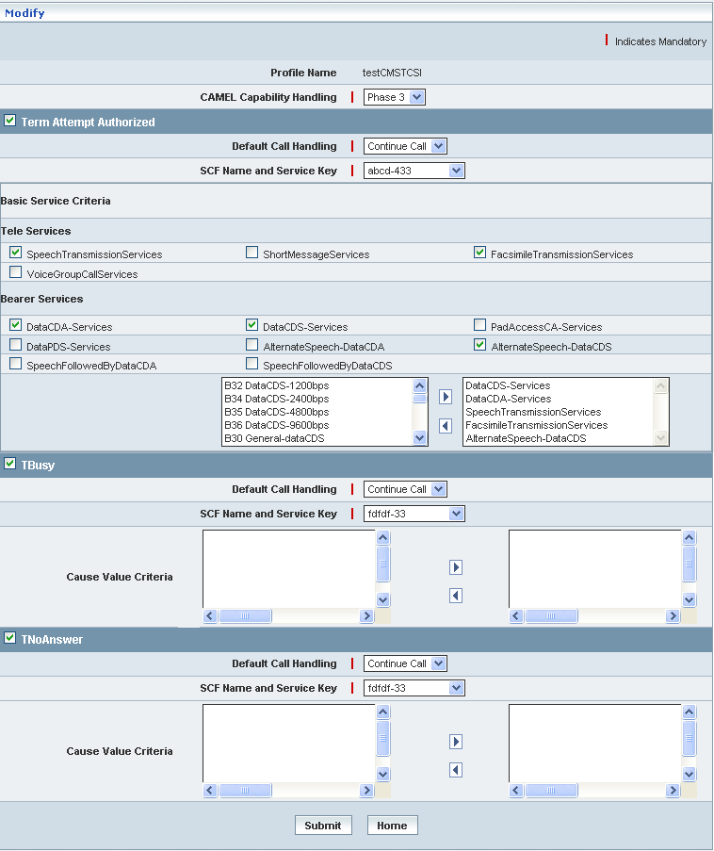

| **STEP** | **ACTION** |
| --- | --- |
|  | Name of the profile will be dynamically displayed in the <Profile Name> field and this cannot be modified |
|  | User can make necessary changes / updates to the existing values / configurations of the profile, yet subject to the stipulations related to mapping parameters |
|  | On clicking the **Modify** button at the bottom of the ‘Modify’ screen, profile (VMSC Terminating CSI) details will be updated accordingly and a message window to that effect will be displayed    On clicking the **Home** button of the message window, it directs the user back to the VMSC Terminating CSI profiles grid |
|  | On clicking the **Home** button of the ‘Modify’ screen (before updating the details related to profile), it directs the user to the VMSC Terminating CSI profiles grid |

**Delete**

Home Location Register 🡪 CAMEL Subscriptions 🡪 GSM CAMEL Subscriptions 🡪 VMSC Terminating CSI 🡪 Manage 🡪 Delete

Delete enables the user to delete an existing VMSC Terminating CSI profile.

On clicking the **‘Delete’** link of a chosen ‘Profile’ (from the VMSC Terminating CSI Profiles List); corresponding information related to the profile will be displayed in a separate screen enabling the user to delete the profile.

The screen below shows the details related to an existing VMSC Terminating CSI profile, which enables the user to delete the same (Profile).

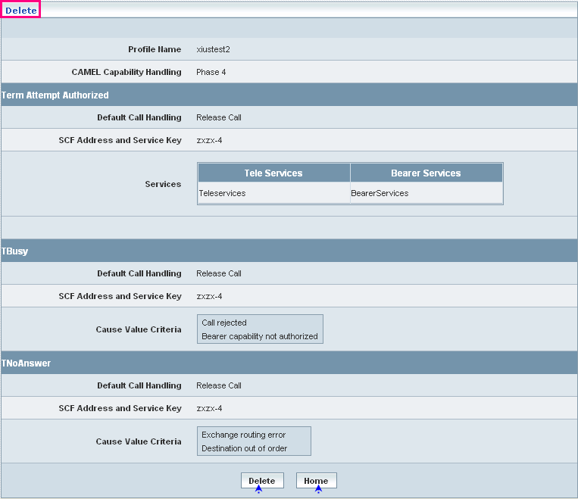

| **STEP** | **ACTION** |
| --- | --- |
|  | User can peruse the existing values / configurations of the profile before deleting the profile |
|  | On clicking the **Delete** at the bottom of the ‘Delete’ screen, it displays an alert window enabling the user to confirm deletion of the chosen profile (VMSC Terminating CSI)  Wor6  On clicking the **OK** button of the alert window, the chosen VMSC Terminating CSI profile will be deleted and a message window to that effect will be displayed  WorF  On clicking the **Cancel** button of the alert window, it retains the corresponding ‘Delete’ screen  On clicking the **Home** button of the message window, it directs the user back to the VMSC Terminating CSI profiles grid |
|  | On clicking the **Home** button of the ‘Delete’ screen (before deleting the profile), it directs the user to the VMSC Terminating CSI profiles grid |

**Searching for a specific VMSC Terminating CSI profiles (Record)**



| **STEP** | **ACTION** |
| --- | --- |
|  | Select a search criterion (‘Profile Name’) from the drop-down list of the search criteria of the <Search> field  **\*** By default the list of search criterion (‘Profile Name’) will be dynamically displayed as drop-down list of the <Search> field |
|  | Enter the ‘Profile Name’ that corresponds with the given search criterion |
|  | On clicking the **Go** button, the corresponding VMSC Terminating CSI profiles (record) will be highlighted among the list of VMSC Terminating CSI profiles records. |

The screen below depicts fetching and displaying the give VMSC Terminating CSI profiles record.

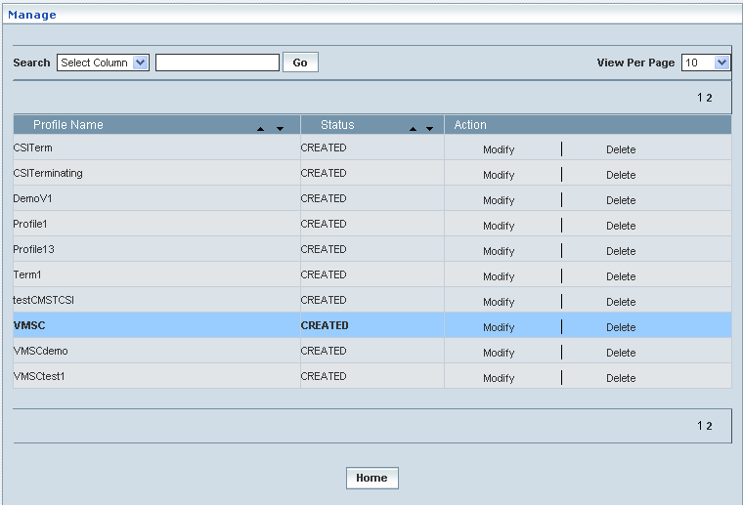

## Supplementary Services CSI

Supplementary Services CSI enables the user to create and manage the supplementary services that could be offered to the CSI subscribers. This helps creating various Supplementary Services CSI profiles, which in turn provide a wider flexibility in catering the same to different customer subscription types and varied demands.

In order to create a supplementary service, it should be configured by pooling certain values and parameters that constitute a service, which could be offered to a subscriber.

**Create / View**

Home Location Register 🡪 CAMEL Subscriptions 🡪 GSM CAMEL Subscriptions 🡪 Supplementary Services CSI 🡪 Create / View

Initially, ‘Supplementary Services CSI’ displays a grid showing the list of existing supplementary services CSI Profiles that are configured and created. This list may include those profiles that are created and approved, created and rejected and also those created but still to be approved or rejected.

The screen below shows the list of various Supplementary Services CSI profiles in a grid.

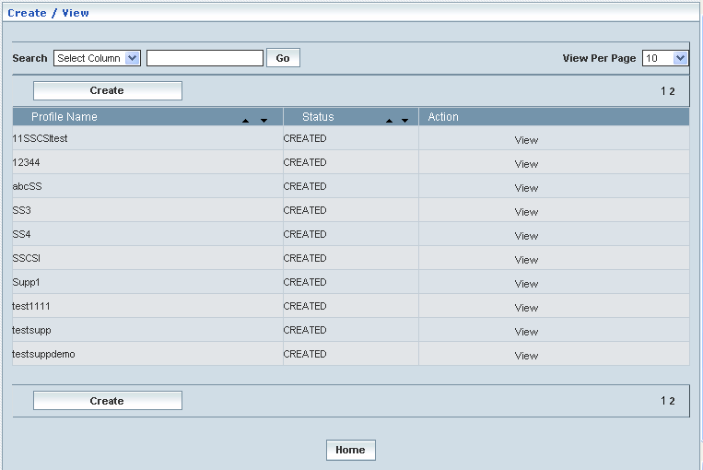

| **STEP** | | **ACTION** |
| --- | --- | --- |
|  | | By default, the list of profiles (Supplementary Services CSI) will be displayed as records in a grid. The columns include ‘Profile Name’, ‘Status’ and ‘Action’ |
|  |  | User can customize the view for the number of records to be displayed each time (per page) in a grid.  However, this option is applicable only if the total number of records exceeds 10. And also with the immediate effect of increase in the number of records more than 10, a ‘Search’ option would be dynamically displayed. |
| Select the number of records (For Ex: 10) from the drop-down list of the <View Per Page> field. |
| With the effect of choosing the desired number (10) for the display of records per page, the same (10 records) will be displayed in the grid. |
| User can sort the records in ascending and descending orders with the help of up-arrow and down-arrows respectively |
| However, based on the total number of records, page numbers will be dynamically displayed at the left bottom of the screen |
| User can navigate for subsequent records (10 each time) by clicking the desired ‘page number’ |
|  | | Status indicates the profile status whether just created (Created) or created and approved (Approved) or created but rejected (Rejected) |
|  | | On clicking the **Create** button, ‘Create’ screen will be displayed enabling the user to create a new ‘Profile’ (Supplementary Service Profile) |
|  | | On clicking the **View** link of a chosen ‘Profile’, corresponding information related to the profile (Supplementary Service Profile) will be displayed in a separate screen enabling the user to peruse details of the profile |
|  | | On clicking the **Home** button at the bottom of the grid, it redirects the user to the ‘Supplementary Service CSI’ main page |

**Create**

Home Location Register 🡪 CAMEL Subscriptions 🡪 GSM CAMEL Subscriptions 🡪 Supplementary Service CSI 🡪 Create / View

Create enables the user to create a new profile (Supplementary Service CSI Profile) and attribute various values to constitute the same.

**NOTE:** Only three CAMEL Capability Handling phases (Phase2, Phase3 & Phase4) are relatable to **Supplementary Service CSI Profile** creation. However, the new proposed profile creation shall be based on the chosen phase (Phase2/Phase3/Phase4).

The screen below shows creating a new profile as Supplementary Service CSI

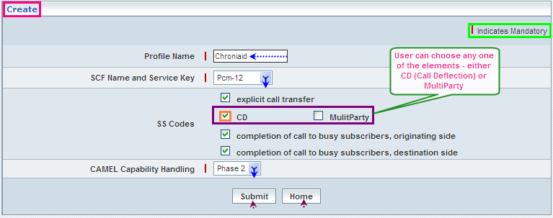

| **STEP** | **ACTION** |
| --- | --- |
|  | User must essentially enter the details related to a new profile where it is a mandatory information |
|  | Enter name of the supplementary service profile in <Profile Name> field |
|  | Select a pair representing the combination of SCF Name and Service Key to specify the SCF Name & Service Key mix for the ‘Supplementary Service CSI’ element, from the drop-down list of the <SCF Name and Service Key> field  **\*** By default, the list of pairs representing SCF Name and Service Key will be dynamically displayed as drop-down list of the <SCF Name and Service Key> field |
|  | Select the desired supplementary service codes (SS Codes)  **NOTE:** However, user can choose either ‘Call Deflection’ or ‘Multi-Party’ but not the both |
|  | Select a CAMEL capability handling Phase (Phase2, Phase3 and Phase4) to specify the CAMEL capability handling from the drop-down list of the <CAMEL Capability Handling> field  **\*** By default, the list of phases will be dynamically displayed as drop-down list of the <CAMEL Capability Handling> field |
|  | On clicking the **Submit** button, new profile (Supplementary Service CSI) will be created and a message window to that effect will be displayed  Wor15  On clicking the **Home** button of the message window, it directs the user back to the ‘’Supplementary Service CSI profiles grid |
|  | On clicking the **Home** button of the ‘Create’ screen (before creating any new profile), it directs the user to the ‘Supplementary Service CSI’ profiles grid |

**View**

Home Location Register 🡪 CAMEL Subscriptions 🡪 GSM CAMEL Subscriptions 🡪 Supplementary Service CSI 🡪 Create / View

View enables the user to peruse details related to chosen profile (Supplementary Service CSI).

On clicking the **‘View’** link of a chosen ‘Profile’ (Supplementary Service CSI from the Supplementary Services CSI List); corresponding information related to the profile will be displayed in a separate screen enabling the user to peruse details of the Supplementary Service CSI profile.

The screen below displays the details related to a chosen profile (Supplementary Service CSI)

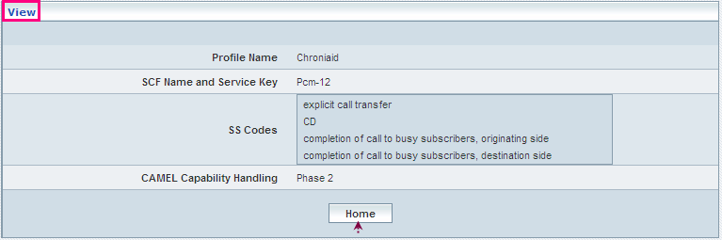

| **STEP** | **ACTION** |
| --- | --- |
|  | User can peruse details related to the chosen ‘Supplementary Service CSI’ Profile |
|  | On clicking the **Home** button at the bottom of the ‘View’ Screen’’, it redirects the user to the ‘Supplementary Service CSI’ profiles grid |

**Searching for a specific Supplementary Service CSI profiles (Record)**



| **STEP** | **ACTION** |
| --- | --- |
|  | Select a search criterion (‘Profile Name’) from the drop-down list of the search criteria of the <Search> field  **\*** By default the list of search criterion (‘Profile Name’) will be dynamically displayed as drop-down list of the <Search> field |
|  | Enter the ‘Profile Name’ that corresponds with the given search criterion |
|  | On clicking the **Go** button, the corresponding Supplementary Service CSI Profiles (record) will be highlighted among the list of Supplementary Service CSI Profiles records. |

The screen below depicts fetching and displaying the give Supplementary Service CSI Profiles record.

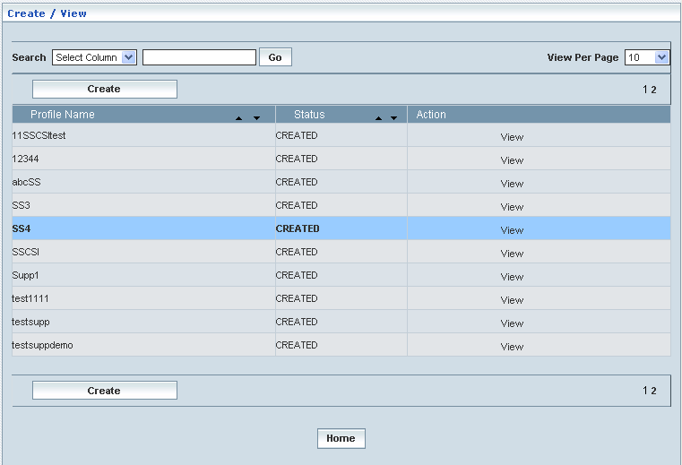

**Manage**

Home Location Register 🡪 CAMEL Subscriptions 🡪 GSM CAMEL Subscriptions 🡪 Supplementary Service CSI 🡪 Manage

‘Manage’ helps the user modifying and deleting (managing) a chosen Supplementary Service CSI profile that was created, but still to be approved.

Initially, the screen displays the list of Supplementary Service CSI profiles that were configured and created.

The screen below shows the list of various Supplementary Service CSI (Profiles) configurations in a grid.

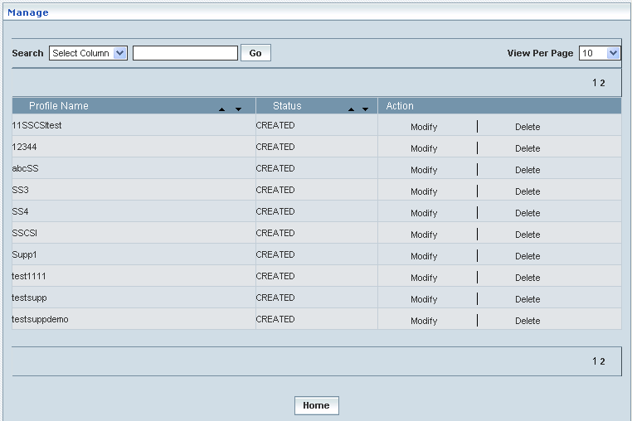

| **STEP** | | **ACTION** |
| --- | --- | --- |
|  | | By default, the list of profiles (Supplementary Service CSI profiles) will be displayed as records in a grid. The columns include ‘Profile Name’, ‘Status’ and ‘Action’ |
|  |  | User can customize the view for the number of records to be displayed each time (per page) in a grid.  However, this option is applicable only if the total number of records exceeds 10. And also with the immediate effect of increase in the number of records more than 10, a ‘Search’ option would be dynamically displayed. |
| Select the number of records (For Ex: 10) from the drop-down list of the <View Per Page> field. |
| With the effect of choosing the desired number (10) for the display of records per page, the same (10 records) will be displayed in the grid. |
| User can sort the records in ascending and descending orders with the help of up-arrow and down-arrows respectively |
| However, based on the total number of records, page numbers will be dynamically displayed at the left bottom of the screen |
| User can navigate for subsequent records (10 each time) by clicking the desired ‘page number’ |
|  | | On clicking the **Modify** link of a chosen ‘Profile’, corresponding information related to the profile will be displayed in a separate screen enabling the user to modify / update details of the profile |
|  | | On clicking the **Delete** link of a chosen ‘Profile’, corresponding information related to the profile will be displayed in a separate screen enabling the user to delete the profile |
|  | | On clicking the **Home** button at the bottom of the grid, it redirects the user to the ‘Supplementary Service CSI’ main page |

**Modify**

Home Location Register 🡪 CAMEL Subscriptions 🡪 GSM CAMEL Subscriptions 🡪 Supplementary Service CSI 🡪 Manage 🡪 Modify

Modify enables the user to modify / update the details related to an existing Supplementary Service CSI profile.

On clicking the **‘Modify’** link of a chosen ‘Profile’ (Supplementary Service CSI from the Supplementary Services CSI List); corresponding information related to the profile will be displayed in a separate screen enabling the user to modify / update details of the Supplementary Service CSI profile.

The screen below shows modifying / updating the details related to an existing Supplementary Service CSI profile.

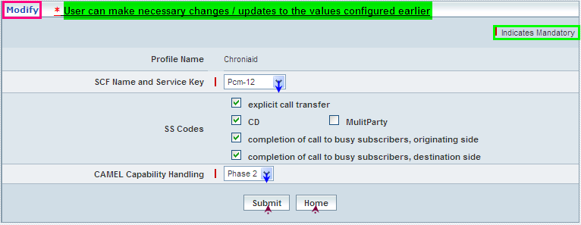

| **STEP** | **ACTION** |
| --- | --- |
|  | Name of the profile will be dynamically displayed in the <Profile Name> field and this cannot be modified |
|  | User can make necessary changes / updates to the existing values / configurations of the profile |
|  | On clicking the **Submit** button at the bottom of the ‘Modify’ screen, profile (Supplementary Service CSI) details will be updated accordingly and a message window to that effect will be displayed  Wor19  On clicking the **Home** button of the message window, it directs the user back to the Supplementary Service CSI profiles grid |
|  | On clicking the **Home** button of the ‘Modify’ screen (before updating the details related to profile), it directs the user to the Supplementary Service CSI profiles grid |

**Delete**

Home Location Register 🡪 CAMEL Subscriptions 🡪 GSM CAMEL Subscriptions 🡪 Supplementary Service CSI 🡪 Manage 🡪 Delete

Delete enables the user to delete an existing Supplementary Service CSI profile.

On clicking the **‘Delete’** link of a chosen ‘Profile’ (Supplementary Service CSI from the Supplementary Services CSI List); corresponding information related to the profile will be displayed in a separate screen enabling the user to delete the Supplementary Service CSI profile.

The screen below shows the details related to an existing Supplementary Service CSI profile, which enables the user to delete the same (Profile).

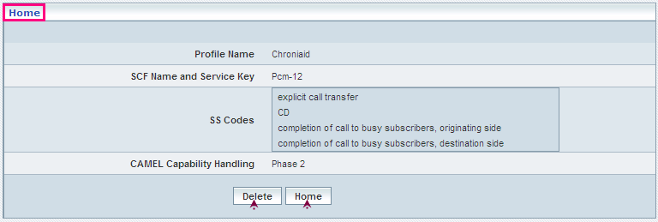

| **STEP** | **ACTION** |
| --- | --- |
|  | User can peruse the existing values / configurations of the profile before deleting the profile |
|  | On clicking the **Delete** at the bottom of the ‘Delete’ screen, it displays an alert window enabling the user to confirm deletion of the chosen profile (Supplementary Service CSI)  Wor6  On clicking the **OK** button of the alert window, the chosen Supplementary Service CSI profile will be deleted and a message window to that effect will be displayed  Wor1B  On clicking the **Cancel** button of the alert window, it retains the corresponding ‘Delete’ screen  On clicking the **Home** button of the message window, it directs the user back to the ‘Supplementary Service CSI’ profiles grid |
|  | On clicking the **Home** button of the ‘Delete’ screen (before deleting the profile), it directs the user to the ‘Supplementary Service CSI’ profiles grid |

**Searching for a specific Supplementary Service CSI profiles (Record)**



| **STEP** | **ACTION** |
| --- | --- |
|  | Select a search criterion (‘Profile Name’) from the drop-down list of the search criteria of the <Search> field  **\*** By default the list of search criterion (‘Profile Name’) will be dynamically displayed as drop-down list of the <Search> field |
|  | Enter the ‘Profile Name’ that corresponds with the given search criterion |
|  | On clicking the **Go** button, the corresponding Supplementary Service CSI Profiles (record) will be highlighted among the list of Supplementary Service CSI Profiles records. |

The screen below depicts fetching and displaying the give Supplementary Service CSI Profiles record.

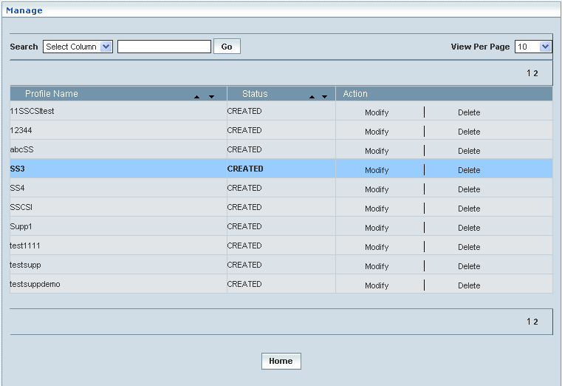

## Translation Information Flag CSI

Translation Information Flag CSI helps indicating the VLR not to attempt performing any deflective actions on the serving numbers (DTN). This helps creating various Translation Information Flag CSI profiles, which in turn provide a wider flexibility in attributing the same to different customer subscription types and varied demands.

Translation Information Flag can either be set ‘False’ / ‘True’ accordingly. This can be attributed to a profile that would be created and defined with respect to the (configured) corresponding CAMEL Capability Handling (Phase).

**Create / View**

Home Location Register 🡪 CAMEL Subscriptions 🡪 GSM CAMEL Subscriptions 🡪 Translation Information Flag CSI 🡪 Create / View

Initially, ‘Translation Information Flag CSI’ displays a grid showing the list of existing profiles that are configured and created. This list may include those profiles that are created and approved, created and rejected and also those created but still to be approved or rejected.

The screen below shows the list of various profiles pertaining to Translation Information Flag CSI in a grid.

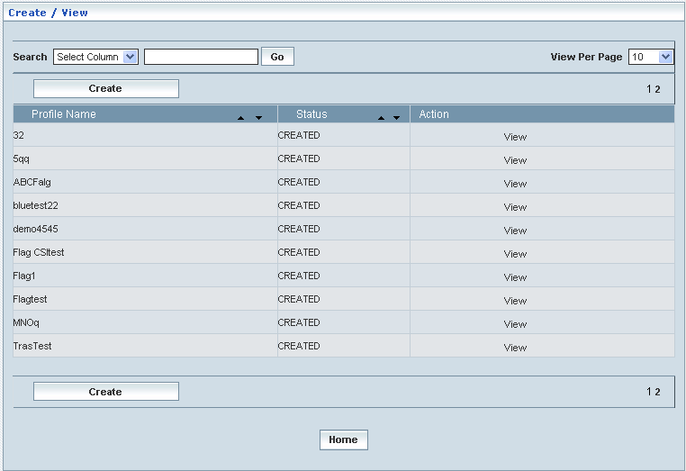

| **STEP** | | **ACTION** |
| --- | --- | --- |
|  | | By default, the list of profiles (Translation Information Flag CSI) will be displayed as records in a grid. The columns include ‘Profile Name’, ‘Status’ and ‘Action’ |
|  |  | User can customize the view for the number of records to be displayed each time (per page) in a grid.  However, this option is applicable only if the total number of records exceeds 10. And also with the immediate effect of increase in the number of records more than 10, a ‘Search’ option would be dynamically displayed. |
| Select the number of records (For Ex: 10) from the drop-down list of the <View Per Page> field. |
| With the effect of choosing the desired number (10) for the display of records per page, the same (10 records) will be displayed in the grid. |
| User can sort the records in ascending and descending orders with the help of up-arrow and down-arrows respectively |
| However, based on the total number of records, page numbers will be dynamically displayed at the left bottom of the screen |
| User can navigate for subsequent records (10 each time) by clicking the desired ‘page number’ |
|  | | Status indicates the profile status whether just created (Created) or created and approved (Approved) or created but rejected (Rejected) |
|  | | On clicking the **Create** button, ‘Create’ screen will be displayed enabling the user to create a new ‘Profile’ (Translation Information Flag Profile) |
|  | | On clicking the **View** link of a chosen ‘Profile’, corresponding information related to the profile (Translation Information Flag Profile) will be displayed in a separate screen enabling the user to peruse details of the profile |
|  | | On clicking the **Home** button at the bottom of the grid, it redirects the user to the ‘Translation Information Flag CSI’ main page |

**Create**

Home Location Register 🡪 CAMEL Subscriptions 🡪 GSM CAMEL Subscriptions 🡪 Translation Information Flag CSI 🡪 Create / View

Create enables the user to create a new profile (Translation Information Flag CSI Profile) and attribute various values to constitute the same.

**NOTE:** Only three CAMEL Capability Handling phases (Phase2, Phase3 & Phase4) are relatable to **Translation Information Flag CSI** creation. However, the new proposed Flag creation shall be based on the chosen Capability Handling phase (Phase2/Phase3/Phase4).

The screen below shows creating a new profile as Translation Information Flag CSI

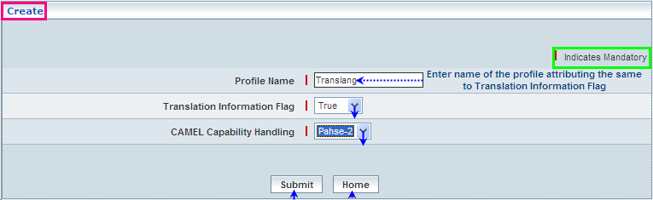

| **STEP** | **ACTION** |
| --- | --- |
|  | User must essentially enter the details related to a new profile where it is a mandatory information |
|  | Enter name of the Translation Information Flag CSI profile in <Profile Name> field |
|  | Select a value (False / True) of Translation Information Flag to attribute the same , from the drop-down list of the < Translation Information Flag> field  **\*** By default, the values (False / True) will be displayed as drop-down of the <Translation Information Flag> field |
|  | Select a Phase (Phase2, Phase3 and Phase4) to specify the CAMEL capability handling from the drop-down list of the <CAMEL Capability Handling> field  **\*** By default, the list of phases will be dynamically displayed as drop-down list of the <CAMEL Capability Handling> field |
|  | On clicking the **Submit** button, new profile (Translation Information Flag CSI) will be created and a message window to that effect will be displayed  Wor5D  On clicking the **Home** button of the message window, it directs the user back to the Translation Information Flag CSI profiles grid |
|  | On clicking the **Home** button of the ‘Create’ screen (before creating any new profile), it directs the user to the Translation Information Flag CSI profiles grid |

**View**

Home Location Register 🡪 CAMEL Subscriptions 🡪 GSM CAMEL Subscriptions 🡪 Translation Information Flag CSI 🡪 Create / View

View enables the user to peruse details related to chosen profile (Translation Information Flag CSI).

On clicking the **‘View’** link of a chosen ‘Profile’ (from the Translation Information Flag CSI Profiles List); corresponding information related to the profile will be displayed in a separate screen enabling the user to peruse details of the profile – Translation Information Flag CSI.

The screen below displays the details related to chosen profile (Translation Information Flag CSI)

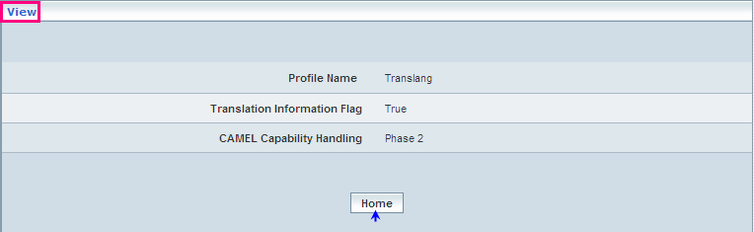

| **STEP** | **ACTION** |
| --- | --- |
|  | User can peruse details related to the chosen Translation Information Flag CSI Profile |
|  | On clicking the **Home** button at the bottom of the ‘View’ Screen, it redirects the user to the ‘Translation Information Flag CSI’ profiles grid |

**Searching for a specific Translation Information Flag CSI profiles (Record)**



| **STEP** | **ACTION** |
| --- | --- |
|  | Select a search criterion (‘Profile Name’) from the drop-down list of the search criteria of the <Search> field  **\*** By default the list of search criterion (‘Profile Name’) will be dynamically displayed as drop-down list of the <Search> field |
|  | Enter the ‘Profile Name’ that corresponds with the given search criterion |
|  | On clicking the **Go** button, the corresponding Translation Information Flag CSI Profiles (record) will be highlighted among the list of Translation Information Flag CSI Profiles records. |

The screen below depicts fetching and displaying the give Translation Information Flag CSI Profiles record.

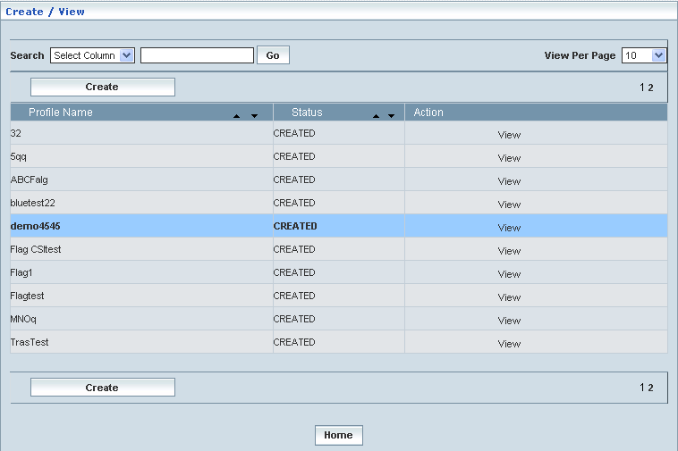

**Manage**

Home Location Register 🡪 CAMEL Subscriptions 🡪 GSM CAMEL Subscriptions 🡪 Translation Information Flag CSI 🡪 Manage

‘Manage’ helps the user modifying and deleting (managing) a chosen Translation Information Flag CSI profile that was created, but still to be approved

Initially, the screen displays the list of Translation Information Flag CSI profiles that were configured and created.

The screen below shows the list of various Translation Information Flag CSI (Profiles) configurations in a grid.

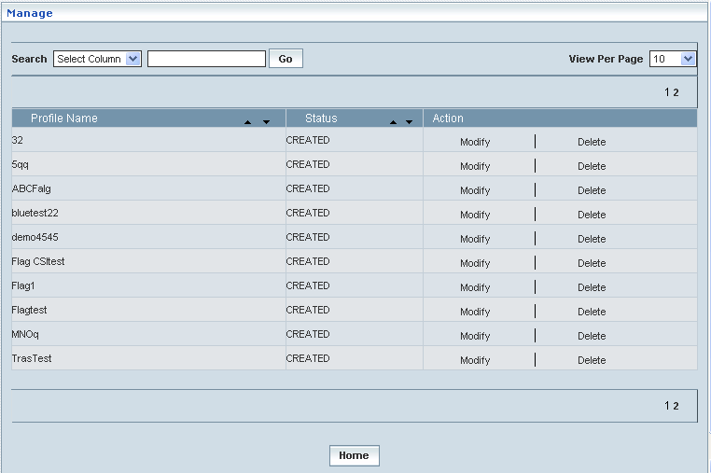

| **STEP** | | **ACTION** |
| --- | --- | --- |
|  | | By default, the list of profiles (Translation Information Flag CSI profiles) will be displayed as records in a grid. The columns include ‘Profile Name’, ‘Status’ and ‘Action’ |
|  |  | User can customize the view for the number of records to be displayed each time (per page) in a grid.  However, this option is applicable only if the total number of records exceeds 10. And also with the immediate effect of increase in the number of records more than 10, a ‘Search’ option would be dynamically displayed. |
| Select the number of records (For Ex: 10) from the drop-down list of the <View Per Page> field. |
| With the effect of choosing the desired number (10) for the display of records per page, the same (10 records) will be displayed in the grid. |
| User can sort the records in ascending and descending orders with the help of up-arrow and down-arrows respectively |
| However, based on the total number of records, page numbers will be dynamically displayed at the left bottom of the screen |
| User can navigate for subsequent records (10 each time) by clicking the desired ‘page number’ |
|  | | On clicking the **Modify** link of a chosen ‘Profile’, corresponding information related to the profile will be displayed in a separate screen enabling the user to modify / update details of the profile |
|  | | On clicking the **Delete** link of a chosen ‘Profile’, corresponding information related to the profile will be displayed in a separate screen enabling the user to delete the profile |
|  | | On clicking the **Home** button at the bottom of the grid, it redirects the user to the ‘Translation Information Flag CSI’ main page |

**Modify**

Home Location Register 🡪 CAMEL Subscriptions 🡪 GSM CAMEL Subscriptions 🡪 Translation Information Flag CSI 🡪 Manage 🡪 Modify

Modify enables the user to modify / update the details related to an existing Translation Information Flag CSI profile.

On clicking the **‘Modify’** link of a chosen ‘Profile’ (from the Translation Information Flag CSI Profiles List); corresponding information related to the profile will be displayed in a separate screen enabling the user to modify / update details of the profile – Translation Information Flag CSI.

The screen below shows modifying / updating the details related to an existing Translation Information Flag CSI profile.

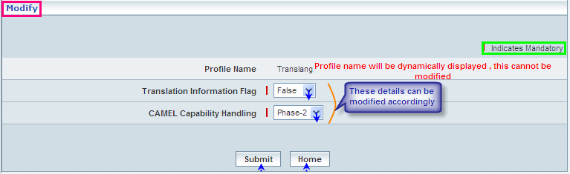

| **STEP** | **ACTION** |
| --- | --- |
|  | Name of the profile will be dynamically displayed in the <Profile Name> field and this cannot be modified |
|  | User can make necessary changes / updates to the existing values / configurations of the profile |
|  | On clicking the **Submit** button at the bottom of the ‘Modify’ screen, profile (Translation Information Flag CSI) details will be updated accordingly and a message window to that effect will be displayed  Wor61  On clicking the **Home** button of the message window, it directs the user back to the Translation Information Flag CSI profiles grid |
|  | On clicking the **Home** button of the ‘Modify’ screen (before updating the details related to profile), it directs the user to the Translation Information Flag CSI profiles grid |

**Delete**

Home Location Register 🡪 CAMEL Subscriptions 🡪 GSM CAMEL Subscriptions 🡪 Translation Information Flag CSI 🡪 Manage 🡪 Delete

Delete enables the user to delete an existing Translation Information Flag CSI profile.

On clicking the **‘Delete’** link of a chosen ‘Profile’ (from the Translation Information Flag CSI Profiles List); corresponding information related to the profile will be displayed in a separate screen enabling the user to delete the profile – Translation Information Flag CSI.

The screen below shows the details related to an existing Translation Information Flag CSI profile, which enables the user to delete the same (Profile).

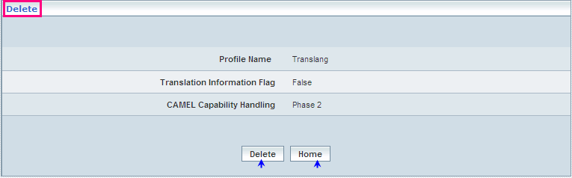

| **STEP** | **ACTION** |
| --- | --- |
|  | User can peruse the existing values / configurations of the profile before deleting the profile |
|  | On clicking the **Delete** at the bottom of the ‘Delete’ screen, it displays an alert window enabling the user to confirm deletion of the chosen profile (Translation Information Flag CSI)  Wor6  On clicking the **OK** button of the alert window, the chosen Translation Information Flag CSI profile will be deleted and a message window to that effect will be displayed  Wor1B  On clicking the **Cancel** button of the alert window, it retains the corresponding ‘Delete’ screen  On clicking the **Home** button of the message window, it directs the user back to the ‘Translation Information Flag CSI’ profiles grid |
|  | On clicking the **Home** button of the ‘Delete’ screen (before deleting the profile), it directs the user to the ‘Translation Information Flag CSI’ profiles grid |

**Searching for a specific Translation Information Flag CSI profiles (Record)**



| **STEP** | **ACTION** |
| --- | --- |
|  | Select a search criterion (‘Profile Name’) from the drop-down list of the search criteria of the <Search> field  **\*** By default the list of search criterion (‘Profile Name’) will be dynamically displayed as drop-down list of the <Search> field |
|  | Enter the ‘Profile Name’ that corresponds with the given search criterion |
|  | On clicking the **Go** button, the corresponding Translation Information Flag CSI Profiles (record) will be highlighted among the list of Translation Information Flag CSI Profiles records. |

The screen below depicts fetching and displaying the give Translation Information Flag CSI Profiles record.

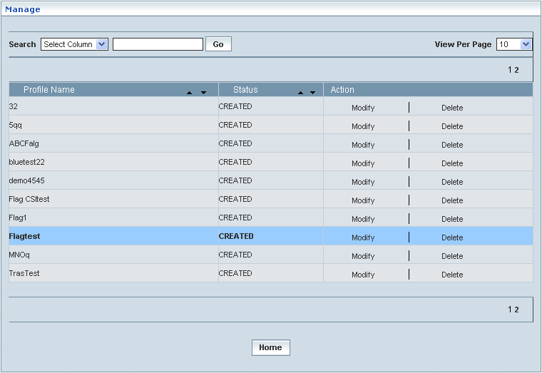

## Mobility Management GSM CSI

Mobility Management GSM CSI enables the user to configure parameters related to CAMEL Subscription Information (CSI) in terms of GSM Visiting Location perspective and with respect to the defined MM codes. This helps creating various Mobility Management GSM CSI profiles, which in turn provide a wider flexibility in attributing the same to different customer subscription types and varied demands.

**Create View**

Home Location Register 🡪 CAMEL Subscriptions 🡪 GSM CAMEL Subscriptions 🡪 Mobility Management GSM CSI 🡪 Create / View

Initially, ‘Mobility Management GSM CSI’ displays a grid showing the list of existing profiles that are configured and created. This list may include those profiles that are created and approved, created and rejected and also those created but still to be approved or rejected.

The screen below shows the list of various profiles pertaining to Mobility Management GSM CSI in a grid.

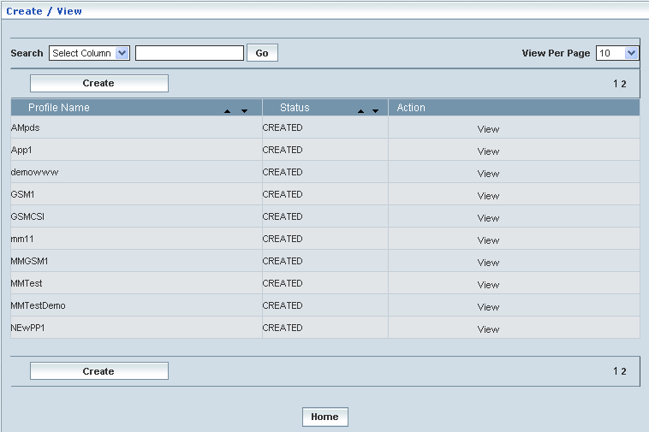

| **STEP** | | **ACTION** |
| --- | --- | --- |
|  | | By default, the list of profiles (Mobility Management GSM CSI) will be displayed as records in a grid. The columns include ‘Profile Name’, ‘Status’ and ‘Action’ |
|  |  | User can customize the view for the number of records to be displayed each time (per page) in a grid.  However, this option is applicable only if the total number of records exceeds 10. And also with the immediate effect of increase in the number of records more than 10, a ‘Search’ option would be dynamically displayed. |
| Select the number of records (For Ex: 10) from the drop-down list of the <View Per Page> field. |
| With the effect of choosing the desired number (10) for the display of records per page, the same (10 records) will be displayed in the grid. |
| User can sort the records in ascending and descending orders with the help of up-arrow and down-arrows respectively |
| However, based on the total number of records, page numbers will be dynamically displayed at the left bottom of the screen |
| User can navigate for subsequent records (10 each time) by clicking the desired ‘page number’ |
|  | | Status indicates the profile status whether just created (Created) or created and approved (Approved) or created but rejected (Rejected) |
|  | | On clicking the **Create** button, ‘Create’ screen will be displayed enabling the user to create a new ‘Profile’ (Mobility Management GSM CSI Profile) |
|  | | On clicking the **View** link of a chosen ‘Profile’, corresponding information related to the profile (Mobility Management GSM CSI Profile) will be displayed in a separate screen enabling the user to peruse details of the profile |
|  | | On clicking the **Home** button at the bottom of the grid, it redirects the user to the ‘Mobility Management GSM CSI’ main page |

**Create**

Home Location Register 🡪 CAMEL Subscriptions 🡪 GSM CAMEL Subscriptions 🡪 Mobility Management GSM CSI 🡪 Create / View

Create enables the user to create a new profile (Mobility Management GSM CSI Profile) and attribute various values to constitute the same.

**NOTE:** Only two CAMEL Capability Handling phases (Phase3 & Phase4) are relatable to **Mobility Management GSM** **CSI Profile** creation. However, the new proposed profile creation shall be based on the chosen CAMEL Capability Handling Phase (Phase3/Phase4).

The screen below shows creating a new profile as Mobility Management GSM CSI.

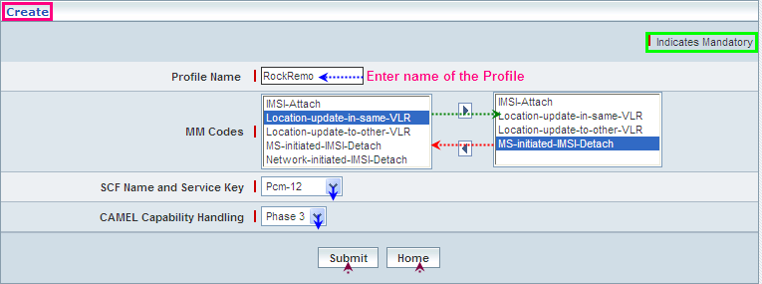

| **STEP** | **ACTION** |
| --- | --- |
|  | User must essentially enter the details related to a new profile where it is a mandatory information |
|  | Enter name of the Mobile Management CSI profile in <Profile Name> field |
|  | The default list of MM Codes will be dynamically displayed in the text field, which is on to the left side of the screen  Select the desired code from the list (of the left text field) and on clicking the right arrow button, the code (as a string) will be moved to the adjacent field  User can enter the desired number of codes in a similar fashion  However if the user wants to just remove any code (any time before creating the profile), selecting the code from the right text field and subsequently clicking the left arrow button removes the code |
|  | Select a pair representing the combination of SCF Name and Service Key to specify the SCF Name & Service Key mix for the ‘Mobile Management CSI’ element, from the drop-down list of the <SCF Name and Service Key> field  **\*** By default, the list of pairs representing SCF Name and Service Key will be dynamically displayed as drop-down list of the <SCF Name and Service Key> field |
|  | Select a Phase (Phase3 and Phase4) to specify the CAMEL capability handling from the drop-down list of the <CAMEL Capability Handling> field  **\*** By default, the list of phases will be dynamically displayed as drop-down list of the <CAMEL Capability Handling> field |
|  | On clicking the **Submit** button, new profile (Mobility Management GSM CSI) will be created and a message window to that effect will be displayed  Wor65  On clicking the **Home** button of the message window, it directs the user back to the Mobility Management GSM CSI profiles grid |
|  | On clicking the **Home** button of the ‘Create’ screen (before creating any new profile), it directs the user to the Mobility Management GSM CSI profiles grid |

**View**

Home Location Register 🡪 CAMEL Subscriptions 🡪 GSM CAMEL Subscriptions 🡪 Mobility Management GSM CSI 🡪 Create / View

View enables the user to peruse details related to chosen profile (Mobility Management GSM CSI).

On clicking the **‘View’** link of a chosen ‘Profile’ (from the Mobility Management GSM CSI Profiles List); corresponding information related to the profile will be displayed in a separate screen enabling the user to peruse details of the profile – Mobility Management GSM CSI.

The screen below displays the details related to chosen profile (Mobility Management GSM CSI)

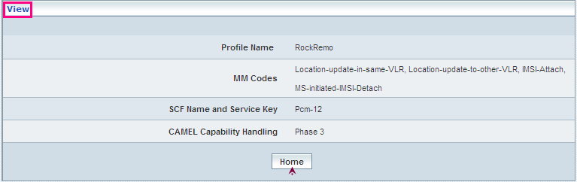

| **STEP** | **ACTION** |
| --- | --- |
|  | User can peruse details related to the chosen ‘Mobility Management GSM CSI’ Profile |
|  | On clicking the **Home** button at the bottom of the ‘View’ Screen, it redirects the user to the ‘Mobility Management GSM CSI’ profiles grid |

**Searching for a specific Mobility Management GSM CSI profiles (Record)**



| **STEP** | **ACTION** |
| --- | --- |
|  | Select a search criterion (‘Profile Name’) from the drop-down list of the search criteria of the <Search> field  **\*** By default the list of search criterion (‘Profile Name’) will be dynamically displayed as drop-down list of the <Search> field |
|  | Enter the ‘Profile Name’ that corresponds with the given search criterion |
|  | On clicking the **Go** button, the corresponding Mobility Management GSM CSI Profiles (record) will be highlighted among the list of Mobility Management GSM CSI Profiles records. |

The screen below depicts fetching and displaying the give Mobility Management GSM CSI Profiles record.

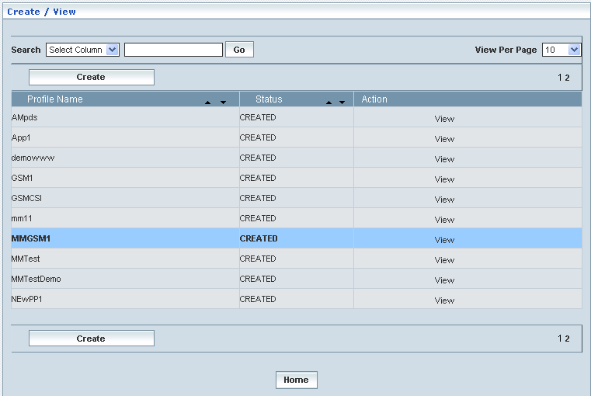

**Manage**

Home Location Register 🡪 CAMEL Subscriptions 🡪 GSM CAMEL Subscriptions 🡪 Mobility Management GSM CSI 🡪 Manage

‘Manage’ helps the user modifying and deleting (managing) a chosen Mobility Management GSM CSI profile that was created, but still to be approved

Initially, the screen displays the list of Mobility Management GSM CSI profiles that were configured and created.

The screen below shows the list of various Mobility Management GSM CSI (Profiles) configurations in a grid.

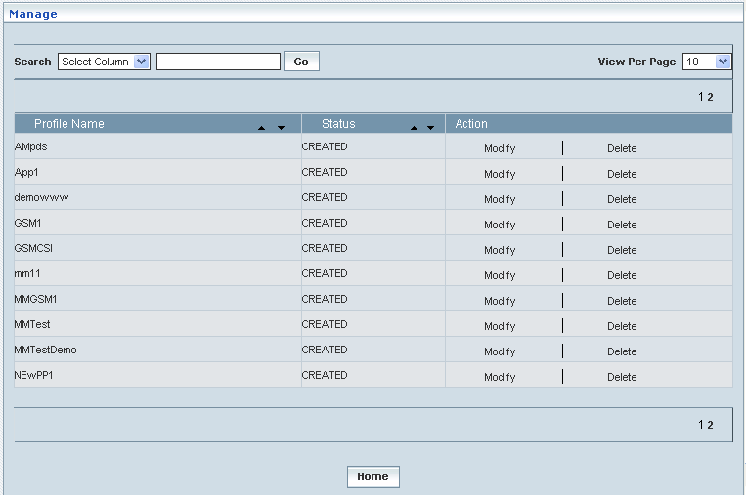

| **STEP** | | **ACTION** |
| --- | --- | --- |
|  | | By default, the list of profiles (Mobility Management GSM CSI profiles) will be displayed as records in a grid. The columns include ‘Profile Name’, ‘Status’ and ‘Action’ |
|  |  | User can customize the view for the number of records to be displayed each time (per page) in a grid.  However, this option is applicable only if the total number of records exceeds 10. And also with the immediate effect of increase in the number of records more than 10, a ‘Search’ option would be dynamically displayed. |
| Select the number of records (For Ex: 10) from the drop-down list of the <View Per Page> field. |
| With the effect of choosing the desired number (10) for the display of records per page, the same (10 records) will be displayed in the grid. |
| User can sort the records in ascending and descending orders with the help of up-arrow and down-arrows respectively |
| However, based on the total number of records, page numbers will be dynamically displayed at the left bottom of the screen |
| User can navigate for subsequent records (10 each time) by clicking the desired ‘page number’ |
|  | | On clicking the **Modify** link of a chosen ‘Profile’, corresponding information related to the profile will be displayed in a separate screen enabling the user to modify / update details of the profile |
|  | | On clicking the **Delete** link of a chosen ‘Profile’, corresponding information related to the profile will be displayed in a separate screen enabling the user to delete the profile |
|  | | On clicking the **Home** button at the bottom of the grid, it redirects the user to the ‘Mobility Management GSM CSI’ main page |

**Modify**

Home Location Register 🡪 CAMEL Subscriptions 🡪 GSM CAMEL Subscriptions 🡪 Mobility Management GSM CSI 🡪 Manage 🡪 Modify

Modify enables the user to modify / update the details related to an existing Mobility Management GSM CSI profile.

On clicking the **‘Modify’** link of a chosen ‘Profile’ (from the Mobility Management GSM CSI Profiles List); corresponding information related to the profile will be displayed in a separate screen enabling the user to modify / update details of the profile – Mobility Management GSM CSI.

The screen below shows modifying / updating the details related to an existing Mobility Management GSM CSI profile.

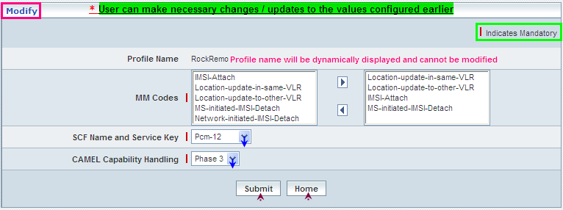

| **STEP** | **ACTION** |
| --- | --- |
|  | Name of the profile will be dynamically displayed in the <Profile Name> field and this cannot be modified |
|  | User can make necessary changes / updates to the existing values / configurations of the profile |
|  | On clicking the **Submit** button at the bottom of the ‘Modify’ screen, profile (Mobility Management GSM CSI) details will be updated accordingly and a message window to that effect will be displayed  Wor6E  On clicking the **Home** button of the message window, it directs the user back to the Mobility Management GSM CSI profiles grid |
|  | On clicking the **Home** button of the ‘Modify’ screen (before updating the details related to profile), it directs the user to the Translation Mobility Management GSM CSI profiles grid |

**Delete**

Home Location Register 🡪 CAMEL Subscriptions 🡪 GSM CAMEL Subscriptions 🡪 Mobility Management GSM CSI 🡪 Manage 🡪 Delete

Delete enables the user to delete an existing Mobility Management GSM CSI profile.

On clicking the **‘Delete’** link of a chosen ‘Profile’ (from the Mobility Management GSM CSI Profiles List); corresponding information related to the profile will be displayed in a separate screen enabling the user to delete the profile – Mobility Management GSM CSI.

The screen below shows the details related to an existing Mobility Management GSM CSI profile, which enables the user to delete the same (Profile).

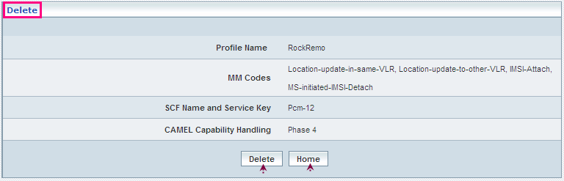

| **STEP** | **ACTION** |
| --- | --- |
|  | User can peruse the existing values / configurations of the profile before deleting the profile |
|  | On clicking the **Delete** at the bottom of the ‘Delete’ screen, it displays an alert window enabling the user to confirm deletion of the chosen profile (Mobility Management GSM CSI)  Wor6  On clicking the **OK** button of the alert window, the chosen Mobility Management GSM CSI profile will be deleted and a message window to that effect will be displayed  Wor70  On clicking the **Cancel** button of the alert window, it retains the corresponding ‘Delete’ screen  On clicking the **Home** button of the message window, it directs the user back to the Mobility Management GSM CSI profiles grid |
|  | On clicking the **Home** button of the ‘Delete’ screen (before deleting the profile), it directs the user to the Mobility Management GSM CSI profiles grid |

**Searching for a specific Mobility Management GSM CSI profiles (Record)**



| **STEP** | **ACTION** |
| --- | --- |
|  | Select a search criterion (‘Profile Name’) from the drop-down list of the search criteria of the <Search> field  **\*** By default the list of search criterion (‘Profile Name’) will be dynamically displayed as drop-down list of the <Search> field |
|  | Enter the ‘Profile Name’ that corresponds with the given search criterion |
|  | On clicking the **Go** button, the corresponding Mobility Management GSM CSI Profiles (record) will be highlighted among the list of Mobility Management GSM CSI Profiles records. |

The screen below depicts fetching and displaying the give Mobility Management GSM CSI Profiles record.

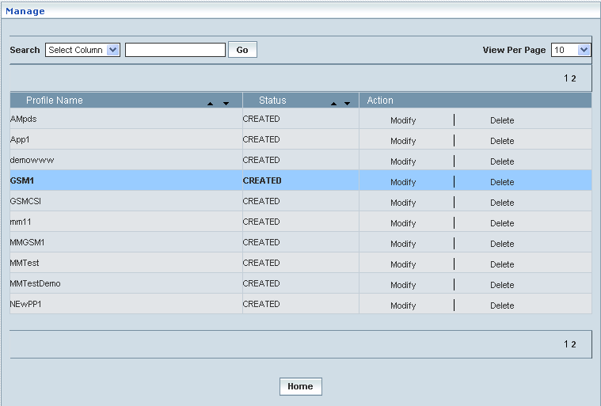

## Mobile Originating SMS CSI

Mobile Originating SMS CSI data defines the contents of the MO SMS (Short Message Service) CAMEL subscription information. The MO SMS CAMEL Subscription Information helps performing the inter-work between

* gsmSCF and gsmSSF for CAMEL control of ***circuit switched*** MO SMS
* gsmSCF and gprsSSF, for CAMEL control of ***packet switched*** MO SMS

This also helps creating various Mobile Originating SMS CSI profiles, which in turn provide a wider flexibility in attributing the same to different customer subscription types and varied demands in the space of SMS service.

MO-SMS-CSI consists of the following data items:

* *DP Value:* The DP value identifies the DP in the MO SMS State Model, where service triggering may take place; for MO-SMS-CSI, the only allowed DP value is *SMS-Collected-Info*
* *gsmSCF Name:* The gsmSCF Name is the address (E164 number) of the gsmSCF where the MO SMS CAMEL Service associated with this TDP locates the right subscriber
* *Service Key:* The service Key identifies the service logic that shall be applied to the gsmSCF
* *Default SMS handling:* The default SMS handling indicates whether the MO SMS submission request shall be rejected or continued in case of error during the dialogue between the gsmSSF and gsmSCF or between the gprsSSF and gsmSCF
* *CAMEL Capability Handling:* CAMEL Capability Handling indicates the CAMEL Phase that is required for the MO SMS service. The CAMEL Capability Handling for MO-SMS-CSI shall have the value CAMEL phase 3
* *CSI state:* indicates whether the MO-SMS-CSI is active or not
* *Notification flag:* Indicates whether the change of the SMS-CSI shall invoke a notification on change of Subscriber Data or not

**Create / View**

Home Location Register 🡪 CAMEL Subscriptions 🡪 GPRS CAMEL Subscriptions 🡪 Mobile Originating SMS CSI 🡪 Create / View

Initially, ‘Mobile Originating SMS CSI’ displays a grid showing the list of existing profiles that are configured and created. This list may include those profiles that are created and approved, created and rejected and also those created but still to be approved or rejected.

The screen below shows the list of various Mobile Originating SMS CSI configurations in a grid.

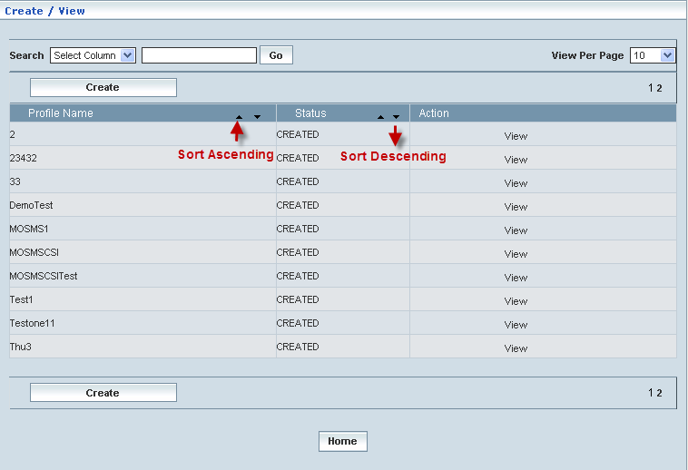

| **STEP** | | **ACTION** |
| --- | --- | --- |
|  | | By default, the list of profiles (Mobile Originating SMS CSI) will be displayed as records in a grid. The columns include ‘Profile Name’, ‘Status’ and ‘Action’ |
|  |  | User can customize the view for the number of records to be displayed each time (per page) in a grid.  However, this option is applicable only if the total number of records exceeds 10. And also with the immediate effect of increase in the number of records more than 10, a ‘Search’ option would be dynamically displayed. |
| Select the number of records (For Ex: 10) from the drop-down list of the <View Per Page> field. |
| With the effect of choosing the desired number (10) for the display of records per page, the same (10 records) will be displayed in the grid. |
| User can sort the records in ascending and descending orders with the help of up-arrow and down-arrows respectively |
| However, based on the total number of records, page numbers will be dynamically displayed at the left bottom of the screen |
| User can navigate for subsequent records (10 each time) by clicking the desired ‘page number’ |
|  | | Status indicates the profile status whether just created (Created) or created and approved (Approved) or created but rejected (Rejected) |
|  | | On clicking the **Create** button, ‘Create’ screen will be displayed enabling the user to create a new ‘Profile’ (Mobile Originating SMS CSI Profile) |
|  | | On clicking the **View** link of a chosen ‘Profile’, corresponding information related to the profile will be displayed in a separate screen enabling the user to peruse details of the profile |
|  | | On clicking the **Home** button at the bottom of the grid, it redirects the user to the ‘Mobile Originating SMS CSI’ main page |

**Create**

Home Location Register 🡪 CAMEL Subscriptions 🡪 GPRS CAMEL Subscriptions 🡪 Mobile Originating SMS CSI 🡪 Create / View

Create enables the user to create a new profile (Mobile Originating SMS CSI Profile) and attribute various values to constitute the same.

The screen below shows creating a new profile as Mobile Originating SMS CSI

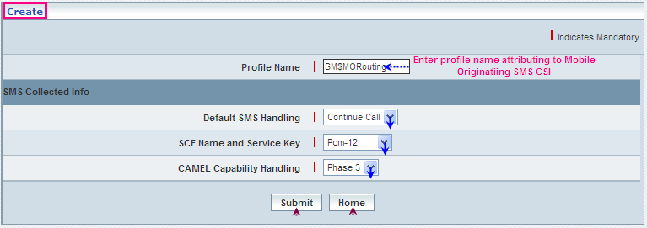

| **STEP** | **ACTION** |
| --- | --- |
|  | User must essentially enter the details related to a new profile where it is a mandatory information |
|  | Enter name of the profile in <Profile Name> field |
|  | **SMS Collected Info Block:**  Select a default SMS handling element (Continue Call or Release Call) to specify a default setting for the SMS handling, from the drop-down list of the <Default SMS Handling> field  * By default, the list of SMS handling elements (Continue Call / Release Call) will be dynamically displayed as drop-down list of the <Default SMS Handling> field |
|  | Select a pair representing the combination of SCF Name and Service Key to specify the SCF Name & Service Key mix for the ‘Mobile Originating SMS CSI’ element, from the drop-down list of the <SCF Name and Service Key> field  **\*** By default, the list of pairs representing SCF Name and Service Key will be dynamically displayed as drop-down list of the <SCF Name and Service Key> field |
|  | Select a CAMEL Capability Handling Phase (Phase3 and Phase4) to specify the CAMEL capability handling from the drop-down list of the <CAMEL Capability Handling> field  **\*** By default, the list of phases will be dynamically displayed as drop-down list of the <CAMEL Capability Handling> field |
|  | On clicking the **Submit** button, new profile (Mobile Originating SMS CSI) will be created and a message window to that effect will be displayed  Wor81  On clicking the **Home** button of the message window, it directs the user back to the Mobile Originating SMS CSI profiles grid |
|  | On clicking the **Home** button of the ‘Create’ screen (before creating any new profile), it directs the user to the Mobile Originating SMS CSI profiles grid |

**View**

Home Location Register 🡪 CAMEL Subscriptions 🡪 GPRS CAMEL Subscriptions 🡪 Mobile Originating SMS CSI 🡪 Create / View

View enables the user to peruse details related to chosen profile (Mobile Originating SMS CSI).

On clicking the **‘View’** link of a chosen ‘Profile’ (from the Mobile Originating SMS CSI Profiles List); corresponding information related to the profile will be displayed in a separate screen enabling the user to peruse details of the profile – Mobile Originating SMS CSI.

The screen below displays the details related to chosen profile (Mobile Originating SMS CSI)

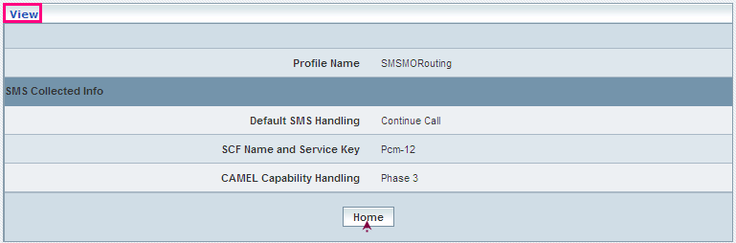

| **STEP** | **ACTION** |
| --- | --- |
|  | User can peruse details related to the chosen ‘Mobile Originating SMS CSI’ Profile |
|  | On clicking the **Home** button at the bottom of the ‘View’ Screen, it redirects the user to the ‘Mobile Originating SMS CSI’ profiles grid |

**Searching for a specific Mobile Originating SMS CSI profiles (Record)**



| **STEP** | **ACTION** |
| --- | --- |
|  | Select a search criterion (‘Profile Name’) from the drop-down list of the search criteria of the <Search> field  **\*** By default the list of search criterion (‘Profile Name’) will be dynamically displayed as drop-down list of the <Search> field |
|  | Enter the ‘Profile Name’ that corresponds with the given search criterion |
|  | On clicking the **Go** button, the corresponding Mobile Originating SMS CSI Profiles (record) will be highlighted among the list of Mobile Originating SMS CSI Profiles records. |

The screen below depicts fetching and displaying the give Mobile Originating SMS CSI Profiles record.

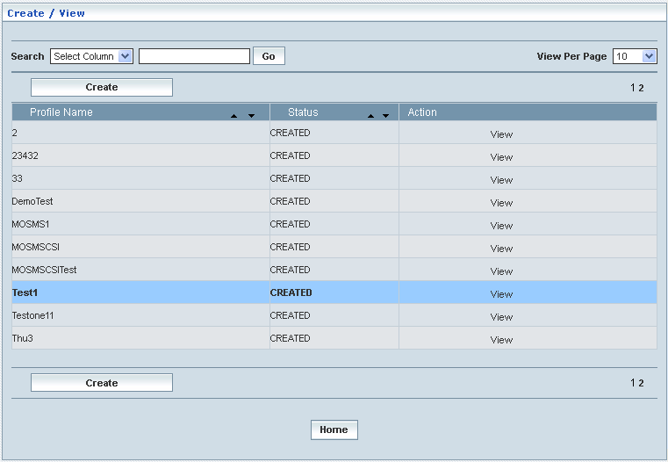

**Manage**

Home Location Register 🡪 CAMEL Subscriptions 🡪 GPRS CAMEL Subscriptions 🡪 Mobile Originating SMS CSI 🡪 Manage

‘Manage’ helps the user modifying and deleting (managing) a chosen Mobile Originating SMS CSI profile that was created, but still to be approved.

Initially, the screen displays the list of Mobile Originating SMS CSI profiles that were configured and created.

The screen below shows the list of various Mobile Originating SMS CSI (Profiles) configurations in a grid.

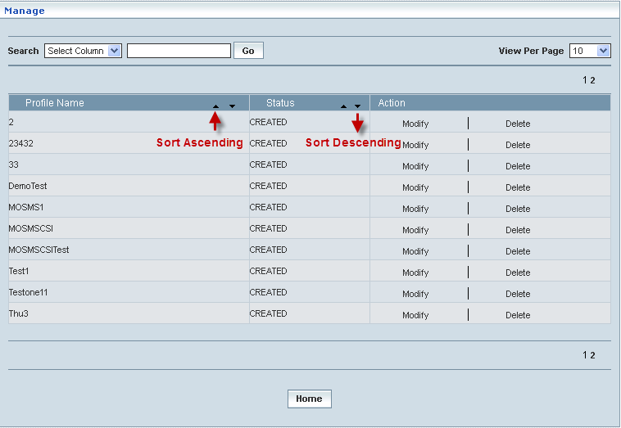

| **STEP** | | **ACTION** |
| --- | --- | --- |
|  | | By default, the list of profiles will be displayed as records in a grid. The columns include ‘Profile Name’, ‘Status’ and ‘Action’ |
|  |  | User can customize the view for the number of records to be displayed each time (per page) in a grid.  However, this option is applicable only if the total number of records exceeds 10. And also with the immediate effect of increase in the number of records more than 10, a ‘Search’ option would be dynamically displayed. |
| Select the number of records (For Ex: 10) from the drop-down list of the <View Per Page> field. |
| With the effect of choosing the desired number (10) for the display of records per page, the same (10 records) will be displayed in the grid. |
| User can sort the records in ascending and descending orders with the help of up-arrow and down-arrows respectively |
| However, based on the total number of records, page numbers will be dynamically displayed at the left bottom of the screen |
| User can navigate for subsequent records (10 each time) by clicking the desired ‘page number’ |
|  | | Status indicates the profile status whether just created (Created) or created and approved (Approved) or created but rejected (Rejected) |
|  | | On clicking the **Modify** link of a chosen ‘Profile’, corresponding information related to the profile will be displayed in a separate screen enabling the user to modify / update details of the profile |
|  | | On clicking the **Delete** link of a chosen ‘Profile’, corresponding information related to the profile will be displayed in a separate screen enabling the user to delete the profile |
|  | | On clicking the **Home** button at the bottom of the grid, it redirects the user to the ‘Mobile Originating SMS CSI’ main page |

**Modify**

Home Location Register 🡪 CAMEL Subscriptions 🡪 GPRS CAMEL Subscriptions 🡪 Mobile Originating SMS CSI 🡪 Manage 🡪 Modify

Modify enables the user to modify / update the details related to an existing Mobile Originating SMS CSI profile.

On clicking the **‘Modify’** link of a chosen ‘Profile’ (from the Mobile Originating SMS CSI Profiles List); corresponding information related to the profile will be displayed in a separate screen enabling the user to modify / update details of the profile – Mobile Originating SMS CSI.

The screen below shows modifying / updating the details related to an existing Mobile Originating SMS CSI profile.

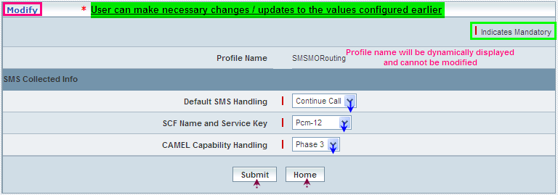

| **STEP** | **ACTION** |
| --- | --- |
|  | Name of the profile will be dynamically displayed in the <Profile Name> field and this cannot be modified |
|  | User can make necessary changes / updates to the existing values / configurations of the profile |
|  | On clicking the **Submit** button at the bottom of the ‘Modify’ screen, profile (Mobile Originating SMS CSI) details will be updated accordingly and a message window to that effect will be displayed  Wor84  On clicking the **Home** button of the message window, it directs the user back to the Mobile Originating SMS CSI profiles grid |
|  | On clicking the **Home** button of the ‘Modify’ screen (before updating the details related to profile), it directs the user to the Mobile Originating SMS CSI profiles grid |

**Delete**

Home Location Register 🡪 CAMEL Subscriptions 🡪 GPRS CAMEL Subscriptions 🡪 Mobile Originating SMS CSI 🡪 Manage 🡪 Delete

Delete enables the user to delete an existing Mobile Originating SMS CSI profile.

On clicking the **‘Delete’** link of a chosen ‘Profile’ (from the Mobile Originating SMS CSI Profiles List); corresponding information related to the profile will be displayed in a separate screen enabling the user to delete the profile – Mobile Originating SMS CSI.

The screen below shows the details related to an existing Mobile Originating SMS CSI profile, which enables the user to delete the same (Profile).

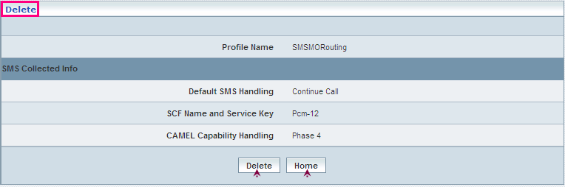

| **STEP** | **ACTION** |
| --- | --- |
|  | User can peruse the existing values / configurations of the profile before deleting the profile |
|  | On clicking the **Delete** at the bottom of the ‘Delete’ screen, it displays an alert window enabling the user to confirm deletion of the chosen profile (Mobile Originating SMS CSI)  Wor6  On clicking the **OK** button of the alert window, the chosen Mobile Originating SMS CSI profile will be deleted and a message window to that effect will be displayed  Wor86  On clicking the **Cancel** button of the alert window, it retains the corresponding ‘Delete’ screen  On clicking the **Home** button of the message window, it directs the user back to the ‘Mobile Originating SMS CSI’ profiles grid |
|  | On clicking the **Home** button of the ‘Delete’ screen (before deleting the profile), it directs the user to the ‘Mobile Originating SMS CSI’ profiles grid |

**Searching for a specific Mobile Originating SMS CSI profiles (Record)**



| **STEP** | **ACTION** |
| --- | --- |
|  | Select a search criterion (‘Profile Name’) from the drop-down list of the search criteria of the <Search> field  **\*** By default the list of search criterion (‘Profile Name’) will be dynamically displayed as drop-down list of the <Search> field |
|  | Enter the ‘Profile Name’ that corresponds with the given search criterion |
|  | On clicking the **Go** button, the corresponding Mobile Originating SMS CSI Profiles (record) will be highlighted among the list of Mobile Originating SMS CSI Profiles records. |

The screen below depicts fetching and displaying the give Mobile Originating SMS CSI Profiles record.

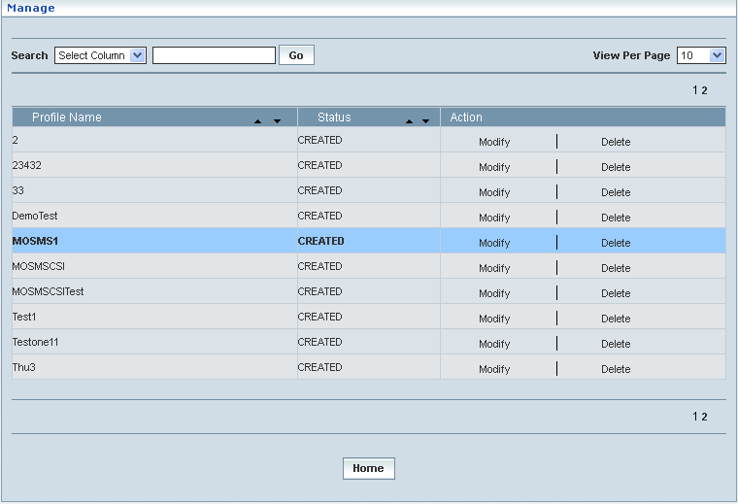

## Mobile Terminating SMS CSI

Mobile Terminating SMS CSI data defines the contents of the MT SMS (Short Message Service) CAMEL subscription information. The MT SMS CAMEL Subscription Information helps performing the inter-work between

* gsmSCF and gsmSSF for CAMEL control of ***circuit switched*** MT SMS
* gsmSCF and gprsSSF, for CAMEL control of ***packet switched*** MTSMS

This also helps creating various Mobile Terminating SMS CSI profiles, which in turn provide a wider flexibility in attributing the same to different customer subscription types and varied demands in the space of SMS service.

MT-SMS-CSI consists of the following data items:

* *DP Value:* The DP value identifies the DP in the MT SMS State Model, where service triggering may take place; for MT-SMS-CSI, the only allowed DP value is *SMS-Delivery-Request*
* *gsmSCF Name:* The gsmSCF Name is the address (E164 number) of the gsmSCF where the MT SMS CAMEL Service associated with this TDP locates the right subscriber
* *Service Key:* The service Key identifies the service logic that shall be applied to the gsmSCF
* *Default SMS handling:* The default SMS handling indicates whether the MT SMS submission request shall be rejected or continued in case of error during the dialogue between the gsmSSF and gsmSCF or between the gprsSSF and gsmSCF
* *DP criterion:* The DP criterion indicates as to which criterion the gsmSSF shall access the gsmSCF. A DP criterion is associated with each TDP (Trigger Detection Point). For MT-SMS the DP criterion is the TDPU type. The criterion may be absent.

**Create / View**

Home Location Register 🡪 CAMEL Subscriptions 🡪 GPRS CAMEL Subscriptions 🡪 Mobile Terminating SMS CSI 🡪 Create / View

Initially, ‘Mobile Terminating SMS CSI’ displays a grid showing the list of existing profiles that are configured and created. This list may include those profiles that are created and approved, created and rejected and also those created but still to be approved or rejected.

The screen below shows the list of various Mobile Terminating SMS CSI configurations in a grid.

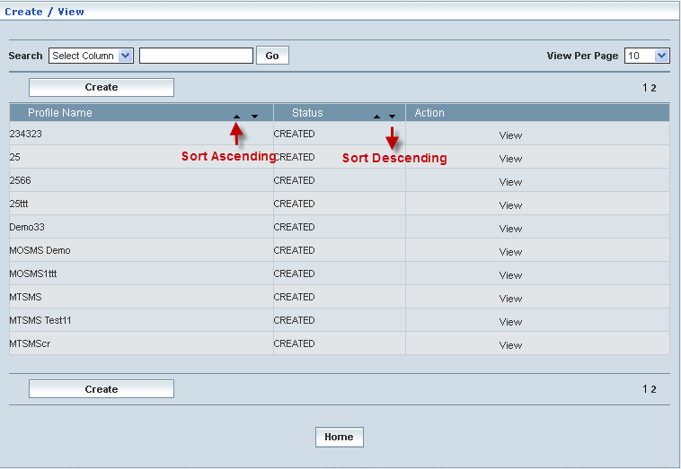

| **STEP** | | **ACTION** |
| --- | --- | --- |
|  | | By default, the list of profiles (Mobile Terminating SMS CSI) will be displayed as records in a grid. The columns include ‘Profile Name’, ‘Status’ and ‘Action’ |
|  |  | User can customize the view for the number of records to be displayed each time (per page) in a grid.  However, this option is applicable only if the total number of records exceeds 10. And also with the immediate effect of increase in the number of records more than 10, a ‘Search’ option would be dynamically displayed. |
| Select the number of records (For Ex: 10) from the drop-down list of the <View Per Page> field. |
| With the effect of choosing the desired number (10) for the display of records per page, the same (10 records) will be displayed in the grid. |
| User can sort the records in ascending and descending orders with the help of up-arrow and down-arrows respectively |
| However, based on the total number of records, page numbers will be dynamically displayed at the left bottom of the screen |
| User can navigate for subsequent records (10 each time) by clicking the desired ‘page number’ |
|  | | Status indicates the profile status whether just created (Created) or created and approved (Approved) or created but rejected (Rejected) |
|  | | On clicking the **Create** button, ‘Create’ screen will be displayed enabling the user to create a new ‘Profile’ (Mobile Terminating SMS CSI Profile) |
|  | | On clicking the **View** link of a chosen ‘Profile’, corresponding information related to the profile will be displayed in a separate screen enabling the user to peruse details of the profile |
|  | | On clicking the **Home** button at the bottom of the grid, it redirects the user to the ‘Mobile Terminating SMS CSI’ main page |

**Create**

Home Location Register 🡪 CAMEL Subscriptions 🡪 GPRS CAMEL Subscriptions 🡪 Mobile Terminating SMS CSI 🡪 Create / View

Create enables the user to create a new profile (Mobile Terminating SMS CSI Profile) and attribute various values to constitute the same.

The screen below shows creating a new profile as Mobile Terminating SMS CSI

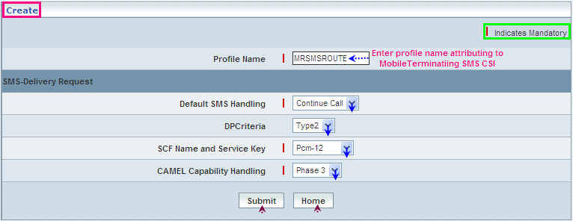

| **STEP** | **ACTION** |
| --- | --- |
|  | User must essentially enter the details related to a new profile where it is a mandatory information |
|  | Enter name of the profile in <Profile Name> field |
|  | **SMS Delivery Request Block:**  Select a default SMS handling element (Continue Call or Release Call) to specify a default setting for the SMS handling, from the drop-down list of the <Default SMS Handling> field  **\*** By default, the list of SMS handling elements (Continue Call / Release Call) will be dynamically displayed as drop-down list of the <Default SMS Handling> field |
|  | Select a DP criterion (Type1 or Type2) to specify a default DP criterion, from the drop-down list of the <DP Criteria> field  **\*** By default, the list of DP criteria (Type1 / Type2) will be dynamically displayed as drop-down list of the <DP criteria> field |
|  | Select a pair representing the combination of SCF Name and Service Key to specify the SCF Name & Service Key mix for the ‘Mobile Terminating SMS CSI’ element, from the drop-down list of the <SCF Name and Service Key> field  **\*** By default, the list of pairs representing SCF Name and Service Key will be dynamically displayed as drop-down list of the <SCF Name and Service Key> field |
|  | Select a CAMEL Capability Handling Phase (Phase3 and Phase4) to specify the CAMEL capability handling from the drop-down list of the <CAMEL Capability Handling> field  **\*** By default, the list of phases will be dynamically displayed as drop-down list of the <CAMEL Capability Handling> field |
|  | On clicking the **Submit** button, new profile (Mobile Terminating SMS CSI) will be created and a message window to that effect will be displayed  Wor88  On clicking the **Home** button of the message window, it directs the user back to the ‘Mobile Terminating SMS CSI’ profiles grid |
|  | On clicking the **Home** button of the ‘Create’ screen (before creating any new profile), it directs the user to the ‘Mobile Terminating SMS CSI’ profiles grid |

**View**

Home Location Register 🡪 CAMEL Subscriptions 🡪 GPRS CAMEL Subscriptions 🡪 Mobile Terminating SMS CSI 🡪 Create / View

View enables the user to peruse details related to chosen profile (Mobile Terminating SMS CSI).

On clicking the **‘View’** link of a chosen ‘Profile’ (from the Mobile Terminating SMS CSI Profiles List); corresponding information related to the profile will be displayed in a separate screen enabling the user to peruse details of the profile – Mobile Terminating

SMS CSI.

The screen below displays the details related to chosen profile (Mobile Terminating SMS CSI)

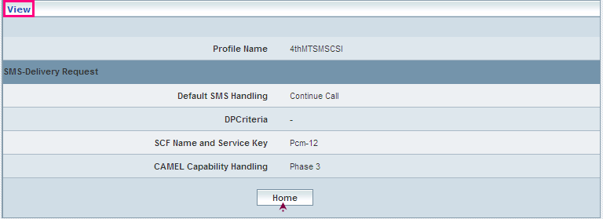

| **STEP** | **ACTION** |
| --- | --- |
|  | User can peruse details related to the chosen Mobile Terminating SMS CSI Profile |
|  | On clicking the **Home** button at the bottom of the ‘View Screen’, it redirects the user to the ‘Mobile Terminating SMS CSI’ profiles grid |

**Searching for a specific Mobile Terminating SMS CSI profiles (Record)**



| **STEP** | **ACTION** |
| --- | --- |
|  | Select a search criterion (‘Profile Name’) from the drop-down list of the search criteria of the <Search> field  **\*** By default the list of search criterion (‘Profile Name’) will be dynamically displayed as drop-down list of the <Search> field |
|  | Enter the ‘Profile Name’ that corresponds with the given search criterion |
|  | On clicking the **Go** button, the corresponding Mobile Terminating SMS CSI Profiles (record) will be highlighted among the list of Mobile Terminating SMS CSI Profiles records. |

The screen below depicts fetching and displaying the give Mobile Terminating SMS CSI Profiles record.

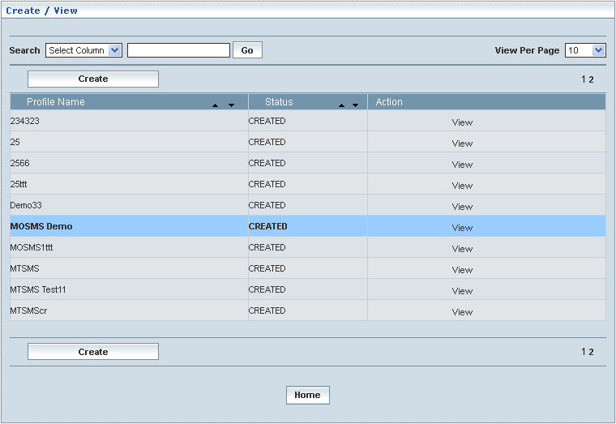

**Manage**

Home Location Register 🡪 CAMEL Subscriptions 🡪 GPRS CAMEL Subscriptions 🡪 Mobile Terminating SMS CSI 🡪 Manage

‘Manage’ helps the user modifying and deleting (managing) a chosen Mobile Terminating SMS CSI profile that was created, but still to be approved.

Initially, the screen displays the list of Mobile Terminating SMS CSI profiles that were configured and created.

The screen below shows the list of various Mobile Terminating SMS CSI (Profiles) configurations in a grid.

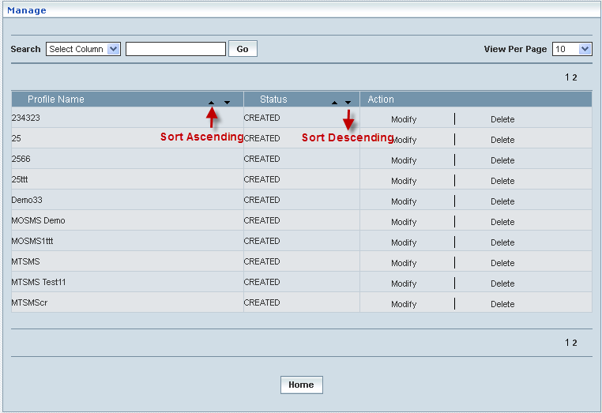

| **STEP** | | **ACTION** |
| --- | --- | --- |
|  | | By default, the list of profiles will be displayed as records in a grid. The columns include ‘Profile Name’, ‘Status’ and ‘Action’ |
|  |  | User can customize the view for the number of records to be displayed each time (per page) in a grid.  However, this option is applicable only if the total number of records exceeds 10. And also with the immediate effect of increase in the number of records more than 10, a ‘Search’ option would be dynamically displayed. |
| Select the number of records (For Ex: 10) from the drop-down list of the <View Per Page> field. |
| With the effect of choosing the desired number (10) for the display of records per page, the same (10 records) will be displayed in the grid. |
| User can sort the records in ascending and descending orders with the help of up-arrow and down-arrows respectively |
| However, based on the total number of records, page numbers will be dynamically displayed at the left bottom of the screen |
| User can navigate for subsequent records (10 each time) by clicking the desired ‘page number’ |
|  | | On clicking the **Modify** link of a chosen ‘Profile’, corresponding information related to the profile will be displayed in a separate screen enabling the user to modify / update details of the profile |
|  | | On clicking the **Delete** link of a chosen ‘Profile’, corresponding information related to the profile will be displayed in a separate screen enabling the user to delete the profile |
|  | | On clicking the **Home** button at the bottom of the grid, it redirects the user to the ‘Mobile Terminating SMS CSI’ main page |

**Modify**

Home Location Register 🡪 CAMEL Subscriptions 🡪 GPRS CAMEL Subscriptions 🡪 Mobile Terminating SMS CSI 🡪 Manage 🡪 Modify

Modify enables the user to modify / update the details related to an existing Mobile Terminating SMS CSI profile.

On clicking the **‘Modify’** link of a chosen ‘Profile’ (from the Mobile Terminating SMS CSI Profiles List); corresponding information related to the profile will be displayed in a separate screen enabling the user to modify / update details of the profile – Mobile Terminating SMS CSI.

The screen below shows modifying / updating the details related to an existing Mobile Terminating SMS CSI profile.

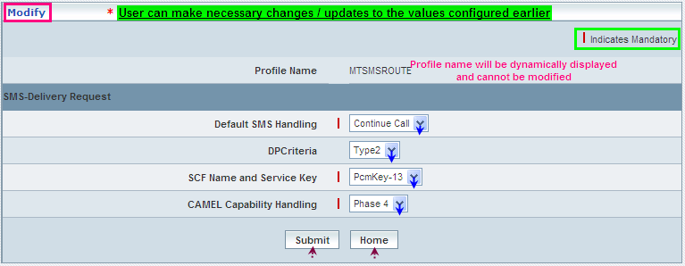

| **STEP** | **ACTION** |
| --- | --- |
|  | Name of the profile will be dynamically displayed in the <Profile Name> field and this cannot be modified |
|  | User can make necessary changes / updates to the existing values / configurations of the profile |
|  | On clicking the **Submit** button at the bottom of the ‘Modify’ screen, profile (Mobile Terminating SMS CSI) details will be updated accordingly and a message window to that effect will be displayed  Wor8B  On clicking the **Home** button of the message window, it directs the user back to the ‘Mobile Terminating SMS CSI’ profiles grid |
|  | On clicking the **Home** button of the ‘Modify’ screen (before updating the details related to profile), it directs the user to the ‘Mobile Terminating SMS CSI’ profiles grid |

**Delete**

Home Location Register 🡪 CAMEL Subscriptions 🡪 GPRS CAMEL Subscriptions 🡪 Mobile Terminating SMS CSI 🡪 Manage 🡪 Delete

Delete enables the user to delete an existing Mobile Terminating SMS CSI profile.

On clicking the **‘Delete’** link of a chosen ‘Profile’ (from the Mobile Terminating SMS CSI Profiles List); corresponding information related to the profile will be displayed in a separate screen enabling the user to delete the – Mobile Terminating SMS CSI.

The screen below shows the details related to an existing Mobile Terminating SMS CSI profile, which enables the user to delete the same (Profile).

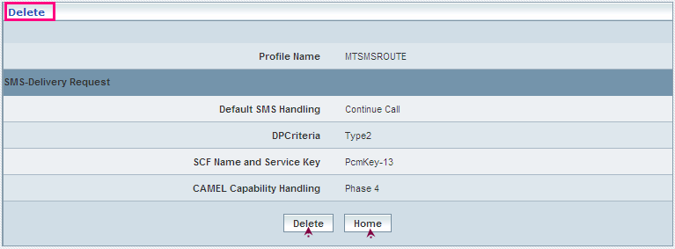

| **STEP** | **ACTION** |
| --- | --- |
|  | User can peruse the existing values / configurations of the profile before deleting the profile |
|  | On clicking the **Delete** at the bottom of the ‘Delete’ screen, it displays an alert window enabling the user to confirm deletion of the chosen profile (Mobile Terminating SMS CSI)  Wor6  On clicking the **OK** button of the alert window, the chosen Mobile Terminating SMS CSI profile will be deleted and a message window to that effect will be displayed  Wor8D  On clicking the **Cancel** button of the alert window, it retains the corresponding ‘Delete’ screen  On clicking the **Home** button of the message window, it directs the user back to the Mobile Terminating SMS CSI profiles grid |
|  | On clicking the **Home** button of the ‘Delete’ screen (before deleting the profile), it directs the user to the Mobile Terminating SMS CSI profiles grid |

**Searching for a specific Mobile Terminating SMS CSI profiles (Record)**



| **STEP** | **ACTION** |
| --- | --- |
|  | Select a search criterion (‘Profile Name’) from the drop-down list of the search criteria of the <Search> field  **\*** By default the list of search criterion (‘Profile Name’) will be dynamically displayed as drop-down list of the <Search> field |
|  | Enter the ‘Profile Name’ that corresponds with the given search criterion |
|  | On clicking the **Go** button, the corresponding Mobile Terminating SMS CSI Profiles (record) will be highlighted among the list of Mobile Terminating SMS CSI Profiles records. |

The screen below depicts fetching and displaying the give Mobile Terminating SMS CSI Profiles record.

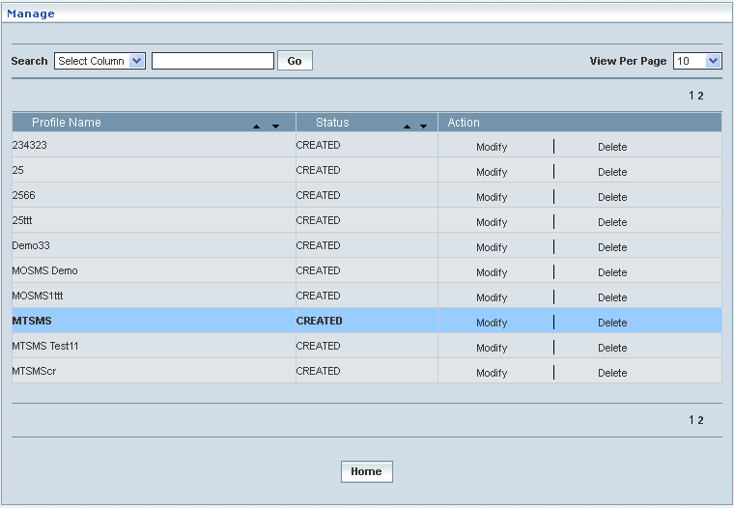

## Dialed Service CSI

Dialled Service CSI data defines the contents of the dialled service CAMEL subscription information that is employed to inter-work with the GSMSCF for MO and MT call. This helps creating various Dialled Service CSI profiles, which in turn provide a wider flexibility in attributing the same to different customer subscription types and varied demands.

**Create / View**

Home Location Register 🡪 CAMEL Subscriptions 🡪 GSM CAMEL Subscriptions 🡪 Dialed Service CSI 🡪 Create / View

Initially, ‘Dialed Service CSI’ displays a grid showing the list of existing profiles that are configured and created. This list may include those profiles that are created and approved, created and rejected and also those created but still to be approved or rejected.

The screen below shows the list of various profiles pertaining to Dialed Service CSI in a grid.

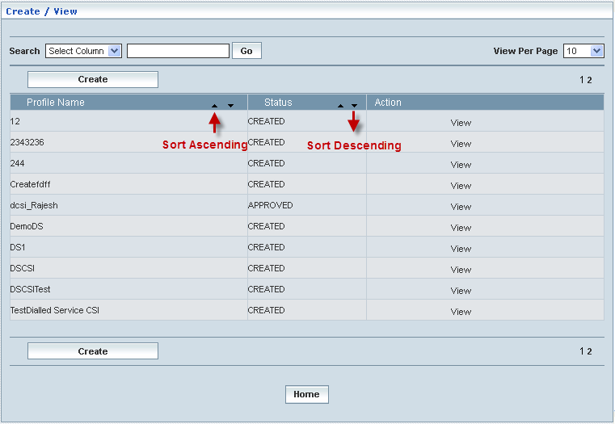

|  |  |  |
| --- | --- | --- |
| **STEP** | | **ACTION** |
|  | | By default, the list of profiles (Dialed Service CSI) will be displayed as records in a grid. The columns include ‘Profile Name’, ‘Status’ and ‘Action’ |
|  |  | User can customize the view for the number of records to be displayed each time (per page) in a grid.  However, this option is applicable only if the total number of records exceeds 10. And also with the immediate effect of increase in the number of records more than 10, a ‘Search’ option would be dynamically displayed. |
| Select the number of records (For Ex: 10) from the drop-down list of the <View Per Page> field. |
| With the effect of choosing the desired number (10) for the display of records per page, the same (10 records) will be displayed in the grid. |
| User can sort the records in ascending and descending orders with the help of up-arrow and down-arrows respectively |
| However, based on the total number of records, page numbers will be dynamically displayed at the left bottom of the screen |
| User can navigate for subsequent records (10 each time) by clicking the desired ‘page number’ |
|  | | Status indicates the profile status whether just created (Created) or created and approved (Approved) |
|  | | On clicking the **Create** button, ‘Create’ screen will be displayed enabling the user to create a new ‘Profile’ (Dialed Service CSI Profile) |
|  | | On clicking the **View** link of a chosen ‘Profile’, corresponding information related to the profile (Dialed Service CSI Profile) will be displayed in a separate screen enabling the user to peruse details of the profile |
|  | | On clicking the **Home** button at the bottom of the grid, it redirects the user to the ‘Dialed Service CSI’ main page |

**Create**

Home Location Register 🡪 CAMEL Subscriptions 🡪 GSM CAMEL Subscriptions 🡪 Dialed Service CSI 🡪 Create / View

Create enables the user to create a new profile (Dialed Service CSI Profile) and attribute various values to constitute the same.

**NOTE:** Only two CAMEL Capability Handling phases (Phase3 & Phase4) are relatable to **Dialed Service CSI Profile** creation. However, the new proposed profile creation shall be based on the chosen CAMEL Capability Handling phase (Phase3/Phase4).

The screen below shows creating a new profile as Dialed Service CSI.

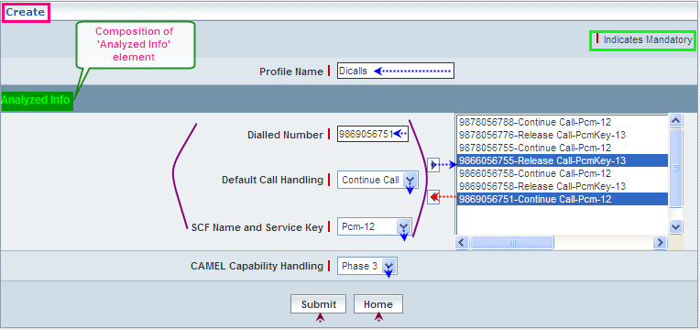

| **STEP** | **ACTION** |
| --- | --- |
|  | User must essentially enter the details related to a new profile where it is a mandatory information |
|  | Enter name of the Dialed Service CSI profile in <Profile Name> field |
|  | **Analyzed Block:**  Enter a dialed number in the <Dialed Number> field |
|  | Select a Default Call Handling element (Continue Call or Release Call) to specify a default setting for the call handling, from the drop-down list of the <Default Call Handling> field  **\*** By default, the list of call handling elements (Continue Call / Release Call) will be dynamically displayed as drop-down list of the <Default Call Handling> field |
|  | Select a pair representing the combination of SCF Name and Service Key to specify the SCF Name & Service Key mix for the ‘Term Attempt Authorized’ element, from the drop-down list of the <SCF Name and Service Key> field  **\*** By default, the list of pairs representing SCF Name and Service Key will be dynamically displayed as drop-down list of the <SCF Name and Service Key> field |
|  | Clicking the right-arrow button, the composition (as a string) will be moved to the adjacent field  User can enter the desired number of combinations that correspond to different & unique dialed numbers  However if the user wants to just remove any combination (any time before creating the profile), selecting the mix from the right text field and subsequently clicking the left-arrow button removes the mix |
|  | Select a CAMEL Capability Handling Phase (Phase3 and Phase4) to specify the CAMEL capability handling from the drop-down list of the <CAMEL Capability Handling> field  **\*** By default, the list of phases will be dynamically displayed as drop-down list of the <CAMEL Capability Handling> field |
|  | On clicking the **Submit** button, new profile (Dialed Service CSI) will be created and a message window to that effect will be displayed  Wor74  On clicking the **Home** button of the message window, it directs the user back to the ‘Dialed Service CSI’ profiles grid |
|  | On clicking the **Home** button of the ‘Create’ screen (before creating any new profile), it directs the user to the ‘Dialed Service CSI’ profiles grid |

**View**

Home Location Register 🡪 CAMEL Subscriptions 🡪 GSM CAMEL Subscriptions 🡪 Dialed Service CSI 🡪 Create / View

View enables the user to peruse details related to chosen profile (Dialed Service CSI).

On clicking the **‘View’** link of a chosen ‘Profile’ (from the Dialed Service CSI Profiles List); corresponding information related to the profile will be displayed in a separate screen enabling the user to peruse details of the profile – Dialed Service CSI Profile.

The screen below displays the details related to chosen profile (Dialed Service CSI).

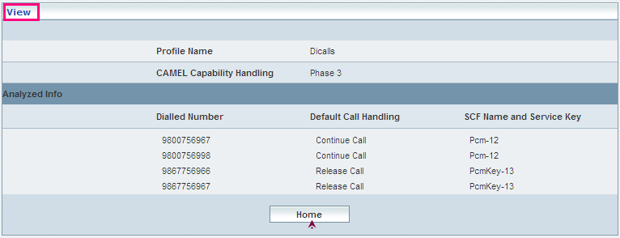

| **STEP** | **ACTION** |
| --- | --- |
|  | User can peruse details related to the chosen Dialed Service CSI Profile |
|  | On clicking the **Home** button at the bottom of the ‘View’ Screen, it redirects the user to the ‘Dialed Service CSI’ profiles grid |

**Searching for a specific Dialed Service CSI profiles (Record)**



| **STEP** | **ACTION** |
| --- | --- |
|  | Select a search criterion (‘Profile Name’) from the drop-down list of the search criteria of the <Search> field  **\*** By default the list of search criterion (‘Profile Name’) will be dynamically displayed as drop-down list of the <Search> field |
|  | Enter the ‘Profile Name’ that corresponds with the given search criterion |
|  | On clicking the **Go** button, the corresponding Dialed Service CSI Profiles (record) will be highlighted among the list of Dialed Service CSI Profiles records. |

The screen below depicts fetching and displaying the give Dialed Service CSI Profiles record.

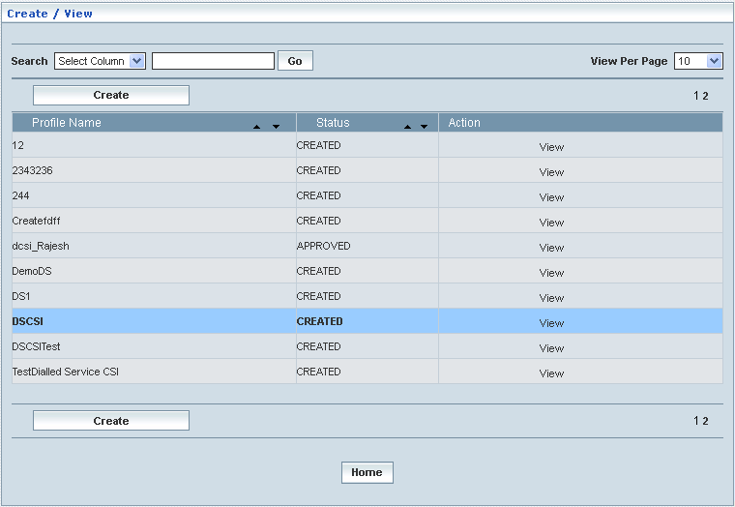

**Manage**

Home Location Register 🡪 CAMEL Subscriptions 🡪 GSM CAMEL Subscriptions 🡪 Dialed Service CSI 🡪 Manage

‘Manage’ helps the user modifying and deleting (managing) a chosen Dialed Service CSI profile that was created, but still to be approved. Initially, the screen displays the list of Dialed Service CSI profiles that were configured and created.

The screen below shows the list of various Dialed Service CSI (Profiles) configurations in a grid.

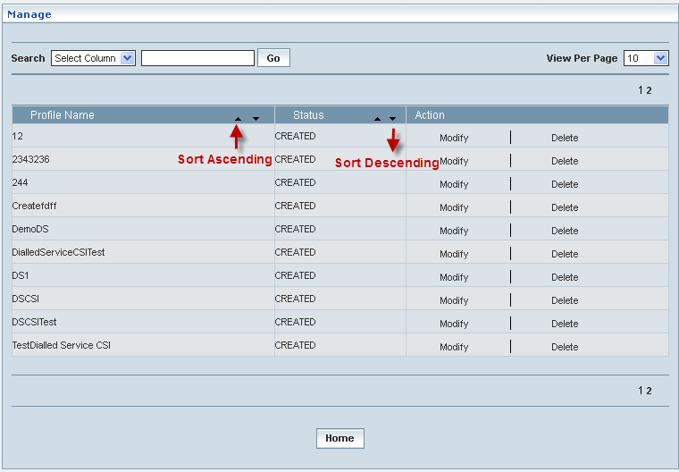

| **STEP** | | **ACTION** |
| --- | --- | --- |
|  | | By default, the list of profiles (Dialed Service CSI profiles) will be displayed as records in a grid. The columns include ‘Profile Name’, ‘Status’ and ‘Action’ |
|  |  | User can customize the view for the number of records to be displayed each time (per page) in a grid.  However, this option is applicable only if the total number of records exceeds 10. And also with the immediate effect of increase in the number of records more than 10, a ‘Search’ option would be dynamically displayed. |
| Select the number of records (For Ex: 10) from the drop-down list of the <View Per Page> field. |
| With the effect of choosing the desired number (10) for the display of records per page, the same (10 records) will be displayed in the grid. |
| User can sort the records in ascending and descending orders with the help of up-arrow and down-arrows respectively |
| However, based on the total number of records, page numbers will be dynamically displayed at the left bottom of the screen |
| User can navigate for subsequent records (10 each time) by clicking the desired ‘page number’ |
|  | | On clicking the **Modify** link of a chosen ‘Profile’, corresponding information related to the profile will be displayed in a separate screen enabling the user to modify / update details of the profile |
|  | | On clicking the **Delete** link of a chosen ‘Profile’, corresponding information related to the profile will be displayed in a separate screen enabling the user to delete the profile |
|  | | On clicking the **Home** button at the bottom of the grid, it redirects the user to the ‘Dialed Service CSI’ main page |

**Modify**

Home Location Register 🡪 CAMEL Subscriptions 🡪 GSM CAMEL Subscriptions 🡪 Dialed Service CSI 🡪 Manage 🡪 Modify

Modify enables the user to modify / update the details related to an existing Dialed Service CSI profile.

On clicking the **‘Modify’** link of a chosen ‘Profile’ (from the Dialed Service CSI Profiles List); corresponding information related to the profile will be displayed in a separate screen enabling the user to modify / update details of the – Dialed Service CSI Profile.

The screen below shows modifying / updating the details related to an existing Dialed Service CSI profile.

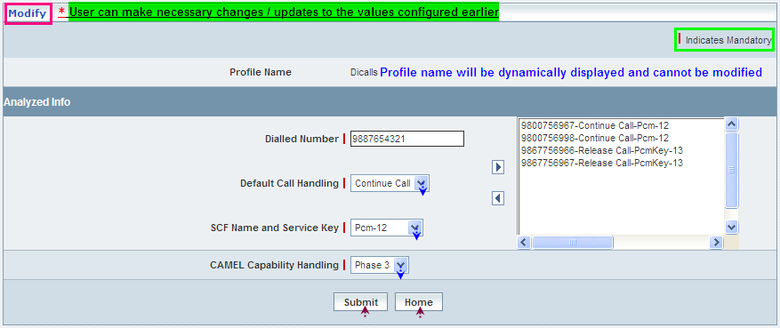

| **STEP** | **ACTION** |
| --- | --- |
|  | Name of the profile will be dynamically displayed in the <Profile Name> field and this cannot be modified |
|  | User can make necessary changes / updates to the existing values / configurations of the profile |
|  | On clicking the **Submit** button at the bottom of the ‘Modify’ screen, profile (Dialed Service CSI) details will be updated accordingly and a message window to that effect will be displayed  Wor77  On clicking the **Home** button of the message window, it directs the user back to the Dialed Service CSI profiles grid |
|  | On clicking the **Home** button of the ‘Modify’ screen (before updating the details related to profile), it directs the user to the Translation Dialed Service CSI profiles grid |

**Delete**

Home Location Register 🡪 CAMEL Subscriptions 🡪 GSM CAMEL Subscriptions 🡪 Dialed Service CSI 🡪 Manage 🡪 Delete

Delete enables the user to delete an existing Dialed Service CSI profile.

On clicking the **‘Delete’** link of a chosen ‘Profile’ (from the Dialed Service CSI Profiles List); corresponding information related to the profile will be displayed in a separate screen enabling the user to delete the – Dialed Service CSI Profile.

The screen below shows the details related to an existing Dialed Service CSI profile, which enables the user to delete the same (Profile).

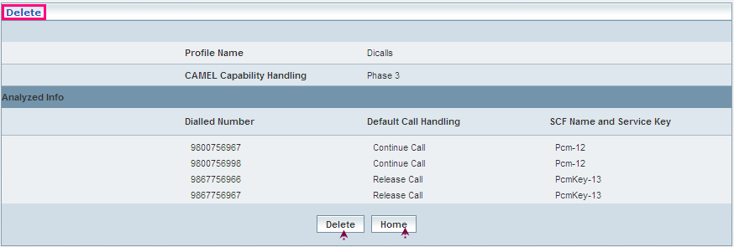

| **STEP** | **ACTION** |
| --- | --- |
|  | User can peruse the existing values / configurations of the profile before deleting the profile |
|  | On clicking the **Delete** button at the bottom of the ‘Delete’ screen, it displays an alert window enabling the user to confirm deletion of the chosen profile (Dialed Service CSI)  Wor6  On clicking the **OK** button of the alert window, the chosen Dialed Service CSI profile will be deleted and a message window to that effect will be displayed  Wor79  On clicking the **Cancel** button of the alert window, it retains the corresponding ‘Delete’ screen  On clicking the **Home** button of the message window, it directs the user back to the Dialed Service CSI profiles grid |
|  | On clicking the **Home** button of the ‘Delete’ screen (before deleting the profile), it directs the user to the Dialed Service CSI profiles grid |

**Searching for a specific Dialed Service CSI profiles (Record)**



| **STEP** | **ACTION** |
| --- | --- |
|  | Select a search criterion (‘Profile Name’) from the drop-down list of the search criteria of the <Search> field  **\*** By default the list of search criterion (‘Profile Name’) will be dynamically displayed as drop-down list of the <Search> field |
|  | Enter the ‘Profile Name’ that corresponds with the given search criterion |
|  | On clicking the **Go** button, the corresponding Dialed Service CSI Profiles (record) will be highlighted among the list of Dialed Service CSI Profiles records. |

The screen below depicts fetching and displaying the give Dialed Service CSI Profiles record.

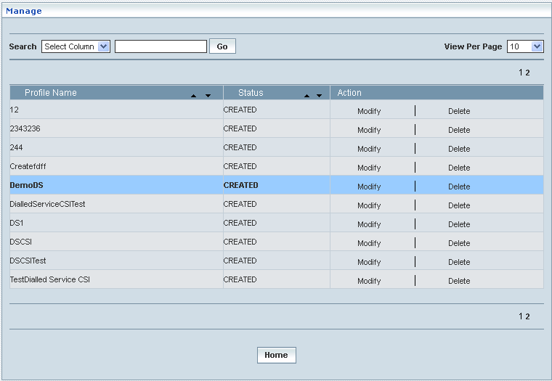

## USSD CSI

USSD CSI data comprises the receipt requests from the MS (Mobile Station) and helps the USSD tracking those requests through the information related to the corresponding service codes and GSM SCF Name and SCF address. Thus it consists of a list:

* Service code: the service code that defines a specific application in the GSM SCF
* GSM SCF Name and SCF Address: the GSM SCF Name and SCF address (E.164 number), which the USSD application identifies the subscriber

This also helps creating various USSD CSI profiles, which in turn provide a wider flexibility in attributing the same to different customer subscription types and varied demands.

**Create / View**

Home Location Register 🡪 CAMEL Subscriptions 🡪 GSM CAMEL Subscriptions 🡪 USSD CSI 🡪 Create / View

Initially, ‘USSD CSI’ displays a grid showing the list of existing profiles that are configured and created. This list may include those profiles that are created and approved, created and rejected and also those created but still to be approved or rejected.

The screen below shows the list of various profiles pertaining to USSD CSI in a grid.

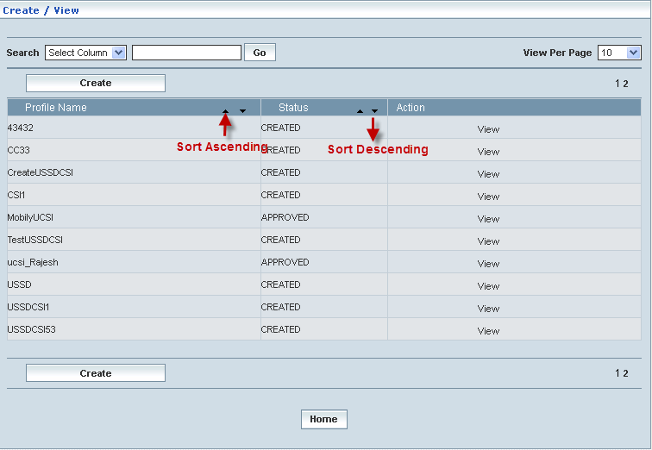

|  |  |  |
| --- | --- | --- |
| **STEP** | | **ACTION** |
|  | | By default, the list of profiles (USSD CSI) will be displayed as records in a grid. The columns include ‘Profile Name’, ‘Status’ and ‘Action’ |
|  |  | User can customize the view for the number of records to be displayed each time (per page) in a grid.  However, this option is applicable only if the total number of records exceeds 10. And also with the immediate effect of increase in the number of records more than 10, a ‘Search’ option would be dynamically displayed. |
| Select the number of records (For Ex: 10) from the drop-down list of the <View Per Page> field. |
| With the effect of choosing the desired number (10) for the display of records per page, the same (10 records) will be displayed in the grid. |
| User can sort the records in ascending and descending orders with the help of up-arrow and down-arrows respectively |
| However, based on the total number of records, page numbers will be dynamically displayed at the left bottom of the screen |
| User can navigate for subsequent records (10 each time) by clicking the desired ‘page number’ |
|  | | Status indicates the profile status whether just created (Created) or created and approved (Approved) or created but rejected (Rejected) |
|  | | On clicking the **Create** button, ‘Create’ screen will be displayed enabling the user to create a new ‘Profile’ (USSD CSI Profile) |
|  | | On clicking the **View** link of a chosen ‘Profile’, corresponding information related to the profile (USSD CSI Profile) will be displayed in a separate screen enabling the user to peruse details of the profile |
|  | | On clicking the **Home** button at the bottom of the grid, it redirects the user to the ‘USSD CSI’ main page |

**Create**

Home Location Register 🡪 CAMEL Subscriptions 🡪 GSM CAMEL Subscriptions 🡪 USSD CSI 🡪 Create / View

Create enables the user to create a new profile (USSD CSI Profile) and attribute various values to constitute the same.

The screen below shows creating a new profile as USSD CSI.

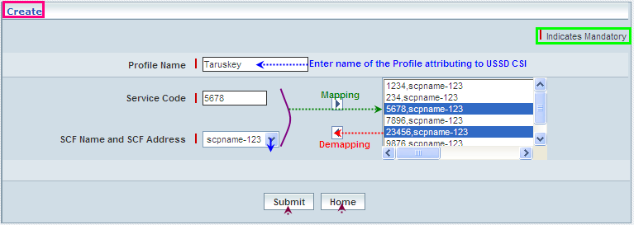

| **STEP** | **ACTION** |
| --- | --- |
|  | User must essentially enter the details related to a new profile where it is a mandatory information |
|  | Enter name of the USSD CSI profile in <Profile Name> field |
|  | Enter a service code in <Service Code> field, attributing to the proposed profile  **NOTE:** The <Service Code> field should be numeric value of 10 digits only. |
|  | Select an address representing the SCF Name and SCF Address relating to the proposed profile from the drop-down list of the < SCF Name and SCF Address> field  The list of gsmSCF addresses: represent those addresses to which the notifications on ***Change of Subscriber Data*** are to be sent  **\*** By default, the list of SCF Name and SCF Address will be dynamically displayed as drop-down list of the <SCF Name and SCF Address> field |
|  | Clicking the right-arrow button, the composition (as a string) will be moved to the adjacent field  User can enter the desired number of combinations that correspond to different & unique service codes  However if the user wants to just remove any combination (any time before creating the profile), selecting the mix from the right text field and subsequently clicking the left-arrow button removes the mix |
|  | On clicking the **Submit** button, new profile (USSD CSI) will be created and a message window to that effect will be displayed    On clicking the **Home** button of the message window, it directs the user back to the USSD CSI profiles grid |
|  | On clicking the **Create** button of the ‘Create’ screen (before creating any new profile), it directs the user to the USSD CSI profiles grid |

**View**

Home Location Register 🡪 CAMEL Subscriptions 🡪 GSM CAMEL Subscriptions USSD CSI 🡪 Create / View

View enables the user to peruse details related to chosen profile (USSD CSI).

On clicking the **‘View’** link of a chosen ‘Profile’ (from the USSD CSI Profiles List); corresponding information related to the profile will be displayed in a separate screen enabling the user to peruse details of the profile – USSD CSI.

The screen below displays the details related to chosen profile (USSD CSI).

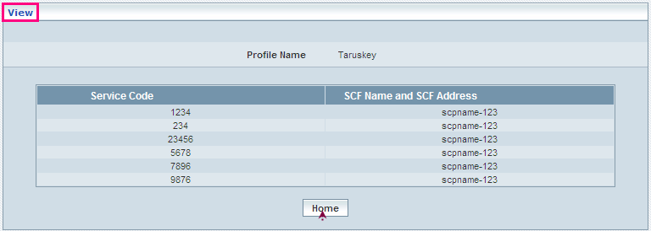

| **STEP** | **ACTION** |
| --- | --- |
|  | User can peruse details related to the chosen USSD CSI Profile |
|  | On clicking the **Home** button at the bottom of the ‘View Screen’, it redirects the user to the ‘USSD CSI’ profiles grid |

**Searching for a specific USSD CSI profiles (Record)**



| **STEP** | **ACTION** |
| --- | --- |
|  | Select a search criterion (‘Profile Name’) from the drop-down list of the search criteria of the <Search> field  **\*** By default the list of search criterion (‘Profile Name’) will be dynamically displayed as drop-down list of the <Search> field |
|  | Enter the ‘Profile Name’ that corresponds with the given search criterion |
|  | On clicking the **Go** button, the corresponding USSD CSI Profiles (record) will be highlighted among the list of USSD CSI Profiles records. |

The screen below depicts fetching and displaying the give USSD CSI Profiles record.

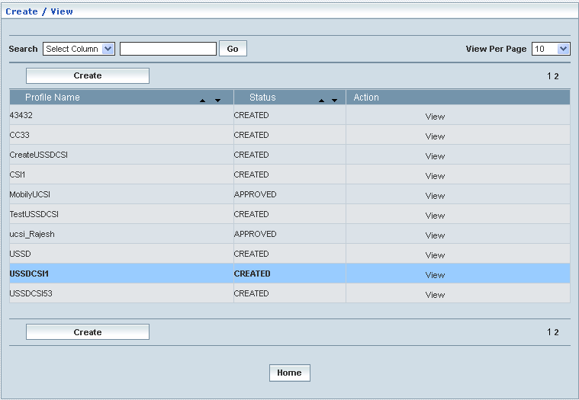

**Manage**

Home Location Register 🡪 CAMEL Subscriptions 🡪 GSM CAMEL Subscriptions 🡪 USSD CSI 🡪 Manage

‘Manage’ helps the user modifying and deleting (managing) a chosen USSD CSI profile that was created, but still to be approved

Initially, the screen displays the list of USSD CSI profiles that were configured and created.

The screen below shows the list of various USSD CSI (Profiles) configurations in a grid.

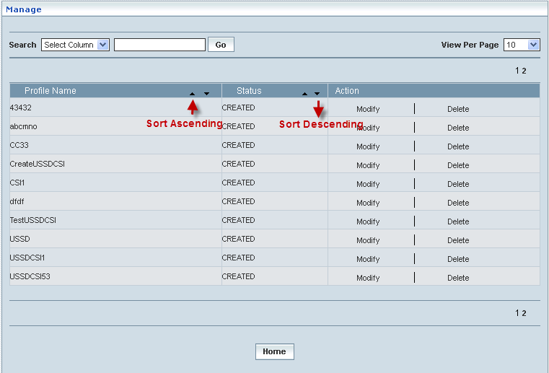

| **STEP** | | **ACTION** |
| --- | --- | --- |
|  | | By default, the list of profiles (USSD CSI profiles) will be displayed as records in a grid. The columns include ‘Profile Name’, ‘Status’ and ‘Action’ |
|  |  | User can customize the view for the number of records to be displayed each time (per page) in a grid.  However, this option is applicable only if the total number of records exceeds 10. And also with the immediate effect of increase in the number of records more than 10, a ‘Search’ option would be dynamically displayed. |
| Select the number of records (For Ex: 10) from the drop-down list of the <View Per Page> field. |
| With the effect of choosing the desired number (10) for the display of records per page, the same (10 records) will be displayed in the grid. |
| User can sort the records in ascending and descending orders with the help of up-arrow and down-arrows respectively |
| However, based on the total number of records, page numbers will be dynamically displayed at the left bottom of the screen |
| User can navigate for subsequent records (10 each time) by clicking the desired ‘page number’ |
|  | | On clicking the **Modify** link of a chosen ‘Profile’, corresponding information related to the profile will be displayed in a separate screen enabling the user to modify / update details of the profile |
|  | | On clicking the **Delete** link of a chosen ‘Profile’, corresponding information related to the profile will be displayed in a separate screen enabling the user to delete the profile |
|  | | On clicking the **Home** button at the bottom of the grid, it redirects the user to the ‘USSD CSI’ main page |

**Modify**

Home Location Register 🡪 CAMEL Subscriptions 🡪 GSM CAMEL Subscriptions 🡪 USSD CSI 🡪 Manage 🡪 Modify

Modify enables the user to modify / update the details related to an existing USSD CSI profile.

On clicking the **‘Modify’** link of a chosen ‘Profile’ (from the USSD CSI Profiles List); corresponding information related to the profile will be displayed in a separate screen enabling the user to modify / update details of the – USSD CSI.

The screen below shows modifying / updating the details related to an existing USSD CSI profile.

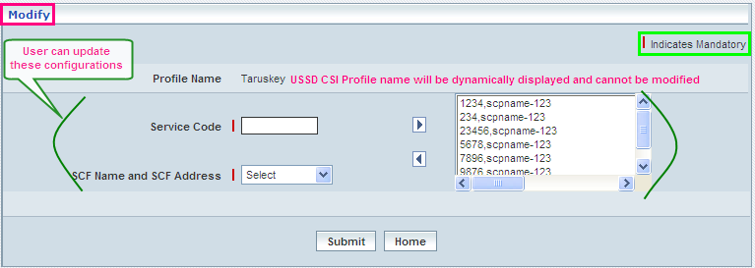

| **STEP** | **ACTION** |
| --- | --- |
|  | Name of the profile will be dynamically displayed in the <Profile Name> field and this cannot be modified |
|  | User can make necessary changes / updates to the existing values / configurations (Service Code & SCF Name and SCF Address) of the profile |
|  | On clicking the **Submit** button at the bottom of the ‘Modify’ screen, profile (USSD CSI) details will be updated accordingly and a message window to that effect will be displayed    On clicking the **Home** button of the message window, it directs the user back to the USSD CSI profiles grid |
|  | On clicking the **Home** button of the ‘Modify’ screen (before updating the details related to profile), it directs the user to the Translation USSD CSI profiles grid |

**Delete**

Home Location Register 🡪 CAMEL Subscriptions 🡪 GSM CAMEL Subscriptions 🡪 USSD CSI 🡪 Manage 🡪 Delete

Delete enables the user to delete an existing USSD CSI profile.

On clicking the **‘Delete’** link of a chosen ‘Profile’ (from the USSD CSI Profiles List); corresponding information related to the profile will be displayed in a separate screen enabling the user to delete the – USSD CSI.

The screen below shows the details related to an existing USSD CSI profile, which enables the user to delete the same (Profile).

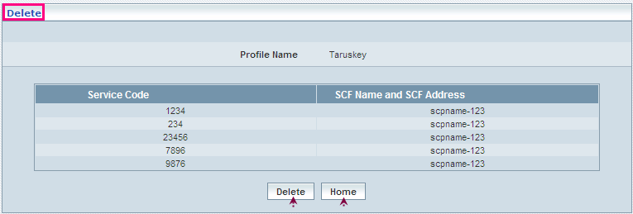

| **STEP** | **ACTION** |
| --- | --- |
|  | User can peruse the existing values / configurations of the profile before deleting the profile |
|  | On clicking the **Delete** at the bottom of the ‘Delete’ screen, it displays an alert window enabling the user to confirm deletion of the chosen profile (USSD CSI)  Wor6  On clicking the **OK** button of the alert window, the chosen USSD CSI profile will be deleted and a message window to that effect will be displayed    On clicking the **Cancel** button of the alert window, it retains the corresponding ‘Delete’ screen  On clicking the **Home** button of the message window, it directs the user back to the ‘USSD CSI’ profiles grid |
|  | On clicking the **Home** button of the ‘Delete’ screen (before deleting the profile), it directs the user to the ‘USSD CSI’ profiles grid |

**Searching for a specific USSD CSI profiles (Record)**



| **STEP** | **ACTION** |
| --- | --- |
|  | Select a search criterion (‘Profile Name’) from the drop-down list of the search criteria of the <Search> field  **\*** By default the list of search criterion (‘Profile Name’) will be dynamically displayed as drop-down list of the <Search> field |
|  | Enter the ‘Profile Name’ that corresponds with the given search criterion |
|  | On clicking the **Go** button, the corresponding USSD CSI Profiles (record) will be highlighted among the list of USSD CSI Profiles records. |

The screen below depicts fetching and displaying the give USSD CSI Profiles record.

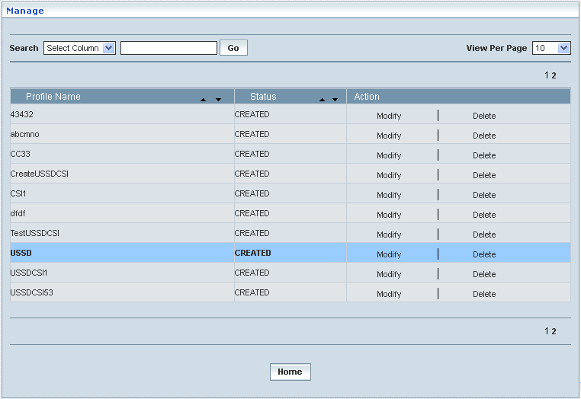

## GPRS – CAMLE Subscriptions

Home Location Register 🡪 CAMEL Subscriptions 🡪 GPRS CAMEL Subscriptions

Customized Application for the Mobile network Enhanced Logic (CAMEL) is an important standard for intelligent mobile communications networks. CAMEL enables mobile network operators to offer value-added services quickly and efficiently. This section deals with the CAMEL Subscriptions for GPRS based subscriber data to be handled by HLR.

### GPRS CSI

GPRS CSI data defines the contents of the GPRS CAMEL subscription information. The GPRS CAMEL Subscription Information helps performing the inter-work between gsmSCF and gprsSSF, for CAMEL control of packet switch call. This also helps creating various GPRS CSI profiles, which in turn provide a wider flexibility in attributing the same to different customer subscription types and varied demands.

GPRS-CSI consists of the following data items:

* *TDP Value:* The TDP value identifies the trigger detection point (TDP) in the GPRS State Model where the required service shall be invoked
* *SCF Name::* The SCF Name is the address (E.164 number) of the gsmSCF, where the GPRS CAMEL Service associated with this TDP is located for the subscriber
* *Service Key:* The service key helps identifying the service logic that shall be applied in gsmSCF environment
* *Default GPRS handling:* The default GPRS handling indicates whether the GPRS submission request shall be rejected or continued in case of error during the dialogue between the gprsSSF and gsmSCF
* *CAMEL Capability Handling:* CAMEL Capability Handling indicates the CAMEL Phase that is required for the GPRS service. The CAMEL Capability Handling for GPRS-CSI shall have the value CAMEL phase 3 and phase 4

Initially, ‘GPRS CSI’ displays a grid showing the list of existing profiles that are configured and created. This list may include those profiles that are created and approved, created and rejected and also those created but still to be approved or rejected.

**Create / View**

Home Location Register 🡪 CAMEL Subscriptions 🡪 GPRS CAMEL Subscriptions 🡪 GPRS CSI 🡪 Create / View

GPRS CSI enables the user to configure parameters related to CAMEL Subscription Information (CSI).

The screen below shows the list of various GPRS CSI configurations in a grid.

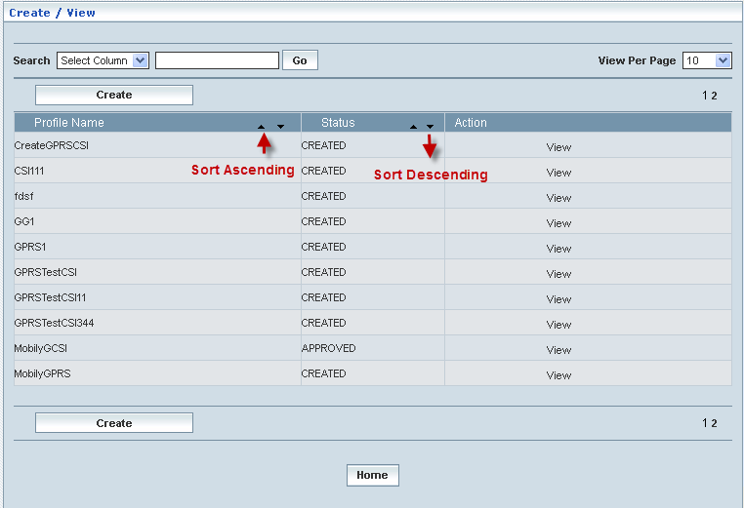

| **STEP** | | **ACTION** |
| --- | --- | --- |
|  | | By default, the list of profiles (GPRS CSI) will be displayed as records in a grid. The columns include ‘Profile Name’, ‘Status’ and ‘Action’ |
|  |  | User can customize the view for the number of records to be displayed each time (per page) in a grid.  However, this option is applicable only if the total number of records exceeds 10. And also with the immediate effect of increase in the number of records more than 10, a ‘Search’ option would be dynamically displayed. |
| Select the number of records (For Ex: 10) from the drop-down list of the <View Per Page> field. |
| With the effect of choosing the desired number (10) for the display of records per page, the same (10 records) will be displayed in the grid. |
| User can sort the records in ascending and descending orders with the help of up-arrow and down-arrows respectively |
| However, based on the total number of records, page numbers will be dynamically displayed at the left bottom of the screen |
| User can navigate for subsequent records (10 each time) by clicking the desired ‘page number’ |
|  | | Status indicates the profile status whether just created (Created) or created and approved (Approved) or created but rejected (Rejected) |
|  | | On clicking the **Create** button, ‘Create’ screen will be displayed enabling the user to create a new ‘Profile’ (GPRS CSI Profile) |
|  | | On clicking the **View** link of a chosen ‘Profile’, corresponding information related to the profile will be displayed in a separate screen enabling the user to peruse details of the profile |
|  | | On clicking the Home button at the bottom of the grid, it redirects the user to the ‘GPRS CSI’ main page |

**Create**

Home Location Register 🡪 CAMEL Subscriptions 🡪 GPRS CAMEL Subscriptions 🡪 GPRS CSI 🡪 Create / View

Create enables the user to create a new profile (GPRS CSI Profile) and attribute various values to constitute the same.

The screen below shows creating a new profile as GPRS CSI

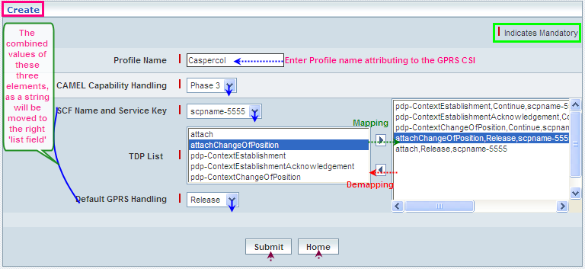

| **STEP** | **ACTION** |
| --- | --- |
|  | User must essentially enter the details related to a new profile where it is a mandatory information |
|  | Enter name of the profile in <Profile Name> field |
|  | Select a CAMEL capability handling Phase (Phase3 and Phase4) to specify the CAMEL capability handling from the drop-down list of the <CAMEL Capability Handling> field  **\*** By default, the list of phases will be dynamically displayed as drop-down list of the <CAMEL Capability Handling> field |
|  | Select a pair representing the combination of SCF Name and Service Key to specify the SCF Name & Service Key mix for the GPRS CSI element, from the drop-down list of the <SCF Name and Service Key> field  **\*** By default, the list of pairs representing SCF Name and Service Key will be dynamically displayed as drop-down list of the <SCF Name and Service Key> field |
|  | The default list of TDP (Trigger Detection Points) will be dynamically displayed in the text field, which is on to the left side of the screen  Select the desired TDP value from the list (of the left text field) |
|  | Select a Default GPRS Handling element (Continue or Release) to specify a default setting for the GPRS handling, from the drop-down list of the <Default GPRS Handling> field  **\*** By default, the list of GPRS handling elements (Continue / Release) will be dynamically displayed as drop-down list of the <Default GPRS Handling> field |
|  | On clicking the right-arrow button, the combined values of **SCF Name & Service Key**, **TDP and** **Default GPRS Handling** (together as a string, yet separated by commas) will be moved to the adjacent list field  User can configure and enter the desired number of such values in a similar fashion but, subject to the maximum limitation of **5 (Five)** TDP values  However, if the user wants to just remove any combination (any time before creating the profile), selecting the combination string from the right text field and subsequently clicking the left-arrow button removes the combination |
|  | On clicking the **Submit** button, new profile (GPRS CSI) will be created and a message window to that effect will be displayed    On clicking the **Home** button of the message window, it directs the user back to the ‘GPRS CSI’ profiles grid |
|  | On clicking the **Home** button of the ‘Create’ screen (before creating any new profile), it directs the user to the ‘GPRS CSI’ profiles grid |

**View**

Home Location Register 🡪 CAMEL Subscriptions 🡪 GPRS CAMEL Subscriptions 🡪 GPRS CSI 🡪 Create / View

View enables the user to peruse details related to chosen profile (GPRS CSI).

On clicking the **‘View’** link of a chosen ‘Profile’ (from the GPRS CSI Profiles List); corresponding information related to the profile will be displayed in a separate screen enabling the user to peruse details of the profile – GPRS CSI.

The screen below displays the details related to chosen profile (GPRS CSI)

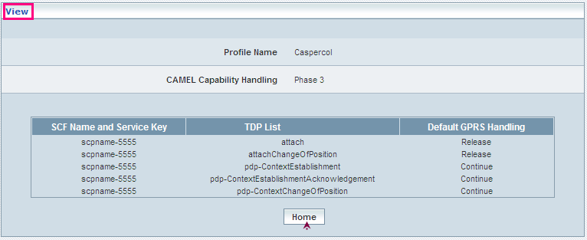

| **STEP** | **ACTION** |
| --- | --- |
|  | User can peruse details related to the chosen GPRS CSI Profile |
|  | On clicking the **Home** button at the bottom of the ‘View Screen’, it redirects the user to the ‘GPRS CSI’ profiles grid |

**Searching for a specific GPRS CSI profiles (Record)**



| **STEP** | **ACTION** |
| --- | --- |
|  | Select a search criterion (‘Profile Name’) from the drop-down list of the search criteria of the <Search> field  **\*** By default the list of search criterion (‘Profile Name’) will be dynamically displayed as drop-down list of the <Search> field |
|  | Enter the ‘Profile Name’ that corresponds with the given search criterion |
|  | On clicking the **Go** button, the corresponding GPRS CSI Profiles (record) will be highlighted among the list of GPRS CSI Profiles records. |

The screen below depicts fetching and displaying the give GPRS CSI Profiles record.

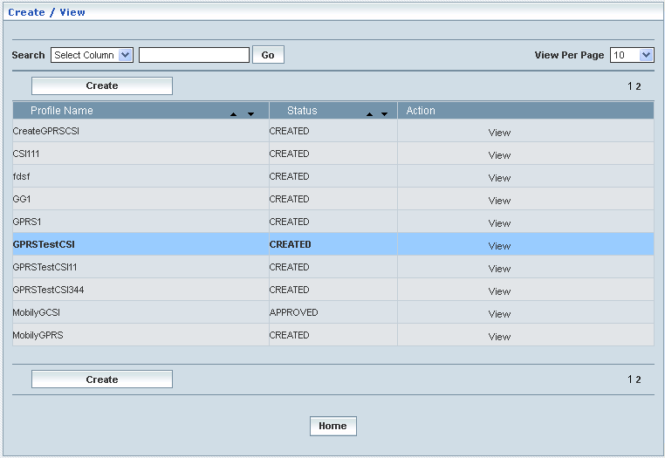

**Manage**

Home Location Register 🡪 CAMEL Subscriptions 🡪 GPRS CAMEL Subscriptions 🡪 GPRS CSI 🡪 Manage

‘Manage’ helps the user modifying and deleting (managing) a chosen GPRS CSI profile that was created, but still to be approved.

Initially, the screen displays the list of GPRS CSI profiles that were configured and created.

The screen below shows the list of various GPRS CSI (Profiles) configurations in a grid.

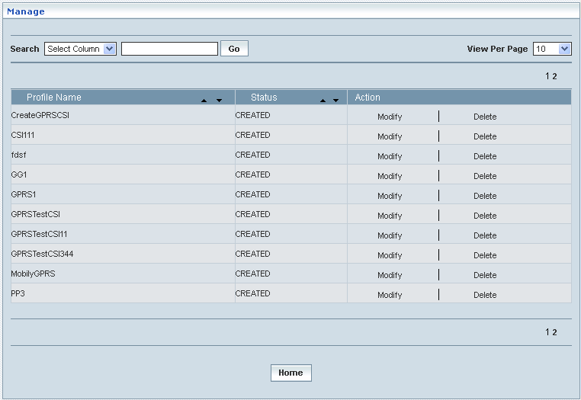

| **STEP** | | **ACTION** |
| --- | --- | --- |
|  | | By default, the list of profiles (GPRS CSI) will be displayed as records in a grid. The columns include ‘Profile Name’, ‘Status’ and ‘Action’ |
|  |  | User can customize the view for the number of records to be displayed each time (per page) in a grid.  However, this option is applicable only if the total number of records exceeds 10. And also with the immediate effect of increase in the number of records more than 10, a ‘Search’ option would be dynamically displayed. |
| Select the number of records (For Ex: 10) from the drop-down list of the <View Per Page> field. |
| With the effect of choosing the desired number (10) for the display of records per page, the same (10 records) will be displayed in the grid. |
| User can sort the records in ascending and descending orders with the help of up-arrow and down-arrows respectively |
| However, based on the total number of records, page numbers will be dynamically displayed at the left bottom of the screen |
| User can navigate for subsequent records (10 each time) by clicking the desired ‘page number’ |
|  | | On clicking the **Modify** link of a chosen ‘Profile’, corresponding information related to the profile will be displayed in a separate screen enabling the user to modify / update details of the profile |
|  | | On clicking the **Delete** link of a chosen ‘Profile’, corresponding information related to the profile will be displayed in a separate screen enabling the user to delete the profile |
|  | | On clicking the **Home** button at the bottom of the grid, it redirects the user to the ‘GPRS CSI’ main page |

**Modify**

Home Location Register 🡪 CAMEL Subscriptions 🡪 GPRS CAMEL Subscriptions 🡪 GPRS CSI 🡪 Manage 🡪 Modify

Modify enables the user to modify / update the details related to an existing GPRS CSI profile that was just created, however, was still not approved.

On clicking the **‘Modify’** link of a chosen ‘Profile’ (from the GPRS CSI Profiles List); corresponding information related to the profile will be displayed in a separate screen enabling the user to modify / update details of the – GPRS CSI.

The screen below shows modifying / updating the details related to an existing GPRS CSI profile.

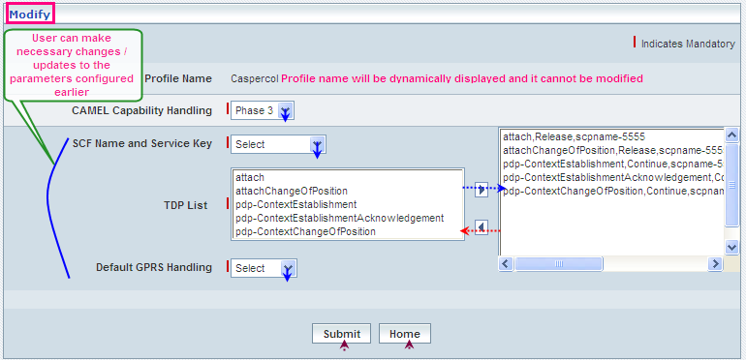

| **STEP** | **ACTION** |
| --- | --- |
|  | Name of the profile will be dynamically displayed in the <Profile Name> field and this cannot be modified |
|  | User can make necessary changes / updates to the existing values / configurations of the profile, yet subject to the stipulations related to TDP mapping |
|  | On clicking the **Submit** button at the bottom of the ‘Modify’ screen, profile (GPRS CSI) details will be updated accordingly and a message window to that effect will be displayed    On clicking the **Home** button of the message window, it directs the user back to the ‘GPRS CSI’ profiles grid |
|  | On clicking the **Home** button of the ‘Modify’ screen (before updating the details related to profile), it directs the user to the ‘GPRS CSI’ profiles grid |

**Delete**

Home Location Register 🡪 CAMEL Subscriptions 🡪 GPRS CAMEL Subscriptions 🡪 GPRS CSI 🡪 Manage 🡪 Delete

Delete enables the user to delete an existing GPRS CSI profile that was just created, however, was still not approved.

On clicking the **‘Delete’** link of a chosen ‘Profile’ (from the GPRS CSI Profiles List); corresponding information related to the profile will be displayed in a separate screen enabling the user to delete the – GPRS CSI.

The screen below shows the details related to an existing GPRS CSI profile, which enables the user to delete the same (Profile).

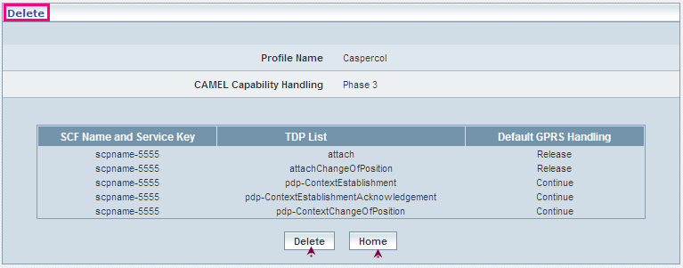

| **STEP** | **ACTION** |
| --- | --- |
|  | User can peruse the existing values / configurations of the profile before deleting the profile |
|  | On clicking the **Delete** at the bottom of the ‘Delete’ screen, it displays an alert window enabling the user to confirm deletion of the chosen profile (GPRS CSI)  Wor6  On clicking the **OK** button of the alert window, the chosen GPRS CSI profile will be deleted and a message window to that effect will be displayed    On clicking the **Cancel** button of the alert window, it retains the corresponding ‘Delete’ screen  On clicking the **Home** button of the message window, it directs the user back to the ‘GPRS CSI’ profiles grid |
|  | On clicking the **Home** button of the ‘Delete’ screen (before deleting the profile), it directs the user to the ‘GPRS CSI’ profiles grid |

**Searching for a specific GPRS CSI profiles (Record)**



| **STEP** | **ACTION** |
| --- | --- |
|  | Select a search criterion (‘Profile Name’) from the drop-down list of the search criteria of the <Search> field  **\*** By default the list of search criterion (‘Profile Name’) will be dynamically displayed as drop-down list of the <Search> field |
|  | Enter the ‘Profile Name’ that corresponds with the given search criterion |
|  | On clicking the **Go** button, the corresponding GPRS CSI Profiles (record) will be highlighted among the list of GPRS CSI Profiles records. |

The screen below depicts fetching and displaying the give GPRS CSI Profiles record.

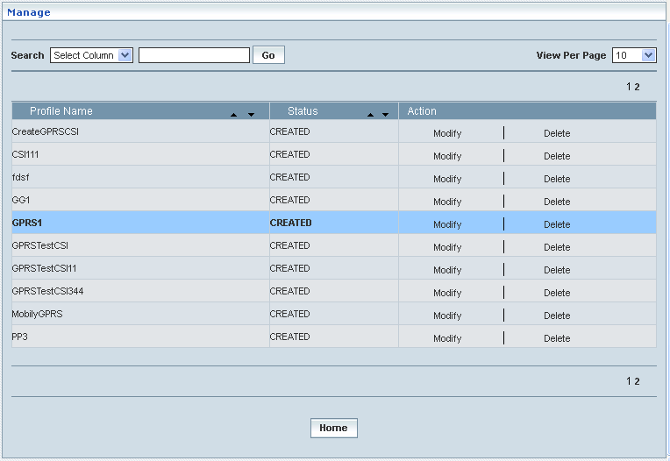

### Mobility Management GPRS CSI

Home Location Register >CAMEL Subscriptions >GPRS CAMEL Subscriptions >Mobility Management GPRS CSI

Mobility Management GPRS CSI enables the user to configure parameters related to CAMEL Subscription Information (CSI) in terms of GSM-GPRS Visiting Location perspective and with respect to the defined MM codes. This also helps creating various Mobility Management GPRS CSI profiles, which in turn provide a wider flexibility in attributing the same to different customer subscription types and varied demands.

**Create / View**

Home Location Register 🡪 CAMEL Subscriptions 🡪 GPRS CAMEL Subscriptions 🡪 Mobility Management GPRS CSI 🡪 Create / View

Initially, ‘Mobility Management GPRS CSI’ displays a grid showing the list of existing profiles that are configured and created. This list may include those profiles that are created and approved, created and rejected and also those created but still to be approved or rejected.

The screen below shows the list of various profiles pertaining to Mobility Management GPRS CSI in a grid.

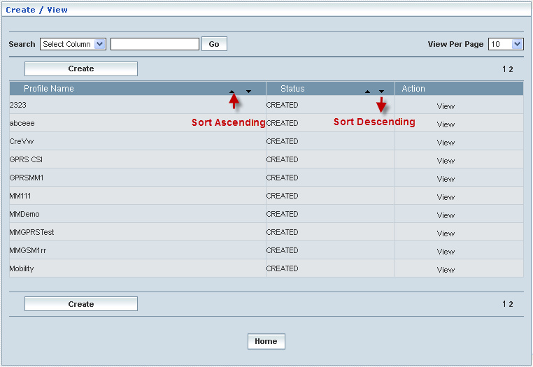

| **STEP** | | **ACTION** |
| --- | --- | --- |
|  | | By default, the list of profiles (Mobility Management GPRS CSI) will be displayed as records in a grid. The columns include ‘Profile Name’, ‘Status’ and ‘Action’ |
|  |  | User can customize the view for the number of records to be displayed each time (per page) in a grid.  However, this option is applicable only if the total number of records exceeds 10. And also with the immediate effect of increase in the number of records more than 10, a ‘Search’ option would be dynamically displayed. |
| Select the number of records (For Ex: 10) from the drop-down list of the <View Per Page> field. |
| With the effect of choosing the desired number (10) for the display of records per page, the same (10 records) will be displayed in the grid. |
| User can sort the records in ascending and descending orders with the help of up-arrow and down-arrows respectively |
| However, based on the total number of records, page numbers will be dynamically displayed at the left bottom of the screen |
| User can navigate for subsequent records (10 each time) by clicking the desired ‘page number’ |
|  | | Status indicates the profile status whether just created (Created) or created and approved (Approved) or created but rejected (Rejected) |
|  | | On clicking the **Create** button, ‘Create’ screen will be displayed enabling the user to create a new ‘Profile’ (Mobility Management GPRS CSI Profile) |
|  | | On clicking the **View** link of a chosen ‘Profile’, corresponding information related to the profile (Mobility Management GPRS CSI Profile) will be displayed in a separate screen enabling the user to peruse details of the profile |
|  | | On clicking the **Home** button at the bottom of the grid, it redirects the user to the ‘Mobility Management GPRS CSI’ main page |

**Create**

Home Location Register 🡪 CAMEL Subscriptions 🡪 GPRS CAMEL Subscriptions 🡪 Mobility Management GPRS CSI 🡪 Create / View

Create enables the user to create a new profile (Mobility Management GPRS CSI Profile) and attribute various values to constitute the same.

The screen below shows creating a new profile as Mobility Management GPRS CSI.

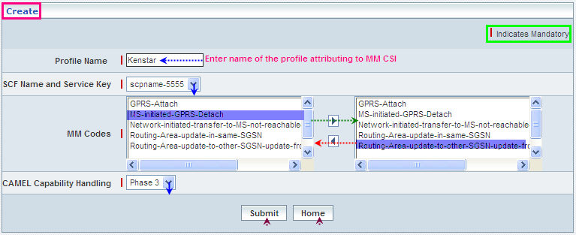

| **STEP** | **ACTION** |
| --- | --- |
|  | User must essentially enter the details related to a new profile where it is a mandatory information |
|  | Enter name of the Mobile Management GPRS CSI profile in <Profile Name> field |
|  | Select a pair representing the combination of SCF Name and Service Key to specify the SCF Name & Service Key mix for the ‘Mobile Management GPRS CSI’ element, from the drop-down list of the <SCF Name and Service Key> field  **\*** By default, the list of pairs representing SCF Name and Service Key will be dynamically displayed as drop-down list of the <SCF Name and Service Key> field |
|  | The default list of MM Codes will be dynamically displayed in the text field, which is on to the left side of the screen  Select the desired code from the list (of the left text field) and on clicking the right-arrow button, the code (as a string) will be moved to the adjacent field  User can enter the desired number of codes in a similar fashion  However if the user wants to just remove any code (anytime before creating the profile), selecting the code from the right text field and subsequently clicking the left-arrow button removes the code |
|  | Select a Phase (Phase3 and Phase4) to specify the CAMEL capability handling from the drop-down list of the <CAMEL Capability Handling> field  **\*** By default, the list of phases will be dynamically displayed as drop-down list of the <CAMEL Capability Handling> field |
|  | On clicking the **Submit** button, new profile (Mobility Management GPRS CSI) will be created and a message window to that effect will be displayed    On clicking the **Home** button of the message window, it directs the user back to the Mobility Management GPRS CSI profiles grid |
|  | On clicking the **Home** button of the ‘Create’ screen (before creating any new profile), it directs the user to the Mobility Management GPRS CSI profiles grid |

**View**

Home Location Register 🡪 CAMEL Subscriptions 🡪 GPRS CAMEL Subscriptions 🡪 Mobility Management GPRS CSI 🡪 Create / View

View enables the user to peruse details related to chosen profile (Mobility Management GPRS CSI).

On clicking the **‘View‘** link of a chosen ‘Profile’ (from the Mobility Management GPRS CSI Profiles List); corresponding information related to the profile will be displayed in a separate screen enabling the user to peruse details of the profile – Mobility Management GPRS CSI.

The screen below displays the details related to chosen profile (Mobility Management GPRS CSI)

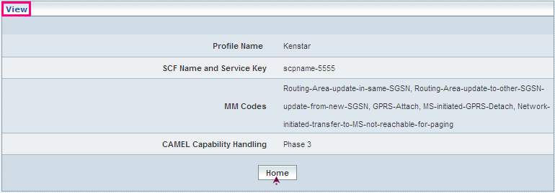

| **STEP** | **ACTION** |
| --- | --- |
|  | User can peruse details related to the chosen Mobility Management GPRS CSI Profile |
|  | On clicking the **Home** button at the bottom of the ‘View Screen’, it redirects the user to the ‘Mobility Management GPRS CSI’ profiles grid |

**Searching for a specific Mobility Management GPRS CSI profiles (Record)**



| **STEP** | **ACTION** |
| --- | --- |
|  | Select a search criterion (‘Profile Name’) from the drop-down list of the search criteria of the <Search> field  **\*** By default the list of search criterion (‘Profile Name’) will be dynamically displayed as drop-down list of the <Search> field |
|  | Enter the ‘Profile Name’ that corresponds with the given search criterion |
|  | On clicking the **Go** button, the corresponding Mobility Management GPRS CSI Profiles (record) will be highlighted among the list of Mobility Management GPRS CSI Profiles records. |

The screen below depicts fetching and displaying the give Mobility Management GPRS CSI Profiles record.

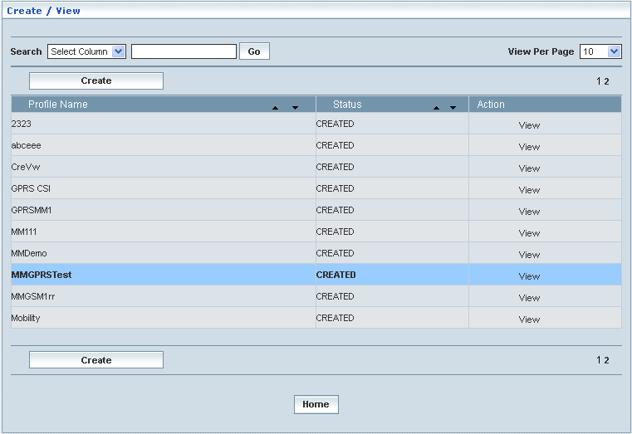

**Manage**

Home Location Register 🡪 CAMEL Subscriptions 🡪 GPRS CAMEL Subscriptions 🡪 Mobility Management GPRS CSI 🡪 Manage

‘Manage’ helps the user modifying and deleting (managing) a chosen Mobility Management GPRS CSI profile that was created, but still to be approved.

Initially, the screen displays the list of Mobility Management GPRS CSI profiles that were configured and created.

The screen below shows the list of various Mobility Management GPRS CSI (Profiles) configurations in a grid.

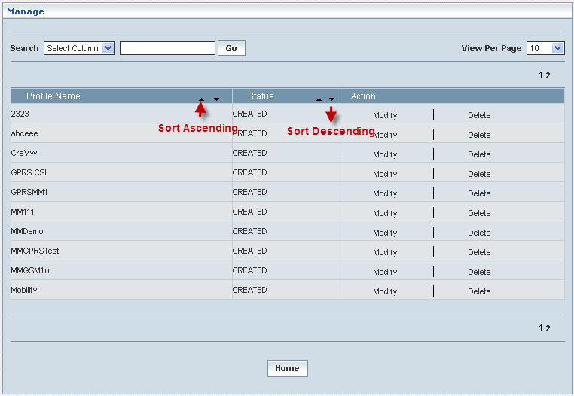

| **STEP** | | **ACTION** |
| --- | --- | --- |
|  | | By default, the list of profiles (Mobility Management GPRS CSI profiles) will be displayed as records in a grid. The columns include ‘Profile Name’, ‘Status’ and ‘Action’ |
|  |  | User can customize the view for the number of records to be displayed each time (per page) in a grid.  However, this option is applicable only if the total number of records exceeds 10. And also with the immediate effect of increase in the number of records more than 10, a ‘Search’ option would be dynamically displayed. |
| Select the number of records (For Ex: 10) from the drop-down list of the <View Per Page> field. |
| With the effect of choosing the desired number (10) for the display of records per page, the same (10 records) will be displayed in the grid. |
| User can sort the records in ascending and descending orders with the help of up-arrow and down-arrows respectively |
| However, based on the total number of records, page numbers will be dynamically displayed at the left bottom of the screen |
| User can navigate for subsequent records (10 each time) by clicking the desired ‘page number’ |
|  | | Status indicates the profile status whether just created (Created) or created and approved (Approved) or created but rejected (Rejected) |
|  | | On clicking the **Modify** link of a chosen ‘Profile’, corresponding information related to the profile will be displayed in a separate screen enabling the user to modify / update details of the profile |
|  | | On clicking the **Delete** link of a chosen ‘Profile’, corresponding information related to the profile will be displayed in a separate screen enabling the user to delete the profile |
|  | | On clicking the **Home** button at the bottom of the grid, it redirects the user to the ‘Mobility Management GPRS CSI’ main page |

**Modify**

Home Location Register 🡪 CAMEL Subscriptions 🡪 GPRS CAMEL Subscriptions 🡪 Mobility Management GPRS CSI 🡪 Manage 🡪 Modify

Modify enables the user to modify / update the details related to an existing Mobility Management GPRS CSI profile.

On clicking the **‘Modify’** link of a chosen ‘Profile’ (from the Mobility Management GPRS CSI Profiles List); corresponding information related to the profile will be displayed in a separate screen enabling the user to modify / update details of the profile – Mobility Management GPRS CSI.

The screen below shows modifying / updating the details related to an existing Mobility Management GPRS CSI profile.

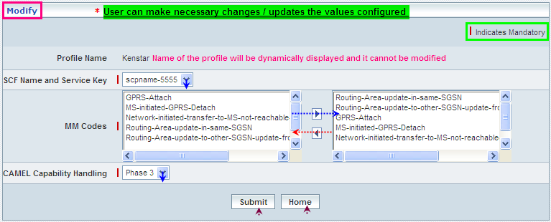

| **STEP** | **ACTION** |
| --- | --- |
|  | Name of the profile will be dynamically displayed in the <Profile Name> field and this cannot be modified |
|  | User can make necessary changes / updates to the existing values / configurations of the profile |
|  | On clicking the **Submit** button at the bottom of the ‘Modify’ screen, profile (Mobility Management GPRS CSI) details will be updated accordingly and a message window to that effect will be displayed    On clicking the **Home** button of the message window, it directs the user back to the ‘Mobility Management GPRS CSI’ profiles grid |
|  | On clicking the **Home** button of the ‘Modify’ screen (before updating the details related to profile), it directs the user to the Translation ‘Mobility Management GPRS CSI’ profiles grid |

**Delete**

Home Location Register 🡪 CAMEL Subscriptions 🡪 GPRS CAMEL Subscriptions 🡪 Mobility Management GPRS CSI 🡪 Manage 🡪 Delete

Delete enables the user to delete an existing Mobility Management GPRS CSI profile.

On clicking the **‘Delete’** link of a chosen ‘Profile’ (from the Mobility Management GPRS CSI Profiles List); corresponding information related to the profile will be displayed in a separate screen enabling the user to delete the – Mobility Management GPRS CSI.

The screen below shows the details related to an existing Mobility Management GPRS CSI profile, which enables the user to delete the same (Profile).

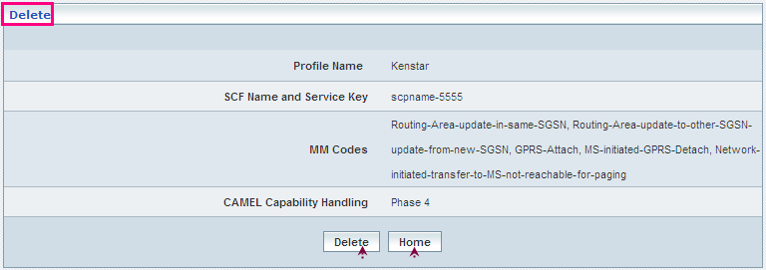

| **STEP** | **ACTION** |
| --- | --- |
|  | User can peruse the existing values / configurations of the profile before deleting the profile |
|  | On clicking the **Delete** at the bottom of the ‘Delete’ screen, it displays an alert window enabling the user to confirm deletion of the chosen profile (Mobility Management GPRS CSI)  Wor6  On clicking the **OK** button of the alert window, the chosen Mobility Management GPRS CSI profile will be deleted and a message window to that effect will be displayed    On clicking the **Cancel** button of the alert window, it retains the corresponding ‘Delete’ screen  On clicking the **Home** button of the message window, it directs the user back to the ‘Mobility Management GPRS CSI’ profiles grid |
|  | On clicking the **Home** button of the ‘Delete’ screen (before deleting the profile), it directs the user to the ‘Mobility Management GPRS CSI’ profiles grid |

**Searching for a specific Mobility Management GPRS CSI profiles (Record)**



| **STEP** | **ACTION** |
| --- | --- |
|  | Select a search criterion (‘Profile Name’) from the drop-down list of the search criteria of the <Search> field  **\*** By default the list of search criterion (‘Profile Name’) will be dynamically displayed as drop-down list of the <Search> field |
|  | Enter the ‘Profile Name’ that corresponds with the given search criterion |
|  | On clicking the **Go** button, the corresponding Mobility Management GPRS CSI Profiles (record) will be highlighted among the list of Mobility Management GPRS CSI Profiles records. |

The screen below depicts fetching and displaying the give Mobility Management GPRS CSI Profiles record.

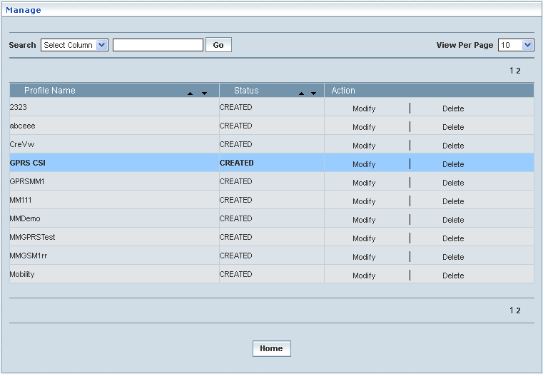

## Approve / Reject CSI Profile

Approve / Reject CSI Profile enables the user to approve or reject the profiles (the total range of GSM and GPRS CAMEL Subscription Profiles)

Thus Approve / Reject CSI help the user performing the following functions:

* Approve
* Reject

Approve / Reject CSI Profile displays a screen showing the list of entire profiles (regardless of the type) that include GSM and GPRS CAMEL Subscription Profiles. The list of profiles comprises:

* + **GSM Camel Subscriptions**
* Originating CSI
* Terminating CSI
* VMSC Terminating CSI
* Supplementary Services CSI
* Translation Information Flag CSI
* Mobility Management GSM CSI
* Dialed Services CSI
* USSD CSI
  + **GPRS CAMEL Subscriptions**
* GPRS CSI
* Mobility Management GPRS CSI
* Mobile Originating SMS CSI
* Mobile Terminating SMS CSI

Home Location Register 🡪 Approve / Reject CSI Profile

Initially, ‘Approve / Reject CSI Profile, displays a grid showing the list of entire profiles (regardless of the Profile type – all pertaining to the above mentioned list) that were configured and created. This list includes only those profiles that are created and yet to be approved or rejected.

This module also helps to fetch a desired profile with the help of the **‘Search’** option based on the provided search criterion. The search criteria include: Profile Name

The screen below shows the list of records for the entire Profiles that were configured and created.

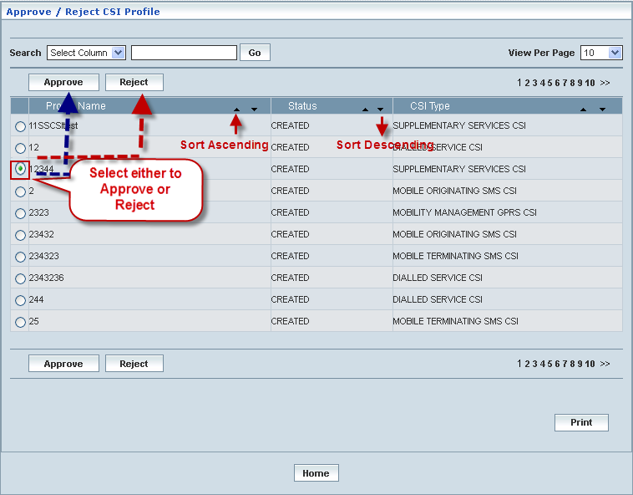

| **STEP** | | **ACTION** |
| --- | --- | --- |
|  | | By default, the list of entire profiles (of all types) that were created will be displayed as records in a grid. The columns include ‘Profile Name’, ‘Status’ and ‘CSI Type’ |
|  |  | User can customize the view for the number of records to be displayed each time (per page) in a grid.  However, this option is applicable only if the total number of records exceeds 10. And also with the immediate effect of increase in the number of records more than 10, a ‘Search’ option would be dynamically displayed. |
| Select the number of records (For Ex: 10) from the drop-down list of the <View Per Page> field. |
| With the effect of choosing the desired number (10) for the display of records per page, the same (10 records) will be displayed in the grid. |
| User can sort the records in ascending and descending orders with the help of up-arrow and down-arrows respectively |
| However, based on the total number of records, page numbers will be dynamically displayed at the left bottom of the screen |
| User can navigate for subsequent records (10 each time) by clicking the desired ‘page number’ |
|  | | **To Approve a Profile:**  Select the corresponding radio option of the desired profile to approve the same |
|  | | On clicking the **Approve** button, an alert window message will be displayed enabling the user to confirm approval of the chosen profile  Wor63  On clicking the **OK** button of the alert window, the chosen profile will be approved and a message window to that effect will be displayed  Wor65  On clicking the **Cancel** button of the alert window, it retains the Approve / Reject Profiles grid  On clicking the **Home** button of the message window, it redirects the user to the ‘Approve / Reject Profiles’ grid  **NOTE:** The Profile that was approved will be disappeared from the Approve / Reject Profiles grid. However, status related to the Profile will be dynamically updated (changed to ‘Approved’ from ‘Created’) in the corresponding Profile Type grid |
|  | | **To Reject a Profile:**  Select the corresponding radio option of the desired profile to reject the same |
|  | | On clicking the **Reject** button, an alert window message will be displayed enabling the user to confirm rejection of the chosen profile  Wor66  On clicking the **OK** button of the alert window, the chosen profile will be rejected and a message window to that effect will be displayed  Wor68  On clicking the **Cancel** button of the alert window, it retains the Approve / Reject Profiles grid  On clicking the **Home** button of the message window, it redirects the user to the ‘Approve / Reject Profiles’ grid  **NOTE:** Status related to the Profile will be dynamically updated (changed to ‘Rejected’ from ‘Created’) in the corresponding Profile Type grid and as well as in Approve / Reject Profiles grid  **\*** Once rejected profile can always be approved any time later by way of similar process of approving a profile |
|  | | On clicking the **Print** button at the bottom of the grid, user can take printouts of the Specific CSI Profile(s) list |
|  | | On clicking the **Home** button at the bottom of the grid, it redirects the user to the ‘HLR’ main page |

**Searching for a specific CSI Profile (Record)**

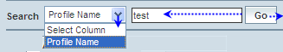

| **STEP** | **ACTION** |
| --- | --- |
|  | Select a search criterion (Profile Name) from the drop-down list of the search criteria of the <Search> field  **\*** By default the list of search criterion (Profile Name) will be dynamically displayed as drop-down list of the <Search> field |
|  | Enter the value (Profile Name) that corresponds with the given search criterion |
|  | On clicking the **Go** button, the corresponding Profile (record) will be highlighted among the list of CSI Profiles records |

The screen below depicts fetching and displaying the specific CSI Profile record.

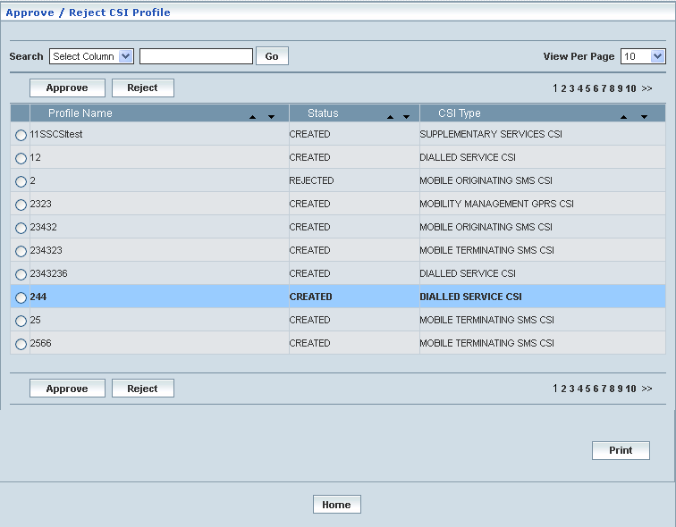

# Supplementary Services

Home Location Register 🡪 Supplementary Services

Supplementary Services enables the user to create and manage the supplementary services that could be offered to the mobile subscribers in general. This helps creating various Supplementary Service profiles, which in turn provide a wider flexibility in catering the same to different customer subscription types and varied demands.

In order to create a supplementary service, it should be configured by pooling certain basic services categorized under different Supplementary Service Codes that constitute a service.

## CUG Profile

Home Location Register 🡪 Supplementary Services 🡪 CUG Profile

This section enables users to perform the following tasks of the CUG Profile (Closed User Group Profile)

This module helps the user performing the following actions:

* Create
* View
* Modify
* Delete
* Search

**Create**

Home Location Register 🡪 Supplementary Services 🡪 CUG Profile 🡪 Create

Create enables the user to create a new CUG Profile.

The screen below shows creating a new CUG Profile

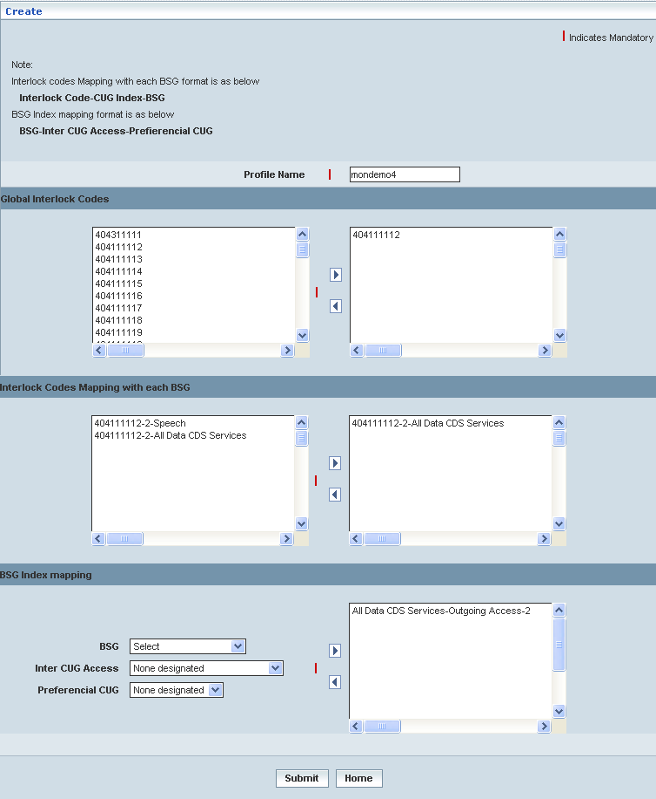

| **STEP** | **ACTION** |
| --- | --- |
|  | User must enter the details of the CUG Profile details where it is a mandatory information |
|  | Enter Profile Name in <Profile Name> field. |
|  | **Global Interlock Codes:**  By default, Global Interlock Codes are displayed in <Global Interlock Codes> list box.  On clicking  button allows the user to map at least one Global Interlock Codes to CUG Profile and it moves to the adjacent field. On clicking the user can perform un-mapping at least, one Global Interlock Codes to CUG Profile and vice versa. |
|  | **Interlock Codes Mapping with each BSG:**  By default, Interlock Codes Mapping with each BSG(s) is displayed in  <Interlock Codes Mapping with each BSG> list box.  On clicking  button allows the user to map at least one Interlock Codes with BSG and it moves to the adjacent field. On clicking the user can perform un-mapping at least, one Interlock Codes with BSG and vice versa. |
|  | **BSG Index mapping:**  By default, the data within the BSG Index mapping gets displayed related to the Interlock Codes mapping with each BSG |
|  | Select the BSG data from <BSG> drop-down list |
|  | Select Inter CUG Access from <Inter CUG Access> drop-down list |
|  | Select Preferencial CUG from <Preferencial CUG> drop-down list |
|  | On clicking  button allows the user to map at least one BSG – Inter CUG Access – Preferencial CUG and it moves to the adjacent field. On clicking  the user can perform un-mapping at least one BSG – Inter CUG Access – Preferencial CUG and vice versa. |
|  | On clicking the **Submit** button, the new CUG Profile will be created successfully. A message window will be displayed to that effect    On clicking the **Home** button of the message window, it redirects the user to the ‘Create’ Screen |
|  | On clicking the **Home** button at the bottom of the ‘Create’ Screen (before creating a new CUG Profile), it redirects the user to the ‘CUG Profile’ Screen |

**Manage**

Home Location Register 🡪 Supplementary Services 🡪 CUG Profile 🡪 Manage

Manage enables the users to perform view, search, modify, print and delete CUG Profile

The screen below shows the ‘Manage’ Screen

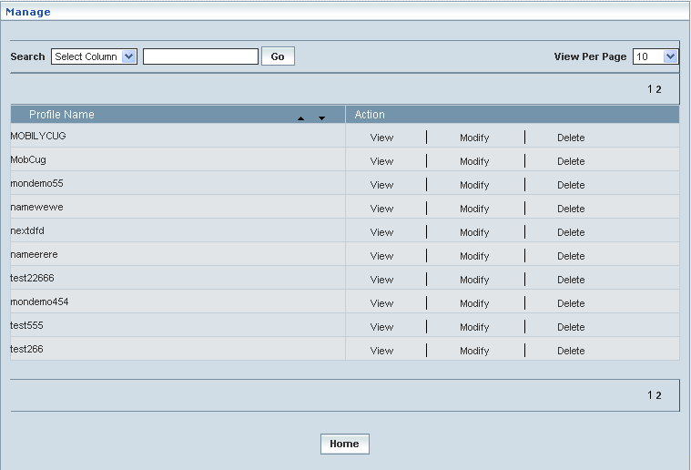

| **STEP** | | **ACTION** |
| --- | --- | --- |
|  | | By default, the list of CUG Profiles will be displayed as records in a grid. The columns include ‘Profile Name’ and ‘Action’ |
|  |  | User can customize the view for the number of records to be displayed each time (per page) in a grid.  However, this option is applicable only if the total number of records exceeds 10. And also with the immediate effect of increase in the number of records more than 10, a ‘Search’ option would be dynamically displayed. |
| Select the number of records (For Ex: 10) from the drop-down list of the <View Per Page> field. |
| With the effect of choosing the desired number (10) for the display of records per page, the same (10 records) will be displayed in the grid. |
| User can sort the records in ascending and descending orders with the help of up-arrow and down-arrows respectively |
| However, based on the total number of records, page numbers will be dynamically displayed at the left bottom of the screen |
| User can navigate for subsequent records (10 each time) by clicking the desired ‘page number’ |
|  | | On clicking the **View** link, ‘View’ screen will be displayed enabling the user to view the details of chosen ‘CUG Profile’ |
|  | | On clicking the **Modify** link, ‘Modify’ screen will be displayed enabling the user to update / change corresponding values (as required) of a chosen ‘CUG Profile’ |
|  | | On clicking the **Delete** link, of a chosen ‘CUG Profile’, it enables the user to delete the same |
|  | | On clicking the **Home** button at the bottom of the grid, it redirects the user to the ‘HLR’ main page |

**View**

On clicking the **‘View’** link of a chosen ‘CUG Profile’ (from the CUG Profile List); corresponding information related to the CUG Profile will be displayed in a separate screen enabling the user to peruse details of the same.

The screen below shows the view of a chosen CUG Profile.

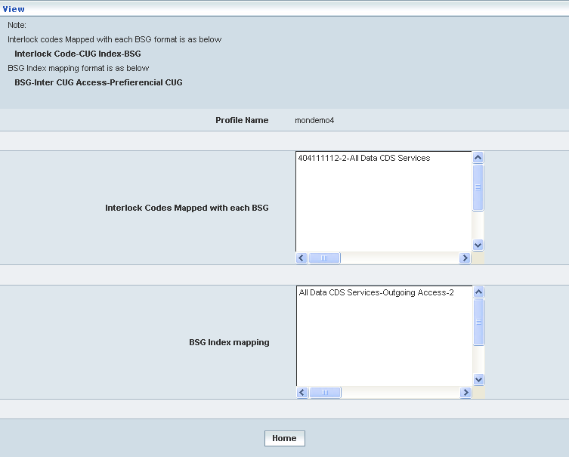

| **STEP** | **ACTION** |
| --- | --- |
|  | ‘Interlock Codes Mapped with each BSG’ and ‘BSG Index mapping’ mapping will be dynamically displayed in their respective fields |
|  | On clicking the **Home** button at the bottom of the ‘View’ Screen, it redirects the user to the ‘Manage’ Screen |

**Modify**

On clicking the **‘Modify’** link of a chosen ‘CUG Profile’ (from the CUG Profile List); corresponding information related to the CUG Profile will be displayed in a separate screen enabling the user to modify details of the same.

The screen below shows modifying / updating an existing CUG Profile

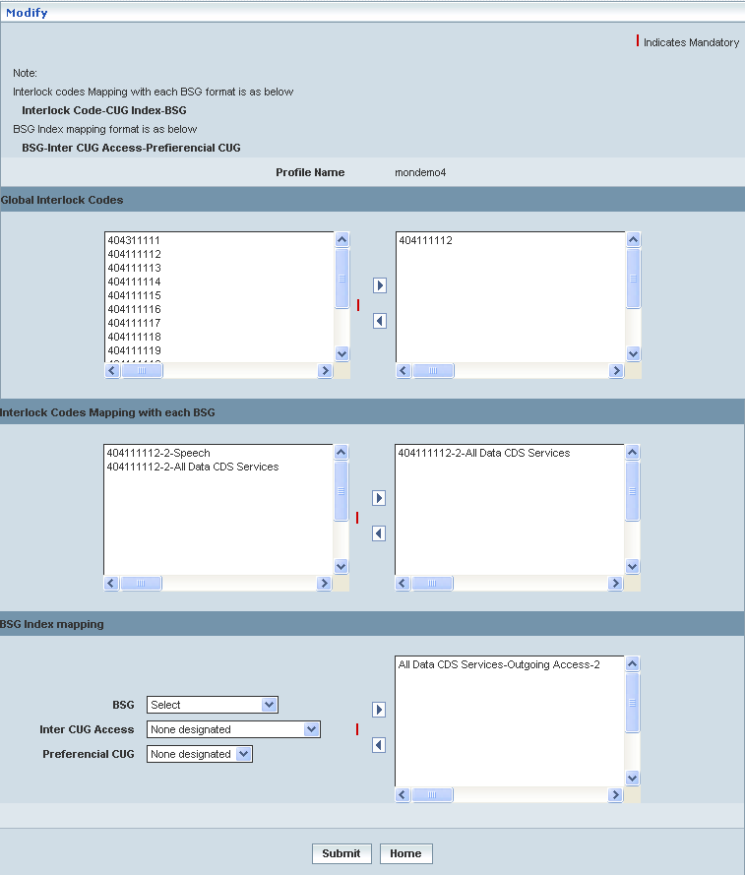

| **STEP** | **ACTION** |
| --- | --- |
|  | User can make necessary changes related to CUG Profile by performing the following tasks:  a. Mapping at least one ‘Global Interlock Codes’ to CUG Profile  b. Mapping at least one ‘Interlock Codes with BSG’  c. Selecting BSG data from <BSG> drop-down list  d. Selecting Inter CUG Access from <Inter CUG Access> drop-down list  e. Selecting Preferencial CUG from <Preferencial CUG> drop-down list and  f. Mapping at least one BSG – Inter CUG Access – Preferencial CUG |
|  | On clicking the **Submit** button, the changes made will be updated accordingly in the database. A message window will be displayed to that effect    On clicking the **Home** button of the message window, it redirects the user to the ‘Manage’ Screen |
|  | On clicking the **Home** button at the bottom of the ‘Modify’ Screen (before submission), it redirects to the ‘CUG Profile’ Screen |

**Delete**

On clicking the **‘Delete’** link of a chosen ‘CUG Profile’ (from the CUG Profile List); corresponding information related to the CUG Profile will be displayed in a separate screen enabling the user to delete details of the same.

The screen below shows deleting an existing CUG Profile

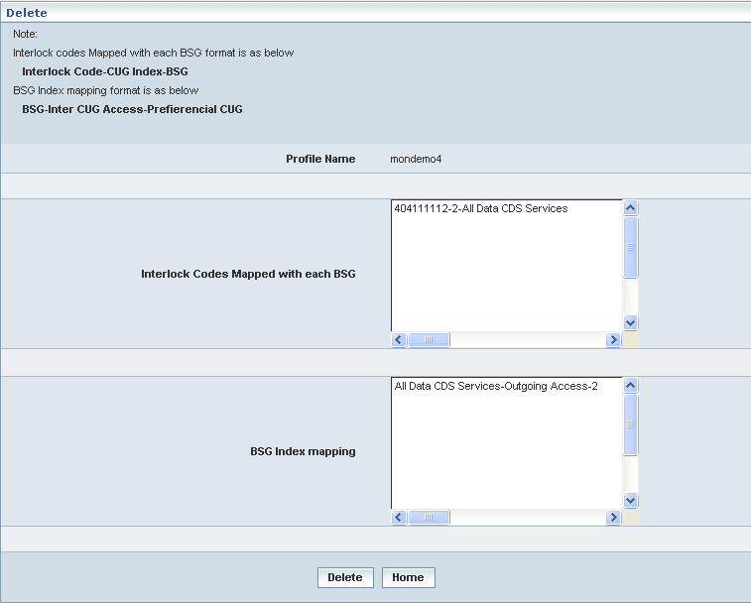

| **STEP** | **ACTION** |
| --- | --- |
|  | On clicking the **Delete** button, an alert message window will be displayed enabling the user to confirm deletion of the chosen CUG ProfileSNAGHTML8bb1f6 |
|  | On clicking the **OK** button of the alert message window, the chosen CUG Profile details will be deleted and a message window will be displayed to that effect. It will be disappeared from the ‘CUG Profile’ grid.    On clicking the **Home** button of the message window, it directs the user to ‘Manage’ Screen  On clicking the **Cancel** button of the alert message window, it retains the grid without deleting the CUG Profile record |
|  | On clicking the **Home** button at the bottom of the ‘Delete’ screen (before submission), it redirects to the ‘CUG Profile’ Screen |

**Searching for a specific CUG Profile (Record)**

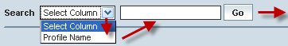

| **STEP** | **ACTION** |
| --- | --- |
|  | Select a search criterion (‘Profile Name’) from the drop-down list of the search criteria of the <Search> field  **\*** By default the list of search criterion (‘Profile Name’) will be dynamically displayed as drop-down list of the <Search> field |
|  | Enter the ‘Profile Name’ that corresponds with the given search criterion |
|  | On clicking the **Go** button, the corresponding CUG Profile (record) will be highlighted among the list of CUG Profile records. |

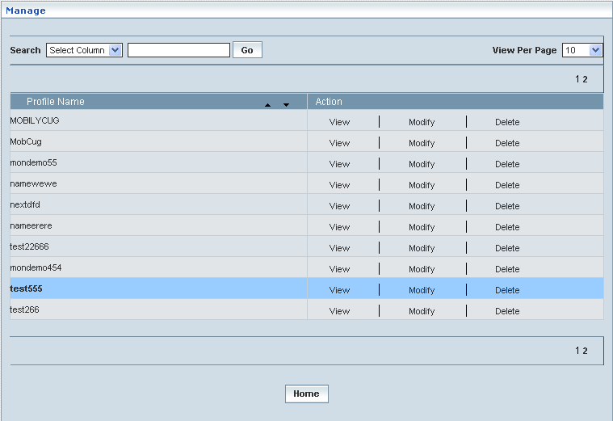

## SS Profile Management

Home Location Register 🡪 Supplementary Services 🡪 SS Profile Management

Initially, ‘Supplementary Services’ displays a grid showing the list of existing supplementary services’ Profile Managements that are configured and created. This list may include those profiles that are created and approved, created and rejected and also those created but still to be approved or rejected.

**Create / View**

Home Location Register 🡪 Supplementary Services 🡪 SS Profile Management 🡪 Create / View

This allows the user to create a new profile and peruse the details related to the existing profiles

The screen below shows the list of various Supplementary Services Profile Managements in a grid.

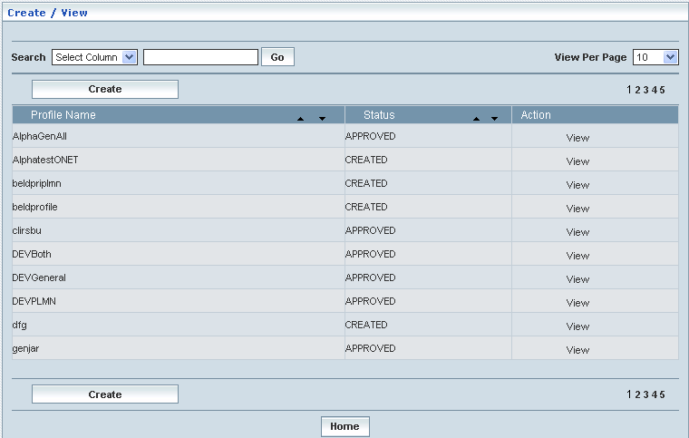

| **STEP** | | **ACTION** |
| --- | --- | --- |
|  | | By default, the list of profiles (Supplementary Services Profile Management) will be displayed as records in a grid. The columns include ‘Profile Name’, ‘Status’ and ‘Action’ |
|  |  | User can customize the view for the number of records to be displayed each time (per page) in a grid.  However, this option is applicable only if the total number of records exceeds 10. And also with the immediate effect of increase in the number of records more than 10, a ‘Search’ option would be dynamically displayed. |
| Select the number of records (For Ex: 10) from the drop-down list of the <View Per Page> field. |
| With the effect of choosing the desired number (10) for the display of records per page, the same (10 records) will be displayed in the grid. |
| User can sort the records in ascending and descending orders with the help of up-arrow and down-arrows respectively |
| However, based on the total number of records, page numbers will be dynamically displayed at the left bottom of the screen |
| User can navigate for subsequent records (10 each time) by clicking the desired ‘page number’ |
|  | | Status indicates the profile status whether just created (Created) or created and approved (Approved) or created but rejected (Rejected) |
|  | | On clicking the **Create** button, ‘Create’ screen will be displayed enabling the user to create a new ‘Profile’ (Supplementary Service Profile Management) |
|  | | On clicking the **View** link of a chosen ‘Profile’, corresponding information related to the profile will be displayed in a separate screen enabling the user to peruse details of the profile |
|  | | On clicking the **Home** button at the bottom of the grid, it redirects the user to the ‘Supplementary Services Profile Management’ main page |

**Create**

Home Location Register 🡪 Supplementary Services 🡪 SS Profile Management 🡪 Create/View

Create enables the user to create a new profile (Supplementary Service Profile Management) and attribute various values to constitute the same.

The screen below shows creating a new profile as Supplementary Service Profile Management

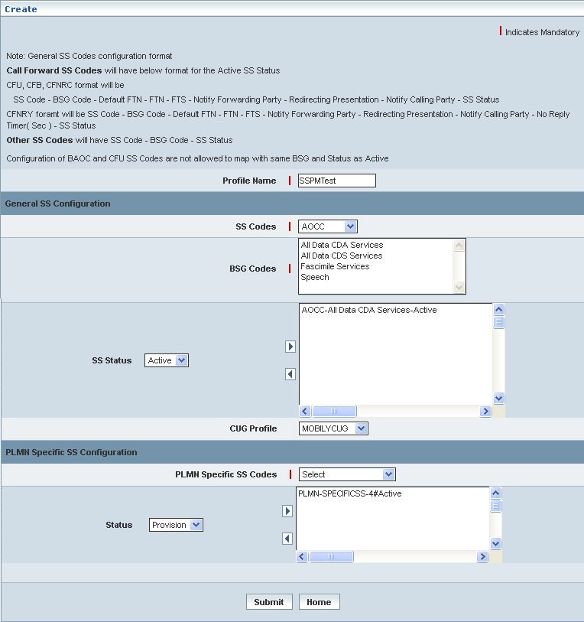

| **STEP** | **ACTION** |
| --- | --- |
|  | User must essentially enter the details related to a new profile where it is a mandatory information |
|  | Enter name of the profile in <Profile Name> field, attributing to the proposed Supplementary Service Profile |
|  | **General SS Configuration:**  Select an SS Code from <SS Codes> drop-down list for General SS Configuration and PLMN Specific SS Configuration  **\*** By default, the list of BSG Codes will be dynamically displayed in the <BSG Codes> field and the SS Status related to the ‘SS Codes’ also dynamically displayed in <SS Status> field |
|  | Select BSG Codes from <BSG Codes> field |
|  | Select SS Status from <SS Status> field |
|  | On clicking the right-arrow button, the basic service along with (name of) the SS Codes, BSG Codes and the corresponding SS Status (as a string) will be moved to the adjacent field  User can move the desired number of services from different Basic Services Groups belonging to different SS Codes in a similar fashion  However if the user wants to just remove any service (any time before creating the profile), selecting the service from the right text field and subsequently clicking the left-arrow button removes the service |
|  | Select CUG Profile from <CUG Profile> drop-down list |
|  | **PLMN Specific SS Configuration:**  Select PLMN Specific SS Codes from <PLMN Specific SS Codes> drop-down list |
|  | Select the status for the PLMN Specific SS Configuration from <Status> drop-down list |
|  | On clicking the right-arrow button, the PLMN Specific SS Configuration and Status (as a string) will be moved to the adjacent field  However if the user wants to just remove any service (any time before creating the profile), selecting the service from the right text field and subsequently clicking the left-arrow button removes the service |
|  | On clicking the **Submit** button, new profile (Supplementary Service) will be created and a message window to that effect will be displayed    On clicking the **Home** button of the message window, it directs the user back to the Supplementary Services profiles grid |
|  | On clicking the **Home** button of the ‘Create’ screen (before creating any new profile), it directs the user to the Supplementary Services profiles grid |

**View**

Home Location Register 🡪 Supplementary Services 🡪 Profile Management 🡪 Create / View

View enables the user to peruse details related to chosen profile (Supplementary Service Profile).

On clicking the **‘View’** link of a chosen ‘Profile’ (from the Supplementary Service Profiles List); corresponding information related to the profile will be displayed in a separate screen enabling the user to peruse details of the profile – Supplementary Service.

The screen below displays the details related to chosen profile (Supplementary Services Profile)

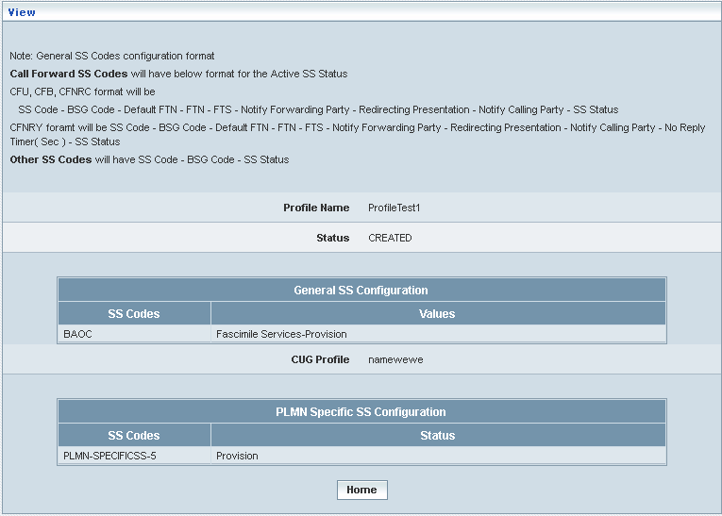

| **STEP** | **ACTION** |
| --- | --- |
|  | User can peruse details related to the chosen Supplementary Service Profile |
|  | On clicking the **Home** button at the bottom of the ‘View’ Screen, it redirects the user to the Supplementary Services profiles grid |

**Searching for a specific Supplementary Services profiles (Record)**



| **STEP** | **ACTION** |
| --- | --- |
|  | Select a search criterion (‘Profile Name’) from the drop-down list of the search criteria of the <Search> field  **\*** By default the list of search criterion (‘Profile Name’) will be dynamically displayed as drop-down list of the <Search> field |
|  | Enter the ‘Profile Name’ that corresponds with the given search criterion |
|  | On clicking the **Go** button, the corresponding Supplementary Services Profiles (record) will be highlighted among the list of Supplementary Services Profiles records. |

The screen below depicts fetching and displaying the give Supplementary Services Profiles record.

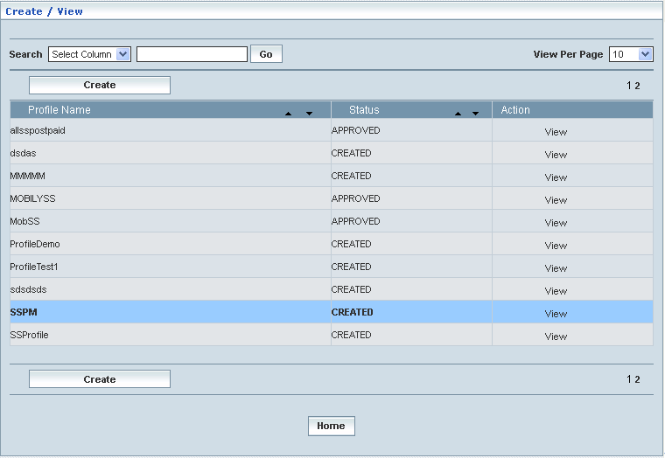

**Manage**

Home Location Register 🡪 Supplementary Services 🡪 SS Profile Management 🡪 Manage

‘Manage’ helps the user modifying and deleting (managing) a chosen Supplementary Service profile that was created, but still to be approved. This module also helps **approving** or **rejecting** the profile.

Initially, ‘Supplementary Services’ displays a grid showing the list of existing supplementary services’ Profiles that were configured and created.

The screen below shows the list of various Supplementary Service (Profiles) configurations in a grid.

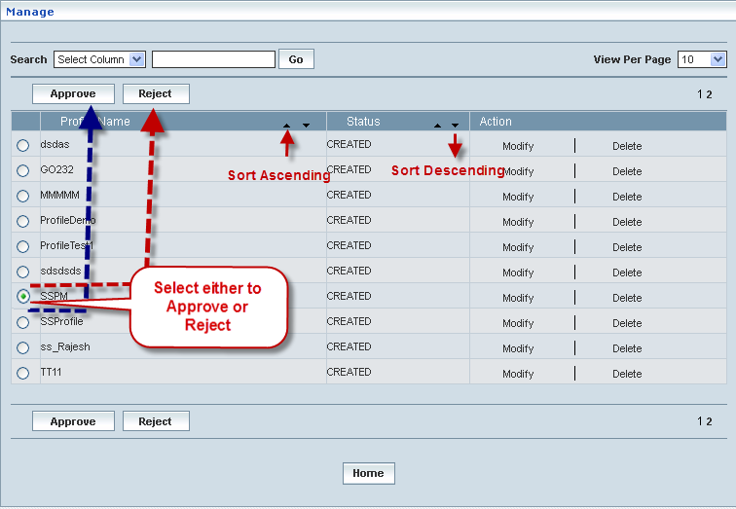

| **STEP** | | **ACTION** |
| --- | --- | --- |
|  | | By default, the list of Supplementary Service profiles will be displayed as records in a grid. The columns include ‘Profile Name’, ‘Status’ and ‘Action’ |
|  |  | User can customize the view for the number of records to be displayed each time (per page) in a grid.  However, this option is applicable only if the total number of records exceeds 10. And also with the immediate effect of increase in the number of records more than 10, a ‘Search’ option would be dynamically displayed. |
| Select the number of records (For Ex: 10) from the drop-down list of the <View Per Page> field. |
| With the effect of choosing the desired number (10) for the display of records per page, the same (10 records) will be displayed in the grid. |
| User can sort the records in ascending and descending orders with the help of up-arrow and down-arrows respectively |
| However, based on the total number of records, page numbers will be dynamically displayed at the left bottom of the screen |
| User can navigate for subsequent records (10 each time) by clicking the desired ‘page number’ |
|  | | On clicking the **Modify** link of a chosen ‘Profile’, corresponding information related to the profile will be displayed in a separate screen enabling the user to modify / update details of the profile |
|  | | On clicking the **Delete** link of a chosen ‘Profile’, corresponding information related to the profile will be displayed in a separate screen enabling the user to delete the profile |
|  | | **To Approve a Profile:**  Select the corresponding radio option of the desired profile to approve the same |
|  | | On clicking the **Approved** button, an alert window message will be displayed enabling the user to confirm approval of the chosen profile  Wor63  On clicking the **OK** button of the alert window, the chosen profile will be approved and a message window to that effect will be displayed  Wor72  On clicking the **Cancel** button of the alert window, it retains the ‘Manage Profiles’ grid  On clicking the **Home** button of the message window, it redirects the user to the ‘Manage Profiles’ grid  **NOTE:** The Profile that was approved will be disappeared from the ‘Manage Profiles’ grid. However, status related to the Profile will be dynamically updated (changed to ‘Approved’ from ‘Created’) in the ‘Supplementary Services Profiles’ grid |
|  | | **To Reject a Profile:**  Select the corresponding radio option of the desired profile to reject the same |
|  | | On clicking the **Reject** button, an alert window message will be displayed enabling the user to confirm rejection of the chosen profile  Wor66  On clicking the **OK** button of the alert window, the chosen profile will be rejected and a message window to that effect will be displayed  Wor73  On clicking the **Cancel** button of the alert window, it retains the ‘Manage Profiles’ grid  On clicking the **Home** button of the message window, it redirects the user to the ‘Manage Profiles’ grid  **NOTE:** Status related to the Profile will be dynamically updated (changed to ‘Rejected’ from ‘Created’) in the Supplementary Services grid and as well as in ‘Manage Profiles’ grid  **\*** Once rejected profile can always be approved any time later by way of similar process of approving a profile |
|  | | On clicking the **Home** button at the bottom of the grid, it redirects the user to the ‘Supplementary Services’ main page |

**Modify:**

Home Location Register 🡪 Supplementary Services 🡪 Profile Management 🡪 Manage

🡪 Modify

Modify enables the user to modify / update the details related to an existing Supplementary Services profile.

On clicking the **‘Modify’** link of a chosen ‘Profile’ (from the Supplementary Service Profiles List); corresponding information related to the profile will be displayed in a separate screen enabling the user to modify / update details of the profile – Supplementary Service.

The screen below shows modifying / updating the details related to an existing Supplementary Services profile.

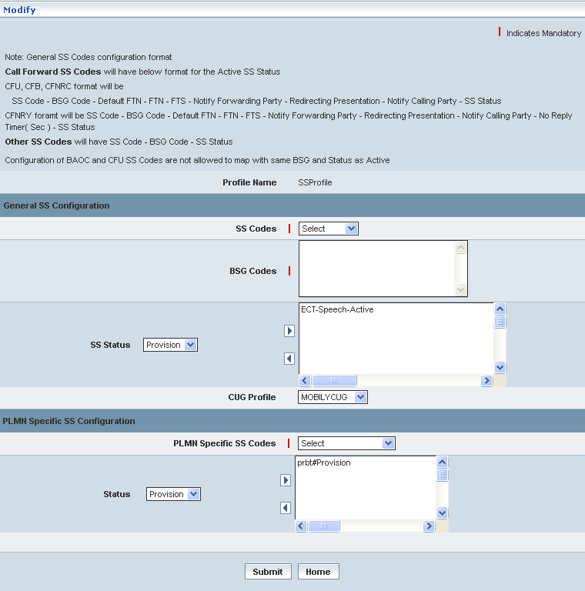

| **STEP** | **ACTION** |
| --- | --- |
|  | Name of the profile will be dynamically displayed in the <Profile Name> field and this cannot be modified |
|  | User can make necessary changes / updates to the existing values / configurations of the profile |
|  | On clicking the **Submit** button at the bottom of the ‘Modify’ screen, profile (Supplementary Services profile) details will be updated accordingly and a message window to that effect will be displayed  Wor74  On clicking the **Home** button of the message window, it directs the user back to the ‘Manage Profiles’ grid |
|  | On clicking the **Home** button of the ‘Modify’ screen (before updating the details related to profile), it directs the user to the ‘Supplementary Services Profile Management’ main page |

**Delete**

Home Location Register 🡪 Supplementary Services 🡪 Profile Management 🡪 Manage

🡪 Delete

Delete enables the user to delete an existing Supplementary Services profile.

On clicking the **‘Delete’** link of a chosen ‘Profile’ (from the Supplementary Service Profiles List); corresponding information related to the profile will be displayed in a separate screen enabling the user to delete the profile.

The screen below shows the details related to an existing Supplementary Services profile, which enables the user to delete the same (Profile) – Supplementary Service.

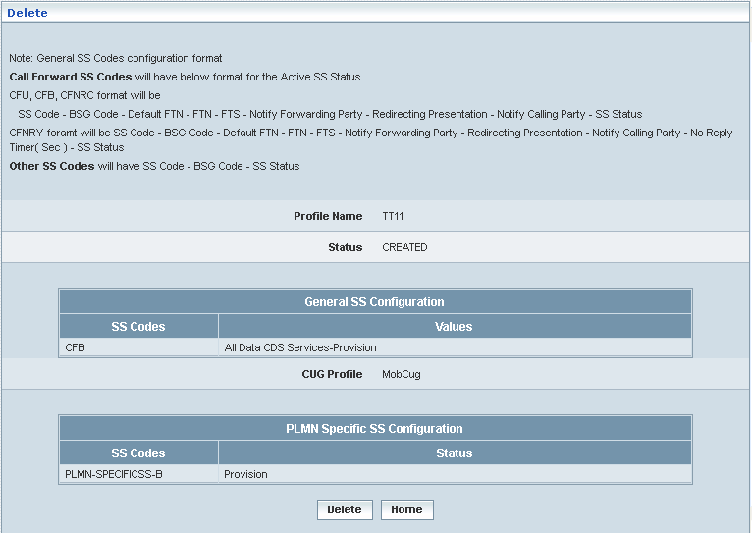

| **STEP** | **ACTION** |
| --- | --- |
|  | User can peruse the existing values / configurations of the profile before deleting the profile |
|  | On clicking the **Delete** at the bottom of the ‘Delete’ screen, it displays an alert window enabling the user to confirm deletion of the chosen profile (Supplementary Services profile)  Wor6  On clicking the **OK** button of the alert window, the chosen Mobile Supplementary Services profile will be deleted and a message window to that effect will be displayed    On clicking the **Cancel** button of the alert window, it retains the corresponding ‘Delete’ screen  On clicking the **Home** button of the message window, it directs the user back to the ‘Manage Profiles’ grid |
|  | On clicking the **Home** button of the ‘Delete’ screen (before deleting the profile), it directs the user to the ‘Supplementary Services Profile Management’ main page |

**Searching for a specific Supplementary Services profiles (Record)**



| **STEP** | **ACTION** |
| --- | --- |
|  | Select a search criterion (‘Profile Name’) from the drop-down list of the search criteria of the <Search> field  **\*** By default the list of search criterion (‘Profile Name’) will be dynamically displayed as drop-down list of the <Search> field |
|  | Enter the ‘Profile Name’ that corresponds with the given search criterion |
|  | On clicking the **Go** button, the corresponding Supplementary Services Profiles (record) will be highlighted among the list of Supplementary Services Profiles records. |

The screen below depicts fetching and displaying the give Supplementary Services Profiles record.

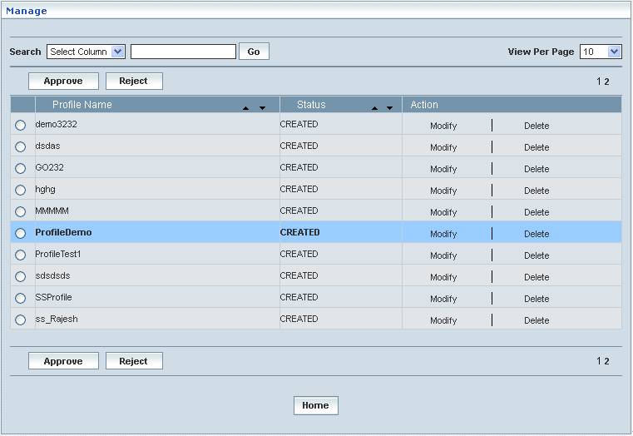

# Location Services

Location Services contains the GLMC profiles, LCS Services, External Clients, and LCS Profiles. User can create or manager GLMC profiles, LCS Services, External Clients, and LCS Profiles. Create includes create / view. Manage includes modify, delete, approve, and reject.

Home Location Register 🡪 Location Services

## GMLC Profile

The GMLC initiates location requests on behalf of external clients. The E.164 address of the GMLC is provided to an HLR when the GMLC requests a serving MSC address or SGSN address from the HLR for a target MS. The E.164 address of the GMLC is also provided to a serving MSC or SGSN when the GMLC requests the location of a target MS served by this MSC or SGSN.

Home Location Register 🡪 Location Services 🡪 GMLC Profile

Initially, ‘GMLC Profile’ displays a grid showing the list of existing GMLC Profiles that are configured and created. This list may include those profiles that are created and approved, created and rejected and also those created but still to be approved or rejected.

**Create / View**

Home Location Register 🡪 Location Services 🡪 GMLC Profile 🡪 Create / View

This allows the user to create a new GMLC profile and peruse the details related to the existing profiles.

The screen below shows the list of various GMLC profiles in a grid.

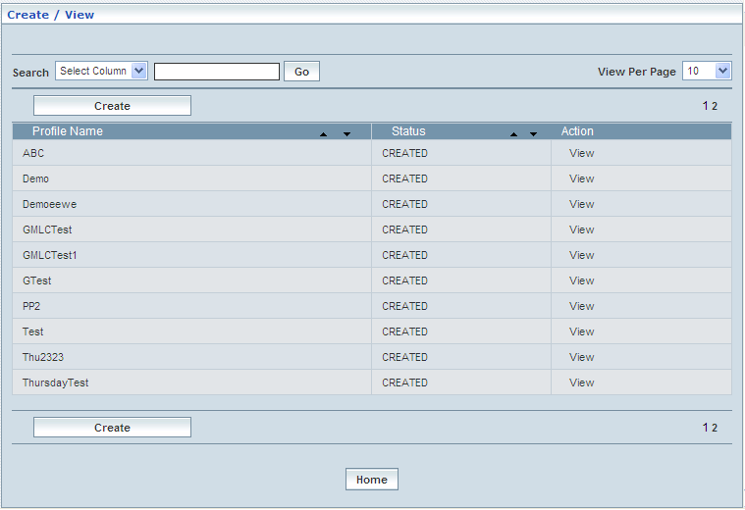

| **STEP** | | **ACTION** |
| --- | --- | --- |
|  | | By default, the list of profiles (GMLC) will be displayed as records in a grid. The columns include ‘Profile Name’, ‘Status’ and ‘Action’ |
|  |  | User can customize the view for the number of records to be displayed each time (per page) in a grid.  However, this option is applicable only if the total number of records exceeds 10. And also with the immediate effect of increase in the number of records more than 10, a ‘Search’ option would be dynamically displayed. |
| Select the number of records (For Ex: 10) from the drop-down list of the <View Per Page> field. |
| With the effect of choosing the desired number (10) for the display of records per page, the same (10 records) will be displayed in the grid. |
| User can sort the records in ascending and descending orders with the help of up-arrow and down-arrows respectively |
| However, based on the total number of records, page numbers will be dynamically displayed at the left bottom of the screen |
| User can navigate for subsequent records (10 each time) by clicking the desired ‘page number’ |
|  | | Status indicates the profile status whether just created (Created) or created and approved (Approved) or created but rejected (Rejected) |
|  | | On clicking the **Create** button, ‘Create’ screen will be displayed enabling the user to create a new ‘Profile’ (GMLC Profile) |
|  | | On clicking the **View** link of a chosen ‘Profile’, corresponding information related to the profile will be displayed in a separate screen enabling the user to peruse details of the profile |
|  | | On clicking the **Home** button at the bottom of the grid, it redirects the user to the ‘GMLC Profiles’ main page |

The screen below shows to create a new GMLC Profile

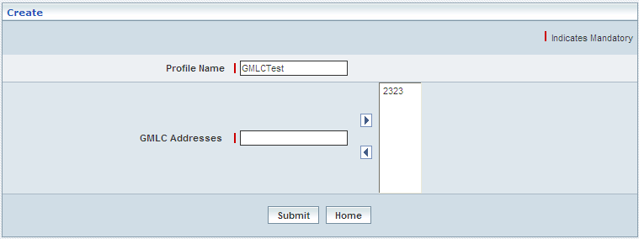

| **STEP** | **ACTION** |
| --- | --- |
|  | User must essentially enter the details related to a new profile where it is a mandatory information |
|  | Enter name of the profile in <Profile Name> field. |
|  | Enter the GMLC address in the <GMLC Addresses> field  **NOTE:** GLMC address should be numeric value |
|  | Click the right-arrow to add the GMLC address for mapping |
|  | To remove from mapping, select the GMLC address and then click left-arrow. |
|  | On clicking the **Submit** button, new profile (GMLC Profile) will be created and a message window to that effect will be displayed    On clicking the **Home** button of the message window, it directs the user back to the ‘GMLC Profiles’ grid |
|  | On clicking the **Home** button of the ‘Create’ screen (before creating any new profile), it directs the user to the ‘GMLC Profiles’ main page |

**View**

Home Location Register 🡪 Location Services 🡪 GMLC Profile 🡪 Create / View

View enables the user to peruse details related to chosen profile (GMLC Service Profile).

On clicking the **‘View’** link of a chosen ‘Profile’ (from the GMLC Profiles List); corresponding information related to the profile will be displayed in a separate screen enabling the user to peruse details of the profile – GMLC profile.

The screen below displays the details related to chosen profile (GMLC Profile).

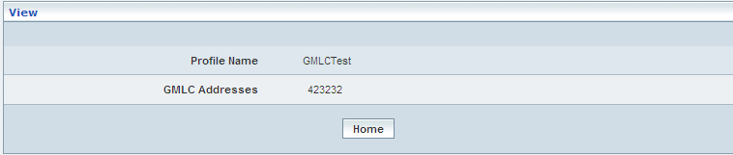

| **STEP** | **ACTION** |
| --- | --- |
|  | User can peruse details related to the chosen GMLC Profile |
|  | On clicking the **Home** button at the bottom of the ‘View’ Screen, it redirects the user to the ‘GMLC Profiles’ grid |

**Searching for a specific GMLC Profiles (Record)**

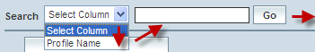

| **STEP** | **ACTION** |
| --- | --- |
|  | Select a search criterion (Profile Name) from the drop-down list of the search criteria of the <Search> field  **\*** By default the list of search criterion (Profile Name) will be dynamically displayed as drop-down list of the <Search> field |
|  | Enter the Profile Name that corresponds with the given search criterion |
|  | On clicking the **Go** button, the corresponding GMLC Profiles (record) will be highlighted among the list of GMLC Profiles records. |

The screen below depicts fetching and displaying the give GMLC Profiles record.

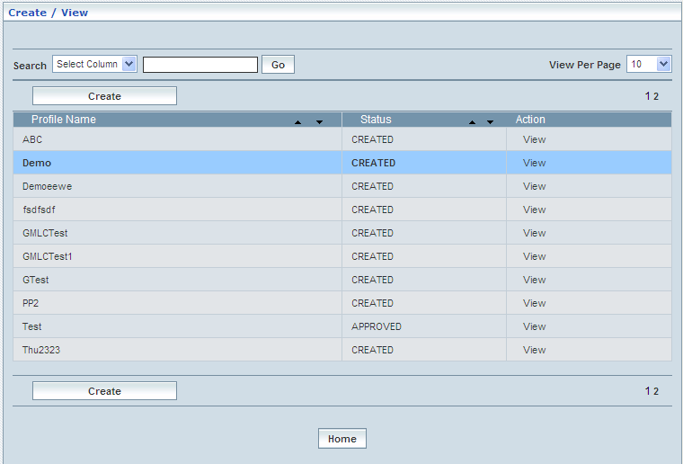

**Manage**

Home Location Register 🡪 Location Services 🡪 GMLC Profile 🡪 Manage

‘Manage’ helps the user modifying and deleting (managing) a chosen GMLC profile that was created, but still to be approved. This module also helps **approving** or **rejecting** the profile.

Initially, ‘GMLC’ displays a grid showing the list of existing supplementary services’ Profiles that were configured and created.

The screen below shows the list of various GMLC Profiles configurations in a grid.

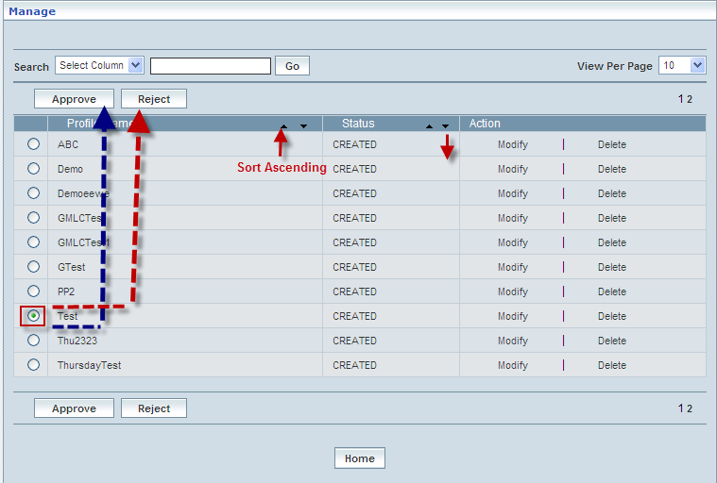

|  |  |  |
| --- | --- | --- |
| **STEP** | | **ACTION** |
|  | | By default, the list of GMLC profiles will be displayed as records in a grid. The columns include ‘Profile Name’, ‘Status’ and ‘Action’ |
|  |  | User can customize the view for the number of records to be displayed each time (per page) in a grid.  However, this option is applicable only if the total number of records exceeds 10. And also with the immediate effect of increase in the number of records more than 10, a ‘Search’ option would be dynamically displayed. |
| Select the number of records (For Ex: 10) from the drop-down list of the <View Per Page> field. |
| With the effect of choosing the desired number (10) for the display of records per page, the same (10 records) will be displayed in the grid. |
| User can sort the records in ascending and descending orders with the help of up-arrow and down-arrows respectively |
| However, based on the total number of records, page numbers will be dynamically displayed at the left bottom of the screen |
| User can navigate for subsequent records (10 each time) by clicking the desired ‘page number’ |
|  | | On clicking the **Modify** link of a chosen ‘Profile’, corresponding information related to the profile will be displayed in a separate screen enabling the user to modify / update details of the profile |
|  | | On clicking the **Delete** link of a chosen ‘Profile’, corresponding information related to the profile will be displayed in a separate screen enabling the user to delete the profile |
|  | | **To Approve a Profile:**  Select the corresponding radio option of the desired profile to approve the same |
|  | | On clicking the **Approve** button, an alert window message will be displayed enabling the user to confirm approval of the chosen profile  Wor63  On clicking the **OK** button of the alert window, the chosen profile will be approved and a message window to that effect will be displayed  Wor7D  On clicking the **Cancel** button of the alert window, it retains the ‘Manage Profiles’ grid  On clicking the **Home** button of the message window, it redirects the user to the ‘Manage Profiles’ grid  **NOTE:** The Profile that was approved will be disappeared from the ‘Manage Profiles’ grid. However, status related to the Profile will be dynamically updated (changed to ‘Approved’ from ‘Created’) in the ‘PDP Profiles’ grid |
|  | | **To Reject a Profile:**  Select the corresponding radio option of the desired profile to reject the same |
|  | | On clicking the **Reject** button, an alert window message will be displayed enabling the user to confirm rejection of the chosen profile  Wor66  On clicking the **OK** button of the alert window, the chosen profile will be rejected and a message window to that effect will be displayed  Wor7E  On clicking the **Cancel** button of the alert window, it retains the ‘Manage Profiles’ grid  On clicking the **Home** button of the message window, it redirects the user to the ‘Manage Profiles’ grid  **NOTE:** Status related to the Profile will be dynamically updated (changed to ‘Rejected’ from ‘Created’) in the Profiles grid and as well as in ‘Manage Profiles’ grid  **\*** Once rejected profile can always be approved any time later by way of similar process of approving a profile |
|  | | On clicking the **Home** button at the bottom of the grid, it redirects the user to the ‘GMLC Profiles’ main page |

**Modify**

Home Location Register 🡪 Location Services 🡪 GMLC Profile 🡪 Manage

🡪 Modify

Modify enables the user to modify / update the details related to an existing GMLC profile.

On clicking the **‘Modify’** link of a chosen ‘Profile’ (from the GMLC Profiles List); corresponding information related to the profile will be displayed in a separate screen enabling the user to modify / update details of the profile – GMLC.

The screen below shows modifying / updating the details related to an existing GMLC profile.

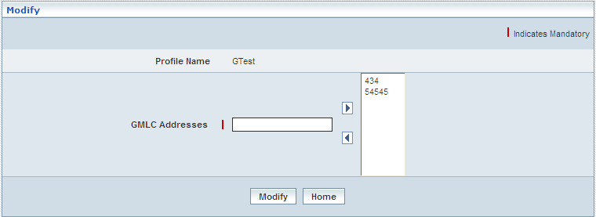

| **STEP** | **ACTION** |
| --- | --- |
|  | Name of the profile will be dynamically displayed in the <Profile Name> field and this cannot be modified |
|  | User can make necessary changes / updates to the existing values / configurations of the profile |
|  | On clicking the **Submit** button at the bottom of the ‘Modify’ screen, profile (GMLC profile) details will be updated accordingly and a message window to that effect will be displayed    On clicking the **Home** button of the message window, it directs the user back to the ‘Manage Profiles’ grid |
|  | On clicking the **Home** button of the ‘Modify’ screen (before updating the details related to profile), it directs the user to the ‘Manage Profiles’ grid |

**Delete**

Home Location Register 🡪 Location Services 🡪 GMLC Profile 🡪 Manage 🡪 Delete

Delete enables the user to delete an existing GMLC Services profile.

On clicking the **‘Delete’** link of a chosen ‘Profile’ (from the GMLC Profiles List); corresponding information related to the profile will be displayed in a separate screen enabling the user to delete the profile.

The screen below shows the details related to an existing GMLC profile, which enables the user to delete the same (Profile) – GMLC.

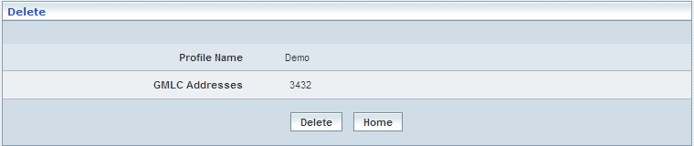

| **STEP** | **ACTION** |
| --- | --- |
|  | User can peruse the existing values / configurations of the profile before deleting the profile |
|  | On clicking the **Delete** at the bottom of the ‘Delete’ screen, it displays an alert window enabling the user to confirm deletion of the chosen profile (Supplementary Services profile)  Wor6  On clicking the **OK** button of the alert window, the chosen Mobile Supplementary Services profile will be deleted and a message window to that effect will be displayed    On clicking the **Cancel** button of the alert window, it retains the corresponding ‘Delete’ screen  On clicking the **Home** button of the message window, it directs the user back to the ‘Manage Profiles’ grid |
|  | On clicking the **Home** button of the ‘Delete’ screen (before deleting the profile), it directs the user to the ‘Manage Profiles’ grid |

**Searching for a specific GMLC Profiles (Record)**



| **STEP** | **ACTION** |
| --- | --- |
|  | Select a search criterion (Profile Name) from the drop-down list of the search criteria of the <Search> field  **\*** By default the list of search criterion (Profile Name) will be dynamically displayed as drop-down list of the <Search> field |
|  | Enter the Profile Name that corresponds with the given search criterion |
|  | On clicking the **Go** button, the corresponding GMLC Profiles (record) will be highlighted among the list of GMLC Profile records. |

The screen below depicts fetching and displaying the give GMLC Profile record.

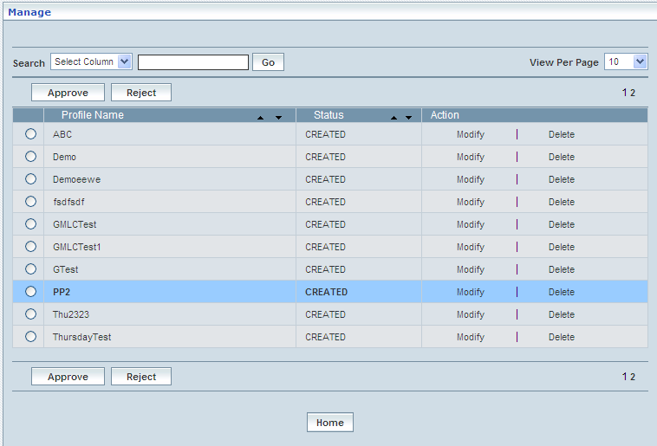

## LCS Services

Home Location Register 🡪 Location Services 🡪 LCS Services

Location Services (LCS) is the actual geographic position of the mobile station, geographic position is in terms of latitude, longitude and relative velocity of the mobile station.

In this section user can create, view, and modify the LCS services. User can also approve or reject the LCS services.

This section enables users to perform the following tasks of the LCS Services (Location Services. This usually implies positioning of an MS for commercial services, not emergency services)

This module helps the user performing the following actions:

* Create
* View
* Modify
* Delete
* Approve
* Reject
* Search

**Create / View**

Home Location Register 🡪 Location Services 🡪 LCS Services 🡪 Create / View

This allows the user to create a new LCS service and peruse the details related to the existing services

The screen below shows the list of various LCS Services in a grid.

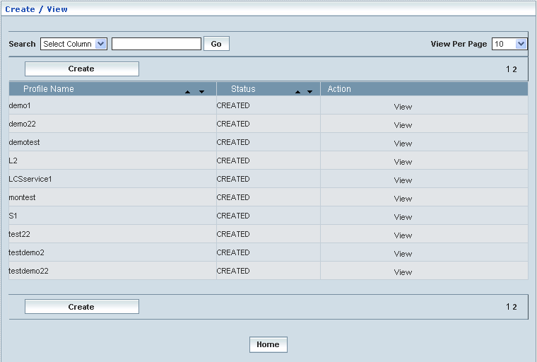

| **STEP** | | **ACTION** |
| --- | --- | --- |
|  | | By default, the list of LCS services will be displayed as records in a grid. The columns include ‘Profile Name’, ‘Status’ and ‘Action’ |
|  |  | User can customize the view for the number of records to be displayed each time (per page) in a grid.  However, this option is applicable only if the total number of records exceeds 10. And also with the immediate effect of increase in the number of records more than 10, a ‘Search’ option would be dynamically displayed. |
| Select the number of records (For Ex: 10) from the drop-down list of the <View Per Page> field. |
| With the effect of choosing the desired number (10) for the display of records per page, the same (10 records) will be displayed in the grid. |
| User can sort the records in ascending and descending orders with the help of up-arrow and down-arrows respectively |
| However, based on the total number of records, page numbers will be dynamically displayed at the left bottom of the screen |
| User can navigate for subsequent records (10 each time) by clicking the desired ‘page number’ |
|  | | Status indicates the profile status whether just created (Created) or created and approved (Approved) or created but rejected (Rejected) |
|  | | On clicking the **Create** button, ‘Create’ screen will be displayed enabling the user to create a new LCS Service |
|  | | On clicking the **View** link of a chosen Service, corresponding information related to the profile will be displayed in a separate screen enabling the user to peruse details of the profile |
|  | | On clicking the **Home** button at the bottom of the grid, it redirects the user to the ‘LCS Services’ main page |

**Create**

Home Location Register 🡪 Location Services 🡪 LCS Services 🡪 Create / View

Create enables the user to create a new LCS Service.

The screen below shows creating a new LCS Service

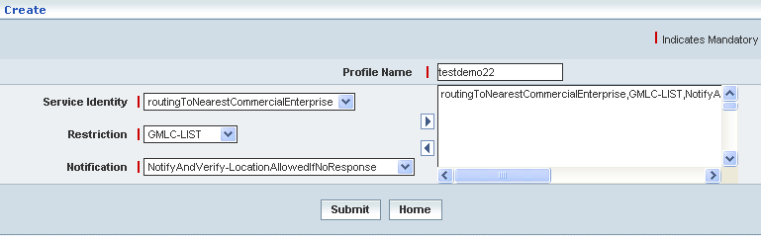

| **STEP** | **ACTION** |
| --- | --- |
|  | User must enter the details of the LCS Services details where it is a mandatory information |
|  | Enter Profile Name in <Profile Name> field. |
|  | Select the service identity from <Service Identity> field |
|  | Select the restriction from <Restriction> field |
|  | Select the notification from <Notification> field |
|  | On clicking the right-arrow button, the service identity, restriction, and notification (as a string) will be moved to the adjacent field.  User can move the desired number of services from different service identities. User cannot map the duplicate service identity.  However if the user wants to just remove any service (any time before creating the profile), selecting the service from the right text field and subsequently clicking the left-arrow button removes the service |
|  | On clicking the **Submit** button, the new LCS Service will be created successfully. A message window will be displayed to that effect    On clicking the **Home** button of the message window, it redirects the user to the ‘Create’ Screen |
|  | On clicking the **Home** button at the bottom of the ‘Create’ Screen (before creating a new LCS Service), it redirects the user to the ‘LCS Service’ Screen |

**View**

On clicking the **‘View’** link of a chosen ‘LCS Service’ (from the LCS Service List); corresponding information related to the LCS Service will be displayed in a separate screen enabling the user to peruse details of the same.

The screen below shows the view of a chosen LCS Service.

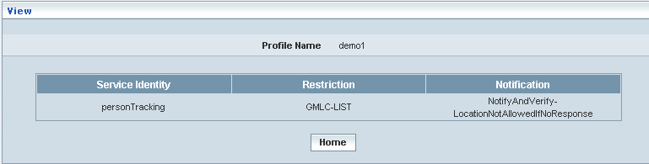

| **STEP** | **ACTION** |
| --- | --- |
|  | The ‘Profile Name’, ‘Service Identity’, ‘Restriction’ and ‘Notification’ details will be dynamically displayed in their respective fields |
|  | On clicking the **Home** button at the bottom of the ‘View’ Screen, it redirects the user to the ‘LCS Services’ profiles grid |

**Manage**

Home Location Register 🡪 Location Services 🡪 LCS Services 🡪 Manage

Manage enables the users to perform search, modify, delete, approve and delete LCS Services

The screen below shows the ‘Manage’ Screen

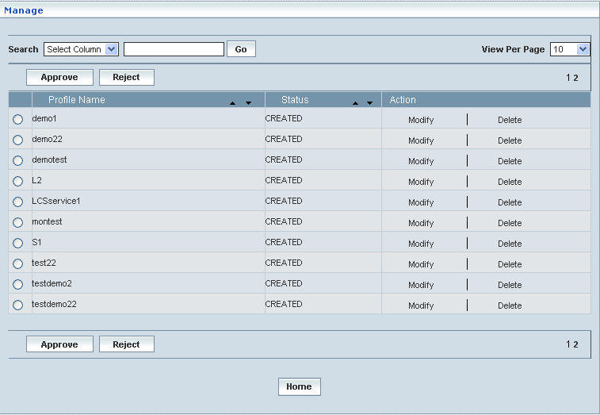

| **STEP** | | **ACTION** |
| --- | --- | --- |
|  | | By default, the list of LCS Services will be displayed as records in a grid. The columns include ‘Profile Name’, ‘Status’ and ‘Action’ |
|  |  | User can customize the view for the number of records to be displayed each time (per page) in a grid.  However, this option is applicable only if the total number of records exceeds 10. And also with the immediate effect of increase in the number of records more than 10, a ‘Search’ option would be dynamically displayed. |
| Select the number of records (For Ex: 10) from the drop-down list of the <View Per Page> field. |
| With the effect of choosing the desired number (10) for the display of records per page, the same (10 records) will be displayed in the grid. |
| User can sort the records in ascending and descending orders with the help of up-arrow and down-arrows respectively |
| However, based on the total number of records, page numbers will be dynamically displayed at the left bottom of the screen |
| User can navigate for subsequent records (10 each time) by clicking the desired ‘page number’ |
|  | | On clicking the **Modify** link, ‘Modify’ screen will be displayed enabling the user to update / change corresponding values (as required) of a chosen ‘LCS Services’ |
|  | | On clicking the **Delete** link, of a chosen ‘LCS Services’, it enables the user to delete the same |
|  | | **To Approve a LCS Service:**  Select the corresponding radio option of the desired service to approve the same |
|  | | On clicking the **Approve** button, an alert window message will be displayed enabling the user to confirm approval of the chosen service  SNAGHTMLae5025  On clicking the **OK** button of the alert window, the chosen service will be approved and a message window to that effect will be displayed    On clicking the **Cancel** button of the alert window, it retains the ‘Manage Service‘ grid  On clicking the **Home** button of the message window, it redirects the user to the ‘Manage Services’ grid  **NOTE:** The service that was approved will be disappeared from the ‘Manage Services’ grid. However, status related to the service will be dynamically updated (changed to ‘Approved’ from ‘Created’) in the ‘Services’ grid |
|  | | **To Reject a Services:**  Select the corresponding radio option of the desired service to reject the same  On clicking the **Reject** button, an alert window message will be displayed enabling the user to confirm rejection of the chosen service.  SNAGHTMLaf5502  On clicking the **OK** button of the alert window, the chosen service will be rejected and a message window to that effect will be displayed    On clicking the **Cancel** button of the alert window, it retains the ‘Manage Services’ grid  On clicking the **Home** button of the message window, it redirects the user to the ‘Manage Services’ grid  **NOTE:** Status related to the Services will be dynamically updated (changed to ‘Rejected’ from ‘Created’) in the Service grid and as well as in ‘Manage Services’ grid  **\*** Once rejected service can always be approved any time later by way of similar process of approving a service |
|  | | On clicking the **Home** button at the bottom of the grid, it redirects the user to the ‘LCS Services’ main page |

**Modify**

On clicking the **‘Modify’** link of a chosen ‘LCS Services’ (from the LCS Services List); corresponding information related to the LCS Services will be displayed in a separate screen enabling the user to modify details of the same.

The screen below shows modifying / updating an existing LCS Services

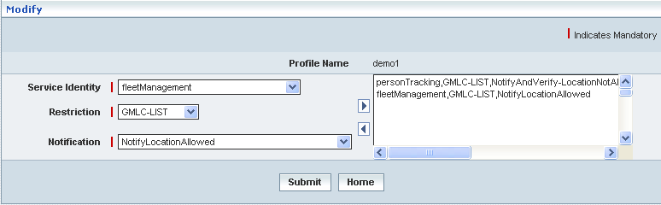

| **STEP** | **ACTION** |
| --- | --- |
|  | Name of the profile will be dynamically displayed in the <Profile Name> field and this cannot be modified |
|  | User can make necessary changes related to LCS Services (‘Service Identity’, ‘Restriction’, ‘Notification’ and mapping alteast one service |
|  | On clicking the **Submit** button, the changes made will be updated accordingly in the database. A message window will be displayed to that effect    On clicking the **Home** button of the message window, it redirects the user to the ‘Manage’ Screen |
|  | On clicking the **Home** button at the bottom of the ‘Modify’ Screen (before submission), it redirects to the ‘LCS Services’ Screen |

**Delete**

On clicking the **‘Delete’** link of a chosen ‘LCS Services’ (from the LCS Services List); corresponding information related to the LCS Services will be displayed in a separate screen enabling the user to delete details of the same.

The screen below shows deleting an existing LCS Service

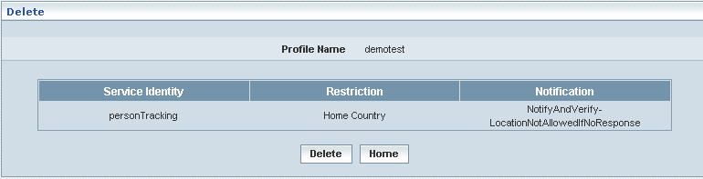

| **STEP** | **ACTION** |
| --- | --- |
|  | On clicking the **Delete** button, an alert message window will be displayed enabling the user to confirm deletion of the chosen LCS Service SNAGHTMLac73a4 |
|  | On clicking the **OK** button of the alert message window, the chosen LCS Service details will be deleted and a message window will be displayed to that effect. It will be disappeared from the ‘LCS Services’ grid.    On clicking the **Home** button of the message window, it directs the user to ‘Manage’ Screen  On clicking the **Cancel** button of the alert message window, it retains the grid without deleting the LCS Services record |
|  | On clicking the **Home** button at the bottom of the ‘Delete’ screen (before submission), it redirects to the ‘LCS Services’ Screen |

**Searching for a specific CUG Profile (Record)**



| **STEP** | **ACTION** |
| --- | --- |
|  | Select a search criterion (‘Profile Name’) from the drop-down list of the search criteria of the <Search> field  **\*** By default the list of search criterion (‘Profile Name’) will be dynamically displayed as drop-down list of the <Search> field |
|  | Enter the ‘Profile Name’ that corresponds with the given search criterion |
|  | On clicking the **Go** button, the corresponding LCS Services (record) will be highlighted among the list of LCS Services records. |

The screen below depicts fetching and displaying the give LCS Services record.

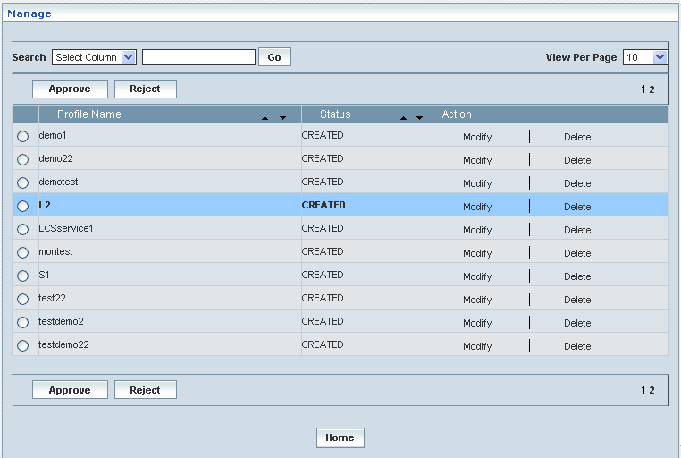

## External Clients

This parameter is only applicable to the call/session unrelated privacy class and call/session related privacy class, and gives the identities of the external clients that are allowed to locate a target MS for a MT-LR. Each identity is an international (e.g.E.164) address. For each identified external client, GMLC restrictions may be defined. It may also be indicated if the MS shall be notified of a non-restricted MT-LR from each identified LCS client and, if so, whether notification only or notification with privacy verification shall apply.

**Create / View**

Home Location Register 🡪 Location Service 🡪 External Client 🡪 Create / View

This allows the user to create a new profile and peruse the details related to the existing profiles.

The screen below shows the list of various External Client profiles in a grid.

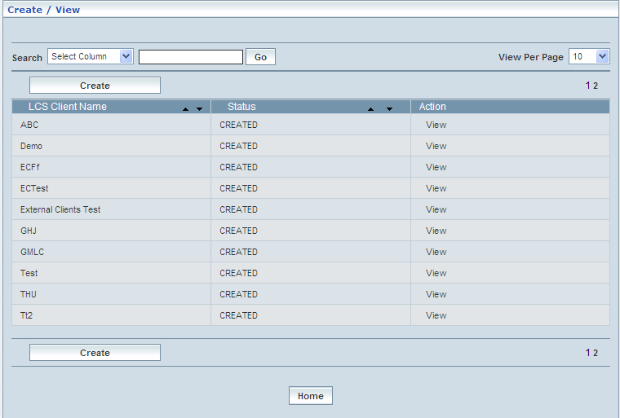

| **STEP** | | **ACTION** |
| --- | --- | --- |
|  | | By default, the list of profiles (External Client) will be displayed as records in a grid. The columns include ‘LCS client name, ‘Status’ and ‘Action’ |
|  |  | User can customize the view for the number of records to be displayed each time (per page) in a grid.  However, this option is applicable only if the total number of records exceeds 10. And also with the immediate effect of increase in the number of records more than 10, a ‘Search’ option would be dynamically displayed. |
| Select the number of records (For Ex: 10) from the drop-down list of the <View Per Page> field. |
| With the effect of choosing the desired number (10) for the display of records per page, the same (10 records) will be displayed in the grid. |
| User can sort the records in ascending and descending orders with the help of up-arrow and down-arrows respectively |
| However, based on the total number of records, page numbers will be dynamically displayed at the left bottom of the screen |
| User can navigate for subsequent records (10 each time) by clicking the desired ‘page number’ |
|  | | Status indicates the profile status whether just created (Created) or created and approved (Approved) or created but rejected (Rejected) |
|  | | On clicking the **Create** button, ‘Create’ screen will be displayed enabling the user to create a new ‘Profile’ (External Client) |
|  | | On clicking the **View** link of a chosen ‘Profile’, corresponding information related to the profile will be displayed in a separate screen enabling the user to peruse details of the profile |
|  | | On clicking the **Home** button at the bottom of the grid, it redirects the user to the ‘External Client’ main page |

**Create**

Home Location Register 🡪 Location Service 🡪 External Client 🡪 Create / View

Create enables the user to create a new profile (External client) and attribute various values to constitute the same.

The screen below shows creating a new profile as External client profile

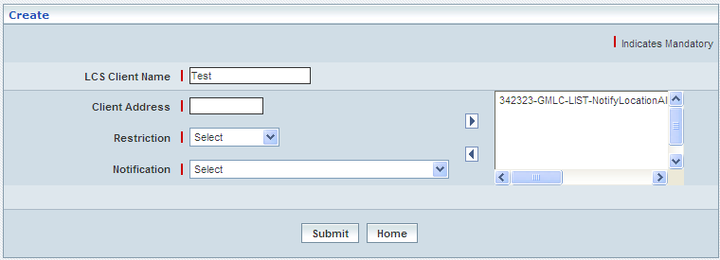

| **STEP** | **ACTION** |
| --- | --- |
|  | User must essentially enter the details related to a new profile where it is a mandatory information |
|  | Enter name of the LCS client name in <LCS Client Name> field. |
|  | Select the client address in the <Client Address> field.  **NOTE:** The <Client Address> should be numeric value only. |
|  | Select the restriction, such as, GMLC-LIST, Home county. |
|  | Select the notification in the <Notification> field. |
|  | On clicking the right-arrow button, the client address, restriction, and notification (as a string) will be moved to the adjacent field.  User can move the desired number of services from different service identities. User cannot map the duplicate client address.  However if the user wants to just remove any service (any time before creating the profile), selecting the service from the right text field and subsequently clicking the left-arrow button removes the service |
|  | On clicking the **Submit** button, new profile (external client) will be created and a message window to that effect will be displayed.    On clicking the **Home** button of the message window, it directs the user back to the ‘External Clients Profiles’ grid |
|  | On clicking the **Home** button of the ‘Create’ screen (before creating any new profile), it directs the user to the ‘External Client’ main page |

**View**

Home Location Register 🡪 Location Service 🡪 External Client 🡪 Create / View

View enables the user to peruse details related to chosen profile (External client)

On clicking the **‘View’** link of a chosen ‘Profile’ (from the External Client List); corresponding information related to the profile will be displayed in a separate screen enabling the user to peruse details of the profile - External client.

The screen below displays the details related to chosen profile (External client)

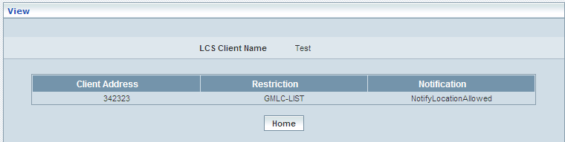

| **STEP** | **ACTION** |
| --- | --- |
|  | User can peruse details related to the chosen PDP Profile |
|  | On clicking the **Home** button at the bottom of the ‘View’ Screen, it redirects the user to the ‘External Clients’ Profile grid |

**Searching for a specific External Clients Profile (Record)**

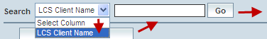

| **STEP** | **ACTION** |
| --- | --- |
|  | Select a search criterion (LCS Client Name) from the drop-down list of the search criteria of the <Search> field  **\*** By default the list of search criterion (LCS Client Name) will be dynamically displayed as drop-down list of the <Search> field |
|  | Enter the LCS Client Name that corresponds with the given search criterion |
|  | On clicking the **Go** button, the corresponding External Clients Profile (record) will be highlighted among the list of External Clients Profile records. |

The screen below depicts fetching and displaying the give External Clients Profile record.

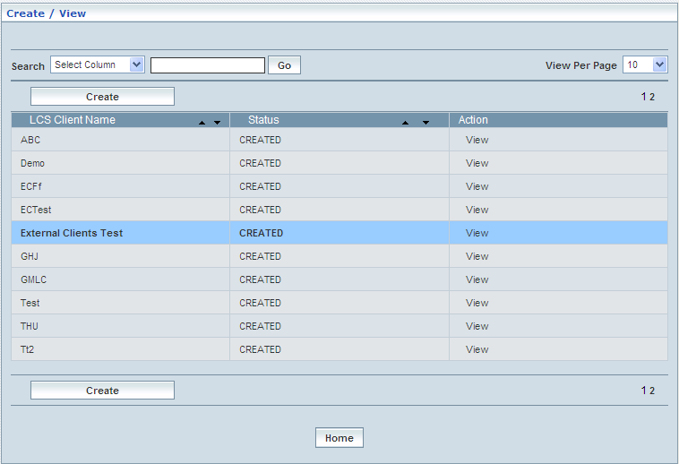

**Manage**

Home Location Register 🡪 Location Services 🡪 External Client 🡪 Manage

‘Manage’ helps the user modifying and deleting (managing) a chosen External client that was created, but still to be approved. This module also helps **approving** or **rejecting** the profile.

Initially, ‘External client displays a grid showing the list of existing External client that were configured and created.

The screen below shows the list of various External client (Profiles) configurations in a grid. Descending

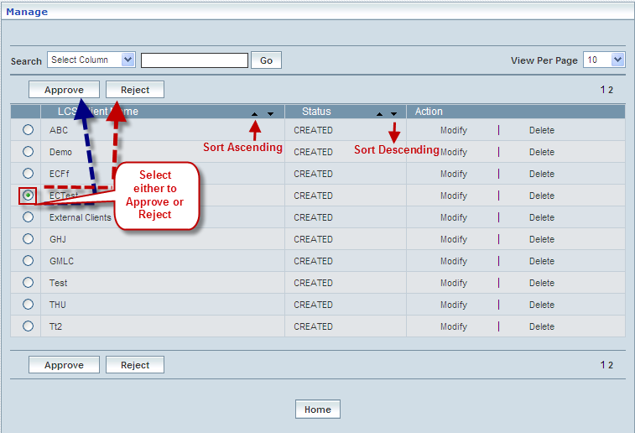

| **STEP** | | **ACTION** |
| --- | --- | --- |
|  | | By default, the list of external clients will be displayed as records in a grid. The columns include ‘LCS Client Name’, ‘Status’ and ‘Action’ |
|  |  | User can customize the view for the number of records to be displayed each time (per page) in a grid.  However, this option is applicable only if the total number of records exceeds 10. And also with the immediate effect of increase in the number of records more than 10, a ‘Search’ option would be dynamically displayed. |
| Select the number of records (For Ex: 10) from the drop-down list of the <View Per Page> field. |
| With the effect of choosing the desired number (10) for the display of records per page, the same (10 records) will be displayed in the grid. |
| User can sort the records in ascending and descending orders with the help of up-arrow and down-arrows respectively |
| However, based on the total number of records, page numbers will be dynamically displayed at the left bottom of the screen |
| User can navigate for subsequent records (10 each time) by clicking the desired ‘page number’ |
|  | | On clicking the **Modify** link of a chosen ‘Profile’, corresponding information related to the profile will be displayed in a separate screen enabling the user to modify / update details of the profile |
|  | | On clicking the **Delete** link of a chosen ‘Profile’, corresponding information related to the profile will be displayed in a separate screen enabling the user to delete the profile |
|  | | **To Approve a Profile:**  Select the corresponding radio option of the desired profile to approve the same |
|  | | On clicking the **Approve** button, an alert window message will be displayed enabling the user to confirm approval of the chosen profile  C:\DOCUME~1\rajini.sn\LOCALS~1\Temp\SNAGHTML11c6aab.PNG  On clicking the **OK** button of the alert window, the chosen profile will be approved and a message window to that effect will be displayed    On clicking the **Cancel** button of the alert window, it retains the ‘Manage Profiles’ grid  On clicking the **Home** button of the message window, it redirects the user to the ‘Manage Profiles’ grid  **NOTE:** The Profile that was approved will be disappeared from the ‘Manage Profiles’ grid. However, status related to the Profile will be dynamically updated (changed to ‘Approved’ from ‘Created’) in the ‘PDP Profiles’ grid |
|  | | **To Reject a Profile:**  Select the corresponding radio option of the desired profile to reject the same |
|  | | On clicking the **Reject** button, an alert window message will be displayed enabling the user to confirm rejection of the chosen profile  C:\DOCUME~1\rajini.sn\LOCALS~1\Temp\SNAGHTML11d1717.PNG  On clicking the **OK** button of the alert window, the chosen profile will be rejected and a message window to that effect will be displayed    On clicking the **Cancel** button of the alert window, it retains the ‘Manage Profiles’ grid  On clicking the **Home** button of the message window, it redirects the user to the ‘Manage Profiles’ grid  **NOTE:** Status related to the Profile will be dynamically updated (changed to ‘Rejected’ from ‘Created’) in the external clients grid and as well as in ‘Manage Profiles’ grid  **\*** Once rejected profile can always be approved any time later by way of similar process of approving a profile |
|  | | On clicking the **Home** button at the bottom of the grid, it redirects the user to the ‘External Clients’ main page |

**Modify**

Home Location Register 🡪 Location Services 🡪 External Client🡪 Manage 🡪 Modify

Modify enables the user to modify / update the details related to an existing external client.

On clicking the **‘Modify’** link of a chosen ‘Profile’ (from the external client List); corresponding information related to the profile will be displayed in a separate screen enabling the user to modify / update details of the profile- external client.

The screen below shows modifying / updating the details related to an existing external client profile.

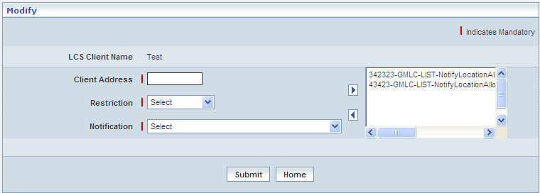

| **STEP** | **ACTION** |
| --- | --- |
|  | Name of the profile will be dynamically displayed in the <LCS client Name> field and this cannot be modified |
|  | User can make necessary changes / updates to the existing values / configurations of the profile |
|  | On clicking the **Submit** button at the bottom of the ‘Modify’ screen, profile (external client) details will be updated accordingly and a message window to that effect will be displayed    On clicking the **Home** button of the message window, it directs the user back to the ‘Manage Profiles’ grid |
|  | On clicking the **Home** button of the ‘Modify’ screen (before updating the details related to profile), it directs the user to the ‘Manage Profiles’ grid |

**Delete**

Home Location Register 🡪 Location Services 🡪 External Client🡪 Manage 🡪 Delete

Delete enables the user to delete existing external clients.

On clicking the **‘Delete’** link of a chosen ‘Profile’ (from the external clients List); corresponding information related to the profile will be displayed in a separate screen enabling the user to delete the profile- external clients.

The screen below shows the details related to an existing External Client profile, which enables the user to delete the same (Profile).

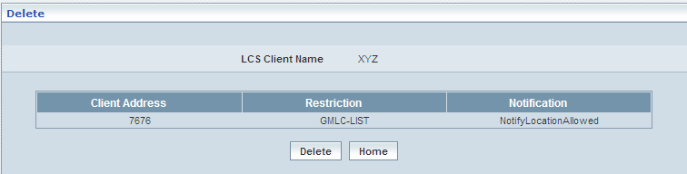

| **STEP** | **ACTION** |
| --- | --- |
|  | User can peruse the existing values / configurations of the profile before deleting the profile |
|  | On clicking the **Delete** at the bottom of the ‘Delete’ screen, it displays an alert window enabling the user to confirm deletion of the chosen profile (external client)  C:\DOCUME~1\rajini.sn\LOCALS~1\Temp\SNAGHTML12021f6.PNG  On clicking the **OK** button of the alert window, the chosen PDP profile will be deleted and a message window to that effect will be displayed    On clicking the **Cancel** button of the alert window, it retains the corresponding ‘Delete’ screen  On clicking the **Home** button of the message window, it directs the user back to the ‘Manage Profiles’ grid |
|  | On clicking the **Home** button of the ‘Delete’ screen (before deleting the profile), it directs the user to the ‘Manage Profiles’ grid |

**Searching for a specific External Clients Profile (Record)**



| **STEP** | **ACTION** |
| --- | --- |
|  | Select a search criterion (LCS Client Name) from the drop-down list of the search criteria of the <Search> field  **\*** By default the list of search criterion (LCS Client Name) will be dynamically displayed as drop-down list of the <Search> field |
|  | Enter the LCS Client Name that corresponds with the given search criterion |
|  | On clicking the **Go** button, the corresponding External Clients Profile (record) will be highlighted among the list of External Clients Profile records. |

The screen below depicts fetching and displaying the give External Clients Profile record.

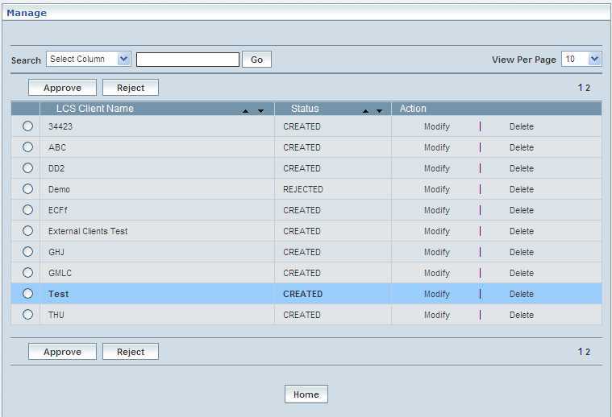

## LCS Profiles

In this section user can create, view, and modify the LCS profile. User can also approve or reject the LCS profile.

**Create / View**

Home Location Register 🡪 Location Services 🡪 LCS Profiles 🡪 Create / View

This allows the user to create a new profile and peruse the details related to the existing profiles

The screen below shows the list of various LCS profiles in a grid.

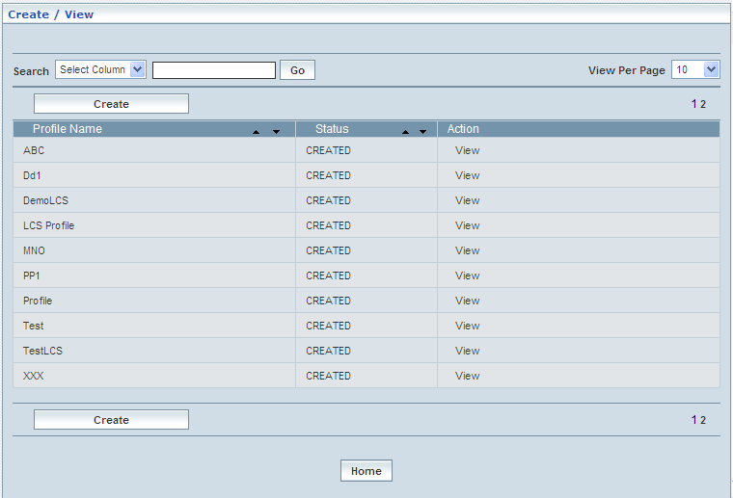

| **STEP** | | **ACTION** |
| --- | --- | --- |
|  | | By default, the list of profiles (LCS) will be displayed as records in a grid. The columns include ‘Profile Name’, ‘Status’ and ‘Action’ |
|  |  | User can customize the view for the number of records to be displayed each time (per page) in a grid.  However, this option is applicable only if the total number of records exceeds 10. And also with the immediate effect of increase in the number of records more than 10, a ‘Search’ option would be dynamically displayed. |
| Select the number of records (For Ex: 10) from the drop-down list of the <View Per Page> field. |
| With the effect of choosing the desired number (10) for the display of records per page, the same (10 records) will be displayed in the grid. |
| User can sort the records in ascending and descending orders with the help of up-arrow and down-arrows respectively |
| However, based on the total number of records, page numbers will be dynamically displayed at the left bottom of the screen |
| User can navigate for subsequent records (10 each time) by clicking the desired ‘page number’ |
|  | | Status indicates the profile status whether just created (Created) or created and approved (Approved) or created but rejected (Rejected) |
|  | | On clicking the **Create** button, ‘Create’ screen will be displayed enabling the user to create a new ‘Profile’ (LCS Profile) |
|  | | On clicking the **View** link of a chosen ‘Profile’, corresponding information related to the profile will be displayed in a separate screen enabling the user to peruse details of the profile |
|  | | On clicking the **Home** button at the bottom of the grid, it redirects the user to the ‘LCS Profile’ main page |

**Create**

Home Location Register 🡪 Location Services 🡪 LCS Profiles 🡪 Create / View

Create enables the user to create a new profile (LCS Profile) and attribute various values to constitute the same.

The screen below shows creating a new profile as LCS Profile

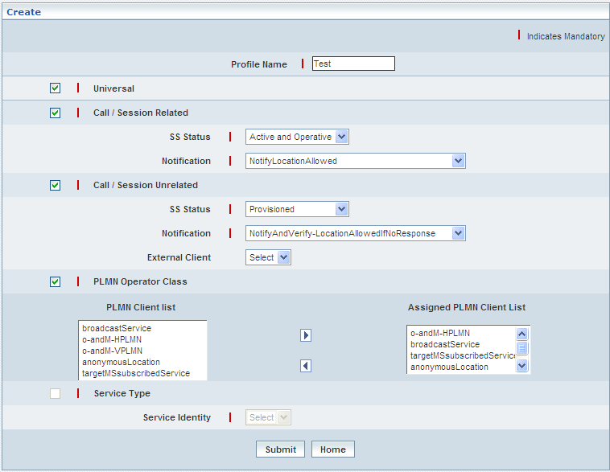

| **STEP** | **ACTION** |
| --- | --- |
|  | User must essentially enter the details related to a new profile where it is mandatory information. |
|  | Enter name of the profile name in <Profile Name> field. |
|  | LCS profile contains five SS codes including Universal, Call/Session Related, Call/Session Unrelated, PLMN Operator Class, and Service Type. User can either select Universal, Call/Session Related, Call/Session Unrelated, PLMN Operator Class or Service Type. |
|  | Select ‘Universal’. |
|  | Select ‘Call/Session Related’. The <SS Status> and <Notification> fields are activated only if the ‘Call/Session Related’ is selected. User has to enter the activated details. |
|  | Select ‘Call/Session Unrelated’. The <SS Status>, <Notification> and <External Client> fields are activated only if the ‘Call/Session Unrelated> is selected. User has to enter the activated details. |
|  | Select ‘PLMN Operator Class’. The list of <PLMN Client list> is activated. User has to map at least one PLMN client to the <Assigned PLMN Client List>. |
|  | Select ‘Service Type’. Choose the identity. User can choose the identity only if the service type is selected. User has to enter the activated details. |
|  | On clicking the **Submit** button, new profile (LCS) will be created and a message window to that effect will be displayed    On clicking the **Home** button of the message window, it directs the user back to the ‘LCS Profiles’ grid |
|  | On clicking the **Home** button of the ‘Create’ screen (before creating any new profile), it directs the user to the ‘LCS Profiles’ grid |

**View**

Home Location Register 🡪 Location Services 🡪 LCS Profiles 🡪 Create / View

View enables the user to peruse details related to chosen profile (LCS Profile).

On clicking the **‘View’** link of a chosen ‘Profile’ (from the LCS Profiles List); corresponding information related to the profile will be displayed in a separate screen enabling the user to peruse details of the profile – LCS.

The screen below displays the details related to chosen profile (LCS Profile)

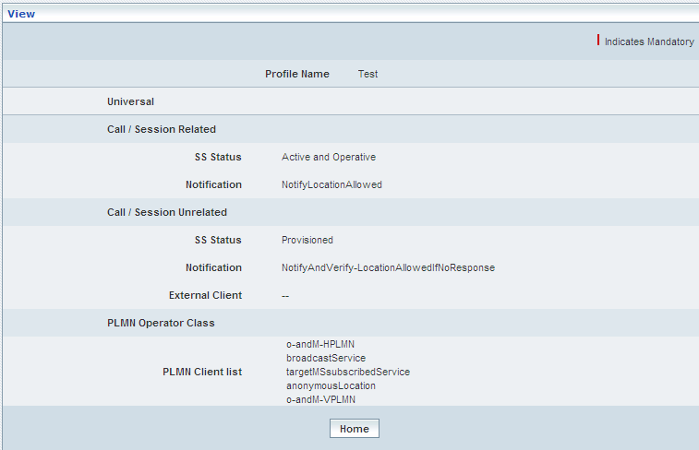

| **STEP** | **ACTION** |
| --- | --- |
|  | User can peruse details related to the chosen LCS Profile |
|  | On clicking the **Home** button at the bottom of the ‘View’ Screen, it redirects the user to the ‘LCS Profiles’ grid |

**Searching for a specific LCS Profile (Record)**



| **STEP** | **ACTION** |
| --- | --- |
|  | Select a search criterion (Profile Name) from the drop-down list of the search criteria of the <Search> field  **\*** By default the list of search criterion (Profile Name) will be dynamically displayed as drop-down list of the <Search> field |
|  | Enter the Profile Name that corresponds with the given search criterion |
|  | On clicking the **Go** button, the corresponding LCS Profile (record) will be highlighted among the list of LCS Profile records. |

The screen below depicts fetching and displaying the give LCS Profile record.

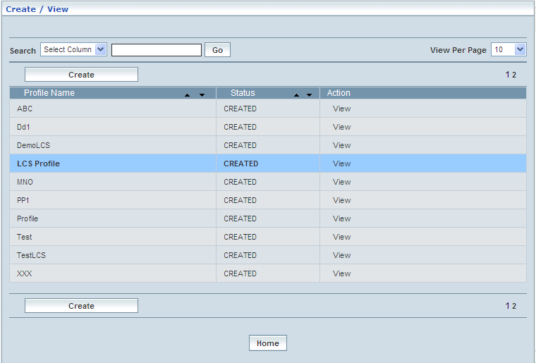

**Manage**

Home Location Register 🡪 Location Services 🡪 LCS Profiles 🡪 Manage

‘Manage’ helps the user modifying and deleting (managing) a chosen LCS profile that was created, but still to be approved. This module also helps **approving** or **rejecting** the profile.

Initially, ‘LCS displays a grid showing the list of existing LCS Profiles that were configured and created.

The screen below shows the list of various LCS (Profiles) configurations in a grid.

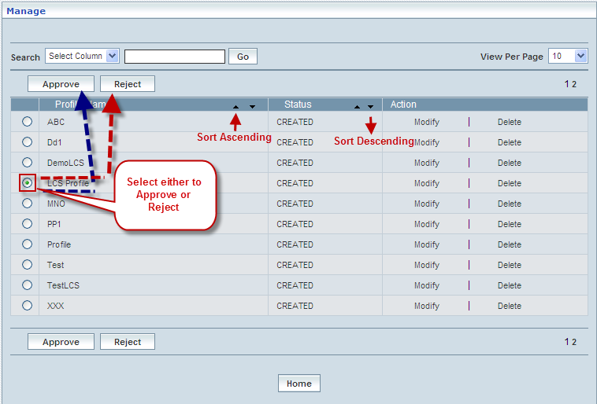

| **STEP** | | **ACTION** |
| --- | --- | --- |
|  | | By default, the list of LCS profiles will be displayed as records in a grid. The columns include ‘Profile Name’, ‘Status’ and ‘Action’ |
|  |  | User can customize the view for the number of records to be displayed each time (per page) in a grid.  However, this option is applicable only if the total number of records exceeds 10. And also with the immediate effect of increase in the number of records more than 10, a ‘Search’ option would be dynamically displayed. |
| Select the number of records (For Ex: 10) from the drop-down list of the <View Per Page> field. |
| With the effect of choosing the desired number (10) for the display of records per page, the same (10 records) will be displayed in the grid. |
| User can sort the records in ascending and descending orders with the help of up-arrow and down-arrows respectively |
| However, based on the total number of records, page numbers will be dynamically displayed at the left bottom of the screen |
| User can navigate for subsequent records (10 each time) by clicking the desired ‘page number’ |
|  | | On clicking the **Modify** link of a chosen ‘Profile’, corresponding information related to the profile will be displayed in a separate screen enabling the user to modify / update details of the profile |
|  | | On clicking the **Delete** link of a chosen ‘Profile’, corresponding information related to the profile will be displayed in a separate screen enabling the user to delete the profile |
|  | | **To Approve a Profile:**  Select the corresponding radio option of the desired profile to approve the same |
|  | | On clicking the **Approve** button, an alert window message will be displayed enabling the user to confirm approval of the chosen profile  Wor63  On clicking the **OK** button of the alert window, the chosen profile will be approved and a message window to that effect will be displayed  Wor7D  On clicking the **Cancel** button of the alert window, it retains the ‘Manage Profiles’ grid  On clicking the **Home** button of the message window, it redirects the user to the ‘Manage Profiles’ grid  **NOTE:** The Profile that was approved will be disappeared from the ‘Manage Profiles’ grid. However, status related to the Profile will be dynamically updated (changed to ‘Approved’ from ‘Created’) in the ‘Profiles’ grid |
|  | | **To Reject a Profile:**  Select the corresponding radio option of the desired profile to reject the same |
|  | | On clicking the **Reject** button, an alert window message will be displayed enabling the user to confirm rejection of the chosen profile  Wor66  On clicking the **OK** button of the alert window, the chosen profile will be rejected and a message window to that effect will be displayed  Wor7E  On clicking the **Home** button of the alert window, it retains the ‘Manage Profiles’ grid  On clicking the **Home** button of the message window, it redirects the user to the ‘Manage Profiles’ grid  **NOTE:** Status related to the Profile will be dynamically updated (changed to ‘Rejected’ from ‘Created’) in the Profiles grid and as well as in ‘Manage Profiles’ grid  **\*** Once rejected profile can always be approved any time later by way of similar process of approving a profile |
|  | | On clicking the **Home** button at the bottom of the grid, it redirects the user to the ‘LCS Profiles’ main page |

**Modify**

Home Location Register 🡪 Location Services 🡪 LCS Profiles 🡪 Manage🡪 Modify

Modify enables the user to modify / update the details related to an existing LCS profile.

On clicking the **‘Modify’** link of a chosen ‘Profile’ (from the LCS Profiles List); corresponding information related to the profile will be displayed in a separate screen enabling the user to modify / update details of the profile – LCS profile.

The screen below shows modifying / updating the details related to an existing LCS profile.

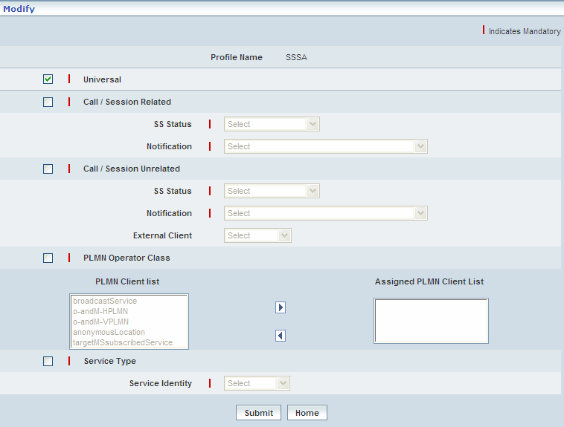

| **STEP** | **ACTION** |
| --- | --- |
|  | Name of the profile will be dynamically displayed in the <Profile Name> field and this cannot be modified |
|  | User can make necessary changes / updates to the existing values / configurations of the profile |
|  | On clicking the **Submit** button at the bottom of the ‘Modify’ screen, profile (LCS profile) details will be updated accordingly and a message window to that effect will be displayed  Wor74  On clicking the **Home** button of the message window, it directs the user back to the ‘Manage Profiles’ grid |
|  | On clicking the **Home** button of the ‘Modify’ screen (before updating the details related to profile), it directs the user to the ‘Manage Profiles’ grid |

**Delete**

Home Location Register 🡪 Location Services 🡪 LCS Profiles 🡪 Manage🡪 Delete

Delete enables the user to delete an existing LCS profile.

On clicking the **‘Delete’** link of a chosen ‘Profile’ (from the LCS Profiles List); corresponding information related to the profile will be displayed in a separate screen enabling the user to delete the profile.

The screen below shows the details related to an existing LCS profile, which enables the user to delete the same (Profile) – LCS.

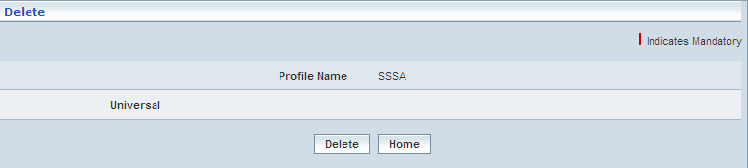

| **STEP** | **ACTION** |
| --- | --- |
|  | User can peruse the existing values / configurations of the profile before deleting the profile |
|  | On clicking the **Delete** at the bottom of the ‘Delete’ screen, it displays an alert window enabling the user to confirm deletion of the chosen profile (LCS profile)  Wor6  On clicking the **OK** button of the alert window, the chosen Mobile LCS profile will be deleted and a message window to that effect will be displayed    On clicking the **Cancel** button of the alert window, it retains the corresponding ‘Delete’ screen  On clicking the Home button of the message window, it directs the user back to the ‘Manage Profiles’ grid |
|  | On clicking the **Home** button of the ‘Delete’ screen (before deleting the profile), it directs the user to the ‘Manage Profiles’ grid |

**Searching for a specific LCS Profile (Record)**



| **STEP** | **ACTION** |
| --- | --- |
|  | Select a search criterion (Profile Name) from the drop-down list of the search criteria of the <Search> field  **\*** By default the list of search criterion (Profile Name) will be dynamically displayed as drop-down list of the <Search> field |
|  | Enter the Profile Name that corresponds with the given search criterion |
|  | On clicking the **Go** button, the corresponding LCS Profile (record) will be highlighted among the list of LCS Profile records. |

The screen below depicts fetching and displaying the give LCS Profile record.

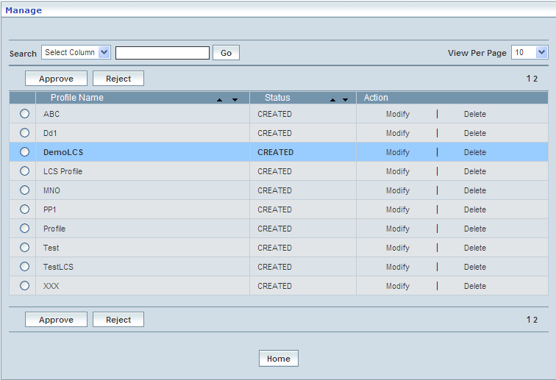

# PDP Profile Management

Packet Data Protocol (PDP) Profile contains the data, PDP Type & Address related to a subscriber that needs to be permanently and conditionally stored in HLR (Home Location Register), SGSN (Serving GPRS Service Node) and GGSN (Gateway GPRS Support Node).

Home Location Register 🡪 PDP Profile Management

Initially, PDP Profile Management displays a grid showing the list of existing PDP Profiles that are configured and created. This list may include those profiles that are created and approved, created and rejected and also those created but still to be approved or rejected.

**Create / View**

Home Location Register 🡪 PDP Profile Management 🡪 Create / View

This allows the user to create a new profile and peruse the details related to the existing profiles

The screen below shows the list of various PDP profiles in a grid.

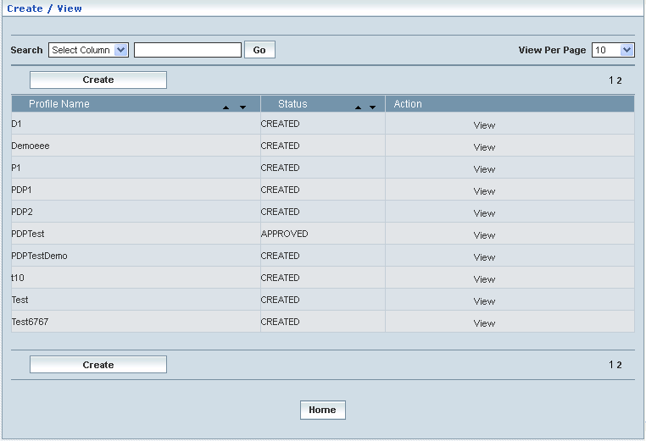

| **STEP** | | **ACTION** |
| --- | --- | --- |
|  | | By default, the list of profiles (PDP Profiles) will be displayed as records in a grid. The columns include ‘Profile Name’, ‘Status’ and ‘Action’ |
|  |  | User can customize the view for the number of records to be displayed each time (per page) in a grid.  However, this option is applicable only if the total number of records exceeds 10. And also with the immediate effect of increase in the number of records more than 10, a ‘Search’ option would be dynamically displayed. |
| Select the number of records (For Ex: 10) from the drop-down list of the <View Per Page> field. |
| With the effect of choosing the desired number (10) for the display of records per page, the same (10 records) will be displayed in the grid. |
| User can sort the records in ascending and descending orders with the help of up-arrow and down-arrows respectively |
| However, based on the total number of records, page numbers will be dynamically displayed at the left bottom of the screen |
| User can navigate for subsequent records (10 each time) by clicking the desired ‘page number’ |
|  | | Status indicates the profile status whether just created (Created) or created and approved (Approved) or created but rejected (Rejected) |
|  | | On clicking the **Create** button, ‘Create’ screen will be displayed enabling the user to create a new ‘Profile’ (PDP Profile) |
|  | | On clicking the **View** link of a chosen ‘Profile’, corresponding information related to the profile will be displayed in a separate screen enabling the user to peruse details of the profile |
|  | | On clicking the **Home** button at the bottom of the grid, it redirects the user to the ‘PDP Profiles Management’ main page |

**Create**

Home Location Register 🡪 PDP Profile Management 🡪 Create / View

Create enables the user to create a new profile (PDP Profile) and attribute various values to constitute the same.

The screen below shows creating a new profile as PDP Profile

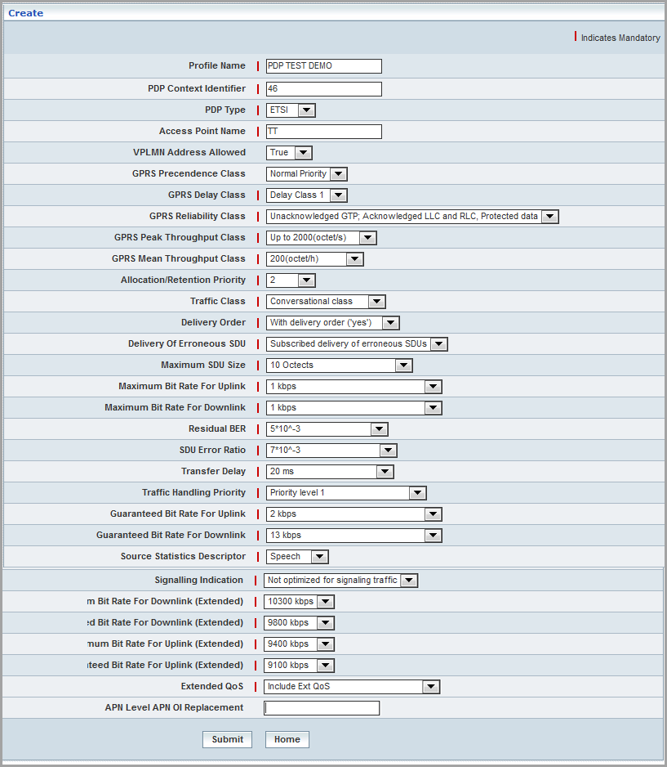

| **STEP** | **ACTION** |
| --- | --- |
|  | User must essentially enter the details related to a new profile where it is a mandatory information |
|  | Enter name of the profile in <Profile Name> field, attributing to the proposed PDP Profile |
|  | Enter a context identifier representing the PDP context identifier in the <PDP Context Identifier> field |
|  | Select PDP type from the drop-down list of the <PDP Type> field  **\*** By default, the list of PDP types (ETSI / IETF) will be dynamically displayed as drop-down list of the <PDP Type> field |
|  | Enter name of the access point in the <Access Point Name> field, to indicate location / trace of the access point for the proposed PDP Profile  **NOTE:** Access Point Name length should be more than or equal to 2 characters |
|  | Select the allowed VPLMN address, whether ‘False’ or ‘True’ from the drop-down list of the <VPLMN Address Allowed> field  **\*** By default, the list (True / False) will be dynamically displayed as drop-down list of the <VPLMN Address Allowed> field |
|  | Select a class to indicate the GPRS Precedence from the drop-down list of the <GPRS Precedence Class> field  **\*** By default, the list of classes (Normal Priority / Low Priority / High Priority) will be dynamically displayed as drop-down list of the <GPRS Precedence Class> field |
|  | Select a class to indicate the GPRS delay from the drop-down list of the <GPRS Delay Class> field  **\*** By default, the list of classes (1 / 2 / 3 / 4) will be dynamically displayed as drop-down list of the <GPRS Delay Class> field |
|  | Select a class to indicate the GPRS Reliability from the drop-down list of the <GPRS Reliability Class> field  **\*** By default, the list of classes related to GPRS reliability will be dynamically displayed as drop-down list of the <GPRS Reliability Class> field |
|  | Select a class to indicate the GPRS peak throughput from the drop-down list of the <GPRS Peak Throughput Class> field  **\*** By default, the list of classes related to GPRS peak throughput will be dynamically displayed as drop-down list of the <GPRS Peak Throughput Class> field |
|  | Select a class to indicate the GPRS mean throughput from the drop-down list of the <GPRS Mean Throughput Class> field  **\*** By default, the list of classes related to GPRS peak throughput will be dynamically displayed as drop-down list of the <GPRS Mean Throughput Class> field |
|  | Select a priority to indicate the allocation/retention from the drop-down list of the <Allocation/Retention Priority> field  **\*** By default, the list of priorities (1 / 2 / 3 / 4) will be dynamically displayed as drop-down list of the <Allocation/Retention Priority> field |
|  | Select a class to indicate the Traffic from the drop-down list of the <Traffic Class> field  **\*** By default, the list of classes (Subscribed traffic class / Conversational class / Streaming class / Interactive class / Background class) will be dynamically displayed as drop-down list of the <Traffic Class> field |
|  | Select an order to indicate the Deliver from the drop-down list of the <Deliver Order> field  **\*** By default, the list of orders (Subscribed delivery order / With delivery order (‘yes’) / Without delivery order (‘no’) / Reserved 1)  will be dynamically displayed as drop-down list of the <Deliver Order> field |
|  | Select a SDU to indicate the Delivery of Erroneous from the drop-down list of the <Delivery of Erroneous SDU> field  **\*** By default, the list of SDU related to Delivery of Erroneous reliability will be dynamically displayed as drop-down list of the < Delivery of Erroneous SDU> field |
|  | Select a Size to indicate the Maximum SDU from the drop-down list of the <Maximum SDU Size> field  **\*** By default, the list of Size related to Maximum SDU reliability will be dynamically displayed as drop-down list of the <Maximum SDU Size> field |
|  | Select a Maximum Bit Rate to indicate for Uplink from the drop-down list of the <Maximum Bit Rate For Uplink> field  **\*** By default, the list of Maximum Bit Rate related for Uplink reliability will be dynamically displayed as drop-down list of the <Maximum Bit Rate For Uplink> field |
|  | Select a Maximum Bit Rate to indicate for Downlink from the drop-down list of the <Maximum Bit Rate For Downlink> field  **\*** By default, the list of Maximum Bit Rate related for Downlink reliability will be dynamically displayed as drop-down list of the <Maximum Bit Rate For Downlink> field |
|  | Select a BER to indicate the Residual from the drop-down list of the <Residual BER> field  **\*** By default, the list of BER related to Residual reliability will be dynamically displayed as drop-down list of the <Residual BER> field |
|  | Select an Error Ratio to indicate SDU from the drop-down list of the <SDU Error Ratio> field  **\*** By default, the list of Error Ratio related to SDU reliability will be dynamically displayed as drop-down list of the <SDU Error Ratio> field |
|  | Select a Delay to indicate Transfer from the drop-down list of the <Transfer Delay> field  **\*** By default, the list of Delay related to Transfer reliability will be dynamically displayed as drop-down list of the <Transfer Delay> field |
|  | Select a Priority to indicate Traffic Handling from the drop-down list of the <Traffic Handling Priority> field  **\*** By default, the list of Priority related to Transfer Handling reliability will be dynamically displayed as drop-down list of the <Traffic Handling Priority> field |
|  | Select a Guaranteed Bit Rate to indicate for Uplink from the drop-down list of the <Guaranteed Bit Rate For Uplink> field  **\*** By default, the list of Guaranteed Bit Rate related For Uplink reliability will be dynamically displayed as drop-down list of the <Guaranteed Bit Rate For Uplink> field |
|  | Select a Guaranteed Bit Rate to indicate for Downlink from the drop-down list of the <Guaranteed Bit Rate For Downlink> field  **\*** By default, the list of Guaranteed Bit Rate related for Downlink reliability will be dynamically displayed as drop-down list of the <Guaranteed Bit Rate For Downlink> field |
|  | Select a Descriptor to indicate Source Statistics from the drop-down list of the <Source Statistics Descriptor> field  **\*** By default, the list of Descriptor related to Source Statistics reliability will be dynamically displayed as drop-down list of the <Source Statistics Descriptor> field |
|  | Select an Indication to indicate Signaling from the drop-down list of the <Signaling Indication> field  **\*** By default, the list of Indication related to Signaling reliability will be dynamically displayed as drop-down list of the <Signaling Indication> field |
|  | Select a Maximum Bit Rate to indicate for Downlink (Extended) from the drop-down list of the <Maximum Bit Rate For Downlink (Extended)> field  **\*** By default, the list of Maximum Bit Rate related For Downlink (Extended) reliability will be dynamically displayed as drop-down list of the <Maximum Bit Rate For Downlink (Extended)> field |
|  | Select a Guaranteed Bit Rate to indicate for Downlink (Extended) from the drop-down list of the <Guaranteed Bit Rate For Downlink (Extended)> field  **\*** By default, the list of Guaranteed Bit Rate related For Downlink (Extended) reliability will be dynamically displayed as drop-down list of the <Guaranteed Bit Rate For Downlink (Extended)> field |
|  | Select a Maximum Bit Rate to indicate for Uplink (Extended) from the drop-down list of the <Maximum Bit Rate For Uplink (Extended)> field  **\*** By default, the list of Maximum Bit Rate related For Uplink (Extended) reliability will be dynamically displayed as drop-down list of the <Maximum Bit Rate For Uplink (Extended)> field |
|  | Select a Guaranteed Bit Rate to indicate for Uplink (Extended) from the drop-down list of the <Guaranteed Bit Rate For Uplink (Extended)> field  **\*** By default, the list of Guaranteed Bit Rate related For Uplink (Extended) reliability will be dynamically displayed as drop-down list of the <Guaranteed Bit Rate For Uplink (Extended)> field |
|  | Select **Extended QOS** from the drop down list |
|  | **APN Level APN OI Replacement:** Enter a name in order to locate the home GGSN.  The configured profiles shall be displayed/available at PDP Profiles during the configuration of Home Profiles. For more information, refer *Subscriber Profile Management* > *Home Profile*. |
|  | On clicking the **Submit** button, new profile (PDP Profile) will be created and a message window to that effect will be displayed    On clicking the **Home** button of the message window, it directs the user back to the ‘PDP Profiles’ grid |
|  | On clicking the **Home** button of the ‘Create / View’ Screen (before creating any new profile), it directs the user to the ‘PDP Profile Management’ Screen |

**View**

Home Location Register 🡪 PDP Profile Management 🡪 Create / View

View enables the user to peruse details related to chosen profile (PDP Profile).

On clicking the **‘View’** link of a chosen ‘Profile’ (from the PDP Profiles List); corresponding information related to the profile will be displayed in a separate screen enabling the user to peruse details of the profile - PDP.

The screen below displays the details related to chosen profile (PDP Profile)

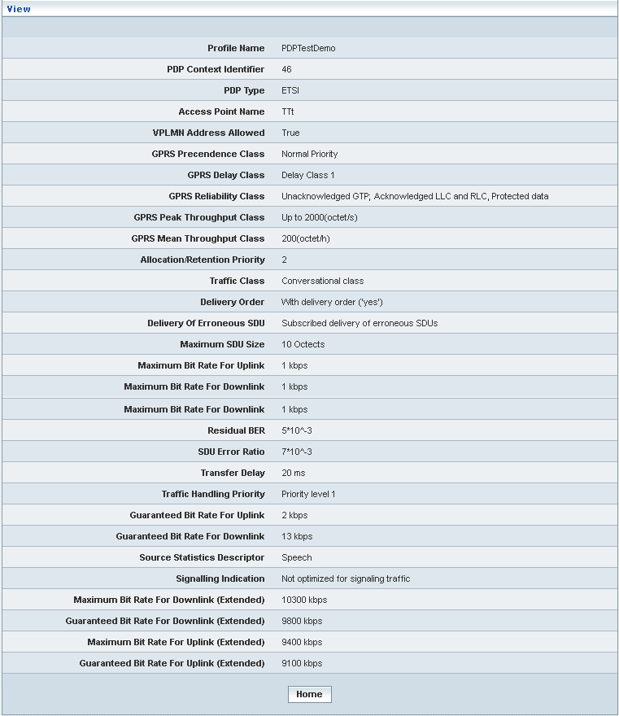

| **STEP** | **ACTION** |
| --- | --- |
|  | User can peruse details related to the chosen PDP Profile |
|  | On clicking the **Home** button at the bottom of the ‘View’ Screen, it redirects the user to the ‘PDP Profiles’ grid |

**Searching for a specific PDP Profile Management (Record)**

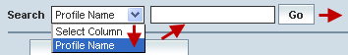

| **STEP** | **ACTION** |
| --- | --- |
|  | Select a search criterion (‘Profile Name’) from the drop-down list of the search criteria of the <Search> field  **\*** By default the list of search criterion (‘Profile Name’) will be dynamically displayed as drop-down list of the <Search> field |
|  | Enter the ‘Profile Name’ that corresponds with the given search criterion |
|  | On clicking the **Go** button, the corresponding PDP Profile Management (record) will be highlighted among the list of PDP Profile Management records. |

The screen below depicts fetching and displaying the give PDP Profile Managements record.

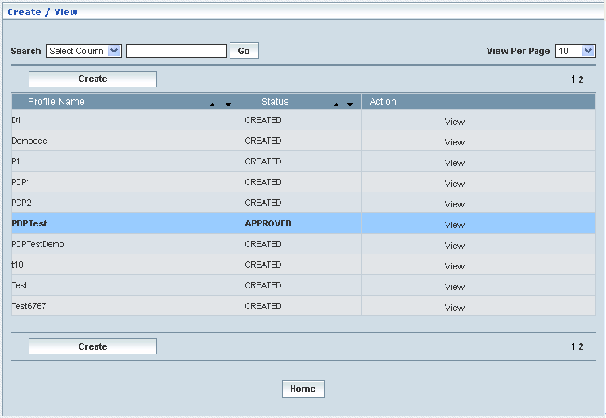

**Manage**

Home Location Register 🡪 PDP Profile Management 🡪 Manage

‘Manage’ helps the user modifying and deleting (managing) a chosen PDP profile that was created, but still to be approved. This module also helps **approving** or **rejecting** the profile.

Initially, ‘PDP Profiles’ displays a grid showing the list of existing PDP Profiles that were configured and created.

The screen below shows the list of various PDP (Profiles) configurations in a grid.

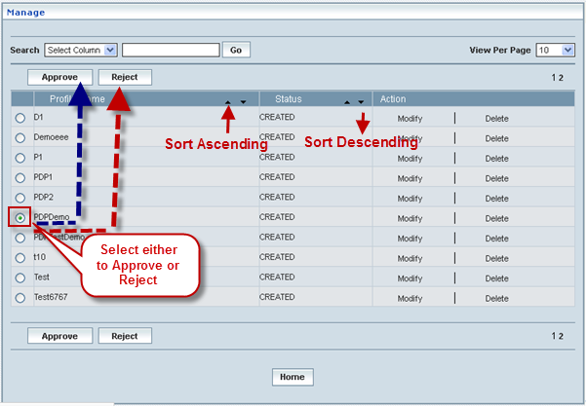

| **STEP** | | **ACTION** |
| --- | --- | --- |
|  | | By default, the list of PDP profiles will be displayed as records in a grid. The columns include ‘Profile Name’, ‘Status’ and ‘Action’ |
|  |  | User can customize the view for the number of records to be displayed each time (per page) in a grid.  However, this option is applicable only if the total number of records exceeds 10. And also with the immediate effect of increase in the number of records more than 10, a ‘Search’ option would be dynamically displayed. |
| Select the number of records (For Ex: 10) from the drop-down list of the <View Per Page> field. |
| With the effect of choosing the desired number (10) for the display of records per page, the same (10 records) will be displayed in the grid. |
| User can sort the records in ascending and descending orders with the help of up-arrow and down-arrows respectively |
| However, based on the total number of records, page numbers will be dynamically displayed at the left bottom of the screen |
| User can navigate for subsequent records (10 each time) by clicking the desired ‘page number’ |
|  | | On clicking the **Modify** link of a chosen ‘Profile’, corresponding information related to the profile will be displayed in a separate screen enabling the user to modify / update details of the profile |
|  | | On clicking the **Delete** link of a chosen ‘Profile’, corresponding information related to the profile will be displayed in a separate screen enabling the user to delete the profile |
|  | | **To Approve a Profile:**  Select the corresponding radio option of the desired profile to approve the same |
|  | | On clicking the **Approve** button, an alert window message will be displayed enabling the user to confirm approval of the chosen profile  Wor63  On clicking the **OK** button of the alert window, the chosen profile will be approved and a message window to that effect will be displayed  Wor7D  On clicking the **Cancel** button of the alert window, it retains the ‘Manage Profiles’ grid  On clicking the Home button of the message window, it redirects the user to the ‘Manage Profiles’ grid  **NOTE:** The Profile that was approved will be disappeared from the ‘Manage Profiles’ grid. However, status related to the Profile will be dynamically updated (changed to ‘Approved’ from ‘Created’) in the ‘PDP Profiles’ grid |
|  | | **To Reject a Profile:**  Select the corresponding radio option of the desired profile to reject the same |
|  | | On clicking the **Reject** button, an alert window message will be displayed enabling the user to confirm rejection of the chosen profile  Wor66  On clicking the **OK** button of the alert window, the chosen profile will be rejected and a message window to that effect will be displayed  Wor7E  On clicking the **Cancel** button of the alert window, it retains the ‘Manage Profiles’ grid  On clicking the **Home** button of the message window, it redirects the user to the ‘Manage Profiles’ grid  **NOTE:** Status related to the Profile will be dynamically updated (changed to ‘Rejected’ from ‘Created’) in the PDP Profiles grid and as well as in ‘Manage Profiles’ grid  **\*** Once rejected profile can always be approved any time later by way of similar process of approving a profile |
|  | | On clicking the **Home** button at the bottom of the grid, it redirects the user to the ‘PDP Profiles Management’ main page |

**Modify**

Home Location Register 🡪 PDP Profile Management 🡪 Manage 🡪 Modify

Modify enables the user to modify / update the details related to an existing PDP profile.

On clicking the **‘Modify’** link of a chosen ‘Profile’ (from the PDP Profiles List); corresponding information related to the profile will be displayed in a separate screen enabling the user to modify / update details of the profile- PDP.

The screen below shows modifying / updating the details related to an existing PDP profile.

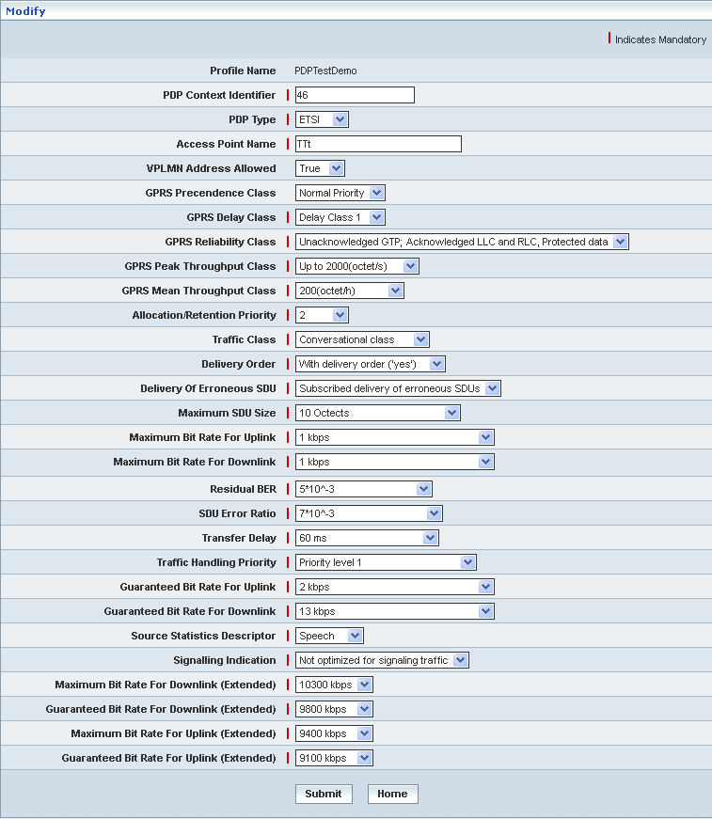

| **STEP** | **ACTION** |
| --- | --- |
|  | Name of the profile will be dynamically displayed in the <Profile Name> field and this cannot be modified |
|  | User can make necessary changes / updates to the existing values / configurations of the profile |
|  | On clicking the **Submit** button at the bottom of the ‘Modify’ screen, profile (PDP profile) details will be updated accordingly and a message window to that effect will be displayed    On clicking the **Home** button of the message window, it directs the user back to the ‘Manage Profiles’ grid |
|  | On clicking the **Home** button of the ‘Modify’ screen (before updating the details related to profile), it directs the user to the ‘Manage Profiles’ grid |

**Delete**

Home Location Register 🡪 PDP Profile Management 🡪 Manage 🡪 Delete

Delete enables the user to delete an existing PDP profile.

On clicking the **‘Delete’** link of a chosen ‘Profile’ (from the PDP Profiles List); corresponding information related to the profile will be displayed in a separate screen enabling the user to delete the profile- PDP.

The screen below shows the details related to an existing PDP profile, which enables the user to delete the same (Profile).

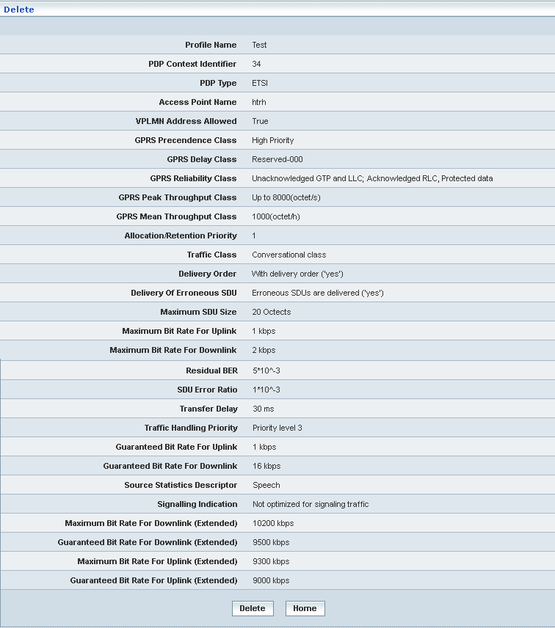

| **STEP** | **ACTION** |
| --- | --- |
|  | User can peruse the existing values / configurations of the profile before deleting the profile |
|  | On clicking the **Delete** at the bottom of the ‘Delete’ screen, it displays an alert window enabling the user to confirm deletion of the chosen profile (PDP profile)  Wor84  On clicking the **OK** button of the alert window, the chosen PDP profile will be deleted and a message window to that effect will be displayed    On clicking the **Cancel** button of the alert window, it retains the corresponding ‘Delete’ screen  On clicking the **Home** button of the message window, it directs the user back to the ‘Manage Profiles’ grid |
|  | On clicking the **Home** button of the ‘Delete’ screen (before deleting the profile), it directs the user to the ‘Manage Profiles’ grid |

**Searching for a specific PDP Profile Management (Record)**



| **STEP** | **ACTION** |
| --- | --- |
|  | Select a search criterion (‘Profile Name’) from the drop-down list of the search criteria of the <Search> field  **\*** By default the list of search criterion (‘Profile Name’) will be dynamically displayed as drop-down list of the <Search> field |
|  | Enter the ‘Profile Name’ that corresponds with the given search criterion |
|  | On clicking the **Go** button, the corresponding PDP Profile Management (record) will be highlighted among the list of PDP Profile Management records. |

The screen below depicts fetching and displaying the give PDP Profile Managements record.

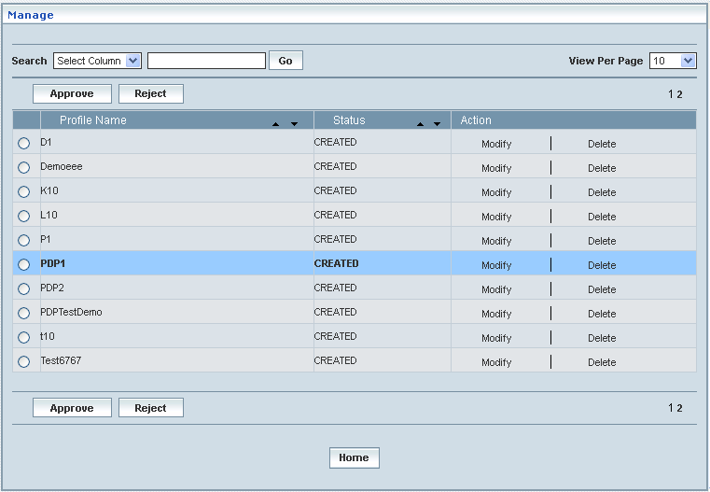

# Bearer Capability Profiles

Bearer Capability Profile contains the data that needs to be permanently and conditionally stored in HLR (ITC value and Service Code) along with other attributes (Home Location Register).

Home Location Register 🡪 Bearer Capability Profiles

Initially, Bearer Capability Profile displays a grid showing the list of existing profiles that are configured and created. This list may include those profiles that are created and approved, created and rejected and also those created but still to be approved or rejected.

**Create / View**

Home Location Register 🡪 Bearer Capability Profiles 🡪 Create / View

This allows the user to create a new profile and peruse the details related to the existing profiles

The screen below shows the list of various Bearer Capability profiles in a grid.

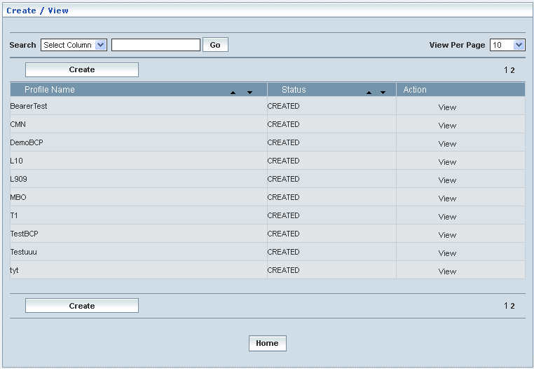

| **STEP** | | **ACTION** |
| --- | --- | --- |
|  | | By default, the list of profiles (Bearer Capability Profiles) will be displayed as records in a grid. The columns include ‘Profile Name’, ‘Status’ and ‘Action’ |
|  |  | User can customize the view for the number of records to be displayed each time (per page) in a grid.  However, this option is applicable only if the total number of records exceeds 10. And also with the immediate effect of increase in the number of records more than 10, a ‘Search’ option would be dynamically displayed. |
| Select the number of records (For Ex: 10) from the drop-down list of the <View Per Page> field. |
| With the effect of choosing the desired number (10) for the display of records per page, the same (10 records) will be displayed in the grid. |
| User can sort the records in ascending and descending orders with the help of up-arrow and down-arrows respectively |
| However, based on the total number of records, page numbers will be dynamically displayed at the left bottom of the screen |
| User can navigate for subsequent records (10 each time) by clicking the desired ‘page number’ |
| **2** | | Status indicates the profile status whether just created (Created) or created and approved (Approved) or created but rejected (Rejected) |
|  | | On clicking the **Create** button, ‘Create’ screen will be displayed enabling the user to create a new ‘Profile’ (Bearer Capability Profile) |
|  | | On clicking the **View** link of a chosen ‘Profile’, corresponding information related to the profile will be displayed in a separate screen enabling the user to peruse details of the profile |
|  | | On clicking the **Home** button at the bottom of the grid, it redirects the user to the ‘Bearer Capability Profiles’ main page |

**Create:**

Home Location Register 🡪 Bearer Capability Profiles 🡪 Create / View

Create enables the user to create a new profile (Bearer Capability Profile) and attribute various values to constitute the same.

The screen below shows creating a new profile as Bearer Capability Profile

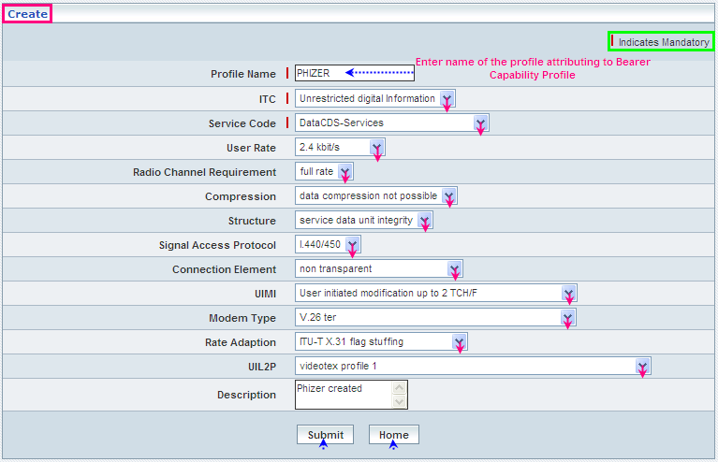

| **STEP** | **ACTION** |
| --- | --- |
|  | User must essentially enter the details related to a new profile where it is a mandatory information |
|  | Select ITC value from the drop-down list of the <ITC> field  **\*** By default, the list of ITC values (Speech / Unrestricted Digital Information / 3.1 KHz audio / Restricted Digital Information) will be dynamically displayed as drop-down list of the <ITC> field |
|  | Select a service code from the drop-down list of the <Service Code> field  **\*** By default, the list of service codes will be dynamically displayed as drop-down list of the <Service Code> field |
|  | Select a ‘user rate’ from the drop-down list of the <User Rate> field  **\*** By default, the list of user rates will be dynamically displayed as drop-down list of the <User Rate> field |
|  | Select a ‘radio channel requirement’ from the drop-down list of the <Radio Channel Requirement> field  **\*** By default, the list of radio channel requirements will be dynamically displayed as drop-down list of the <Radio Channel Requirement> field |
|  | Select a ‘compression value’ from the drop-down list of the <Compression> field  **\*** By default, the list of compression values will be dynamically displayed as drop-down list of the <Compression> field |
|  | Select a structure value from the drop-down list of the <Structure> field  **\*** By default, the list of structure values will be dynamically displayed as drop-down list of the <Structure> field |
|  | Select a value of signal access protocol from the drop-down list of the <Signal Access Protocol> field  **\*** By default, the list of signal access protocols will be dynamically displayed as drop-down list of the <Signal Access Protocol> field |
|  | Select a value for ‘connection element’ from the drop-down list of the <Connection Element> field  **\*** By default, the list of connection elements will be dynamically displayed as drop-down list of the <Connection Element> field |
|  | Select a value for UIMI from the drop-down list of the <UIMI> field  **\*** By default, the list of values for UIMI will be dynamically displayed as drop-down list of the <UIMI> field |
|  | Select a value for Modern Type from the drop-down list of the <Modern Type> field  **\*** By default, the list of values for Modern types will be dynamically displayed as drop-down list of the <Modern Type> field |
|  | Select a value for rate adaption from the drop-down list of the <Rate Adaption> field  **\*** By default, the list of values for rate adaption will be dynamically displayed as drop-down list of the <Rate Adaption>field |
|  | Select a value for UIL2P from the drop-down list of the <UIL2P> field  **\*** By default, the list of values for UIMI will be dynamically displayed as drop-down list of the <UIL2P> field |
|  | On clicking the **Submit** button, new profile (Bearer Capability Profile) will be created and a message window to that effect will be displayed    On clicking the **Home** button of the message window, it directs the user back to the Bearer Capability Profiles grid |
|  | On clicking the **Home** button of the ‘Create’ screen (before creating any new profile), it directs the user to the Bearer Capability Profiles grid |

**View**

Home Location Register 🡪 Bearer Capability Profiles 🡪 Create / View

View enables the user to peruse details related to chosen profile (Bearer Capability Profile).

On clicking the **‘View’** link of a chosen ‘Profile’ (from the Bearer Capability Profiles List); corresponding information related to the profile will be displayed in a separate screen enabling the user to peruse details of the profile - Bearer Capability.

The screen below displays the details related to chosen profile (Bearer Capability Profile)

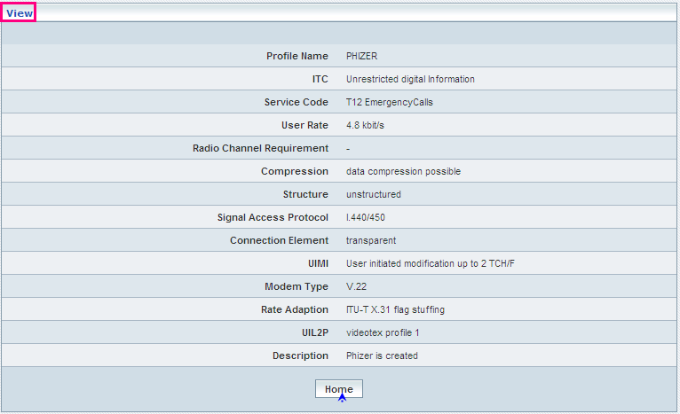

| **STEP** | **ACTION** |
| --- | --- |
|  | User can peruse details related to the chosen Bearer Capability Profile |
|  | On clicking the **Home** button at the bottom of the ‘View’ Screen, it redirects the user to the ‘Bearer Capability Profiles’ Screen |

**Searching for a specific Bearer Capability Profiles (Record)**

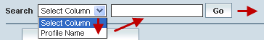

| **STEP** | **ACTION** |
| --- | --- |
|  | Select a search criterion (‘Profile Name’) from the drop-down list of the search criteria of the <Search> field  **\*** By default the list of search criterion (‘Profile Name’) will be dynamically displayed as drop-down list of the <Search> field |
|  | Enter the ‘Profile Name’ that corresponds with the given search criterion |
|  | On clicking the **Go** button, the corresponding Bearer Capability Profiles (record) will be highlighted among the list of Bearer Capability Profiles records. |

The screen below depicts fetching and displaying the give Bearer Capability Profiles record.

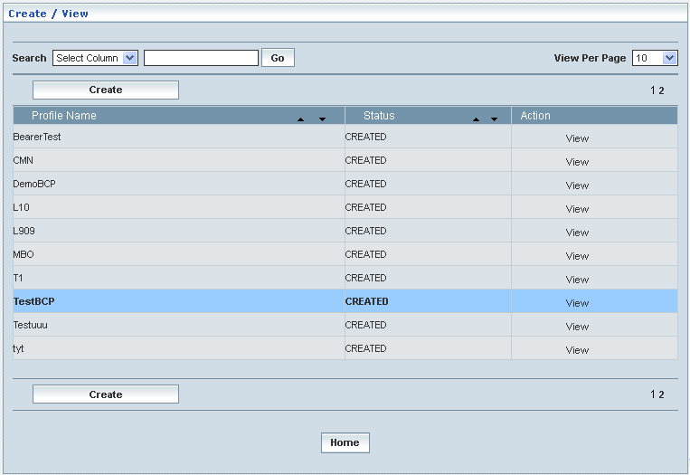

**Manage**

Home Location Register 🡪 Bearer Capability Profiles 🡪 Manage

‘Manage’ helps the user modifying and deleting (managing) a chosen Bearer Capability Profile that was created, but still to be approved. This module also helps **approving** or **rejecting** the profile.

Initially, ‘Bearer Capability Profiles’ displays a grid showing the list of existing Bearer Capability Profiles that were configured and created.

The screen below shows the list of various Bearer Capability (Profiles) configurations in a grid.

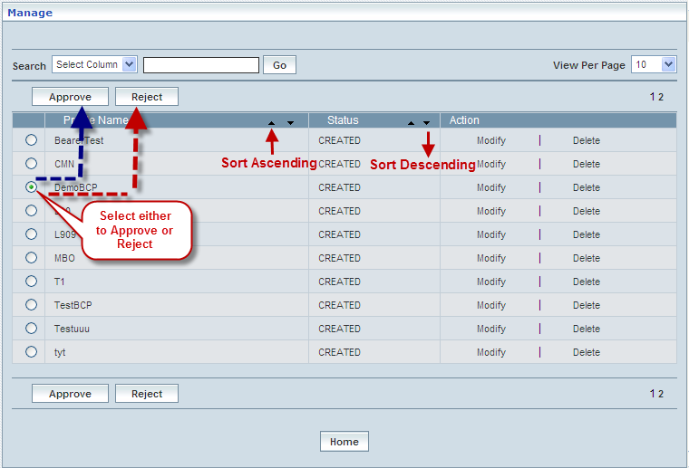

| **STEP** | | **ACTION** |
| --- | --- | --- |
|  | | By default, the list of Bearer Capability profiles will be displayed as records in a grid. The columns include ‘Profile Name’, ‘Status’ and ‘Action’ |
|  |  | User can customize the view for the number of records to be displayed each time (per page) in a grid.  However, this option is applicable only if the total number of records exceeds 10. And also with the immediate effect of increase in the number of records more than 10, a ‘Search’ option would be dynamically displayed. |
| Select the number of records (For Ex: 10) from the drop-down list of the <View Per Page> field. |
| With the effect of choosing the desired number (10) for the display of records per page, the same (10 records) will be displayed in the grid. |
| User can sort the records in ascending and descending orders with the help of up-arrow and down-arrows respectively |
| However, based on the total number of records, page numbers will be dynamically displayed at the left bottom of the screen |
| User can navigate for subsequent records (10 each time) by clicking the desired ‘page number’ |
| **2** | | On clicking the **Modify** link of a chosen ‘Profile’, corresponding information related to the profile will be displayed in a separate screen enabling the user to modify / update details of the profile |
|  | | On clicking the **Delete** link of a chosen ‘Profile’, corresponding information related to the profile will be displayed in a separate screen enabling the user to delete the profile |
|  | | **To Approve a Profile:**  Select the corresponding radio option of the desired profile to approve the same |
|  | | On clicking the **Approve** button, an alert window message will be displayed enabling the user to confirm approval of the chosen profile  Wor63  On clicking the **OK** button of the alert window, the chosen profile will be approved and a message window to that effect will be displayed  Wor7D  On clicking the **Cancel** button of the alert window, it retains the ‘Manage Profiles’ grid  On clicking the **Home** button of the message window, it redirects the user to the ‘Manage Profiles’ grid  **NOTE:** The Profile that was approved will be disappeared from the ‘Manage Profiles’ grid. However, status related to the Profile will be dynamically updated (changed to ‘Approved’ from ‘Created’) in the ‘Bearer Capability Profiles’ grid |
|  | | **To Reject a Profile:**  Select the corresponding radio option of the desired profile to reject the same |
|  | | On clicking the **Reject** button, an alert window message will be displayed enabling the user to confirm rejection of the chosen profile  Wor66  On clicking the **OK** button of the alert window, the chosen profile will be rejected and a message window to that effect will be displayed  Wor7E  On clicking the **Cancel** button of the alert window, it retains the ‘Manage Profiles’ grid  On clicking the **Home** button of the message window, it redirects the user to the ‘Manage Profiles’ grid  **NOTE:** Status related to the Profile will be dynamically updated (changed to ‘Rejected’ from ‘Created’) in the Bearer Capability Profiles grid and as well as in ‘Manage Profiles’ grid  **\*** Once rejected profile can always be approved any time later by way of similar process of approving a profile |
|  | | On clicking the **Print** button at the bottom of the grid, user can take printouts of the Profiles’ list |
|  | | On clicking the **Home** button at the bottom of the grid, it redirects the user to the ‘Bearer Capability Profiles’ main page |

**Modify**

Home Location Register 🡪 Bearer Capability Profiles 🡪 Manage 🡪 Modify

Modify enables the user to modify / update the details related to an existing Bearer Capability Profile.

On clicking the **‘Modify’** link of a chosen ‘Profile’ (from the Bearer Capability Profiles List); corresponding information related to the profile will be displayed in a separate screen enabling the user to modify / update details of the profile- Bearer Capability.

The screen below shows modifying / updating the details related to an existing Bearer Capability Profile.

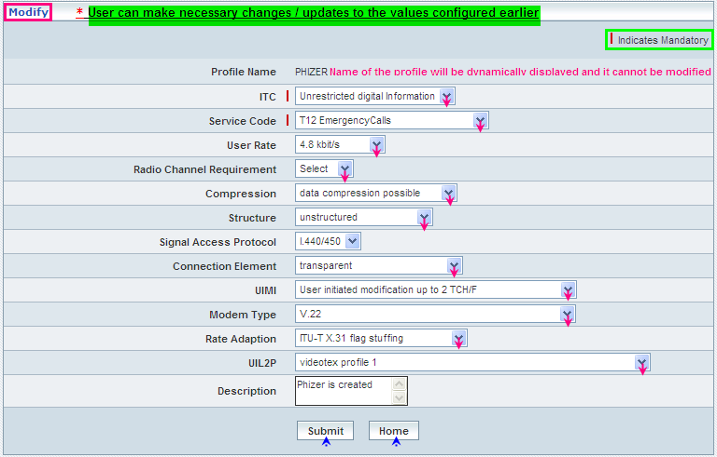

| **STEP** | **ACTION** |
| --- | --- |
|  | Name of the profile will be dynamically displayed in the <Profile Name> field and this cannot be modified |
|  | User can make necessary changes / updates to the existing values / configurations of the profile |
|  | On clicking the **Submit** button at the bottom of the ‘Modify’ screen, profile (Bearer Capability Profile) details will be updated accordingly and a message window to that effect will be displayed    On clicking the **Home** button of the message window, it directs the user back to the ‘Manage Profiles’ grid |
|  | On clicking the **Home** button of the ‘Modify’ screen (before updating the details related to profile), it directs the user to the ‘Manage Profiles’ grid |

**Delete**

Home Location Register 🡪 Bearer Capability Profiles 🡪 Manage 🡪 Delete

Delete enables the user to delete an existing Bearer Capability Profile.

On clicking the **‘Delete’** link of a chosen ‘Profile’ (from the Bearer Capability Profiles List); corresponding information related to the profile will be displayed in a separate screen enabling the user to delete the profile- Bearer Capability.

The screen below shows the details related to an existing Bearer Capability Profile, which enables the user to delete the same (Profile).

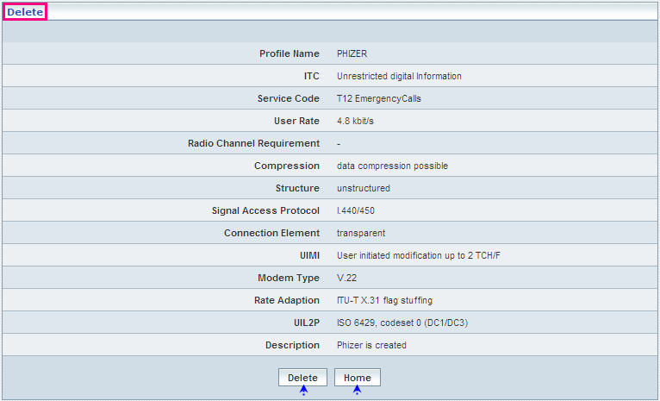

| **STEP** | **ACTION** |
| --- | --- |
|  | User can peruse the existing values / configurations of the profile before deleting the profile |
|  | On clicking the **Delete** at the bottom of the ‘Delete’ screen, it displays an alert window enabling the user to confirm deletion of the chosen profile (Bearer Capability Profile)  Wor84  On clicking the **OK** button of the alert window, the chosen Bearer Capability Profile will be deleted and a message window to that effect will be displayed    On clicking the **Cancel** button of the alert window, it retains the corresponding ‘Delete’ screen  On clicking the **Home** button of the message window, it directs the user back to the ‘Manage Profiles’ grid |
|  | On clicking the **Home** button of the ‘Delete’ screen (before deleting the profile), it directs the user to the ‘Manage Profiles’ grid |

**Searching for a specific Bearer Capability Profiles (Record)**



| **STEP** | **ACTION** |
| --- | --- |
|  | Select a search criterion (‘Profile Name’) from the drop-down list of the search criteria of the <Search> field  **\*** By default the list of search criterion (‘Profile Name’) will be dynamically displayed as drop-down list of the <Search> field |
|  | Enter the ‘Profile Name’ that corresponds with the given search criterion |
|  | On clicking the **Go** button, the corresponding Bearer Capability Profiles (record) will be highlighted among the list of Bearer Capability Profiles records. |

The screen below depicts fetching and displaying the give Bearer Capability Profiles record.

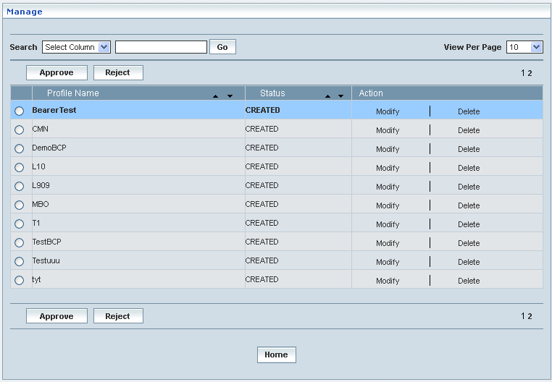

# Special Services

Special Services contains the profiles, such as SoLSA (Support Of Location Service Area) and RSZI (Regional Subscription Zone Identity) related to a subscriber that needs to be permanently and conditionally stored in HLR (Home Location Register)

Home Location Register 🡪 Special Services

## SoLSA

Initially, Special Services (SoLSA - Support Of Location Service Area) displays a grid showing the list of existing Profile that are configured and created. This list may include those profiles that are created, and managed by viewing, modifying and deleting the same.

**Create**

Home Location Register 🡪 Special Services 🡪 SoLSA Profile 🡪 Create

Create enables the user to create a new profile (SoLSA Profile) and attribute various values to constitute the same.

The screen below shows creating a new profile as SoLSA Profile

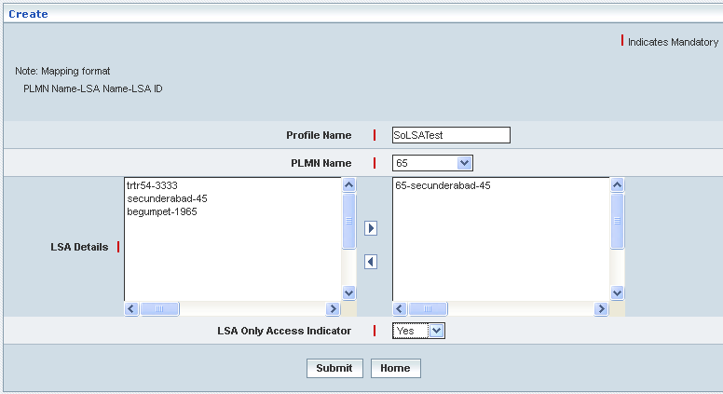

| **STEP** | **ACTION** |
| --- | --- |
|  | User must essentially enter the details related to a new profile where it is a mandatory information |
|  | Enter name of the profile in <Profile Name> field, attributing to the proposed SoLSA Profile |
|  | Select name of the PLMN from <PLMN Name> drop-down list  **\*** By default, its related data gets displayed in <LSA Details> field |
|  | Select the LSA Details and click  button to map at least one PLMN – LSA Details configuration.  **\*** If you want to un-map the same click  button |
|  | Select the LSA Only Access Indicator, whether ‘False’ or ‘True’ from the drop-down list of the <LSA Only Access Indicator> field  **\*** By default, the list (True / False) will be dynamically displayed as drop-down list of the <LSA Only Access Indicator> field |
|  | On clicking the **Submit** button, new profile (SoLSA Profile) will be created and a message window to that effect will be displayed    On clicking the **Home** button of the message window, it directs the user back to the ‘Create’ Screen |
|  | On clicking the **Home** button of the ‘Create’ Screen (before creating any new profile), it directs the user to the ‘SoLSA Profile’ Screen |

**Manage**

Home Location Register 🡪 Special Services 🡪 SoLSA Profile 🡪 Manage

‘Manage’ helps the user viewing, modifying and deleting (managing) a chosen SoLSA profile that was created.

Initially, ‘SoLSA Profile’ displays a grid showing the list of existing SoLSA Profile that were configured and created.

The screen below shows the list of various SoLSA (Profiles) configurations in a grid.

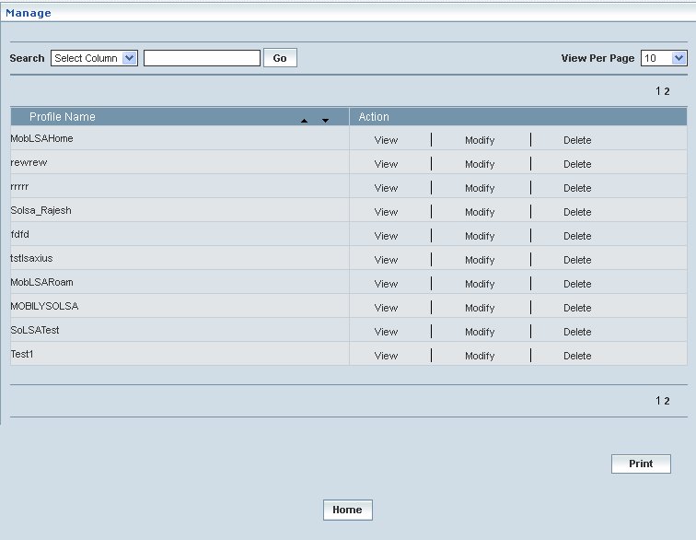

| **STEP** | | **ACTION** |
| --- | --- | --- |
|  | | By default, the list of SoLSA profiles will be displayed as records in a grid. The columns include ‘Profile Name’ and ‘Action’ |
|  |  | User can customize the view for the number of records to be displayed each time (per page) in a grid.  However, this option is applicable only if the total number of records exceeds 10. And also with the immediate effect of increase in the number of records more than 10, a ‘Search’ option would be dynamically displayed. |
| Select the number of records (For Ex: 10) from the drop-down list of the <View Per Page> field. |
| With the effect of choosing the desired number (10) for the display of records per page, the same (10 records) will be displayed in the grid. |
| User can sort the records in ascending and descending orders with the help of up-arrow and down-arrows respectively |
| However, based on the total number of records, page numbers will be dynamically displayed at the left bottom of the screen |
| User can navigate for subsequent records (10 each time) by clicking the desired ‘page number’ |
| **2** | | On clicking the **View** link of a chosen ‘Profile’, corresponding information related to the profile will be displayed in a separate screen enabling the user to view details of the profile |
|  | | On clicking the **Modify** link of a chosen ‘Profile’, corresponding information related to the profile will be displayed in a separate screen enabling the user to modify / update details of the profile |
|  | | On clicking the **Delete** link of a chosen ‘Profile’, corresponding information related to the profile will be displayed in a separate screen enabling the user to delete the profile |
|  | | On clicking the **Print** button at the bottom of the grid, user can take printouts of the SoLSA Profile list |
|  | | On clicking the **Home** button at the bottom of the grid, it redirects the user to the ‘SoLSA Profile’ main page |

**View**

Home Location Register 🡪 Special Services 🡪 SoLSA Profile 🡪 Manage 🡪 View

View enables the user to peruse details related to chosen profile (SoLSA Profile).

On clicking the **‘View’** link of a chosen ‘Profile’ (from the SoLSA Profiles List); corresponding information related to the profile will be displayed in a separate screen enabling the user to peruse details of the profile - SoLSA.

The screen below displays the details related to chosen profile (SoLSA Profile)

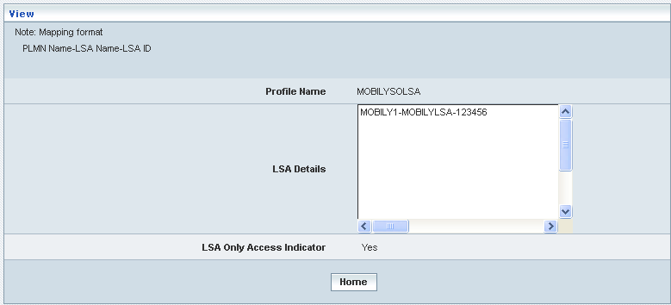

| **STEP** | **ACTION** |
| --- | --- |
|  | User can peruse details related to the chosen SoLSA Profile |
|  | On clicking the **Home** button at the bottom of the ‘View’ Screen, it redirects the user to the ‘SoLSA Profile’ Screen |

**Modify**

Home Location Register 🡪 Special Services 🡪 SoLSA Profile 🡪 Manage 🡪 Modify

Modify enables the user to modify / update the details related to an existing SoLSA profile.

On clicking the **‘Modify’** link of a chosen ‘Profile’ (from the SoLSA Profiles List); corresponding information related to the profile will be displayed in a separate screen enabling the user to modify / update details of the profile- SoLSA.

The screen below shows modifying / updating the details related to an existing SoLSA profile.

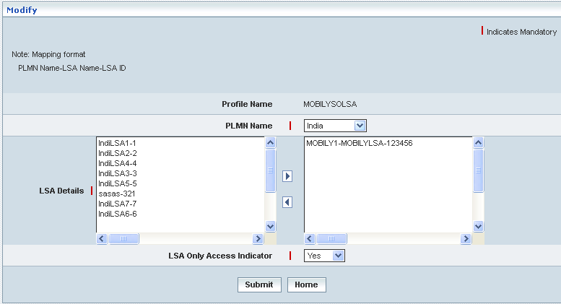

| **STEP** | **ACTION** |
| --- | --- |
|  | Name of the profile will be dynamically displayed in the <Profile Name> field and this cannot be modified |
|  | User can make necessary changes / updates to the existing values / configurations of the profile |
|  | On clicking the **Submit** button at the bottom of the ‘Modify’ screen, profile (SoLSA profile) details will be updated accordingly and a message window to that effect will be displayed    On clicking the **Home** button of the message window, it directs the user back to the ‘Manage Profiles’ grid |
|  | On clicking the **Home** button of the ‘Modify’ screen (before updating the details related to profile), it directs the user to the ‘Manage Profiles’ grid |

**Delete**

Home Location Register 🡪 Special Services 🡪 SoLSA Profile 🡪 Manage 🡪 Delete

Delete enables the user to delete an existing SoLSA profile.

On clicking the **‘Delete’** link of a chosen ‘Profile’ (from the SoLSA Profile List); corresponding information related to the profile will be displayed in a separate screen enabling the user to delete the profile- SoLSA.

The screen below shows the details related to an existing SoLSA profile, which enables the user to delete the same (Profile).

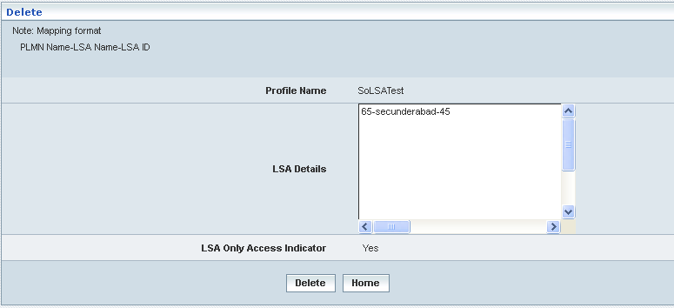

| **STEP** | **ACTION** |
| --- | --- |
|  | User can peruse the existing values / configurations of the profile before deleting the profile |
|  | On clicking the **Delete** at the bottom of the ‘Delete’ screen, it displays an alert window enabling the user to confirm deletion of the chosen profile (SoLSA profile)  C:\DOCUME~1\rajini.sn\LOCALS~1\Temp\SNAGHTML20d546.PNG  On clicking the **OK** button of the alert window, the chosen SoLSA profile will be deleted and a message window to that effect will be displayed    On clicking the **Cancel** button of the alert window, it retains the corresponding ‘Delete’ screen  On clicking the **Home** button of the message window, it directs the user back to the ‘Manage Profiles’ grid |
|  | On clicking the **Home** button of the ‘Delete’ screen (before deleting the profile), it directs the user to the ‘Manage Profiles’ grid |

**Searching for a specific SoLSA Profile (Record)**



| **STEP** | **ACTION** |
| --- | --- |
|  | Select a search criterion (‘Profile Name’) from the drop-down list of the search criteria of the <Search> field  **\*** By default the list of search criterion (‘Profile Name’) will be dynamically displayed as drop-down list of the <Search> field |
|  | Enter the ‘Profile Name’ that corresponds with the given search criterion |
|  | On clicking the **Go** button, the corresponding SoLSA Profile (record) will be highlighted among the list of SoLSA Profile records. |

The screen below depicts fetching and displaying the give SoLSA Profile record.

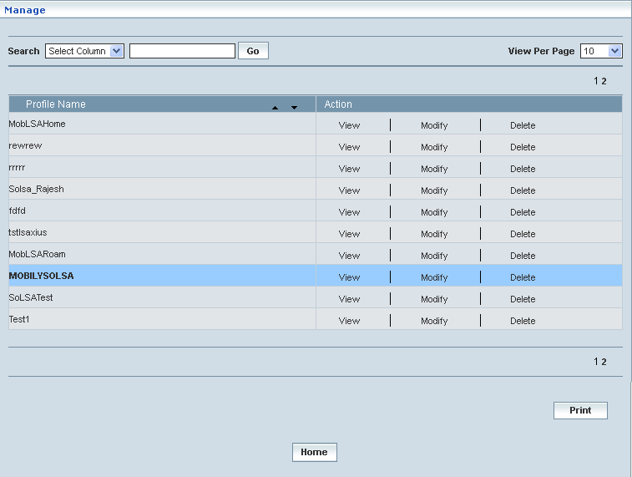

## RSZI

Initially, Special Services (RSZI - Regional Subscription Zone Identity) displays a grid showing the list of existing Profile that are configured and created. This list may include those profiles that are created, and managed by viewing, modifying and deleting the same.

**Create**

Home Location Register 🡪 Special Services 🡪 RSZI Profile 🡪 Create

Create enables the user to create a new profile (RSZI Profile) and attribute various values to constitute the same.

The screen below shows creating a new profile as RSZI Profile

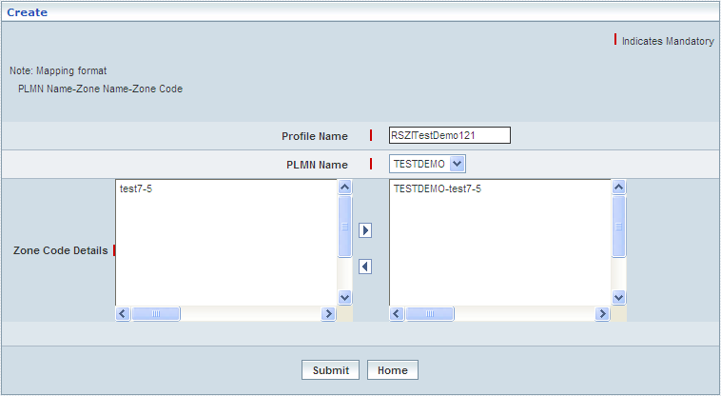

| **STEP** | **ACTION** |
| --- | --- |
|  | User must essentially enter the details related to a new profile where it is a mandatory information |
|  | Enter name of the profile in <Profile Name> field, attributing to the proposed RSZI Profile |
|  | Select name of the PLMN from <PLMN Name> drop-down list  **\*** By default, its related data gets displayed in <Zone Code Details> field |
|  | Select the Zone Code Details and click  button to map at least one Zone Code Details  **\*** If you want to un-map the same click  button |
|  | On clicking the **Submit** button, new profile (RSZI Profile) will be created and a message window to that effect will be displayed    On clicking the **Home** button of the message window, it directs the user back to the ‘Create’ Screen |
|  | On clicking the **Home** button of the ‘Create’ Screen (before creating any new profile), it directs the user to the ‘RSZI Profile’ Screen |

**Manage**

Home Location Register 🡪 Special Services 🡪 RSZI Profile 🡪 Manage

‘Manage’ helps the user viewing, modifying and deleting (managing) a chosen RSZI profile that was created.

Initially, ‘RSZI Profile’ displays a grid showing the list of existing RSZI Profile that were configured and created.

The screen below shows the list of various RSZI (Profiles) configurations in a grid.

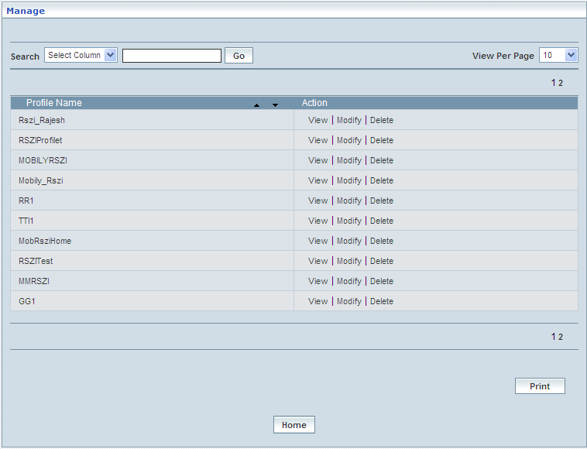

| **STEP** | | **ACTION** |
| --- | --- | --- |
|  | | By default, the list of RSZI profiles will be displayed as records in a grid. The columns include ‘Profile Name’ and ‘Action’ |
|  |  | User can customize the view for the number of records to be displayed each time (per page) in a grid.  However, this option is applicable only if the total number of records exceeds 10. And also with the immediate effect of increase in the number of records more than 10, a ‘Search’ option would be dynamically displayed. |
| Select the number of records (For Ex: 10) from the drop-down list of the <View Per Page> field. |
| With the effect of choosing the desired number (10) for the display of records per page, the same (10 records) will be displayed in the grid. |
| User can sort the records in ascending and descending orders with the help of up-arrow and down-arrows respectively |
| However, based on the total number of records, page numbers will be dynamically displayed at the left bottom of the screen |
| User can navigate for subsequent records (10 each time) by clicking the desired ‘page number’ |
| **2** | | On clicking the **View** link of a chosen ‘Profile’, corresponding information related to the profile will be displayed in a separate screen enabling the user to view details of the profile |
|  | | On clicking the **Modify** link of a chosen ‘Profile’, corresponding information related to the profile will be displayed in a separate screen enabling the user to modify / update details of the profile |
|  | | On clicking the **Delete** link of a chosen ‘Profile’, corresponding information related to the profile will be displayed in a separate screen enabling the user to delete the profile |
|  | | On clicking the **Print** button at the bottom of the grid, user can take printouts of the RSZI Profile list |
|  | | On clicking the **Home** button at the bottom of the grid, it redirects the user to the ‘RSZI Profile’ main page |

**View**

Home Location Register 🡪 Special Services 🡪 RSZI Profile 🡪 Manage 🡪 View

View enables the user to peruse details related to chosen profile (RSZI Profile).

On clicking the **‘View’** link of a chosen ‘Profile’ (from the RSZI Profiles List); corresponding information related to the profile will be displayed in a separate screen enabling the user to peruse details of the profile - RSZI.

The screen below displays the details related to chosen profile (RSZI Profile)

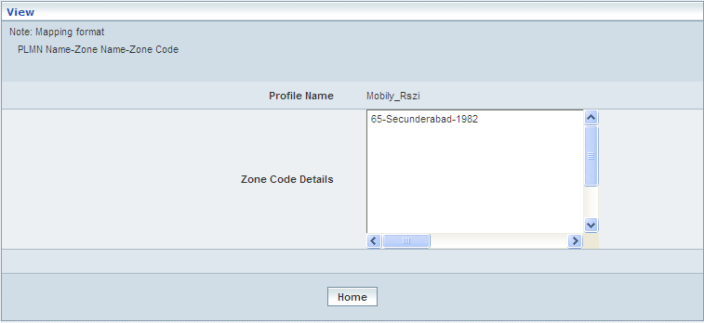

| **STEP** | **ACTION** |
| --- | --- |
|  | User can peruse details related to the chosen RSZI Profile |
|  | On clicking the **Home** button at the bottom of the ‘View’ Screen, it redirects the user to the ‘RSZI Profile’ Screen |

**Modify**

Home Location Register 🡪 Special Services 🡪 RSZI Profile 🡪 Manage 🡪 Modify

Modify enables the user to modify / update the details related to an existing RSZI profile.

On clicking the **‘Modify’** link of a chosen ‘Profile’ (from the RSZI Profiles List); corresponding information related to the profile will be displayed in a separate screen enabling the user to modify / update details of the profile- RSZI.

The screen below shows modifying / updating the details related to an existing RSZI profile.

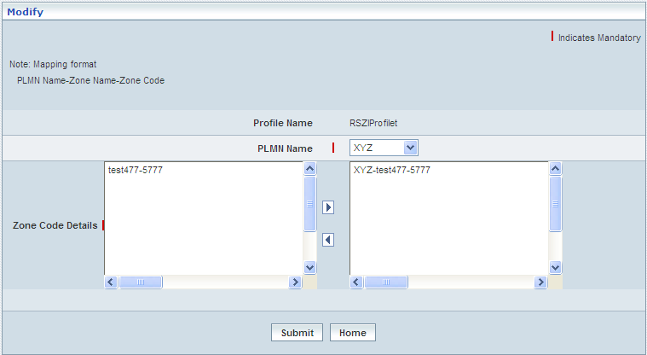

| **STEP** | **ACTION** |
| --- | --- |
|  | Name of the profile will be dynamically displayed in the <Profile Name> field and this cannot be modified |
|  | User can make necessary changes / updates to the existing values / configurations of the profile |
|  | On clicking the **Submit** button at the bottom of the ‘Modify’ screen, profile (RSZI profile) details will be updated accordingly and a message window to that effect will be displayed    On clicking the **Home** button of the message window, it directs the user back to the ‘Manage Profiles’ grid |
|  | On clicking the **Home** button of the ‘Modify’ screen (before updating the details related to profile), it directs the user to the ‘Manage Profiles’ grid |

**Delete**

Home Location Register 🡪 Special Services 🡪 RSZI Profile 🡪 Manage 🡪 Delete

Delete enables the user to delete an existing RSZI profile.

On clicking the **‘Delete’** link of a chosen ‘Profile’ (from the RSZI Profile List); corresponding information related to the profile will be displayed in a separate screen enabling the user to delete the profile- RSZI.

The screen below shows the details related to an existing RSZI profile, which enables the user to delete the same (Profile).

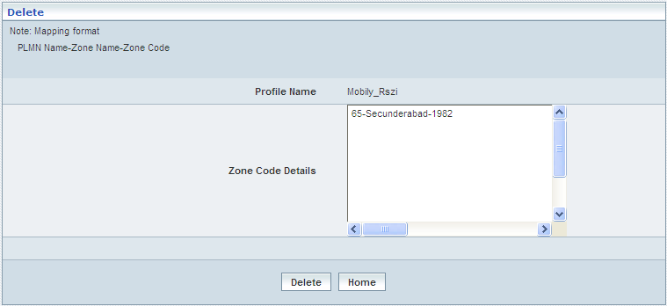

| **STEP** | **ACTION** |
| --- | --- |
|  | User can peruse the existing values / configurations of the profile before deleting the profile |
|  | On clicking the **Delete** at the bottom of the ‘Delete’ screen, it displays an alert window enabling the user to confirm deletion of the chosen profile (RSZI profile)  C:\DOCUME~1\rajini.sn\LOCALS~1\Temp\SNAGHTML34a4ce.PNG  On clicking the **OK** button of the alert window, the chosen RSZI profile will be deleted and a message window to that effect will be displayed    On clicking the **Cancel** button of the alert window, it retains the corresponding ‘Delete’ screen  On clicking the **Home** button of the message window, it directs the user back to the ‘Manage Profiles’ grid |
|  | On clicking the **Home** button of the ‘Delete’ screen (before deleting the profile), it directs the user to the ‘Manage Profiles’ grid |

**Searching for a specific RSZI Profile (Record)**



| **STEP** | **ACTION** |
| --- | --- |
|  | Select a search criterion (‘Profile Name’) from the drop-down list of the search criteria of the <Search> field  **\*** By default the list of search criterion (‘Profile Name’) will be dynamically displayed as drop-down list of the <Search> field |
|  | Enter the ‘Profile Name’ that corresponds with the given search criterion |
|  | On clicking the **Go** button, the corresponding RSZI Profile (record) will be highlighted among the list of RSZI Profile records. |

The screen below depicts fetching and displaying the give RSZI Profile record.

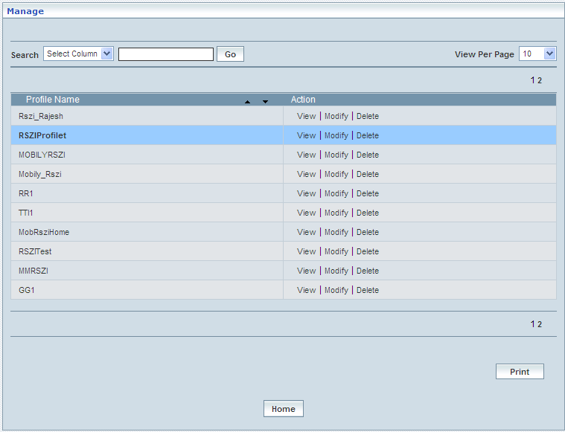

# Subscriber Profile Management

Subscriber Profile Management enables the user to create and manage (Approve / Reject / Modify / Delete) the subscriber profiles.

The subscriber profiles are classified in to two types–Homes and Roaming profiles.

This module also helps to fetch a desired subscriber profile with the help of the **‘Search’** option based on the provided search criterion. The search criteria include: Profile Name & Default Profile

## Home Profile

Home Location Register 🡪 Subscriber Profile Management 🡪 Home Profile

Initially, Home Profile displays a grid showing the list of existing Subscriber Profiles that are configured and created. This list may include those profiles that are created and approved, created and rejected and also those created but still to be approved or rejected.

**Create / View**

Home Location Register🡪Subscriber Profile Management🡪Home Profile🡪Create / View

This allows the user to create a new profile and peruse the details related to the existing profiles

The screen below shows the list of various Subscriber profiles in a grid.

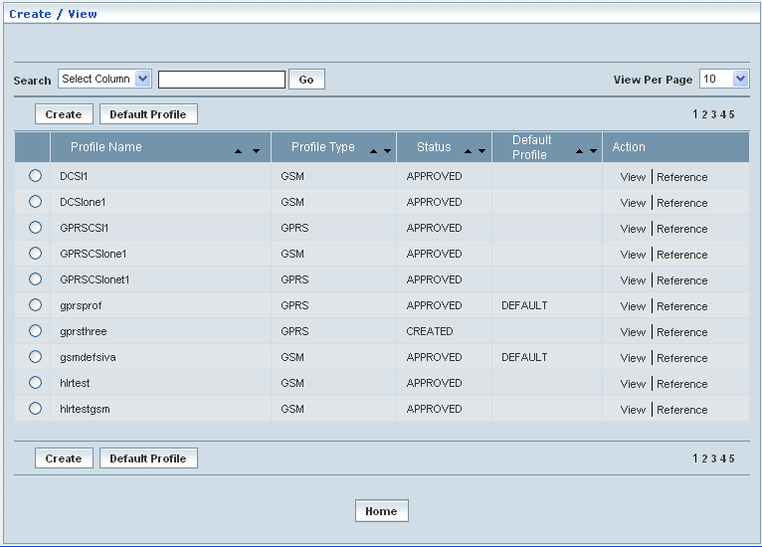

| **STEP** | | **ACTION** |
| --- | --- | --- |
|  | | By default, the list of profiles (Subscriber Profiles) will be displayed as records in a grid. The columns include ‘Profile Name’, ‘Profile Type’, ‘Status’, ‘Default Profile’ and ‘Action’ |
|  |  | User can customize the view for the number of records to be displayed each time (per page) in a grid.  However, this option is applicable only if the total number of records exceeds 10. And also with the immediate effect of increase in the number of records more than 10, a ‘Search’ option would be dynamically displayed. |
| Select the number of records (For Ex: 10) from the drop-down list of the <View Per Page> field. |
| With the effect of choosing the desired number (10) for the display of records per page, the same (10 records) will be displayed in the grid. |
| User can sort the records in ascending and descending orders with the help of up-arrow and down-arrows respectively |
| However, based on the total number of records, page numbers will be dynamically displayed at the left bottom of the screen |
| User can navigate for subsequent records (10 each time) by clicking the desired ‘page number’ |
| **2** | | Status indicates the profile status whether just created (Created) or created and approved (Approved) or created but rejected (Rejected) |
|  | | On clicking the **Create** button, ‘Create’ screen will be displayed enabling the user to create a new ‘Profile’ (Subscriber Profile) |
|  | | On clicking the **Default Profile** button, it enables the user to set a chosen profile as a ‘Default Profile’ |
|  | | On clicking the **View** link of a chosen ‘Profile’, corresponding information related to the profile will be displayed in a separate screen enabling the user to peruse details of the profile |
|  | | On clicking the **Reference** link of a chosen ‘Profile’, a replica of the profile will be displayed in a separate screen (along with all the configured values / parameters of the chosen profile). This enables the user to create another profile with similar configured values or with slight changes but with a distinct name. This provision of reference creation in fact reduces the time in creating a profile similar to the one that already exists |
|  | | On clicking the **Home** button at the bottom of the grid, it redirects the user to the ‘Subscriber Profiles Management’ main page |

**Create**

Home Location Register🡪Subscriber Profile Management🡪Home Profile🡪Create / View

Create enables the user to create a new profile (Subscriber Profile) and attribute various values to constitute the same.

However, Subscriber Profile shall be classified based on the selection of **Network Access Mode** and can create the profile accordingly.

**Network Access Modes** can be of two types:

* GSM
* GPRS

The screen below shows creating a new profile as Subscriber Profile, selecting the **Network Access Mode** as **GSM**

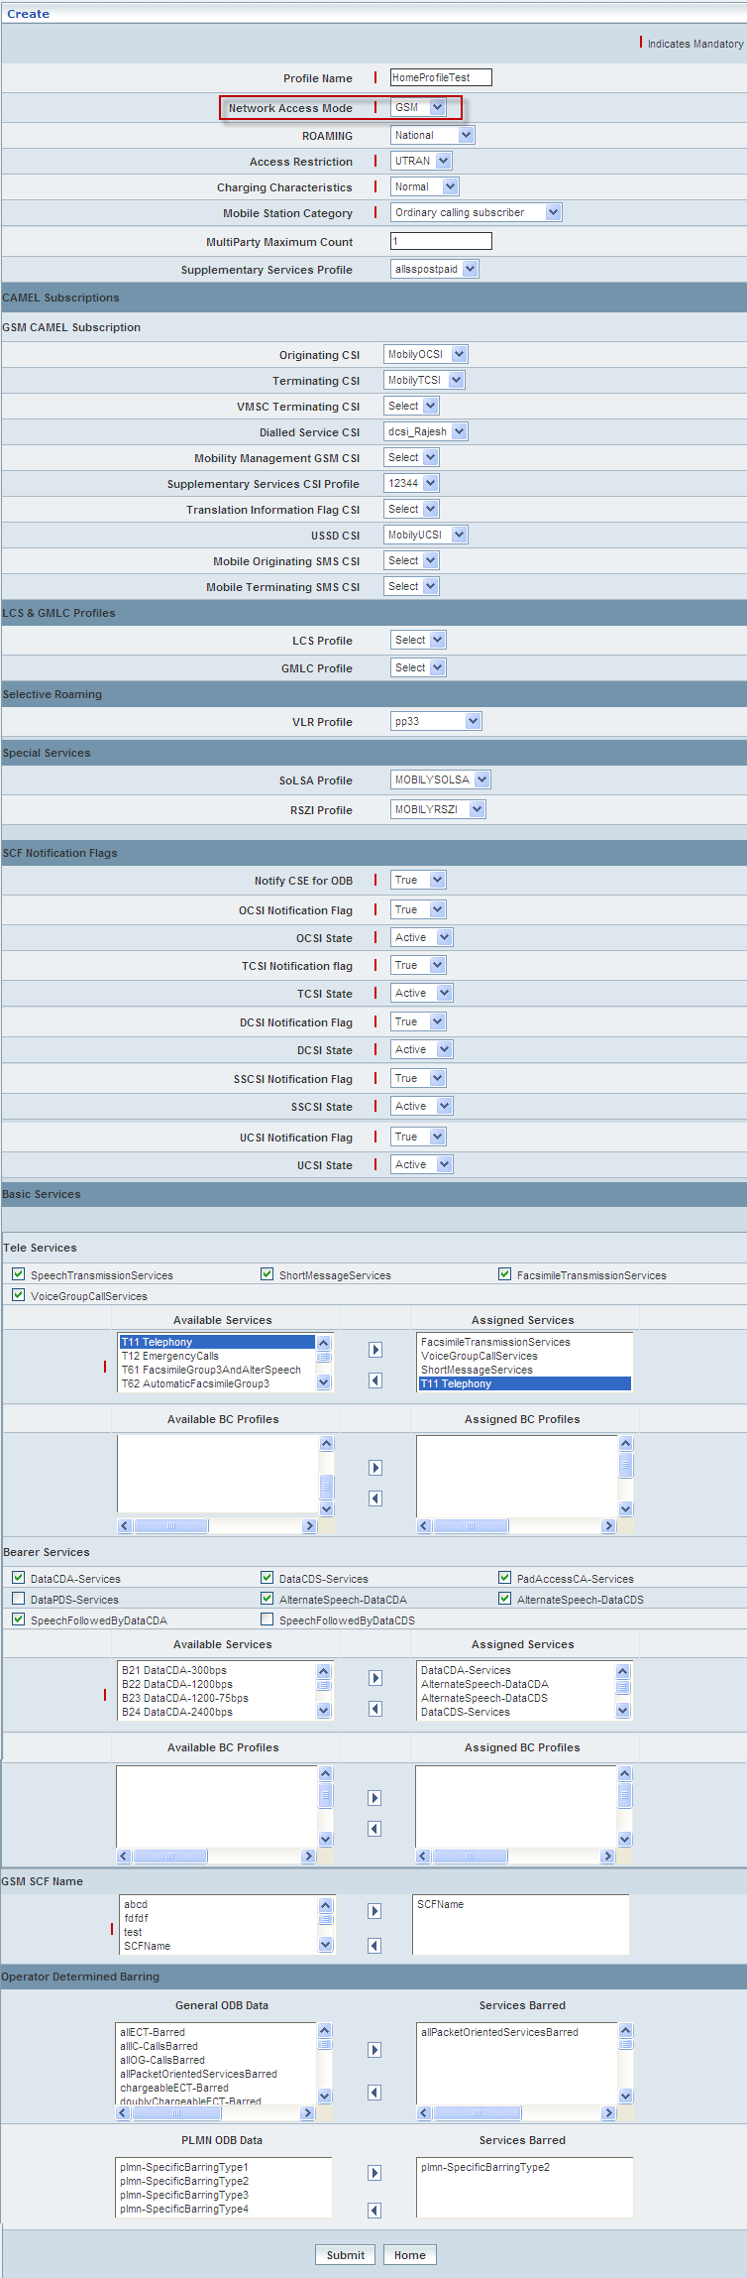

| **STEP** | **ACTION** |
| --- | --- |
|  | User must essentially enter the details related to a new profile where it is a mandatory information |
|  | Enter name of the profile in <Profile Name> field attributing to the proposed Subscriber Profile, where the access mode is **GSM** |
|  | Select the network access mode (**GSM** / GPRS) to specify the subscriber’s network access mode from the drop-down list of the <Network Access Mode> field  **\*** By default, the list of network access modes will be dynamically displayed as drop-down list of the <Network Access Mode> field  **NOTE:** In this case, the Network Access Mode is **GSM** |
|  | Select a roaming option (Not Allowed/National/International) to specify the subscriber’s roaming provision from the drop-down list of the <Roaming> field  **\*** By default, the list of options related to roaming facility will be dynamically displayed as drop-down list of the <Roaming> field |
|  | Select the access restriction (UTRAN/GERAN) to specify subscriber’s restriction to access from the drop-down list of the <Access Restriction> field  **\*** By default, the list of options related to access restriction will be dynamically displayed as drop-down list of the <Access Restriction> field |
|  | Select the charging model (Normal/Pre-Paid/Flat-Rate/Billing) to specify subscriber’s billing or charging pattern from the drop-down list of the <Charging Characteristics> field  **\*** By default, the list of charging options will be dynamically displayed as drop-down list of the <Charging Characteristics> field |
|  | Select one of the Mobile Station (Call Service) categories to specify subscriber’s preferred category from the drop-down list of the <Mobile Station Categories> field  **\*** By default, the list of default Call Service options (Mobile Station Categories) will be dynamically displayed as drop-down list of the <Mobile Station Categories> field |
|  | Enter multi-party maximum count (**> 2 and < = 5)** in the <Multi-Party Maximum Count> field |
|  | Select a supplementary service profile to specify subscriber’s preferred package of supplementary services from the drop-down list of the <Supplementary Services Profile> field  **\*** By default, the list of supplementary services profiles will be dynamically displayed as drop-down list of the <Supplementary Services Profile> field |
|  | **CAMEL Subscriptions: GSM**  Select values for each of the GSM-CAMEL Subscription elements (Originating CSI, Terminating CSI, VMSC Terminating CSI, Dialed Service CSI, Mobility Management CSI, Supplementary Services CSI, Translation Information Flag CSI, USSD CSI, Mobile Originating SMS CSI and Mobile Terminating SMS CSI) from their corresponding drop-down lists respectively  **\*** By default, the list of values for each of the CAMEL Subscription elements will be dynamically displayed as drop-down list of the respective fields |
|  | **LCS & GMLC Profile: GSM**  Select values for the LCS and GMLC profiles from their corresponding drop-down lists respectively  **\*** By default, the list of values for each of the LCS and GMLC profiles will be dynamically displayed as drop-down list of the respective fields |
|  | **Selective Roaming: GSM**  Select values for the VLR profile from their corresponding drop-down lists respectively  **\*** By default, the list of values for the VLR profiles will be dynamically displayed as drop-down list of the respective fields |
|  | **Special Services**  Select values for the SoLSA and RSZI profile from their corresponding drop-down lists respectively  **\*** By default, the list of values for the SoLSA and RSZI profiles will be dynamically displayed as drop-down list of the respective fields |
|  | **SCF Notification Flags: GSM**  SCF Notification - Notify CSE for ODB is mandatory and the user must compulsorily set the preferred value (True / False) for the same  Rest of the SCF Notifications shall be applicable based on the selection related to GSM-CAMEL Subscription elements, **only** the resultant SCF Notifications will be dynamically displayed enabling the user to set corresponding parameters (‘value-True/False’ & ‘status-Active/Inactive’) accordingly  **\*** By default, the value (**True / False**) and the status (**Active / Inactive**) for each of the SCF Notifications will be displayed as corresponding drop-downs respectively |
|  | **Basic Services Block:**  Basic services comprise **Tele Services** and **Bearer Services**  **NOTE:** Only **5 (Five) BC Profiles** pertaining to a **Tele sub-service** can be assigned  However, more than one Tele sub-service, subject to 5 BC Profiles (each) can be assigned  **NOTE:** Only **5 (Five) BC Profiles** pertaining to each **Bearer service (Data CDA Service / Data CDS Service)** can be assigned |
|  | **Tele Services**   * Parent services of the selected services (as a string) will be dynamically moved to the **<Assigned Services>** text field below, which is on to the right side of the screen and the corresponding sub-services will be dynamically moved to the text field **<Available Services>** which is on to the left side of the screen |
| Select the desired sub service from the list **<Available Services>** and on clicking the right-arrow button, the sub-service (as a string) will be moved to the <**Assigned Services**> field and reckoned as an assigned service |
| With the effect of a sub service being assigned, the corresponding list of BC Profiles (**if any**) will be dynamically displayed in the **<Available BC Profiles>** text field below, which is on to the left side of the screen |
| Select the desired BC Profile from the list **<Available BC Profiles>** and on clicking the right-arrow button, the BC Profile (as a string) will be moved to the <**Assigned BC Profiles**> field and reckoned as an assigned (BC) Profile |
| However, if the user wants to just remove any Tele Service, (any time before creating the profile); selecting the service from the <**Assigned Services**> text field and subsequently clicking, the left-arrow button removes the service. Consequently, the corresponding BC profiles those ‘available’ and as well ‘assigned’ (BC profiles) will also be removed from the corresponding text fields |
| Similarly, if the user wants to just remove any BC Profile (any time before creating the profile), selecting the profile from the <**Assigned BC Profiles**> text field and subsequently clicking the left-arrow button removes the same |
|  | **Bearer Services**   * On selecting a Bearer Service (Data CDA / Data CDS), the corresponding list of BC Profiles will be dynamically displayed in the **<Available BC Profiles>** text field below, which is on to the left side of the screen |
| Select the desired BC Profile from the list **<Available BC Profiles>** and on clicking the right-arrow button, the BC Profile (as a string) will be moved to the <**Assigned BC Profiles**> field and reckoned as an assigned (BC) Profile |
| If the user deselects (un-checks) any Bearer Service, the corresponding BC profiles those ‘available’ and as well ‘assigned’ (BC profiles) will also be removed from the corresponding text fields |
| If the user wants to just remove any BC Profile (any time before creating the profile), selecting the profile from the <**Assigned BC Profiles**> text field and subsequently clicking the left-arrow button removes the same |
|  | **GSM SCF Name Block:**  By default, the list of names (addresses) will be dynamically displayed in the text field, which is on to the left side of the screen |
|  | **Operator Determined Barring: GSM**  By default the various barring services are displayed in General ODB Data and PLMN ODB Data.   * To add the services form **General ODB Data** or **PLMN ODB Data** to **Services Barred**, select the service to be barred from respective operator and click rightarrow   To remove the selected barred services form **Services Barred** operator, select the services to be removed and click left arow |
|  | On mapping the desired number of names (addresses), those names (each of them as a string) will be dynamically moved to the text field, which is on to the right side of the screen |
|  | On clicking the **Submit** button, new profile (Subscriber Profile) will be created and a message window will be displayed to that effect    On clicking the **Home** button of the message window, it directs the user back to the ‘Subscriber Profiles’ grid |
|  | On clicking the **Home** button of the ‘Create’ screen (before creating any new profile), it directs the user to the ‘Subscriber Profiles’ grid |

The screen below shows creating a new profile as Subscriber Profile, selecting the **Network Access Mode** as **GPRS**

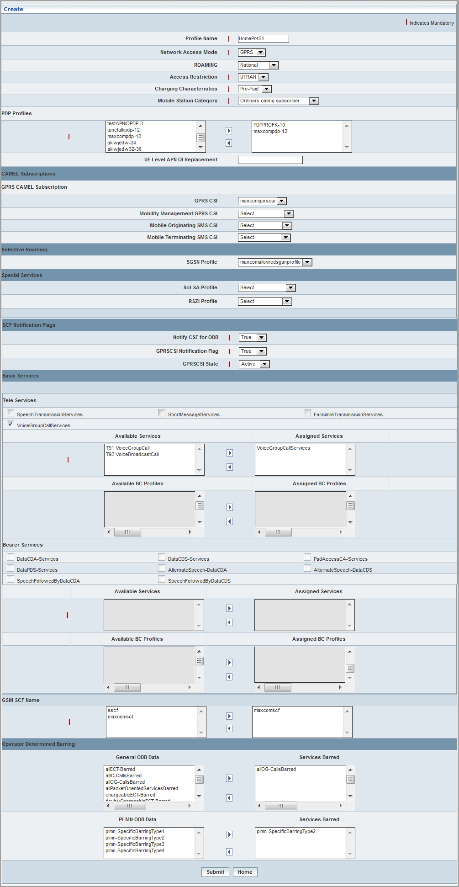

0

| **STEP** | **ACTION** |
| --- | --- |
|  | User must essentially enter the details related to a new profile where it is a mandatory information |
|  | Enter name of the profile in <Profile Name> field attributing to the proposed Subscriber Profile, where the access mode is GPRS |
|  | Select the network access mode (GSM / **GPRS**) to specify the subscriber’s network access mode from the drop-down list of the <Network Access Mode> field  **\*** By default, the list of network access modes will be dynamically displayed as drop-down list of the <Network Access Mode> field  **NOTE:** In this case, the Network Access Mode is **GPRS** |
|  | Select a roaming option (Not Allowed/National/International) to specify the subscriber’s roaming provision from the drop-down list of the <Roaming> field  **\*** By default, the list of options related to roaming facility will be dynamically displayed as drop-down list of the <Roaming> field |
|  | Select the access restriction (UTRAN/GERAN) to specify subscriber’s restriction to access from the drop-down list of the <Access Restriction> field  **\*** By default, the list of options related to access restriction will be dynamically displayed as drop-down list of the <Access Restriction> field |
|  | Select the charging model (Normal/Pre-Paid/Flat-Rate/Billing) to specify subscriber’s billing or charging pattern from the drop-down list of the <Charging Characteristics> field  **\*** By default, the list of charging options will be dynamically displayed as drop-down list of the <Charging Characteristics> field |
|  | Select one of the Mobile Station (Call Service) categories to specify subscriber’s preferred category from the drop-down list of the <Mobile Station Categories> field  **\*** By default, the list of default Call Service options (Mobile Station Categories) will be dynamically displayed as drop-down list of the <Mobile Station Categories> field |
|  | Based on the selection of Network Access Mode as **GPRS,** PDP Profiles section will be dynamically displayed  By default, the list of PDP Profiles will be dynamically displayed in the text field, which is on to the left side of the screen  Select the desired PDP Profile from the list <Left Text Field> and on clicking the right-arrow button, the profile (as a string) will be moved to the <Text Field> which is on to the right side of the screen  On mapping the desired number of PDP Profiles (each of them as a string) will be dynamically moved to the text field  However if the user wants to just remove any PDP profile (any time before creating the profile), selecting the PDP profile from the right text field and subsequently clicking the left-arrow button removes the PDP profile |
|  | Based on the selection of Network Access Mode as **GPRS**, **UE Level APN OI Replacement** section will be dynamically displayed.  **UE Level APN OI Replacement**: Enter a name to locate the Home GGSN.  **APN-OI-Replacement**: Enter a name to locate the Home GGSN.  The configured profiles shall be displayed/available at PDP Profiles during the creation of subscribers. For more information, refer *Subscriber Management* > *Create Subscriber*. |
|  | **CAMEL Subscriptions Block: GPRS**  Select values for each of the GPRS-CAMEL Subscription elements (GPRS CSI, Mobility Management CSI, Mobile Originating SMS CSI and Mobile Terminating SMS CSI) from their corresponding drop-down lists respectively  **\*** By default, the list of values for each of the CAMEL Subscription elements will be dynamically displayed as drop-down list of the respective fields |
|  | **Selective Roaming: GPRS**  Select values for the SGSN profile from their corresponding drop-down lists respectively  **\*** By default, the list of values for the SGSN profiles will be dynamically displayed as drop-down list of the respective fields |
|  | **Special Services**  Select values for the SoLSA and RSZI profile from their corresponding drop-down lists respectively  **\*** By default, the list of values for the SoLSA and RSZI profiles will be dynamically displayed as drop-down list of the respective fields |
|  | **SCF Notifications Block: GPRS**  SCF Notification - Notify CSE for ODB is mandatory and the user must compulsorily set the preferred value (True / False) for the same  Rest of the SCF Notifications shall be applicable based on the selection related to GPRS-CAMEL Subscription elements, **only** the resultant SCF Notifications will be dynamically displayed enabling the user to set corresponding parameters (‘value-True/False’ & ‘status-Active/Inactive’) accordingly  **\*** By default, the value (**True / False**) and the status (**Active / Inactive**) for each of the SCF Notifications will be displayed as corresponding drop-downs respectively |
|  | **Basic Services Block:**  Basic services comprise **Tele Services** and **Bearer Services**  **NOTE:** Only **5 (Five) BC Profiles** pertaining to a **Tele sub-service** can be assigned  However, more than one Tele sub-service, subject to 5 BC Profiles (each) can be assigned  **NOTE:** Only **5 (Five) BC Profiles** pertaining to each **Bearer service (Data CDA Service / Data CDS Service)** can be assigned |
|  | **Tele Services**   * On selecting a specific Tele Service, the corresponding Parent services (as a string) will be dynamically moved to the **<Assigned Services>** text field below, which is on to the right side of the screen and the corresponding sub-services will be dynamically moved to the text field **<Available Services>** which is on to the left side of the screen |
|  | Select the desired sub service from the list **<Available Services>** and on clicking the right-arrow button, the sub-service (as a string) will be moved to the <**Assigned Services**> field and reckoned as an assigned service |
|  | However if the user wants to just remove any service (any time before creating the profile), selecting the service from the <**Assigned Services**> text field and subsequently clicking the left-arrow button removes the service  **NOTE:** BC Profiles and Bearer Services are not applicable for GPRS Network |
|  | **Bearer Services**   * On selecting a Bearer Service (Data CDA / Data CDS), the corresponding list of BC Profiles will be dynamically displayed in the **<Available BC Profiles>** text field below, which is on to the left side of the screen |
| Select the desired BC Profile from the list **<Available BC Profiles>** and on clicking the right-arrow button, the BC Profile (as a string) will be moved to the <**Assigned BC Profiles**> field and reckoned as an assigned (BC) Profile |
| If the user deselects (un-checks) any Bearer Service, the corresponding BC profiles those ‘available’ and as well ‘assigned’ (BC profiles) will also be removed from the corresponding text fields |
| If the user wants to just remove any BC Profile (any time before creating the profile), selecting the profile from the <**Assigned BC Profiles**> text field and subsequently clicking the left-arrow button removes the same |
|  | **GSM SCF Name Block:**  By default, the list of names (addresses) will be dynamically displayed in the text field, which is on to the left side of the screen |
|  | **Operator Determined Barring: GSM**  By default the various barring services are displayed in General ODB Data and PLMN ODB Data.   * To add the services form **General ODB Data** or **PLMN ODB Data** to **Services Barred**, select the service to be barred from respective operator and click rightarrow   To remove the selected barred services form **Services Barred** operator, select the services to be removed and click left arow |
|  | On mapping the desired number of names (addresses), those names (each of them as a string) will be dynamically moved to the text field, which is on to the right side of the screen |
|  | On clicking the **Submit** button, new profile (Subscriber Profile) will be created and a message window to that effect will be displayed  Wor5F  On clicking the **Home** button of the message window, it directs the user back to the Subscriber Profiles grid |
|  | On clicking the **Home** button of the ‘Create’ screen (before creating any new profile), it directs the user to the Subscriber Profiles grid |

**Default Profile**

Home Location Register🡪Subscriber Profile Management🡪Home Profile🡪Create / View

‘Default Profile’ enables the user to set a chosen profile as a ‘Default Profile’.

On clicking the **‘Default Profile’** button, it enables the user to set a chosen profile as a ‘Default Profile’.

User can choose two default profiles, one from each ‘Profile Type’ (GSM or GPRS).



| **STEP** | **ACTION** |
| --- | --- |
|  | User must select the radio button of the desired profile that is proposed to be set as default profile |
|  | On clicking the **Default Profile** button, it displays an alert window enabling the user to confirm setting of the chosen profile as the ‘Default Profile’  C:\DOCUME~1\rajini.sn\LOCALS~1\Temp\SNAGHTML18644ff.PNG  On clicking the **OK** button, the chosen profile will be automatically reckoned as the Default Profile and a message window will be displayed to that effect    On clicking the **Cancel** button of the alert window, it retains the ‘Subscriber Profile Management – Create / View’ Grid (without setting the chosen profile as Default Profile)  On clicking the **Home** button of the message window, it directs the user back to the ‘Create / View’ Screen |
|  | On clicking the **Home** button of the ‘Create’ Screen (before setting it as to default profile), it directs the user to the ‘Home Profile’ Screen  **\*** In the ‘Default Profile’ column it is marked as ‘Default’ |

**View**

Home Location Register 🡪 Subscriber Profile Management 🡪 Home Profile 🡪 Create / View

View enables the user to peruse details related to chosen profile (Subscriber Profile).

On clicking the **‘View’** link of a chosen ‘Profile’ (from the Subscriber Profiles List); corresponding information related to the profile will be displayed in a separate screen enabling the user to peruse details of the Subscriber Profile.

The screen below displays the details related to chosen profile (Subscriber Profile)

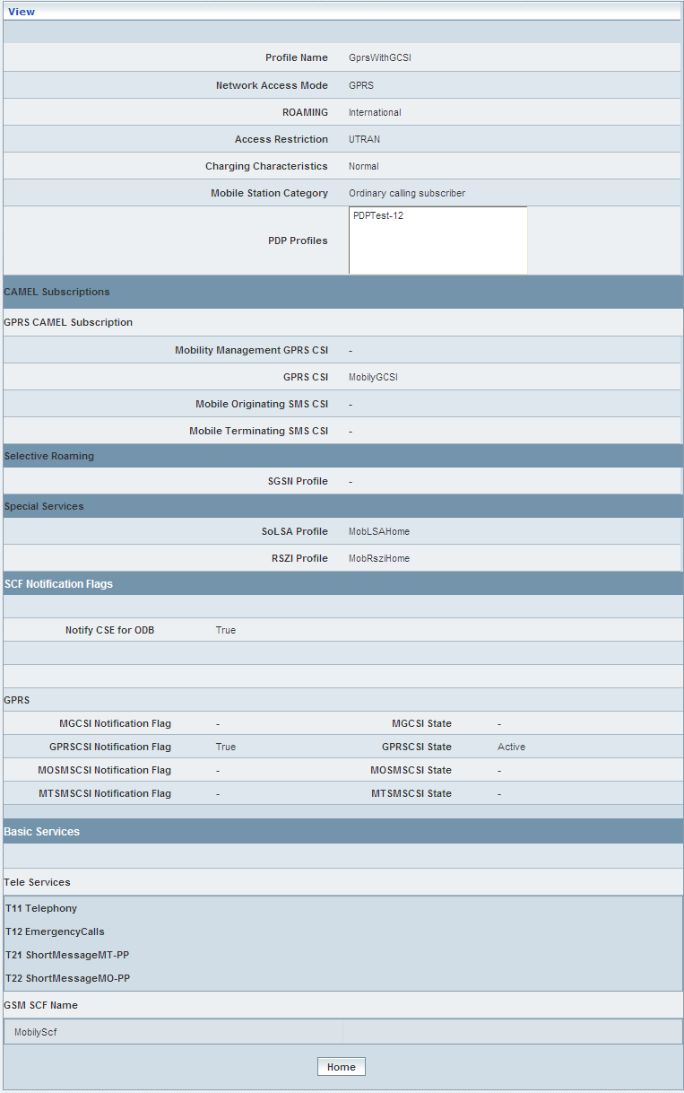

| **STEP** | **ACTION** |
| --- | --- |
|  | User can peruse details related to the chosen Subscriber Profile |
|  | On clicking the **Home** button at the bottom of the ‘View’ Screen, it redirects the user to the ‘Subscriber Profiles’ grid |

**Reference**

Home Location Register 🡪 Subscriber Profile Management 🡪 Home Profile 🡪 Create / View

On clicking the **‘Reference’** link of a chosen ‘Profile’ (from the list of subscriber profiles), a replica of the profile will be displayed in a separate screen (along with all the configured values / parameters of the chosen profile). This enables the user to create another profile with similar configured values or with slight changes but with a distinct name. This provision of reference creation in fact reduces the time in creating a profile similar to the one that already exists

The screen below displays the details related to chosen profile (Subscriber Profile) enabling the user to create a reference / similar profile with distinct name

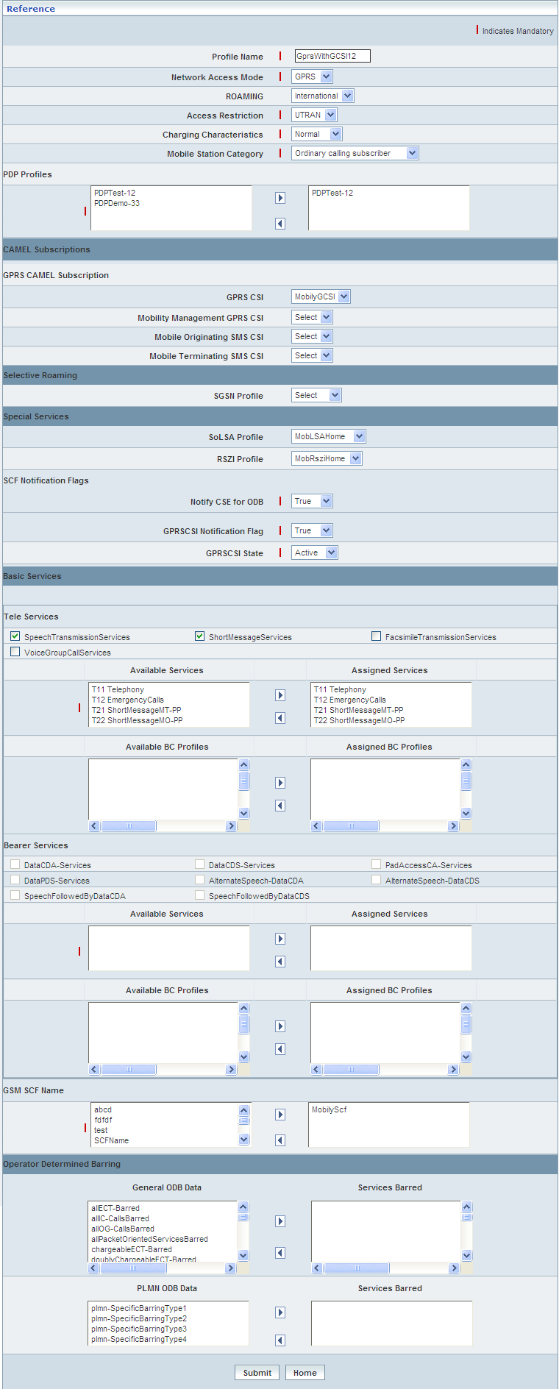

| **STEP** | **ACTION** |
| --- | --- |
|  | User can create a different Subscriber Profile that is similar to the reference profile, but with a distinct name  Enter a different name in the <Profile Name> field |
|  | User can either retain all the values that were configured for the reference profile to attribute the same to the proposed profile or can make minor changes to the existing values |
|  | On clicking the **Submit** button, new profile (Subscriber Profile) will be created and a message window to that effect will be displayed    On clicking the **Home** button of the message window, it directs the user back to the Subscriber Profiles grid |
|  | On clicking the **Home** button at the bottom of the ‘Reference Screen’ (before creating a similar profile), it redirects the user to the Subscriber Profiles grid |

**Searching for a specific Subscriber - Home Profile (Record)**

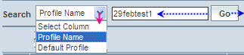

| **STEP** | **ACTION** |
| --- | --- |
|  | Select a search criterion (‘Profile Name’ or ‘Default Profile’) from the drop-down list of the search criteria of the <Search> field  **\*** By default the list of search criterion (‘Profile Name’ or ‘Default Profile’) will be dynamically displayed as drop-down list of the <Search> field |
|  | Enter the value (‘Profile Name’ or ‘Default Profile’) that corresponds with the given search criterion |
|  | On clicking the **Go** button, the corresponding Subscriber - Home Profile (record) will be highlighted among the list of Profiles records |

The screen below depicts fetching and displaying the Subscriber - Home Profile record.

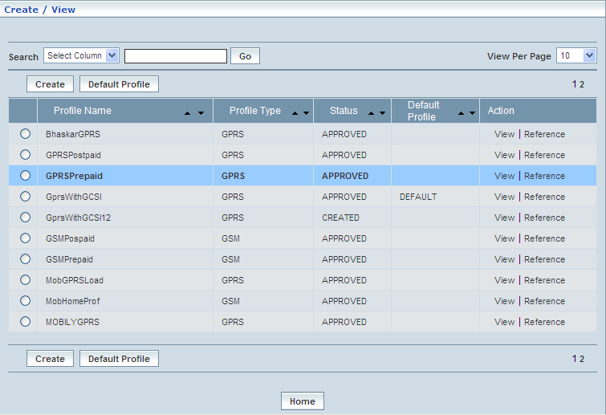

**Manage**

‘Manage’ helps the user modifying and deleting (managing) a chosen Subscriber profile that was created, but still to be approved. This module also helps **approving** or **rejecting** the profile.

Home Location Register 🡪 Subscriber Profile Management 🡪 Home Profile 🡪Manage

Initially, ‘Subscriber Profiles Management’ displays a grid showing the list of existing supplementary services’ Profiles that were configured and created.

The screen below shows the list of various Subscriber Profiles in a grid.

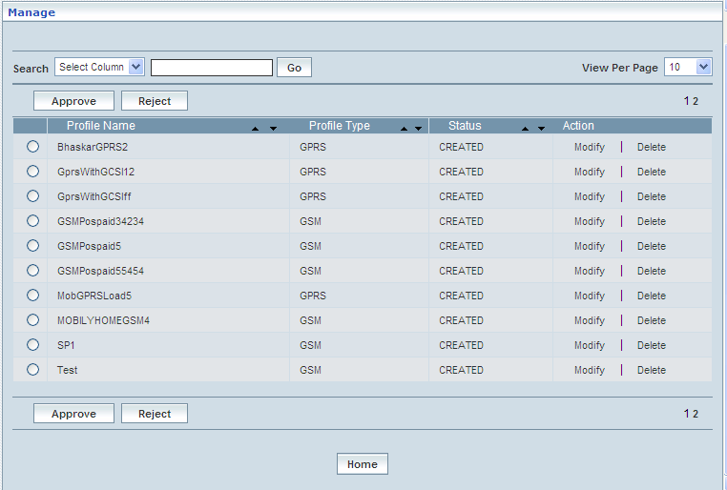

| **STEP** | | **ACTION** |
| --- | --- | --- |
|  | | By default, the list of Subscriber profiles will be displayed as records in a grid. The columns include ‘Profile Name’, ‘Profile Type’, ‘Status’ and ‘Action’ |
|  |  | User can customize the view for the number of records to be displayed each time (per page) in a grid.  However, this option is applicable only if the total number of records exceeds 10. And also with the immediate effect of increase in the number of records more than 10, a ‘Search’ option would be dynamically displayed. |
| Select the number of records (For Ex: 10) from the drop-down list of the <View Per Page> field. |
| With the effect of choosing the desired number (10) for the display of records per page, the same (10 records) will be displayed in the grid. |
| User can sort the records in ascending and descending orders with the help of up-arrow and down-arrows respectively |
| However, based on the total number of records, page numbers will be dynamically displayed at the left bottom of the screen |
| User can navigate for subsequent records (10 each time) by clicking the desired ‘page number’ |
| **2** | | On clicking the **Modify** link of a chosen ‘Profile’, corresponding information related to the profile will be displayed in a separate screen enabling the user to modify / update details of the profile |
|  | | On clicking the **Delete** link of a chosen ‘Profile’, corresponding information related to the profile will be displayed in a separate screen enabling the user to delete the profile |
|  | | **To Approve a Profile:**  Select the corresponding radio option of the desired profile to approve the same |
|  | | On clicking the **Approve** button, an alert window message will be displayed enabling the user to confirm approval of the chosen profile  Wor63  On clicking the **OK** button of the alert window, the chosen profile will be approved and a message window to that effect will be displayed  Wor66  On clicking the **Cancel** button of the alert window, it retains the ‘Manage Profiles’ grid  On clicking the **Home** button of the message window, it redirects the user to the ‘Manage Profiles’ grid  **NOTE:** The Profile that was approved will be disappeared from the ‘Manage Profiles’ grid. However, status related to the Profile will be dynamically updated (changed to ‘Approved’ from ‘Created’) in the ‘Subscriber Profiles’ grid |
|  | | **To Reject a Profile:**  Select the corresponding radio option of the desired profile to reject the same |
|  | | On clicking the **Reject** button, an alert window message will be displayed enabling the user to confirm rejection of the chosen profile  Wor66  On clicking the **OK** button of the alert window, the chosen profile will be rejected and a message window to that effect will be displayed  Wor65  On clicking the **Cancel** button of the alert window, it retains the ‘Manage Profiles’ grid  On clicking the **Home** button of the message window, it redirects the user to the ‘Manage Profiles’ grid  **NOTE:** Status related to the Profile will be dynamically updated (changed to ‘Rejected’ from ‘Created’) in the Subscriber Profiles grid and as well as in ‘Manage Profiles’ grid  **\*** Once rejected profile can always be approved any time later by way of similar process of approving a profile |
|  | | On clicking the **Home** button at the bottom of the grid, it redirects the user to the ‘Subscriber Profiles Management’ main page |

**Modify**

Modify enables the user to modify / update the details related to an existing Subscriber profile.

Home Location Register🡪Subscriber Profile Management 🡪 Home Profile 🡪 Manage 🡪 Modify

On clicking the **‘Modify’** link of a chosen ‘Profile’ (from the Subscriber Profiles List); corresponding information related to the profile will be displayed in a separate screen enabling the user to modify / update details of the Subscriber Profile.

The screen below shows modifying / updating the details related to an existing Subscriber profile.

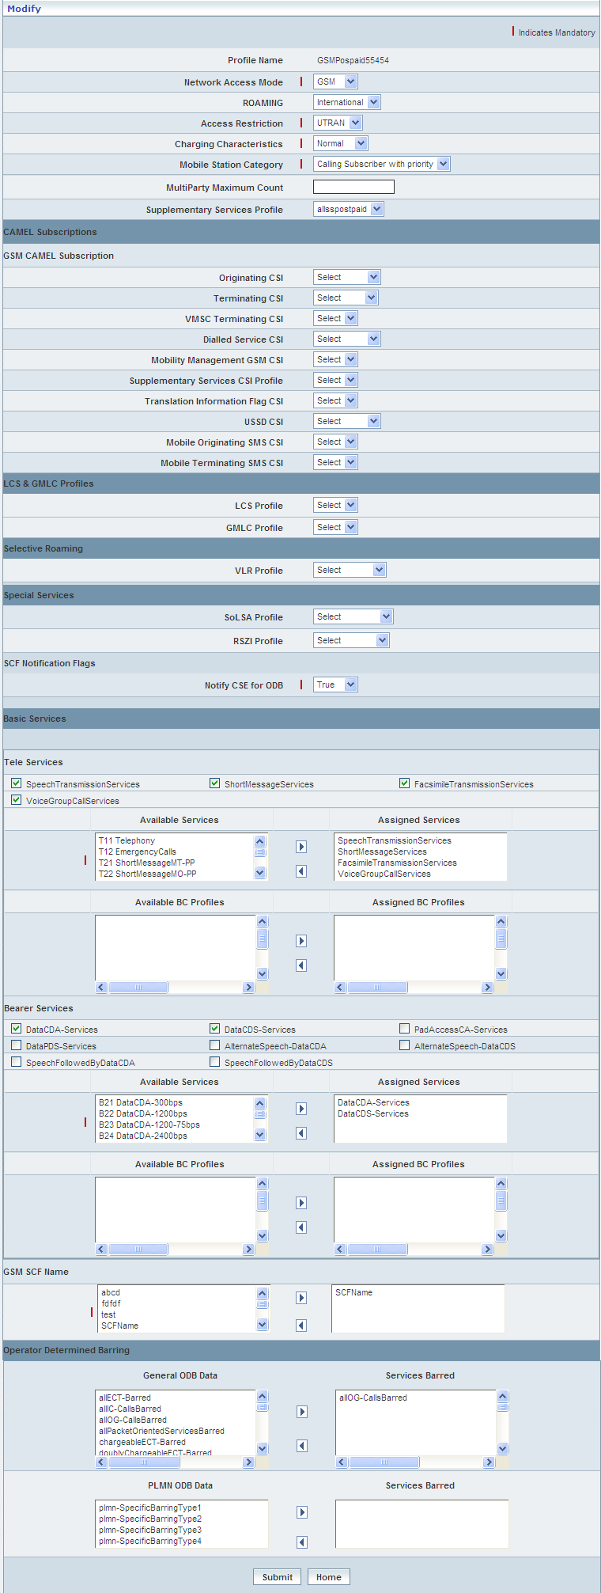

| **STEP** | **ACTION** |
| --- | --- |
|  | Name of the profile will be dynamically displayed in the <Profile Name> field and this cannot be modified |
|  | User can make necessary changes / updates to the existing values / configurations of the profile |
|  | On clicking the **Submit** button at the bottom of the ‘Modify’ screen, profile (Subscriber profile) details will be updated accordingly and a message window to that effect will be displayed    On clicking the **Home** button of the message window, it directs the user back to the ‘Manage Profiles’ grid |
|  | On clicking the **Home** button of the ‘Modify’ screen (before updating the details related to profile), it directs the user to the ‘Manage Profiles’ grid |

**Delete**

Home Location Register 🡪 Subscriber Profile Management 🡪 Home Profile 🡪 Manage 🡪 Delete

Delete enables the user to delete an existing Subscriber profile.

On clicking the **‘Delete’** link of a chosen ‘Profile’ (from the Subscriber Profiles List); corresponding information related to the profile will be displayed in a separate screen enabling the user to delete the Subscriber Profile.

The screen below shows the details related to an existing Subscriber profile, which enables the user to delete the same (Profile).

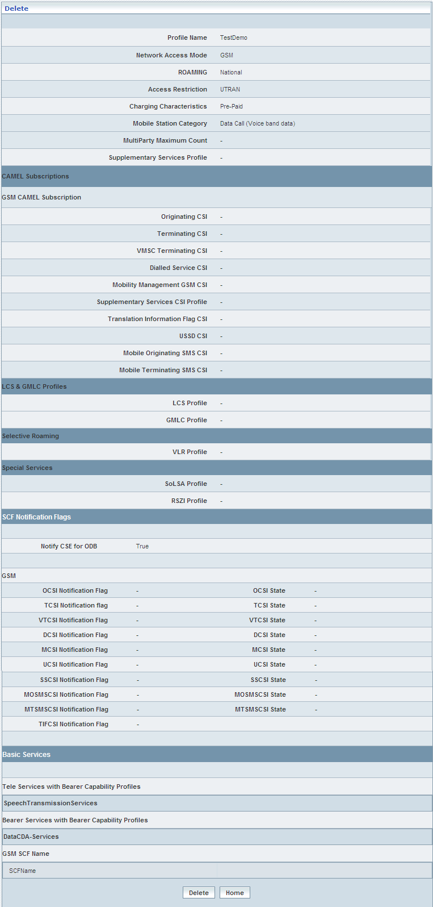

| **STEP** | **ACTION** |
| --- | --- |
|  | User can peruse the existing values / configurations of the profile before deleting the profile |
|  | On clicking the **Delete** at the bottom of the ‘Delete’ screen, it displays an alert window enabling the user to confirm deletion of the chosen profile (Subscriber profile)  Wor69  On clicking the **OK** button of the alert window, the chosen Subscriber profile will be deleted and a message window to that effect will be displayed    On clicking the **Cancel** button of the alert window, it retains the corresponding ‘Delete’ screen  On clicking the **Home** button of the message window, it directs the user back to the ‘Manage Profiles’ grid |
|  | On clicking the **Home** button of the ‘Delete’ screen (before deleting the profile), it directs the user to the ‘Manage Profiles’ grid |

**Searching for a specific Subscriber - Home Profile (Record)**

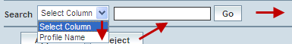

| **STEP** | **ACTION** |
| --- | --- |
|  | Select a search criterion (‘Profile Name’) from the drop-down list of the search criteria of the <Search> field  **\*** By default the list of search criterion (‘Profile Name’) will be dynamically displayed as drop-down list of the <Search> field |
|  | Enter the value (‘Profile Name’) that corresponds with the given search criterion |
|  | On clicking the **Go** button, the corresponding Subscriber - Home Profile (record) will be highlighted among the list of Profiles records |

The screen below depicts fetching and displaying the Subscriber - Home Profile record.

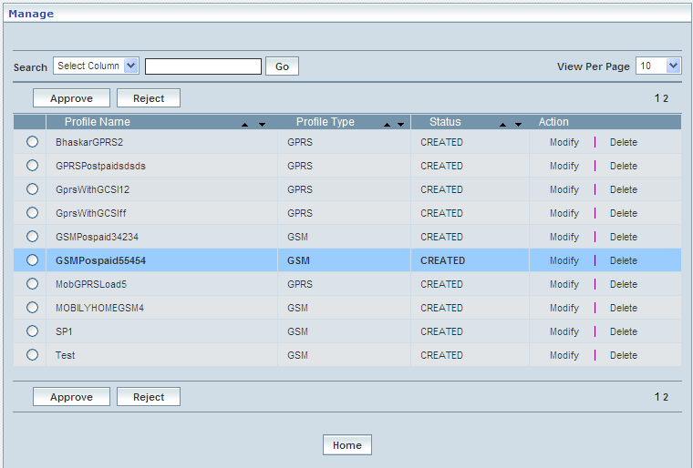

# Subscriber Management

This chapter describes how to manage subscribers using various management options like Authentication, create, refer, and upload subscribers. This chapter also talks about other options such as provisioning subscribers, attach/detach SS codes (Bulk), add/remove Tele-Bearer (Bulk), and LCS services.

Home Location Register 🡪 Subscriber Management

Subscriber Management administers and streamlines the information related to subscribers and few associated or default service offerings that could be assigned to subscribers based on their subscriptions.

This Module thus maintains the details related to following supplementary services:

* Call Barring
* Call Forwarding
* Line Identity
* Call Completion
* Other Supplementary Services

Subscriber Management allows the user performing the following functions:

* Manage KI Key Index
* Manage OP Index
* Authentication Centre
* Authentication View
* Create Subscriber
* Reference Subscriber
* Bulk Subscriber Creation
* Provision / Modify GPRS (Bulk)
* Upload OCSI Number Criteria
* Change Subscriber Profile
* Change IMSI / MSISDN (Bulk)
* Operator Determined Barring
* Activate / Deactivate Subscribers
* Attach / Detach SS Codes (Bulk)
* Add / Remove Tele-Bearer(Bulk)
* Subscriber Information
* Remove Subscriber
* Remove Subscribers (Bulk)
* Cancel Location (Bulk)

## Manage KI Key Index

The manage KI Index module shows the user to create new KI key index. The KI key is created based on the index value and the encoding algorithm.

Initially the Manage KI Key Index screen is displayed as shown below.

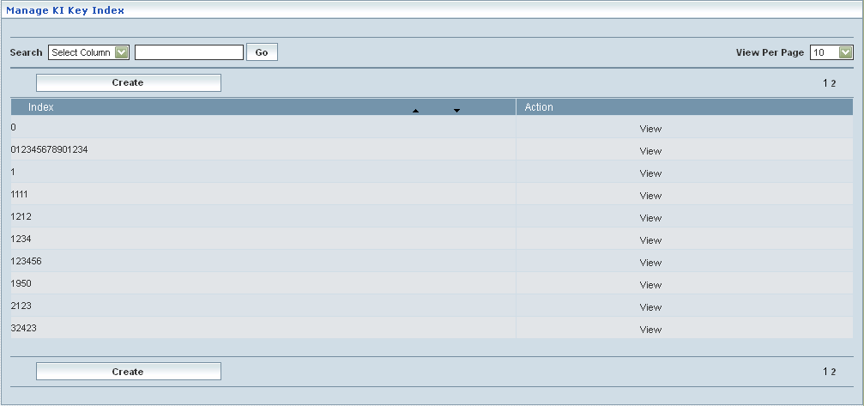

**View**

This module enables the user to view the existing KI key Index and value configurations

The below screen shows the existing KI Key index configuration

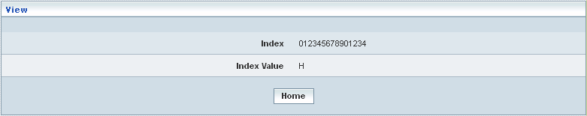

| **STEP** | **ACTION** |
| --- | --- |
|  | Click on the **View** link from the Manage KI Key Index screen. A new window appears with the KI key Index and Value details |
|  | On clicking the **Home** button, it only redirects the user back to the ‘Manage KI Key Index’ main page |

**Create**

The user can create new KI Key Index and value based on the Encoding Algorithm using this module.

The below screen shows the create KI Key index details

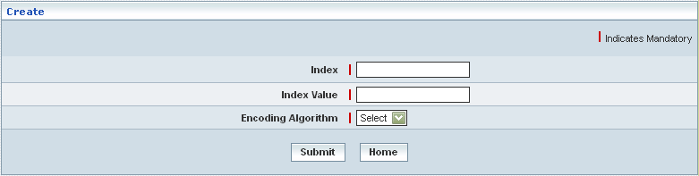

| **STEP** | **ACTION** |
| --- | --- |
|  | Click on the  button from the Manage KI Key Index screen. A new window appears with the KI key Index and Value fields |
|  | Enter preferred KI Key Index number in the <Index> field |
|  | Enter the corresponding KI Key Index value in the <Index Value> field |
|  | Select the encoding algorithm from the <Encoding Algorithm> dropdown   * AES * DES |
|  | Click on **Submit** button, the new KI key Index is inserted successfully and a success message to that effect is displayed. |
|  | On clicking the **Home** button, it only redirects the user back to the ‘Manage KI Key Index’ main page |

## Manage OP Index

The manage KI Index module shows the user to create new OP index. Initially the Manage OP Index screen is displayed as shown below.

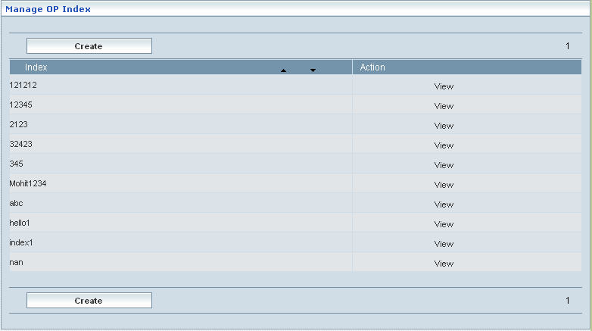

**View**

This module enables the user to view the existing OP Index and value configurations

The below screen shows the existing OP index configuration

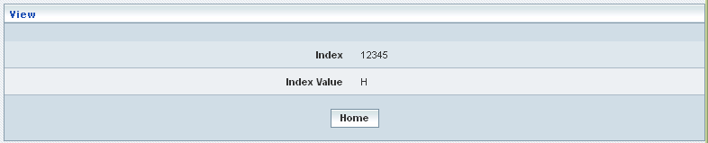

| **STEP** | **ACTION** |
| --- | --- |
|  | Click on the **View** link from the Manage OP Index screen. A new window appears with the OP Index and Value details |
|  | On clicking the **Home** button, it only redirects the user back to the ‘Manage OP Index’ main page |

**Create**

The user can create new OP Index and value using this module.

The below screen shows the create KI Key index details

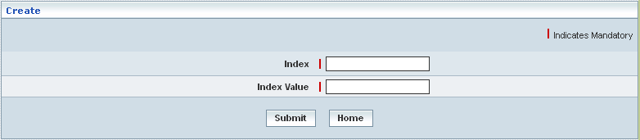

| **STEP** | **ACTION** |
| --- | --- |
|  | Click on the  button from the Manage OP Index screen. A new window appears with the OP Index and Value fields |
|  | Enter preferred OP Index number in the <Index> field |
|  | Enter the corresponding OP Index value in the <Index Value> field |
|  | Click on **Submit** button, the new OP Index is inserted successfully and a success message to that effect is displayed. |
|  | On clicking the **Home** button, it only redirects the user back to the ‘Manage OP Index’ main page |

## Authentication Center

VLR indicates authentication request whenever there is a location update. Authentication Center queries the data base for KI and OPC for the requested IMSI. With these details Authentication center generates triplet (SRES, RAND, KC) and sends to VLR in authentication response.

Home Location Register 🡪 Subscriber Management 🡪 Authentication Center

Authentication Center here in this context is a storing location for storing the data related to various IMSI (International Mobile Subscriber Identifier) numbers along with the corresponding cipher codes (KI and OPC, Authentication Algorithm, Node Type, AMF and Encryption Algorithm). This allows the user to store a set/group of IMSI (IMSI numbers along with cipher codes, each one as record in a new line) at a stretch in bulk.

Mapping a subscriber’s profile to an IMSI which is authenticated by the Authentication Center

The proposed file for upload needs to be encrypted before uploading the file. Encryption shall be executed through FTP (File Transfer Protocol).

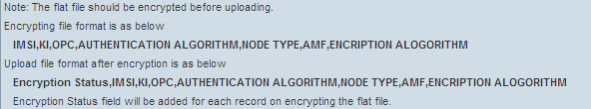

The screen below shows uploading the encrypted flat-file that consists of IMSI along with the corresponding cipher codes (stored as records)

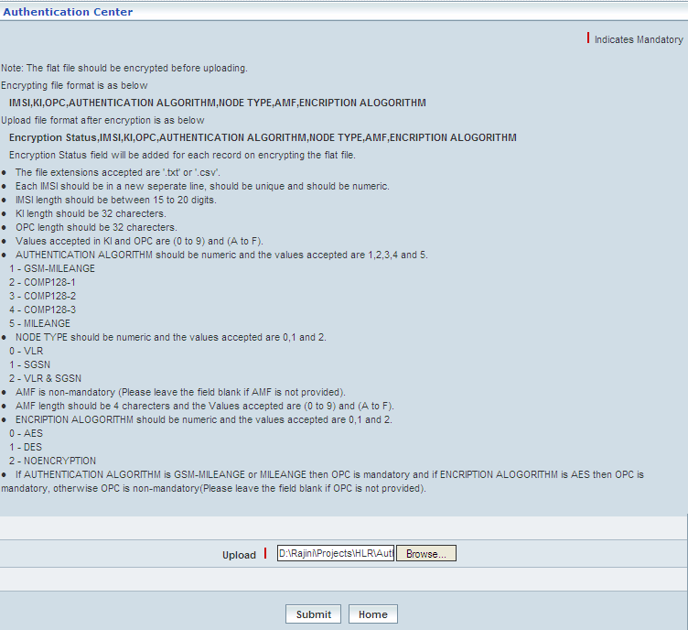

| **STEP** | **ACTION** |
| --- | --- |
|  | Browse for the encrypted Flat file that consists of a set of IMSI numbers (along with the corresponding cipher codes) |
|  | On clicking the **Submit** button, a message window to that effect will be displayed confirming the successful upload  In case of the upload failure, the corresponding ‘Error Records’ will be automatically displayed |
|  | On clicking the **Home** button (prior to upload of the flat file), it only redirects the user back to the ‘Subscriber Management’ main page |

## Authentication View

Home Location Register 🡪 Subscriber Management 🡪 Authentication View

Authentication view allows the user obtaining authentication details related to a given IMSI. Initially, it displays a screen enabling the user to provide an IMSI for obtaining the corresponding authentication details.

The screen below shows entering an IMSI.

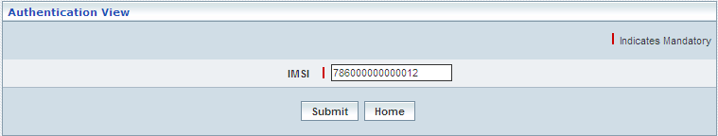

| **STEP** | **ACTION** |
| --- | --- |
|  | Enter an IMSI in the <IMSI> field |
|  | On clicking the **Submit** button the corresponding authentication algorithm will be displayed in separate screen    On clicking the **Home** button of the message window, it directs the user back to the ‘Authentication View’ Screen |
|  | On clicking the **Home** button (prior to submission of IMSI), it directs the user to the ‘Subscriber Management’ main page |

## Create Subscriber

Home Location Register 🡪 Subscriber Management 🡪 Create Subscriber

‘Create Subscribers’ helps the user creating subscribers by way of relating all the required attributes. Subscribers may belong to GSM and GPRS Networks.

The screen below shows creating a subscriber belonging to **GSM** Network.

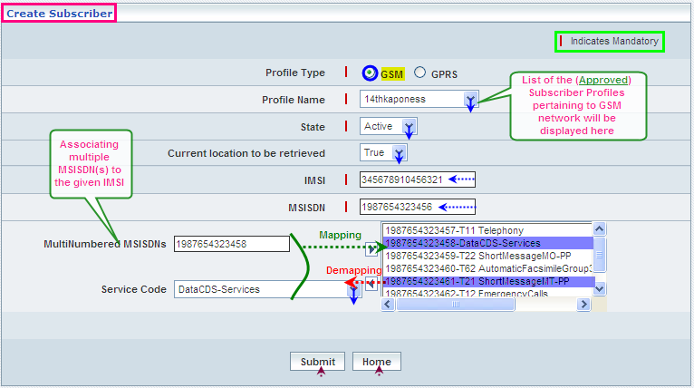

| **STEP** | **ACTION** |
| --- | --- |
|  | Select radio option (GSM / GPRS) to specify the network for the proposed subscriber  In this case – Subscriber belongs to GSM Network |
|  | With the effect of selecting GSM Network, only the corresponding (subscriber) profiles will be dynamically displayed as drop-down list of the <Profile Name> field  **NOTE:** However, the subscriber profiles include **Only** the approved profiles |
|  | Select a profile from the drop down list of the <Profile Name> field |
|  | Select status (**Active /** **Inactive**) to indicate initial default status of the subscriber from the drop-down list of the <State> field  **\*** By default, the status elements (**Active /** **Inactive**) will be dynamically displayed as drop-down list of the <State> field |
|  | Select a value (**True /** **False**) to indicate default value of the subscriber for the ‘current location to be retrieved’ feature  **\*** By default, the value elements (**True /** **False**) will be dynamically displayed as drop-down list of the <current location to be retrieved> field |
|  | Enter IMSI number in the <IMSI> field  **NOTE:** Given IMSI must be the constituent of the Configured series. If the user is trying to enter an IMSI, which the series has not been configured, an alert message will be displayed to that effect  C:\DOCUME~1\rajini.sn\LOCALS~1\Temp\SNAGHTMLc4a81d.PNG |
|  | Enter MSISDN number in the <MSISDN> field  **NOTE:** Given MSISDN must be the constituent of the Configured series. If the user is trying to enter an MSISDN, which the series has not been configured, an alert message will be displayed to that effect    C:\DOCUME~1\rajini.sn\LOCALS~1\Temp\SNAGHTMLc5832b.PNG  **NOTE:** First given MSISDN shall be reckoned as basic MSISDN and several other discrete MSISDN can be assigned to the given IMSI |
|  | Enter MSISDN (additional and other than basic MSISDN) in the <Multi Numbered MSISDNs> field |
|  | Select the SS Code for additional MSISDN from the drop-down list of the <SS Code> field  **\*** By default, the list of SS Codes will be dynamically displayed as drop-down list of the <SS Code> field  **NOTE:** SS Code must be unique to each of those MSISDN(s) attributed to the given IMSI |
|  | On clicking the right-arrow button, the combination of (additional) MSISDN and the chosen SS Code (as a string) will be moved to the <Text Field> which is on to the right side of the screen  User can assign the required number of MSISDN(s) in a similar fashion  However if the user wants to remove an MSISDN (any time before creating the Subscriber), selecting a combination from the right text field and subsequently clicking the left-arrow button removes the same |
|  | On clicking the **Submit** button, subscriber will be created, a message window will be displayed to that effect    On clicking the **Home** button of the message window, it directs the user back to the ‘Create Subscriber’ Screen |
|  | On clicking the **Home** button (prior to submission of IMSI), it directs the user to the ‘Subscriber Management’ main page |

The screen below shows creating a subscriber belonging to **GPRS** Network.

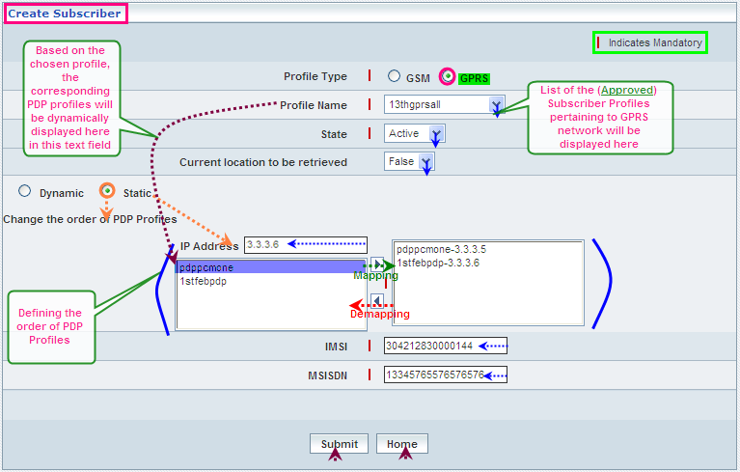

|  |  |
| --- | --- |
| **STEP** | **ACTION** |
|  | Select radio option (GSM / GPRS) to specify the network for the proposed subscriber  In this case – Subscriber belongs to GSM Network |
|  | With the effect of selecting GPRS Network, only the corresponding (subscriber) profiles will be dynamically displayed as drop-down list of the <Profile Name> field  **NOTE:** However, the subscriber profiles include **Only** the approved profiles |
|  | Select a profile from the drop down list of the <Profile Name> field |
|  | With the effect of choosing a specific profile, **Only** the corresponding PDP profiles will be dynamically displayed in the text field which is on to left side of the screen. These profiles have to be prioritized in a specific order based on the type (dynamic / static) of profiles composition.  **Note**: The PDP Profiles shall be configured for the subscriber’s (level) at Subscriber Profile Management. For more information, refer *Subscriber Profile Management > Home Profile*. |
|  | Select status (**Active /** **Inactive**) to indicate initial default status of the subscriber from the drop-down list of the <State> field  **\*** By default, the status elements (**Active /** **Inactive**) will be dynamically displayed as drop-down list of the <Status> field |
|  | Select a value (**True /** **False**) to indicate default value of the subscriber for the ‘current location to be retrieved’ feature  **\*** By default, the value elements (**True /** **False**) will be dynamically displayed as drop-down list of the <current location to be retrieved> field |
|  | Select radio option  (Dynamic / Static) to specify the nature of Profiles Composition |
|  | The option ‘Dynamic’ indicates random attribution of profiles to the GPRS Subscriber, whereas ‘Static’ indicates fixed / defined attribution of profiles |
|  | With the effect of choosing ‘Static’ Option, order prioritization of PDP profiles with respect to various IP Addresses becomes mandatory |
|  | Enter IP Address in the <IP Address> field |
|  | Select a Profile from the list of Profiles in the text field  **NOTE:** IP Address must be unique to each of those attributed Profiles |
|  | On clicking the right-arrow button, the combination of IP address and the chosen Profile (as a string) will be moved to the <Text Field> which is on to the right side of the screen  User can assign the required number of IP Addresses in a similar fashion  However if the user wants to remove an IP Address (any time before creating the Subscriber), selecting a combination from the right text field and subsequently clicking the left-arrow button removes the same  **NOTE:** Nevertheless, it is mandatory to prioritize the order of entire PDP Profiles (in contemplation with various IP Addresses) of the chosen Profile |
|  | Enter IMSI number in the <IMSI> field  **NOTE:** Given IMSI must be the constituent of the Configured series. If the user is trying to enter an IMSI, which the series has not been configured, an alert message will be displayed to that effect    New  C:\DOCUME~1\rajini.sn\LOCALS~1\Temp\SNAGHTMLb5cbfa.PNG |
|  | Enter MSISDN number in the <MSISDN> field  **NOTE:** Given MSISDN must be the constituent of the Configured series. If the user is trying to enter an MSISDN, which the series has not been configured, an alert message will be displayed to that effect    New  C:\DOCUME~1\rajini.sn\LOCALS~1\Temp\SNAGHTMLb66099.PNG |
|  | On clicking the **OK** button, subscriber will be created, a message window will be displayed to that effect    On clicking the **Home** button of the message window, it directs the user back to the ‘Create Subscriber’ Screen |
|  | On clicking the **Home** button (prior to submission of IMSI), it directs the user to the ‘Subscriber Management’ main page |

## Reference Subscriber

Home Location Register 🡪 Subscriber Management 🡪 Reference Subscriber

‘Reference Subscriber’ enables the user to create an identical Subscriber précis similar to that of the one which is already in existence. In other words, a new Subscriber précis can be created having the similar configuration as that of the existing IMSI of the Subscriber. This minimizes the time and effort in creating a new Subscriber précis with similar configurations as that of the existing Subscriber’s IMSI. At the time attributing a précis with reference to the existing IMSI, it is also essential to provide a new MSISDN in order to complete creating a subscriber.

The screen below shows creating a Subscriber précis with the existing reference.

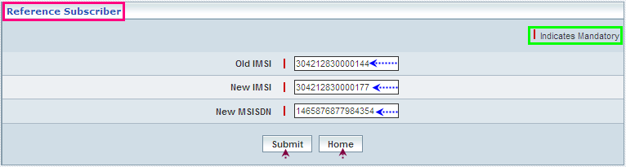

| **STEP** | **ACTION** |
| --- | --- |
|  | Enter old (reference) IMSI in the <Old IMSI> field  **NOTE:**   * Reference IMSI must belong to an existing subscriber * Given IMSI must be the constituent of the Configured series. If the user is trying to enter an IMSI, which the series has not been configured, an alert message will be displayed to that effect |
|  | Enter new (proposed) IMSI in the <New IMSI> field  **NOTE:**   * New IMSI must be authenticated but should not belong to any existing subscriber * The Network Access Mode (GSM / GPRS / GSM-GPRS) of new IMSI should be similar to that of Old IMSI or it should be (neutrally) GSM-GPRS   Given IMSI must be the constituent of the Configured series. If the user is trying to enter an IMSI, which the series has not been configured, an alert message will be displayed to that effect |
|  | Enter MSISDN (new) in the <MSISDN> field  **NOTE:** Given MSISDN must be the constituent of the Configured series. If the user is trying to enter an MSISDN, which the series has not been configured, an alert message will be displayed to that effect |
|  | On clicking the **Submit** button the corresponding authentication algorithm will be displayed in separate screen |
|  | On clicking the **Home** button (prior to submission of IMSI), it directs the user to the ‘Subscriber Management’ main page |

## Bulk Subscriber Creation

Home Location Register 🡪 Subscriber Management 🡪 Bulk Subscriber Creation

‘Upload Subscribers’ helps the user storing data (of a group of subscribers) related to various IMSI (International Mobile Subscriber Identifier) numbers along with the corresponding MSISDN and also along with the corresponding cipher codes when authentication is required to be mentioned. This allows the user to store a set/group of IMSI at a stretch in bulk (IMSI numbers along with MSISDN and also along with cipher codes, as the case may be) and attributing the values and parameters that correspond with the associated Network Access Mode of the set of IMSI.

However, uploading the subscribers’ data shall be carried out in contemplation with each of the following network access modes:

* GSM
* GPRS

The screen below shows assigning the values to a bulk upload of the group of Subscribers’ details, where the network access mode is **GSM**.

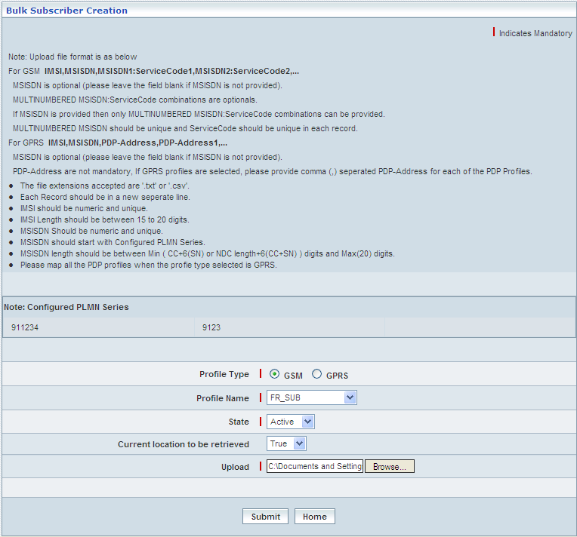

| **STEP** | **ACTION** |
| --- | --- |
|  | Select a radio option (**GSM**/GPRS) to specify the profile type, in other words select the network access mode of the profile  **NOTE:** First Case - **GSM** |
|  | With the effect of selecting the profile’s network access mode, the corresponding list of (**Only** Approved profiles) (names) will be dynamically displayed as a drop-down list of the <Profile Name> field  select the desired profile name from the drop-down list of the <Profile Name>field |
|  | Select status (**Active /** **Inactive**) to indicate initial default status of the subscriber from the drop-down list of the <State> field  **\*** By default, the status elements (**Active /** **Inactive**) will be dynamically displayed as drop-down list of the <State> field |
|  | Select a value (**True /** **False**) to indicate default value of the subscriber for the ‘current location to be retrieved’ feature  **\*** By default, the value elements (**True /** **False**) will be dynamically displayed as drop-down list of the <current location to be retrieved> field |
|  | Browse for a Flat file that consists of a set of IMSI numbers along with the corresponding MSISDN and along with cipher codes |
|  | On clicking the **Submit** button, a message window to that effect will be displayed confirming the successful upload |
|  | On clicking the **Home** button (prior to upload of the flat file), it only redirects the user back to the ‘Subscriber Management’ main page |

The screen below shows assigning the values to a bulk upload of the group of Subscribers’ details, where the network access mode is **GPRS**.

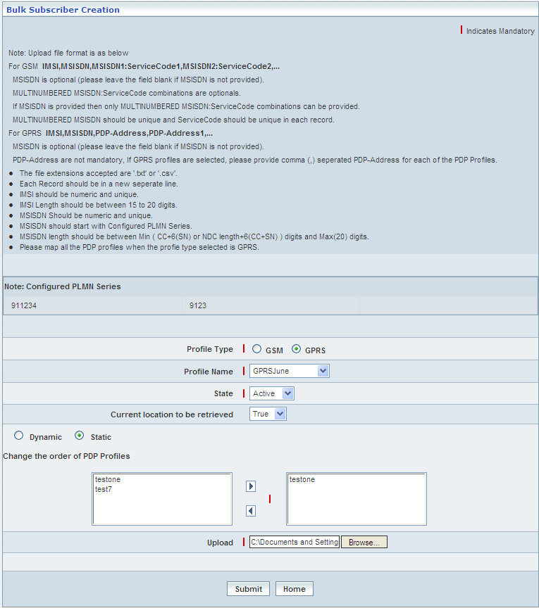

| **STEP** | **ACTION** |
| --- | --- |
|  | Select a radio option (GSM/**GPRS**) to specify the profile type, in other words select the network access mode of the profile; **NOTE:** Second Case - **GPRS** |
|  | With the effect of selecting the profile’s network access mode, the corresponding list of profiles (**Only** Approved profiles) (names) will be dynamically displayed as a drop-down list of the <Profile Name> field  select the desired profile from the drop-down list of the <Profile Name>field; Select a profile from the drop down list of the <Profile Name> field |
|  | Select status (**Active /** **Inactive**) to indicate initial default status of the subscriber from the drop-down list of the <State> field  **\*** By default, the status elements (**Active /** **Inactive**) will be dynamically displayed as drop-down list of the <State> field |
|  | Select a value (**True /** **False**) to indicate default value of the subscriber for the ‘current location to be retrieved’ feature  **\*** By default, the value elements (**True /** **False**) will be dynamically displayed as drop-down list of the <current location to be retrieved> field |
|  | Select radio option (Dynamic / Static) to specify the nature of Profiles Composition |
|  | The option ‘Dynamic’ indicates random attribution of profiles to the GPRS Subscriber, whereas ‘Static’ indicates fixed / defined attribution of profiles |
|  | With the effect of choosing ‘Static’ Option, order prioritization of PDP profiles becomes mandatory ; Select a PDP Profile from the list of PCP Profiles in the text field |
|  | On clicking the right-arrow button, the chosen Profile (as a string) will be moved to the <Text Field> which is on to the right side of the screen  User can assign the required number of Profiles in a similar fashion  However if the user wants to remove a Profile (any time before uploading the file), selecting a profile from the right text field and subsequently clicking the left-arrow button removes the same  **NOTE:** Nevertheless, it is mandatory to prioritize the order of entire PDP Profiles of the chosen Profile |
|  | Browse for a Flat file that consists of a set of IMSI numbers along with the corresponding MSISDN and along with cipher codes |
|  | On clicking the **Submit** button, a message window to that effect will be displayed confirming the successful upload |
|  | On clicking the **Home** button (prior to upload of the flat file), it only redirects the user back to the ‘Subscriber Management’ main page |

## Provision / Modify GPRS (Bulk)

Home Location Register 🡪 Subscriber Management 🡪 Provision / Modify GPRS (Bulk)

‘Provision / Modify GPRS (Bulk)’ helps the user provisioning (new) or updating (existing) Profiles in contemplation with the corresponding PDP profiles of subscribers in bulk at a stretch.

Provisioning of GPRS is applicable only to those subscribers belonging to the network access mode being 2 in terms of Authentication.

If both GSM and GPRS network access modes have been assigned to subscribers, consequently, the corresponding Tele services of the selected GPRS profiles must be the sub-set of their respective GSM Tele services.

The screen below shows provisioning / updating (as the case may be) the PDP profiles of a group of subscribers in bulk at a stretch.

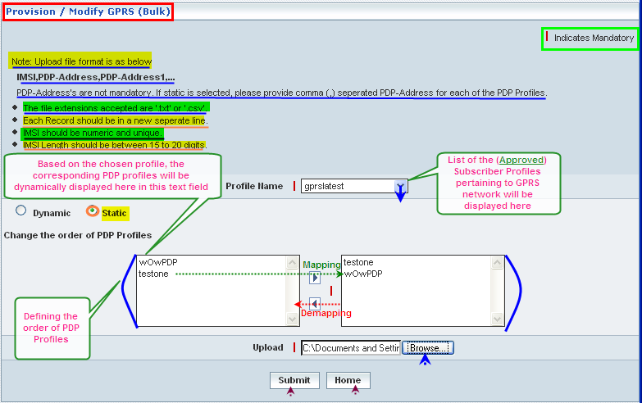

| **STEP** | **ACTION** |
| --- | --- |
|  | Select a profile from the drop down list of the <Profile Name> field |
|  | With the effect of choosing a specific profile, **Only** the corresponding PDP profiles will be dynamically displayed in the text field which is on to left side of the screen. These profiles have to be prioritized in a specific order based on the type (dynamic / static) of profiles composition |
|  | Select radio option (Dynamic / Static) to specify the nature of Profiles Composition |
|  | The option ‘Dynamic’ indicates random attribution of profiles to the GPRS Subscriber, whereas ‘Static’ indicates fixed / defined attribution of profiles |
|  | With the effect of choosing ‘Static’ Option, order prioritization of PDP profiles with respect to various IP Addresses becomes mandatory |
|  | Select a Profile from the list of Profiles in the text field  **NOTE:** IP Address must be unique to each of those attributed Profiles |
|  | On clicking the right-arrow button, chosen Profile (as a string) will be moved to the <Text Field> which is on to the right side of the screen  User has to assign the entire profiles in a similar fashion  However if the user wants to remove a profile (any time before creating the Subscriber), selecting a profile and subsequently clicking the left-arrow button removes the same  **NOTE:** Nevertheless, it is mandatory to prioritize the order of entire PDP Profiles of the chosen Profile |
|  | User must follow the guide lines for Data Formats related IMSI and PDP Addresses |
|  | Browse for a Flat file that consists of a set of records containing IMSI and the PDP Addresses (mentioned in a specific format and each one starting in a new line) |
|  | On clicking the **Submit** button, provisioning GPRS / updating the GPRS Profiles related to a group of subscribers will be carried out and a message window will be displayed to that effect    On clicking the **Home** button of the message window, it directs the user back to the ‘Provision / Modify GPRS (Bulk)’ screen |
|  | On clicking the **Home** button of the Provision/Modify GPRS screen, it directs the user to the ‘Subscriber Management’ main page |

## Upload OCSI Number Criteria

Home Location Register 🡪 Subscriber Management 🡪 Upload OCSI Number Criteria

‘Upload OCSI Number Criteria’ helps the user uploading a set of OCSI Numbers in bulk / at a stretch. OCSI number is a combined element of the following constituents.

* IMSI (International Mobile Subscriber Identifier)
* Match Type
* Destination Number Length(s) (Respectively for the count of numbers configured)
* Corresponding Destination Numbers (as configured)

The screen below shows uploading a set / group of OCSI Numbers in bulk.

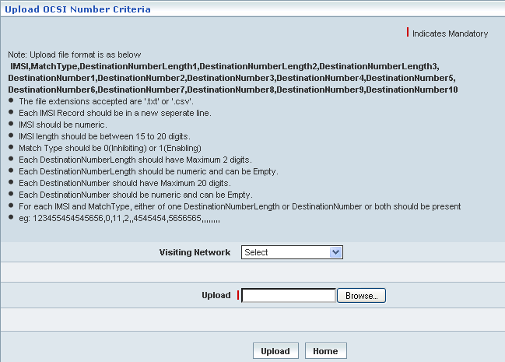

| **STEP** | **ACTION** |
| --- | --- |
|  | User must follow the guide lines for Data Formats of the OCSI Number |
|  | User can upload OCSI number criteria by selecting the desired visiting network from the <Visiting Network> drop-down list |
|  | Browse for a Flat file that consists of a set of OCSI numbers in a specific format and each one starting in a new line |
|  | On clicking the **Submit** button, a message window to that effect will be displayed confirming the successful upload |
|  | On clicking the **Home** button (prior to upload of the flat file), it only redirects the user back to the ‘Subscriber Management’ main page |

## Change Subscriber Profile

Home Location Register 🡪 Subscriber Management 🡪 Change Subscriber Profile

‘Change Subscriber Profile’ helps the user changing data related to a set of IMSI (International Mobile Subscriber Identifier) at a stretch in bulk. In other words, this allows the user to change values and parameters that correspond to the relevant Network Access for a set/group of IMSI at a stretch in bulk.

However, changes to the subscribers’ data shall be carried out in contemplation with each of the following network access modes:

* GSM
* GPRS

**\*** Once, any network access related changes made to the values & parameters of a set of IMSI, the changed values are applicable and effective (for the said set of IMSI) till the next change. In other words, in the event of changing network access values of the IMSI, the old (existing) values will be terminated and IMSI numbers will be updated with the changed values.

The screen below shows changing network access related values for a group of Subscribers’ IMSI, where the network access mode is **GSM**.

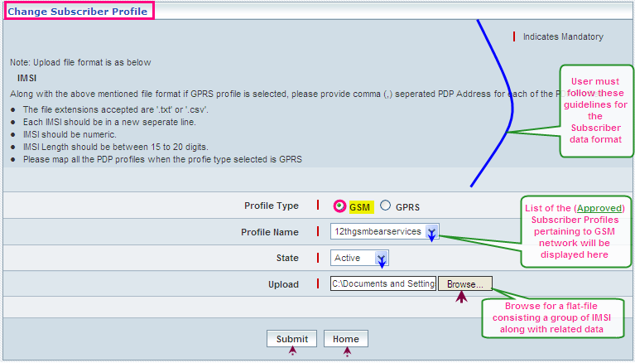

| **STEP** | **ACTION** |
| --- | --- |
|  | Select a radio option (**GSM**/GPRS) to specify the profile type, in other words select the network access mode of the profile  **NOTE:** First Case - **GSM** |
|  | With the effect of selecting the profile’s network access mode, the corresponding list of (**Only** Approved profiles) (names) will be dynamically displayed as a drop-down list of the <Profile Name> field  select the desired profile name from the drop-down list of the <Profile Name>field |
|  | Select status (**Active /** **Inactive**) to indicate initial default status of the subscriber from the drop-down list of the <State> field  **\*** By default, the status elements (**Active /** **Inactive**) will be dynamically displayed as drop-down list of the <State> field |
|  | Browse for a Flat file that consists of a set of IMSI numbers, in a specific format and each one starting in a new line |
|  | On clicking the **Submit** button, a message window to that effect will be displayed confirming the updates to the values pertaining the set of IMSI    On clicking the **Home** button of the message window, it redirects the user to the ‘Change Subscriber Profile’ Screen |
|  | On clicking the **Home** button (prior to upload of the flat file), it only redirects the user back to the ‘Subscriber Management’ main page |

The screen below shows changing network access related values for a group of Subscribers’ IMSI, where the network access mode is **GPRS**.

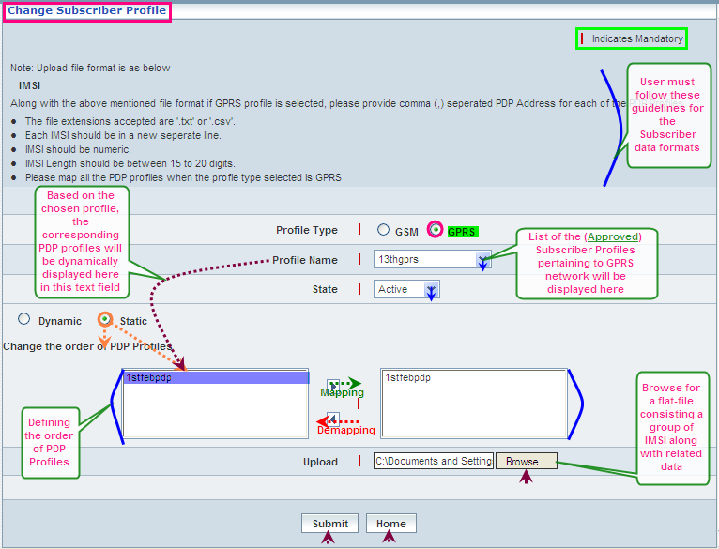

| **STEP** | **ACTION** |
| --- | --- |
|  | Select a radio option (GSM/**GPRS**) to specify the profile type, in other words select the network access mode of the profile  **NOTE:** Second Case - **GPRS** |
|  | With the effect of selecting the profile’s network access mode, the corresponding list of profiles (**Only** Approved profiles) (names) will be dynamically displayed as a drop-down list of the <Profile Name> field  select the desired profile from the drop-down list of the <Profile Name>field; Select a profile from the drop down list of the <Profile Name> field |
|  | Select status (**Active /** **Inactive**) to indicate initial default status of the subscriber from the drop-down list of the <State> field  **\*** By default, the status elements (**Active /** **Inactive**) will be dynamically displayed as drop-down list of the <State> field |
|  | Select radio option (Dynamic / Static) to specify the nature of Profiles Composition |
|  | The option ‘Dynamic’ indicates random attribution of profiles to the GPRS Subscriber, whereas ‘Static’ indicates fixed / defined attribution of profiles |
|  | With the effect of choosing ‘Static’ Option, order prioritization of PDP profiles becomes mandatory ; Select a PDP Profile from the list of PCP Profiles in the text field |
|  | On clicking the right-arrow button, the chosen Profile (as a string) will be moved to the <Text Field> which is on to the right side of the screen  User can assign the required number of Profiles in a similar fashion  However if the user wants to remove a Profile (any time before uploading the file), selecting a profile from the right text field and subsequently clicking the left-arrow button removes the same  **NOTE:** Nevertheless, it is mandatory to prioritize the order of entire PDP Profiles of the chosen Profile |
|  | Browse for a Flat file that consists of a set of IMSI in a specific format and each one starting in a new line |
|  | On clicking the **Submit** button, a message window to that effect will be displayed confirming the updates to the values pertaining the set of IMSI |
|  | On clicking the **Home** button (prior to upload of the flat file), it only redirects the user back to the ‘Subscriber Management’ main page |

## Change IMSI/MSISDN (Bulk)

Home Location Register 🡪 Subscriber Management 🡪 Change IMSI/MSISDN (Bulk)

‘Change IMSI/MSISDN (Bulk)’ helps the user to change the data related to a set of IMSI (International Mobile Subscriber Identifier), MSISDN (Mobile Subscriber ISDN Number) and add MSISDN at a stretch in bulk.

The screen below shows changing of IMSI, changing of MSISDN and adding of MSISDN by browsing the .txt file.

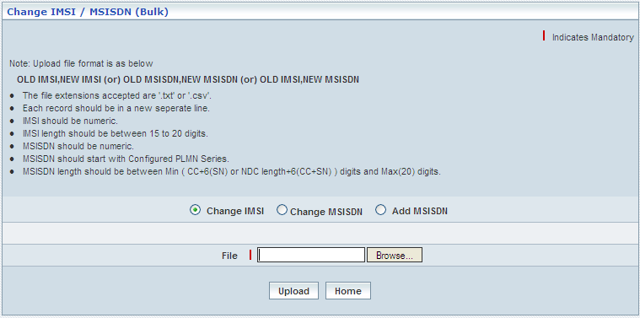

**Change IMSI**

The screen below shows uploading a set / group of subscribers in bulk for Change IMSI

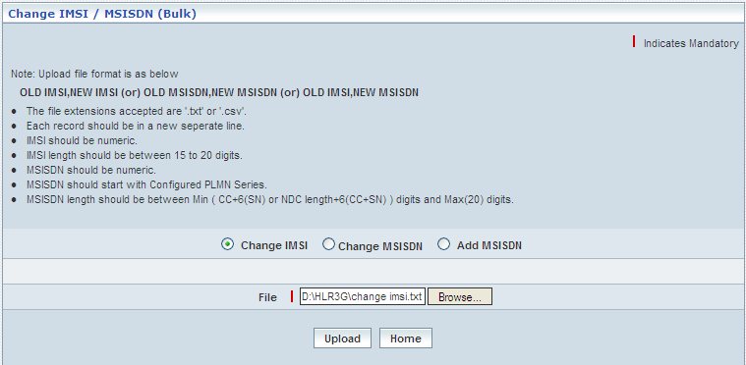

| **STEP** | **ACTION** |
| --- | --- |
|  | Select the Change IMSI radio button |
|  | Browse for a Flat file that consists of a set of Change IMSI numbers in a specific format and each one starting in a new line |
|  | On clicking the **Upload** button, a message window to that effect will be displayed confirming the successful upload    On clicking the **Home** button of the message window, it directs the user back to the ‘Change IMSI/MSISDN (Bulk)’ Screen |
|  | On clicking the **Home** button (prior to upload of the flat file), it only redirects the user back to the ‘Subscriber Management’ main page |

**Change MSISDN**

The screen below shows uploading a set / group of subscribers in bulk for Change MSISDN

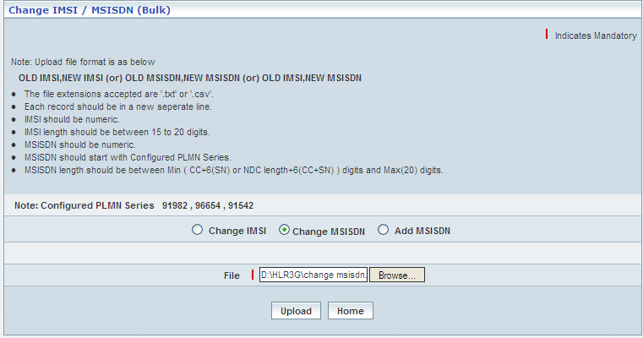

| **STEP** | **ACTION** |
| --- | --- |
|  | Select the Change MSISDN radio button |
|  | Browse for a Flat file that consists of a set of Change IMSI numbers in a specific format and each one starting in a new line |
|  | On clicking the **Upload** button, a message window to that effect will be displayed confirming the successful upload    On clicking the **Home** button of the message window, it directs the user back to the ‘Change IMSI/MSISDN (Bulk)’ Screen |
|  | On clicking the **Home** button (prior to upload of the flat file), it only redirects the user back to the ‘Subscriber Management’ main page |

**Add MSISDN**

The screen below shows uploading a set / group of subscribers in bulk for ADD MSISDN

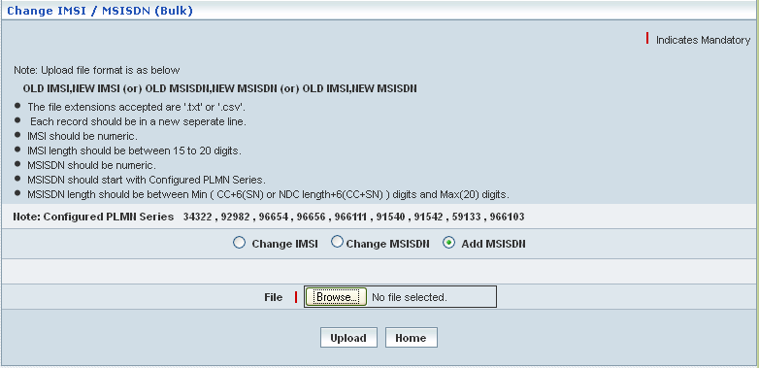

| **STEP** | **ACTION** |
| --- | --- |
|  | Select the Add MSISDN radio button |
|  | Browse for a Flat file that consists of a set of Add IMSI numbers in a specific format and each one starting in a new line |
|  | On clicking the **Upload** button, a message window to that effect will be displayed confirming the successful upload    On clicking the **Home** button of the message window, it directs the user back to the ‘Change IMSI/MSISDN (Bulk)’ Screen |
|  | On clicking the **Home** button (prior to upload of the flat file), it only redirects the user back to the ‘Subscriber Management’ main page |

## Operator Determined Barring

Home Location Register 🡪 Subscriber Management 🡪 Operator Determined Barring

**‘Operator Determined Barring’** helps the Operator (user) to bar certain services to a set of IMSI (International Mobile Subscriber Identifier) at a stretch in bulk. In other words, this allows the Operator barring a group of subscribers in bulk from certain services and those subscribers shall be identified with respect to their IMSI for this purpose.

**\*** Once the subscribers are barred from services defined by the operator, the blockage is applicable and effective till the next update.

The screen below shows barring certain services to a set / group of IMSI.

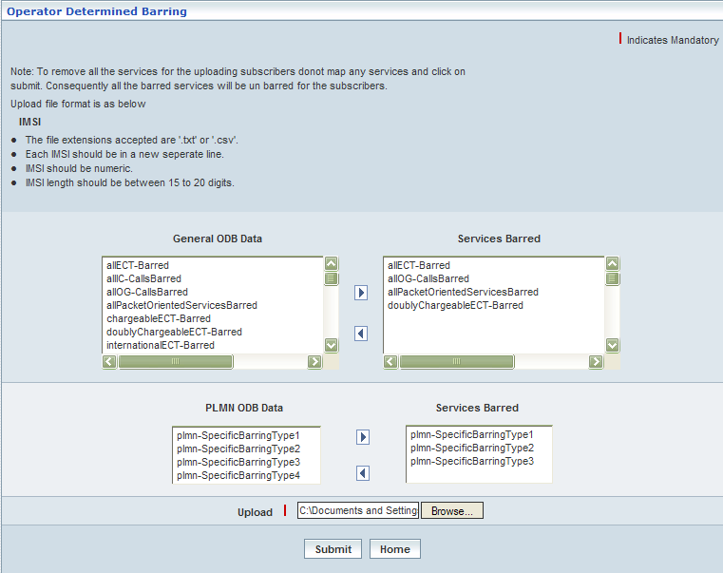

| **STEP** | **ACTION** |
| --- | --- |
|  | There are two ways that an operator can bar different subscribers from using those barred services accordingly   * + General (general & usual services)   + PLMN (explicit to the operator specific) |
|  | **\*** **General**  In this case, the corresponding list of operator-services will be dynamically displayed in the <**General ODB Data**> text field, which is on to the left side of the screen  Select the desired service from the list <**General ODB Data**> and on clicking the right-arrow button, the service (as a string) will be moved to the <**Services Barred**> text field, which is on to the right side of the screen |
|  | However if the user wants to just remove any service (any time before submission of barring), selecting the service from the <**Services Barred**> text field and subsequently clicking the left-arrow button removes the service |
|  | **\*** **PLMN**  In this case, the corresponding list of operator-services will be dynamically displayed in the <**PLMN ODB Data**> text field, which is on to the left side of the screen  Select the desired service from the list < **PLMN ODB Data**> and on clicking the right-arrow button, the service (as a string) will be moved to the <**Services Barred**> text field, which is on to the right side of the screen |
|  | However if the user wants to just remove any service (any time before submission of barring), selecting the service from the <**Services Barred**> text field and subsequently clicking the left-arrow button removes the service |
|  | Browse for a Flat file that consists of a set of IMSI numbers in a specific format and each one starting in a new line |
|  | On clicking the **Submit** button, a message window to that effect will be displayed    On clicking the **Home** button of the message window, it directs the user back to the ‘Operator Determined Barring’ Screen |
|  | On clicking the **Home** button (prior to upload of the flat file), it only redirects the user back to the ‘HLR’ main page |

## Activate / Deactivate Subscribers

Home Location Register 🡪 Subscriber Management 🡪 Subscriber Information

‘Activate / Deactivate subscribers’ here in this context refers the activation and deactivation of subscribers in bulk. This enables the user to either activate or deactivate subscribers as the case may be.

The screen below shows activating the subscribers.

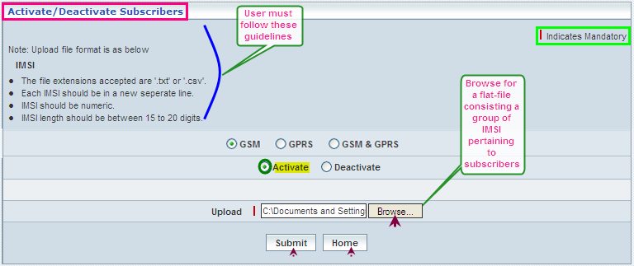

| **STEP** | **ACTION** |
| --- | --- |
|  | Select radio option (GSM /GPRS / GSM&GPRS) to specify the network type of the subscribers |
|  | Select radio option (**Activate** / **Deactivate**) to specify an action whether to activate or deactivate the subscribers |
|  | Browse for a Flat file that consists of a set of IMSI numbers (pertaining to subscribers in bulk) in a specific format and each one starting in a new line |
|  | On clicking the **Submit** button, a message window to that effect will be displayed confirming the successful upload |
|  | On clicking the **Home** button (prior to upload of the flat file), it only redirects the user back to the ‘HLR’ main page |

The screen below shows deactivating the subscribers.

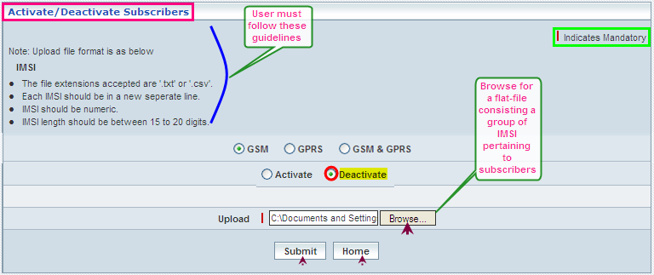

| **STEP** | **ACTION** |
| --- | --- |
|  | Select radio option (**Activate** / **Deactivate**) to specify an action whether to activate or deactivate the subscribers |
|  | Browse for a Flat file that consists of a set of IMSI numbers (pertaining to subscribers in bulk) in a specific format and each one starting in a new line |
|  | On clicking the **Submit** button, a message window to that effect will be displayed confirming the successful upload |
|  | On clicking the **Home** button (prior to upload of the flat file), it only redirects the user back to the ‘HLR’ main page |

## Attach / Detach SS Codes (Bulk)

Home Location Register 🡪 Subscriber Management 🡪 Attach / Detach SS Codes (Bulk)

‘Attach / Detach SS Codes’ helps the user uploading the subscribers in bulk to whom the supplementary services needs to be attached (few more to the existing services) or detached (withdraw certain services from the existing services).

Attaching the supplementary services refers to adding few more supplementary services in addition to the existing services of the subscriber. Whereas, detaching the supplementary services refers to withdrawing certain services from the existing services of the subscriber. Attach and detach features shall be functioning independently but not together at a time.

Supplementary services here in this context have been indicated through SS Codes and are categorized into General SS Codes and PLMN Specific SS Codes.

The screen below shows Attach / Detach SS Codes (Bulk).

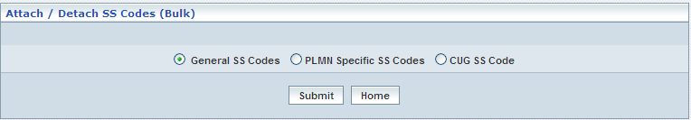

| **STEP** | **ACTION** |
| --- | --- |
|  | Select the desired radio option of SS Codes (General / PLMN Specific / CUG) to attach or detach |
|  | On clicking the **Submit** button, it navigates to another window according to the selection |
|  | On clicking the **Home** button at the bottom, it redirects the user to the ‘Subscriber Management’ records grid |

**General SS Codes - Attach**

The screen below shows **attaching** the supplementary services to a group of subscribers represented by way of their IMSI(s).

The below screen displays the attach of the General SS Codes

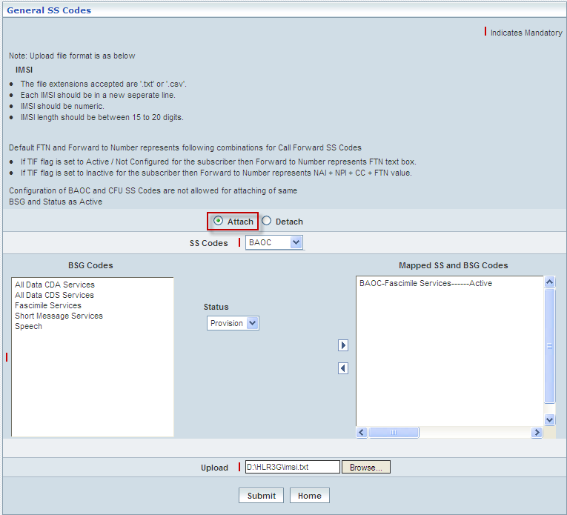

| **STEP** | **ACTION** |
| --- | --- |
|  | Select radio option (**Attach** / **Detach**) to specify an action whether to attach or detach the services to the subscribers  First Case: **Attach** |
|  | Select an SS Code from the drop-down list of the <SS Codes> field  **\*** By default, the list of SS Codes will be dynamically displayed as drop-down list of the <SS Codes> field |
|  | With the effect of selecting an SS Code, the corresponding list of basic services (group of services pertaining to the chosen SS Code) will be dynamically displayed in the text box, which is on to left side of the screen |
|  | Select the desired service from the list (of the left text field) and specify its’ status whether ‘**Active**’ and ‘**Provision**’ by way of selecting the preferred status from the drop-down list of the <Status> field  **\*** By default, the list of ‘status criteria’ (**Active / Provision**) will be dynamically displayed as drop-down list of the <Status> field  Relevant Status Criteria will be dynamically displayed in contemplation with the chosen SS Code |
|  | On clicking the right-arrow button, the basic service along with (name of) the SS code, corresponding status and along with other configurations (if any) will be moved to the adjacent field  User can move the desired number of services from different Basic Services Groups belonging to different SS Codes in a similar fashion  However if the user wants to just remove any service (any time before attaching the services), selecting the service from the right text field and subsequently clicking the left-arrow button removes the service |
|  | Browse for a Flat file that consists of a set of IMSI numbers (pertaining to subscribers in bulk) in a specific format and each one starting in a new line |
|  | On clicking the **Submit** button, a message window to that effect will be displayed confirming the successful upload    On clicking the **Home** button of the message window, it directs the user back to the ‘General SS Codes’ Screen |
|  | On clicking the **Home** button (prior to upload of the flat file), it only redirects the user back to the ‘Attach / Detach SS Codes (Bulk)’ main page |

**General SS Codes - Detach**

The screen below shows **detaching** the supplementary services from the existing services pertaining to a group of subscribers represented by way of their IMSI(s).

The below screen displays the detach of the General SS codes

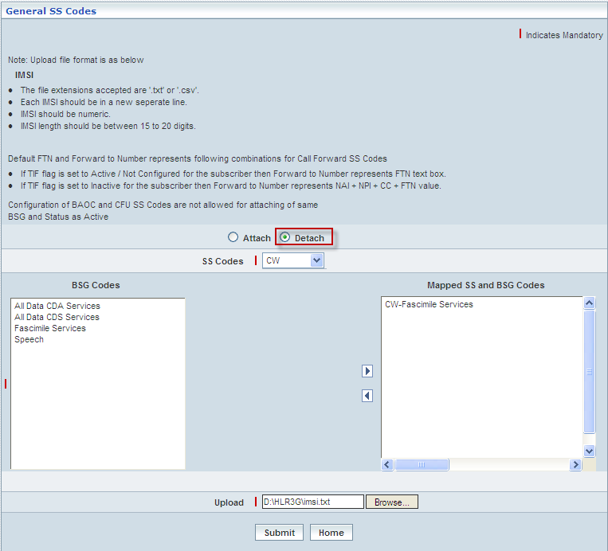

|  |  |
| --- | --- |
| **STEP** | **ACTION** |
|  | Select radio option (**Attach** / **Detach**) to specify an action whether to attach or detach the services to the subscribers  Second Case: **Detach** |
|  | Select an SS Code from the drop-down list of the <SS Codes> field  **\*** By default, the list of SS Codes will be dynamically displayed as drop-down list of the <SS Codes> field |
|  | With the effect of selecting an SS Code, the corresponding list of basic services (group of services pertaining to the chosen SS Code) will be dynamically displayed in the text box, which is on to left side of the screen |
|  | Select the desired service from the list (of the left text field) |
|  | On clicking the right-arrow button, the basic service along with (name of) the SS code will be moved to the adjacent field  User can move the desired number of services from different Basic Services Groups belonging to different SS Codes in a similar fashion  However if the user wants to just remove any service (any time before attaching the services), selecting the service from the right text field and subsequently clicking the left-arrow button removes the service |
|  | Browse for a Flat file that consists of a set of IMSI numbers (pertaining to subscribers in bulk) in a specific format and each one starting in a new line |
|  | On clicking the **Submit** button, a message window to that effect will be displayed confirming the successful upload    On clicking the **Home** button of the message window, it directs the user back to the ‘General SS Codes’ Screen |
|  | On clicking the **Home** button (prior to upload of the flat file), it only redirects the user back to the ‘Attach / Detach SS Codes (Bulk)’ main page |

**PLMN Specific SS Codes - Attach**

The screen below shows **attaching** the supplementary services to a group of subscribers represented by way of their IMSI(s).

The below screen displays attach of the PLMN Specific SS Codes

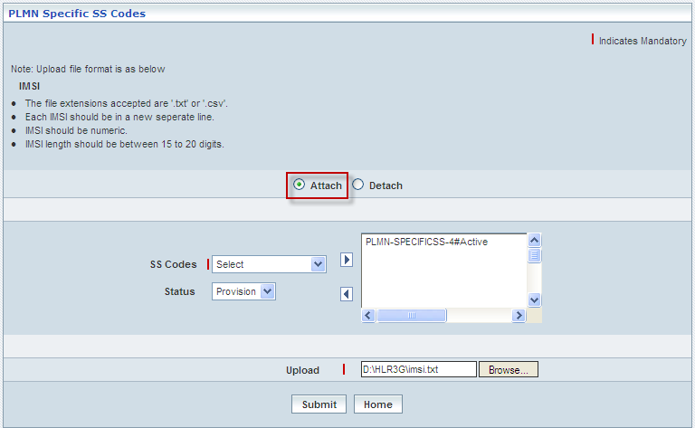

| **STEP** | **ACTION** |
| --- | --- |
|  | Select radio option (**Attach** / **Detach**) to specify an action whether to attach or detach the services to the subscribers  First Case: **Attach** |
|  | Select an SS Code from the drop-down list of the <SS Codes> field  **\*** By default, the list of SS Codes will be dynamically displayed as drop-down list of the <SS Codes> field |
|  | Select the desired service from the list (of the left text field) and specify its’ status whether ‘**Active**’ and ‘**Provision**’ by way of selecting the preferred status from the drop-down list of the <Status> field  **\*** By default, the list of ‘status criteria’ (**Active / Provision**) will be dynamically displayed as drop-down list of the <Status> field  Relevant Status Criteria will be dynamically displayed in contemplation with the chosen SS Code |
|  | On clicking the right-arrow button, the basic service along with (name of) the SS code, corresponding status and along with other configurations (if any) will be moved to the adjacent field  User can move the desired number of services from different Basic Services Groups belonging to different SS Codes in a similar fashion  However if the user wants to just remove any service (any time before attaching the services), selecting the service from the right text field and subsequently clicking the left-arrow button removes the service |
|  | Browse for a Flat file that consists of a set of IMSI numbers (pertaining to subscribers in bulk) in a specific format and each one starting in a new line |
|  | On clicking the **Submit** button, a message window to that effect will be displayed confirming the successful upload    On clicking the **Home** button of the message window, it directs the user back to the ‘PLMN Specific SS Codes’ Screen |
|  | On clicking the **Home** button (prior to upload of the flat file), it only redirects the user back to the ‘Attach / Detach SS Codes (Bulk)’ main page |

**PLMN Specific SS Codes - Detach**

The screen below shows **detaching** the supplementary services from the existing services pertaining to a group of subscribers represented by way of their IMSI(s).

The below screen displays the detach of the PLMN Specific SS Codes

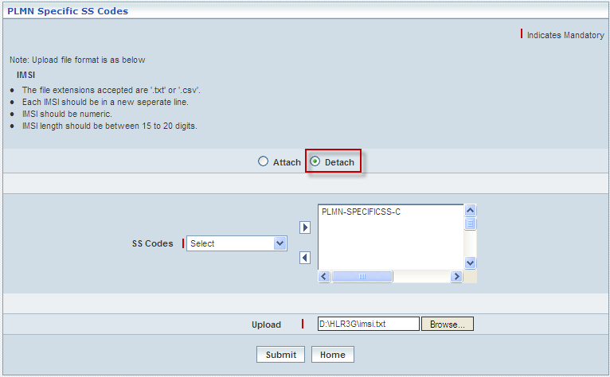

|  |  |
| --- | --- |
| **STEP** | **ACTION** |
|  | Select radio option (**Attach** / **Detach**) to specify an action whether to attach or detach the services to the subscribers  Second Case: **Detach** |
|  | Select an SS Code from the drop-down list of the <SS Codes> field  **\*** By default, the list of SS Codes will be dynamically displayed as drop-down list of the <SS Codes> field |
|  | On clicking the right-arrow button, the PLMN Specific SS Codes will be moved to the adjacent field. User can move the same by selecting the it from the right text field and subsequently clicking the left-arrow button |
|  | Browse for a Flat file that consists of a set of IMSI numbers (pertaining to subscribers in bulk) in a specific format and each one starting in a new line |
|  | On clicking the **Submit** button, a message window to that effect will be displayed confirming the successful upload    On clicking the **Home** button of the message window, it directs the user back to the ‘PLMN Specific SS Codes’ Screen |
|  | On clicking the **Home** button (prior to upload of the flat file), it only redirects the user back to the ‘Attach / Detach SS Codes (Bulk)’ main page |

**CUG SS Code - Attach**

The screen below shows **attaching** the supplementary services to a group of subscribers represented by way of their IMSI(s).

The below screen displays the attach of the CUG SS Code

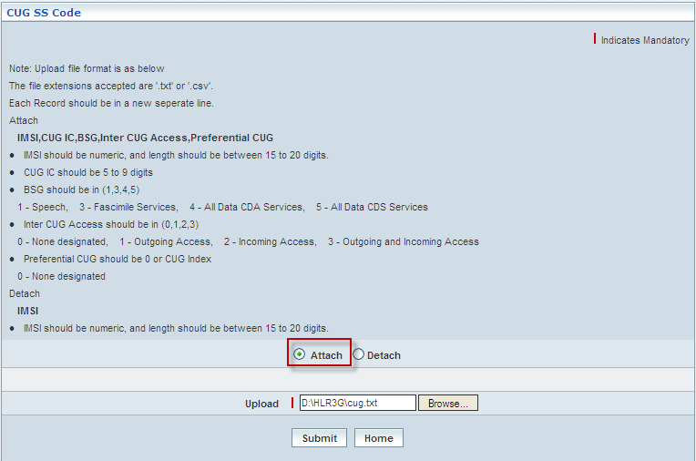

| **STEP** | **ACTION** |
| --- | --- |
|  | Select radio option (**Attach** / **Detach**) to specify an action whether to attach or detach the services to the subscribers  First Case: **Attach** |
|  | Browse for a Flat file that consists of a set of IMSI, CUG IC, BSG, Inter CUG Access, Preferential CUG numbers (pertaining to subscribers in bulk) in a specific format and each one starting in a new line |
|  | On clicking the **Submit** button, a message window to that effect will be displayed confirming the successful upload    On clicking the **Home** button of the message window, it directs the user back to the ‘CUG SS Code’ Screen |
|  | On clicking the **Home** button (prior to upload of the flat file), it only redirects the user back to the ‘Attach / Detach SS Codes (Bulk)’ main page |

**CUG SS Code - Detach**

The screen below shows **detaching** the supplementary services from the existing services pertaining to a group of subscribers represented by way of their IMSI(s).

The below screen displays the detach of the CUG SS Code

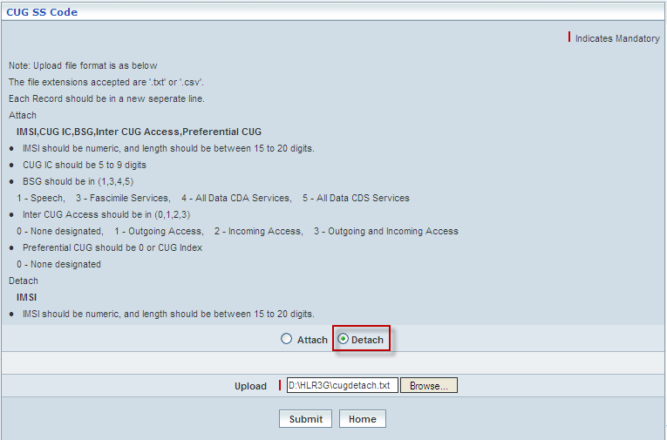

|  |  |
| --- | --- |
| **STEP** | **ACTION** |
|  | Select radio option (**Attach** / **Detach**) to specify an action whether to attach or detach the services to the subscribers  Second Case: **Detach** |
|  | Browse for a Flat file that consists of a set of IMSI, CUG IC, BSG, Inter CUG Access, Preferential CUG numbers (pertaining to subscribers in bulk) in a specific format and each one starting in a new line |
|  | On clicking the **Submit** button, a message window to that effect will be displayed confirming the successful upload    On clicking the **Home** button of the message window, it directs the user back to the ‘CUG SS Code’ Screen |
|  | On clicking the **Home** button (prior to upload of the flat file), it only redirects the user back to the ‘Attach / Detach SS Codes (Bulk)’ main page |

## Add / Remove Tele-Bearer (Bulk)

Home Location Register 🡪 Subscriber Management 🡪 Add / Remove Tele-Bearer (Bulk)

‘Add / Remove Tele Bearer (Bulk)’ helps the user to modify / update the existing configurations of the Tele Bearers services for a set of subscribers in bulk (at a stretch) where the network access mode is GSM. This screen also helps to modify / update the existing multi-numbered MSISDN.

If the GSM Profile of the subscriber includes Supplementary Service profile, it is mandatory to have the corresponding SS Codes of that profile to be retained while updating the services.

The screen below displays updating the configuration related to Tele Bearer services of a set of subscribers in bulk (at a stretch) – Add

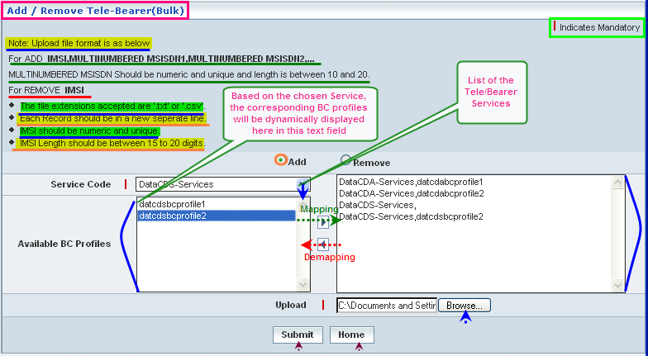

| **STEP** | **ACTION** |
| --- | --- |
|  | Choose the radio option Add / Remove as the case may be |
|  | **ADD Case:**  Select a service code from the drop-down list of the service codes from the <Service Codes> field  By default, the entire list of services (child services) will be dynamically displayed as drop-down list of the <Service Codes> field  With the effect of selecting a service, the corresponding list of BC profiles will be dynamically displayed in the <Available BC Profiles> text field |
|  | Select the desired BC Profile from the list **<Available BC Profiles>** and on clicking the right-arrow button, the BC Profile along with the Service Code (as a string) will be moved to the right text field  **NOTE:**   * Assigning BC Profiles with Service Code is not mandatory, it is only an option * Only **5** BC Profiles of a service code can be mapped   However if the user wants to remove any service (any time before attaching the services), selecting the service from the right text field and subsequently clicking the left-arrow button removes the service |
|  | Browse for a Flat file that consists of a set of records consisting of IMSI along with MSISDN multi-numbers (pertaining to subscribers in bulk) in a specific format and each one starting in a new line  **NOTE:**   * Associating multi-numbers to IMSI is not mandatory, it is only an option. Only IMSI(s) can be uploaded * Associating multi-number to IMSI will be assigned to services based on the order of mapped services |
|  | On clicking the **Submit** button, updates related to Tele Bearer Services will be carried out and a message window will be displayed to that effect    On clicking the **Home** button of the message window, it directs the user back to the ‘Add/Remove Tele Bearer (Bulk)’ screen |
|  | On clicking the **Home** button of the Add / Remove Tele Bearer (Bulk) screen, it directs the user to the ‘Subscriber Information’ main page |

The screen below displays updating the configuration related to Tele Bearer services of a set of subscribers in bulk (at a stretch) - Remove

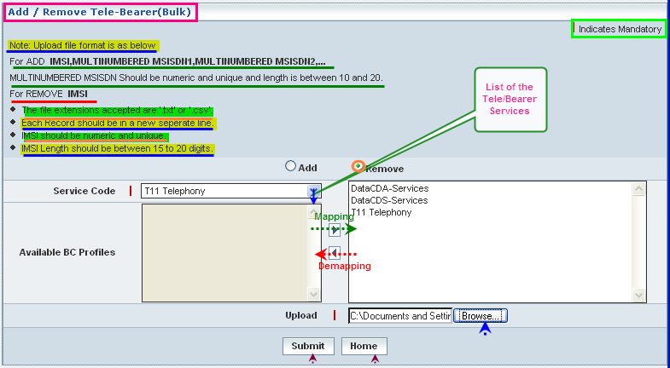

| **STEP** | **ACTION** |
| --- | --- |
|  | Choose the radio option Add / Remove as the case may be |
|  | **Remove Case:**  Select a service code from the drop-down list of the service codes from the <Service Codes> field  By default, the entire list of services (child services) will be dynamically displayed as drop-down list of the <Service Codes> field |
|  | On clicking the right-arrow button, the corresponding Service Codes (as a string) will be moved to the right text field  However if the user wants to remove any service (any time before attaching the services), selecting the service from the right text field and subsequently clicking the left-arrow button removes the service |
|  | Browse for a Flat file that consists of a set of records consisting of IMSI (pertaining to subscribers in bulk) in a specific format and each one starting in a new line |
|  | On clicking the **Submit** button, updates related to Tele Bearer Services will be carried out and a message window will be displayed to that effect    On clicking the **Home** button of the message window, it directs the user back to the ‘Add/Remove Tele Bearer (Bulk)’ screen |
|  | On clicking the **Home** button of the Add / Remove Tele Bearer (Bulk) screen, it directs the user to the ‘Subscriber Information’ main page |

## Subscriber Information

Home Location Register 🡪 Subscriber Management 🡪 Subscriber Information

‘Subscriber Information’ helps the user perusing details (certain standard information) like Basic Details of the chosen subscriber and helps providing various services through the corresponding navigation screens. The services include ‘Supplementary Services’, ‘Operator Determined Barring’, ‘Modify CSI Flags & State’, ‘Change IMSI’, ‘Add/Change MSISDN’, ‘Deactivate GSM Subscription’, ‘Attach / Detach SS Codes’, ‘OCSI Number Criteria’, ‘Provision/Modify GPRS’, ‘Trace Active’, ‘GSM Tele-Bearer Services’, ‘Multi-Numbered MSISDNs’, ’MOLR Capability’, ‘Allowed VLR Profile’, ‘VPLMN Restriction’. ‘GSM SoLSA Data’ and ‘GSM RSZI Data’

Initially, it displays a screen enabling the user to enter an IMSI or the MSISDN (two options) to obtain the corresponding details.

The screen below shows entering the subscriber’s IMSI or MSISDN.

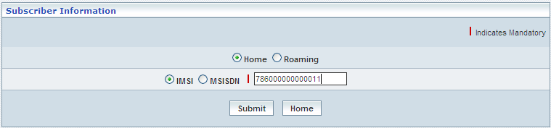

**Or**

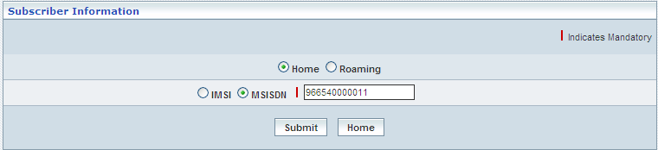

| **STEP** | **ACTION** |
| --- | --- |
|  | Select the radio option (Home/Roaming) to specify the subscriber identity reference (User Input - Reference) |
|  | Select the radio option (IMSI/MSISDN) to specify the subscriber identity reference (User Input - Reference) |
|  | Enter an IMSI number in the <IMSI> field or the MSISDN in the <MSISDN>, as the case may be |
|  | On clicking the **Submit** button, it displays the entire details related to the given subscriber in a different screen enabling the user to peruse the information accordingly  **NOTE:** Only the corresponding services (based on the given subscriber IMSI) will be displayed as discrete buttons just below the basic details |
|  | On clicking the **Home** button (prior to the submission of IMSI or MISISDN), it only redirects the user back to the ‘Subscriber Profile Management’ main page |

The screen below shows basic details and other information through the navigation buttons at the bottom of the screen.

The details and the navigation buttons at the bottom displayed on the screen depend on the type of profile (Home / Roaming) the subscriber is provisioned with.

However, the options and provisions of the features displayed as navigation buttons does not change for both the profiles.

* Supplementary Services
* Operator Determined Barring
* Modify CSI Flags & State
* Change IMSI
* Add/Change MSISDN
* Activate / Deactivate GSM Subscription
* Activate / Deactivate GPRS Subscription
* Attach / Detach SS Codes
* OCSI Number Criteria
* Provision / Modify GPRS
* Trace Active
* GSM Tele-Bearer Services
* Multi-Numbered MSISDN(s)
* MOLR CAPABALITY
* Allowed VLR Profile
* Allowed SGSN Profile
* VPLMN Restriction
* GSM SoLSA Data
* GPRS SoLSA Data
* GSM RSZI Data
* GPRS RSZI Data

The below screen displays the subscriber information under profile Home

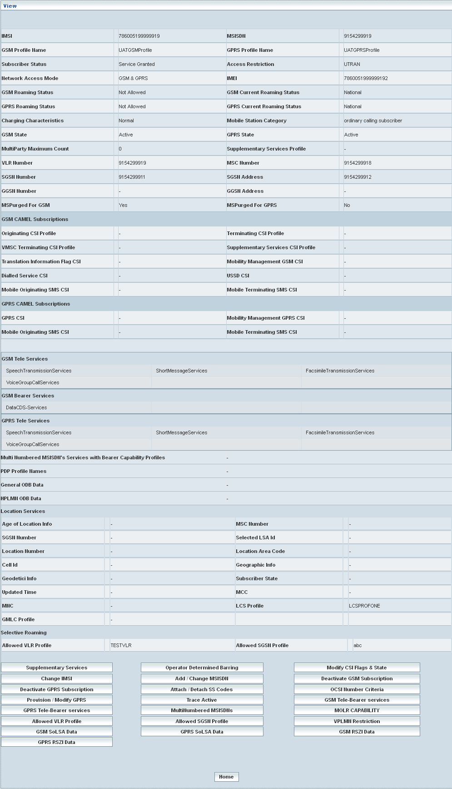

The below screen displays the subscriber information under profile Roam

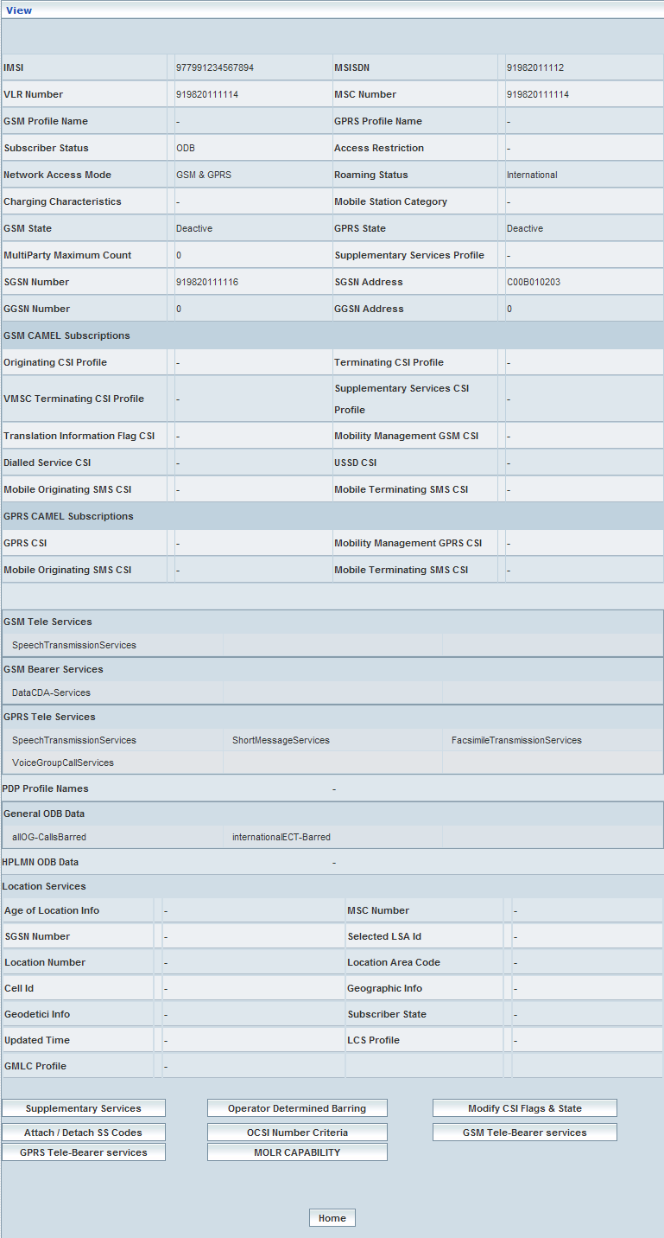

| **STEP** | **ACTION** |
| --- | --- |
|  | User can peruse basic details of the subscriber |
|  | On clicking the **Supplementary Services** button at the bottom of the screen, a navigation screen will be displayed enabling the user to obtain corresponding ‘Supplementary Services’ details accordingly |
|  | On clicking the **Operator Determined Barring** button, it displays the corresponding ‘Operator Determined Barring’ screen in a different screen enabling the user to bar certain services at runtime (to change the current barring and bar few other services) |
|  | On clicking the **Modify CSI Flags & State** button, it displays the presently configured values of the CSI Flags in a separate screen enabling the user to modify / update the values accordingly. |
|  | On clicking the **Change IMSI** button, it displays the present IMSI of the subscriber in a separate screen enabling the user to provide a new IMSI in place of the Old IMSI |
|  | On clicking the **Add/Change MSISDN** button, it displays the present MSISDN of the subscriber in a separate screen enabling the user to provide a new IMSI in place of the Old MSISDN |
|  | On clicking the **Deactivate GSM Subscription** button, it enables the user to change the status of a GSM subscriber from activation to deactivation |
|  | On clicking the **Attach/Detach SS Codes** button, it enables the user to attach or detach, as the case may be, certain services represented by way of SS Codes |
|  | On clicking the **OCSI Number Criteria** button, it enables the user to attribute an OCSI number that is a combined element of the following constituents.   * IMSI (International Mobile Subscriber Identifier) * Match Type * Destination Number Length(s) (Respectively for the count of numbers configured) * Corresponding Destination Numbers (as configured) |
|  | On clicking the **Provision/Modify GPRS** button, it enables the user provisioning or modifying GPRS service to a GSM service |
|  | On clicking the **Trace Active** button, it enables the user to modify / update Trace Active services |
|  | On clicking the **GSM Tele-Bearer Services** button, it enables the user to modify / update GSM Tele-Bearer services |
|  | On clicking the **MultiNumbered MSISND’s** button, it enables the user to provide multi-numbered MSISDN(s) |
|  | On clicking the **MOLR CAPABILITY** button, it enables the user to modify / update MOLR Capability services |
|  | On clicking the **Allowed VLR Profile** button, it enables the user to modify / update Allowed VLR profile |
|  | On clicking the **VPLMN Restriction** button, it enables the user to create and modify/update the VPLMN Restriction details |
|  | On clicking the **GSM SoLSA Data** button, it enables the user to manually modify/update the GSM SoSLA Data details |
|  | On clicking the **GSM RSZI Data** button, it enables the user to manually modify/update the GSM RSZI details |
|  | On clicking the **Home** button of the ‘Subscriber Details’ screen, it only redirects the user back to the ‘Subscriber Information’ screen |

**Supplementary Services**

On clicking the ‘Supplementary Services’ button at the bottom of the screen, a navigation screen will be displayed enabling the user to obtain corresponding supplementary services’ details accordingly. Supplementary Services include:

* + Call Barring
  + Call Forwarding
  + Line Identify
  + Call Completion
  + Others (Other Services)
  + Call Charging
  + LCS Services
  + PLMN Specific SS
  + Communication of Interest

The screen below is the navigation screen to peruse various Supplementary Services of the chosen subscriber.

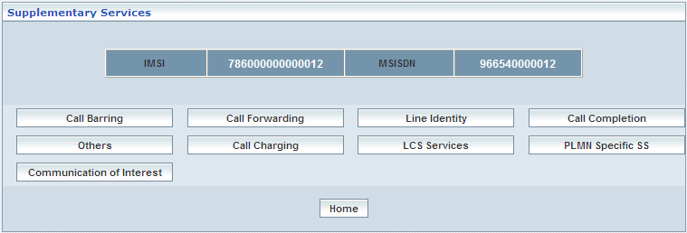

| **STEP** | **ACTION** |
| --- | --- |
|  | Corresponding IMSI & MSISDN of the Subscriber will be dynamically displayed in their respective fields |
|  | Details related to each of the supplementary services (Call Barring, Call Forwarding, Line Identity, Call Completion, Others, Call Charging, LCS Services, PLMN Specific SS and Communication of Interest) can be obtained in a separate screen by clicking the respective buttons  **NOTE:** If this subscriber had not been configured for any of these services, a message window will be displayed stating that this subscriber profile has not been configured for the chosen supplementary service and it directs the user to the corresponding service screen allowing the user to configure run-time  Wor83B  On clicking the **Home** button of the message window, it directs the user to the corresponding ‘Supplementary Services’ Screen |
|  | On clicking the **Home** button of the ‘Supplementary Services’ screen, it redirects the user back to the ‘Subscriber Information – View’ screen |

**Call Barring**

‘Call Barring’ helps the user in provisioning the ‘Call Barring’ service (a supplementary service – service different from default services and it is categorized as supplementary service) to a specific subscriber in contemplation with his/her respective IMSI.

The screen below shows configuring the **Call Barring – Details**.

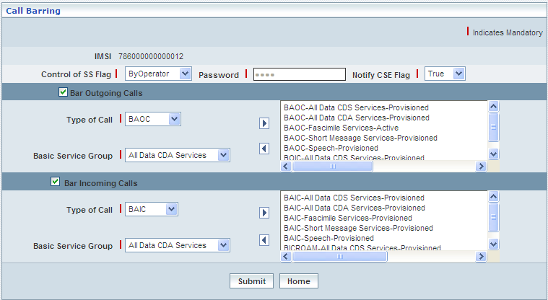

| **STEP** | **ACTION - Call Barring Details Screen** |
| --- | --- |
|  | Given IMSI number will be dynamically displayed in the <IMSI> field |
|  | Control of SS Flag:  Select an option (By Subscriber / By Operator) to specify the default option for the ‘Control of SS Flag’ element from the drop-down list of the <Control of SS Flag> field  **\*** By default, the options (By Subscriber / By Operator) will be dynamically displayed as drop-down list of the <Control of SS Flag> field  **NOTE:** **'Password'** field will be enabled only for **'By Subscriber'** Option  **‘By Operator’** Option does not require a password and hence, **'Password'** field will be disabled for **‘By Operator’** Option  If the chosen option for ‘Control of SS Flag’ is ‘By Subscriber user must enter a password in the <Password> filed  **NOTE:** Password must have 0000–9999 digits: only numeric |
|  | Notify CSE Flag:  User can specify a value (True / False) to indicate default value for the CSE Flag |
|  | **Bar Outgoing Calls:**  On selecting the ‘Bar Outgoing Calls’ check box, the corresponding fields will be enabled allowing the user to change the existing services |
|  | **\*** However, if the user submits the details without checking the Service blocks, all the pre-configured services shall be dynamically updated to the provisioned state |
|  | **To Map a service:**  Select a call type from the drop-down list of the <Type of Call> field  **\*** By default, the call types will be dynamically displayed as drop-down list of the <Type of Call> field |
|  | With the effect of selecting a call type, the corresponding BSG(s) will be dynamically displayed as a drop-down list of the <Basic Services Group> field |
|  | Select a service from the drop-down list of the <Basic Service Group> field |
|  | **[***The chosen service (BSG) that needs to be changed requires deletion from the services list in the right list field (pre-configured or existing services list).*  ***To remove a service:***  *Select the desired service from the right list field and subsequently clicking the left-arrow button removes the chosen service***]** |
|  | On clicking the right-arrow button, the mapped service details will be moved to the adjacent List field which is on right top of the ‘Bar Outgoing Calls’ Block  However, the password & Control of SS Flag details will be simultaneously moved to the List field at the bottom of the ‘Bar Outgoing Calls’ Block |
|  | **Bar Incoming Calls:**  User can also map the Bar Incoming Calls service in a similar fashion as mentioned above |
|  | On clicking the **Submit** button, Call Barring service shall be provisioned to the given IMSI and a message will be displayed to that effect    On clicking the **Home** button of the message window, it directs the user back to the ‘Supplementary Services’ screen |
|  | On clicking the **Home** button of the ‘Call Barring – Details’ screen (prior to submission of the Call Barring services), it only redirects the user back to the ‘Supplementary Services’ screen |

**Call Forwarding**

‘Call Forwarding’ helps the user in provisioning the ‘Call Forwarding’ service (a supplementary service – service different from default services and it is categorized as supplementary service) to a specific subscriber in contemplation with his/her respective IMSI.

The screen below shows configuring the **Call Forwarding – Details**.

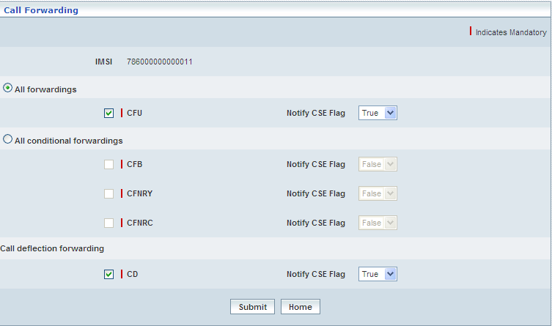

| **STEP** | **ACTION – Call Forwarding Details Screen** |
| --- | --- |
|  | Given IMSI number will be dynamically displayed in the <IMSI> field |
|  | There are 2 radio options, such as ‘All forwardings’ and ‘All conditional forwardings’. ‘All forwardings’, which in turn consists of ‘CFU’ (Call Forwarding Unconditional) option and ‘All conditional forwardings’, which in turn consists of ‘CFB’ (Call Forwarding on Busy), ‘CFNRY’ (Call Forwarding No Reply) and ‘CFNRC’ (Call Forwarding Not Reachable) and other option, such as ‘Call deflection forwarding’, which in turn consists of ‘CD’ (Call Deflection) |
|  | **All forwardings:**  On selecting ‘All forwardings’ radio button, ‘CFU’ sub-service gets enabled.  On selecting ‘CFU’ (Call Forwarding Unconditional) check-box, the ‘Call Forwarding’ related to ‘CFU’ gets displayed in separate screen |
|  | **To Map a service:**  Select a service group from the drop-down list of the <Basic Service Group> field  **\*** Based on the selection of Call Forwarding Type, only the corresponding BSG (Basic Services Group) services will be displayed as drop-down list <Basic Services Group> field |
|  | **[***The chosen service (BSG) that needs to be changed requires deletion from the services list in the right list field (pre-configured or existing services list).*  ***To remove a service:***  *Select the desired service from the right list field and subsequently clicking the left-arrow button removes the chosen service***]** |
|  | Select status (Registered / Active) from the drop-down list of the <Status> field to specify service status  **\*** By default, the status options will be dynamically displayed as drop-down list of the <Status> field |
|  | **\*** By default, the FTN number is displayed in <Default FTN> field |
|  | **\*** By default, number to which the call would be forwarded to, as the case may be – will be dynamically displayed in the <Forwarded To Number> field |
|  | Enter a number indicating as alias (sub-address) to which the call would be forwarded to, as the case may be – in the <Forwarded To Sub-address> field  **NOTE:** Forward to sub-address feature is optional |
|  | **If the Sub-Address Type is:**  **NSAP:** Actual number submitted shall append with a standard tag and the given FTS value will be flipped accordingly to get stored in database |
|  | ***If FTS is even:***  **Example:**  FTS from GUI = 9949023009  DB = 08009994200390 |
|  | ***If FTS is odd:***  **Example:**  FTS from GUI = 99490230091  --994902300910 (when FTS value is odd, **‘0’** will be appended to the given FTS value)  DB = 0800999420039001 |
|  | **User Specific:** Actual number submitted shall append with a standard tag and the given FTS value will be flipped accordingly to get stored in database |
|  | ***If FTS is even:***  **Example:**  FTS from GUI = 9949023009  DB = 0:9949023009 |
|  | ***If FTS is odd:***  **Example:**  FTS from GUI = 994902399  --994902300910 (when FTS value is odd, **‘0’** will be appended to the given FTS value)  DB = 8:9949023990 |
|  | Select a value (Yes / No) to specify the default value for the ‘Notify Forwarding Party’ element from the drop-down list of the <Notify Forwarding Party> field  **\*** By default, the values (Yes/No) will be dynamically displayed as drop-down list of the <Notify Forwarding Party> field |
|  | Select a value (Yes / No) to specify the default value for the ‘Redirecting Presentation’ element from the drop-down list of the <Redirecting Presentation> field  **\*** By default, the values (Yes/No) will be dynamically displayed as drop-down list of the <Redirecting Presentation> field |
|  | Select a value (Yes / No) to specify the default value for the ‘Notify Calling Party’ element from the drop-down list of the <Notify Calling Party> field  **\*** By default, the values (Yes/No) will be dynamically displayed as drop-down list of the <Notify Calling Party> field |
|  | On clicking the right-arrow button, the mapped service details will be moved to the adjacent List field which is on to the right side of the screen |
|  | On clicking the **Save** button, configured services will be saved and stored internally |
|  | On clicking the **Close** button (prior to configuration of services), it directs the user back to the ‘Call Forwarding - Details ’ screen |
|  | Select a value (Yes / No) to specify the default value for the ‘Notify CSE’ element from the drop-down list of the <Notify CSE Flag> field  **\*** By default, the values (Yes/No) will be dynamically displayed as drop-down list of the <Notify CCE Flag> field |
|  | **All conditional forwardings:**  On selecting ‘All conditional forwardings’ radio button, ‘CFB’ (Call Forwarding on Busy), ‘CFNRY’ (Call Forwarding No Reply) and ‘CFNRC’ (Call Forwarding Not Reachable) sub-services gets enabled.  On selecting ‘CFB’, ‘CFNRY’ or ‘CFNRC’ checkboxes, its related details are displayed in separate screen  **NOTE:** The data entry for these three options is same as above, which is described for ‘CFU’ and click **Save** button to save the data. |
|  | **Call deflection forwarding:**  In this deflection, only one options, such as ‘CD’ is available.  On selecting the **CD** (*Call Deflection)* of the ‘**Call deflection forwarding’**, however subject to the chosen option, the corresponding details related to conditional sub-services will be dynamically displayed in a separate screen enabling the user to configure services    **NOTE:** The data entry for this ‘CD’ is also same as above, which is described for ‘CFU’ and click **Save** button to save the data. |
|  | On clicking the **Submit** button, Call Forwarding service shall be provisioned to the given IMSI and a message will be displayed to that effect    On clicking the **Home** button of the message window, it directs the user back to the ‘Supplementary Services’ screen |
|  | On clicking the **Home** button of the ‘Call Forwarding’ screen (prior to submission of the Call Forwarding services), it only redirects the user back to the ‘Supplementary Services’ main page |

**Line Identity**

‘Line Identity’ helps the user in provisioning the ‘Line Identity’ service (a supplementary service – service different from default services and it is categorized as supplementary service) to a specific subscriber in contemplation with his/her respective IMSI.

The screen below shows configuring the **Line Identity – Details**.

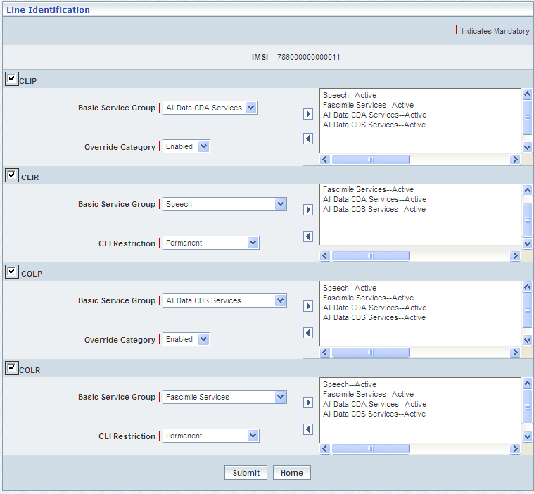

| **STEP** | **ACTION – Line Identity Details Screen** |
| --- | --- |
|  | Given IMSI number will be dynamically displayed in the <IMSI> field |
|  | **Calling Line Identification Presentation (CLIP):**  On the ‘Calling Line Identification Presentation’check box, the corresponding fields will be enabled allowing the user to change the existing services |
|  | **\*** However, if the user submits the details without checking the Service blocks, all the pre-configured services shall be dynamically updated to the provisioned state |
|  | **To Map a service:**  Select a service group from the drop-down list of the <Basic Service Group> field  **\*** Based on the selection of ‘Calling Line Identification Presentation’, only the corresponding BSG (Basic Services Group) services will be displayed as drop-down list <Basic Services Group> field |
|  | **[***The chosen service (BSG) that needs to be changed requires deletion from the services list in the right list field (pre-configured or existing services list).*  ***To remove a service:***  *Select the desired service from the right list field and subsequently clicking the left-arrow button removes the chosen service***]**  All Line Identity supplementary service basic service groups’ status is always active. |
|  | If CLIP and COLP are being selected, CLI restrictions will not be applicable. For CLIR & CLOR a default value for Override Category (Enabled / Disabled) from the drop-down list of the <CLI Restrictions> field  **\*** By default, the Override Category options will be dynamically displayed as drop-down list of the <Override Category> field |
|  | If CLIR and COLR are being selected, Override Category will not be applicable. For CLIP & CLOP Select a default value for CLI Restriction (Permanent/ TempDefaultRestriction/TempDefaultAllowed) from the drop-down list of the <CLI Restriction> field  **\*** By default, the CLI Restriction options will be dynamically displayed as drop-down list of the <CLI Restriction> field |
|  | On clicking the right-arrow button, the mapped service details will be moved to the adjacent List field which is on to the right side of the ‘Calling Line Identification Presentation’ Block |
|  | **Calling Line Identification Restriction (CLIR)**  User can map the above said services also in a similar fashion as mentioned above |
|  | **Connected Line Identification Presentation (COLP)**  User can map the above said services also in a similar fashion as mentioned above |
|  | **Connected Line Identification Restriction (COLR)**  User can map the above said services also in a similar fashion as mentioned above |
|  | On clicking the **Submit** button, Line Identity service shall be applied to the given IMSI and a message will be displayed to that effect    On clicking the **Home** button of the message window, it directs the user back to the ‘Supplementary Services’ screen |
|  | On clicking the **Home** button of the ‘Line Identification – Details’ screen (prior to submission of the Line Identity services), it only redirects the user back to the ‘Supplementary Services’ screen |

**Call Completion**

‘Call Completion’ helps the user in provisioning the ‘Call Completion’ service (a supplementary service – service different from default services and it is categorized as supplementary service) to a specific subscriber in contemplation with his/her respective IMSI.

The screen below shows configuring the **Call Completion – Details**.

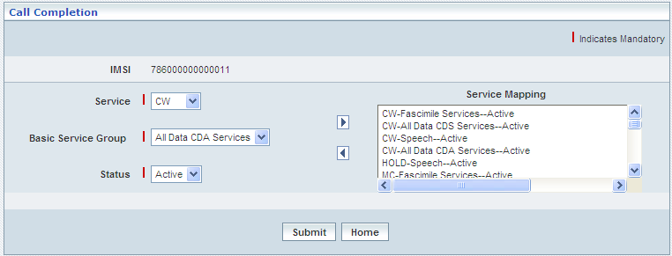

| **STEP** | **ACTION – Call Completion Details Screen** |
| --- | --- |
|  | Given IMSI number will be dynamically displayed in the <IMSI> field |
|  | **To Map a service:**  Select a service from the drop-down list of the <Service> field  **\*** Based on the selection of Service, only the corresponding BSG (Basic Services Group) services will be displayed as drop-down list <Basic Services Group> field |
|  | Select a Basic Service group from the drop-down list of the <Basic Service Group> field |
|  | * Select status (Active) from the drop-down list of the <Status> field for Call Wait Basic Service Groups. By default, the status options (Only Active in this case) will be dynamically displayed as drop-down list of the <Status> field. * NBR user value should be less than or equal to NBRSB value of System Parameters for Multi Call Supplementary services. NBR user value is same for all Multi call BSGs. |
|  | **[***The chosen service (BSG) that needs to be changed requires deletion from the services list in the right list field (pre-configured or existing services list).*  ***To remove a service:***  *Select the desired service from the right list field and subsequently clicking the left-arrow button removes the chosen service***]**  **\*** However, the SS Code ‘HOLD’ once mapped shall be constantly in active state and cannot be removed |
|  | On clicking the right arrow button, the mapped service details will be moved to the adjacent List field which is on to the right side. All Multi call BSGs status is always active or in withdrawal status. |
|  | On clicking the **Submit** button, Call Completion service shall be applied to the given IMSI and a message will be displayed to that effect    On clicking the **Home** button of the message window, it directs the user back to the ‘Supplementary Services’ screen |
|  | On clicking the **Home** button of the ‘Call Completion – Details’ screen (prior to submission of the Call Completion services), it only redirects the user back to the ‘Supplementary Services’ screen |

**Others (Other Supplementary Services)**

‘Other Supplementary Services’ helps the user in provisioning the ‘Other Supplementary Services’ (supplementary services – service different from default services and it is categorized as supplementary service) to a specific subscriber in contemplation with his/her respective IMSI.

The screen below shows configuring the **Other (Other Supplementary Services) – Details**.

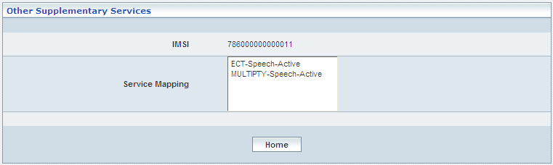

| **STEP** | **ACTION - Other Supplementary Services – Details Screen** |
| --- | --- |
|  | Given IMSI number will be dynamically displayed in the <IMSI> field |
|  | **Service Mapping:**  The listed services in the <Service Mapping> field are the configured supplementary services for the current subscriber. All corresponding Other Supplementary services are always active. |
|  | On clicking the **Home** button of the ‘Other Supplementary Services – Details’ screen it redirects the user back to the ‘Supplementary Services’ screen |

**Call Charging**

Call charging helps you to provisioning the call charging services, where you can view the services of the IMSI.

Services provides by the Call Charging:

1. AOCC - Advice of Charge Charging
2. AOCI - Advice of Charge Information

AOCC: - AoCC is a supplementary service that may be subscribed to enable a user to invoke AoC (Advice of Charge) on the MS (Mobile Station). The supplementary AoCC service is activated for every prepaid customer in the HLR, which will be used in call setup and tariff switching.

AOCI: Advice of Charge Information supplementary service permits the MS (Mobile Station) to display an accurate estimate of the size of the bill, which will eventually be levied in the HPLMN (Home Public Land Mobile Network).

The screen below shows configuring the **Call charges**

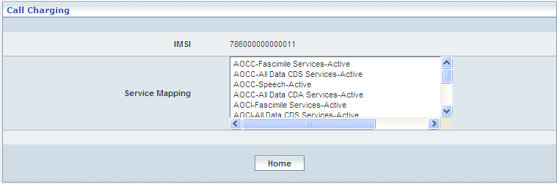

| **STEP** | **ACTION - Other Supplementary Services – Details Screen** |
| --- | --- |
|  | Given IMSI number will be dynamically displayed in the <IMSI> field |
|  | **Service Mapping:**  The listed services in the <Service Mapping> field are the configured supplementary services for the current subscriber. The AOCC and AOCI services are always the status is active. |
|  | On clicking the **Home** button of the ‘Call Charging – Details’ screen it redirects the user back to the ‘Supplementary Services’ screen |

**LCS Services**

LCS Services describes the list of LCS services for the IMSI. In profile level, if the LCS profile is selected, the same services of the profile will be available to the IMSI. User can modify the services at IMSI level. The services are universal, call/session related, call/session unrelated, PLMN operation class, service type, service identity.

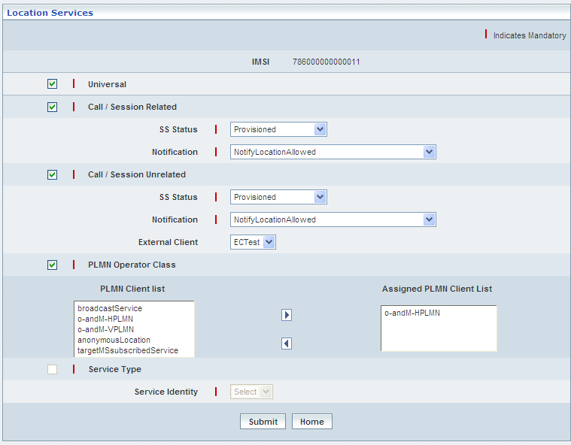

| **STEP** | **ACTION** |
| --- | --- |
|  | User must essentially enter the details related to a new profile where it is mandatory information. |
|  | LCS profile contains five SS codes including Universal, Call/Session Related, Call/Session Unrelated, PLMN Operator Class, and Service Type. User can either select Universal, Call/Session Related, Call/Session Unrelated, PLMN Operator Class or Service Type. |
|  | Given IMSI number will be dynamically displayed in the <IMSI> field |
|  | Select ‘Universal’. |
|  | Select ‘Call/Session Related’. The <SS Status> and <Notification> fields are activated only if the ‘Call/Session Related’ is selected. User has to enter the activated details. |
|  | Select ‘Call/Session Unrelated’. The <SS Status>, <Notification> and <External Client> fields are activated only if the ‘Call/Session Unrelated> is selected. User has to enter the activated details. |
|  | Select ‘PLMN Operator Class’. The list of <PLMN Client list> is activated. User has to map at least one PLMN client to the <Assigned PLMN Client List>. |
|  | Select ‘Service Type’. Choose the identity. User can choose the identity only if the service type is selected. User has to enter the activated details. |
|  | On clicking the **Submit** button, new profile (LCS) will be created and a message window to that effect will be displayed    On clicking the **Home** button of the message window, it directs the user back to the ‘Supplementary Services’ Screen |
|  | On clicking the **Home** button of the ‘Location Services’ screen (prior to submission of the Location services), it directs the user to ‘Supplementary Services’ screen |

**PLMN Specific SS**

PLMN Specific SS Services describes the list of PLMN Specific SS Codes services for the IMSI.

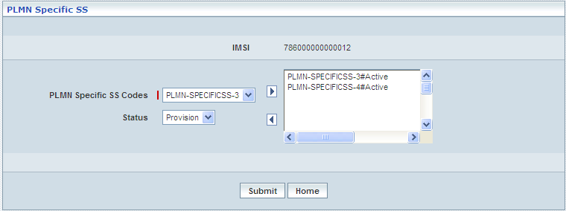

| **STEP** | **ACTION** |
| --- | --- |
|  | Given IMSI number will be dynamically displayed in the <IMSI> field |
|  | Select PLMN Specific SS codes from <PLMN Specific SS Codes> drop-down list |
|  | Select the status of the codes from <Status> drop-down list |
|  | On clicking the right-arrow button, the PLMN Specific SS codes along with the selected features will be moved to the adjacent field  **\*** There can be several PLMN Specific SS codes assigned and hence, user can enter the desired number of PLMN Specific SS codes in a similar fashion |
|  | However, if the user wants to remove a given PLMN Specific SS codes, selecting a string that needs to be removed from the list (of PLMN Specific SS codes) and subsequently clicking the left-arrow button removes the same |
|  | On clicking the **Submit** button, the PLMN Specific SS codes will be stored in the database. A message window will be displayed to that effect    On clicking the **Home** button of the message window, it redirects the user to the ‘PLMN Specific SS’ screen |
|  | On clicking the **Home** button of the ‘PLMN Specific SS’ screen (prior to submission of the PLMN Specific SS services), it directs the user to ‘Supplementary Services’ screen |

**Operator Determined Barring**

On clicking the **Operator Determined Barring** button; the corresponding screen will be displayed enabling the user to configure values to provide ‘Operator Determined Barring’ service.

The screen below shows the ‘Operator Determined Barring’, enabling the user to update Operator Determined Barring – services for the given subscriber

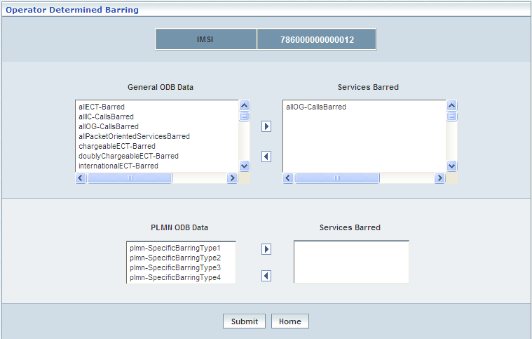

| **STEP** | **ACTION** |
| --- | --- |
|  | Given IMSI number will be dynamically displayed in the <IMSI> field |
|  | Currently barred services (Operator Determined Barring-Services) will be displayed in the ‘Operator Determined Barring’ screen |
|  | **NOTE:** However, if the user wants to update the barred services of the subscriber, it can be done in a similar fashion as explained above under the section ‘Operator Determined Barring’ – **Operator Determined Barring** (Click this hyperlink) |

**Modify CSI Flags & State**

On clicking the **Modify CSI Flags & State** button; the corresponding screen will be displayed enabling the user to modify / update the values related to CSI Flags of the chosen subscriber.

The screen below shows the presently configure values for CSI Flags enabling the user to update them accordingly.

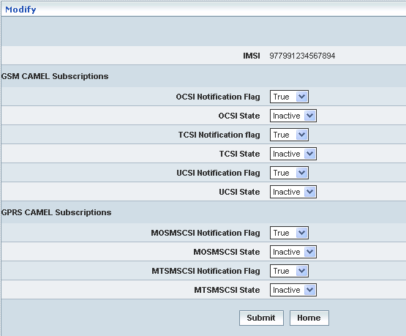

| **STEP** | **ACTION** |
| --- | --- |
|  | IMSI of the chosen subscriber will be dynamically displayed in the <IMSI> field  Based on the Subscriber’s CAMEL subscription (GSM / GPRS), only the corresponding notification elements will be dynamically displayed enabling the user to modify / update values accordingly |
|  | User can modify ‘CSI Flag’ (Notification & State) values as required |
|  | On clicking the **Submit** button, ‘CSI Flag’ will be updated with respect to the given IMSI. A message window will be displayed to that effect  Wor73  On clicking the **Home** button of the message window, it directs the user back to the ‘Subscriber Information - View’ screen |
|  | On clicking the **Home** button of the ‘Modify’ screen (prior to submission of updates), it only redirects the user back to the ‘Subscriber Information - View’ screen |

**Change IMSI**

On clicking the **Change IMSI** button; the corresponding screen will be displayed enabling the user to modify / update IMSI (number) of the chosen subscriber.

The screen below shows updating (changing) the IMSI of a chosen subscriber.

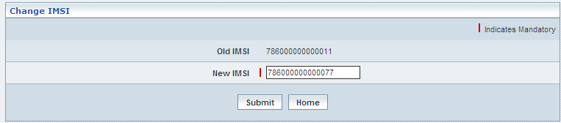

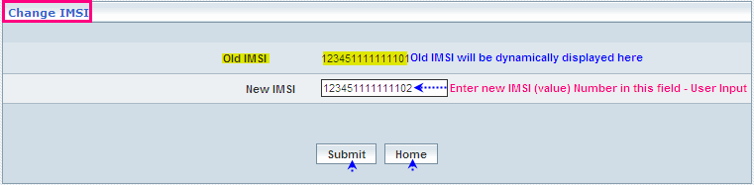

| **STEP** | **ACTION** |
| --- | --- |
|  | Current IMSI of the chosen subscriber will be dynamically displayed in the <Old IMSI> field |
|  | User can enter new IMSI (value) number in the <New IMSI> field  Authentication should be similar for new IMSI as that of the old IMSI |
|  | On clicking the **Submit** button, ‘New IMSI’ will be updated. A message window will be displayed to that effect  Wor7A  On clicking the **Home** button of the message window, it directs the user back to the ‘Subscriber Information - View’ screen |
|  | On clicking the **Home** button of the ‘Change IMSI’ screen (prior to submission of changed IMSI), it only redirects the user back to the ‘Subscriber Information - View’ screen |

**Add/Change MSISDN**

On clicking the **Add/Change MSISDN** button; the corresponding screen will be displayed enabling the user to add / modify / update MSISDN (number) of the chosen subscriber.

The screen below shows updating (changing) the MSISDN of a chosen subscriber.

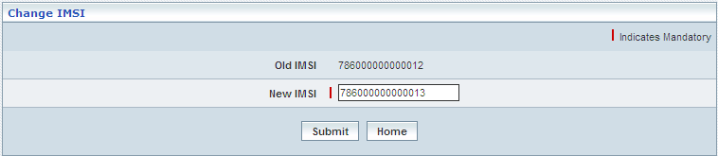

| **STEP** | **ACTION** |
| --- | --- |
|  | Current MSISDN of the chosen subscriber will be dynamically displayed in the <Old MSISDN> field  If the chosen subscriber does not have an MSISDN, user can add a new MSISDN |
|  | User can enter new MSISDN number in the <New MSISDN> field |
|  | On clicking the **Submit** button, ‘New MSISDN’ will be updated. A message window will be displayed to that effect  Wor7F  On clicking the **Home** button of the message window, it directs the user back to the ‘Subscriber Information - View’ screen |
|  | On clicking the **Home** button of the ‘Change IMSI’ screen (prior to submission of changed IMSI), it only redirects the user back to the ‘Subscriber Information - View’ screen |

**Activate / Deactivate GSM Subscription**

User can activate or deactivate the GSM subscription status of a subscriber.

The screen below shows updating (changing) the **Status** (activation / deactivation) of a GSM - subscriber.

This subscriber been in **active** state, **Activate GSM Subscription** button is displayed (by default initially) which enables the user to activate the subscriber.

The screen shows activating the GSM Subscription

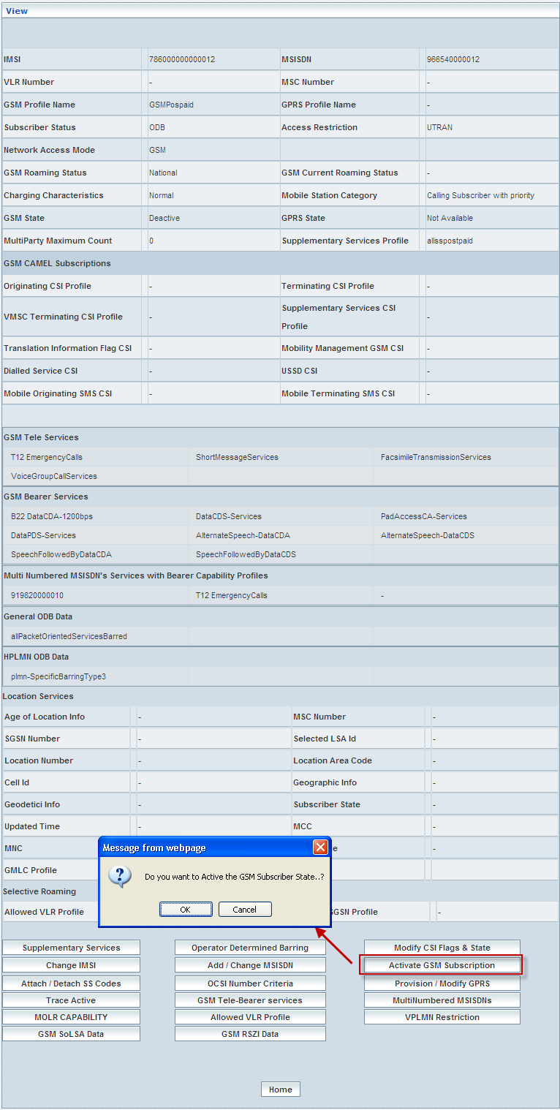

This subscriber been in **Inactive** state, **Activate GSM Subscription** button would have been displayed instead of **Deactivate GSM** **Subscription** button, which enables the user to deactivate the subscriber.

The screen shows deactivating the GSM Subscription

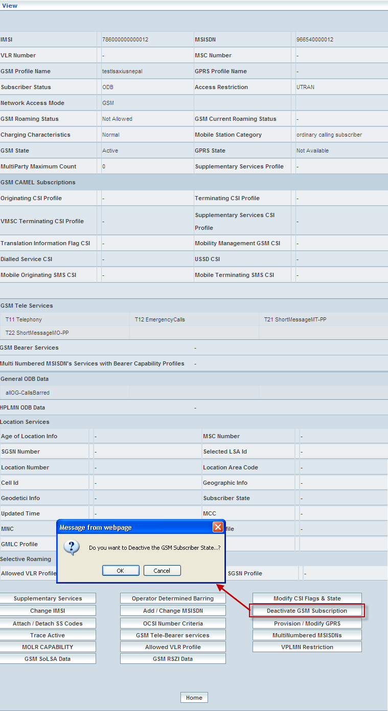

| **STEP** | **ACTION** |
| --- | --- |
|  | Present status (whether Active / Inactive) of the subscriber will be displayed in the <Subscriber State> field |
|  | On clicking the **Deactivate GSM Subscription** button; an alert message window will be displayed enabling the user to confirm status change of the chosen subscriber |
|  | On clicking the **OK** button of the alert message window, Subscriber Status will be updated (From '**Active**' to '**Inactive**' and '**Inactive**' to '**Active'** - as the case may be) accordingly. A message window will be displayed to that effect    On clicking the **Cancel** button of the alert message window, it retains the ‘Subscriber Information - View’ screen (without any changes made to the subscriber’s Status) |
|  | On clicking the **Home** button of the message window, it redirects the user back to the ‘Subscriber Information - View’ screen.  User can verify the changed Status (From '**Active**' to '**Inactive**' and '**Inactive**' to '**Active'** - as the case may be) of the subscriber accordingly in the <Subscriber State> field |

**Attach / Detach SS Codes**

Attaching the supplementary services refers to adding few more supplementary services in addition to the existing services of the chosen subscriber. Whereas, detaching the supplementary services refers to withdrawing certain services from the existing services of the subscriber. Attach and detach features shall be functioning independently but not together at a time.

Supplementary services here in this context have been indicated through SS Codes.

The screen below shows **attaching** the supplementary services to this chosen subscriber represented by way of his / her IMSI

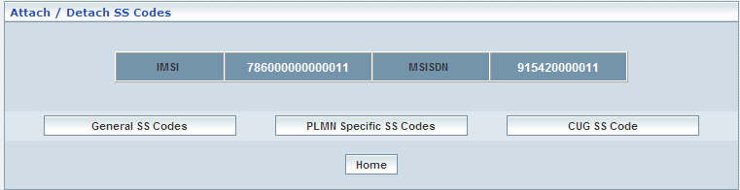

**General SS Codes**

The screen below shows attaching/uploading the General SS Codes

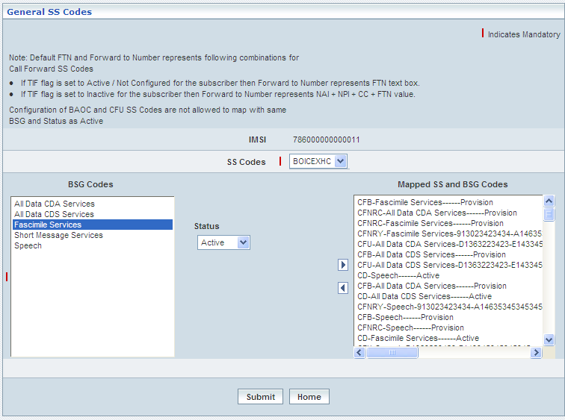

| **STEP** | **ACTION** |
| --- | --- |
|  | By default, IMSI number will be dynamically displayed in <IMSI> field |
|  | Select an SS Code from the drop-down list of the <SS Codes> field  **\*** By default, the list of SS Codes will be dynamically displayed as drop-down list of the <SS Codes> field |
|  | With the effect of selecting an SS Code, the corresponding list of basic services (group of services pertaining to the chosen SS Code) will be dynamically displayed in the <BSG Codes> list box, which is on to left side of the screen and its status, such as ‘Active’ and ‘Provision’ will also dynamically displayed in <Status> drop-down list and it gets enabled |
|  | Select the desired service from the <BSG codes> list and select the status from <Status> drop-down list and then click right-arrow button, the basic service along with (name of) the SS code, corresponding status and along with other configurations (if any) will be moved to the adjacent field  User can move the desired number of services from different Basic Services Groups belonging to different SS Codes in a similar fashion  However if the user wants to just remove any service (any time before attaching the services), selecting the service from the right text field and subsequently clicking the left-arrow button removes the service |
|  | On clicking the **Submit** button, a message window to that effect will be displayed confirming the updates to the supplementary services of the subscriber    On clicking the **Home** button of the message window, it redirects the user to the ‘General SS Codes’ screen |
|  | On clicking the **Home** button (prior attaching/uploading the General SS Codes), it only redirects the user back to the ‘Attach / Detach SS Codes’ main page |

**PLMN Specific SS Codes**

The screen below shows attaching/uploading the PLMN Specific SS Codes

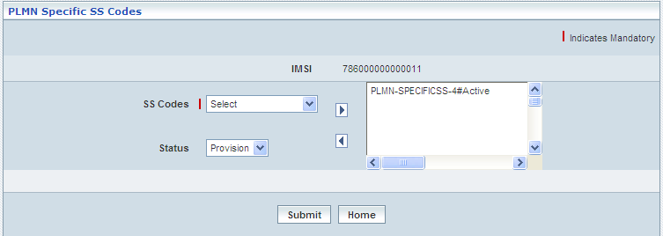

| **STEP** | **ACTION** |
| --- | --- |
|  | By default, IMSI number will be dynamically displayed in <IMSI> field |
|  | Select an SS Code from the drop-down list of the <SS Codes> field  **\*** By default, the list of SS Codes will be dynamically displayed as drop-down list of the <SS Codes> field |
|  | Select the status from <Status> drop-down list and then click right-arrow button, the basic service along with (name of) the SS code, corresponding status will be moved to the adjacent field  User can move the desired number of services from different Basic Services Groups belonging to different SS Codes in a similar fashion  However if the user wants to just remove any service (any time before attaching the services), selecting the service from the right text field and subsequently clicking the left-arrow button removes the service |
|  | On clicking the right-arrow button, the basic service along with (name of) the SS code, corresponding status and along with other configurations (if any) will be moved to the adjacent field  User can move the desired number of services from different Basic Services Groups belonging to different SS Codes in a similar fashion  However if the user wants to just remove any service (any time before attaching the services), selecting the service from the right text field and subsequently clicking the left-arrow button removes the service |
|  | On clicking the **Submit** button, a message window to that effect will be displayed confirming the updates to the supplementary services of the subscriber    On clicking the **Home** button of the message window, it directs the user back to the ‘PLMN Specific SS Codes’ Screen |
|  | On clicking the **Home** button (prior attaching/uploading the PLMN Specific SS Codes), it only redirects the user back to ‘Attach / Detach SS Codes’ main page |

**CUG SS Codes - Attach**

The screen below shows **attaching** the supplementary services to a group of subscribers represented by way of their IMSI(s).

The below screen displays the attach of the CUG SS Code

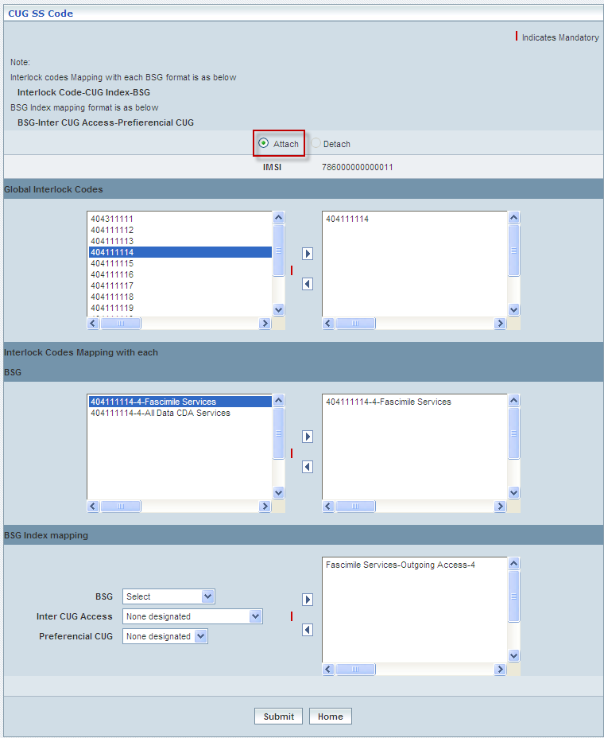

| **STEP** | **ACTION** |
| --- | --- |
|  | Select radio option (**Attach** / **Detach**) to specify an action whether to attach or detach the services to the subscribers  First Case: **Attach** |
|  | By default, IMSI number will be dynamically displayed in <IMSI> field |
|  | **Global Interlock Codes:**  Select the global interlock codes from the list and click right-arrow button, the global interlock codes will be moved to the adjacent field  However if the user wants to just remove the global interlock codes (any time before attaching the services), selecting the service from the right text field and subsequently clicking the left-arrow button removes the service |
|  | **Interlock Codes Mapping with each BSG:**  By default on selecting the Global Interlock Codes and mapping the same, its related details are displayed in this Block.  Select the interlock codes from the list and click right-arrow button, the interlock codes will be moved to the adjacent field  However if the user wants to just remove the interlock codes (any time before attaching the services), selecting the service from the right text field and subsequently clicking the left-arrow button removes the service |
|  | **BSG Index Mapping:**  Select BSG from <BSG> drop-down list,  Select Inter CUG Access from <Inter CUG Access> drop-down list,  Select Perferential CUG from <Perferential CUG>drop-down list and  click right-arrow button, to map atleast one BSG index mapping it will be moved to the adjacent field  However if the user wants to just remove the mapping gof BSG index (anytime before attaching the services), selecting the service from the right text field and subsequently clicking the left-arrow button removes the service |
|  | On clicking the **Submit** button, a message window to that effect will be displayed confirming the successful upload    On clicking the **Home** button of the message window, it directs the user back to the ‘CUG SS Code’ Screen |
|  | On clicking the **Home** button (prior to upload of the flat file), it only redirects the user back to the ‘Attach / Detach SS Codes (Bulk)’ main page |

**CUG SS Code - Detach**

The screen below shows **detaching** the supplementary services from the existing services pertaining to a group of subscribers represented by way of their IMSI(s).

The below screen displays the detach of the CUG SS Code

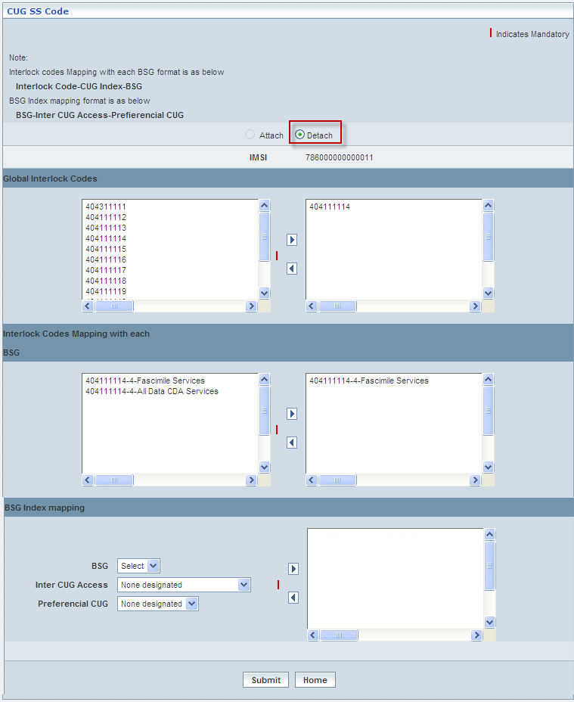

|  |  |
| --- | --- |
| **STEP** | **ACTION** |
|  | Select radio option (**Attach** / **Detach**) to specify an action whether to attach or detach the services to the subscribers  Second Case: **Detach** |
|  | By default, IMSI number will be dynamically displayed in <IMSI> field |
|  | Mapping of all the Block are dynamically displayed in their respected fields |
|  | On clicking the **Submit** button, a message window to that effect will be displayed confirming the successful upload    On clicking the **Home** button of the message window, it directs the user back to the ‘CUG SS Code’ Screen |
|  | On clicking the **Home** button (prior to upload of the flat file), it only redirects the user back to the ‘Attach / Detach SS Codes (Bulk)’ main page |

**OCSI Number Criteria**

‘OCSI Number Criteria’ helps the user in the following ways:

* View the current configuration details of the OCSI Number Criteria of the chosen subscriber
* Modify the existing configuration details of the OCSI Number Criteria of the chosen subscriber

OCSI number is a combined element of the following constituents.

* IMSI (International Mobile Subscriber Identifier)
* Match Type
* Destination Number Length(s) (Respectively for the count of numbers configured)
* Corresponding Destination Numbers (as configured)

Initially, it displays a screen enabling the user to select an option for viewing or updating the details related to OCSI criteria of the subscriber

The screen below shows choosing an option (View / Modify).

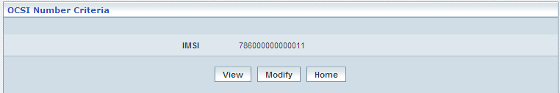

| **STEP** | **ACTION** |
| --- | --- |
|  | IMSI of the chosen subscriber will be dynamically displayed in the <IMSI> field |
|  | On clicking the **View** button, the corresponding details related to OCSI Number Criteria of the chosen subscriber will be displayed in a separate screen |
|  | On clicking the **Modify** button, the corresponding details related to OCSI Number Criteria of the chosen subscriber will be displayed in a separate screen, enabling the user to modify / update present configurations of the OCSI Number Criteria |
|  | On clicking the **Home** button (prior to view or modify), it redirects the user back to the ‘Subscriber Information’ main page |

**View**

The screen below shows details related to OCSI Number Criteria of the chosen subscriber.

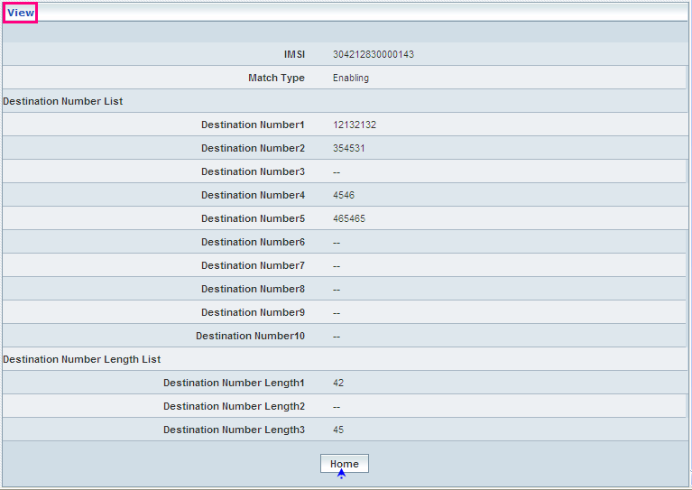

| **STEP** | **ACTION** |
| --- | --- |
|  | User can peruse details related to OCSI Number Criteria of the chosen subscriber |
|  | On clicking the **Home** button, it redirects the user back to the ‘OCSI Number Criteria’ main page |

**Modify**

The screen below shows updating the details related to OCSI Number Criteria of the chosen subscriber.

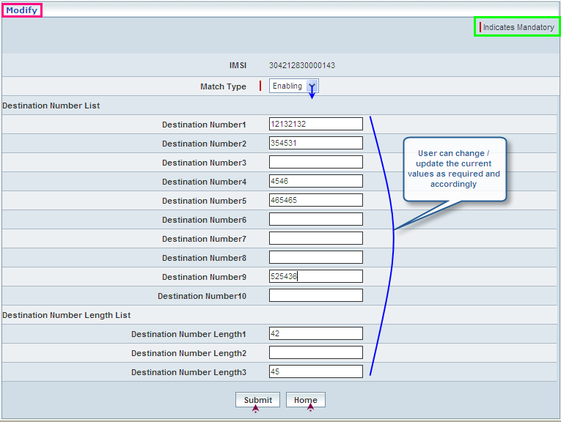

| **STEP** | **ACTION** |
| --- | --- |
|  | IMSI of the chosen subscriber will be dynamically displayed in the <IMSI> field |
|  | User can change match type value  Select the preferred match type from the drop-down list of the <Match Type> field |
|  | On clicking the **Submit** button, the corresponding details related to OCSI Number Criteria of the chosen subscriber will be updated and a message window will be displayed to that effect    On clicking the **Home** button of the message window, it redirects the user back to the ‘OCSI Number Criteria’ main page |
|  | On clicking the **Home** button (prior to view or modify), it redirects the user back to the ‘Subscriber Information’ main page |

**Provision / Modify GPRS**

‘Provision / Modify GPRS’ helps the user provisioning (new) or updating (existing) Profiles in contemplation with the corresponding PDP profiles of the chosen subscriber.

Provisioning of GPRS is applicable only to those subscribers belonging to the network access mode being 2 in terms of Authentication.

If both GSM and GPRS network access modes have been assigned to a subscriber, consequently, the corresponding Tele services of the selected GPRS profile must be the sub-set of the GSM Tele services.

The screen below shows provisioning / updating (as the case may be) the PDP profiles of the chosen subscriber.

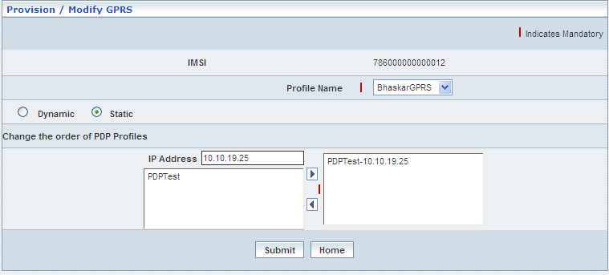

| **STEP** | **ACTION** |
| --- | --- |
|  | IMSI of the chosen subscriber will be dynamically displayed in the <IMSI> field |
|  | Select a profile from the drop down list of the <Profile Name> field |
|  | With the effect of choosing a specific profile, **Only** the corresponding PDP profiles will be dynamically displayed in the text field which is on to left side of the screen. These profiles have to be prioritized in a specific order based on the type (dynamic / static) of profiles composition |
|  | Select radio option (Dynamic / Static) to specify the nature of Profiles Composition |
|  | The option ‘Dynamic’ indicates random attribution of profiles to the GPRS Subscriber, whereas ‘Static’ indicates fixed / defined attribution of profiles |
|  | With the effect of choosing ‘Static’ Option, order prioritization of PDP profiles with respect to various IP Addresses becomes mandatory |
|  | Enter IP Address in the <IP Address> field |
|  | Select a Profile from the list of Profiles in the text field  **NOTE:** IP Address must be unique to each of those attributed Profiles |
|  | On clicking the right-arrow button, the combination of IP address and the chosen Profile (as a string) will be moved to the <Text Field> which is on to the right side of the screen  User can assign the required number of IP Addresses in a similar fashion  However if the user wants to remove an IP Address (any time before creating the Subscriber), selecting a combination from the right text field and subsequently clicking the left-arrow button removes the same  **NOTE:** Nevertheless, it is mandatory to prioritize the order of entire PDP Profiles (in contemplation with various/or similar IP Addresses) of the chosen Profile |
|  | On clicking the **Submit** button, provisioning GPRS / updating the GPRS Profiles related to the subscriber (as the case may be) will be carried out and a message window will be displayed to that effect  Error      On clicking the **Home** button of the message window, it directs the user back to the ‘Subscriber Information’ Screen |
|  | On clicking the **Home** button (before provisioning GPRS / updating the GPRS Profiles), it directs the user to the ‘Subscriber Management’ main page |

**Trace Active/Trace Deactive**

Trace Activity helps the users to modify/update the Trace type and HLR Trace type. It consists of two events—Event 1 and Event 2. The Event 1 includes the following events— MOC, MTC, SMS MO, SMS MT, PDS MO, PDS MT, SS, Location Updates, IMSI attach, and detach. The Event 2 includes the following events—MOC, MTC, SMS_MO, SMS_MT, PDS MO, PDS MT, and SS. By default, the Trace Active button is shown in subscriber information. One the trace is active, then the enables trace deactivate in the place of Trace active.

User can activate or deactivate the Trace Type and HLR Trace Type.

This trace type been in **active** state, **Trace Active** button is displayed (by default initially) which enables the user to activate the trace type and HLR trace type.

The screen shows activating the Trace Type and HLR Trace Type

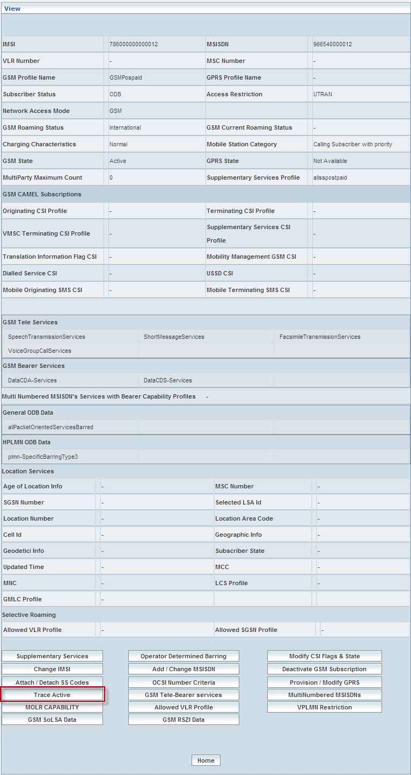

| **STEP** | **ACTION** |
| --- | --- |
|  | Present status (whether Active / Inactive) of the trace type will be displayed in the <Subscriber State> field |
|  | On clicking the **Trace** **Active** button; ‘Trace Active’ Screen will be displayed enabling the user to enter the details of the trace types |

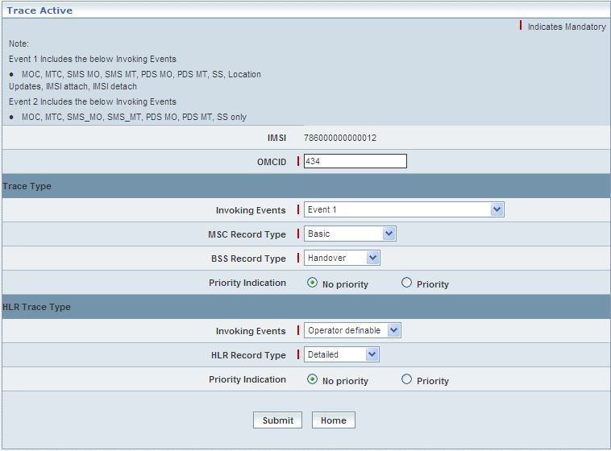

| **STEP** | **ACTION** |
| --- | --- |
|  | IMSI of the chosen subscriber will be dynamically displayed in the <IMSI> field |
|  | Enter OMCID number in the <OMCID> field |
|  | In **Trace Type**:  Select invoking events in the <Invoking Events> fields.  Select MSC record type in the <MSC Record Type> fields.  Select BSC record type in the <BSC Record Type> fields.  Choose Priority Indication, such as, No Priority or Priority. |
|  | In **HLR Trace Type**:  Select invoking events in the <Invoking Events> fields.  Select HLR record type in the <HLR Record Type> fields.  Choose Priority Indication, such as, No Priority or Priority. |
|  | On clicking the **Submit** button, the alert message window will be displayed  C:\DOCUME~1\rajini.sn\LOCALS~1\Temp\SNAGHTML18daab.PNG  On clicking the **OK** button of the alert message window, Trace Type will be activated. A message window will be displayed to that effect    On clicking the **Cancel** button of the alert message window, it retains the ‘Trace Active’ screen (without any changes made to the Trace Type)  On clicking the **Home** button of the message window, it directs the user back to the ‘Subscriber Information - View’ Screen |
|  | On clicking the **Home** button (before activating/deactivating the Trace type and HLR Trace Type.), it directs the user to the ‘Subscriber Management’ main page |

This subscriber been in **Inactive** state, **Trace Deactive** button would have been displayed instead of **Trace Active** button, which enables the user to deactivate the Trace Type and HLR Trace Type.

The screen shows deactivating the Trace Type and HLR Trace Type

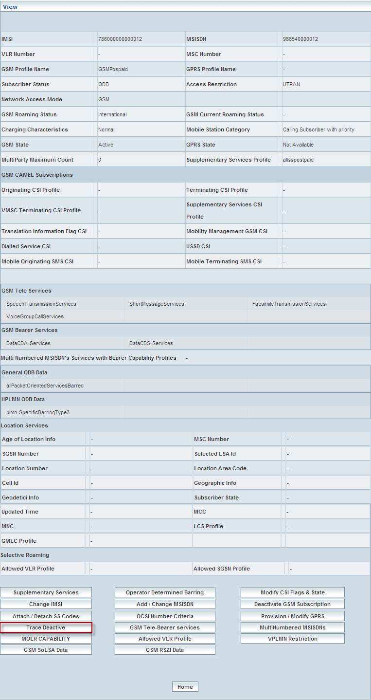

| **STEP** | **ACTION** |
| --- | --- |
|  | On clicking the **Trace Deactive** button, the alert message window will be displayed  C:\DOCUME~1\rajini.sn\LOCALS~1\Temp\SNAGHTML1b6686.PNG  On clicking the **OK** button of the alert message window, Trace Type will be deactivated. A message window will be displayed to that effect    On clicking the **Cancel** button of the alert message window, it retains the ‘Trace Active’ screen (without any changes made to the Trace Type)  On clicking the **Home** button of the message window, it directs the user back to the ‘Subscriber Information - View’ Screen |
|  | On clicking the **Home** button (before activating/deactivating the Trace type and HLR Trace Type.), it directs the user to the ‘Subscriber Management’ main page |

**GSM Tele-Bearer Services**

GSM Tele-Bearer Services helps the users to change the GSM Tele-Bearer Services

The screen shows changing GSM Tele-Bearer Services

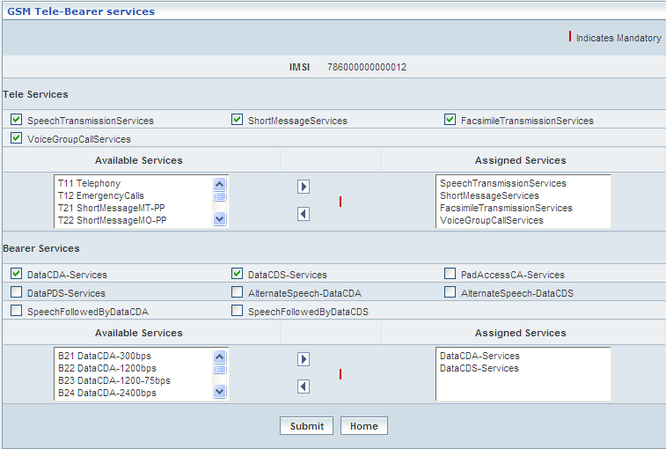

| **STEP** | **ACTION** |
| --- | --- |
|  | IMSI of the chosen subscriber will be dynamically displayed in the <IMSI> field |
|  | **Tele Services**  On selecting a specific Tele Service, the corresponding Parent services (as a string) will be dynamically moved to the **<Assigned Services>** text field below, which is on to the right side of the screen and the corresponding sub-services will be dynamically moved to the text field **<Available Services>** which is on to the left side of the screen |
|  | Select the desired sub service from the list **<Available Services>** and on clicking the right-arrow button, the sub-service (as a string) will be moved to the **<Assigned Services>** field and reckoned as an assigned service |
|  | However if the user wants to just remove any service (any time before creating the profile), selecting the service from the **<Assigned Services>** text field and subsequently clicking the left-arrow button removes the service |
|  | **Bearer Services**  On selecting a specific Bearer Service, the corresponding Parent services (as a string) will be dynamically moved to the **<Assigned Services>** text field below, which is on to the right side of the screen and the corresponding sub-services will be dynamically moved to the text field **<Available Services>** which is on to the left side of the screen |
|  | Select the desired sub service from the list **<Available Services>** and on clicking the right-arrow button, the sub-service (as a string) will be moved to the **<Assigned Services>** field and reckoned as an assigned service |
|  | However if the user wants to just remove any service (any time before creating the profile), selecting the service from the **<Assigned Services>** text field and subsequently clicking the left-arrow button removes the service |
|  | On clicking the **Submit** button, provisioning GSM changing Tele-Bearer Services related to the subscriber (as the case may be) will be carried out and a message window will be displayed to that effect    On clicking the **Home** button of the message window, it directs the user back to the ‘GSM Tele-Bearer Services’ Screen |
|  | On clicking the **Home** button (before changing the GSM Tele-Bearer Services.), it directs the user to the ‘Subscriber Management’ main page |

**MultiNumbered MSISDN(s)**

‘MultiNumbered MSISDN(S)’ helps the user to provide multiple MSISDN attributing to the subscriber’s IMSI to represent discrete services.

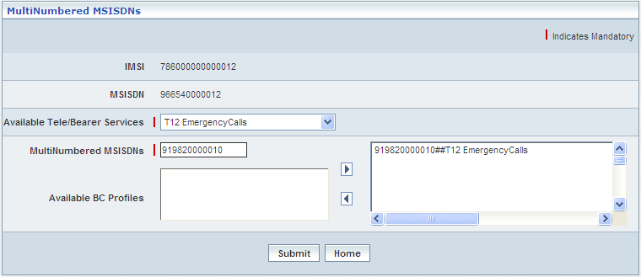

| **STEP** | **ACTION** |
| --- | --- |
|  | IMSI & MSISDN of the chosen subscriber will be dynamically displayed in their respective fields <IMSI> & <MSISDN> fields |
|  | Select a Tele Bearer service from the drop-down list of the <Available TeleBearer Services> field  Only those sub-services belonging to the attributed GSM Tele Bearer services of the Subscriber will be displayed here. |
|  | With the effect of selecting a GSM Tele Bearer service, the corresponding list of BC Profiles (**if any**) will be dynamically displayed in the **<Available BC Profiles>** text field below, which is on to the left side of the screen |
|  | Enter MSISDN (additional and other than basic MSISDN) in the <MultiNumbered MSISDNs> field  **NOTE:** Given MSISDN must be the constituent of the Configured series |
|  | Select the desired BC Profile from the list **<Available BC Profiles>** and on clicking the right-arrow button, the components as multinumber MSISDN-BC Profile-Tele Bearer service (as a string) will be moved to the adjacent text field and reckoned as an assigned service to the give additional (multinumber) MSISDN  User can assign one multinumber MSISDN to only one service  Maximum **5** BC Profiles pertaining to a specific teleservice can be mapped to discrete multinumber MSISDN(s) |
|  | On clicking the **Submit** button, provisioning / updating services to various multinumber MSISDN(s) will be carried out and a message window will be displayed to that effect    On clicking the **Home** button of the message window, it directs the user back to the ‘MultiNumber MSISDN(s)’ screen |
|  | On clicking the **Home** button, (before provide multiple MSISDN attributing to the subscriber’s IMSI) it directs the user to the ‘Subscriber Information’ main page |

**MOLR CAPABILITY**

‘MOLR CAPABILITY’ helps the user to provide supplementary service name (allMOLR-SS,basicSelfLocation, and transfer to third party) and SS Status (Non provisioned, provisioned, and Active & Operative) combination to the subscriber. User can modify the Supplementary Service Name and SS Status. The mapped services (In combination of both) should be unique.

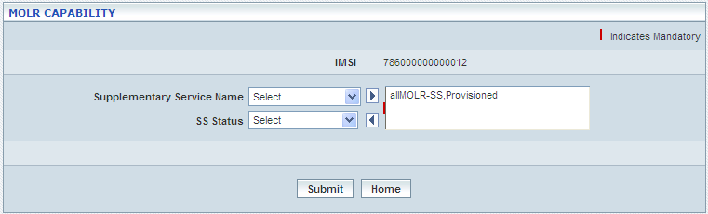

| **STEP** | **ACTION** |
| --- | --- |
|  | IMSI & MSISDN of the chosen subscriber will be dynamically displayed in their respective fields <IMSI> & <MSISDN> fields |
|  | Select the supplementary service name the <Supplementary Service Name> field. |
|  | Select the SS status the <SS Status> field. |
|  | On clicking the right-arrow button, the selected service (as a string) will be moved to the <Text Field> which is on to the right side of the screen  However if the user wants to just remove any service, selecting the service from the right text field and subsequently clicking the left-arrow button removes the service. |
|  | On clicking the **Submit** button, MOLR capability is assigned to the subscriber and a message window to that effect will be displayed    On clicking the **Home** button of the message window, it directs the user back to the ‘MOLR CAPABILITY’ screen |
|  | On clicking the **Home** button, (before modify the Supplementary Service Name and SS Status) it directs the user to the ‘Subscriber Information’ main page |

**Allowed VLR Profile**

Allowed VLR Profile helps the user to provide profile name and available VLR profiles to the subscriber’s IMSI to represent discrete services. User can view and modify the VLR profiles. The service is available only when the network access mode is GSM or GSM &GPRS.

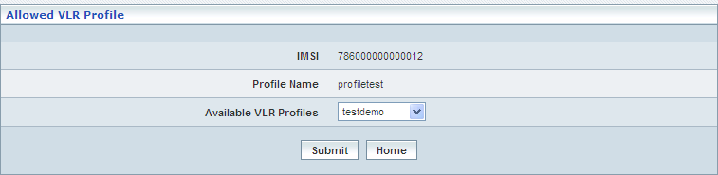

| **STEP** | **ACTION** |
| --- | --- |
|  | IMSI of the chosen subscriber will be dynamically displayed in their respective <IMSI> field |
|  | Selected VLR Profile Name will be dynamically displayed in <Profile Name> field |
|  | Select the available VLR profile from <Available VLR Profiles> field. |
|  | On clicking the **Submit** button, changes the service profile and a message window will be displayed to that effect    On clicking the **Home** button of the message window, it directs the user back to the ‘Allowed VLR Profile’ screen - view |
|  | On clicking the **Home** button, it directs the user to the ‘Subscriber Information - View’ main page |

**VPLMN Restriction**

VPLMN (Visited Public Land Mobile Network) Restriction module enables the user to manually create and modify/update the VPLMN Restriction details

**NOTE:** Initially, if the VPLMN Restriction details are not present, then the user is allowed to create a new VPLMN Restriction. If they already exist, then the user is allowed to modify the VPLMN Restriction details.

**Create**

This section helps the users to create a new VPLMN Restriction.

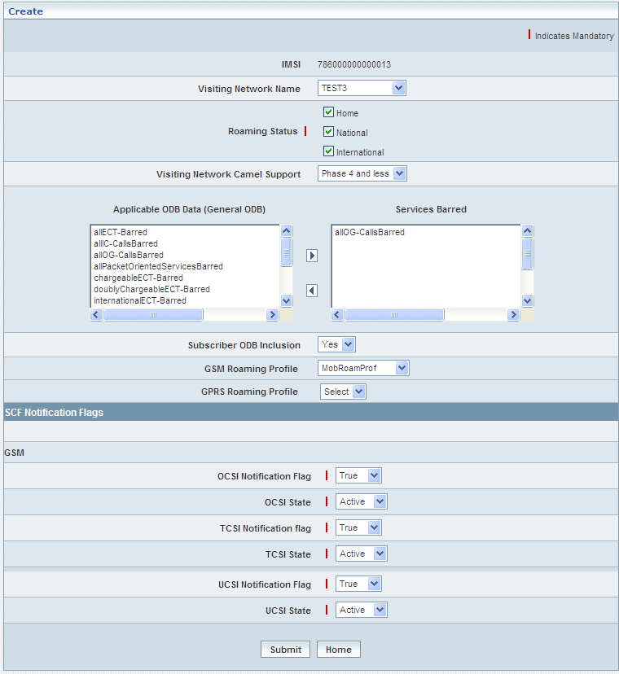

| **STEP** | **ACTION** |
| --- | --- |
|  | IMSI of the chosen subscriber will be dynamically displayed in their respective <IMSI> field |
|  | **NOTE:** However, if the user wants to create update a new VPLMN Restriction, it can be done in a similar fashion as explained above under the section ‘VPLMN Restriction’ – **VPLMN Restriction** (Click this hyperlink) |

**Modify**

This section helps the users to modify the existing VPLMN Restriction details.

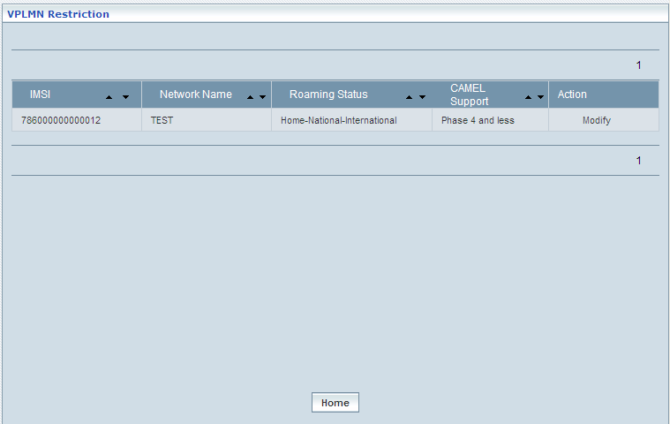

| **STEP** | **ACTION** |
| --- | --- |
|  | By default, the list of VPLMN Restriction created will be displayed as records in a grid. The columns include ‘IMSI’, ‘Network Name’, ‘Roaming Status’, ‘CAMEL Support’ and ‘Action’ |
|  | On clicking the **Modify** link, ‘Modify’ screen will be displayed enabling the user to update / change corresponding values (as required) of a chosen VPLMN Restriction |
|  | On clicking the **Home** button at the bottom of the grid, (before modifying VPLM Restriction) it redirects the user to the ‘Subscriber Information - View‘ main page |

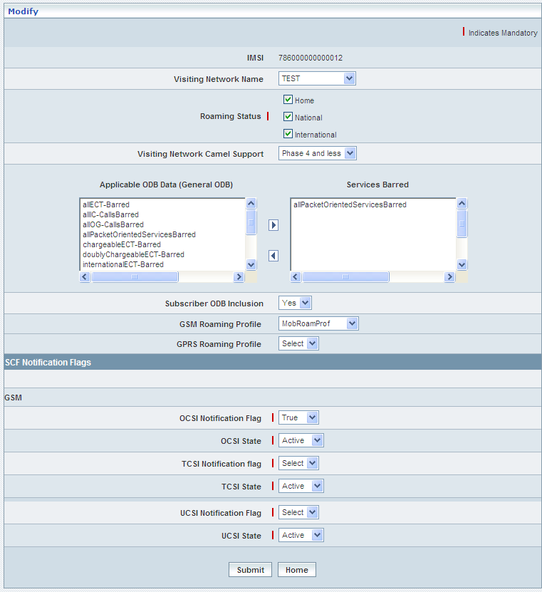

| **STEP** | **ACTION** |
| --- | --- |
|  | IMSI of the chosen subscriber will be dynamically displayed in their respective <IMSI> field |
|  | User can make necessary changes related to VPLMN Restriction |
|  | On clicking the **Submit** button, the changes made will be updated accordingly in the database. A message window will be displayed to that effect    On clicking the **Home** button of the message window, it redirects the user to the ‘VPLMN Restriction’ grid |
|  | On clicking the **Home** button at the bottom of the grid, (before modifying VPLM Restriction) it redirects the user to the ‘Subscriber Information - View‘ main page |

**GSM SoLSA Data**

GSM Special Services (SoLSA - Support Of Location Service Area) Data module enables the user to manually modify/update the GSM SoSLA Data details

This section helps the users to modify/update the existing GSM SoSLA Data details.

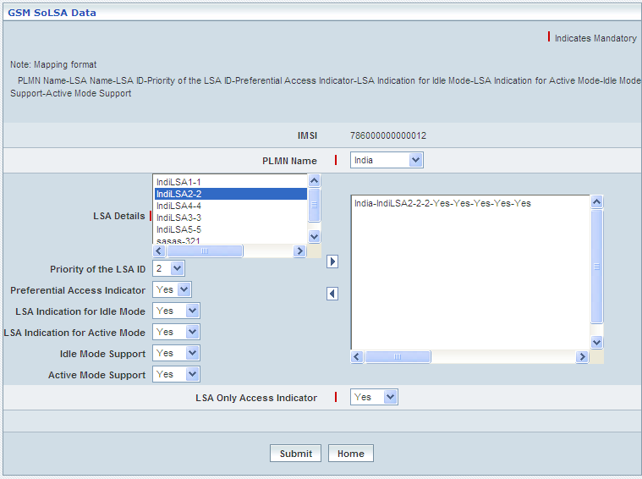

| **STEP** | **ACTION** |
| --- | --- |
|  | IMSI of the chosen subscriber will be dynamically displayed in their respective <IMSI> field |
|  | Select the PLMN Name in <PLMN Name> field.  **NOTE:** The selected <PLMN Name> related LSA details are dynamically displayed in <LSA Details> list box |
|  | Select the priority of the LSA ID number from <Priority of the LSA ID> drop-down list |
|  | Set the preferential access indicator to ‘Yes’ or ‘No’ from <Preferential Access Indicator> drop-down list |
|  | Set the LSA indication for idle mode to ‘Yes’ or ‘No’ from <LSA Indication for Idle Mode> drop-down list |
|  | Set the LSA indication for active mode to ‘Yes’ or ‘No’ from <LSA Indication for Active Mode> drop-down list |
|  | Set the idle mode support to ‘Yes’ or ‘No’ from <Idle Mode Support> drop-down list |
|  | Set the active mode support to ‘Yes’ or ‘No’ from <Active Mode Support> drop-down list |
|  | Set the LSA only access indicator to ‘Yes’ or ‘No’ from < LSA only access indicator> drop-down list |
|  | On clicking  button allows the user to map atleast one LSA configuration to the selected PLMN and it moves to the adjacent field. On clicking  the user can perform un-mapping at least one LSA configuration and vice versa. |
|  | On clicking the **Submit** button, the changes made will be updated accordingly in the database. A message window will be displayed to that effect    On clicking the **Home** button of the message window, it redirects the user to the ‘GSM SoLSA Data’ Screen |
|  | On clicking the **Home** button at the bottom, (before modifying GSM SoLSA Data details) it redirects the user to the ‘Subscriber Information - View‘ main page |

**GSM RSZI**

GSM RSZI (RSZI - Regional Subscription Zone Identity) module enables the user to manually modify/update the GSM RSZI details

This section helps the users to modify/update the existing GSM RSZI details.

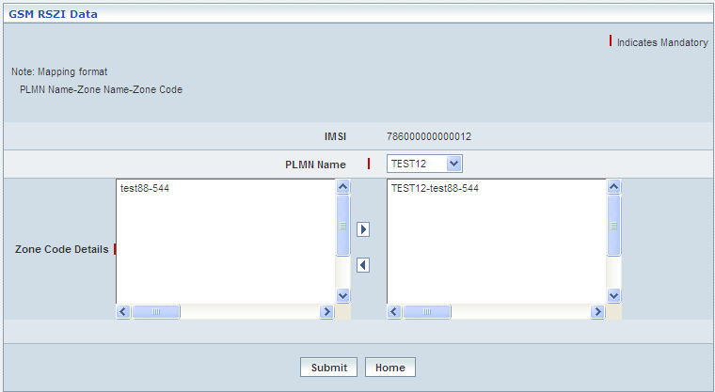

| **STEP** | **ACTION** |
| --- | --- |
|  | IMSI of the chosen subscriber will be dynamically displayed in their respective <IMSI> field |
|  | Select the PLMN Name in <PLMN Name> field.  **NOTE:** The selected <PLMN Name> related Zone Code details are dynamically displayed in <Zone Code Details> list box |
|  | On clicking  button allows the user to map at least one Zone Code details configuration to the selected PLMN and it moves to the adjacent field. On clicking  the user can perform un-mapping atleast one Zone Code details configuration and vice versa. |
|  | On clicking the **Submit** button, the changes made will be updated accordingly in the database. A message window will be displayed to that effect    On clicking the **Home** button of the message window, it directs the user back to the ‘GSM RSZI Data’ Screen |
|  | On clicking the **Home** button at the bottom, (before modifying GSM RSZI Data details) it redirects the user to the ‘Subscriber Information - View‘ main page |

## Remove Subscriber

Home Location Register 🡪 Subscriber Management 🡪 Remove Subscribers

‘Remove Subscribers’ helps the user removing an individual subscriber (from provisioning the mobile services) each at a time.

The screen below shows removing a subscriber from further provisioning of mobile services.

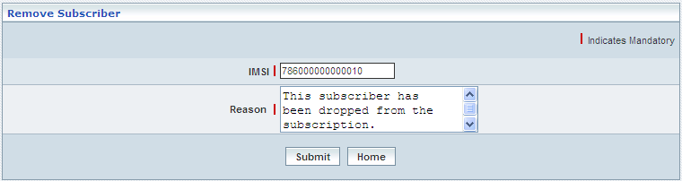

| **STEP** | **ACTION** |
| --- | --- |
|  | Enter IMSI of the subscriber (who is proposed to be removed) in the <IMSI> field |
|  | User can enter a description in the <Reason> text field stating the reason for removal of the subscriber |
|  | On clicking the **Submit** button, a message window will be displayed to that effect    On clicking the **Home** button of the message window, it directs the user back to the ‘Remove Subscriber’ Screen |
|  | On clicking the **Home** button (prior to submission of removal), it only redirects the user back to the ‘Subscriber Management’ main page |

## Remove Subscriber (Bulk)

Home Location Register 🡪 Subscriber Management 🡪 Remove Subscribers (Bulk)

‘Remove Subscribers’ helps the user removing a set of subscribers (from provisioning the mobile services) in bulk / at a stretch.

The screen below shows removing a set / group of subscribers in bulk (barring) from further provisioning of mobile services.

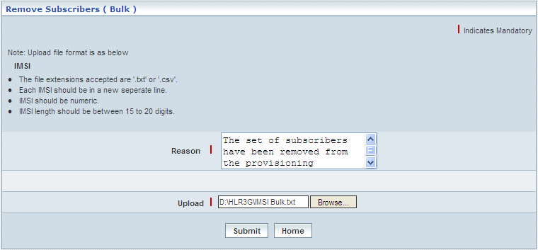

| **STEP** | **ACTION** |
| --- | --- |
|  | User can enter a description in the <Reason> text field stating the reason for removal of subscribers |
|  | Browse for a Flat file that consists of a set of IMSI numbers in a specific format and each one starting in a new line |
|  | On clicking the **Submit** button, a message window to that effect will be displayed confirming the successful upload    On clicking the **Home** button of the message window, it directs the user back to the ‘Remove Subscriber (Bulk)’ Screen |
|  | On clicking the **Home** button (prior to upload of the flat file), it only redirects the user back to the ‘Subscriber Management’ main page |

## Cancel Location (Bulk)

Home Location Register 🡪 Subscriber Management 🡪 Cancel Location (Bulk)

In order to send the details related to ‘Cancellation of Location Update’ to the respective VLR(s)-(roaming locations) of a group of subscribers at a stretch (in bulk), the corresponding IMSI(s) of the group of subscribers shall be uploaded.

Thus, ‘Cancel Location’ helps the user uploading a set of subscribers, where the corresponding details related to ‘Cancellation of Location Update’ shall be sent to their respective VLR(s) – (roaming locations).

The screen below shows Cancel Location (Bulk) window

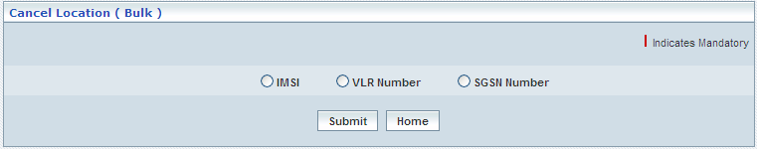

**IMSI**

The screen below shows uploading a set / group of subscribers in bulk for IMSI

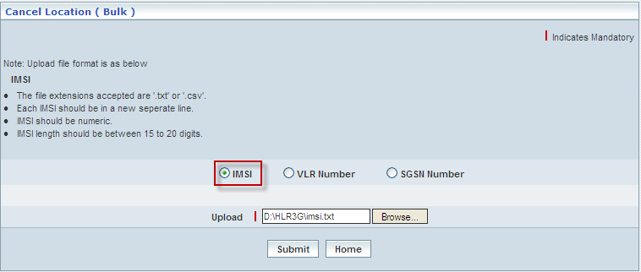

| **STEP** | **ACTION** |
| --- | --- |
|  | Select the IMSI radio button |
|  | Browse for a Flat file that consists of a set of IMSI numbers in a specific format and each one starting in a new line |
|  | On clicking the **Submit** button, a message window to that effect will be displayed confirming the successful upload    On clicking the **Home** button of the message window, it directs the user back to the ‘Cancel Location (Bulk)’ Screen |
|  | On clicking the **Home** button (prior to upload of the flat file), it only redirects the user back to the ‘Subscriber Management’ main page |

**VLR Number**

The screen below shows uploading a set / group of subscribers in bulk for VLR Number

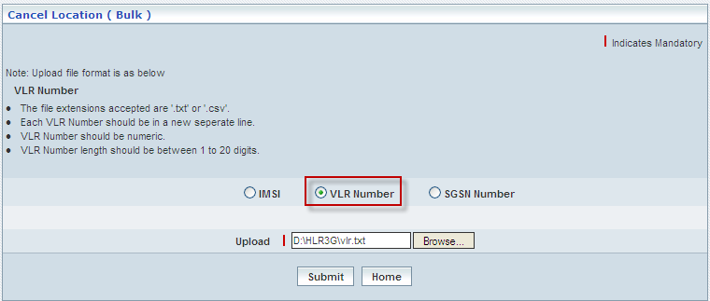

| **STEP** | **ACTION** |
| --- | --- |
|  | Select the VLR Number radio button |
|  | Browse for a Flat file that consists of a set of IMSI numbers in a specific format and each one starting in a new line |
|  | On clicking the **Submit** button, a message window to that effect will be displayed confirming the successful upload    On clicking the **Home** button of the message window, it directs the user back to the ‘Cancel Location (Bulk)’ Screen |
|  | On clicking the **Home** button (prior to upload of the flat file), it only redirects the user back to the ‘Subscriber Management’ main page |

**SGSN Number**

The screen below shows uploading a set / group of subscribers in bulk for SGSN Number



| **STEP** | **ACTION** |
| --- | --- |
|  | Select the SGSN Number radio button |
|  | Browse for a Flat file that consists of a set of IMSI numbers in a specific format and each one starting in a new line |
|  | On clicking the **Submit** button, a message window to that effect will be displayed confirming the successful upload    On clicking the **Home** button of the message window, it directs the user back to the ‘Cancel Location (Bulk)’ Screen |
|  | On clicking the **Home** button (prior to upload of the flat file), it only redirects the user back to the ‘Subscriber Management’ main page |

# Roaming Management

Home Location Register 🡪 Roaming Management

Roaming Management administers and streamlines the information related to subscribers’ roaming provisions. This module also enables the user to define roaming limitations and restrictions.

This Module maintains the details related to following roaming provisions:

* Subscriber Roaming
* VPLMN Configuration
* VPLMN Restriction
* Restricted VLR(s)
* Restricted SGSN(s)
* Allowed VLR(s)
* Allowed SGSN(s)
* Change Allowed VLR/SGSN (Bulk)

## Subscriber Roaming

Home Location Register 🡪 Roaming Management 🡪 Subscriber Roaming

‘Subscriber Roaming’ here in this context is the roaming facility that was provisioned to the given subscriber and this sub-module also allows the user to obtain the subscriber’s current roaming status & eligibility options to subsequently update his / her roaming status.

The screen below shows entering an IMSI related to a subscriber in order to obtain his / her current roaming status and eligibility.

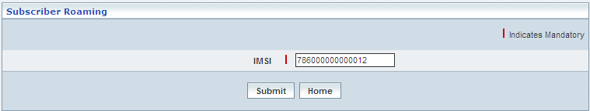

| **STEP** | **ACTION** |
| --- | --- |
|  | Enter an IMSI (number) in the <IMSI> field in order to check for the subscriber’s current roaming status and eligibility |
|  | On clicking the **Submit** button, it displays details related to subscriber’s current roaming status and eligibility in a different screen |
|  | On clicking the **Home** button (prior to the submission of IMSI), it only redirects the user back to the ‘Roaming Management’ main page |

The screen below shows the roaming status and eligibility related to the given subscriber.

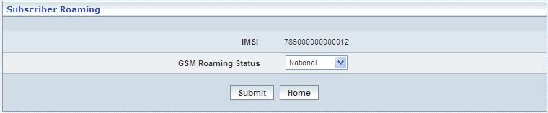

| **STEP** | **ACTION** |
| --- | --- |
|  | By default the current status will be dynamically highlighted & displayed in the <Roaming Status> field  The list of eligibility roaming options (for the given subscriber) will be dynamically displayed as a drop-down list of the <Roaming Status> field |
|  | User can update the subscriber’s roaming status by selecting the desired option (Not Allowed / National / International) from the drop-down list and subsequently by clicking the **Submit** button, the subscriber’s roaming status will be updated  A message window to that effect will be displayed    On clicking the **Home** button of the message window, it directs the user back to the ‘Subscriber Roaming’ screen |
|  | On clicking the **Home** button (prior to update the roaming status), it only redirects the user back to the ‘Roaming Management’ screen |

## VPLMN Configuration

Home Location Register 🡪 Roaming Management 🡪 VPLMN Configuration

VPLMN (Visited Public Land Mobile Network) Configuration module enables the user to manually configure VPLMN with the following Numbering Plans:

* NANP: North American Numbering Plan (Explicitly meant for North America)
* E164: This term covers any other Numbering Plans other than US & Canada Numbering Plans

The details related to NANP Numbering Plan includes Visiting Network Name, CC (Country Code), Area Code, NXX and Station Code.

The details related to E164 Numbering Plan includes Visiting Network Name, CC (Country Code), NDC and Station Code.

This module helps the user performing the following actions:

* Create
* Upload
* View
* Modify
* Delete

The screen below displays existing VPLMN Configuration details of both the Numbering Plans.

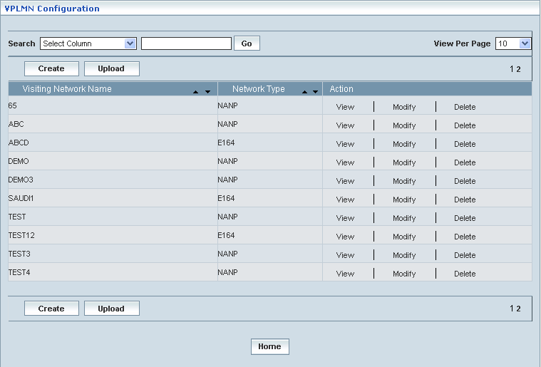

| **STEP** | | **ACTION** |
| --- | --- | --- |
|  | | By default, the list of VPLMN Configuration will be displayed as records in a grid. The columns include ‘Visiting Network Name’, ‘Network Type’ and ‘Action’ |
|  |  | User can customize the view for the number of records to be displayed each time (per page) in a grid.  However, this option is applicable only if the total number of records exceeds 10. And also with the immediate effect of increase in the number of records more than 10, a ‘Search’ option would be dynamically displayed. |
| Select the number of records (For Ex: 10) from the drop-down list of the <View Per Page> field. |
| With the effect of choosing the desired number (10) for the display of records per page, the same (10 records) will be displayed in the grid. |
| User can sort the records in ascending and descending orders with the help of up-arrow and down-arrows respectively |
| However, based on the total number of records, page numbers will be dynamically displayed at the left bottom of the screen |
| User can navigate for subsequent records (10 each time) by clicking the desired ‘page number’ |
| **2** | | On clicking the **Create** button, ‘Create’ screen will be displayed enabling the user to create a new VPLMN Configuration based on Numbering Plans, such as ‘NANP’ and ‘E164’ |
|  | | On clicking the **Upload** button, ‘Upload’ screen will be displayed enabling the user to browse and locate the ‘.txt’ or ‘.csv’ file and upload |
|  | | On clicking the **View** link, ‘View’ screen will be displayed enabling the user to view the corresponding values (as required) of a chosen Numbering Plans. |
|  | | On clicking the **Modify** link, ‘Modify’ screen will be displayed enabling the user to update / change corresponding values (as required) of a chosen Numbering Plans. |
|  | | On clicking the **Delete** link, ‘Delete’ screen will be displayed enables the user to delete the same |
|  | | On clicking the **Home** button at the bottom of the grid, it redirects the user to the ‘Roaming Management’ main page |

**Create**

Create enables the user to configure the VPLMN with the NANP and E164 Numbering Plans.

**Create - NANP**

The screen below shows creating a new VPLMN with NANP

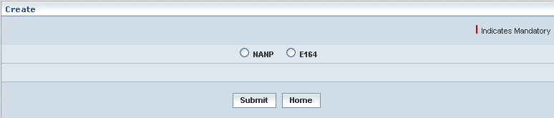

| **STEP** | **ACTION** |
| --- | --- |
|  | Select the desired radio option to choose a Numbering Plan, Ex: NANP |
|  | The corresponding details will be displayed. The user must enter the required details in their respective fields |

The screen below shows entering details related to NANP Numbering Plan.

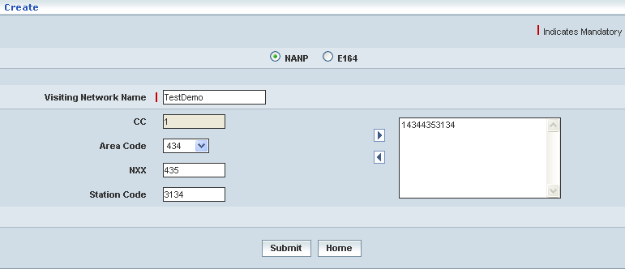

| **STEP** | **ACTION** |
| --- | --- |
|  | Enter the Visiting Network Name in <Visiting Network Name> field.  **NOTE:** By default, the CC (Country Code) is **1 (one)** for the NANP |
|  | Select the Area Code from <Area Code> field. |
|  | Enter the NXX digit of the NANP directory number in <NXX> field |
|  | Enter the Station Code in <Station Code> field |
|  | Click  button to map VLR NUMBER combination, it moves to the adjust field. Click  button to remove from mapping the VLR NUMBER combination. |
|  | On clicking **Submit** button, the new VPLMN related to NANP will be created and added to the existing list. A message window will be displayed to that effect.    On clicking **Home** button of the message window, it redirects the user to the ‘VPLMN Configuration’ records grid |
|  | On clicking **Home** button at the bottom of the ‘Create’ Screen (before creating a new VPLMN), it redirects the user to the ‘VPLMN Configuration’ records grid |

**Create – E164**

The screen below shows creating a new VPLMN with E164



| **STEP** | **ACTION** |
| --- | --- |
|  | Select the desired radio option to choose a Numbering Plan, Ex: E164 |
|  | The corresponding details will be displayed. The user must enter the required details in their respective fields |

The screen below shows entering details related to E164 Numbering Plan.

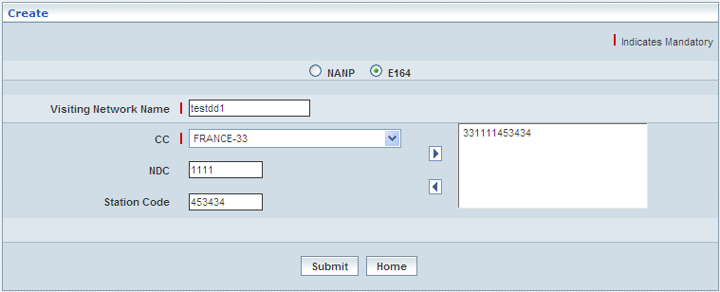

| **STEP** | **ACTION** |
| --- | --- |
|  | Enter the Visiting Network Name in <Visiting Network Name> field. |
|  | Select the CC (Country Code) <CC> field. |
|  | Enter the NDC (National Destination Code) digit of the E164 in <NDC> field |
|  | Enter the Station Code in <Station Code> field |
|  | Click  button to map VLR NUMBER combination, it moves to the adjust field. Click  button to remove from mapping the VLR NUMBER combination. |
|  | On clicking **Submit** button, the new VPLMN related to E164 will be created and added to the existing list. A message window will be displayed to that effect.    On clicking **Home** button of the message window, it redirects the user to the ‘VPLMN Configuration’ records grid |
|  | On clicking **Home** button at the bottom of the ‘Create’ Screen (before creating a new VPLMN), it redirects the user to the ‘VPLMN Configuration’ records grid |

**Upload**

Upload enables the user to upload the VPLMN Configuration file format (such as ‘.txt’ or ‘.csv’) by clicking **Upload** button; corresponding information related to uploading the VPLMN Configuration details will be displayed in a separate screen enabling the user to upload the same.

The screen below shows the uploading of VPLMN Configuration file.

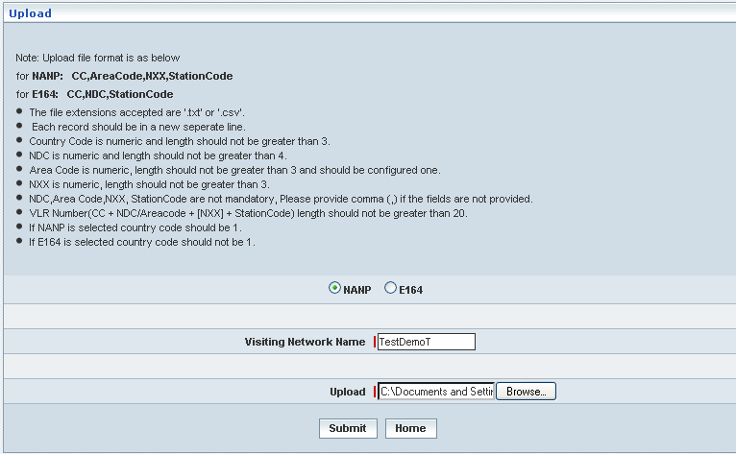

| **STEP** | **ACTION** |
| --- | --- |
|  | Select the desired radio option to choose a Numbering Plan, Ex: NANP or E164 |
|  | Enter the Visiting Network Name in the <Visiting Network Name> field |
|  | Click **Browse** button to upload the file.  **NOTE:** The creation of file format for NANP and E164 related information are displayed in Note: section in the ‘Upload’ Screen |
|  | On clicking the **Submit** button, the file gets uploaded and it will be updated accordingly in the database. A message window will be displayed to that effect    On clicking the **Home** button of the message window, it redirects the user to the ‘Upload’ Screen |
|  | On clicking the **Home** button at the bottom of the ‘Upload’ screen (before submission), it redirects to the ‘VPLMN Configuration’ grid |

**View**

On clicking the **‘View’** link of a chosen ‘VPLMN Configuration’ (from the VPLMN Configuration List); corresponding information related to the VPLMN Configuration will be displayed in a separate screen enabling the user to peruse details of the same.

The screen below shows the view of a chosen VPLMN Configuration.

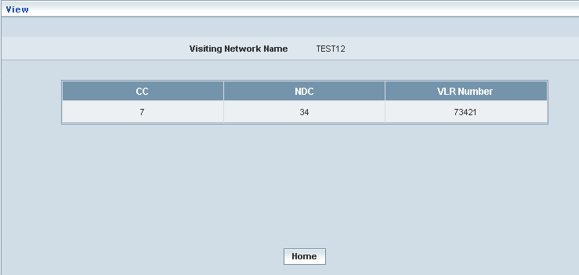

| **STEP** | **ACTION** |
| --- | --- |
|  | ‘Visiting Network Name’, ‘CC’, ‘NDC’ and ‘VLR Number’ will be dynamically displayed in their respective fields |
|  | On clicking the **Home** button at the bottom of the ‘View’ Screen, it redirects the user to the ‘VPLMN Configuration’ records grid |

**Modify**

On clicking the **‘Modify’** link of a chosen ‘VPLMN Configuration’ (from the VPLMN Configuration List); corresponding information related to the VPLMN Configuration will be displayed in a separate screen enabling the user to modify details of the same.

The screen below shows modifying / updating an existing VPLMN Configuration for NANP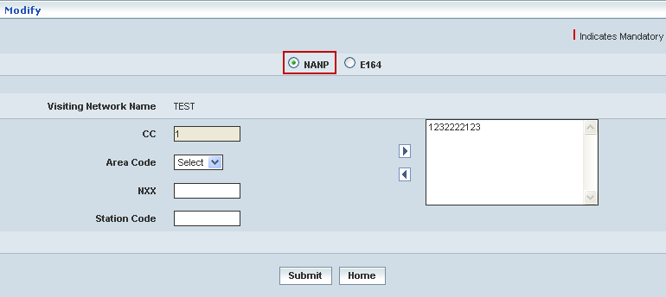

The screen below shows modifying / updating an existing VPLMN Configuration for E164

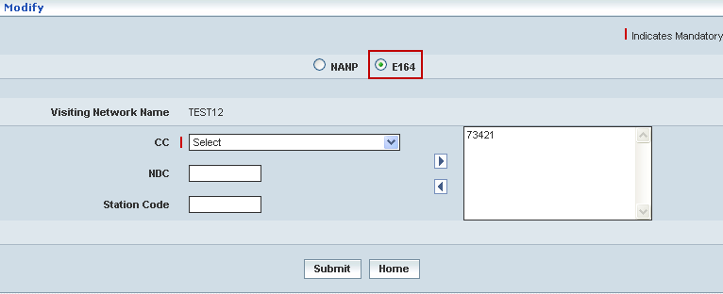

| **STEP** | **ACTION** |
| --- | --- |
|  | User can make necessary changes related to VPLMN Configuration for NANP as (Area code, NXX, Station) and VPLMN Configuration for E164 as (CC, NDC and Station Code) and finally map to VLR NUMBER combination |
|  | On clicking the **Submit** button, the changes made will be updated accordingly in the database. A message window will be displayed to that effect  **NOTE:** If an Area Code has already been assigned to a HLR Address, the same cannot be modified    On clicking the **Home** button of the message window, it redirects the user to the ‘VPLMN Configuration’ grid |
|  | On clicking the **Home** button at the bottom of the ‘Modify’ screen (before submission), it redirects to the ‘VPLMN Configuration’ grid |

**Delete**

On clicking the **‘Delete’** link of a chosen ‘VPLMN Configuration’ (from the VPLMN Configuration List); corresponding information related to the VPLMN Configuration will be displayed in a separate screen enabling the user to delete details of the same.

The screen below shows deleting an existing VPLMN Configuration.

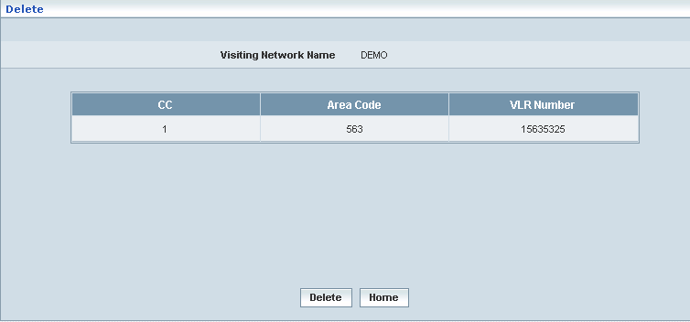

| **STEP** | **ACTION** |
| --- | --- |
|  | On clicking the **Delete** button, an alert message window will be displayed enabling the user to confirm deletion of the chosen VPLMN Configuration  SNAGHTML7c58f2 |
|  | On clicking the **OK** button of the alert message window, the chosen VPLMN Configuration will be deleted and a message window will be displayed to that effect. It will be disappeared from the ‘VPLMN Configuration’ grid    On clicking the **Home** button of the message window, it directs the user to ‘PLMN Area Configuration’ grid  On clicking the **Cancel** button of the alert message window, it retains the grid without deleting the VPLMN Configuration record |
|  | On clicking the **Home** button at the bottom of the ‘Delete’ screen (before submission), it redirects to the VPLMN Configuration’ grid |

**Searching for a specific VPLMN Configuration (Record)**



| **STEP** | **ACTION** |
| --- | --- |
|  | Select a search criterion (Visiting Network Name) from the drop-down list of the search criteria of the <Search> field  **\*** By default the list of search criterion (Visiting Network Name) will be dynamically displayed as drop-down list of the <Search> field |
|  | Enter the Visiting Network Name that corresponds with the given search criterion |
|  | On clicking the **Go** button, the corresponding VPLMN Configuration (record) will be highlighted among the list of VPLMN Configuration records. |

The screen below depicts fetching and displaying the give VPLMN Configuration record.

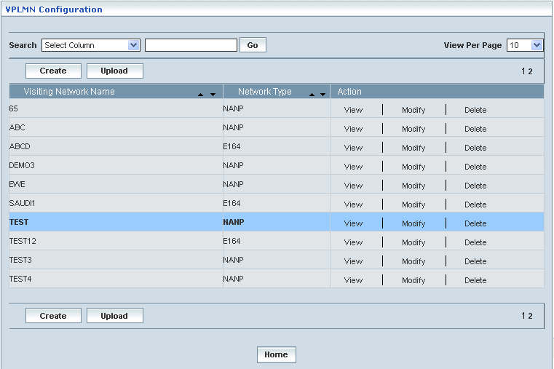

## VPLMN Restriction

Home Location Register 🡪 Roaming Management 🡪 VPLMN Restriction

VPLMN (Visited Public Land Mobile Network) Restriction module enables the user to manually perform the following actions:

* Create
* Upload
* View
* Modify
* Delete
* Search

The screen below displays existing VPLMN Restriction details

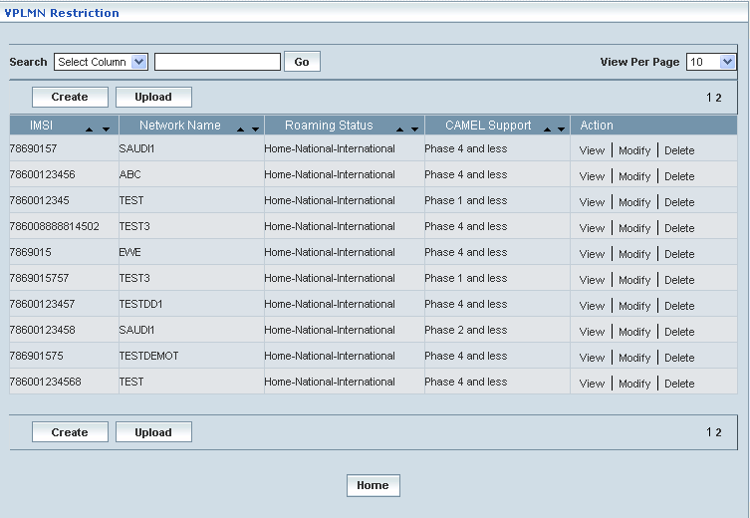

| **STEP** | | **ACTION** |
| --- | --- | --- |
|  | | By default, the list of VPLMN Restriction will be displayed as records in a grid. The columns include ‘IMSI’, ‘Network Name’, ‘Roaming Status’, ‘CAMEL Support’ and ‘Action’ |
|  |  | User can customize the view for the number of records to be displayed each time (per page) in a grid.  However, this option is applicable only if the total number of records exceeds 10. And also with the immediate effect of increase in the number of records more than 10, a ‘Search’ option would be dynamically displayed. |
| Select the number of records (For Ex: 10) from the drop-down list of the <View Per Page> field. |
| With the effect of choosing the desired number (10) for the display of records per page, the same (10 records) will be displayed in the grid. |
| User can sort the records in ascending and descending orders with the help of up-arrow and down-arrows respectively |
| However, based on the total number of records, page numbers will be dynamically displayed at the left bottom of the screen |
| User can navigate for subsequent records (10 each time) by clicking the desired ‘page number’ |
|  | | On clicking the **Create** button, ‘Create’ screen will be displayed enabling the user to create a new VPLMN Restriction |
|  | | On clicking the **Upload** button, ‘Upload’ screen will be displayed enabling the user to browse and locate the ‘.txt’ or ‘.csv’ file and upload |
|  | | On clicking the **View** link, ‘View’ screen will be displayed enabling the user to view the corresponding values (as required) of a chosen VPLMN Restriction |
|  | | On clicking the **Modify** link, ‘Modify’ screen will be displayed enabling the user to update / change corresponding values (as required) of a chosen VPLMN Restriction |
|  | | On clicking the **Delete** link, ‘Delete’ screen will be displayed enables the user to delete the same |
|  | | On clicking the **Home** button at the bottom of the grid, it redirects the user to the ‘Roaming Management’ main page |

**Create**

On clicking the **Create** button; the ‘Create’ Screen displays, which enable the user to create a new VPLMN Restriction.

The screen below shows creating a new VPLMN Restriction. 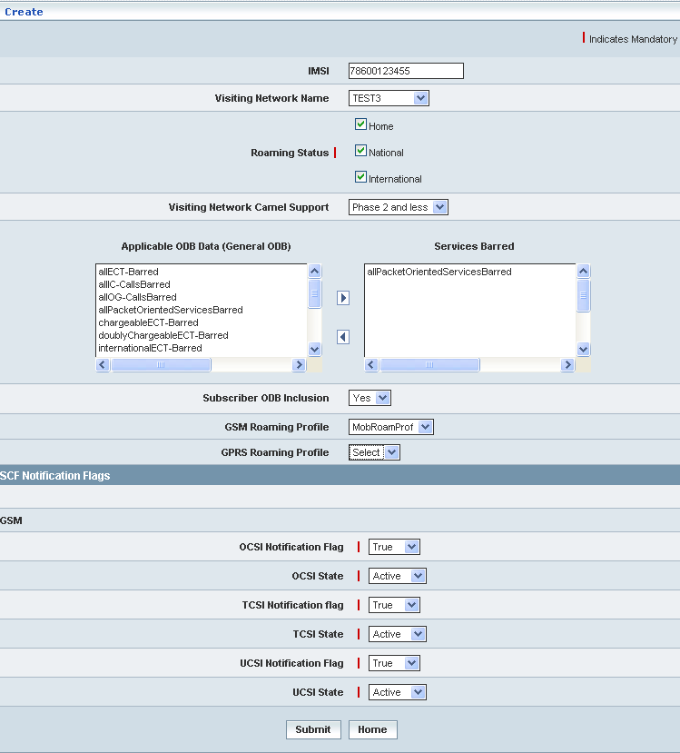

| **STEP** | **ACTION** |
| --- | --- |
|  | User must enter the details for creating VPLMN Configuration where it is a mandatory information |
|  | Enter IMSI (International Mobile Subscriber Identity) number in <IMSI> field.  **NOTE:** IMSI should start with the configured series (such as 78600 and 78690) |
|  | Select Visiting Network Name from <Visiting Network Name> drop-down list. |
|  | Select at least one roaming status (such as ‘Home’, ‘National’ and ‘International) by selecting the checkbox(s) next to it. It is mandatory field. |
|  | Select Visiting Network Camel Support phase from <Visiting Network Camel Support> field |
|  | Select at least one Applicable ODB (Operator Determined Barring) service from <Applicable ODB Data (General ODB)> field and it should be barred by clicking  button, it moves to the adjacent <Services Barred> field. The user can unbarred the same by clicking  button.  **NOTE:** Select at least one Applicable ODB Service to be barred or select GSM/GPRS Roaming Profile. |
|  | Select Subscriber ODB Inclusion or Exclusion by selecting ‘Yes’ or ‘No’ from <Subscriber ODB Inclusion> drop-down list |
|  | Select GSM Roaming Profile type from <GSM Roaming Profile> drop-down list. MobRoamProf – appears . RoamingTest1212 - disappear  **NOTE:**  ‘SCF Notification Flags’ – GSM Panel appears and vice versa. |
|  | Select GPRS Roaming Profile type from <GPRS Roaming Profile> drop-down list. |
| **SCF Notification Flags** | |
|  | Set OCSI Notification Flag to ‘True’ or ‘False’ from <OCSI Notification Flag> drop-down list. |
|  | Set OCSI State to ‘Active’ or ‘Inactive’ from <OCSI State> drop-down list. |
|  | Set TCSI Notification Flag to ‘True’ or ‘False’ from <TCSI Notification Flag> drop-down list. |
|  | Set TCSI State to ‘Active’ or ‘Inactive’ from <TCSI State> drop-down list. |
|  | Set UCSI Notification Flag to ‘True’ or ‘False’ from <UCSI Notification Flag> drop-down list. |
|  | Set UCSI State to ‘Active’ or ‘Inactive’ from <UCSI State> drop-down list. |
|  | On clicking **Submit** button, the new VPLMN Restriction will be created and added to the existing list. A message window will be displayed to that effect.    On clicking **Home** button of the message window, it redirects the user to the ‘VPLMN Restriction’ records grid |
|  | On clicking **Home** button at the bottom of the ‘Create’ Screen (before creating a new VPLMN Restriction), it redirects the user to the ‘VPLMN Restriction’ records grid |

**Upload**

Upload enables the user to upload the VPLMN Restriction file format (such as ‘.txt’ or ‘.csv’) by clicking **Upload** button; corresponding information related to uploading the VPLMN Restriction details will be displayed in a separate screen enabling the user to upload the same.

The screen below shows the uploading of VPLMN Restriction file.

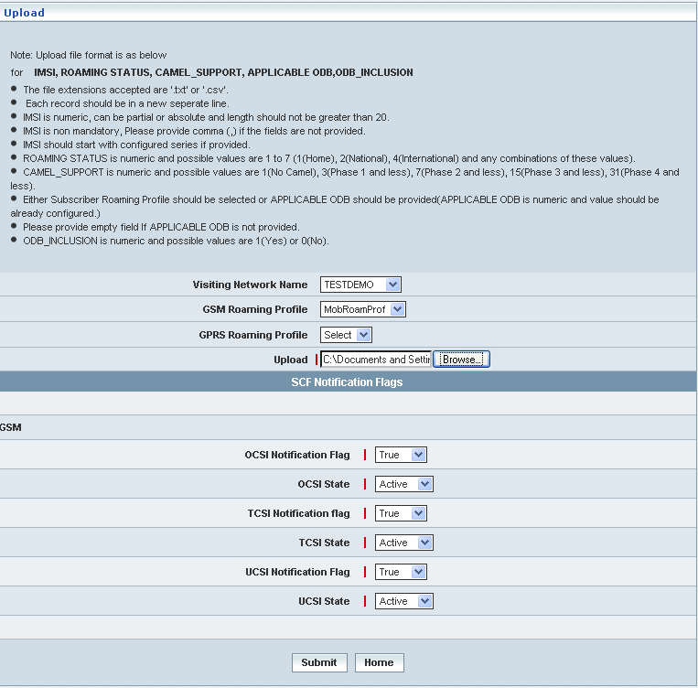

| **STEP** | **ACTION** |
| --- | --- |
|  | Select Visiting Network Name from <Visiting Network Name> drop-down list |
|  | Select GSM Roaming Profile from <GSM Roaming Profile> drop-down list  **NOTE:** ‘SCF Notification Flags’ – GSM Panel appears and vice versa. |
|  | Select GPRS Roaming Profile from <GPRS Roaming Profile> drop-down list |
|  | Click **Browse** button to upload the file.  **NOTE:** The creation of file format for VPLMN Restriction related information are displayed in Note: section in the ‘Upload’ Screen |
| **SCF Notification Flags** | |
|  | Set OCSI Notification Flag to ‘True’ or ‘False’ from <OCSI Notification Flag> drop-down list. |
|  | Set OCSI State to ‘Active’ or ‘Inactive’ from <OCSI State> drop-down list. |
|  | Set TCSI Notification Flag to ‘True’ or ‘False’ from <TCSI Notification Flag> drop-down list. |
|  | Set TCSI State to ‘Active’ or ‘Inactive’ from <TCSI State> drop-down list. |
|  | Set UCSI Notification Flag to ‘True’ or ‘False’ from <UCSI Notification Flag> drop-down list. |
|  | On clicking the **Submit** button, the file gets uploaded and it will be updated accordingly in the database. A message window will be displayed to that effect    On clicking the **Home** button of the message window, it redirects the user to the ‘Upload’ Screen |
|  | On clicking the **Home** button at the bottom of the ‘Upload’ screen (before submission), it redirects to the ‘VPLMN Restriction’ grid |

**View**

On clicking the **‘View’** link of a chosen ‘VPLMN Restriction’ (from the VPLMN Restriction List); corresponding information related to the VPLMN Restriction will be displayed in a separate screen enabling the user to peruse details of the same.

The screen below shows the view of a chosen VPLMN Restriction.

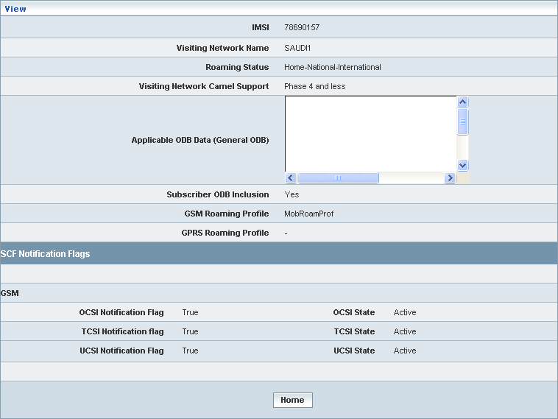

| **STEP** | **ACTION** |
| --- | --- |
|  | ‘IMSI’, ‘Visiting Network Name’, ‘Roaming Status’, ‘Visiting Network Camel Support’, ‘Subscriber ODB Inclusion’, ‘GSM Roaming Profile’ and ‘SCF Notification Flags’ data will be dynamically displayed in their respective fields |
|  | On clicking the **Home** button at the bottom of the ‘View’ Screen, it redirects the user to the ‘VPLMN Restriction’ Screen |

**Modify**

On clicking the **‘Modify’** link of a chosen ‘VPLMN Restriction’ (from the VPLMN Restriction List); corresponding information related to the VPLMN Restriction will be displayed in a separate screen enabling the user to modify details of the same.

The screen below shows modifying / updating an existing VPLMN Restriction

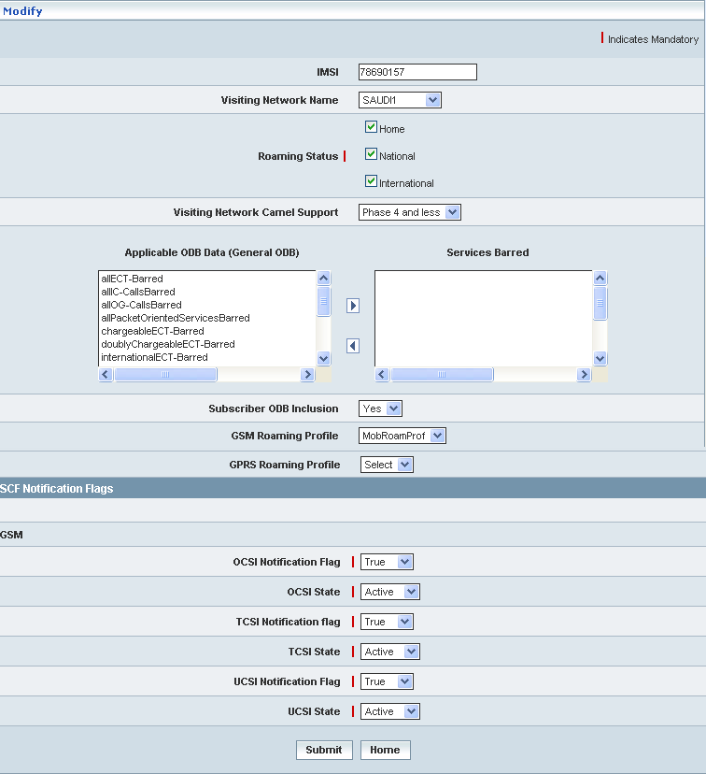

| **STEP** | **ACTION** |
| --- | --- |
|  | User can make necessary changes related to VPLMN Restriction (‘IMSI’, ‘Visiting Network Name’, ‘Roaming Status’, ‘Visiting Network Camel Support’, mapping of at least one ‘Applicable ODB Data (General ODB) with ‘Services Board’, and selecting of other data such as ‘Subscriber ODB Inclusion’, ‘GSM Roaming Profile’, ‘GPRS Roaming Profile’ and data related to ‘SCF Notification Flags’. |
|  | On clicking the **Submit** button, the changes made will be updated accordingly in the database. A message window will be displayed to that effect    On clicking the **Home** button of the message window, it redirects the user to the ‘VPLMN Restriction’ Screen |
|  | On clicking the **Home** button at the bottom of the ‘Modify’ Screen (before submission), it redirects to the ‘VPLMN Restriction’ Screen |

**Delete**

On clicking the **‘Delete’** link of a chosen ‘VPLMN Restriction’ (from the VPLMN Restriction List); corresponding information related to the VPLMN Restriction will be displayed in a separate screen enabling the user to delete details of the same.

The screen below shows deleting an existing VPLMN Restriction

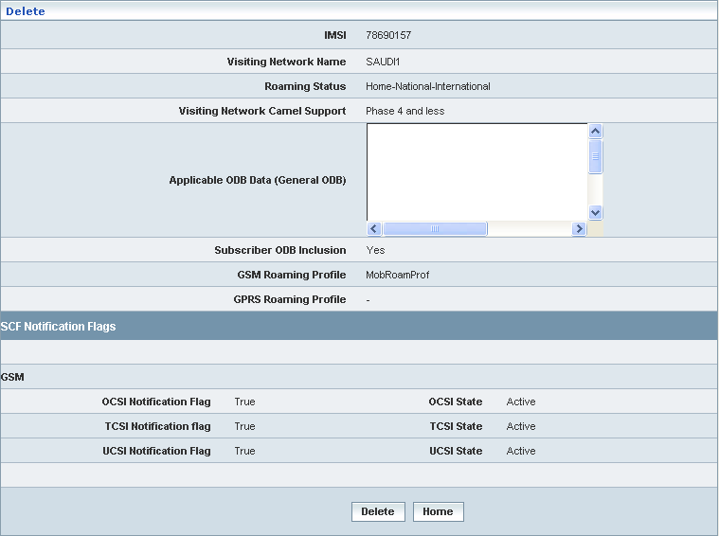

| **STEP** | **ACTION** |
| --- | --- |
|  | On clicking the **Delete** button, an alert message window will be displayed enabling the user to confirm deletion of the chosen VPLMN Restriction SNAGHTML336fe8 |
|  | On clicking the **OK** button of the alert message window, the chosen VPLMN Restrictions details will be deleted and a message window will be displayed to that effect. It will be disappeared from the ‘VPLMN Restriction’ grid.    On clicking the **Home** button of the message window, it directs the user to ‘VPLMN Restriction’ Screen  On clicking the **Cancel** button of the alert message window, it retains the grid without deleting the ‘VPLMN Restriction’ record |
|  | On clicking the **Home** button at the bottom of the ‘Delete’ screen (before submission), it redirects to the ‘VPLMN Restriction’ Screen |

**Searching for a specific VPLMN Restriction (Record)**

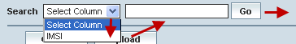

| **STEP** | **ACTION** |
| --- | --- |
|  | Select a search criterion (IMSI) from the drop-down list of the search criteria of the <Search> field  **\*** By default the list of search criterion (IMSI) will be dynamically displayed as drop-down list of the <Search> field |
|  | Enter the IMSI that corresponds with the given search criterion |
|  | On clicking the **Go** button, the corresponding VPLMN Restriction (record) will be highlighted among the list of VPLMN Restriction records. |

The screen below depicts fetching and displaying the give VPLMN Restriction record.

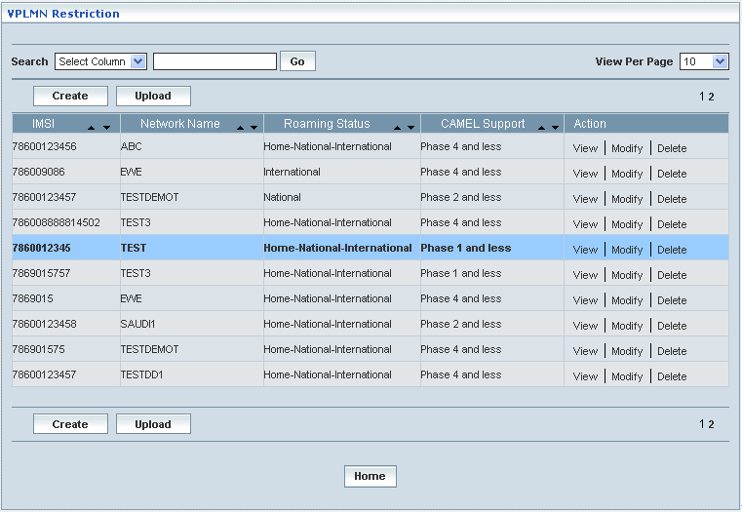

## Restricted VLR(s)

Home Location Register 🡪 Roaming Management 🡪 Restricted VLR(s)

VLR(s) here in this context is the list of locations those represent the Visitor Location Register(s) pertaining to a **GSM** network access mode. Restricted VLR(s) enables the user either to add or remove a set / group of VLR(s) to/from the network sphere. This also allows the user to peruse details related to existing VLR(s). If the VLR is allowed, it cannot be restricted.

This Module maintains the details related to following restricted VLR(s):

* Add / Remove
* Manage

On clicking Add / Remove link the following screen is displayed.

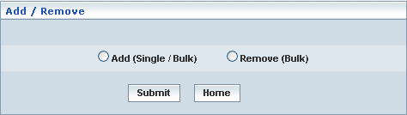

| **STEP** | **ACTION** |
| --- | --- |
|  | Select the radio option (Add / Remove) to specify whether user is intending to add a set of new VLR(s) or remove a group of existing VLR(s) to/from the Network space  The screen gets modified and it displays a list of parameter with their fields |
|  | On clicking the **Home** button (prior to the submission of Restricted VLRs), it only redirects the user back to the ‘Roaming Management’ main page |

**Add**

Home Location Register 🡪 Roaming Management 🡪 Restricted VLR(s) 🡪 Add / Remove

‘Restricted VLR(s) – Add helps the user to add a set of VLR(s) to a network sphere. User can add restricted VLR(s) in single or bulk mode.

The screen below shows adding a set / group of VLR(s) in single or bulk to a network sphere.

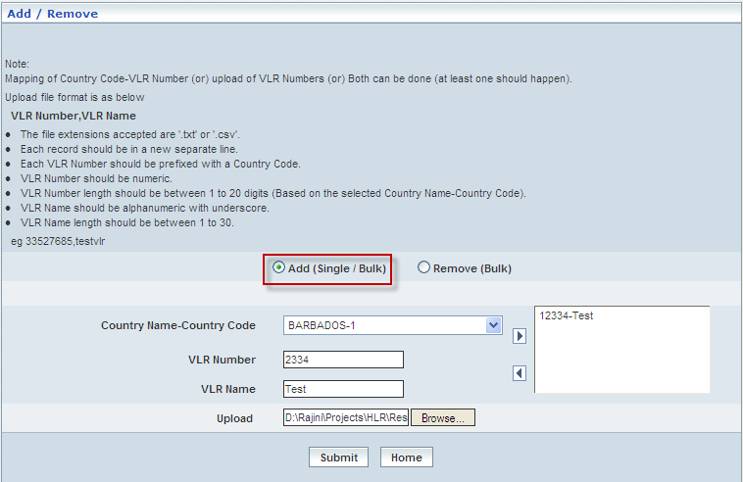

| **STEP** | **ACTION** |
| --- | --- |
|  | User must follow these guide lines & instructions for the Data Formats of the VLR Details |
|  | Select the radio option **Add** to add a set of new VLR(s) to the Network space |
|  | Select country name and country code from the <Country Name – Country Code> drop-down list |
|  | Enter VLR number in the <VLR Number> field |
|  | Enter VLR name in the <VLR Name> field |
|  | On clicking the right-arrow button, the service key (number and name) will be moved to the adjacent field  User can enter the desired number of VLR number in a similar fashion |
|  | However, if the user wants to just remove certain service keys any time before creating or establishing the SCP, selecting the number (service key and name) from the list and subsequently clicking the left-arrow button removes the number |
|  | **Bulk Upload**  Browse for a Flat file that consists of a set of VLR(s) in a specific format and each one starting in a new line |
|  | On clicking the **Submit** button, the VLR numbers are successfully stored in the database  A message window to that effect will be displayed    On clicking **Home** button of the message window, it redirects the user to the ‘Add / Remove’ Screen |
|  | On clicking the **Home** button (prior to upload of the flat file), it only redirects the user back to the ‘Restricted VLR(s)’ main page |

**Remove**

Home Location Register 🡪 Roaming Management 🡪 Restricted VLR(s) 🡪 Add / Remove

‘Restricted VLR(s) –Remove’ helps the user to remove a set of VLR(s) from a network sphere in bulk / at a stretch.

The screen below shows removing a set / group of VLR(s) in bulk from a network sphere

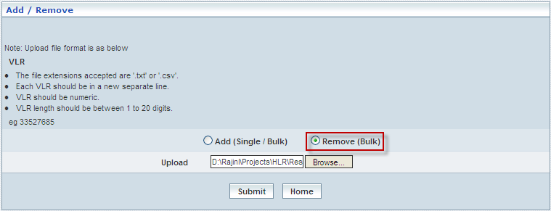

| **STEP** | **ACTION** |
| --- | --- |
|  | User must follow these guide lines & instructions for the Data Formats of the VLR Details |
|  | Select the radio option **Remove** to remove a group of existing VLR(s) from the Network space |
|  | Browse for a Flat file that consists of a set of VLR(s) in a specific format and each one starting in a new line |
|  | On clicking the **Submit** button, a message window to that effect will be displayed confirming the successfully removing VLR(s)    On clicking **Home** button of the message window, it redirects the user to the ‘Add / Remove’ Screen |
|  | On clicking the **Home** button (prior to upload of the flat file), it only redirects the user back to the ‘Restricted VLR(s)’ main page |

**Manage**

Home Location Register 🡪 Roaming Management 🡪 Restricted VLR(s) 🡪 Manage

‘Restricted VLR(s)’ – Manage helps the user to modify or delete the existing VLR(s) in the network.

The screen below shows viewing the list of VLR(s).

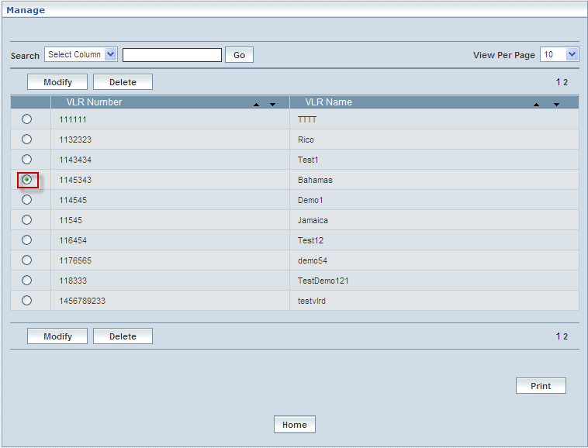

| **STEP** | | **ACTION** |
| --- | --- | --- |
|  | | By default, the list of VLR(s) will be displayed as records in a grid. The columns include VLR Number |
|  |  | User can customize the view for the number of records to be displayed each time (per page) in a grid.  However, this option is applicable only if the total number of records exceeds 10. And also with the immediate effect of increase in the number of records more than 10, a ‘Search’ option would be dynamically displayed. |
| Select the number of records (For Ex: 10) from the drop-down list of the <View Per Page> field. |
| With the effect of choosing the desired number (10) for the display of records per page, the same (10 records) will be displayed in the grid. |
| User can sort the records in ascending and descending orders with the help of up-arrow and down-arrows respectively |
| However, based on the total number of records, page numbers will be dynamically displayed at the left bottom of the screen |
| User can navigate for subsequent records (10 each time) by clicking the desired ‘page number’ |
|  | | On selecting a VLR number and clicking the **Modify** button, user can modify the existing VLR(s) |
|  | | On selecting a VLR number and clicking the **Delete** button, user can delete the existing VLR(s) |
|  | | On clicking the **Print** button at the bottom of the grid, user can take printouts of the VLR(s) list |
|  | | On clicking the **Home** button at the bottom of the grid, it redirects the user to the ‘Restricted VLR(s)’ main page |

**Modify**

Home Location Register 🡪 Roaming Management 🡪 Restricted VLR(s) 🡪 Manage 🡪 Modify

Modify enables the user to modify / update the details related to an existing VLR(s) number.

The screen below shows modifying a VLR(s) number.

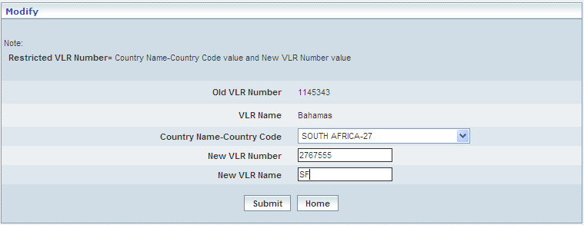

| **STEP** | **ACTION** |
| --- | --- |
|  | Select country name and country code from the <Country Name–Country Code> drop-down list |
|  | Enter new VLR number in the <New VLR Number> field |
|  | Enter new VLR name in the <New VLR Name> field |
|  | On clicking the **Submit** button, the VLR numbers is successfully modified  A message window to that effect will be displayed    On clicking **Home** button of the message window, it redirects the user to the ‘Manage’ grid |
|  | On clicking the **Home** button (prior to upload of the flat file), it only redirects the user back to the ‘Restricted VLR(s)’ main page |

**Delete**

Home Location Register 🡪 Roaming Management 🡪 Restricted VLR(s) 🡪 Manage 🡪 Delete

Delete enables the user to delete the details related to an existing Restricted VLR(s) number.

| **STEP** | **ACTION** |
| --- | --- |
|  | Select a VLR number radio option |
|  | On clicking the **Delete** at the bottom of the ‘Manage’ screen, it displays an alert window enabling the user to confirm deletion of the chosen VLR number  C:\DOCUME~1\rajini.sn\LOCALS~1\Temp\SNAGHTML27b587.PNG  On clicking the **OK** button of the alert window, the chosen Restricted VLR Number will be deleted and a message window to that effect will be displayed    On clicking the **Cancel** button of the alert window, it retains the corresponding ‘Manage’ grid  On clicking the **Home** button of the message window, it directs the user back to the ‘Manage’ grid |
|  | On clicking the **Home** button of the ‘Manage’ screen (before deleting the profile), it directs to the ‘Restricted VLR(s)’ main page |

**Searching for a specific Restricted VLRs(s) (Record)**

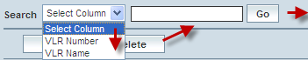

| **STEP** | **ACTION** |
| --- | --- |
|  | Select a search criterion (‘VLR Number’ or ‘VLR Name’) from the drop-down list of the search criteria of the <Search> field  **\*** By default the list of search criterion (‘VLR Number’ or ‘VLR Name’) will be dynamically displayed as drop-down list of the <Search> field |
|  | Enter the ‘VLR Number’ or ‘VLR Name’ that corresponds with the given search criterion |
|  | On clicking the **Go** button, the corresponding Restricted VLR(s) (record) will be highlighted among the list of Restricted VLR(s) records. |

The screen below depicts fetching and displaying the give Restricted VLR(s) record.

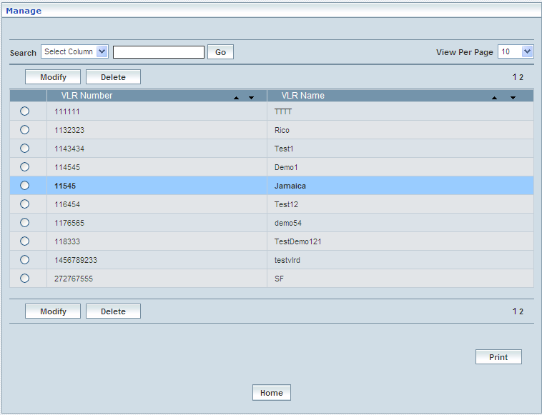

## Restricted SGSN(s)

Home Location Register 🡪 Roaming Management 🡪 Restricted SGSN(s)

SGSN(s)’ here in this context is the list of locations those represent the Visitor Location Register(s) pertaining to a **GPRS** network. Restricted SGSN(s) enables the user either to add or remove a set / group of SGSN(s) to/from the network sphere. This also allows the user to peruse details related to existing SGSN(s). If the SGSN is allowed, it cannot be restricted.

This Module maintains the details related to following restricted SGSN (s):

* Add / Remove
* Manage

On clicking **Add / Remove** link the following screen is displayed.



| **STEP** | **ACTION** |
| --- | --- |
|  | Select the radio option (Add / Remove) to specify whether user is intending to add a set of new SGSN (s) or remove a group of existing SGSN(s) to/from the Network space  The screen gets modified and it displays a list of parameter with their fields |
|  | On clicking the **Home** button (prior to the submission of Restricted SGSN(s), it only redirects the user back to the ‘Roaming Management’ main page |

**Add**

Home Location Register 🡪 Roaming Management 🡪 Restricted SGSN(s) 🡪 Add / Remove

Restricted SGSN(s) – Add helps the user to add a set of SGSN(s) to a GPRS network sphere. User can add restricted SGSN(s) in single or bulk mode.

The screen below shows adding single or group of SGSN(s) in single or bulk to a **GPRS** network sphere.

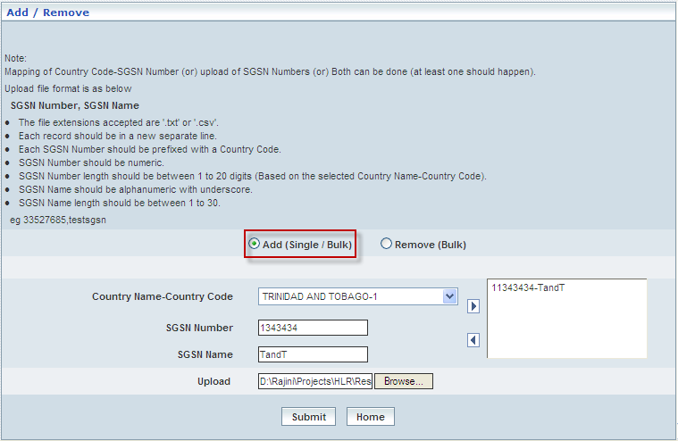

| **STEP** | **ACTION** |
| --- | --- |
|  | User must follow these guide lines & instructions for the Data Formats of the SGSN Details |
|  | Select the radio option **Add** to add a set of new SGSN(s) to the GPRS Network space |
|  | Select country name and country code from the <Country Name–Country Code> drop-down list |
|  | Enter SGSN number in the <SGSN Number> field |
|  | Enter SGSN name in the <SGSN Name> field |
|  | On clicking the right-arrow button, the service key (number) will be moved to the adjacent field  User can enter the desired number of SGSN number and SGSN name in a similar fashion |
|  | However, if the user wants to just remove certain service keys any time before creating or establishing the SGSN, selecting the number (service key) from the list and subsequently clicking the left-arrow button removes the number |
|  | **Bulk Upload**  Browse for a Flat file that consists of a set of SGSN(s) in a specific format and each one starting in a new line |
|  | On clicking the **Submit** button, the SGSN numbers are successfully stored in the database  A message window to that effect will be displayed    On clicking **Home** button of the message window, it redirects the user to the ‘Add / Remove’ Screen |
|  | On clicking the **Home** button (prior to upload of the flat file), it only redirects the user back to the ‘Restricted SGSN(s)’ main page |

**Remove**

Home Location Register 🡪 Roaming Management 🡪 Restricted SGSN(s) 🡪 Add / Remove

Restricted SGSN(s) –Remove helps the user to remove a set of SGSN(s) from a GPRS network sphere in bulk / at a stretch.

The screen below shows removing a set / group of SGSN(s) in bulk from a network sphere

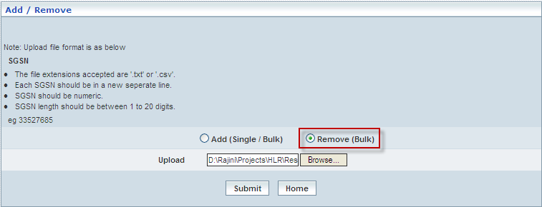

| **STEP** | **ACTION** |
| --- | --- |
|  | User must follow these guide lines & instructions for the Data Formats of the SGSN Details |
|  | Select the radio option **Remove** to remove a group of existing SGSN(s) from a GPRS Network space |
|  | Browse for a Flat file that consists of a set of SGSN(s) in a specific format and each one starting in a new line |
|  | On clicking the **Submit** button, a message window to that effect will be displayed confirming the successfully removing SGSN(s)    On clicking **Home** button of the message window, it redirects the user to the ‘Add / Remove’ Screen |
|  | On clicking the **Home** button (prior to upload of the flat file), it only redirects the user back to the ‘Restricted SGSN(s)’ main page |

**Manage**

Home Location Register 🡪 Roaming Management 🡪 Restricted SGSN(s) 🡪 Manage

Restricted SGSN(s) – Manage helps the user to modify or delete the existing SGSN(s) in the GPRS network.

The screen below shows a list of SGSN(s).

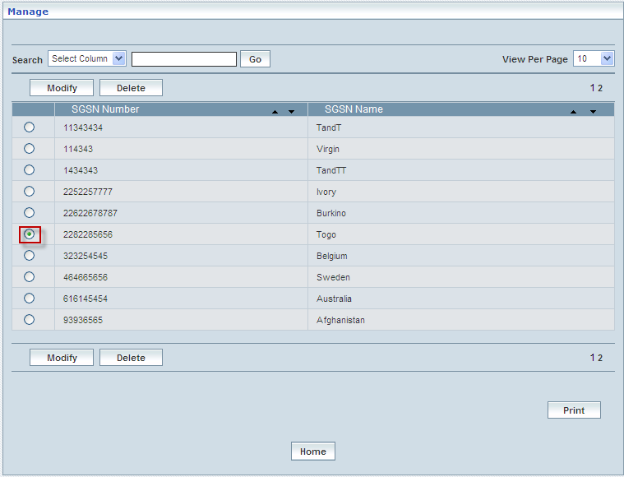

| **STEP** | | **ACTION** |
| --- | --- | --- |
|  | | By default, the list of SGSN(s) will be displayed as records in a grid. The columns include SGSN Number |
|  |  | User can customize the view for the number of records to be displayed each time (per page) in a grid.  However, this option is applicable only if the total number of records exceeds 10. And also with the immediate effect of increase in the number of records more than 10, a ‘Search’ option would be dynamically displayed. |
| Select the number of records (For Ex: 10) from the drop-down list of the <View Per Page> field. |
| With the effect of choosing the desired number (10) for the display of records per page, the same (10 records) will be displayed in the grid. |
| User can sort the records in ascending and descending orders with the help of up-arrow and down-arrows respectively |
| However, based on the total number of records, page numbers will be dynamically displayed at the left bottom of the screen |
| User can navigate for subsequent records (10 each time) by clicking the desired ‘page number’ |
|  | | On selecting a SGSN number and clicking the **Modify** button, user can modify the existing SGSN(s) number |
|  | | On selecting a SGSN number and clicking the **Delete** button, user can delete the existing SGSN(s) number |
|  | | On clicking the **Print** button at the bottom of the grid, user can take printouts of the SGSN(s) list |
|  | | On clicking the **Home** button at the bottom of the grid, it redirects the user to the ‘Restricted SGSN(s)’ main page |

**Modify**

Home Location Register 🡪 Roaming Management 🡪 Restricted SGSN(s) 🡪 Manage 🡪 Modify

Modify enables the user to modify / update the details related to an existing SGSN(s) number.

The screen below shows modifying a SGSN(s) number.

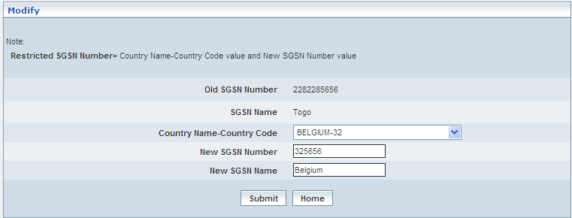

| **STEP** | **ACTION** |
| --- | --- |
|  | Select country name and country code from the Country Name – Country Code dropdown list |
|  | Enter new SGSN number in the New SGSN Number field |
|  | On clicking the **Submit** button, the SGSN numbers is successfully modified  A message window to that effect will be displayed    On clicking **Home** button of the message window, it redirects the user to the ‘Manage’ grid |
|  | On clicking the **Home** button (prior to upload of the flat file), it only redirects the user back to the ‘Restricted SGSN(s)’ main page |

**Delete**

Home Location Register 🡪 Roaming Management 🡪 Restricted SGSN(s) 🡪 Manage 🡪 Delete

Delete enables the user to delete the details related to an existing SGSN(s) number.

| **STEP** | **ACTION** |
| --- | --- |
|  | Select a SGSN number radio option |
|  | On clicking the **Delete** at the bottom of the ‘Manage’ screen, it displays an alert window enabling the user to confirm deletion of the chosen SGSN number  C:\DOCUME~1\rajini.sn\LOCALS~1\Temp\SNAGHTML368b70.PNG  On clicking the **OK** button of the alert window, the chosen Restricted SGSN Number will be deleted and a message window to that effect will be displayed    On clicking the **Cancel** button of the alert window, it retains the corresponding ‘Manage’ grid  On clicking the **Home** button of the message window, it directs the user back to the ‘Manage Profiles’ grid |
|  | On clicking the **Home** button of the ‘Manage’ screen (before deleting the profile), it directs to the ‘Restricted SGSN(s)’ main page |

**Searching for a specific Restricted SGSN(s) (Record)**

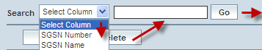

| **STEP** | **ACTION** |
| --- | --- |
|  | Select a search criterion (‘SGSN Number’ or ‘SGSN Name’) from the drop-down list of the search criteria of the <Search> field  **\*** By default the list of search criterion (‘SGSN Number’ or ‘SGSN Name’) will be dynamically displayed as drop-down list of the <Search> field |
|  | Enter the ‘SGSN Number’ or ‘SGSN Name’ that corresponds with the given search criterion |
|  | On clicking the **Go** button, the corresponding Restricted SGSN(s) (record) will be highlighted among the list of Restricted SGSN(s)records. |

The screen below depicts fetching and displaying the give Restricted SGSN(s)record.

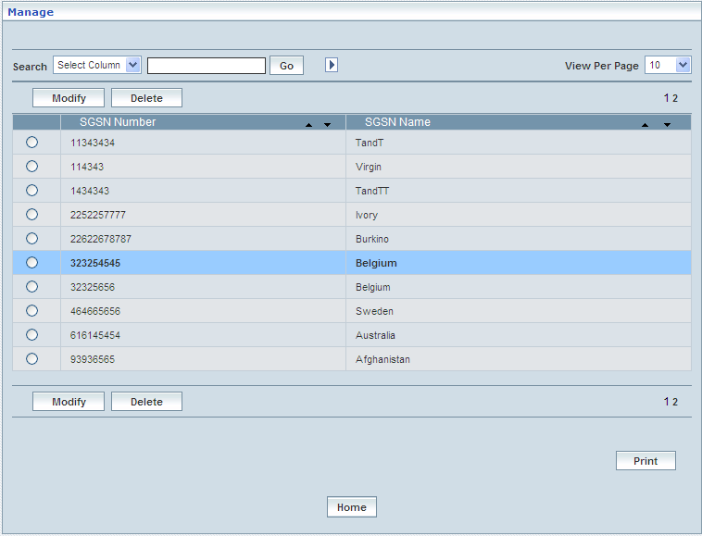

## Allowed VLR(s)

Home Location Register 🡪 Roaming Management 🡪 Allowing VLR(s)

VLR(s) here in this context is the list of locations those represent the Visitor Location Register(s) pertaining to a **GSM** network access mode. Allowing VLR(s) enables the user to create, view, modify and delete a set / group of VLR(s) to/from the network sphere. This also allows the user to peruse details related to existing VLR(s). If the VLR is restricted then it cannot allowed.

The below screen represents the roaming profiles listed in a grid

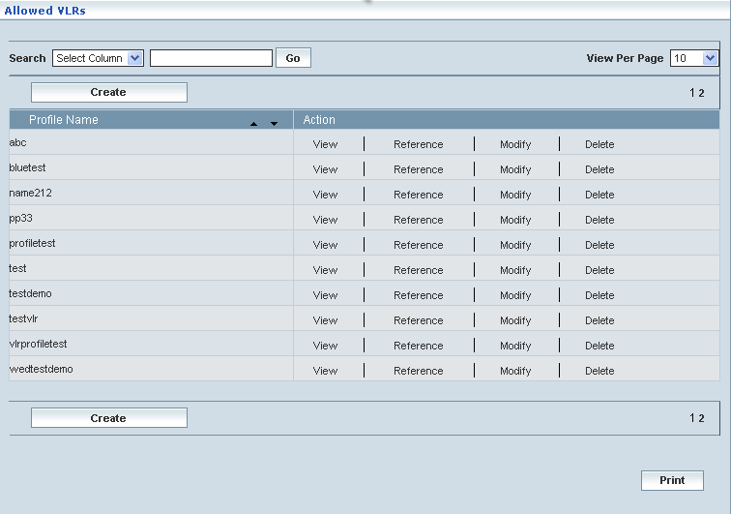

| **STEP** | | **ACTION** |
| --- | --- | --- |
|  | | By default, the list of profiles (Selective Roaming Profiles) will be displayed as records in a grid. The columns include ‘Profile Name’ and ‘Action’ |
|  |  | User can customize the view for the number of records to be displayed each time (per page) in a grid.  However, this option is applicable only if the total number of records exceeds 10. And also with the immediate effect of increase in the number of records more than 10, a ‘Search’ option would be dynamically displayed. |
| Select the number of records (For Ex: 10) from the drop-down list of the <View Per Page> field. |
| With the effect of choosing the desired number (10) for the display of records per page, the same (10 records) will be displayed in the grid. |
| User can sort the records in ascending and descending orders with the help of up-arrow and down-arrows respectively |
| However, based on the total number of records, page numbers will be dynamically displayed at the left bottom of the screen |
| User can navigate for subsequent records (10 each time) by clicking the desired ‘page number’ |
|  | | On clicking the **Create** button, ‘Create’ screen will be displayed enabling the user to create a new ‘Profile’ (roaming Profile) |
|  | | On clicking the **View** link of a chosen ‘Profile’, corresponding information related to the profile will be displayed in a separate screen enabling the user to peruse details of the profile |
|  | | On clicking the **Reference** link of a chosen ‘Profile’, corresponding information related to the profile will be displayed in a separate screen enabling the user to create an another profile with different name with the same details in the profile |
|  | | On clicking the **Modify** button, ‘Modify’ screen will be displayed enabling the user to modify an existing ‘Profile’ (roaming Profile) |
|  | | On clicking the **Delete** button, ‘Delete’ screen will be displayed enabling the user to delete a ‘Profile’ (roaming Profile) |
|  | | On clicking the **Print** button at the bottom of the grid, user can take printouts of the Profiles’ list |

**Create**

Home Location Register 🡪 Roaming Management 🡪 Allowed VLR(s) 🡪 Create

Create enables the user to create a new profile (Selective Roaming Profile) and attribute various values to constitute the same.

The screen below shows creating a new profile as Selective Roaming Profile

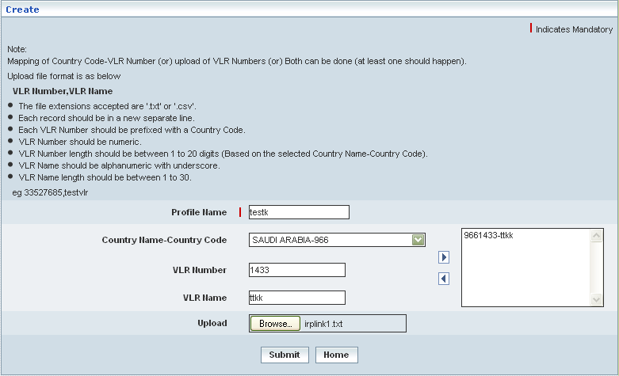

| **STEP** | **ACTION** |
| --- | --- |
|  | User must essentially enter the details related to a new profile where it is a mandatory information |
|  | Enter name of the profile in <Profile Name> field. |
|  | Select the country name and code from the <Country Name-Country Code> field. |
|  | Enter the VLR number in the <VLR Number> field.  **NOTE:** Super and sub-set combination is not accepted between any two VLR numbers of same country |
|  | Enter the VLR name in the <VLR Name> field |
|  | clicking the right-arrow button, the country code and VLR number (as a string) will be moved to the adjacent field  User can enter the desired number of codes in a similar fashion  However if the user wants to just remove any code (any time before creating the profile), selecting the code from the right text field and subsequently clicking the left-arrow button removes the code |
|  | User has an alternative option for uploading VLR numbers using the **Upload** option and with the help of the corresponding **Browse** button |
|  | Browse for a .txt or .csv file that comprises of multiple strings of the country code and VLR number, each in a new line  **NOTE:** Super and sub-set combination is not accepted between any two VLR numbers of same country |
|  | **NOTE:** Mapping of Country Code-VLR Number (one by one) or upload of VLR Numbers using Upload option can be carried out simultaneously. In other words, both the options can be used at a time |
|  | On clicking the **Submit** button, new roaming profile will be created and a message window to that effect will be displayed    On clicking the **Home** button of the message window, it directs the user back to the Mobility ‘Allowed VLRs’ profiles grid |
|  | On clicking the **Home** button of the ‘Create’ screen, it directs the user back to the ‘Allowed VLRs’ profiles grid |

**View**

Home Location Register 🡪 Roaming Management 🡪 Allowed VLR(s) 🡪 View

View enables the user to peruse details related to chosen Selective Roaming profile

On clicking the **‘View’** link of a chosen ‘Profile’ (from the Allowed VLR Profiles List); corresponding information related to the profile will be displayed in a separate screen enabling the user to peruse details of the profile –roaming profile.

The screen below displays the details related to chosen roaming profile.

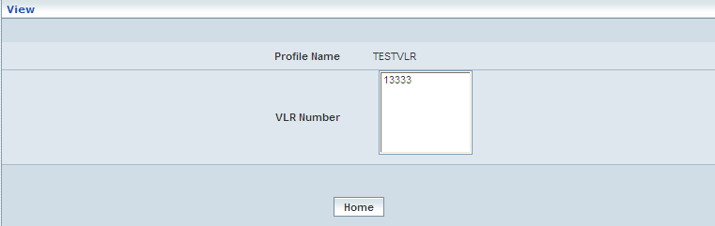

| **STEP** | **ACTION** |
| --- | --- |
|  | User can peruse details related to the chosen roaming Profile |
|  | On clicking the **Home** button at the bottom of the ‘View’ Screen, it redirects the user to the ‘Allowed VLRs’ profiles grid |

**Reference**

Home Location Register 🡪 Roaming Management 🡪 Allowed VLR(s) 🡪 Reference

On clicking the **‘Reference’** link of a chosen ‘Profile’ (from the ‘Allowed VLR’ Profiles List); corresponding information related to the profile will be displayed in a separate screen enabling the user to create a new profile (Selective Roaming Profile) with the existing VLRs.

The screen below shows creating a new profile as Selective Roaming Profile with the existing VLRs.

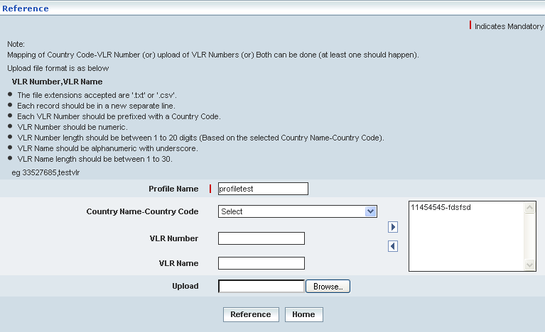

| **STEP** | **ACTION** |
| --- | --- |
|  | User must essentially enter the details related to a new profile where it is a mandatory information |
|  | Enter a different name in <Profile Name> field (different from that of the referred Profile name). If the user does not change the profile name, the following message is displayed. The user must change name of the profile to distinguish it from the referred profile |
|  | User can either retain the current values or make necessary changes / updates to the existing Country Codes / VLRs of the profile as desired. However, super and sub-set combination doesn’t exist between any two VLR numbers of same country |
|  | On clicking the right-arrow button, the country code and VLR number (as a string) will be moved to the adjacent field  User can enter the desired number of codes in a similar fashion  However if the user wants to just remove any code (any time before creating the profile), selecting the code from the right text field and subsequently clicking the left-arrow button removes the code |
|  | User has an alternative option for uploading VLR numbers using the **Upload** option and with the help of the corresponding **Browse** button |
|  | Browse for a .txt or .csv file that comprises of multiple strings of the country code and VLR number, each in a new line  **NOTE:** Super and sub-set combination is not accepted between any two VLR numbers of same country |
|  | **NOTE:** Mapping of Country Code-VLR Number (one by one) or upload of VLR Numbers using Upload option can be carried out simultaneously. In other words, both the options can be used at a time |
|  | On clicking the **Submit** button, new roaming profile will be created and a message window to that effect will be displayed    On clicking **Home** button of the message window, it directs the user back to the ‘Allowed VLR’s’ profiles grid |
|  | On clicking **Home** button of the ‘Reference’ screen, it directs the user back to the ‘Allowed VLRs’ profiles grid |

**Modify**

Home Location Register 🡪 Roaming Management 🡪 Allowed VLR(s) 🡪 Modify

Modify enables the user to modify / update the details related to an existing roaming profile.

On clicking the **‘Modify’** link of a chosen ‘Profile’ (from the Allowed VLRs Profiles List); corresponding information related to the profile will be displayed in a separate screen enabling the user to modify / update details of the profile – Allowed VLRs.

The screen below shows modifying / updating the details related to an existing roaming profile.

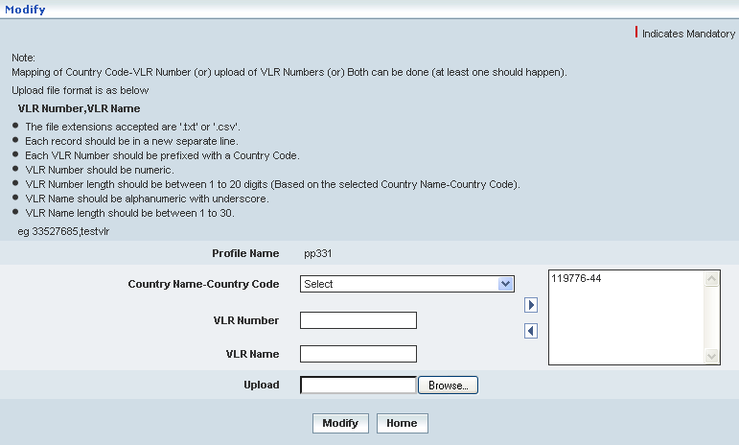

| **STEP** | **ACTION** |
| --- | --- |
|  | Name of the profile will be dynamically displayed in the <Profile Name> field and this cannot be modified |
|  | User can make necessary changes / updates to the existing data in the provided fields and finally perform mapping or upload the .txt file |
|  | On clicking the **Submit** button at the bottom of the ‘Modify’ screen, profile (Allowed VLR) details will be updated accordingly and a message window to that effect will be displayed    On clicking the **Home** button of the message window, it directs the user back to the ‘Allowed VLR’ profiles grid |
|  | On clicking the **Home** button of the ‘Modify’ screen (before updating the details related to profile), it directs the user to the ‘Allowed VLRs’ profiles grid |

**Delete**

Home Location Register 🡪 Roaming Management 🡪 Allowed VLR(s) 🡪 Delete

Delete enables the user to delete an existing roaming profile.

On clicking the **‘Delete’** link of a chosen ‘Profile’ (from the Allowed VLR Profiles List); corresponding information related to the profile will be displayed in a separate screen enabling the user to delete the – Allowed VLR.

The screen below shows the details related to an existing roaming profile, which enables the user to delete the same (Profile).

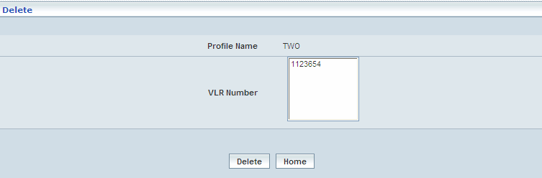

| **STEP** | **ACTION** |
| --- | --- |
|  | User can peruse the existing values / configurations of the profile before deleting the profile |
|  | On clicking the **Delete** at the bottom of the ‘Delete’ screen, it displays an alert window enabling the user to confirm deletion of the chosen profile  SNAGHTML88ba03  On clicking the **OK** button of the alert window, the chosen profile will be deleted and a message window to that effect will be displayed    On clicking the **Cancel** button of the alert window, it retains the corresponding ‘Delete’ screen  On clicking the **Home** button of the message window, it directs the user back to the ‘Allowed VLRs’ profiles grid |
|  | On clicking the **Home** button of the ‘Delete’ screen (before deleting the profile), it directs the user to the ‘Allowed VLRs’ profiles grid |

**Searching for a specific Allowed VLRs profiles (Record)**

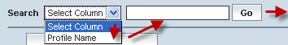

| **STEP** | **ACTION** |
| --- | --- |
|  | Select a search criterion (‘Profile Name’) from the drop-down list of the search criteria of the <Search> field  **\*** By default the list of search criterion (‘Profile Name’) will be dynamically displayed as drop-down list of the <Search> field |
|  | Enter the ‘Profile Name’ that corresponds with the given search criterion |
|  | On clicking the **Go** button, the corresponding Allowed VLRs Profiles (record) will be highlighted among the list of Allowed VLRs Profiles records. |

The screen below depicts fetching and displaying the give Allowed VLRs Profiles record.

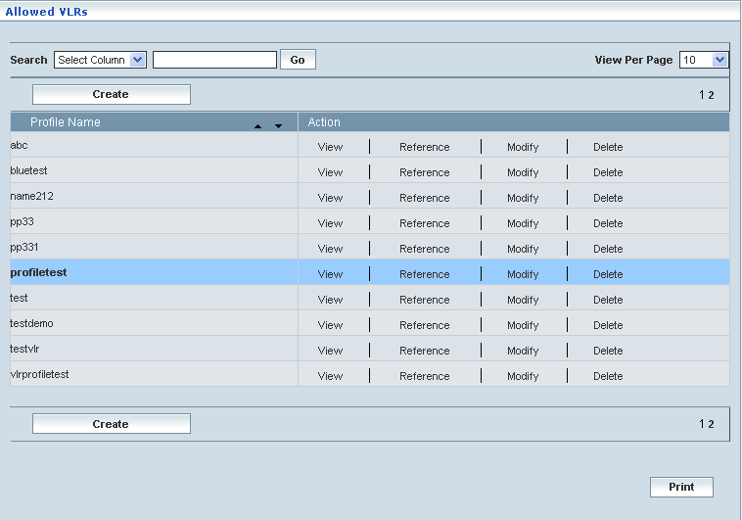

## Allowed SGSN(s)

Home Location Register 🡪 Roaming Management 🡪 Allowing SGSN(s)

SGSN(s)’ here in this context is the list of locations those represent the SGSN(s) pertaining to a **GSM** network access mode. Allowing SGSN(s) enables the user to create, view, and manage a set / group of SGSN (s) to/from the network sphere. This also allows the user to peruse details related to existing SGSN (s). If the SGSN is restricted then it cannot allowed.

The below screen represents the roaming profiles listed in a grid

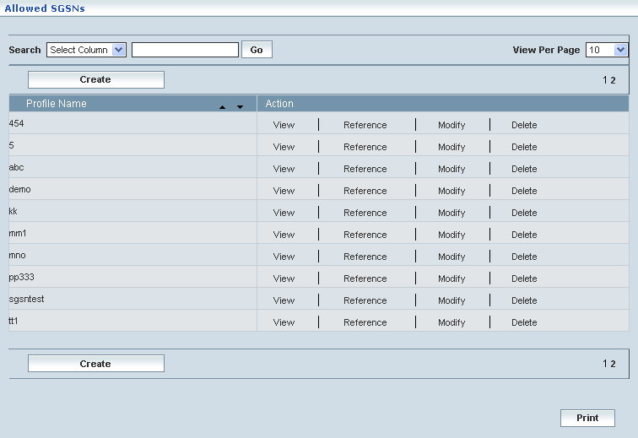

| **STEP** | | **ACTION** |
| --- | --- | --- |
|  | | By default, the list of profiles (Selective Roaming Profiles) will be displayed as records in a grid. The columns include ‘Profile Name’ and ‘Action’ |
|  |  | User can customize the view for the number of records to be displayed each time (per page) in a grid.  However, this option is applicable only if the total number of records exceeds 10. And also with the immediate effect of increase in the number of records more than 10, a ‘Search’ option would be dynamically displayed. |
| Select the number of records (For Ex: 10) from the drop-down list of the <View Per Page> field. |
| With the effect of choosing the desired number (10) for the display of records per page, the same (10 records) will be displayed in the grid. |
| User can sort the records in ascending and descending orders with the help of up-arrow and down-arrows respectively |
| However, based on the total number of records, page numbers will be dynamically displayed at the left bottom of the screen |
| User can navigate for subsequent records (10 each time) by clicking the desired ‘page number’ |
|  | | On clicking the **Create** button, ‘Create’ screen will be displayed enabling the user to create a new ‘Profile’ (roaming Profile) |
|  | | On clicking the **View** link of a chosen ‘Profile’, corresponding information related to the profile will be displayed in a separate screen enabling the user to peruse details of the profile |
|  | | On clicking the **Reference** link of a chosen ‘Profile’, corresponding information related to the profile will be displayed in a separate screen enabling the user to create an another profile with different name with the same details in the profile |
|  | | On clicking the **Modify** button, ‘Modify’ screen will be displayed enabling the user to modify an existing ‘Profile’ (roaming Profile) |
|  | | On clicking the **Delete** button, ‘Delete’ screen will be displayed enabling the user to delete a ‘Profile’ (roaming Profile) |
|  | | On clicking the **Print** button at the bottom of the grid, user can take printouts of the Profiles’ list |

**Create**

Home Location Register 🡪 Roaming Management 🡪 Allowed SGSN(s) 🡪 Create

Create enables the user to create a new profile (Selective Roaming Profile) and attribute various values to constitute the same.

The screen below shows creating a new profile as Selective Roaming Profile

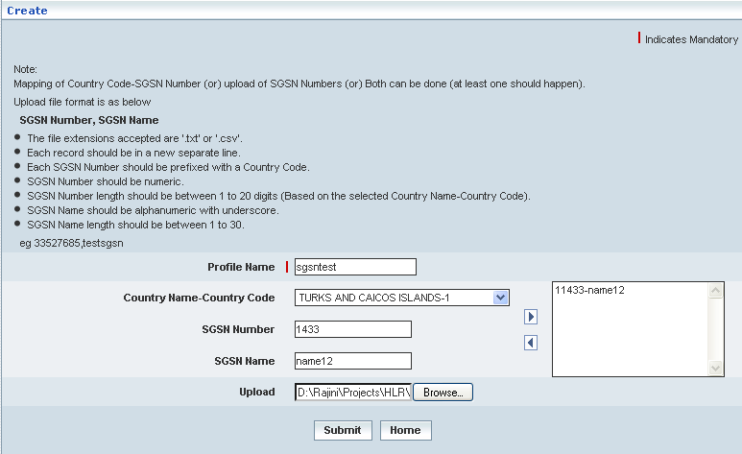

| **STEP** | **ACTION** |
| --- | --- |
|  | User must essentially enter the details related to a new profile where it is a mandatory information |
|  | Enter name of the profile in < Profile Name> field. |
|  | Select the country name and code in the <Country Name- Country Code> field. |
|  | Enter the SGSN number in the <SGSN Number> field.  **NOTE:** Super and sub-set combination doesn’t exist between any two SGSN numbers of same country. |
|  | Enter the VLR name in the <SGSN Name> field |
|  | clicking the right-arrow button, the country code and SGSN number (as a string) will be moved to the adjacent field  User can enter the desired number of SGSNs in a similar fashion  However if the user wants to just remove any SGSN (any time before creating the profile), selecting the code from the right text field and subsequently clicking the left-arrow button removes the same |
|  | User has an alternative option for uploading SGSN numbers using the **Upload** option and with the help of the corresponding **Browse** button |
|  | Browse for a .txt or .csv file that comprises of multiple strings of the country code and SGSN number, each in a new line  **NOTE:** Super and sub-set combination is not accepted between any two SGSN numbers of same country |
|  | **NOTE:** Mapping of Country Code-SGSN Number (one by one) or upload of SGSN Numbers using Upload option can be carried out simultaneously. In other words, both the options can be used at a time |
|  | On clicking the **Submit** button, new roaming profile will be created and a message window to that effect will be displayed    On clicking the **Home** button of the message window, it directs the user back to the Mobility ‘Allowed SGSNs’ profiles grid |
|  | On clicking the **Home** button of the ‘Create’ screen, it directs the user back to the ‘Allowed SGSNs’ profiles grid |

**View**

Home Location Register 🡪 Roaming Management 🡪 Allowed SGSN(s) 🡪 View

View enables the user to peruse details related to chosen roaming profile

On clicking the **‘View’** link of a chosen ‘Profile’ (from the Allowed SGSN Profiles List); corresponding information related to the profile will be displayed in a separate screen enabling the user to peruse details of the profile –roaming profile.

The screen below displays the details related to chosen roaming profile.

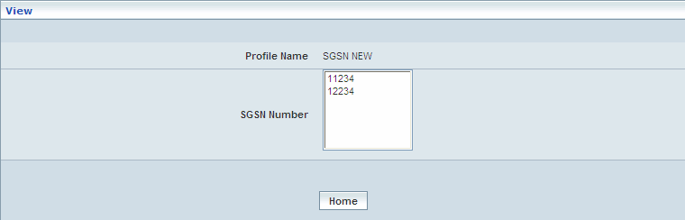

| **STEP** | **ACTION** |
| --- | --- |
|  | User can peruse details related to the chosen roaming Profile |
|  | On clicking the **Home** button at the bottom of the ‘View’ Screen, it redirects the user to the ‘Allowed SGSN’s’ profiles grid |

**Reference**

Home Location Register 🡪 Roaming Management 🡪 Allowed SGSN(s) 🡪 Reference

On clicking the **‘Reference’** link of a chosen ‘Profile’ (from the ‘Allowed SGSNs’ Profiles List); corresponding information related to the profile will be displayed in a separate screen enabling the user to create a new profile (Selective Roaming Profile) with the existing SGSNs.

The screen below shows creating a new profile as Selective Roaming Profile with the existing SGSNRs.

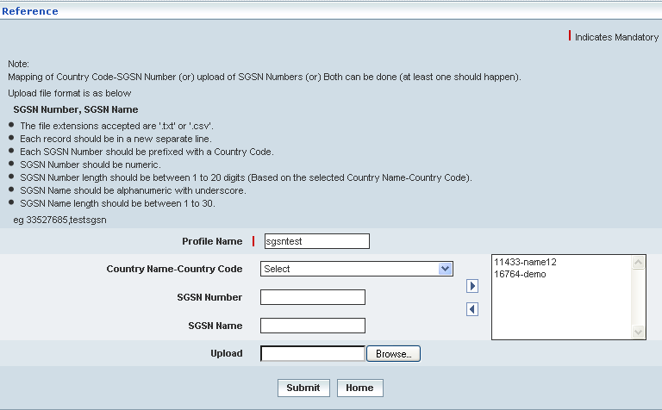

| **STEP** | **ACTION** |
| --- | --- |
|  | User must essentially enter the details related to a new profile where it is a mandatory information |
|  | Enter a different name in <Profile Name> field (different from that of the referred Profile name). If the user does not change the profile name, the following message is displayed. The user must change name of the profile to distinguish it from the referred profile |
|  | User can either retain the current values or make necessary changes / updates to the existing Country Codes / SGSN of the profile.  However, super and sub-set combination doesn’t exist between any two SGSNs of same country |
|  | On clicking the right-arrow button, the country code and SGSN number (as a string) will be moved to the adjacent field. User can enter the desired number of SGSNs in a similar fashion  However, if the user wants to just remove any SGSN (any time before creating the profile), selecting the SGSN from the right text field and subsequently clicking the left-arrow button removes the same |
|  | User has an alternative option for uploading SGSN numbers using the **Upload** option and with the help of the corresponding **Browse** button |
|  | Browse for a .txt or .csv file that comprises of multiple strings of the country code and SGSN number, each in a new line  **NOTE:** Super and sub-set combination is not accepted between any two SGSN numbers of same country |
|  | **NOTE:** Mapping of Country Code-SGSN Number (one by one) or upload of SGSN Numbers using Upload option can be carried out simultaneously. In other words, both the options can be used at a time |
|  | On clicking the **Submit** button, new roaming profile will be created and a message window to that effect will be displayed    On clicking the **Home** button of the message window, it directs the user back to the ‘Allowed SGSNs’ profiles grid |
|  | On clicking the **Home** button of the Reference screen, it directs the user back to the ‘Allowed SGSNs’ profiles grid |

**Modify**

Home Location Register 🡪 Roaming Management 🡪 Allowed SGSN(s) 🡪 Modify

Modify enables the user to modify / update the details related to an existing roaming profile.

On clicking the **‘Modify’** link of a chosen ‘Profile’ (from the Allowed SGSNs Profiles List); corresponding information related to the profile will be displayed in a separate screen enabling the user to modify / update details of the profile – Allowed SGSNs.

The screen below shows modifying / updating the details related to an existing roaming profile.

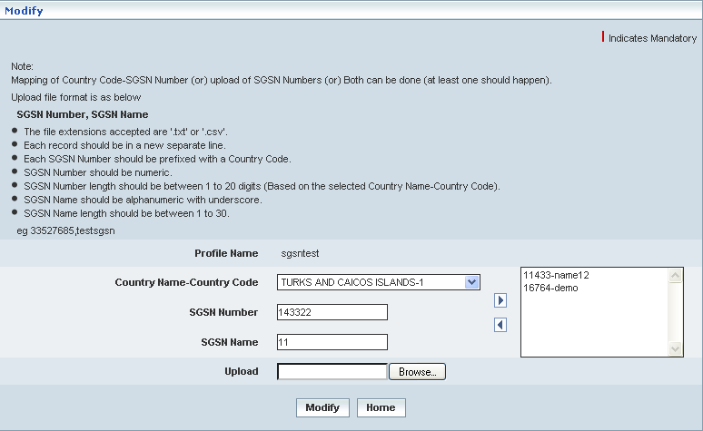

| **STEP** | **ACTION** |
| --- | --- |
|  | Name of the profile will be dynamically displayed in the <Profile Name> field and this cannot be modified |
|  | User can make necessary changes / updates to the existing data in the provided fields and finally perform mapping or upload the .txt file |
|  | On clicking the **Submit** button at the bottom of the ‘Modify’ screen, profile (Allowed SGSN) details will be updated accordingly and a message window to that effect will be displayed    On clicking the **Home** button of the message window, it directs the user back to the ‘Allowed SGSN’ profiles grid |
|  | On clicking the **Home** button of the ‘Modify’ screen (before updating the details related to profile), it directs the user to the ‘Allowed SGSNs’ profiles grid |

**Delete**

Home Location Register 🡪 Roaming Management 🡪 Allowed SGSN(s) 🡪 Delete

Delete enables the user to delete an existing roaming profile.

On clicking the **‘Delete’** link of a chosen ‘Profile’ (from the Allowed SGSN Profiles List); corresponding information related to the profile will be displayed in a separate screen enabling the user to delete the – Allowed SGSN.

The screen below shows the details related to an existing roaming profile, which enables the user to delete the same (Profile).

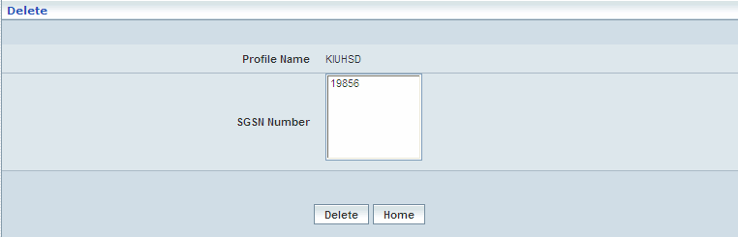

| **STEP** | **ACTION** |
| --- | --- |
|  | User can peruse the existing values / configurations of the profile before deleting the profile |
|  | On clicking the **Delete** at the bottom of the ‘Delete’ screen, it displays an alert window enabling the user to confirm deletion of the chosen profile  SNAGHTML92d645  On clicking the **OK** button of the alert window, the chosen profile will be deleted and a message window to that effect will be displayed    On clicking the **Cancel** button of the alert window, it retains the corresponding ‘Delete’ screen  On clicking the **Home** button of the message window, it directs the user back to the ‘Allowed SGSNs’ profiles grid |
|  | On clicking the **Home** button of the ‘Delete’ screen (before deleting the profile), it directs the user to the ‘Allowed SGSNs’ profiles grid |

**Searching for a specific Allowed SGSNs profiles (Record)**



| **STEP** | **ACTION** |
| --- | --- |
|  | Select a search criterion (‘Profile Name’) from the drop-down list of the search criteria of the <Search> field  **\*** By default the list of search criterion (‘Profile Name’) will be dynamically displayed as drop-down list of the <Search> field |
|  | Enter the ‘Profile Name’ that corresponds with the given search criterion |
|  | On clicking the **Go** button, the corresponding Allowed SGSNSs Profiles (record) will be highlighted among the list of Allowed SGSNSs Profiles records. |

The screen below depicts fetching and displaying the give Allowed SGSNSs Profiles record.

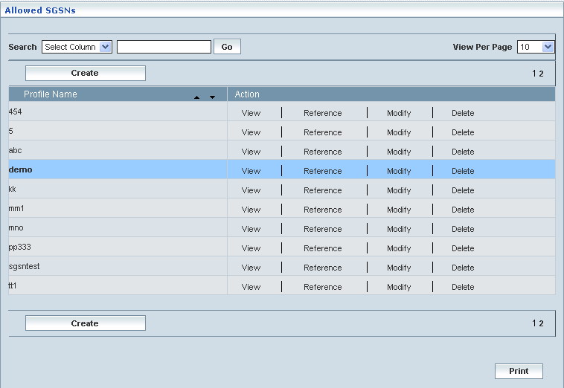

## Allowed VPLMNIDs

Home Location Register 🡪 Roaming Management 🡪 Allowed VPLMNIDs

Allowed VPLMNIDs (Visited Public Land Mobile Network) Configuration module enables the user to associate subscribers profile to the manually configured VPLMN (Visited Public Land Mobile Network) i.e. VPMNID and VPLMN Name.

‘Allowed VPLMNIDs’ feature enables the user to create a profile for the Allowed VPLMNIDs. Assigning/mapping VPMNID (network name) and its relevant VPLMN Name shall create a profile. Hence, MSISDNs (Subscribers) relevant to the mapped network (VPLMNID) are allowed for the roaming services, while subscribers are leaving their Home Public Land Mobile Network.

This module helps the user performing the following actions:

* Create
* View
* Reference
* Modify
* Delete

The screen below displays existing Allowed VPLMNIDs Configuration details:

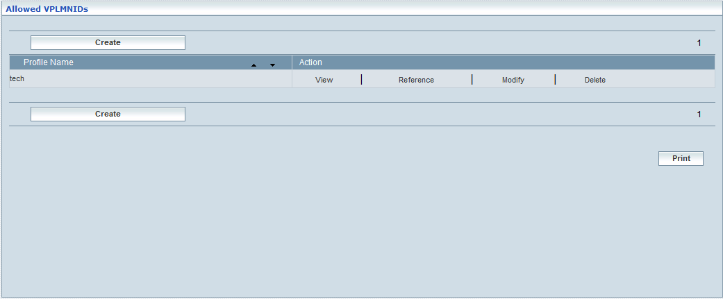

|  |  |  |
| --- | --- | --- |
| **STEP** | | **ACTION** |
|  | | By default, the list of Allowed VPLMNIDs Configuration will be displayed as records in a grid. The columns include ‘Profile Name’ and ‘Action’. |
|  |  | User can customize the view for the number of records to be displayed each time (per page) in a grid.  However, this option is applicable only if the total number of records exceeds 10. And also with the immediate effect of increase in the number of records more than 10, a ‘Search’ option would be dynamically displayed. |
| Select the number of records (For Ex: 10) from the drop-down list of the <View Per Page> field. |
| With the effect of choosing the desired number (10) for the display of records per page, the same (10 records) will be displayed in the grid. |
| User can sort the records in ascending and descending orders with the help of up-arrow and down-arrows respectively |
| However, based on the total number of records, page numbers will be dynamically displayed at the left bottom of the screen |
| User can navigate for subsequent records (10 each time) by clicking the desired ‘page number’ |
| **2** | | On clicking the **Create** button; ‘Create’ screen will be displayed enabling the user to create a profile by mapping the VPLMIDs and VPLMN Name. |
|  | | On clicking the **Upload** button, ‘Upload’ screen will be displayed enabling the user to browse and locate the ‘.txt’ or ‘.csv’ file and upload |
|  | | On clicking the **View** link, ‘View’ screen will be displayed enabling the user to view the Profile Name and corresponding VPLMNIDs associated to the subscriber profile |
|  | | On clicking the **Reference** link, to refer and associate the existing VPLMNIDs to another subscriber profile.(other than existing subscriber)  On clicking the **Reference** link of a chosen ‘Profile’, a replica of the profile will be displayed in a separate screen (along with all the configured values / parameters of the chosen profile). This enables the user to create another profile with similar configured values or with slight changes but with a distinct name. This provision of reference creation in fact reduces the time in creating a profile similar to the one that already exists |
|  | | On clicking the **Modify** link, ‘Modify’ screen will be displayed enabling the user to update / change corresponding VPLMNIDs associated to the subscriber profile |
|  | | On clicking the **Delete** link, ‘Delete’ screen will be displayed enables the user to delete the same |
|  | | On clicking the **Home** button at the bottom of the grid, it redirects the user to the ‘Roaming Management’ main page |

**Create**

Home Location Register 🡪 Roaming Management 🡪 Allowed VPLMNID(s) 🡪 Create

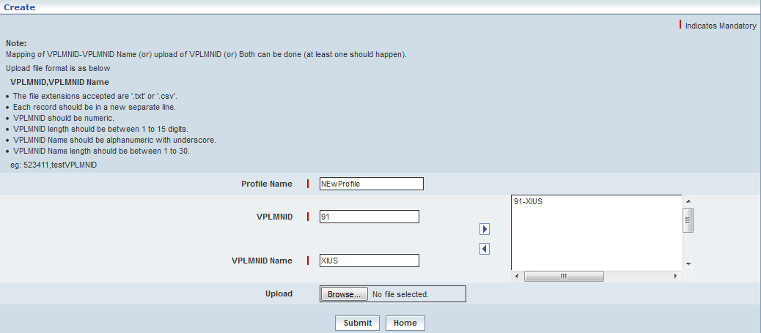

|  |  |
| --- | --- |
| **STEP** | **ACTION** |
|  | Specify the **Profile Name** |
|  | Specify **VPLMNID**, to which the subscriber has to get associated  **Note:** VPLMNIDs are configured at *Home Location Register 🡪 VPLMN Configuration🡪 Create* |
|  | Specify **VPLMN Name**, to which the subscriber has to get associated  **Note:** VPLMN Name are associated to VPLMNIDs. For more information, refer *Home Location Register 🡪 VPLMN Configuration🡪 Create* |
|  | **Upload:** Click the **Browse** button, ‘Upload’ screen will be displayed enabling the user to browse and locate the ‘.txt’ or ‘.csv’ file and upload  Follow the below rules pertaining to file format:  The file extensions accepted are '.txt' or '.csv'.  Each record should be in a new separate line.   * VPLMNID should be numeric. * VPLMNID length should be between 1 to 15 digits. * VPLMNID Name should be alphanumeric with underscore. * VPLMNID Name length should be of 1 to 30 characters. * e.g.: 523411,testVPLMNID |
|  | Click **Submit** to configure the Allowed VPLMNIDs profile |
|  | Click **Home** button, it would redirect the user to the ‘Roaming Management’ main page. |

**View**

Home Location Register 🡪 Roaming Management 🡪 Allowed VPLMNID(s) 🡪 View

View enables the user to peruse details related to chosen roaming profile

On clicking the **‘View’** link of a chosen ‘Profile’ (from the Allowed VPLMNIDs Profiles List); corresponding information related to the profile will be displayed in a separate screen enabling the user to peruse details of the profile –roaming profile.

The screen below displays the details related to chosen roaming profile.

| **STEP** | **ACTION** |
| --- | --- |
|  | User can peruse details related to the chosen roaming Profile |
|  | On clicking the **Home** button at the bottom of the ‘View’ Screen, it redirects the user to the ‘Allowed VPLMIDs’ profiles grid |

**Reference**

Home Location Register 🡪 Roaming Management 🡪 Allowed VPLMNID (s)🡪 Create🡪Reference

On clicking the **‘Reference’** link of a chosen ‘Profile’ (from the Allowed VPLMN IDs profiles), a replica of the profile will be displayed in a separate screen (along with all the configured values / parameters of the chosen profile). This enables the user to create another profile with similar configured values or with slight changes but with a distinct name. This provision of reference creation in fact reduces the time in creating a profile similar to the one that already exists

The screen below displays the details related to chosen profile (Subscriber Profile) enabling the user to create a reference / similar profile with distinct name

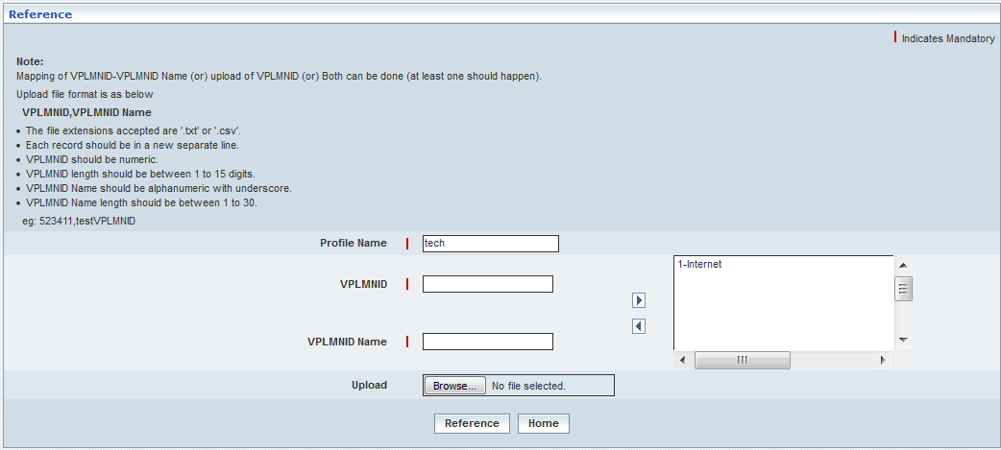

| **STEP** | **ACTION** |
| --- | --- |
|  | Name of the profile will be dynamically displayed in the <Profile Name> field and Specify the Reference **Profile Name.**  Enter a name to profile in order to createareplica of the profile. |
|  | The VPLMNID and VPLMN Name will remain unchanged and finally perform mapping or upload the .txt file |
|  | On clicking the **Reference** button at the bottom of the ‘Reference’ screen, profile (Allowed VPLMNID) details will be copied accordingly and a message window to that effect will be displayed    On clicking the **Home** button of the message window, it directs the user back to the ‘Allowed VPLMNIDs’ profiles grid |
|  | On clicking the **Home** button of the ‘Modify’ screen (before updating the details related to profile), it directs the user to the ‘Allowed VPLMNIDs’ profiles grid |

**Modify**

Home Location Register 🡪 Roaming Management 🡪 Allowed VPLMNID (s) 🡪 Modify

Modify enables the user to modify / update the details related to an existing allowed VPLMN profile.

On clicking the **‘Modify’** link of a chosen ‘Profile’ (from the Allowed VPLMNIDs Profiles List); corresponding information related to the profile will be displayed in a separate screen enabling the user to modify / update details of the profile – Allowed VPLMNIDs.

The screen below shows modifying / updating the details related to an existing roaming profile.

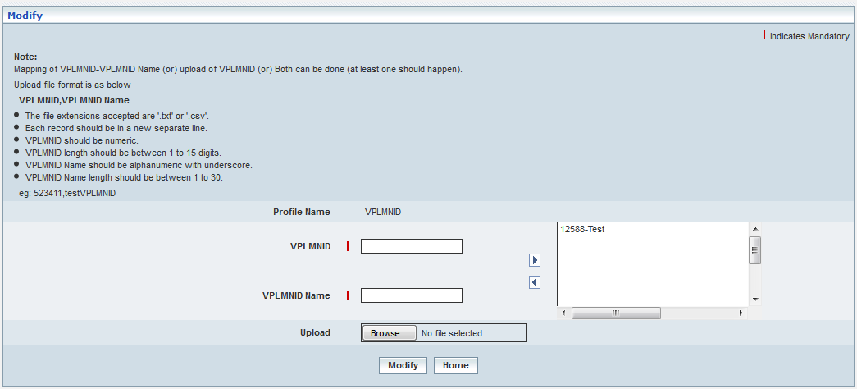

| **STEP** | **ACTION** |
| --- | --- |
|  | Name of the profile will be dynamically displayed in the <Profile Name> field and this cannot be modified |
|  | User can make necessary changes / updates to the existing data in the provided fields and finally perform mapping or upload the .txt file |
|  | On clicking the **Modify** button at the bottom of the ‘Modify’ screen, profile (Allowed VPLMNID) details will be updated accordingly and a message window to that effect will be displayed    On clicking the **Home** button of the message window, it directs the user back to the ‘Allowed VPLMNIDs’ profiles grid |
|  | On clicking the **Home** button of the ‘Modify’ screen (before updating the details related to profile), it directs the user to the ‘Allowed VPLMNIDs’ profiles grid |

**Delete**

Home Location Register 🡪 Roaming Management 🡪 Allowed VPLMNID(s) 🡪 Delete

Delete enables the user to delete an existing roaming profile.

On clicking the **‘Delete’** link of a chosen ‘Profile’ (from the Allowed VPLMNIDs Profiles List); corresponding information related to the profile will be displayed in a separate screen enabling the user to delete the – Allowed VPLMNID profile.

The screen below shows the details related to an existing roaming profile, which enables the user to delete the same (Profile).

|  |  |
| --- | --- |
| **STEP** | **ACTION** |
|  | User can peruse the existing values / configurations of the profile before deleting the profile |
|  | On clicking the **Delete** at the bottom of the ‘Delete’ screen, it displays an alert window enabling the user to confirm deletion of the chosen profile      On clicking the **OK** button of the alert window, the chosen profile will be deleted and a message window to that effect will be displayed    On clicking the **Cancel** button of the alert window, it retains the corresponding ‘Delete’ screen  On clicking the **Home** button of the message window, it directs the user back to the ‘Allowed VPLMNIDs’ profiles grid |
|  | On clicking the **Home** button of the ‘Delete’ screen (before deleting the profile), it directs the user to the ‘Allowed VPLMNIDs’ profiles grid |

## Change Allowed VLR/SGSN (Bulk)

Change Allowed VLR/SGSN (Bulk) helps the user to provide/change profile name and available VLR/SGSN profile, as the case may be, to multiple subscribers at a stretch (in bulk) to represent the corresponding discrete services. The service is available only when the network access mode is GSM, GPRS or GSM &GPRS.

The screen below shows uploading the file to provide/change profile name.

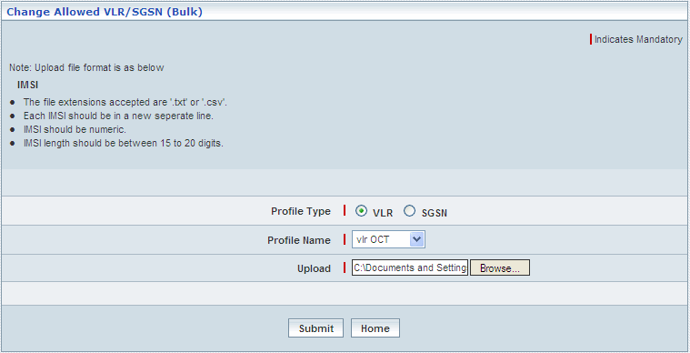

| **STEP** | **ACTION** |
| --- | --- |
|  | User must essentially enter the details related to a new profile where it is a mandatory information |
|  | Select a different profile name from the <Profile Name> drop-down field  By default, the existing profile names would be dynamically displayed as drop-down list of the <Profile Name> field |
|  | User can make necessary changes / updates to the existing Country Codes / SGSN of the profile. Super and sub-set combination doesn’t exist between any two SGSNs of same country |
|  | User has option for uploading IMSI numbers using the **Upload** option and with the help of the **Browse** button |
|  | Browse for a .txt or .csv file that comprises of multiple IMSIs, each in a new line |
|  | On clicking the **Submit** button, new roaming profile will be updated and a message window to that effect will be displayed  Wor4E  On clicking the **Home** button of the message window, it directs the user back to the ‘Change Allowed VLR/SGSN (Bulk)’ screen |
|  | On clicking the **Home** button of the Change Allowed VLR/SGSN (Bulk) screen (before uploading the IMSIs file), it directs the user back to the main page of ‘Roaming Management’ |

# Reports

## Peg Counts

‘Peg Counts’ helps the user to provide the information relevant to count of all calls to an access line or trunk group. The Peg count provides the information relevant to the following services.

* **Authentication Count**: Count relevant to the Subscriber Authentication. The Authentication Count displays information with the following.
  + ***Total Authentication Count****: Displays total count of subscriber authentication*
  + ***Success Authentication Count****: Displays count pertinent to the successful subscriber authentication.*
* **LU GSM Count**: Count relevant to location update for all calls. The LU GSM Count displays information with the following.
  + ***Total LU GSM Count****: Displays total location update count of all calls*
  + ***Success LU GSM Count****: Displays count pertinent to the successful location update for all calls.*
* **LU GPRS Count**: Count relevant to Location update for data related transactions. The LU GPRS Count displays information with the following.
  + ***Total LU GPRS Count****: Displays total location update count related to data*
  + ***Success LU GPRS Count****: Displays count pertinent to the successful location update relevant to data.*
* **SRI Count**: Count relevant to SRI (Send Routing Information count) for calls. SRI is a MAP message sent by the GMSC to the HLR to request routing information in order to route a call towards a mobile subscriber. The SRI Count displays information with the following.
  + ***Total SRI Count****: Displays total SRI count of calls.*
  + ***Success SRI Count****: Displays successful SRI count*
* **SRISM Count**: Count relevant to SRISM count for messages. The SRISM Count displays information with the following.
  + ***Total SRISM Count****: Displays total SRISM count of messages.*
  + ***Success SRISM Count****: Displays successful SRISM count*
* **USSD Count**: Count relevant to USSD transactions.
  + ***Total USSD Count****: Displays total USSD count.*
  + ***Success USSD Count****: Displays successful USSD relevant transactions count.*

# Acronyms and Definitions

|  |  |
| --- | --- |
| Acronym | Definition |
| 3GPP | 3rd Generation Partnership Project |
| ACE | Adaptive Communication Environment |
| AoCC | Advice of Charge (Charging) |
| AoCI | Advice of Charge (Information) |
| AuC | Authentication Center |
| BAIC | Barring of All Incoming Calls |
| BAOC | Barring of All Outgoing Calls |
| BIC-Roam | Barring of Incoming Calls when Roaming Outside the Home PLMN Country |
| BOIC | Barring of Outgoing International Calls |
| BOIC-exHC | Barring of Outgoing International Calls except those directed to the Home PLMN Country |
| CAMEL | Customized Applications for Mobile network Enhanced Logic |
| CCBS | Completion of Calls to Busy Subscribers |
| CC | Country Code |
| CD | Call Deflection |
| CFB | Call Forwarding on Busy |
| CFU | Call Forwarding Unconditional |
| CFNRc | Call Forwarding Not Reachable |
| CFNRy | Call Forwarding No Reply |
| CLIP | Calling Line Identification Presentation |
| CLIR | Calling Line Identification Restriction |
| CNAP | Calling Name Presentation |
| CoLP | Connected Line Identification Presentation |
| CoLR | Connected Line Identification Restriction |
| CSI | CAMEL Subscription Information |
| CUG | Closed User Group |
| CW | Call Waiting |
| D-CSI | Dialed CSI |
| ECT | Explicit Call Transfer |
| EH&D | Event Handler & Dispatcher |
| eMLPP | Enhanced Multi-Level Precedence and Pre-emption |
| FTN | Forward To Numbers |
| GMSC | Gateway MSC |
| GPRS | General Packet Radio System |
| GPRS-CSI | GPRS CAMEL Subscription Information |
| GSM | Global System for Mobile Communication |
| GUI | Graphical User Interface |
| HLR | Home Location Register |
| HPLMN | Home Public Land Mobile Network |
| HOLD | Call Hold |
| IAM | Initial Address Message |
| IMSI | International Mobile Subscriber Identifier |
| LAC | Link Access Control |
| LSA | Localized Service Area |
| MC | Multi Call |
| MCC | Mobile Country Code |
| MCEF | Mobile‑Station‑Memory‑Capacity‑Exceeded‑Flag |
| M-CSI | Mobility Management CSI |
| MG-CSI | Mobility Management for GPRS CSI |
| MNC | Mobile Network Code |
| MNRF | Mobile‑Station‑Not‑Reachable‑Flag |
| MNRG | Mobile‑station‑Not-Reachable-for-GPRS |
| MO | Mobile Origination |
| MO-SMS-CSI | Mobile Originated Short Message Services Camel Subscription Information |
| MPTY | Multi Party Service |
| MS | Mobile Station |
| MSC | Mobile Switching Center |
| MSP | Mobile Services Platform |
| MSISDN | Mobile Subscriber ISDN Number |
| MSRN | Mobile Subscriber Roaming Number |
| MT | Mobile Termination |
| MT-SMS-CSI | Mobile Terminated Short Message Services Camel Subscription Information |
| NANP | North American Numbering Plan |
| NDC | National Destination Code |
| NPA | Area Code (Numbering Plan Area) |
| O-CSI | Originating CSI |
| PLMN | Public Landline Mobile Network |
| RAC | Real Application Cluster |
| RSZI | Regional Subscription Zone Identity |
| SAN | Storage Area Network |
| SC | SMS Center |
| SCF | Service Control Function |
| SCP | Service Control Point |
| SGSN | Serving GPRS Service Node |
| SN | Subscriber Number |
| SMS | Short Message Service |
| SoLSA | Support Of Location Service Area |
| SS7 | Signaling System No. 7 |
| SS-CSI | Supplementary Service Invocation Notification CSI |
| TCAP | Transaction Capabilities Application Part |
| T-CSI | Terminating CSI |
| TIF-CSI | Translation Information Flag CSI |
| TLS | Transport Layer Security |
| TMSC | Transit MSC |
| TS | Technical Specification |
| U-CSI | USSD CSI |
| UG-CSI | USSD General CSI |
| USSD | Unstructured Supplementary Service Data |
| VLR | Visitor Location Register |
| VMSC | Visiting Mobile Switching Center |
| VT-CSI | VMSC Terminating CSI |